David Julian Rapado
Gower College Swansea [Company address]

Introduction

Northern Lights Ltd is an event organising company that is based in Swansea, and they organise events for more than ten people. This does not include this like parties and business meetings. The company has recently opened two new branches in Neath and Carmarthen. The expansion also created a need to change from a manual admin process toa computerised system, aided by database management software, to ensure that as more business comes in all the events are successful.
The events at Northern Lights organise include conferences, workshops, seminars, music festivals and concerts. When Customers make requirements for an event the branch manager then receives and assign the request to the various department for them to then allocate the staff to that event. The branch manager is the primary point of contact with customers.

Database Users
The Database will have different levels of access depending on what the person wants to do with the data. Based on the information obtained from Northern Lights here are the types of users of the data base and their levels of access.
The system Administrator. This user will have full access to all the data and will be responsible for creating and managing all other users.
The senior manager and deputy manager will have access to all the data to their respective branch, including all events, staff and customers. They will be able to add edit or delete.
Staff member, this user will have limited access and will only be able to view and update data related to the specific event they have been assigned to.

Departments for each branch

The database management system is comprised from the following list of tables
Customer, Branch, Staff, Event and Invoice.
The customer table will contain all relevant information on a customer, like their names, contact information, and other relevant information.
The branch table will hold information on the branch, name of the branch, location of the branch and contact information.
The staff table will have all relevant information on each staff member such as name, home address, home contact details, their position in the company, what branch they work at.
The Events table will contain details of the events, including what the event is e.g. Music festival, the date the event is taking place, the location, the staff allocated to that event.
Here is a data dictionary for the attributes in the ERD diagram
Branch table
branch_id Int Primary Key Not Null
is the unique identifier for each branch.
Branch_name: Varchar (50) Not Null
Branch_location Varchar(255) Not Null
Staff table
Staff_id: Int Primary Key Not Null
first_name: varchar(20) Not Null
second_name: varchar(20) Not Null
home_address: varchar (50) Not Null
contact_number: varchar(11) Not Null
staff_grade: varchar (20) Not Null
branch_id Foreign Key reference branch ( branch_id)

Event table
Event_id Int Primary Key Not Null
event_name varchar(25) Not Null
event_date Date Not Null
event_location varchar(25) Not Null
branch_id Foreign Key reference branch(branch_id)
staff_id Foreign Key reference Staff (staff_id)
Customer table
Customer_id Int Primary Key Not Null
Customer_name varchar(25) Not Null
Customer_phone_number varchar(11) Not Null
Invoice table
Invoice_id INT Primary Key
amount decimal (10,2)
event_id Int Foreign Key (event_id) references

The ERD Diagram
The ERD diagram for the database is shown in the attached diagram. With the implementation of this system, Northern Lights can record details of customers along with events and generate and invoice, keeping a record of the income generated from all the various events.
The system will also help keep track of the staff from across the three branches assigning them to specific events enabling them to streamline their operations, this will result in right amount of staff being allocated to the right event, resulting in successful events and increased satisfaction for the customer.

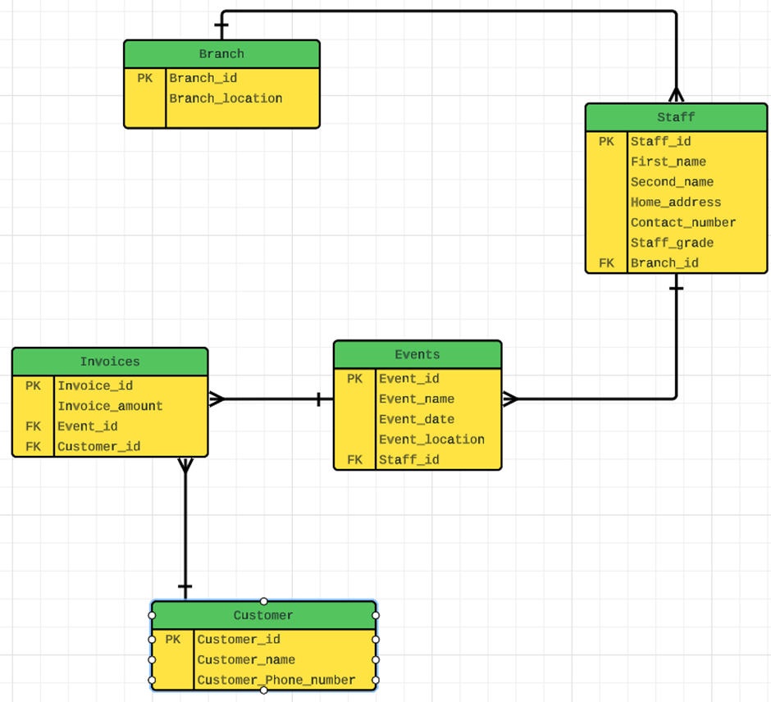

Main Menu from access
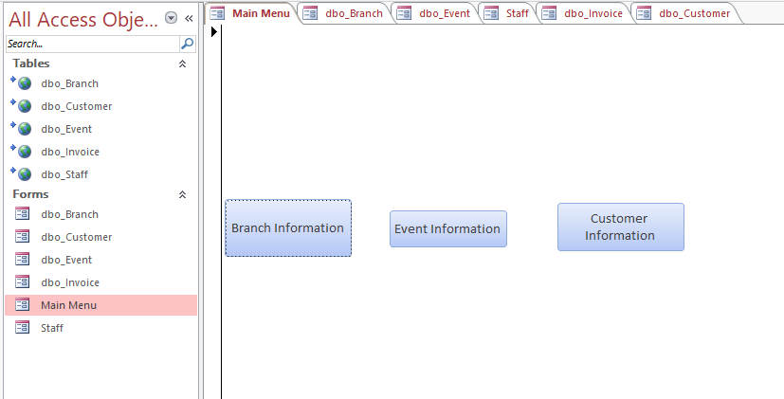

Branch screen
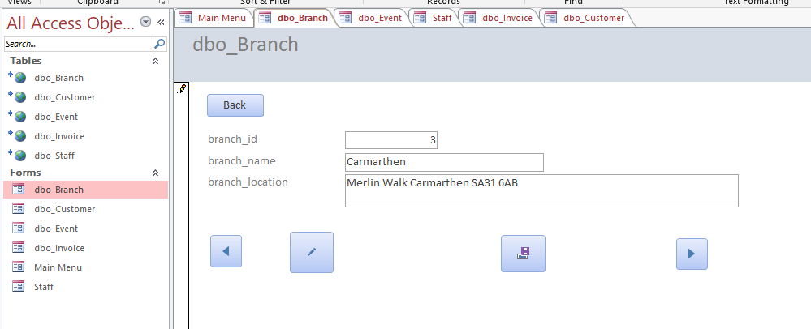

Staff Screen

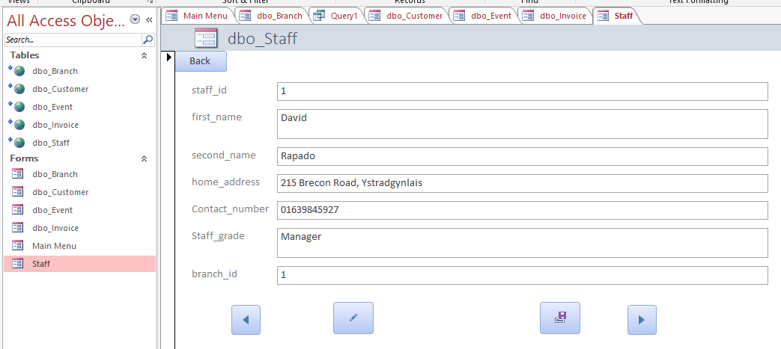

Customer Screen
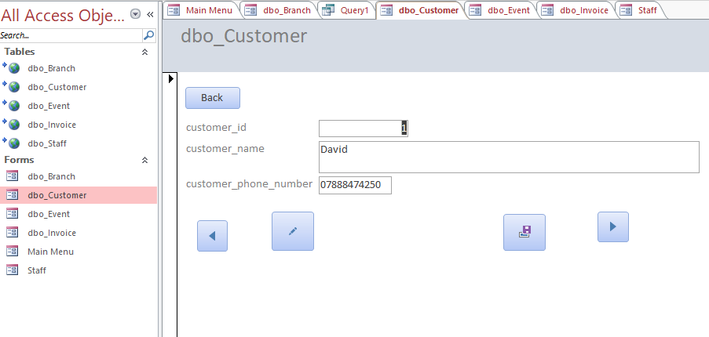

Event Screen
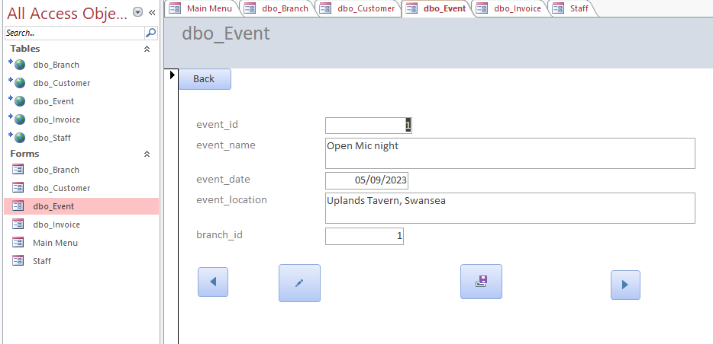

Invoice screen
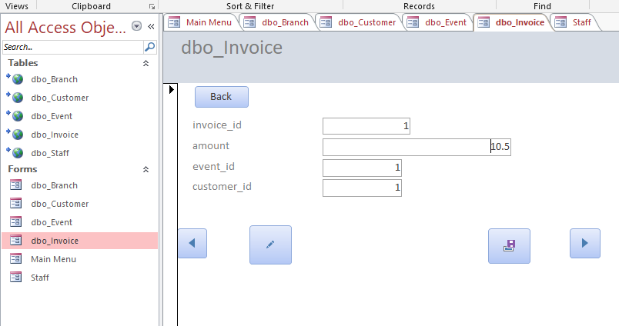

Conclusion

Bibliography

