Owen Bayliss (1708437) – Independent Project (Dissertation) Proposal
Word Count - 1085
Introduction
For my third-year independent project, I propose that I will investigate and explore “The Effects of Surface Quality of Internal Pipework in Friction Loss Reduction in an Automatic Sprinkler System”. I have proposed this investigation as it is both relevant to my degree and my career. As I work in the fire suppression sector and more specifically in the design of fire suppression systems pursuing an independent topic that is both relevant to my course and career is crucial for me to gain valuable experiences and allow myself to apply what I have learned over the duration of the course into my every day working environment. More specifically I can apply the theorems and equations from modules such as stress analysis and dynamics, Advanced process and materials and Structural and Fluid analysis for example. In an automatic wet fire suppression system when a sprinkler head temperature sensitive bulb is triggered and the pressure drops in the system the flow velocity in the system will cause the flow switch to become engaged on the control valve set, this will relay a signal to the pump which will cut in and engage the full system. The purpose of my investigation will be to analyse if I reduce the friction loss in the system, will this allow the system to run more efficiently and save costs. This investigation will also apply to dry systems, dry systems differ to wet systems as dry systems are not constantly primed with water. In a dry system when the sprinkler is triggered the pneumatic pressure loss causes the control valve to open and release water into the system. When producing a hydraulic calculation for a dry system it is crucial that the time from control valve opening too the sprinkler dispersing water must remain under 30 seconds, reducing friction losses and increasing water velocity would have massive benefits in a dry system.
I came to this idea for my independent project whilst completing the designs for a relatively small project in my workplace. This project was a primary school in Swansea. As this project was perceived as being relatively small it was designated by our listing team as a hand calculation project. This meaning that all hydraulic calculations for the automatic wet sprinkler system would have to be completed using the predetermined calculations tables for friction loss in pipe diameters ranging from 150mm to 25mm and using predetermined figures for minimum water supply in a water storage tank and a predetermined size for the electrical or diesel pump that would be selected also by the listing team. All hand calculations would be based on a single design point within the system, this design point was selected using a criterion stated within the LPC folder (the LPC is the governing body for automatic sprinkler systems design for the UK), from there I calculate the pressure losses in each pipe based on the Hazen Williams number for a heavy steel pipe. The main goal of my calculations is to keep the pressure losses from my design point to the control valve set at the bottom of the system below 500mm/sec, balancing my equation by altering the pipe diameters throughout the system. I have included samples of these predetermined tables at the back of this proposal.

Aims & Objectives
As my proposed title would suggest the primary aim of my project is to investigate the effects of the surface quality and material of internal pipework in relation to friction loss and more specifically the reduction of friction loss within a required system.
My intentions are to explore how different materials and surface coatings inside the pipework will affect the fluid flow and friction losses present. I will use this data to investigate if the required pressure produced by the pumps presented in the predetermined tables are necessary for an automatic sprinkler system with an internal coating and whether in fact an internal coating will produce a more efficient system and therefore will require a smaller pump saving on total project costs. Not only will this reduce costs of the pump, but this will also reduce costs in other areas, such as the GRP housing for the pump as this will now see a reduction in size, furthermore the pumphouse valve set and all valves included will now see a reduction in size and therefore costs.
I will explore current internal coatings which are currently being used throughout other areas in industry and whether these would be possible materials and coatings which could be possibly used for my purpose.
Methodology
I desire to conduct this investigation by researching and investigating multiple coatings which are currently used in other areas through experimental methods in testing fluid flow and friction loss and comparing these results with predetermined existing results of friction loss in uncoated heavy metal pipework.
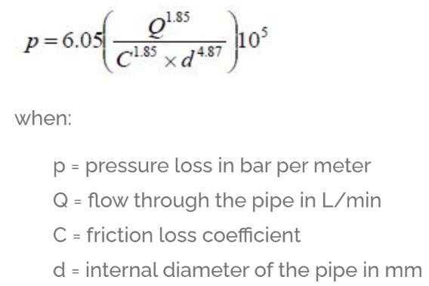
I will also use tools which I already currently have at my disposal to test the friction loss in different pipes constructed of different materials and with different surface coatings. When conducting hydraulic calculations digitally we run a software called FireCAD. This software allows me to confidently produce accurate results for the fluid flow, pressure losses, fluid velocity, flow direction and frictional losses within an entire sprinkler system and also more specifically from a singular sprinkler head or pipe. The program bases all its equations in relation to fluid velocity and pressure losses on the Hazen Williams coefficient for head loss in a pipe and the Darcy Weisbach Equation (depending on the chosen standards decided by the projects intended clients). The Hazen Williams is as follows,

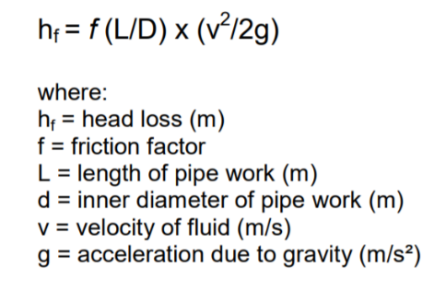
The Hazen Williams equation is used to calculate the pressure loss in a pipe and is used when producing accurate hydraulic calculations. The main investigation area for my project will be the friction of various synthetic coatings that could possibly be used. The Hazen Williams friction loss of coefficient is different to that of the Reynolds number as the Hazen Williams can only be used when the water flow is a turbulent flow (systems, H., 2021). When a sprinkler system is being subjected to different temperatures or extreme temperatures or extreme pressures then the Darcy Weisbach Equation is a more suitable option to use (systems, H., 2021). The Darcy Weisbach Equation is shown below,

As I am investigating the effects in a full automatic sprinkler system I will have to look at other areas that this reduction in friction loss will effect, for example the increased fluid velocity effects on components such as the control valves and butterfly valves.

References
systems, H., 2021. Hazen Williams formula for use in fire sprinkler systems. [online] Canutesoft.com. Available at: <https://www.canutesoft.com/Hydraulic-calculation-for-fire-protection-engineers/the-hazen-williams-formula-for-use-in-fire-sprinkler-systems.html> [Accessed 16 September 2021].
Pipeflow.co.uk. 2021. Darcy-Weisbach Formula. [online] Available at: <https://www.pipeflow.co.uk/public/articles/Darcy_Weisbach_Formula.pdf> [Accessed 16 September 2021].



