Module: Data Handling & Business Intelligence
A Report
On
Current Trends of Business Intelligence

Module code: LCBB5000
Student Name: Felix Lucian Fistoleanu
Student ID: 2115327

Table of Contents
Introduction 3
Engagement with Literature Skills 4
Knowledge and Understanding Skills 5
The concepts and principles of Business Intelligence 5
There models of Data Handling & Business Intelligence 6
Cognitive and Intellectual Skills 8
Critically evaluating information 8
Propose solutions arising problems 9
Practical Skills 10
Examples of practical skills in BI include 10
Transferable Skills for Life and Professional Practice 11
Display transferable skill in life and professional atmosphere. 11
Conclusion 12
References 13

Introduction
Business intelligence (BI) is the process of gathering, integrating, analyzing, and presenting business data for decision-making. Technology developments have led to trends in business intelligence (BI), including the use of AI and ML to automate data analysis and cloud-based BI systems, which offer scalability and flexibility. Big data, self-service analytics, and concepts like data visualization have all significantly influenced business intelligence. The ETL (Extract, Transform, Load) Model and the OLAP (Online Analytical Processing) Model are two models of data processing and BI.

Engagement with Literature Skills
In order to assist decision-making processes, business intelligence (BI) refers to the use of technology, tools, and techniques for gathering, integrating, analyzing, and presenting corporate data. Businesses may use BI to obtain insights into their operations, clients, and markets and then use those insights to drive data-driven choices (Awad, Al Redhaei and Fraihat, 2022). In recent years, a number of business intelligence trends have evolved as a result of technological improvements. The use of artificial intelligence (AI) and machine learning (ML) to automate and improve data analysis is one of the primary trends in business intelligence. The way businesses manage data and make choices is changing as a result of artificial intelligence and machine learning. These technologies are able to evaluate enormous volumes of data at speeds and scales that are unattainable for humans (Bucea-Manea-Țoniş et al., 2022). Cloud-based BI solutions have become increasingly popular due to the advantages they offer over traditional on-premises solutions. With cloud-based BI, businesses can access their data from any location with an internet connection, facilitating communication and collaboration amongst remote staff. Furthermore, cloud-based business intelligence (BI) systems frequently provide cheaper upfront costs and more flexible payment choices, such pay-as-you-go or subscription-based models (Ghelani, 2022). Because of this, companies of all sizes may more easily adopt and manage BI solutions without having to make substantial infrastructure and hardware investments. Greater scalability is another benefit of cloud-based BI tools, as users may quickly increase or decrease usage as necessary.

Knowledge and Understanding Skills

The concepts and principles of Business Intelligence
Data visualization: Data visualization is yet another crucial idea in business intelligence. The process of displaying data in a graphical style, such as charts or graphs, in order to make it easier for people to interpret the data is known as data visualization (Hayajneh et al., 2022). As it enables users to rapidly and readily spot trends, patterns, and outliers in the data, it is a crucial part of BI.

Self-service analytics: Self-service analytics is a key idea in business intelligence. It refers to a feature that allows business people to view and evaluate data without requiring IT assistance.

Big data: BI has been significantly impacted by the emergence of big data. Big data is the term used to describe the enormous amounts of organized and unstructured data that businesses are currently gathering (Hill et al., 2022.). BI tools have evolved to handle big data, enabling businesses to gain insights from large and complex datasets.

There models of Data Handling & Business Intelligence
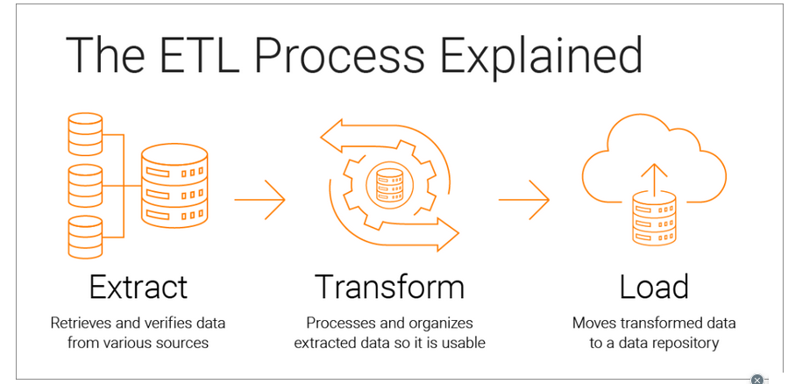
The ETL Model
Figure 1: The ETL Model (source: internet)
A data integration paradigm called the ETL (Extract, Transform, Load) paradigm is employed in business intelligence to transfer data from various sources, transform it into a usable format, and load it into a data warehouse for analysis (Höpken and Fuchs, 2022). There are typically three primary phases to the ETL process:

Data extraction: Data extraction is done during this stage from a variety of sources, including databases, spreadsheets, flat files, and other data sources.

Data transformation: Data transformation is done at this stage to make the information consistent, orderly, and useful (Jaradat et al., 2022). By eliminating duplicates, missing, or unnecessary data, and standardizing the data format, data can be cleaned.

Loading: This stage involves loading the data into a data warehouse or data mart where it can be analyzed, queried and reported (Paczkowski, 2022.). Data can be loaded into the data warehouse in batches or in real-time.

OLAP model
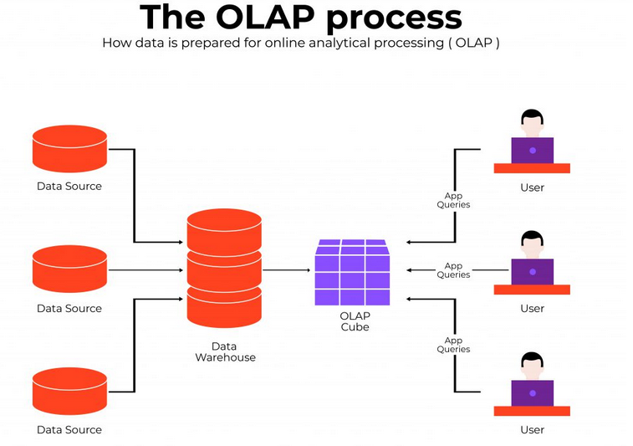
Figure 2: OLAP model (source: internet)

Data in a multidimensional format is stored and managed using the OLAP paradigm, a business intelligence approach. This indicates that the data may be easily evaluated and searched by various variables or metrics since it is structured into dimensions like time, location, product, or customer. Complex inquiries and analysis, including data slicing and dicing by many dimensions, drilling down to more in-depth levels, and aggregating data at various levels of granularity, are all made possible by OLAP. Each cell in the data structure, which resembles a cube, represents a different set of dimensions and measurements. In addition to forecasting, planning, and budgeting, OLAP is frequently utilized in financial, sales, and marketing analyses.

Cognitive and Intellectual Skills

Critically evaluating information
An organized method of looking over the data, finding important elements, and making decisions based on that data is the analysis of BI information (Rana et al., 2022). Here are some procedures to take while analyzing and dissecting BI data:

Understand the data: It's critical to comprehend the data and the environment in which it was obtained before BI information can be analyzed (Singh et al., 2022). This entails being aware of the sources and types of data gathered as well as any potential biases or restrictions.

Break the data down: After understanding the data, one can start to divide it up into smaller components. Data may need to be categorized according to elements like time periods, product categories, or client segments.

Make inferences: Based on the patterns and trends you've discovered after breaking down the data, one can make inferences. In order to do this, he must apply his skill and knowledge to derive inferences from the information.

Compile and compare information: After drawing conclusions, a person might compile the information and compare it to other business intelligence data sets. This may entail contrasting historical data, data from several product lines, or data against industry standards.

Propose solutions arising problems
When making sound judgments and convincing arguments using data and concepts of business Intelligence, it is also important to consider alternative solutions and recommendations (Srivastava et al., 2022).
Reviewing the literature: This can help to build background and make sure that the argument is based on recognized business intelligence theories and research.

Taking into account various viewpoints: This can entail analyzing the data from various Business Intelligence perspectives, taking into account the viewpoints of various stakeholders, or investigating alternate hypotheses.

Recognizing constraints: This may entail identifying biases or restrictions in the data or admitting constraints placed on the use of business intelligence concepts.

Proposing alternative solutions: Offering alternate methods to a problem's solution or investigating other theories are examples of proposing alternative solutions in business intelligence.

Making suggestions: These suggestions must to be based on the data and ought to be realistic and doable.

Practical Skills
The capacity to apply fundamental ideas and principles in practical contexts is one of business intelligence's practical skills. Combining technical, analytical, and communication abilities is necessary to demonstrate actual business intelligence skills. A crucial practical skill in business intelligence is effective communication (Yalcin, Kilic and Delen, 2022). This includes having the ability to communicate complicated data findings to various stakeholders, such as executives, managers, and front-line employees, in a way that is both clear and intelligible. commercial intelligence specialists can assist firms in making decisions that promote commercial success by applying fundamental concepts and principles outside of their original context and demonstrating how they relate to real-world circumstances. Using models, methodologies, approaches, and theories to solve issues and produce potentially innovative artifacts is a practical aspect of business intelligence.

Examples of practical skills in BI include
Predictive analytics is the capacity to employ tools and procedures to analyze data in order to find patterns and trends that can be used to anticipate future events, such as consumer behavior or market movements.

Machine learning: The capacity to create prediction models and automate judgments based on data using machine learning algorithms.

Reporting using business intelligence: The capacity to produce analyses of key performance indicators, patterns, and other metrics crucial for business decision-making.

Transferable Skills for Life and Professional Practice

Display transferable skill in life and professional atmosphere.
Task Completion: Prioritizing tasks, organizing workload, and meeting deadlines. Being flexible and adaptable to changing circumstances. Seeking feedback to improve efficiency and effectiveness.

Collaboration: Working effectively with colleagues from diverse backgrounds and skillsets. Communicating clearly and actively listening to others' viewpoints.

Effective Communication: Presenting information clearly and concisely, both orally and in writing. Adjusting communication style to suit the audience, whether specialist or non-specialist.

Organization: Being well-organized and managing time effectively. Keeping accurate records and maintaining a clean and tidy workspace. Being able to multitask and prioritize tasks effectively.

Conclusion
Business Intelligence (BI) is an essential tool for organizations to gain insights into their operations, customers, and markets, and make data-driven decisions. The use of artificial intelligence and machine learning in BI is transforming the way businesses handle data and make decisions. Cloud-based BI solutions are also becoming increasingly popular due to their flexibility, scalability, and lower upfront costs. The concepts and principles of BI, such as data visualization, self-service analytics, and big data, are crucial for businesses to effectively analyze and interpret their data. The ETL and OLAP models provide different approaches to handling data in BI, with the ETL model used for data integration and transformation, and the OLAP model used for multidimensional analysis.

References
Awad, M., Al Redhaei, A. and Fraihat, S., 2022. Using Business Intelligence to Analyze Road Traffic Accidents. In Proceedings of the Central and Eastern European eDem and eGov Days (pp. 83-92).
Bucea-Manea-Țoniş, R., Kuleto, V., Gudei, S.C.D., Lianu, C., Lianu, C., Ilić, M.P. and Păun, D., 2022. Artificial intelligence potential in higher education institutions enhanced learning environment in Romania and Serbia. Sustainability, 14(10), p.5842.
Ghelani, D., 2022. Complex Business Intelligence Queries in Natural Language.
Hayajneh, J.A.M., Elayan, M.B.H., Abdellatif, M.A.M. and Abubakar, A.M., 2022. Impact of business analytics and π-shaped skills on innovative performance: Findings from PLS-SEM and fsQCA. Technology in Society, 68, p.101914.
Hill, M.A., Overton, T., Kitson, R.R., Thompson, C.D., Brookes, R.H., Coppo, P. and Bayley, L., 2022. ‘They help us realise what we’re actually gaining’: The impact on undergraduates and teaching staff of displaying transferable skills badges. Active learning in higher education, 23(1), pp.17-34.
Höpken, W. and Fuchs, M., 2022. Business Intelligence in Tourism. In Handbook of e-Tourism (pp. 497-527). Cham: Springer International Publishing.
Jaradat, Z., Al-Dmour, A., Alshurafat, H., Al-Hazaima, H. and Al Shbail, M.O., 2022. Factors influencing business intelligence adoption: evidence from Jordan. Journal of Decision Systems, pp.1-21.
Paczkowski, W.R., 2022. Business Analytics: Data Science for Business Problems. Springer Nature.
Rana, N.P., Chatterjee, S., Dwivedi, Y.K. and Akter, S., 2022. Understanding dark side of artificial intelligence (AI) integrated business analytics: assessing firm’s operational inefficiency and competitiveness. European Journal of Information Systems, 31(3), pp.364-387.
Singh, D., Singh, A., Omar, A. and Goyal, S.B. eds., 2022. Business intelligence and human resource management: Concept, cases, and practical applications. CRC Press.
Srivastava, G., Venkataraman, R. and V, K., 2022. A review of the state of the art in business intelligence software. Enterprise Information Systems, 16(1), pp.1-28.
Wee, M., Scheepers, H. and Tian, X., 2022. The role of leadership skills in the adoption of business intelligence and analytics by SMEs. Information Technology & People, (ahead-of-print).
Yalcin, A.S., Kilic, H.S. and Delen, D., 2022. The use of multi-criteria decision-making methods in business analytics: A comprehensive literature review. Technological Forecasting and Social Change, 174, p.121193.

