 | University of Wales  Trinity Saint David
Programme | BA Business management
Module code | LCBB4004
Unit tittle | Marketing Fundamentals
Lecturer | Riaz Bhatti
Student ID | 1916917

[Type the company name]

Student: Silviya Lazarova

Contents
Background on Zara 3
Zara Products 3
Branding Strategy of Zara 6
Customization Offers and Services 7
Zara Promotion Strategy 8
Pricing Strategy 9
References 10

Background on Zara
One of the most fashionable and most famous international fashion brands originated in Galicia, Spain is the brand of Zara that specialises in fast fashion products including clothing and accessories. Zara is a brand that belongs to the Inditex group that is the largest retailer in the world. As per the reports till 2017, Zara is supposed to manage collections of 20 clothing apparels each year thereby ensuring its effectiveness and efficiency in the world of fast fashion. Amancio Ortega established the fashion brand Zara in 1975 by opening its first store in Central A, Coruna, Galicia in Spain. Although the brand was originally named Zorba based on a Greek film of the same name but rearranged them with as there was a bar of the same name two blocks. The company however began its expansion in the international platform from 1988 after entering the market of Portugal and in 1989 in the USA and in 1990 in France. Within the decade of the 90s, the brand expanded to Mexico, Greece, Belgium and Sweden while in the 2000s, in Brazil, Japan, Singapore, Russia, Malaysia, China, Morocco, Estonia, Hungary and Romania, the Philippines, Costa Rica, Indonesia, South Korea, India, Taiwan, South Africa and Australia and in 2012 in Peru. Moreover, the brand with technological advancements also expanded through its online platform since 2010 from Spain to UK Germany and to most of the countries that has its physical stores. The brand was successful in terms of updating its logo recently in 2019 whereby the brand was stated under the Global Fashion Business Journal in the same year for its growth in the textile commerce by 2.17% while other textile brands were facing slow down. This may be identified that the large number of products sold by Zara that is supposedly not repeated in terms of its designs whereby producing 12,000 new designs of clothing every year. Moreover, the brand’s extreme devotion towards providing excellent fashion to the customers and ensuring that it is able to enhance customer loyalty is understood through its effectiveness in the world platform.

Zara Products
Zara is a fast fashion that brand that has enhanced itself as a sustainable clothing brand in the world by undertaking strategies of producing and manufacturing clothes that are efficient clothing brand. Accordingly it produces major clothing products that include:

Organic cotton: the products made out of organic cotton are naturally grown making use of natural fertilisers and pesticides. The brand makes use of this raw materials to produce the clothes that are organic in cotton whereby ensuring to protect the biodiversity and soil fertility.

Recycled products: Zara ensures its sustainability by ensuring to produce clothing of polyester that are made out of recycled plastics. Moreover, the woollen textile products include production processes that are recovered and transformed into new products while ensuring that the waste of the fabrics of woollen and cotton are recycled thus, not lowering the production of the raw materials and conserving water, energy and natural resources.

Sustainable Linen: the raw material of linen is grown organically like cotton thereby ensuring that the products produced are sustainably manufactured using natural fabrics and fertilisers thereby not using seeds that are genetically modified.

Cellulose fibres: the raw materials that are collected from areas of forest and raw material products whereby Zara considers that managing of forests through sustainable products whereby the raw materials are grown in forest areas that belong to communities protecting the area through commitment for reforestation.
Website: https://www.zara.com/in/en/sustainability-products-mkt1455.html

Branding Strategy of Zara

The branding strategy of Zara in terms of providing its customers with newer and fashionable clothes includes identifying the latest trends that are i the highest demand and design its clothes accordingly. The rapidly functioning operations of manufacturing and production ensure the brand to beat its competitors and hold a greater position in the market by designing the latest style trends. Accordingly, its branding strategy includes three main aspects:
Shorter Time Leads: Zara provides its customers with clothes and apparels that they want to buy at a particular point of time rather than focusing on the products that may have its demands in the future. By providing the customers with their presently required demands and ensuring that they are provided with designs exactly at the point when they want it, Zara has enabled shorter leads in time thereby ensuring to provide the customers greater advantage and earning greater brand loyalty.
Lower Quantities ( scarce supply): in terms of ensuring that the brand is able to provide enhance the demands of the customers accordingly, the branding strategy of Zara includes to enhance the customers’ demands in terms of producing lesser number of products for the brand whereby lowering the exposure to a single product thus, making the product more desirable for the customers. Furthermore, with greater stocks of same design in the market the possibility for the product or design to face lower sales is high and with lower quantity products manufactured for the stores, the disposal of the waste also is lowered while ensuring to put up discounted prices during its particular time of the year.
More Styles: the branding strategy of Zara believes in producing more styles rather than larger quantities thereby ensuring to provide the customers with unique designs and styles of clothes. It has been evaluated that Zara produces 12,000 new designs in the clothes every year whereby selling out a style quickly with newer styles more in the range.
Website: https://martinroll.com/resources/articles/strategy/the-secret-of-zaras-success-a-culture-of-customer-co-creation/

Customization Offers and Services
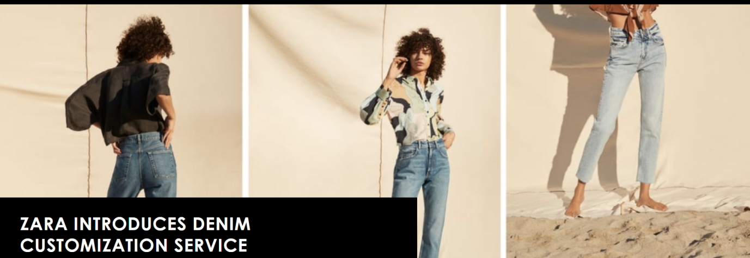
Zara has launched a customization service in three of its global stores in which the customers will be able to embroider words on a selected denim products of the brand. The service has been launched in March 27 of 2020 and it is being called a Zara Edited by the company. The services will only be available in three places namely Amsterdam, Milan and Barcelona. The customers will be able to choose from 13 different range of products and also embroider them with a range of fonts and colours as they wish. Furthermore the shoppers in Italy, Britain, Holland and Spain will be able to order themselves personalised items at their doorstep. Zara has started the in-store personalization aspects as a way to engage with the customers who want to express their individuality. Due to the sheer size of Zara this move will greatly impact its sales and this may increase onto other stores as well in the near future. The company has also introduced an interactive AR experience in 2018 so that the shoppers are able to experience new aspects of shopping in the company. The company is expected to deliver the customised products in the same day so as to increase customer trust and also increase the brand name of the company. However once customised, the items cannot be returned or exchanged back with other products. The company is also moving onto a global online integration from 2020 with online stockrooms and store network platform.
Website: https://thecurrentdaily.com/2019/03/15/zara-introduces-denim-customization-service/

Zara Promotion Strategy

Zara spends less than 0.3% of the revenue in advertising or promotion of its products. The company is famous for being press shy and even the CEO of the company does not hold any press conferences. The company’s, promotion strategy cannot be seen in televisions as it does not engage in flashy campaigns. The unique selling proposition of the company is to have a short processing time, having large variety of styles and also affordable pricing. The company relies on its word of mouth promotion and the social media. The social media marketing reach of Zara is quite exceptional as it has more than 2.5 million followers of Facebook and more than 15 million followers on Instagram. The company spends most of its revenue in opening new stores and decorating the new stores with state of the art technology and new services for the customers. As the company believes that the show windows are suffice for the required advertisements. The strategy of Zara focusing on its stores is visible as through the attention of detail in each of its showrooms. The company is precise, professional and elegant and as the company focuses on its core qualities it hopes that this will bring in new customers by building its popularity and an effective brand image. One of the key promotion strategy of the company is to have based on experience, exclusivity, differentiation and affordability. The company plans its stores accordingly based on places where it has less presence, it has more than 5000 stores worldwide and it has helped the company to become one of the known brands in many countries. The quality of its products does all the promotion of the company as it has poor marketing when it comes to selling its products.
Website: https://www.mbaskool.com/marketing-mix/products/16999-zara.html

Pricing Strategy
The products of Zara are considered to be high on fashion and low on cost. The company provides the latest fashionable products in lower prices in most of its international stores. The company follows the low pricing strategy or the cost leadership strategy as it hopes to become the top brand by offering its products in low prices. The company is able to withhold this strategy as it does not invest in advertising nor on its promotion strategies as well. The company has an overall low cost structure as compared to its competitors. The company sets the market based pricing strategy which also sets the target price the consumer is willing to pay. This helps the company to fix the profit margin they earn on each of the item. The company uses various schemes for the way of sales promotion. The company has low level of discounting all-round the year however it offers discount sales of 50% twice a year for which the customers wait eagerly. The company follows a pricing strategy which has been tailored to the characteristics of the market as consumers are willing to pay as much as based on their income. Furthermore the company meets the particular needs for fast fashion and also provides flexibility and innovation in affordable prices. The latest reports published by the newspaper El Confidencial says that the company’s products are pricing 22-24% higher in France, Italy and Germany whereas it is priced 505 higher in Mexico and Britain. This strategy helps the company to gather profits from all the countries and most sales of 21.4% of total sales from Asian Markets. The sales prospect of Zara is increasing in Asia and the company is planning to differentiate its products in the market so as to increase its sales in the already blooming market.
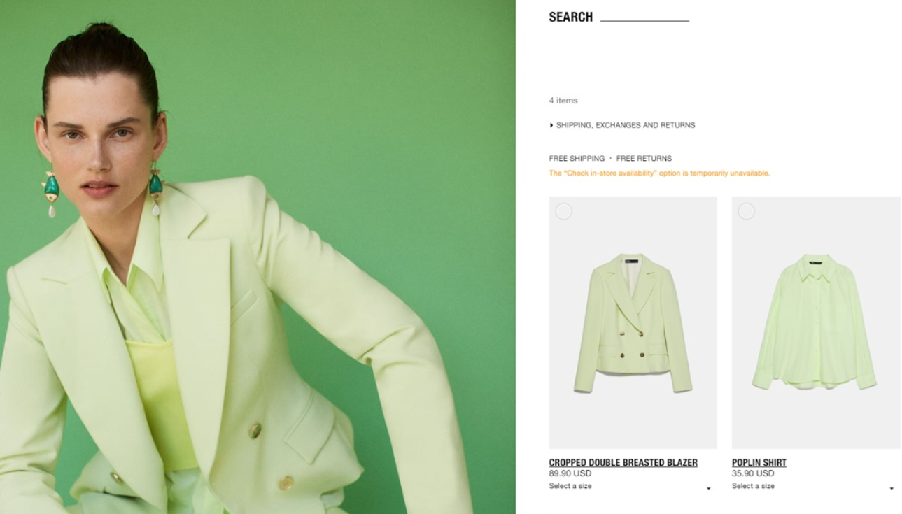
Website: https://growvation.com/srishti-chopra/project/pricing-strategy-of-zara/4e49b367-c7c0-4744-b5d6-c0140b96ee50

References
Chopra, S., 2020. GrowVation. [online] Growvation.com. Available at: <https://growvation.com/srishti-chopra/project/pricing-strategy-of-zara/4e49b367-c7c0-4744-b5d6-c0140b96ee50> [Accessed 30 January 2021].
Rydzek, C., 2019. Zara introduces denim customization service. [online] Current Daily. Available at: <https://thecurrentdaily.com/2019/03/15/zara-introduces-denim-customization-service/> [Accessed 30 January 2021].
Team, M., 2020. Zara Marketing Mix (4Ps) Strategy | MBA Skool-Study.Learn.Share.. [online] MBA Skool-Study.Learn.Share. Available at: <https://www.mbaskool.com/marketing-mix/products/16999-zara.html> [Accessed 30 January 2021].
MartinRoll, 2021. The Secret of Zara’s Success: A Culture of Customer Co-creation | Martin Roll. [online] Martin Roll. Available at: <https://martinroll.com/resources/articles/strategy/the-secret-of-zaras-success-a-culture-of-customer-co-creation/> [Accessed 30 January 2021].
Zara, 2021. PRODUCTS-JOIN LIFE | ZARA India. [online] Zara.com. Available at: <https://www.zara.com/in/en/sustainability-products-mkt1455.html> [Accessed 30 January 2021].
Nissen, M.S., Stokholm, Z.A., Christensen, M.S., Schlünssen, V., Vestergaard, J.M., Iversen, I.B. and Kolstad, H.A., 2018. Sinonasal adenocarcinoma following styrene exposure in the reinforced plastics industry. Occupational and environmental medicine, 75(6), pp.412-414.

