

Name: Javaria Irfan Hafiza
Student number: 2504716
Module code: LCHS4003
Module: Introduction to Health and Social Care
Lecturer’s name: Mumtaz Goolam
Assignment title: Portfolio – Two Tasks Poster and Essay

Table of Contents
Title page 1
Evergreen Residential care home (Task:1)
Explanation of the services 3
Brief history of the services 3
Current functions of RCH……………………………………………………………………………………………………………………………………………………………………4
Challenges faced by RCH…………………………………………………………………………………………………………………………………………………………………….4
Ambulance services (Task :2)
Introduction……………………………………………………………………………………………………………………………………………………………………………………….5
Origins and historical context……………………………………………………………………………………………………………………………………………………………….5
Critical Evaluation of current services functioning……………………………………………………………………………………………………………………………………5
Significance for enhancing quality of life…………………………………………………………………………………………………………………………………………………5
Conclusion……………………………………………………………………………………………………………………………………………………………………………………….6
References…………………………………………………………………………………………………………………………………………………………………………….7,8.9

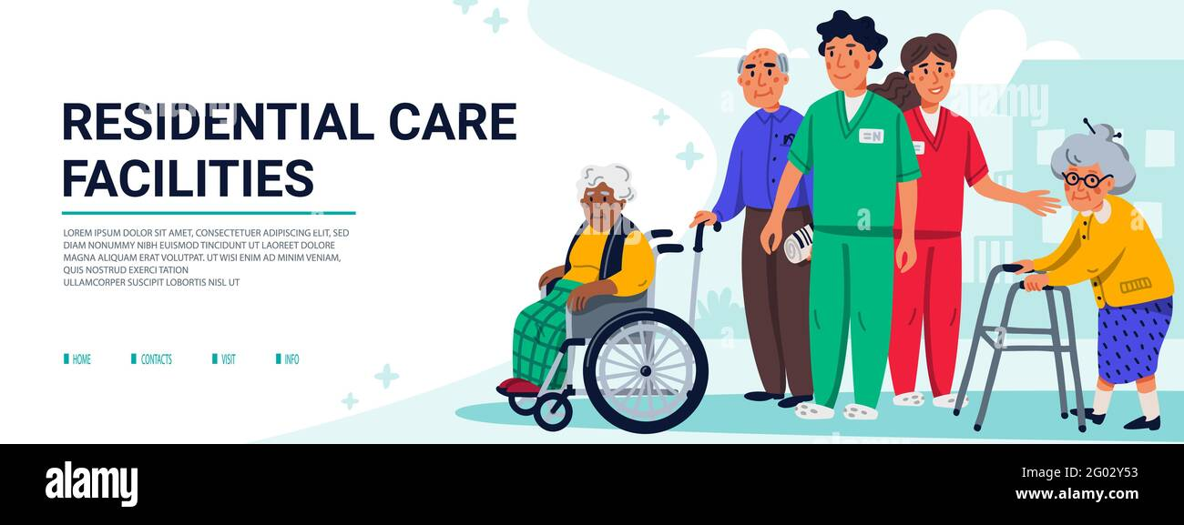
Alamy (n.d.)

A residential care home provides accommodation and personal care for people who cannot live independently at home. Residential homes support individuals with daily activities such as washing, dressing, eating, and taking medication. Staff are available 24 hours a day to ensure safety and wellbeing (NHS, 2023). Residential care centers generally do not offer specialist medical care, as compared to nursing homes. They emphasise helping older people with social activities, relaxation, and individual care. Care homes are controlled by laws that ensure that quality and safety requirements remain consistent and can be managed by the NHS, private companies, foundations, or local governments.
. Vecteezy (2025a)
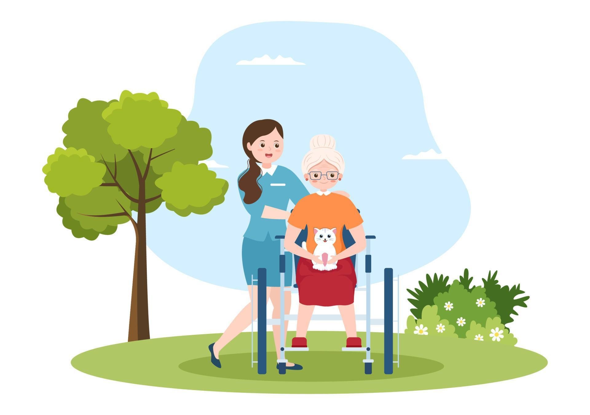

.

In the past, charities and places of worship offered informal support for the vulnerable. While early 20th-century facilities were better organised, they often didn't have sufficient money. Changes introduced in the middle of the 20th century eventually brought professional standards and inspections, transforming care from informal support into regulated services. According to Skills for Care (2023), an important moment in history was the Care Act 2014, which created a legal obligation to "promote individual well-being". This law shifted residential care from a clinical, "one-size-fits-all" model to a person-centred strategy that promoted emotional health and dignity. The system continues to evolve for an elderly population today, moving away from institutional settings and toward conditions which emphasise independence and human rights (Vecteezy (2025b)
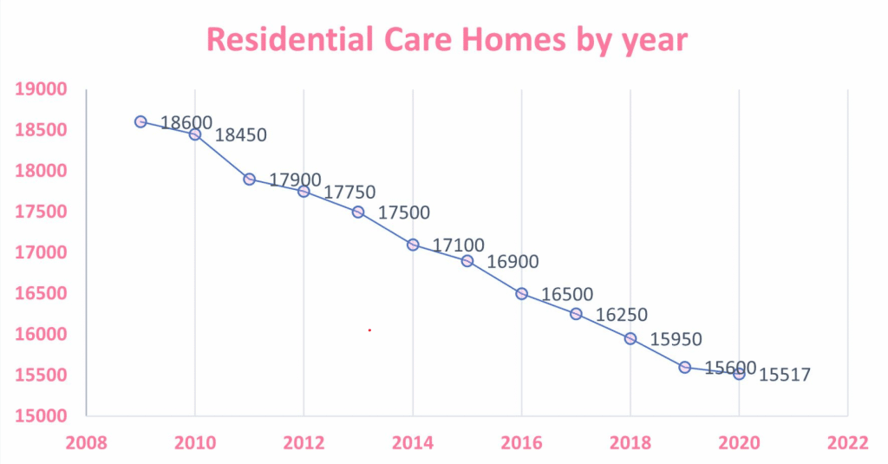

Ever green Residential care home
🕰️ Brief History of Residential Care Homes:
(Chat4Business, 2021
📌 Explanation of the service
v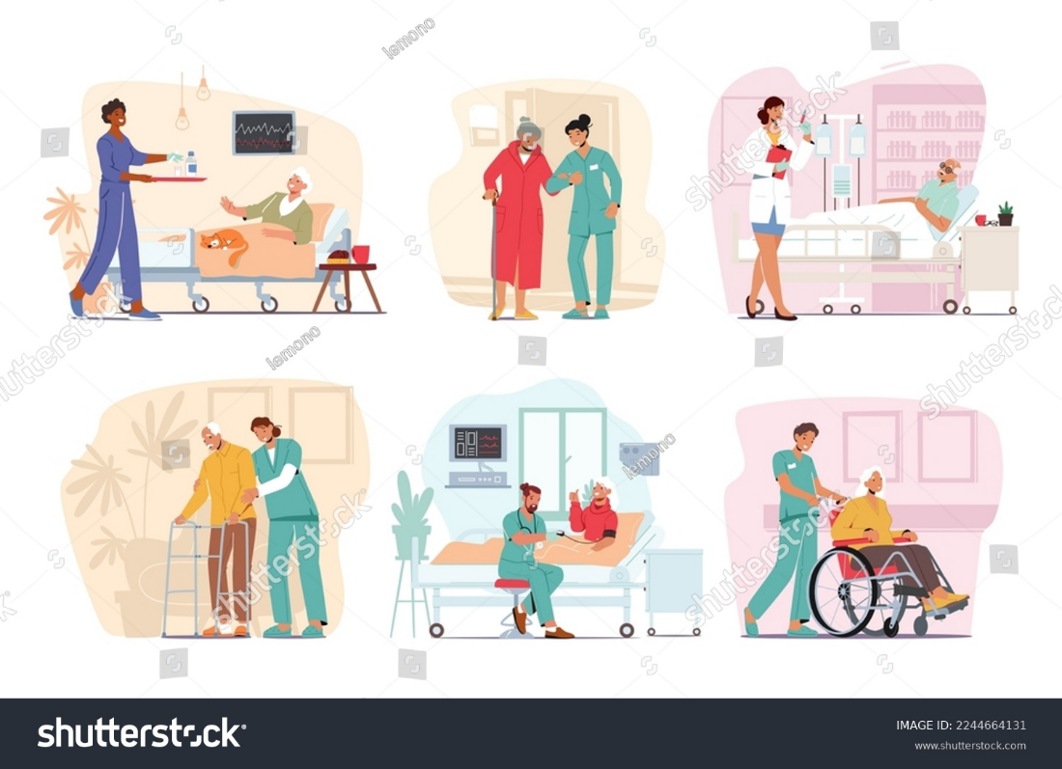
Current functioning of the residential care home
In the UK social care system, residential care homes have become regulated services. To deliver organised, holistic care, they work alongside NHS services, local governments, families, and community organisations. Care that emphasises individual organising, medication help and monitoring, food and nourishment services, secure apartments and private living spaces, organised recreational and social involvement programs, emotional and mental wellbeing support, and 24-hour carer availability are all vital components of the program. Each resident has an individual care plan that is regularly reviewed to reflect changing needs. Residential care homes aim to promote independence while ensuring safety, dignity, and overall well-being for all residents (NICE, 2022).
⚠️ Two Challenges Faced by Residential Care homes
Shutterstock (2023)

Staff Shortage: Residential care homes face significant workforce shortages due to difficulties in recruiting and retaining qualified care staff, caused by factors such as low pay, high workload, emotional demands, and poor staff retention, which negatively impact service quality and resident wellbeing (Skills for Care, 2023). Existing employees are under greater burden due to staff shortages, which results in fatigue, stress, and less time for genuine interaction with residents. This may limit chances for social interaction and decrease emotional support. As a result, residents' general well-being and quality of life may suffer.

Residential care homes face significant financial pressure due to limited funding from local authorities, rising operational costs, and increasing demand for services, which affects their ability to maintain high-quality care and sustainable service delivery (Department of Health and Social Care, 2022). A care facility's ability to fund resident activities, equipment, staff training, and building improvements may be restricted by financial limitations. This can ultimately negatively impact the standard of living for residents and put more pressure on families as well as the larger welfare and healthcare system.

Funding and Financial Pressures:

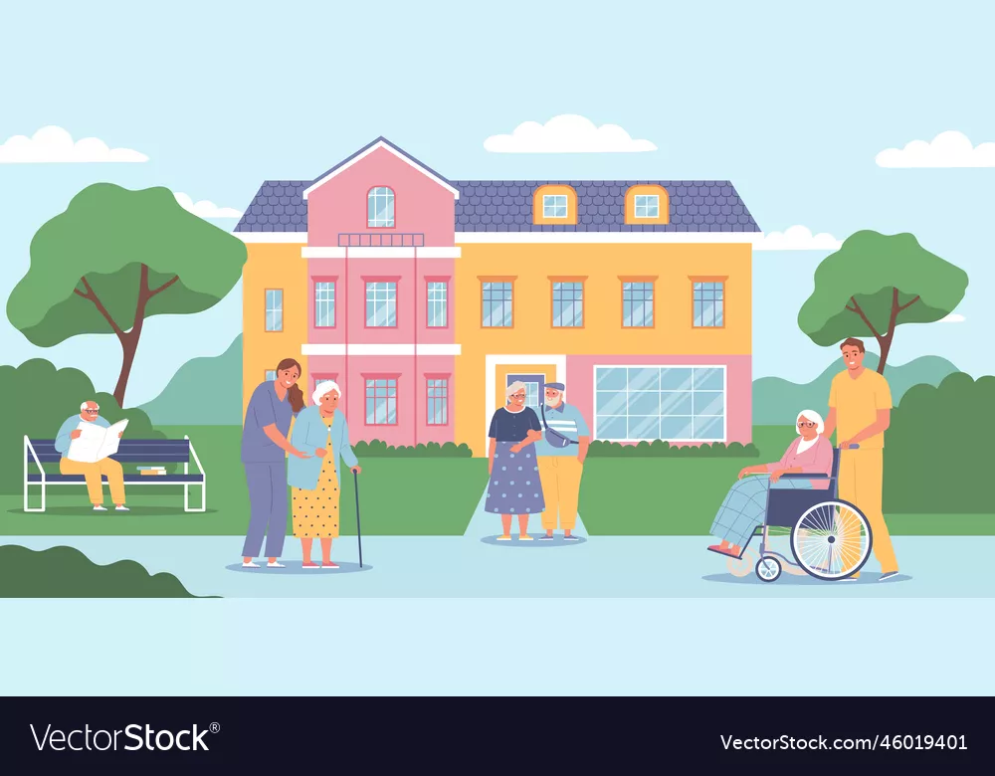
VectorStock (n.d.)
Task 2
Ambulance Services
In the UK, ambulance services are a vital part of emergency medical care. From basic transport teams to highly skilled medical professionals capable of preventing fatalities before patients reach the hospital, a lot has changed. This essay discusses the origins of ambulance services, their current operations, and the reasons they have significance for people's standard of life.

Origins and Historical Context
In the UK, ambulance services did not begin as the advanced emergency care system that operates today. In the early days, before motor vehicles, injured or sick people were taken to hospitals by police, firefighters, or even taxis using stretchers called “litters” (London Ambulance Service NHS Trust, 2025). Early ambulances were horse‑drawn, and the first petrol‑powered ambulances appeared in the early 1900s. These early services existed in parts of the country, but there was no single, coordinated system (London Ambulance Service NHS Trust, 2025).

A major change came after the National Health Service (NHS) was created in 1948. Legislation at that time required that ambulance services be available to all who needed them, free at the point of use (London Ambulance Service NHS Trust, 2025). This led to greater coordination and standardisation. In 1965, nine smaller ambulance services in London merged to form the London Ambulance Service as one integrated service, marking a key point in its development. Paramedics became professionally recognised and now hold degree-level qualifications, a shift from the simple training of early crews. A paramedic is a specialist healthcare professional who provides high-quality, pre-hospital care, often in emergency situations, and possesses the skills to administer life-saving treatment and use advanced equipment (NHS Careers, 2025)

Critical Evaluation of How the Service Functions Today
The ambulance services of today differ significantly from those of the past. In addition to transferring patients to hospitals, paramedics and emergency workers are trained to evaluate and treat patients on the spot. Digital technology and urgent response procedures are used to deal with the massive number of calls received each year. Many patients can receive treatment at home or be directed to community programs, which reduces the pressure on emergency departments.

This technological system has certain benefits. Outside of hospitals, paramedics are highly skilled and capable of performing life-saving treatments. Some services, such as North West Ambulance Service, report improved response times for serious calls by using telephone assessment and targeted dispatch to send ambulances only when needed (North West Ambulance Service, 2025). This makes the service more efficient and patient‑centred.

But there are serious shortcomings. Delays in emergency rooms are a serious problem, and the need for emergency care has increased significantly. According to recent data, emergency medical services in England waste millions of hours annually waiting to transfer patients, which reduces the number of workers available for new calls. Patients may suffer as a result of these delays. Additionally, staff face high stress and safety issues. Reports show record levels of violence and abuse against crews, which affects staff wellbeing (The Guardian, 2025). Stress is also high among 999 call handlers, many of whom quit because of workload pressure, further impacting service performance (The Guardian, 2025).

Significance in Enhancing Quality of Life
In order to increase the quality of life for both individuals and communities, ambulance services are important. Providing immediate expert care can save lives in critical situations like heart attacks, strokes, or severe injuries. Paramedics settle patients, start treatment early, and figure out the best course of action to increase the likelihood of recovery.

Furthermore, modern ambulance services offer comfort to weak individuals like the elderly and those suffering from long-term illnesses. It promotes confidence and wellbeing to know that qualified professionals are available anytime. Additionally, preventing unnecessary hospital stays can be done by treating patients at home when needed. Patients suffer less anxiety, and resources in the larger healthcare system are opened up. By offering life-saving techniques like CPR, ambulance services contribute to improved public health and enhance community results.
Conclusion

In short, ambulance services have grown from fundamental transport systems into advanced specialised care providers. Nowadays, they are significant in fulfilling urgent medical needs and enhancing results for patients. While the service has several challenges, such as hospital transition delays and workplace stress, it remains important to improving quality of life by saving lives and supporting public health.

Reference list :task 1
Alamy (n.d.) Residential care home [Image]. Available at:
https://www.alamy.com/stock-photo/residental-care.html
(Accessed: 27 January 2026).

Care Quality Commission (2022) The state of health care and adult social care in England 2021/22. Available at:
https://www.cqc.org.uk/publications/major-report/state-care
(Accessed: 29 January 2026).

Chat4Business (2021) A Brief Overview of the Care Home Sector and How to Stay Ahead. Available at https://c4b.live/a-brief-overview-of-the-care-home-sector-and-how-to-stay-ahead/
(Accessed: 3 February 2026)

Department of Health and Social Care (2022) Market Sustainability and Fair Cost of Care Fund 2022 to 2023: guidance. Available at: https://www.gov.uk/government/publications/market-sustainability-and-fair-cost-of-care-fund-2022-to-2023-guidance

(Accessed: 27 January 2026).
Local Government Association (2024) The Care Act 2014: Ten years on from Royal Assent. Available at: https://www.local.gov.uk/publications/care-act-2014-ten-years-royal-assent
(Accessed: 27 January 2026).

National Institute for Health and Care Excellence (NICE) (2022) Care homes: topic overview. Available at:
https://www.nice.org.uk/guidance/settings/care-homes
(Accessed: 27 January 2026).

NHS (2023) Care services, equipment and care homes. Available at: https://www.nhs.uk/social-care-and-support/care-services-equipment-and-care-homes/

(Accessed: 27 January 2026).

Shutterstock (2023) Set medical care of elderly people concept [Vector illustration]. Available at:
https://www.shutterstock.com/image-vector/set-medical-care-elderly-people-concept-2244664131
(Accessed: 29 January 2026).

Skills for Care (2023) The state of the adult social care sector and workforce in England. Available at: https://www.skillsforcare.org.uk/Adult-Social-Care-Workforce-Data/workforceintelligence/Reports-and-visualisations/National-information/The-State-of-report.aspx
(Accessed: 27 January 2026).

VectorStock (n.d.) Nursing home vector image [Image]. Available at:
https://www.vectorstock.com/royalty-free-vector/nursing-home-vector-47401285
(Accessed: 27 January 2026).
Vecteezy (2025a) Conceptual flat design icon of home care [Online image]. Available at: https://www.vecteezy.com/vector-art/13259565-conceptual-flat-design-icon-of-home-care
(Accessed: 31 January 2026).

Vecteezy (2025) Elderly Care Services Hand Drawn Cartoon Flat Illustration with Caregiver, Nursing Home, Assisted Living and Support Design [Online image]. Available at: https://www.vecteezy.com/vector-art/10226273-elderly-care-services-hand-drawn-cartoon-flat-illustration-with-caregiver-nursing-home-assisted-living-and-support-design
(Accessed: 31 January 2026).

Reference list task 2
Association of Ambulance Chief Executives (2025) NHS ambulance services achieve performance improvements despite significant growth in demand and handover delays equating to 183 years of lost ambulance capacity. Available at:
https://aace.org.uk/news/nhs-ambulance-services-achieve-performance-improvements-despite-significant-growth-in-demand-and-handover-delays-equating-to-183-years-of-lost-ambulance-capacity
(Accessed: 27 January 2026).

London Ambulance Service NHS Trust (2025) London Ambulance Service celebrates 60 years of saving lives. Available at:
https://www.londonambulance.nhs.uk/2025/03/31/london-ambulance-service-celebrates-60-years-of-saving-lives/
(Accessed: 27 January 2026).

NHS Careers (2025) Paramedic [Online]. Available at: https://www.healthcareers.nhs.uk/explore-roles/allied-health-professionals/roles-allied-health-professions/paramedic
(Accessed: 19 February 2026).

NHS England (2025) Ambulance services are at the heart of the urgent and emergency care system. Available at:
https://www.england.nhs.uk/urgent-emergency-care/improving-ambulance-services/
(Accessed: 27 January 2026).

North West Ambulance Service (2025) Quality Account 2024/25. Available at:
https://www.nwas.nhs.uk/publications/quality-account-2024-25/
(Accessed: 27 January 2026).

The Guardian (2025) Violence and abuse against ambulance staff in UK at highest level on record. Available at:
https://www.theguardian.com/society/2025/apr/24/violence-abuse-against-uk-ambulance-staff-highest-level-ever
(Accessed: 27 January 2026).

