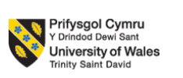

ASSIGNMENT: PORTFOLIO – BRAND EXTENSION

MODULE: MARKETING MANAGEMENT

MODULE CODE: LCMB7024
Student Name: Divya Adduru
Student ID: 2537627

1. Introduction

1.1 Company Overview
IKEA is a Swedish multinational company based in the world that deals with furniture, home furnishings and solutions for life at low prices (Mahalakshmi et al., 2024). The company, which is based on the principles of functional design, affordability and innovation, has become one of the largest home furnishing retailers in the world, operating in over 60 markets. The IKEA business strategy entails sustainability as it focuses on circular economy principles, renewable energy and responsible sourcing.

1.2 Proposed Brand Extension
The report suggests IKEA EcoStay, a green hospitality business that provides green hotels and serviced apartments that are eco-friendly and are designed in the IKEA Scandinavian style and align with the principles of sustainable living. The proposed brand extension is analysed in the report based on STDP analysis, 7Ps marketing mix and reflective assessment of the entire brand development process.

2. Company Background & Sustainable Brand Extension

2.1 Company Background
Ingvar Kamprad, a Swedish resident, established IKEA in 1943 and has expanded it to be one of the most successful home furnishing retailers in the world. The vision of the firm is to make the everyday life of many people a better one by making available well-designed, functional and affordable products in home furnishing. Having hundreds of stores and online platforms in over 60 countries, IKEA has created a robust international presence, which is backed by effective supply chain management, product design and customer-oriented retailing (Haraldsson et al., 2020). The main competencies of the organisation are Scandinavian design skills, cost leadership, operational efficiency, sustainability leadership and good brand recognition.

2.2 IKEA EcoStay
The IKEA EcoStay proposed will rebrand IKEA to be in the sustainable hospitality business by providing eco-friendly hotels and serviced apartments fully equipped with IKEA products. The idea incorporates renewable energy, the principles of a circular economy, smart technologies and locally sourced services to develop environmentally responsible accommodation (Del-Vecchio et al., 2022). This extension is a natural continuation of the IKEA brand identity as it enables customers to enjoy sustainable living outside retail products and also introduces new revenue streams in the fast-emerging sustainable tourism market.
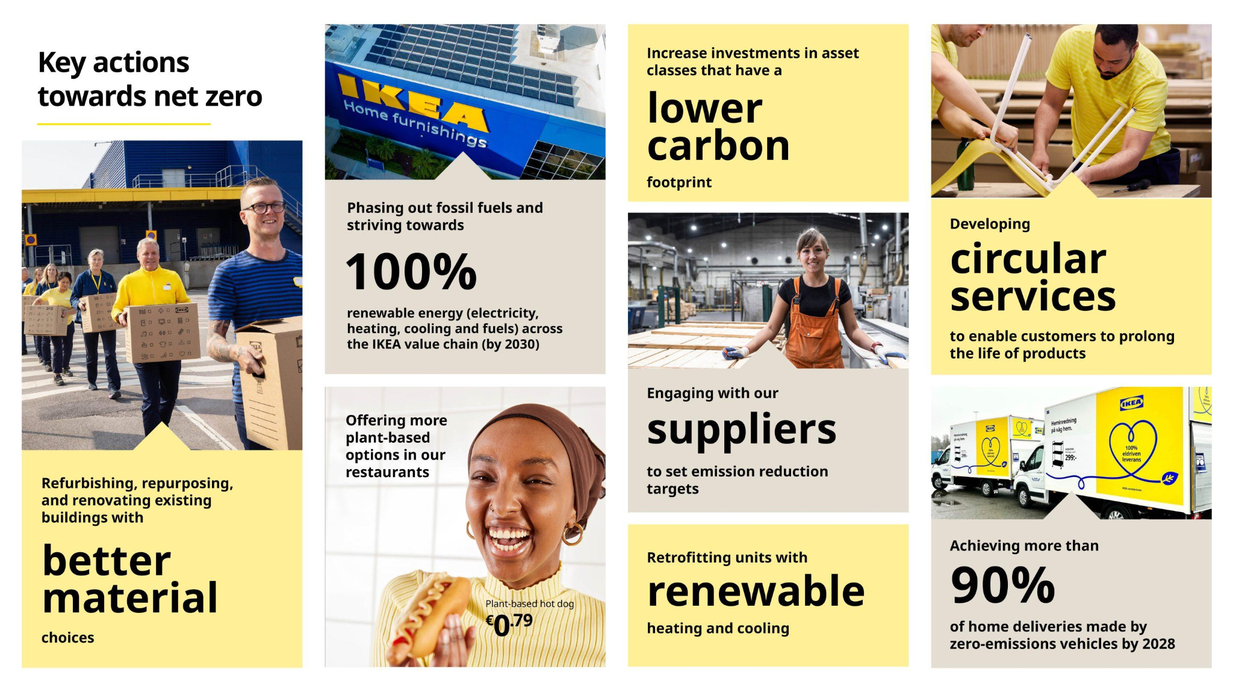
Figure 1: IKEA Sustainability Strategy
Source: (Ingka Group, 2025)

3. STDP Analysis

3.1 Segmentation
Market segmentation also helps organisations to subdivide the heterogeneous markets into smaller groups that share common characteristics, which in turn enables the organisations to tailor their marketing strategies. In the case of IKEA EcoStay, the segmentation will be through geographic, demographic, psychographic and behavioural variables to determine which customers are most likely to appreciate sustainable hospitality experiences.
Demographic segmentation targets consumers between the ages of 25-45 years, mainly middle and upper middleclass professionals, couples, digital nomads and young families (Kim et al., 2021). This customer is likely to have enough free income for leisure and business travel, and be value- and convenience-aware as well as environmentally conscious. Occupation also matters as business travellers and tele-workers might need good Wi-Fi, co-working space and flexible housing. Additional opportunities exist with family rooms and serviced apartments due to family status.
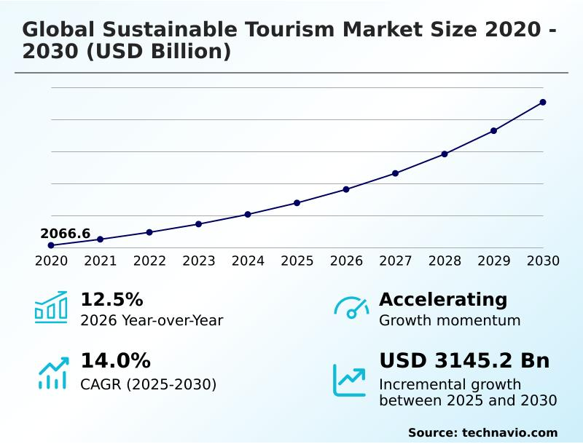
Figure: Sustainable Tourism Market Growth
Source: (Technavio, 2025)
Behavioral segmentation is based on travel frequency, booking behaviour, loyalty and benefits sought. The frequent leisure and business travelers who use digital reservation platforms are an interesting target group (Jiang et al., 2023). Customers who actively look for eco certified accommodation, energy efficient hotel and responsible tourism experiences are relevant. Current IKEA Family members are also a key behavioural segment as there could be familiarity with the brand, which could lead to first purchase, repeat booking and cross buying. IKEA EcoStay is therefore able to tailor offers and stimulate repeat bookings based on booking history and loyalty participation, as well as customer feedback.

3.2 Targeting
IKEA EcoStay follows a differentiated targeting approach, targeting the customer groups that appreciate the importance of sustainability, affordability and modern living experiences. Its main target market is environmentally conscious and professional individuals aged 25-45 years of age, business travellers, digital nomads, and middle- to upper-middle-income couples (Dreher et al., 2023). These consumers are often on the move either on business or recreation and are keen to find accommodation that identifies with their environmental beliefs as well as providing comfort, convenience and contemporary style. The secondary target market is young families, international tourists and IKEA Family members who already know about the products and sustainability programs of the brand. These consumers are lured by low-cost accommodation, practical Scandinavian interior and special hospitality services that reflect IKEA home furnishing solutions. A differentiated targeting strategy is suitable since it will enable IKEA to tailor marketing messages and service delivery to the needs of each customer group without losing its brand identity (Spinoglio, 2020). The strategy also allows IKEA EcoStay to capitalise on the already existing customer base of the company, build brand loyalty and penetrate new markets. The proposed extension can achieve high market acceptance by focusing on consumers who are moving towards sustainable consumption, which will help the business to grow and be competitive in the long run.

3.3 Differentiation
IKEA EcoStay stands out as a blend of low-cost hospitality and Scandinavian design, sustainable living values and the established brand of IKEA. IKEA EcoStay has a chance to compete with traditional hotels based on luxury or location; unlike these hotels, IKEA EcoStay gives its visitors a chance to enjoy fully furnished rooms using IKEA products in an environmentally friendly environment. The extension has a sustainable competitive advantage achieved by the adoption of renewable energy systems, circular economy, responsibly sourced materials and waste reduction programs (Onukwulu et al., 2022). Hotels will use energy-saving technologies, water-saving systems and recyclable furnishings that will support IKEA's long-term practice of environmental stewardship of IKEA. Such efforts not only help in saving the cost of operation but also increase the environmental credibility of the company. Creating customer value is achieved through the provision of low-cost and quality accommodation, as well as original Scandinavian living experiences (Christiansson et al., 2020). Ikea EcoStay's Customer Value Proposition (CVP) is to offer design-led, comfortable, affordable accommodation for environmentally conscious travellers, allowing them to enjoy sustainable Scandinavian living whilst minimising the impact of their stay. It is a proposition that incorporates functional, emotional and experiential value. In terms of services, the guests are offered comfortable rooms and useful facilities at competitive prices. Emotionally, customers can feel good about their travel options for being eco-friendly. In terms of experience, guests are face-to-face with IKEA's Scandinavia design and sustainable living concept.

3.4 Positioning
IKEA EcoStay will be positioned as a low-cost, sustainable and design-oriented hospitality brand that allows customers to experience Scandinavian life and contributes to environmentally responsible tourism. The stance also focuses on the integration of design functionality, affordability, and sustainability, which underlines the long-standing tradition of IKEA to develop practical solutions that can enhance daily life (Friis and Mac, 2025).
Positioning Statement
IKEA EcoStay: "To environmentally conscious travellers wanting an affordable, comfortable and sustainable stay, IKEA EcoStay offers sustainable hotels and serviced apartments with a Scandinavian design heritage. Unlike traditional hotels, it offers sustainable operations, principles of a circular economy and practical living solutions to create an authentic hospitality experience that reflects the commitment of IKEA to create a better everyday life."
In comparison with its rivals like Scandic Hotels, Premier Inn and environmentally conscious Airbnb rooms, IKEA EcoStay stands out as a unified blend of a globally known retail brand and experiential hospitality. Competitors might provide sustainable accommodation, but none of them gives their guests a chance to experience a whole lifestyle concept based on IKEA products and the philosophy of sustainable living (Mahalakshmi et al., 2024). The perceptual positioning map would position IKEA EcoStay in the quadrant that is characterised by high sustainability and high affordability in comparison to high-end luxury eco-resorts and low-end hotels with low environmental programs. This positioning allows the brand extension to fill a unique and defensible market position and helps the brand grow competitively in the long run.
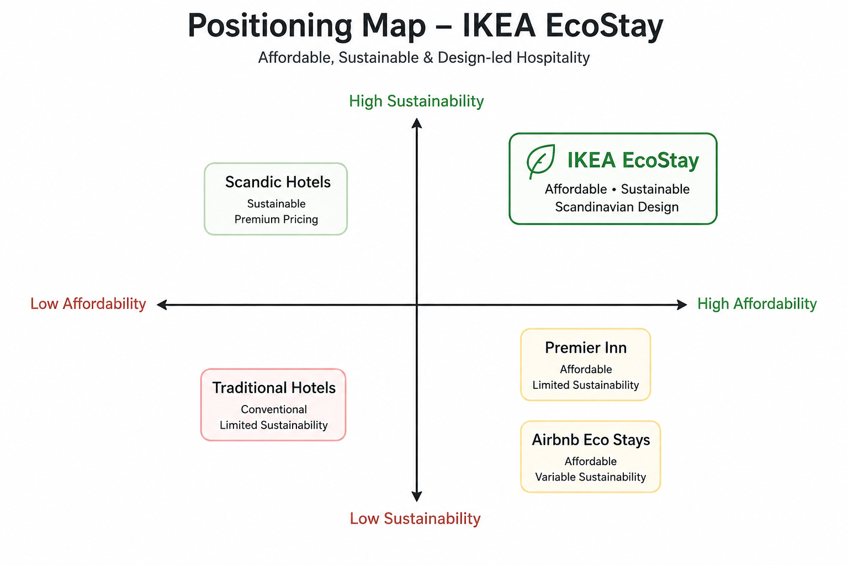
Figure: Positioning Map
Source: Self-Made

4. Marketing Mix (7Ps)

Introduction to the 7Ps
The 7ps marketing mix offers an in-depth model of creating successful service marketing plans (Kwok et al., 2020). Since IKEA EcoStay is a hospitality business, the extended marketing mix will guarantee that all customer touchpoints contribute to the sustainability goals of the brand, competitive positioning and long-term business expansion.
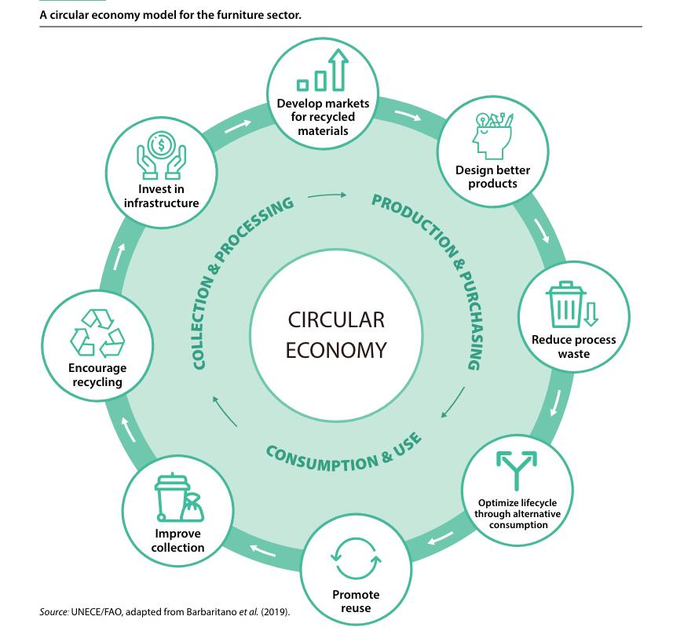
Figure: Circular Economy Model
Source: (UNECE, 2023)

4.1 Product
IKEA EcoStay is an environmentally friendly hotel and serviced apartments that are fully furnished with IKEA furniture and furnishings and smart home solutions. The accommodation is a blend of Scandinavian aesthetics, comfort and functionality with the use of renewable energy systems, recycled materials and energy-efficient technologies. Other services offered are healthy food with locally available products, fitness centres, digital concierge and co-working spaces for business travellers (Sheoran, 2025). The integrated retailing channels also enable guests to buy products that they have tried at the hotel, creating a seamless link between hospitality and home furnishing.

4.2 Price
To achieve both affordability and revenue optimisation, IKEA EcoStay will implement value-based and dynamic pricing. Standard, family and premium hotel rooms will be priced separately and will depend on season, hotel occupancy, weekday/weekend demand and the number of days in advance they are booked. Discounts can be offered for advance reservations, and lastminute rates can be flexible depending on availability. IKEA Family members will enjoy exclusive rates and loyalty benefits, which will give them an incentive to book again (Vives et al., 2020). Value can also be further enhanced through extended-stay and bundled accommodation packages. This will help IKEA EcoStay optimize occupancy and profit, while also helping to position the brand competitively (Kartomo, 2024).

4.3 Place
IKEA EcoStay should first target hotels in major cities across Europe with high tourist numbers, high eco-awareness, accessibility to transport and close to the current IKEA clientele (Svensson et al., 2023). The cities of Stockholm, Copenhagen, Amsterdam and Berlin offer good starting markets thanks to their international guests, urban population, and existing sustainability cultures. The proximity of airports, railway stations and attractions in city centres should be considered as well as public transport access. Reservations will take place via the IKEA website, mobile app and certain online travel agencies. A phased location strategy can then take EcoStay to numerous international tourism and business markets.

4.4 Promotion
IKEA EcoStay will employ a comprehensive promotional mix that will include digital marketing, social media marketing, influencer marketing, public relations and loyalty marketing. Sustainable rooms, guest experiences and environmental efforts can be highlighted on Instagram, TikTok, YouTube and search advertising (Rosário et al., 2023). Partnering with sustainable travel influencers can lend credibility and access to audiences who are already interested in sustainable travel. IKEA Family members enjoy exclusive booking offers, early booking and repeat stay benefits (Husain et al., 2023). It is possible to communicate the link between sustainable living and responsible travelling through a campaign like “Stay IKEA. Live Sustainably.”. Forming partnerships with tourism organisations and corporate travel providers can result in extra bookings (Brdar et al., 2023). To reinforce IKEA EcoStay's sustainability positioning and brand, public relations activities should focus on renewable energy, circular design, and community benefits.

4.5 People
The IKEA EcoStay will be a hotel where the customer experience will be a focal point of the work of the hotel employees. Structured training for staff with regard to hospitality service and IKEA brand values, sustainability and digital booking systems and complaint handling (Entekhabi, 2024). Ongoing training can help to enhance service uniformity and staff confidence. Recognition programmes, performance incentives, and employee feedback mechanisms can help motivate employees. Rewards for sustainability-related behaviours can motivate staff to cut down on waste, save resources and spread the message of sustainability to guests. Having locally employed staff can also help to build relationships within the community. This means well-trained and motivated employees can enhance customer satisfaction, service quality and long-term brand loyalty.

4.6 Process
IKEA EcoStay will provide a seamless customer journey through online reservations, mobile check-in, smart-room technology and digital customer support. The complaints will be received through reception, on the website, via application or email and a structured process will be used to deal with them. It is important that employees respond to complaints quickly, make an investigation, offer a suitable resolution and follow up with the customer. Continuous feedback is provided through post-stay surveys, on-line reviews and customer ratings (Abdou et al., 2020). The management will be able to analyze the overall complaints and satisfaction data to enhance the services. This process is about efficiency, customer relationship management and always looking for ways to improve.

4.7 Physical Evidence
Physical evidence will demonstrate that IKEA EcoStay believes in Scandinavian design and environmental responsibility. IKEA furniture, minimalist interior, and eco-friendly materials and energy-saving lighting will be used to make hotel rooms cozy and convenient. Environmental credibility will be supported by green building certification, visible sustainability information and eco-labels (Khan et al., 2025). The uniforms of the staff, the signage, packaging and digital interfaces will be uniformly branded at all customer touchpoints.

5. Reflection

5.1 Description
The creation of the IKEA EcoStay sustainable brand extension was a chance to use the marketing theories in a practical business situation. The project was to find a suitable organisation, to study its position on the market and to create a sustainable brand extension that could help it to develop in the long-term. A poster was also designed to convey the intended idea in a concise and graphic manner. During the assignment, theories like STDP and the marketing mix of 7Ps were used to create a holistic marketing plan in line with the brand name and sustainability goals of IKEA.

5.2 Feelings
When the project was initially being developed, it was difficult to find a brand extension that was innovative and strategic at the same time as the strengths the company had at that time. Nevertheless, having learned about IKEA's sustainability strategy and the increasing demand on environmentally responsible tourism, I felt more confident in my choice of the hospitality industry. The preparation of the poster also enhanced my self-confidence to present marketing concepts visually and convey strategic concepts in a short and captivating way.

5.3 Evaluation
The inclusion of sustainability in all steps of the proposed marketing plan as opposed to considering it as an independent project was one of the best features of the project. The implementation of STDP and the 7P framework allowed me to create a rational and customer-centred marketing plan that is justified by academic theory. Nevertheless, to create realistic positioning and differentiation strategies, a lot of research on competitors and consumer behaviour was needed, which illustrates the significance of evidence-based decision-making in strategic marketing planning.

5.4 Analysis
The assignment enhanced my knowledge of the role of brand extension strategies in organisational development when backed up with proper market research and sustainable business. I realised that effective brand extensions must be strategically aligned between the parent brand, customer expectations and market opportunities. The use of the STDP framework revealed the need to determine appropriate customer segments prior to developing marketing activities (Nashiroh et al., 2024).

5.5 Conclusion
On the whole, the project has helped me to improve my knowledge of strategic marketing, sustainable brand development and service marketing management. It enhanced my skills in using theoretical frameworks in real business scenarios and my research and communication skills, as well as reinforced my analytical skills. The creation of the IKEA EcoStay idea revealed the power of innovation with a sustainability focus to generate valuable business impact on organisations, customers and the broader society by engaging in responsible long-term business development.

5.6 Action Plan
In my future projects, I will improve my marketing skills with more intensive market research, studying consumer behaviour with primary data and enhancing my skills in interpreting industry reports. I will also strive to improve my presentation and design skills to create more compelling marketing messages.

6. Conclusion
IKEA EcoStay is a strategically aligned opportunity for IKEA to expand its brand to sustainable hospitality. The STDP analysis shows that environmentally conscious professionals, travellers, families and current IKEA customers are interesting segments, the CVP distinguishes the concept by the aspects of affordability, Scandinavian design and sustainable living. The 7Ps recommendations highlight the need for competitive and dynamic hotel pricing, strategic location selection, integrated promotional activity, trained and motivated employees, complaint management and consistent physical evidence.

References
Abdou, A.H., Hassan, T.H. and El Dief, M.M., 2020. A description of green hotel practices and their role in achieving sustainable development. Sustainability, 12(22), p.9624.
Brdar, I., 2023. Green power of influencers: Shaping sustainable consumer behaviour in the tourism industry. FINIZ 2023-Sustainable development as a measure of modern business success, pp.125-130.
Christiansson, M.T. and Rentzhog, O., 2020. Lessons from the “BPO journey” in a public housing company: toward a strategy for BPO. Business Process Management Journal, 26(2), pp.373-404.
Del Vecchio, P., Malandugno, C., Passiante, G. and Sakka, G., 2022. Circular economy business model for smart tourism: the case of Ecobnb. EuroMed Journal of Business, 17(1), pp.88-104.
Dreher, N. and Triandafyllidou, A., 2023. Digital nomads: Toward a future research agenda. Toronto Metropolitan Centre for Immigration and Settlement (TMCIS) and CERC in Migration and Integration: Toronto, ON, Canada.
Entekhabi, M., 2024. Enhancing recruitment strategies in developing nations: A sustainability-focused approach. Cross-Cultural Management Journal, 26(2), pp.127-137.
Friis, H. and Mac, T., 2025. Driving Circularity: The Role of Digital Product Passport in the Swedish Furniture Industry.
Haraldsson, T., Johansson, D. and Lilja, M., 2020. Digital is the new normal:-The effects of digitalization on the IKEA organization in Digitally Advanced Markets.
Husain, M.N., Harahap, E.F., Bachtiar, Y.C., Diawati, P. and Santos, E.R., 2023. The sustainability development dilemma in green public relations: part of CSR failure?. Jurnal Studi Komunikasi, 7(3), pp.759-778.
Ingka Group (2025) Ingka Group reinforces climate commitment with Net Zero Transition Plan. Available at: https://www.ingka.com/newsroom/ingka-group-reinforces-climate-commitment-with-net-zero-transition-plan/ (Accessed: 10 Aug 2026).
Jiang, W., Wang, L. and Zhou, K.Z., 2023. Green practices and customer evaluations of the service experience: The moderating roles of external environmental factors and firm characteristics. Journal of Business Ethics, 183(1), pp.237-253.
Kartomo, T., 2024. The Role Of Discounts And Promotions In Enhancing Consumer Loyalty. Marketica: Jurnal Ilmiah Pemasaran, 1(4), pp.181-190.
Khan, R., Hassan, H. and Sajid, R.N., 2025. IMPACT OF ECO-LABELS ON GREEN PURCHASE BEHAVIOR: MEDIATING ROLE OF ENVIRONMENTAL CONCERN AND ATTITUDE TOWARDS GREEN PRODUCT. Journal of Management Science Research Review, 4(3), pp.650-681.
Kim, A., Kim, K.P. and Nguyen, T.H.D., 2021. The green accommodation management practices: The role of environmentally responsible tourist markets in understanding tourists’ pro-environmental behaviour. Sustainability, 13(4), p.2326.
Kwok, L., Tang, Y. and Yu, B., 2020. The 7 Ps marketing mix of home-sharing services: Mining travelers’ online reviews on Airbnb. International Journal of Hospitality Management, 90, p.102616.
Mahalakshmi, S., Nallasivam, A., Kumar, S.H., Kalavathy, K.S. and Desai, K., 2024, February. Sustainability by design: Ikea’s eco-friendly marketing efforts. In 3rd International Conference on Reinventing Business Practices, Start-ups and Sustainability (ICRBSS 2023) (pp. 145-161). Atlantis Press.
Mahalakshmi, S., Nallasivam, A., Kumar, S.H., Kalavathy, K.S. and Desai, K., 2024, February. Sustainability by design: Ikea’s eco-friendly marketing efforts. In 3rd International Conference on Reinventing Business Practices, Start-ups and Sustainability (ICRBSS 2023) (pp. 145-161). Atlantis Press.
Nashiroh, A.A.S., Shiddiqy, I.A. and Hidayat, M.N., 2024. Exploring the depths of digital marketing: a systematic literature review on segmentation, targeting, differentiation, and positioning strategies. International Journal of Business, Law, and Education, 5(1), pp.1270-1283.
Onukwulu, E.C., Agho, M.O. and Eyo-Udo, N.L., 2022. Circular economy models for sustainable resource management in energy supply chains. World Journal of Advanced Science and Technology, 2(2), pp.034-057.
Rosário, A.T., Lopes, P.R. and Rosário, F.S., 2023. The digital marketing for sustainable development.
Sheoran, M., 2025. Hospitality industry: Insights and perspectives. Educohack Press.
Spinoglio, M.A., 2020. Market Communication Strategy: A case study of IKEA.
Svensson, M., Nygren, S. and Sundqvist, E., 2023. Technology Acceptance in the Age of Mobile Applications.
Technavio (2025) Sustainable tourism market industry analysis. Available at: https://www.technavio.com/report/sustainable-tourism-market-industry-analysis (Accessed: 7 Aug 2026).
United Nations Economic Commission for Europe (UNECE) (2023) The State of the World's Forests 2023. Available at: https://unece.org/info/Forests/pub/367742 (Accessed: Aug 2026).
Vives, A. and Jacob, M., 2020. Dynamic pricing for online hotel demand: The case of resort hotels in Majorca. Journal of vacation marketing, 26(2), pp.268-283.

Appendix:Poster

