Content

- Introduction 2

- Background
2.1 Client profile - Corporate Information 2
2.2 Client profile - Store and employees 3
2.3 Client profile - Financial review 3

- Findings and recommendations

  - Economies Scale vs Long-Run Total Average Costs (LRAC) analysis for Tsui Wah Group 6

  - SWOT analysis for Tsui Wah Group 9

  - Ansoff matrix analysis for Tsui Wah Group 11

  - BCG Matrix analysis for Tsui Wah Group 12

- Conclusion 13

- Reference 14

- Introduction
Our customer, Tsui Wah Restaurant, has been deteriorating its turnover over the past few years and is looking for a solution that will increase revenue. We will analyze their business profile, the reasons for previous successes and current failures, and provide recommendations for the following growth.

- Background

  - Tsui Wah Group’s business condition
During 2016 to 2017, the retail market in Hong Kong and China became better. But the selling and distribution expenses of Tsui Wah Group were not good, because all property rental and related expenses had increased. They can reduce the Tsui Wah Group net profit. On the other hand because the mainland China people or tourist, they can pay more money on the Tsui Wah Group restaurant food/product, the Group can make more profit in this market. So the Tsui Wah Group managers want to develop the growth in the food services in Hong Kong, China and overseas.
Recently Tsui Wah Group has many challenges, such as rental cost, raw material cost and labor cost and they have risen sharply. As Tsui Wah Group managers want to keep the net profit, they decided to control the overall business operational efficiency. Tsui Wah Group purchaser began to buy lower cost food for the restaurant. Tsui Wah Group begin to use centralized kitchens to reduce the food processing cost. But however those methods can reduce the final food quality. Those methods can keep the Tsui Wah Group’ gross margin at 72 percent. But during 2016 to 2017 the net profit was 4.9 percent, during 2017 to 2018 the net profit was 4.4 percent. Because the sales and delivery cost increased and the Tsui Wah had more new restaurants in this year.
(Tusi Wah Group Financial Statements)

2.2 Client profile - Store and employees
On 31 March 2018, the Tsui Wah Group had 68 Restaurants that were owned or/and operated under the brand of ‘Tsui Wah’.
ABOUT TSUI WAH Group
The first Tsui Wah restaurant started in 1967. It is more than 50 years ago. Tsui Wah restaurant provided very good quality food, meal, drink,etc. to Hong Kong people. But however the market competition is high every week every year. Tsui Wah’s managers had plan to develop the business. They opened more new Tsui Wah restaurants in Hong Kong to get more market share. From year 2009 Tsui Wah Group managers decided to open new restaurants in Macau and Main land China. In this time Tsui Wah Group had more than 30 oversea restaurants.
(Tusi Wah Group Financial Statements)

2.3 Client profile - Financial review

Revenue
In 2016 Tsui Wah Group net profit is around HK$1,845.4 million, in 2017 Tsui Wah Group net profit in around HK$1,839.8 million. So the different is equal to HK$ 5.6 million, therefore 5.6/1839.8 x 100% = 0.3%, the net profit is decreased by 0.3$

Although the same-store sales in Hong Kong recorded an increase this year compared with last year, due to the closure of certain restaurants in 2017 and the current year's lease, the income in the district generally declined.

Cost of inventories sold
The cost inventories sold of Tsui Wah Group on 2017 is HK$ 512.1 million,and the cost inventories sold of Tsui Wah Group on 2018 is HK$ 512.4 million. So it is slightly increased by 0.3 million and 0.06%. The cost of inventories sold amounted to around 27.7% Tsui Wah Group’s revenue for year on 2017 and the cost of inventories sold amounted to around 27.9% Tsui Wah Group’s revenue for year on 2018. The cost of sales and income are more stable in year 2018, because Tsui Wah Group used a bulk procurement methods, it used food preparation process and it used centralized kitchens.

Gross profit
The value of Tsui Wah Group profit = revenue – cost of inventories sold. On 2018 the Tsui Wah Group revenue is equal to approximately HK$1,327.4 million. But on 2017 the Tsui Wah Group revenue is equal to approximately HK$1,333.3 million. It represents a slight decrease of approximately 0.4%. On 2017 Tsui Wah Group managers decided to close some restaurant and then profit decreased. So the gross profit margin was stable.

Management Discussion and Analysis
Human resources and remuneration policy
As at 31 March 2018, the Tsui Wah Group (exclude the joint ventures) employed 4,152 employees (2017: around 4,281).
On 2017 the Tsui Wah Group’s staff cost was around HK$531.1 million for the year, but on 2018 the Tsui Wah Group’s staff cost was around HK$531.0 million in 2017. The labor costs decreased by around HK$0.1 million because the Tsui Wah Group improved control of labor costs.

Property rentals and related expenses
The property rental expense is also a big problem for the Tsui Wah Group. On 2017 the Tsui Wah Group’s rental expense was around HK$315.3 million and on 2018 the Tsui Wah Group’s rental expense was around HK$315.3 million. The reason for increment is the commencement of leases.

Selling and distribution expenses
On 2017 the selling and distribution expense is around HK$30.8 million, and on 2018 the selling and distribution expense is around HK$41.8 million. The increment is around HK$41.8 million in 2018. The reason for the increment is due to branding and marketing promotion.

Share of profits from joint ventures
The profit share of the joint venture was approximately HK$39.41 million, representing an increase of approximately HK$7.53 million or approximately 23.5% from approximately HK$31.92 million in 2017. The increase was mainly due to the joint ventures in Macao and a more favorable macroeconomic environment, which stimulated the income of the food and beverage industry as the number of tourists increased.

Income tax expense
The income tax expense decreased by approximately HK$11,300,000 or approximately 30.2% from approximately HK$37,300,000 in 2017 to approximately HK$26.1 million for the year.

Profit
The profit for the year decreased by approximately HK$9.91 million or approximately 10.9% to approximately 10.8% from approximately HK$90.6 million in 2017. This year was approximately HK$80,800,000.

Liquidity and financial resources
The initial cash proceeds from the issued shares of the Group on the Main Board of the Stock Exchange on November 2012 funded its business. The Tsui Wah Group's cash and cash equivalents amounted to around HK$51,200,000, representing an increase of aroound HK$13,380,000 from around HK$496,560,000 as at March 2017. Most of the Group's bank deposits and cash are denominated in Hong Kong dollars and Renminbi.

The current assets and current liabilities of the Tsui Wah Group amounted to around HK$644.2 million ( March 2017: around HK$638,100,000) and around HK$303.2 million (2) March 2017: around HK$304.2 million), while the current ratio was approximately 2.1 times. Calculated by dividing total current assets by total current liabilities (March, 2017: around 2.1 times).

(Tusi Wah Group Financial Statements)

3 Findings and recommendations
3.1 Economies Scale vs Long-Run Total Average Costs (LRAC) analysis for Tsui Wah Group
Refer to the Tsui Wah stock price chart, we learn that there occurs a curve (Economies scale vs long-run total average costs LRAC).

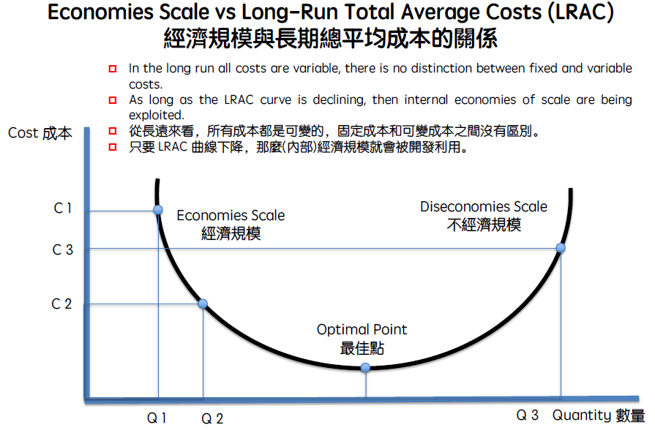
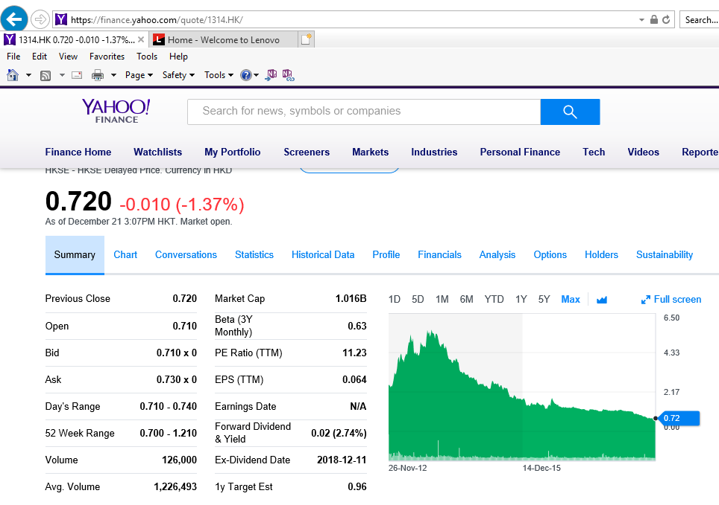

item | year | Tsui Wah Group net profit (HKD)
1 | 2012 | 110,429,000
2 | 2013 | 131,297,000
3 | 2014 | 156,043,000
4 | 2015 | 157,591,000
5 | 2016 | 72,471,000
6 | 2017 | 90,698,000
7 | 2018 | 80,770,000

During the past few years, Tsui Wah group have new restaurants but the profit margin is being poor. So the most suitable solution may be to reduce the number of Tsui Wah restaurants in the future.
According to LRAC theory, business usually continues to grow and prosper, to a certain pitch, will go downturn. In Tsui Wah model, it has a nice growth to start with. As aforesaid, after a certain period of time, when expansion has reached an overwhelming level, management on various aspects will go out of good control. Central management on food purchasing, production process, service quality are stretching to their limits. The rapid increase on business and new branch is a usual killer for many business if not being handled well.
In fact the number of Tsui Wah Group restaurant is as below list:
item | year | No of Tsui Wah restaurant
1 | 2012 | 3
2 | 2013 | 13
3 | 2014 | 22
4 | 2015 | 28
5 | 2016 | 37
6 | 2017 | 64
7 | 2018 | 70

Because profit = sales – cost, cost = sales – profit
So the Tsui Wah Group occurs a curve (Economies scale vs long-run total average costs LRAC).
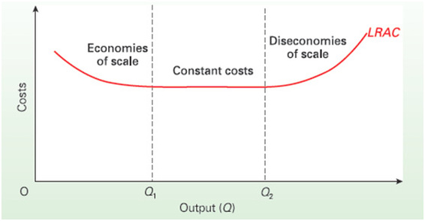

3.2 SWOT analysis for Tsui Wah Group
SWOT (Strengths, Weaknesses, Opportunities, Threats)

Weakness
The weakness of Tsui Wah is its price is higher than the market price among the same category of competitors. Tsui Wah is classified as ‘Cha Chan Tan’ (local restaurant) in Hong Kong. However, its price was set 20% higher than other competitors. The products provided by Tsui Wah however is no big different from other market sharers.
As time goes on, the excitement of customers are decreasing while the food and services of Tsui Wah Restaurant is not improving. Customers started to compare price and quality. They are paying an obvious high price for the same food quality as other competitors. The services provided is not outstanding as the price should have reflected. Furthermore, due to the economic downturn, some of the customers are shifting back to other competitors. To make the matter worse, with the revenue dropping, Tsui Wah could only purchase second best raw materials and unable to enhance their service quality. Those who are leaving with Tsui Wah are mainly the tourists or mainland visitors who come for the brand. In responding to the lower revenue, Tsui Wah buyers have no choice but lower their food purchasing quality.

Strengths
Tsui Wah used to survive very well in the early stage due to its brand. When it first came out to the market, it has an image of ‘Royal’ local restaurant. Tsui Wah invested in its decoration, image and branding. It addressed itself as a representative of local restaurant industry. Tsui Wah is providing the traditional local food, wrapping up with a gorgeous image, locating in key commercial areas and key tourist spots. It has a fame that, ‘Taste the local Hong Kong food, come to Tsui Wah.’ When customers went there, they enjoyed the vanity of being in a famous branded restaurant but having the warmth of local taste at the same time.
Internally, as listed in the beginning of our article, several directors of Tsui Wah were originally the owner of some local restaurants. They have actual hand-on experience on the whole production including raw material purchasing, food processing, production and presentation. They combined their strength to form Tsui Wah Restaurant and finally have it listed successfully.

Threats
Hong Kong's economy slows to 3.2% in 2019: International Monetary Fund
Weak growth forecasts are related to the slowdown in mainland China.
According to the global economic outlook published by the International Monetary Fund, the Hong Kong economy is expected to slow from 3.8% in 2017 to 3.2% in 2019, based on real GDP.
Please also read: The US-China trade war may seriously hit Hong Kong, which relies on exports.
BMI Research said that as the Chinese government began to implement more sustainable growth plans by curbing systemic financial and environmental risks, the city's growth forecast is related to the economic slowdown in the mainland. As the real estate industry begins to show signs of wear and tear, the real estate market is also the culprit.
The International Monetary Fund also pointed out that consumer prices are expected to rise from 1.5% in 2017 to 2.1% expected after two years. Due to limited purchasing power, rising levels of inflation will curb consumer confidence.

Opportunities
Because in Hong Kong, shopping mall supply will hit 13 year high in 2019, so the rental cost for restaurant business may be lower.

So that Tsui Wah Group should give up the high price strategy to keep the profit but should use low price but high quality strategy. Tsui Wah can begin to develop new catering business such as Maxsims restaurant, Café De Coral restaurant, Fairwood restaurant, etc.
On the other hand Tsui Wah Group should begin to reduce number of restaurants in Hong Kong, then it can have more cash flow or budget to develop the new catering business. Tsui Wah and use another name for the new catering business such Wah Wah Group. Tsui Wah can use existing business place and staff in the same location, and then decorate a new style of restaurant such as Maxsims restaurant, Café De Coral restaurant, Fairwood restaurant, etc.
Then Wah Wah group can reduce the price and provide good quality of food/meal to gain higher market share.

Hong Kong is safe city in the world.

3.3 Ansoff matrix analysis for Tsui Wah Group
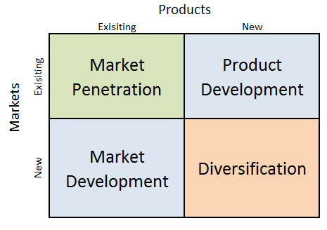
Market development
According to Ansoff matrix, one of the aspect is to perform Market Development. As stated previously, Tsui Wah is listing the highest price among others in the same local restaurant industry. This negative factor has to be removed. Nevertheless, it has to be done wisely that we cannot announce a sudden price cut of 20%, which will only do harm than good. We are going to achieve the price cut through the strategy of Diversification, meanwhile creating several pull factors as a result.
Tsui Wah brand is a listed company and a well-known food industry brand. We should treasure it, modify its structure and gain profit with it.

Market competitors
In Hong Kong, giant chain restaurants are Maxim’s group, Café de Coral and Fairwood. They have very high market sharing and attractive profit margins. To be a successful business, they share a common characteristics: state the lowest price in the market. With the acute high property environment in Hong Kong, the general public are drawn to these chain restaurant by nature. They attract the customers with price. They keep the customers with basic food quality and medium level of environment. Also, these chain restaurants have systemic and efficient management and they can handle a huge amount of customer needs in short intervals of time. Maxim’s group even develop Chinese dim sum restaurants which is also a pre-requisite for Chinese family gathering. Hong Kong people eat out a lot and they basically have no choice but fall into the embrace of these several chain restaurants if they want to achieve lowest expenses.

Product development
On the one hand, Tsui Wah Restaurant can keep its existing location and continue absorbing the revenue from tourists and those who is willing to pay for its brand and environment. On the other hand, Tsui Wah can modify its branch with the structure of various forms such as Dim Sum restaurant, chain fast food restaurant in the format of its competitors, even cake shop or snack shop. Other than the restaurant structure, Tsui Wah should also focus on its food products. The food quality cannot fail. Furthermore, win with food choice. It means not only giving what the competitors have, the lowest price, also provide what they don’t have. If Tsui Wah can open new branch in new face new format new price with brand new choice of food ideas, it will easily and surely draw the market share to them. People need choices.
Market Penetration
App, Delivery Service, delivery charges, convenience, electronic ordering
When considering diversification, market development and product development, we can spare a moment to look into enhancing our technology level when deciding our market penetration strategy. Golden rule for business: be user friendly. Nowadays, it is getting common for restaurants to develop an APP for customers to order delivery. Electronic order can also provide an accurate and efficient service which is beneficial for both sides.

Diversification
Tsui Wah restaurant currently exists in the market as a ‘Cha Chan Tan’ (local restaurant). The style, menu, environment, service and all details are no different from other local food restaurant. It can be an attraction but it is also fatal when the price comes highest in the market without an outstanding food quality to support. In view of this, Tsui Wah can consider the strategy of Diversification, meaning, other than being a local food restaurant, be something more. Hong Kong population has a large proportion goes frequently for Dim Sum during lunch or fast food style meal. These compose of 98% daily diet of a huge amount of Hong Kong population, especially the grass-root level.

3.4 BCG Matrix analysis for Tsui Wah Group
The BCG Matrix works on the principle that Tsui Wah Group should have a portfolio containing both high-growth products requiring cash investment and low-growth products that throw off excess cash. Having both types of products will ensure long-term business success.
Refer to the Tsui Wah Group annual reports, we learn that the market growth in which the product is being sold slowly. And the market share in which the product have a low share of the current market.
So it is dogs, and can consider to divest it.
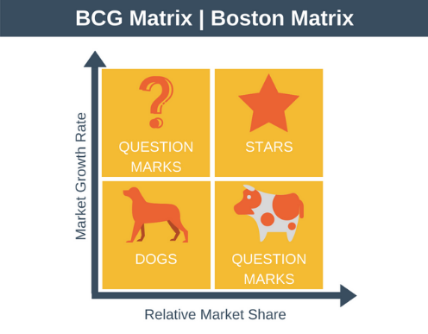
Tsui Wah Group can consider to do the related diversification strategies
The related diversification advantage of the Tsui Wah Group is to get more business growth. Tsui Wah Group’s manages do something different.
Tsui Wah Group can begin to close some non-profitable restaurant, after that it is reduce loss. Then begin to start the following diversification step:
- Find out the new Tsui Wah Group limitation. Look at what new Tsui Wah have to invest, both financially and in term of new resources available.
- Find out the new Tsui Wah Group possibilities. Think what Tsui Wah Group is already done. Think what Tsui Wah Group competitors offering that Tsui Wah Group do not offer.
- To check if the Tsui Wah Group is the catering market leader or not. If Tsui Wah Group has already establish catering market leader, it should be gained expertise, make more connection, and established vendor relationships. And never do the fragmentation
- The good Tsui Wah Group business does not run on autopilot. Find good manager to manage new growth and the foundational work. And prepare the working schedule.

- Conclusion
Related Diversification Strategies for Tsui Wah Group
Tsui Wah Restaurant, has been suffering from revenue drop, after the prime, due to various reasons. It can be revived by closing down some of the prime rent location bearing high menu price. Modify its format and open various Dim Sum restaurants, chain fast food restaurants, cake shop and snack shop. Also provide more new food choice which its competitors don’t have. With lower price, good food quality and more new choice, Tsui Wah will result in a new long lasting prime.
Tsui Wah restaurants are currently located in all the prime location, CBD and tourist spots, bearing acute high rental burden. When expanding its branch, Tsui Wah can consider the model of its competitors, penetrating to all residential areas covering full population of Hong Kong. Tsui Wah will benefit not only from hugely cutting down on rental expenses, it will also receive an outstanding amount of revenue.
With all the above measures, Tsui Wah would easily gain high profit, forming a solid foundation to expand overseas. Among all other competitor, Tsui Wah is the only brand representing Hong Kong local food. It becomes a symbol relating to Hong Kong culture. Tsui Wah carrying the free advertisement from various tourist sources, possesses an irreplaceable advantage to extend overseas. Tsui Wah not only has quality to come first locally, it also has a sound base to turn into a global sized business as a listed company.

- Reference

- Tusi Wah Group Financial Statements/ESG Information – [Annual Report] ANNUAL REPORT 2013 Available at : http://www.tsuiwah.com/investor-relations/finance/annual-report/
- Tusi Wah Group Financial Statements/ESG Information – [Annual Report] ANNUAL REPORT 2014
Available at : http://www.tsuiwah.com/investor-relations/finance/annual-report/
- Tusi Wah Group Financial Statements/ESG Information – [Annual Report] ANNUAL REPORT 2015
Available at : http://www.tsuiwah.com/investor-relations/finance/annual-report/
- Tusi Wah Group Financial Statements/ESG Information – [Annual Report] ANNUAL REPORT 2016
Available at : http://www.tsuiwah.com/investor-relations/finance/annual-report/
- Tusi Wah Group Financial Statements/ESG Information – [Annual Report] ANNUAL REPORT 2018
Available at : http://www.tsuiwah.com/investor-relations/finance/annual-report/
- Café de Coral Financial Report 2017, Available at :
file:///C:/Users/MY-PC/AppData/Local/Microsoft/Windows/INetCache/IE/XJKYAEB3/E00341.pdf
- Fairwood holdings limited annual report 2017, Available at :
file:///C:/Users/MY-PC/AppData/Local/Microsoft/Windows/INetCache/IE/RGOM8ISN/annual_report_2016_2017.pdf
- Ethan M. Rasiel (1999), The Makinsey Way, McGraw-Hill Education.
- Gerald M. Weinberg (2014), More Secrets of Consulting: The Consultant’s Tool-Kit, Leanpub.
- John Hays (2014), The Theory and Practice of Change Management, Palgrave Macmillan.
- John P.Kotter (2002),The Heart of Change, Harvard Business Review Press.
- Louise Wickham and Jeremy Wilcock (2016), Management Consulting: Delivery an Effective Project, Pearson.
- Matthias Kipping and Timothy Clarg (ed.) (2013), The Oxford Handbook of Management Consulting, Oxford University press: Oxford.
- Mick Cope (2000), The Seven Cs of Consulting, Prentice Hall.
- Michael Hammer and James Champy (1994), Reengineering The Corporation: A Manifesto for Business Revolution, Nicholasa Brealey Publishing.
- Milan Kur (ed.) (2002), Management Consulting: A Guide to the Profession, International Labour Office: Geneva.
- Peter Block (2011), Flawless Consulting: A Guide to Getting Your Expertise Used. Jossey-Bass.
- Patrick Dawson and Constantine Andriopulos (2017), Managing Change, Creativity and Innovation SAGE.
- Richard Newton (2012), The Management Consultant: Mastering the Art of Consultancy, Pearson.
- Robert S. Kaplan and David P.Norton (1996), The Balance Scorecard: Translating Strategy into Action, Harvard Business School Press.
- Simon A. Burtonshaw-Gunn (2010), Essential Tools for Management Consulting: Tools, Models and Approaches for Clients and Consultants, Wiley.
- Theodore Levitt (1974), The Marketing Imagination, Then Free Press.
- W. Chan Kim and Renee Mauborgne (2006), Blue Ocean Strategy, Harvard Business School Press.
- Recent Research on Team and Organization Diversity: SWOT analysis and implication, Susan E. Jackson, Aparna Joshi, Niclas L. Erhardt, Volume 29, Issue 6, December 2003, Pages 801-830
- Application of AHP- Ansoff Matrix Analysis in Business Diversification: The case of Evergrande Group, MATEC Wed of Conferences Volume 44,2016, 2016 International Conference on Electronic, Information and Computer Engineering, Article Number 01006
- Strategic attributes and performance in the GCB matrix – A PIMS-based analysis of industrial product businesses, DC Hambrick, IC MacMillan, DL Day – Academy of Management, 1982 journals.aom.org
- Café De Coral finanical report 2018/2019 Available at : http://www.cafedecoral.com/eng/investor_relations/reports/index.jsp
- Café De Coral finanical report 2017/2018 Available at :
http://www.cafedecoral.com/eng/investor_relations/reports/index.jsp
- Café De Coral finanical report 2017/2016 Available at : http://www.cafedecoral.com/eng/investor_relations/reports/index.jsp
- Café De Coral finanical report 2016/2015 Available at : http://www.cafedecoral.com/eng/investor_relations/reports/index.jsp
- Café De Coral finanical report 2015/2014 Available at : http://www.cafedecoral.com/eng/investor_relations/reports/index.jsp
- Café De Coral finanical report 2014/2013 Available at : http://www.cafedecoral.com/eng/investor_relations/reports/index.jsp
- Café De Coral finanical report 2013/2012 Available at : http://www.cafedecoral.com/eng/investor_relations/reports/index.jsp



CONSULTANCY MANAGEMENT

PROJECT INITIATION DOCUMENT (PID)

2018

Students Name: Setoi chi shing
Student number : 1812207

Masters: Consultancy Management
Project Initiation Document (PID)

INSTRUCTIONS:
- Give as much justification as possible for every question asked. This means, you must not limit yourself to just stating WHAT you believe is an appropriate response, but WHY.
- ALWAYS provide an outline of the financial and cost imperatives associated with your project aim and objectives. Remember, you must be able to SELL your project idea.
- Put effort into your PID and you will benefit when it comes to undertaking your project and writing your final report.

PID submission date detailed on module schedule



- Your name: | Seto chi shing
- Organisation name: | ABC Consultancy com, Ltd.
- Your job title/role: | Consultant
- How long have you been in this job/role? | 4 years
- Outline main purpose of your job/role: | My job duty list  Provide consultant service  Provide consultant training  My role list:  Find consultant project
- List the main responsibilities within your job/role: | Honesty  Above all else, a consulting firm must have an honest relationship with its client. The need for transparent and effective communication in all phases of the work a firm performs for its clients is imperative. If a consultant with expertise in the gaming industry is working to help his client obtain a casino license, he must acknowledge his limitations in bringing the coveted license to fruition. He will also need to lay bare any ties he has to industry regulators and competitors, and divulge all possible conflicts of interest.  Client Priority  Once a firm signs on to represent a client, that client needs to know it is the consulting firm’s top priority. Consulting firms often need to choose between clients if the work they will perform for their clients overlaps. Additionally, firms must fully dedicate themselves to their client’s mission, bringing a solid work ethic to each case and dividing staff and hours fairly among their case load. They need to perform all assigned tasks to the utmost of their abilities and resources.
- Client organisation: | TSUI WAH GROUP
- Type of business: | Catering
- No of employees in client organisation: | 2089
- Who is the person mainly supporting your project (Sponsor)? State their job title and their relationship to you: | Name: Mr CC Lee  Job title: Director  Relationship to you: Client
- Aim of project:
In no more than twenty words, state the overall aim of the project. Here you need to compile a sentence that communicates clearly what you intend the project idea to achieve.

Aim:
To study and re-exanimate the Tsui Wah Group business in Hong Kong catering industry.

- Objectives of project:

To increase Tsui Wah Group profit
To increase Tsui Wah Group market share
To increase Tsui Wah Group product line
To decrease Tsui Wan Group running cost

- What is the business case for considering undertaking the project? Here you need to justify how achieving the project aim will advantage and benefit the business and its stakeholders. For example, savings, gaining intelligence of competitors, promoting innovation, return on investment etc.

To improve Tsui Wah Group stock value.

- Identify the risks associated with the project and how these could be overcome.

Quality fulfil all objectives
Time to complete project in time
Cost

- List the information and resources you will need to make your project a success. State why such are needed. These may include, people, time, cash, technology, data. Identify any constraints that you may encounter and explain how you would overcome these.

Past 5 five years Tsui Wah Group, Company, Ltd. annual reports

- State what method you intend to use to collect your primary data. For example, questionnaire, interviews, telephone surveys, focus groups etc. Outline why a particular research method was chosen over alternatives.

NIL

TOP TIP: CHOOSE AN APPROPRIATE METHOD AND ENSURE YOU WILL ACTUALLY BE ABLE TO COLLECT THE DATA YOU REQUIRE. KEEP DATA COLLECTION SIMPLE.
- State from whom you plan to collect primary date and detail any challenges you anticipate. Here you need to consider whether or not you will be given or denied access to personnel and why. Outline how you plan to approach people to take part in your research and why you have chosen such individuals. State why they may agree to take part in your project or indeed refuse. If you plan to collect data from family and/or friends, rationalise such and explain how you will overcome bias etc.

NIL

- State from where you plan to collect secondary data. This means providing an early list of alphabetised websites and a bibliography that details (using Harvard method) the journals, magazines, textbooks and websites you intend to use.

Website addresses:
I get following information for the consultancy project

Company annual report:
http://www.tsuiwah.com/
https://www.maxims.com.hk/en/index.asp
http://www.cafedecoral.com/eng/stra_business_units/quick_service/cafedecarol.jsp

Books (on topic area):
I read following references for my resultant project:
Management Consulting Delivering an effective project , Louise Wickham, Jeremy Wilcock

Books (on research methodology):
Blue Ocean Strategy, W. Chan Kim, Renee Mauborgne

Journals:
Strategies for Diversification, H. Igor Ansoff

- Design a time plan for the lifetime of the project. Begin by breaking down all tasks that need to be undertaken and assess the duration of time you need to devote to each task. Be sure to show tasks in a logical sequence. Be further sure that you plan well enough to enable you submit your project report on the deadline date. Include any meetings that are planned with your project lecturer at UWTSD. Be realistic and make your project manageable, account for holidays and other “off-days”.

Task | Date to be completed
1 Initial contact meeting  Define project objective  Form a project team  Prepare / provide project predict outcome  Reconfirm project objective | 1/12/2018
2 Decision to work together | 3/12/2018
3 Preliminary analysis | 5/12/2018
4 formal proposal | 7/12/2018
5 project charter | 9/12/2018
6 in-depth analysis | 11/12/2018
7 implementation | 13/12/2018
8 delivery | 15/12/2018
9 follow-up | 17/12/2018



