Name : Mourana Yansane
ID number :2207923
Module : Hospitality & Guest services
Lecturer’s :Muhammad Cassamo

HOTEL STANDARDS, REPUTATION MANAGEMENT, BUILDING AND RETAINING CUSTOMER LOYALTY

Introduction
The role and importance of quality service, hospitality, and guest services is playing a major role in the JW Marriott. The purpose of brand consistency, key factors for managing the reputation of the hotel industry and the importance of effective guest reviews management for JW Marriott has been examined in this study.

Findings of the study

Purpose of brand consistency standards for JW Marriott
Brand consistency is playing a major role in the hotel industry. It is helping to develop trust and communication personality and helps to be recognizable. As commented in the works by Lemy et al. (2019), with the help of brand consistency, JW Marriott is able to develop trust and loyalty among its customers. Along with this, with the help of the development of the organizational personality, hotels are attracting customers for choosing their hotels. The main purpose of the brand standards is based on providing guidance regarding the brand, and the proper direction for the branding. On the other hand, Yuldashev et al. (2022) have stated that consistency is supporting the business of JW Marriott by developing the productivity of the hospitality of their business.

Figure 1: Importance of Brand Consistency
(Source: Yuldashev et al. 2022)
Figure 1 is representing the five major important for the development of brand consistency these are based on promoting loyalty and making it feel recognizable. Along with this, it is helping to build trust, develop communications, and show values. With the help of the brand consistency standards, JW Marriott is able to develop the loyalty where people are able to get brand experience. In the thoughts of Khalifa et al.(2022), by developing trust, JW Marriott is able to gain the trust of the guests and able to meet the customer experience.
JW Marriott is creating brand consistency by developing brand identity, providing better brand guidelines, developing the values of the guests, and delivering better brand experiences. As per the comment by Kang et al. (2020), the purpose of the brand consistency for JW Marriott is based on developing brand awareness, and credibility and making them more trustworthy. It is helping to develop the overall visual identity and helps to achieve the goals of the business. Along with this, consistency is helping to maintain the perception and develops brand equity (Castro-Casal et al. 2019). The major purpose of brand consistency for JW Marriott is based on the development of the growth of the business. It is develop the customer experience and leads to the improvement of trust and the loyalty.

Key factors for managing the reputation of the hotel industry
There are various key factors that are helping to maintain the reputation of the hotel industry. As per the notion of Davronov et al. (2021), those key factors are based on social media monitoring, brand-related mentions, review monitoring, and satisfied customers; those are playing a major role in providing a reputation to the hotel industry. By monitoring and motivating for better security services, posting on social media and tracking the review sites JW Marriott is able to maintain its reputation (Marriot, 2023). On the other hand, Mokhtar et al. (2019) have stated that by staying active on social media, JW Marriott is able to create an effective reputation, it is helping to create better relationships among the customers, and able to plan properly for achieving the goals. JW Marriott is the best place to work and provides a better workplace for people.

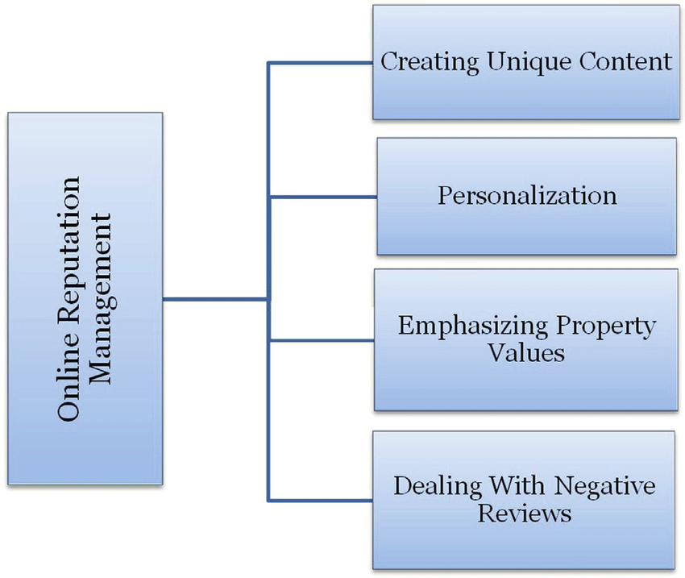
Figure 2: Key factors for managing the reputation
(Source: Davronov et al. 2021)
Figure 2 is representing the key factors for online reputation management which are based on making unique content, dealing the negative reviews, personalization, and determining the value of the property. Along with his, there are various reasons to join JW Marriott which are based on better employee well-being, caring leadership, long values, development diversity, and empathy. JW Marriott is mainly following a supply and demand pricing strategy for analyzing the competition rate and hotel prices.

Importance of effective guest reviews management for JW Marriott
Guest reviews are playing an importance role for hotel owners and guests respectively. Effective guest reviews are developing visibility, and improve customer contact which is creating a positive effect on the guests of the JW Marriott. As stated in the work of Waqanimaravu et al. (2020), online reviews are playing a crucial role in the development of the hotel business as well as it is develops booking, and traffic and making guests feel more special for developing the establishment. On the other hand, Priyo et al. (2019) have stated that in the hospitality industry, online reviews and guest feedback is playing an important role in developing the customer satisfaction rate. Along with this, it is developing the customer loyalty and customer is able to know about the positive and negative aspects of the hotel and its amenities, and the quality of the services.

Figure 3: Importance of effective guest reviews management
(Source: Priyo et al. 2019)
Figure 3 is representing the importance of effective guest reviews management for JW Marriott. Effective guest management is able to develop the brand values, helping to make credibility, improved sales, maintain business insights, and develop visibility for attracting guests.

Impact of negative reviews for guest reviews management
The negative reviews for the guest reviews management are based on less trust, lack of potential customers, and lack of revenue. As commented in the works by Anabila et al. (2022), the negative impact is creating a huge loss of the customers. The negative reviews are coming from bad customer services, false information, and low quality of the work, bad security services, and lack of proper staff services for the hotel industry. For better guest review hotel industry needs to provide proper responses, needs to be empathetic, and professional and avoid aggressive behaviors.

Building and retaining customer loyalty in the hotel industry
Customer loyalty is developed by creating a proper customer base, creating a strong network for promotion purposes, and providing better services to their values. Customer loyalty in the hotel industry is mainly based on guest experience, providing incentives, better impressions, and developing the loyalty program. As commented in the works by Yu et al. (2021), loyalty in the hotel industry is creating a better marketing strategy for determining the hotel chains and being able to determine business properties. By making a better relation among the customer, JW Marriott is able to develop customer loyalty.
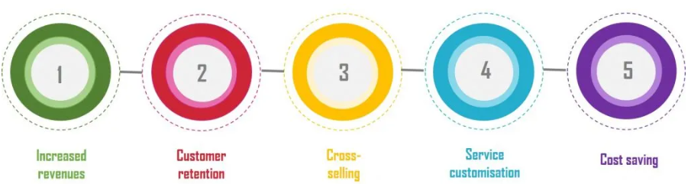
Figure 4: Customer loyalty in the hotel industry
(Source: Lai et al. 2019)
Figure 4 is representing the loyalty of the customers in the hotel industry. These are based on five major aspects, customer loyalty is able to develop the overall revenue, services, cost saving, cross-selling, and customer retention. On the other hand, Lai et al. (2019), the key factors for developing customer loyalty in the hospitality industry are based on offering valuable feedback, examining loyalty program software, and making corporate rewards. The 3Rs for customer loyalty are mainly based on recognition, relevance, and reward.

Purpose to build and retain customer loyalty
The main purpose of building customer loyalty is to develop revenue by increasing the demand of the guests and providing better services to the guests. As commented in the works by NGUYEN et al. (2021), proper customer loyalty is able to maintain the mission and the vision of the organization and provide better corporate values and determine the significance of the employees and develop high engagement. The main purpose of the loyalty program is to develop guest retention and achieve better returns from customers. On the other hand, Ampofo et al. (2020), have stated that the purpose of using the loyalty program for JW Marriott is based on various factors those are includes the growth of the revenue, brand ambassadors, cost control, development of the database, and improvement direct booking.

Obstacles for the certain hospitality business management
There are various challenges that have been faced by the hospital industry based on meeting demands, developing hospitality technology, environmental consideration, and shortage of staff. As commented in the works by Garbin Praničević et al. (2020), poor customer satisfaction is the major reason for creating a negative impact on business management. Communication is the challenging part along with his, sustainability, and the lack of system design is creating negative impacts on the hospitality business management.
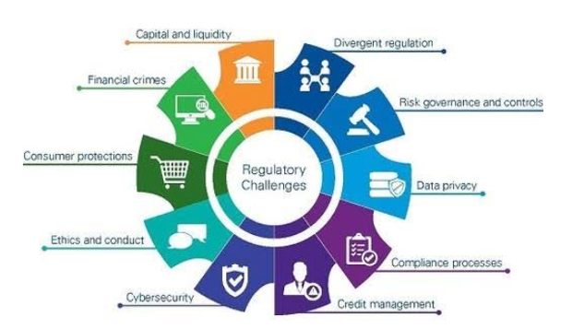
Figure 5: Obstacles to the certain hospitality business management
(Source: Praničević et al. 2020)
Figure 5 is representing the obstacles for the hospitality business management that are based on credit management, cyber security, financial crimes, data privacy, risk controls, risk governance, and consumer protections.

Conclusion
The research paper have been describes the role and importance of quality service, hospitality, and guest services for JW Marriott. Along with this, the importance of hotel standards, reputation management, and building and retaining customer loyalty for the hotel industry have been examined. The Key factors for managing the reputation and the Obstacles to certain hospitality business management have been evaluated.

Recommendations for the hotel industry regarding market trends
The recommendation is based on showing proper care to the employees, developing technology, and determining the valued customer for the development of the services in the hotel industry. As commented in the works by Alzoubi et al. (2021), by direct booking, creating a positive impact on social media and investing more money in the business the hotel industry is able to meet the marketing trends of the hotel; industry. In the modern world, the hotel industry is able to meet the market trends by providing robotic staff, making unique brand expectations, sustainable hotels, and making smart technology in the hotel.

References
Alzoubi, H.M., Vij, M., Vij, A. and Hanaysha, J.R., 2021. What leads guests to satisfaction and loyalty in UAE five-star hotels? AHP analysis to service quality dimensions. ENLIGHTENING TOURISM. A PATHMAKING JOURNAL, 11(1), pp.102-135.
Ampofo, J.A., 2020. Contributions of The hospitality industry (Hotels) in the development of Wa municipality in Ghana. International Journal of Advanced Economics, 2(2), pp.21-38.
Anabila, P., Ameyibor, L.E.K., Allan, M.M. and Alomenu, C., 2022. Service quality and customer loyalty in Ghana’s hotel industry: The mediation effects of satisfaction and delight. Journal of Quality Assurance in Hospitality & Tourism, 23(3), pp.748-770.
Castro-Casal, C., Vila-Vázquez, G. and Pardo-Gayoso, Á., 2019. Sustaining affective commitment and extra-role service among hospitality employees: Interactive effect of empowerment and service training. Sustainability, 11(15), p.4092.
Davronov, I.O., 2021. Economic Development Mechanisms of Innovative Services in Bukhara Hotels. International Journal of Business, Technology and Organizational Behavior (IJBTOB), 1(6), pp.500-509.
Garbin Praničević, D. and Mandić, A., 2020. ICTs in the hospitality industry: An importance-performance analysis among small family-owned hotels. TOURISM: An international interdisciplinary journal, 68(2), pp.221-234.
Kang, H.J.A., Kim, W.G., Choi, H.M. and Li, Y., 2020. How to fuel employees’ prosocial behavior in the hotel service encounter. International Journal of Hospitality Management, 84, p.102333.
Khalifa, G.S., Trung, N.V.H. and Hossain, M.S., 2022. Predicting Customer Engagement Behaviour: The mediating role of hotel functional quality in the Vietnamese Hotel industry. International Journal of Services and Operations Management, 43(3), pp.312-337.
Lai, I.K.W., 2019. Hotel image and reputation on building customer loyalty: An empirical study in Macau. Journal of Hospitality and Tourism Management, 38, pp.111-121.
Lemy, D., Goh, E. and Ferry, J., 2019. Moving out of the silo: How service quality innovations can develop customer loyalty in Indonesia’s hotels. Journal of Vacation Marketing, 25(4), pp.462-479.
Marriott, 2023. About Us. Marriott. Available at: https://www.marriott.com/marriott/aboutmarriott.mi [Accessed on: 25-01-2023]
Mokhtar, S. and Sjahruddin, H., 2019. An examination of the relationships between customer relationship management quality, service quality, customer satisfaction and customer loyalty: The case of five star hotels. Advances in Social Sciences Research Journal, 6(2).
NGUYEN, P.H., 2021. A Fuzzy Analytic Hierarchy Process (FAHP) Based on SERVQUAL for Hotel Service Quality Management: Evidence from Vietnam. The Journal of Asian Finance, Economics and Business, 8(2), pp.1101-1109.
Priyo, J.S., Mohamad, B. and Adetunji, R.R., 2019. An examination of the effects of service quality and customer satisfaction on customer loyalty in the hotel industry. International Journal of Supply Chain Management, 8(1), pp.653-663.
Waqanimaravu, M. and Arasanmi, C.N., 2020. Employee training and service quality in the hospitality industry. Journal of Foodservice Business Research, 23(3), pp.216-227.
Yu, J., Seo, J. and Hyun, S.S., 2021. Perceived hygiene attributes in the hotel industry: customer retention amid the COVID-19 crisis. International Journal of Hospitality Management, 93, p.102768.
Yuldashev, K.S. and Radjabov, O.O., 2022. The Role of Consulting Services in the Development of the Hotel Industry. EUROPEAN JOURNAL OF INNOVATION IN NONFORMAL EDUCATION, 2(6), pp.51-58.

Appendices

Appendix 1: Total Number of Marriott International hotels

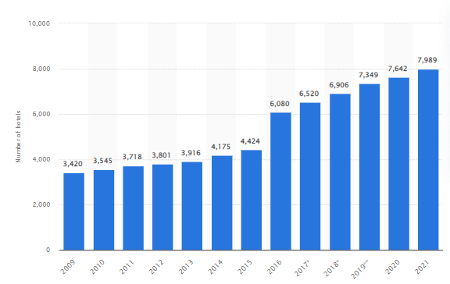
(https://www.statista.com/statistics/247285/number-of-marriott-international-hotels-worldwide/)

