People’s Worlds: Lives and Livelihoods
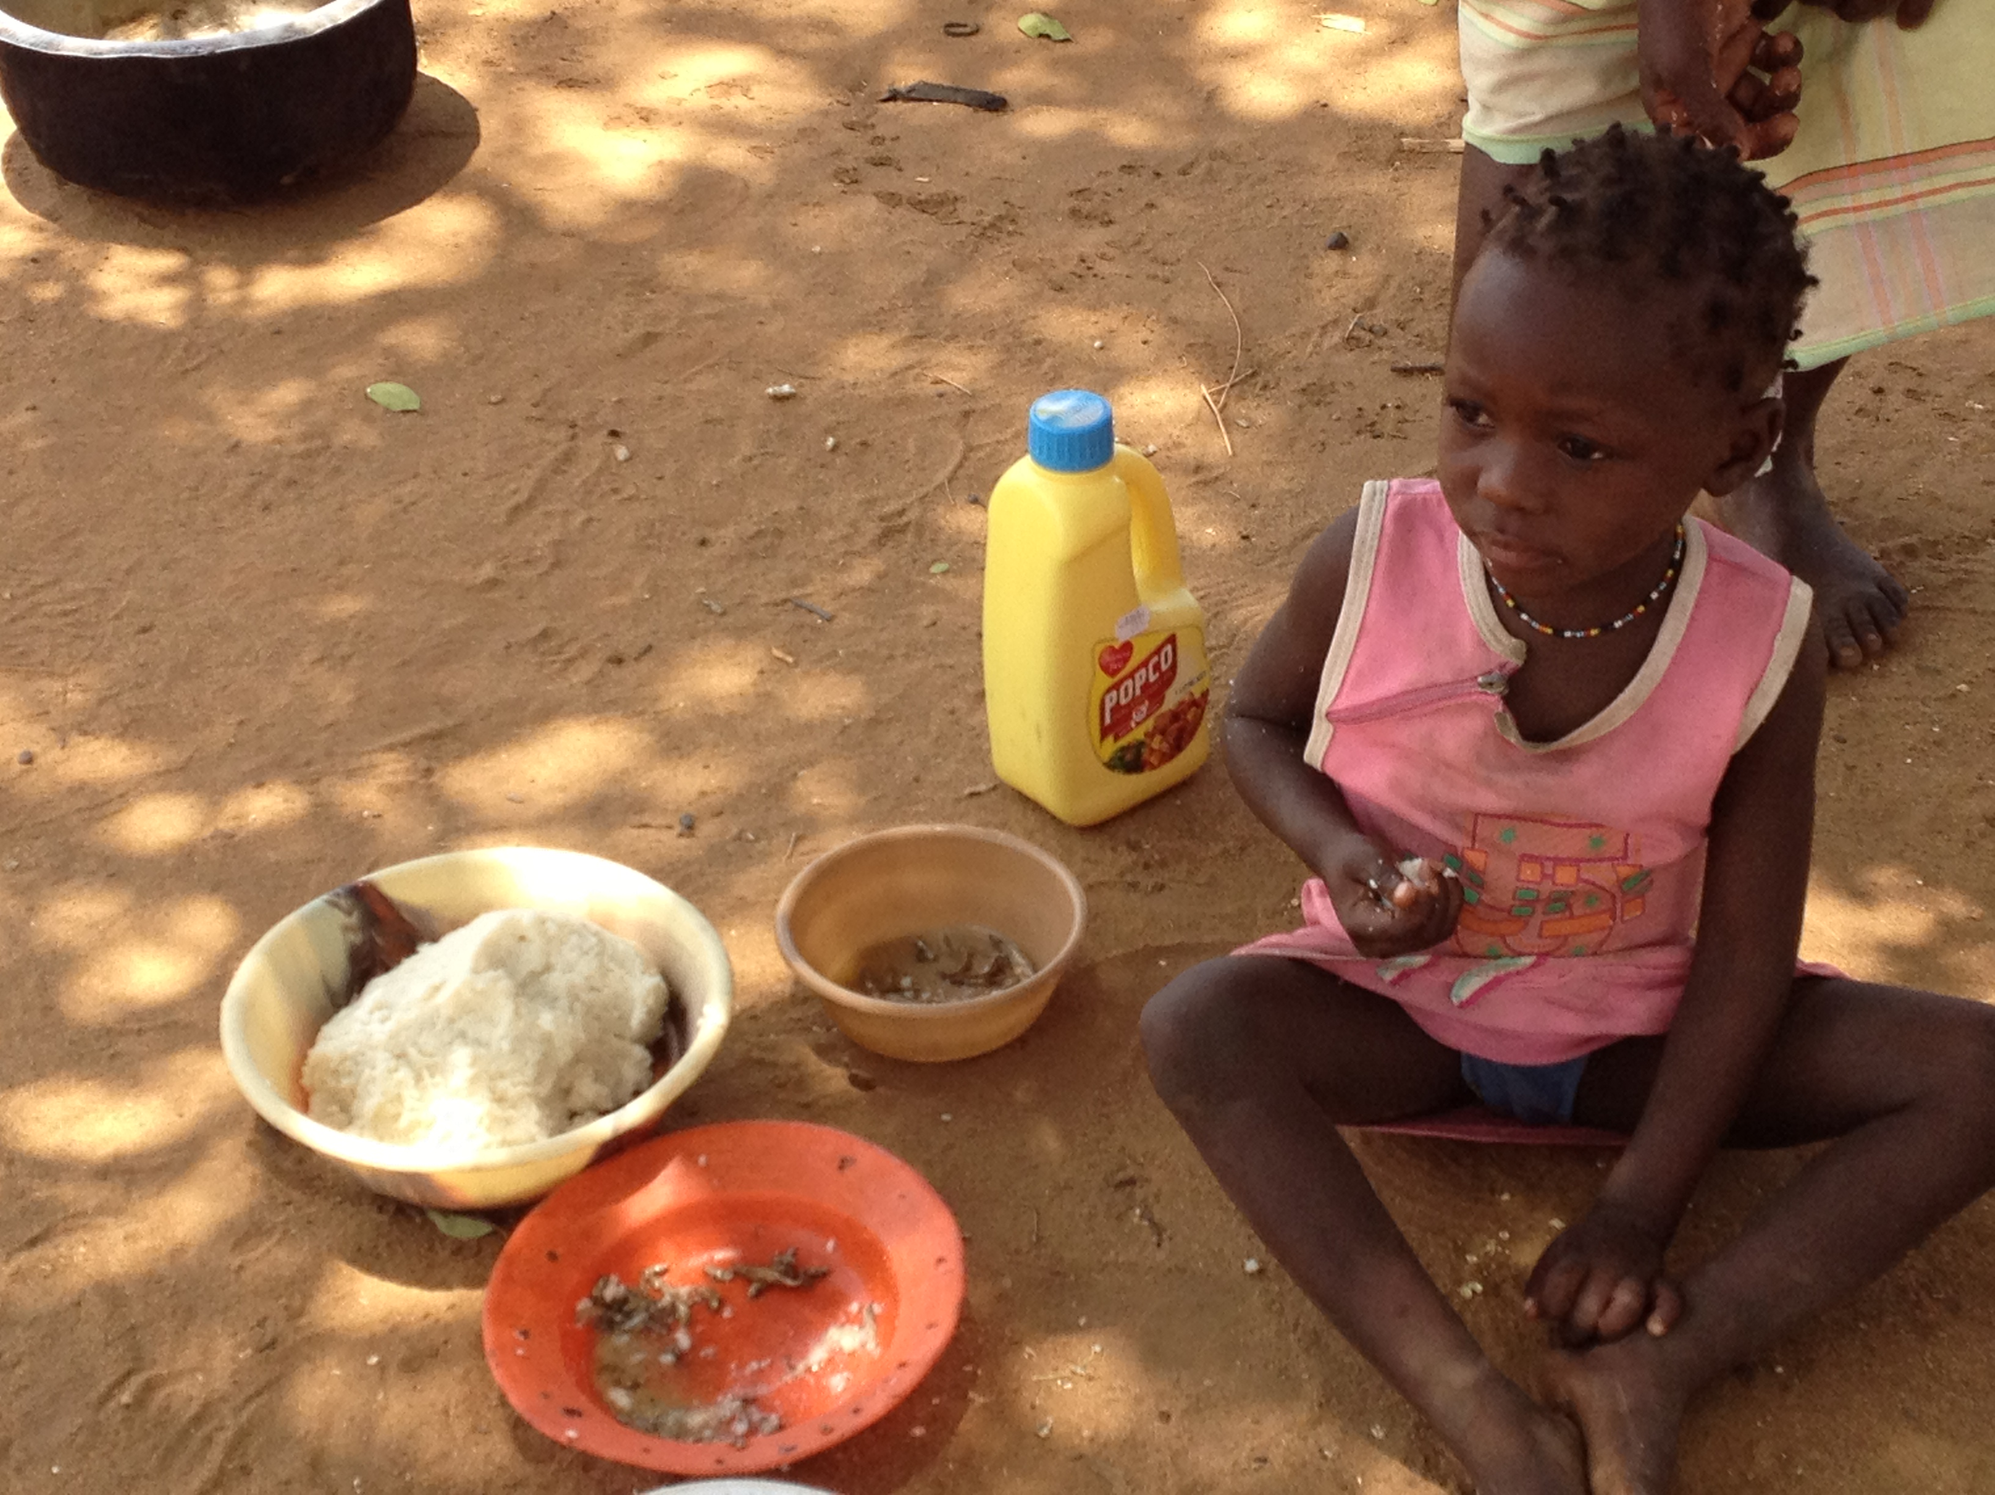

This module will introduce you to how humans manage to live in a variety of different environments. It does this by highlighting the interactive constitutive relationship between ecological conditions, meaning and social structures.

Planet earth offers an extremely wide variety of territories or habitats to the organisms that are alive today. In association with this wonderful variety, this course considers the numerous and often colourful conclusions and methods humans have created to adapt themselves to different circumstances. To do this we will examine a different society nearly every week and reflect not only on how people live in different locations but also how the interaction between location and the living things within it may contribute to social ideologies and practice.

Having established differences, the course considers particulars. To do this we explore human actions and ask how these behaviours function, and if they can be understood to achieve more than subsistence security, whether location is a determinant that can be used to predict behaviour or if human perception of the world is the main constitutive factor in the construction of social groups rules and norms.

You will have 4 hours of lectures each week. Each week we will aim to see a film, after which will be a class discussion session. You will be expected and requested to contribute to the discussion.

Core texts

Ingold, T. 2000Perception of the Environment: essays in livelihood, dwelling and skill. London: Routledge
Peters-golden, H. Culture Sketches: case studies in anthropology (3rd ed). New York: McGraw Hill

ASSESSMENTS

Your knowledge will be measured through the completion of:

- 1 x 2000 word essay (50%) – questions below
- 1 x exam (2000 word equivalent, 50%), after Christmas break

Marking criteria

The marking criteria list the various components that tutors are looking for in your assessments when grading them. The % figure at the end of each component represents the relative importance of that element in the formation of your overall grade. The marking criteria are drawn from the generic Learning Outcomes at level 4 and relate closely to the Grading criteria that judge class (for example a 2:I class compared to a 3rd class). When completing your assessment you should keep in mind both the component and its relative weighting to the overall mark.

Level 4 Essay marking criteria
- Engage directly with the question
- Display a knowledge of the subject being addressed
- Demonstrate awareness of relevant debates
- Show familiarity source materials where appropriate
- Write with structure, clarity and good grammar
- Follow established scholarly conventions on referencing and bibliography

Level 4 Exam question marking criteria

- Engage directly with the question
- Display a knowledge of the subject being addressed
- Demonstrate awareness of relevant debates
- Show familiarity with source materials where appropriate
- Write with structure, clarity and good grammar

TYPES OF ASSESSMENT

Essay
The most common form of written assignment undertaken by students is the essay. Essays remain a primary means of assessing students at all levels of HE study. At level 4 you might be required to present essays of 1000 or 2000 words in length; at level 5 and 6 this will rise to 2000, 2500, 3000 and perhaps even 4000 words, if you decide to do a dissertation, to 7000-8000 words in length. Whatever the length, the principles of essay writing are generally the same.
Essays are a method of testing your ability to collect and process material systematically, in preparation for developing a sustained and detailed argument. That argument will be, in effect, an answer to a specific question. In making an argument (and thus answering the question) statements and opinions have to be backed up with factual details and the opinions of others so as to judge the credibility and authority of that statement. For example, if somebody was to argue that Arsenal were an awful football team, it is only the evidence of their failure to win a European championship in twenty years that gives force and weight to the viewpoint – otherwise it is little more than a personal prejudice, deserving to be ignored. And so it is with all claims. The statement ‘the French Revolution was a bloody affair’ is, as it stands, largely meaningless, until it is supported by evidence.
Evidence bestows depth and veracity upon a statement, or statements, rendering them worthy of a hearing (or reading). Essay answers are, therefore, a blend of analysis and information, ideas supported by detail, the latter strengthening the former and endowing your claims with authority. What essays should not do is simply describe situations.
To acquire information (the evidence) and sharpening your critical and evaluative skills (the argument) there is no substitute for wide reading and clear structured planning.

Examinations

Although the lion’s share of assessment at level 4 is coursework, a small exam component does feature at the end of the year. Exams are a useful device for encouraging students to reflect on their work, to hone their skills of processing and organizing a significant body of knowledge, and then deploying that knowledge in answer to a specific question, under timed conditions. It is not simply a test of memory, though remembering material is clearly useful. Rather it is a test of how you think ‘on your feet’, and what ideas and arguments you are able to develop without the comfort of time and prior knowledge. An exam is then both a test of knowledge and a test of the technique of understanding, analysing and finally answering questions. At level 4 exams are not second marked

Referencing
All academic pieces of work should be researched using library sources and reputable academic sources (including the internet – please use internet sources with care: can you verify their veracity?). Your work should be referenced fully, to source your information and ideas.
Please include a Reference List at the end of each piece of coursework (this should only include those pieces of work cited within your text).
You should follow the referencing guidelines used in the Archaeology and Anthropology Referencing Handbook

Word Count
Please always give your word count at the end of your piece of coursework.

In-Term Assessment

Essay questions (2000 words, 50%) Deadline: TBA

Choose one of the following:

- Using at least two ethnographic examples, explain the problems associated with using the terms ‘nature’ and ‘culture’.

- Foraging represents the oldest method of subsistence. Using ethnographic examples compare and comment on the significance of the differences between a forager and farming lifestyle.

- With reference to specific cultures, demonstrate the connections between belief, environment, social behaviour and social structures.

- Compare and contrast two small scale societies of your choice. Make detailed reference to subsistence methods and how these affect the social structure, and daily lives, of the people involved.

Course content: weekly topics

Week 1 Overview – being

- The environment? The ecology? The difference
- Nature/culture

- Different types of subsistence
- Historical overview of types of subsistence
- Transition into farming - Why farming?

Week 2 Gatherer hunters

- General characteristics gather/hunters
- DESERT - San !Kung Bushmen

- Film: Bushmen of the Kalahari
- Discussion

Week 3: Gatherer hunters in forest

- FOREST – Mbuti of the Ituri Forest
- Baka

- Film – Baka: Cry from the forest
- Discussion

Week 4: Horticulturalist 1

- General characteristics – slash and burn
- Yanomamo, Amazonian rainforest

- Films
- Discussion

Week 5: Horticulturalist 2

- Mountain- Farming on slopes
- Kogi, Columbia, South America

- Film: From the Heart of the World
- Discussion

READING WEEK – in which you READ

Week 6: Horticulturalists 3

- By water – fish/sea
- Trobriand Islanders – Malinowski

- Film
- Discussion

Week 7: Horticulturalists 4

- Sambia, Papua New Guinea
- Semai of Malaysia

Week 8: Pastoralists – Dr Penny Dransart

- To be announced

Week 9: Street children – Dr Rachel Casiday

- To be announced

Week 10: Ecuador – Dr Emma–Jayne Abbots

- To be announced

Reading List

Some explanatory notes:

- The reading lists may look long - this is not to intimidate you, but to provide you with reading options from a library that can only carry limited quantities of books.
- You will find many introductory textbooks at the 301 classmark in the library, and for each week’s topic you will find listings of the relevant chapters from a wide range of these books, of which there are multiple copies of each.
- There are also items listed which are available electronically via ATHENS and JSTOR. If you have any questions about how to use these resources, or if you need help locating specific items, please contact the library staff.
- Some readings will be posted on Moodle for you to read. Please make every effort to read them.

The Environment
Binns, T. 1995, People and environment in Africa, Wiley, Chichester; New York.
Croll, E., & Parkin, D.J. 1992, Bush base: forest farm : culture, environment, and development, Routledge, London; New York.
Crumley, C.L. 2001, New directions in anthropology and environment: intersections, AltaMira Press, Walnut Creek, CA.
Crumley, C.L. 2001, New directions in anthropology and environment: intersections, AltaMira Press, Walnut Creek, CA.
Dasgupta, P. 2001, , Human well-being and the natural environment [Homepage of Oxford University Press], [Online].
Descola, P., Gísli Pálsson, & European Association of Social Anthropologists. Conference 1996, "Nature and society : anthropological perspectives", Routledge, London; New York.
Dove, M., & Carpenter, C. 2008, Environmental anthropology: a historical reader, Blackwell Pub., Malden, MA.
Ellen, R.F., & Fukui, K., 1996, Redefining nature: ecology, culture, and domestication, Berg, Oxford, UK; Washington, D.C.
Ellen, R.F., & Fukui, K., 1996, Redefining nature: ecology, culture, and domestication, Berg, Oxford, UK; Washington, D.C.
Haenn, N., & Wilk, R.R. 2006, The environment in anthropology: a reader in ecology, culture, and sustainable living, New York University Press, New York.
Ingold, T. 1987, Appropriation of Nature. Manchester U.Pr.
Ingold, T., 1994, Companion encyclopedia of anthropology, Routledge, London; New York.
Lee, R.B. & Daly, R.H., 1999, The Cambridge encyclopedia of hunters and gatherers, Cambridge University Press, Cambridge, U.K.; New York, NY.
Lee, R.B. & DeVore, I. 1976, Kalahari hunter-gatherers: studies of the !Kung San and their neighbors, Harvard University Press, Cambridge, Mass.
Milton, K., 2002, Loving nature: towards an ecology of emotion, Routledge, London; New York.
Milton, K., 1996, Environmentalism and cultural theory: exploring the role of anthropology in environmental discourse, Routledge, London; New York.
Milton, K., 1993, Environmentalism: the view from anthropology, Routledge, London; New York.
Moran, E.F. 2006, People and nature : an introduction to human ecological relations, Blackwell Pub., Malden, MA.
Moran, E.F. 2000, Human adaptability: an introduction to ecological anthropology, Westview Press, Boulder, Colo.
Peters-Golden, H. 2002, Culture sketches: case studies in anthropology, McGraw-Hill, Boston.
Ruttan, L.M. & Mulder, M.B. 1999, "Are East African Pastoralists Truly Conservationists?", Current anthropology, vol. 40, no. 5, pp. 621-652.
Simmons, I.G. 1993, Interpreting nature: cultural constructions of the environment, Routledge, London; New York.
Sponsel, L.E. 1995, Indigenous peoples and the future of Amazonia : an ecological anthropology of an endangered world, University of Arizona Press, Tucson.
Strang, V. 1997, Uncommon ground : cultural landscapes and environmental values, Berg, Oxford; New York.
Strauss, S. & Orlove, B.S. 2003, Weather, climate, culture, Berg, Oxford; New York.
Symposium on Man the Hunter, Lee, R.B., DeVore, I. & Nash, J. 1968, Man the hunter, Aldine, Chicago.
Vayda, A.P., & American Museum of Natural History. 1969, Environment and cultural behavior : ecological studies in cultural anthropology, Published for American Museum of Natural History [by] Natural History Press, Garden City, N.Y.
White, R., 1988, The roots of dependency subsistence, environment, and social change among the Choctaws, Pawnees, and Navajos [Homepage of University of Nebraska Press], [Online].
Wreford, A., Moran, D., Adger, W.N. & Organisation for Economic Co-operation and Development. 2010, Climate change and agriculture impacts, adaptation and mitigation [Homepage of OECD], [Online].
Farming
Barker, G. 2006, The agricultural revolution in prehistory: why did foragers become farmers? Oxford University Press, Oxford; New York.
Cauvin, J. & Watkins, T., 2000, The birth of the Gods and the origins of agriculture, Cambridge University Press, Cambridge, UK; New York.
Cohen, M.N. 1977, The food crisis in prehistory : overpopulation and the origins of agriculture, Yale University Press, New Haven [Conn.].
Cowan, C.W., Watson, P.J., & Benco, N.L. 1992, "The Origins of agriculture: an international perspective", Smithsonian Institution Press, Washington.
Dumont, R., 1957, Types of rural economy; studies in world agriculture, Methuen and Co. Ltd., London.
Harris, D.R. 1996, The origins and spread of agriculture and pastoralism in Eurasia, UCL Press, London.
Harris, D.R., Hillman, G.C. & World Archaeological Congress 1989, Foraging and farming : the evolution of plant exploitation, Unwin Hyman, London; Boston.
Maisels, C.K. 1993, , The emergence of civilization from hunting and gathering to agriculture, cities, and the state in the Near East [Homepage of Routledge], [Online].
Peterson, J., 2002, Sexual revolutions : gender and labor at the dawn of agriculture, AltaMira Press, Walnut Creek, CA.
Price, T.D., Gebauer, A.B., & School of American Research (Santa Fe,N.M.) 1995, "Last hunters, first farmers : new perspectives on the prehistoric transition to agriculture", School of American Research Press : Distributed by the University of Washington Press, Santa Fe, N.M.
Rindos, D. 1983, The origins of agriculture: an evolutionary perspective, Academic Press, New York.
Smith, B.D. 1995, The emergence of agriculture, Scientific American Library: Distributed by W.H. Freeman, New York.
Gatherer/hunters
Barker, G. 2006, The agricultural revolution in prehistory: why did foragers become farmers? Oxford University Press, Oxford; New York.
Barnard, A. 1992, Hunters and herders of southern Africa: a comparative ethnography of the Khoisan peoples, Cambridge University Press, Cambridge; New York.
Croll, E., & Parkin, D.J. 1992, Bush base: forest farm : culture, environment, and development, Routledge, London; New York.
Crumley, C.L. 2001, New directions in anthropology and environment: intersections, AltaMira Press, Walnut Creek, CA.
Ingold, T., 1980, Hunters, pastoralists, and ranchers: reindeer economies and their transformations, Cambridge University Press, Cambridge; New York.
Ingold, T., Riches, D. & Woodburn, J. 1988, Hunters and gatherers. 1, History, evolution and social change, Berg, Oxford.
Ingold, T., Riches, D. & Woodburn, J. 1988, Hunters and gatherers. 2, Property, power and ideology, Berg, Oxford.
Lee, R.B. & Daly, R.H., 1999, The Cambridge encyclopedia of hunters and gatherers, Cambridge University Press, Cambridge, U.K.; New York, NY.
Lee, R.B. & DeVore, I. 1976, Kalahari hunter-gatherers: studies of the !Kung San and their neighbors, Harvard University Press, Cambridge, Mass.
Panter-Brick, C., Layton, R., & Rowley-Conwy, P. 2001, Hunter-gatherers : an interdisciplinary perspective, Cambridge University Press, Cambridge, UK; New York.
Symposium on Man the Hunter, Lee, R.B., DeVore, I. & Nash, J. 1968, Man the hunter, Aldine, Chicago.
Pastoralists
Casimir, M.J., Rao, A. & Deutsche Gesellschaft für Völkerkunde. 1992, "Mobility and territoriality : social and spatial boundaries among foragers, fishers, pastoralists, and peripatetics", Berg : Distributed exclusively in the US and Canada by St. Martin's Press, New York.
Chang, C. & Koster, H.A. 1994, Pastoralists at the periphery: herders in a capitalist world, University of Arizona Press, Tucson.
Ingold, T., 1980, Hunters, pastoralists, and ranchers: reindeer economies and their transformations, Cambridge University Press, Cambridge; New York.
Kerttula, A.M. 2000, Antler on the sea : the Yup'ik and Chukchi of the Russian Far East, Cornell University Press, Ithaca, NY.
Rao, A. 1998, Autonomy : life cycle, gender, and status among Himalayan pastoralists, Berghahn Books, New York.
Rigby, P., 1985, Persistent pastoralists: nomadic societies in transition, Zed ; Biblio Distribution Center, London; Totowa, N.J.
Ruttan, L.M. & Mulder, M.B. 1999, "Are East African Pastoralists Truly Conservationists?", Current anthropology, vol. 40, no. 5, pp. 621-652.

