Kieran Brown (2204069)
University Of Wales Trinity St David
Applied Computing – Data Security and Compliance
Assignment 1

Table of Contents

Page 3 – Abstract + Introduction

Page 4 – Task 1: Research in Data Security and Compliance
Security Frameworks

Page 5 – 8 – ISO 27001 Research

Page 9-10 – NIST Cybersecurity Framework Research

Page 11-13 – Security Technologies Research

Page 14 – Task 1 Summary

Page 15–21 - Task 2: Case Scenario Report

Page 22: Conclusion

Page 23-26 - Bibliography

Abstract

This assignment explores the roles of security frameworks and technologies in protecting organisational data and minimising security risks of an organisation. It focuses on analysing different types of security frameworks and their approaches and how they can improve the foundations of any type of organisation. The analysis of security technologies will highlight their significance in enhancing system security.

Introduction

In the recent years businesses have implemented a digital-driven landscape. Cyber security is crucial for a modern organisations sustainability and success as they rely on these technologies to enhance productivity and drive innovation. A “cyber attack can cause major damage to your business”[1]. This means that there is more to a cyber attack than just losing control over a website or account. It can include reputation damage, financial losses, and even legal liabilities.

Task 1: Research in Data Security and Compliance
Security Frameworks

ISO27000

ISO 27000 is a family of standards that are used to manage information security. “it provides an overview of information security management systems”[2] This is supported by the use of other standards in the ISO family such as ISO 27001, which provides the maintaining an Information Security Management System. Implementing ISO 27000 is crucial as it enables organisations to mitigate risks, protect sensitive data and it ensures a structured approach to preventing cyber attacks.

ISO 27001
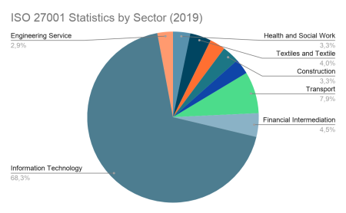
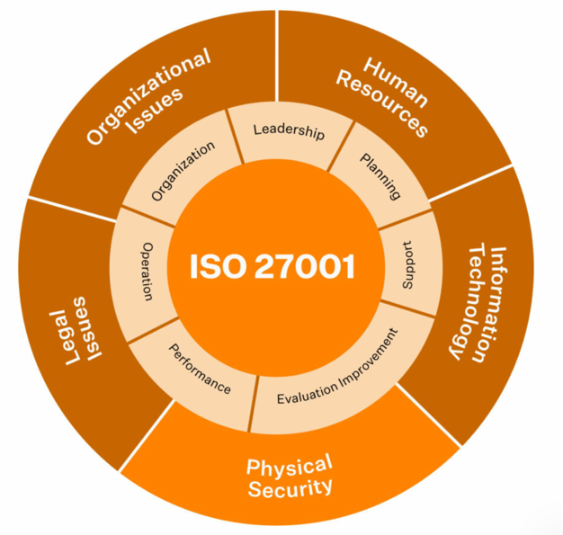
ISO 27001 is the core of ISO 27000 series and provides a well structured framework for creating, implementing, maintaining and always improving an Information Security Management System (ISMS). It is widely recognised as “the global standard for effective information management”[3] This shows its widespread recognition and acceptance worldwide which implies that it is a well-regarded choice for any organisation looking to improve their data security. ISO 27001s purpose is to ensure that organisations are able to manage their security risks in a professional manner. Unlike other frameworks, Its main focus is to establish processes that enable organisations to address their security risks based on their business objectives. It helps organisations continuously mitigate breaches as its emphasis is on continual improvement. ISO 27001 is mostly beneficial in the IT sector, this is evidenced in graph 1 showing the percentage of organisations who have ISO 27001 certification by sector.
Graph 1
Index 1
Key Requirements of ISO 27001

To obtain ISO 27001 certification, an organisation is required to implement an ISMS that meets the required standard of ISO 27001. It is sectioned into 10 steps:

Step 1 – Form an Implementation team
Begin by appointing a project leader responsible for managing and overseeing the implementation of the ISMS

Step 2 – Develop the plan for implementation
This stage requires the creation of a plan for implementing the ISMS

Step 3 – Create the ISMS
Once the plan has been created the implementation of the ISMS can be created after being approved by the board

Step 4 – Perform a risk assessment and Develop a Risk treatment plan.
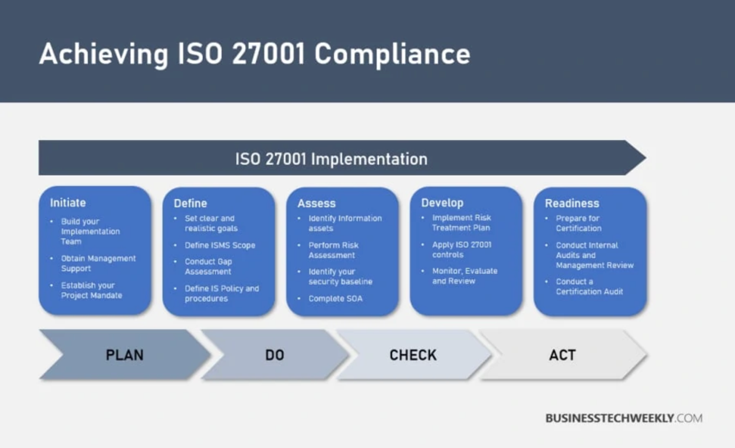
In this step potential risks will need to be determined such as unauthorised access, hardware failures and data breaches. The potential impact on these risks will need to be identified. Once completed decide how to manage each identified risk whether to mitigate, accept, transfer, or avoid.
Index 2

Step 5 – Establish and document policies and procedures
Document the ISMS from beta. Include logs of incident reports and any security activities. Create a detailed process for managing a high level of security.

Step 6 – Implement the ISMS
This is where the ISMS will be given out across the organisation. Employees will need additional training to maintain security.

Step 7 – Conduct internal audits
This stage is where regular internal audits will need to be undertaken to ensure that the ISMS is operating correctly and that it meets the ISO 27001 requirements.

Step 8 – Conduct a review
Staff will review the performance of the ISMS from before and after implementation evidencing how effective it is to the organisation.

Step 9 – Prepare for certification audit
The certification body will review the ISMS and its documentation to ensure that it complies with the ISO 27001 standards.

Step 10 – Obtain ISO 27001 Certification
If the auditor is satisfied an ISO 27001 will be issued to the organisation.

Benefits and drawbacks of ISO 27001

Benefits | Drawbacks
“Increase your organisations credibility and cyber resilience” [4] | Cost of implementation
Regulatory and Legal compliance | Time consuming process
Better stakeholder + customer confidence | Complexity – “The process is manual, time consuming and, error prone”[5]
Improved processes and efficiency | Certification is not a guarantee
Competitive advantage | Maintenance and recertification

ISO 27001 provides many benefits which overall improve any organisations information security. However, its main drawback is its cost for some organisations. It is mostly beneficial to organisations that are handling sensitive customer data. Here is a table of the cost of obtaining ISO 27001 certification:

Number of employees | Number of audit days**  (Stage 1 and Stage 2) | Estimated certification cost ***
1 | 5 | £6,250
11 | 6 | £7,500
16 | 7 | £8,750
26 | 9 | £11,250
46 | 10 | £12,500
66 | 11 | £13,750
86 | 12 | £15,000
126 | 13 | £16,250
426 | 17 | £20,625
626 | 18 | £21,875
876 | 19 | £23,125
1176 | 20 | £24,375
1551 | 21 | £26,250
2026 | 22 | £27,500
2676 | 23 | £28,750
3451 | 24 | £30,000
4351 | 25 | £31,250
5451 | 26 | £32,500
6801 | 27 | £33,750
(Graph 2)

This table shows that the prices of ISO 27001 certification vary depending on the number of employees within an organisation. The second column shows the number of audit days required to complete by an organisation of x employees. It shows that the organisations with less employees require less audit days to achieve ISO 27001 certification, which implies that ISO 27001 have made a compromise for smaller organisations to ensure that the certification is not as time consuming to complete.

ISO 27001 – Real World Application

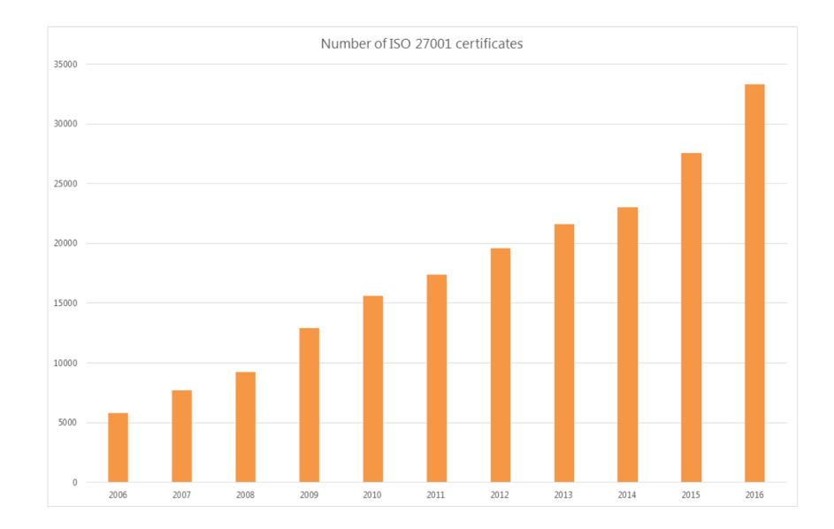
ISO 27001 is now being implemented in most businesses around the world to ensure that they have safe and secure data security. “In the UK, ISO 27001 certifications rose to 3,367, a rise of 21% from the previous year”[6] this indicates that more organisations are realising how important ISO 27001 is and are implementing the framework into their organisations. However, its not just the UK that are identifying the importance of ISO 27001. The number of certificates have risen from 6000 in 2006 to 34000 in 2016 as shown in graph 3. Which is an increase of 467%. This means that based on the same growth rate of approximately 467% over a 10 year period. The projected number of ISO 27001 certificates in 2026 would be approximately 192,667. This data demonstrates the rapid growth of ISO 27001, reflecting its increasing importance in managing information security for organisations worldwide.
Graph 3
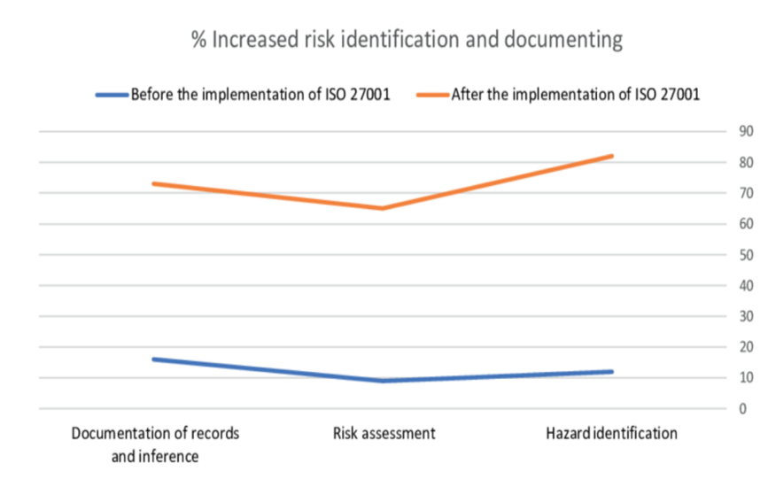
It’s not long before organisations start to see the benefits of implementing ISO 27001 in three areas. Documentation of records, risk assessment and hazard identification. Across all areas, the percentage prior to implementing ISO 27001 are around the 10-20% range. However, after implementation the percentage of all three areas rises to around 70-90%. This graph shows that there is a significant improvement reflecting better identification of potential security threats after implementing ISO 27001.
Graph 4

NIST Cybersecurity Framework
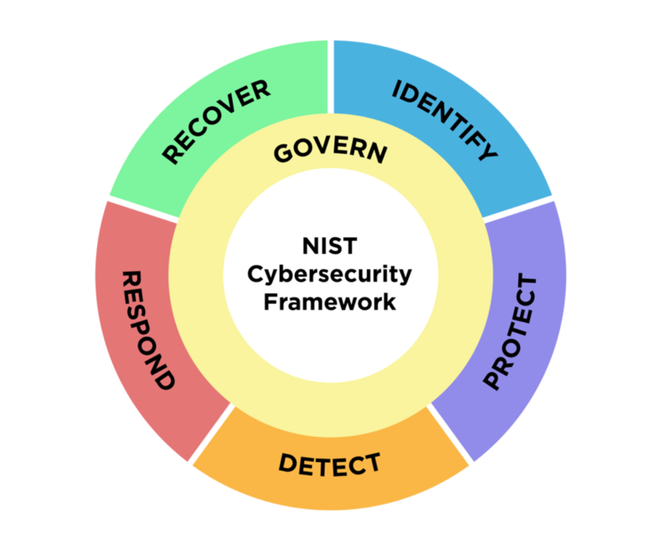
The NIST Cybersecurity Framework is developed by the National institute of standards and technology. It is known for its guidelines made to help organisations manage their cybersecurity and mitigate any threats. “The NIST Cyber Security Framework provides a structured approach to managing cyber security threats”[7] To do this it has five core functions: Identify, Protect, Detect, Respond, and Recover (IPDRR).
Index 3

NIST Cybersecurity Functions

Identify: The identify function includes understanding the organisations systems, data and assets which is then evaluated to mitigate cybersecurity risks effectively. To do this it identifies the resources, assesses and recognises the vulnerabilities within the security which gives the other functions a good foundation to work from.

Protect: The protect function focuses on the implementation of security software as it “supports the ability to limit or contain the impact of potential cybersecurity events” [8] This ensures that organisations can minimise damage that certain cyber threats cause.

Detect: The detect function is when the threat is detected by an organisation. This is assisted by the implementation of monitoring tools, and detection systems that will alert of any malicious activity.

Respond: The respond function includes actions that are to be taken once as soon as a cyber incident is detected by the monitoring systems. To minimise the impact of the attack, an incident response plan will have to be followed.

Recover : The recover functions main focus is on restoring the systems after a cyber attack. This can be making sure that all security measures are still working correctly, and also creating documents to learn from which helps the organisations security system continuously improve.
Benefits and drawbacks of NIST Cybersecurity Framework

Benefits | Drawbacks
Focuses on continuous improvement | Implementation complexity
“Enable long term risk management in cybersecurity”[9] | Can be time consuming to interpret security measures based on their specific organisation
Free to use | Resource intensive

The NIST Cybersecurity framework provides mostly benefits. However, the main drawback is the complexity of the implementation as it does not serve a one size fits all solution to organisations security systems. Although it is free in terms of money, it will cost the organisation a lot of resources to implement.

Real Life Application: NIST Cybersecurity Framework
Graph 5

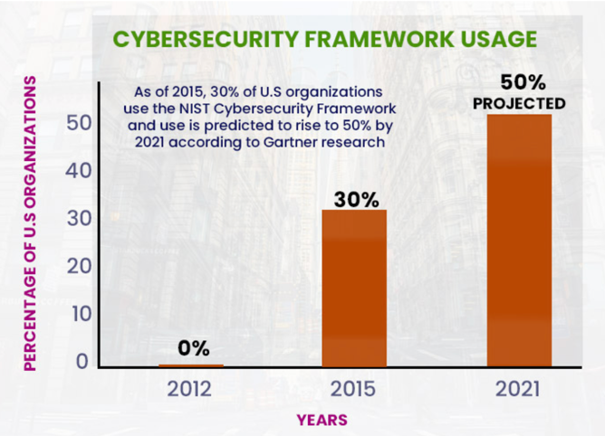
Many organisations in different types of industries around the world have successfully implemented the NIST Cybersecurity framework to improve their security systems. As seen in graph 5 it states “As of 2015 30% of US organisations use the NIST Cybersecurity framework and use is predicted to rise to by 50% by 2021”[9]. Although this data is only spread across a duration of 9 years, it doesn’t only show that the framework is working, it also shows that there is a shift that organisations are taking to ensure that they trying to mitigate the risk of any cyber attacks on their security system.
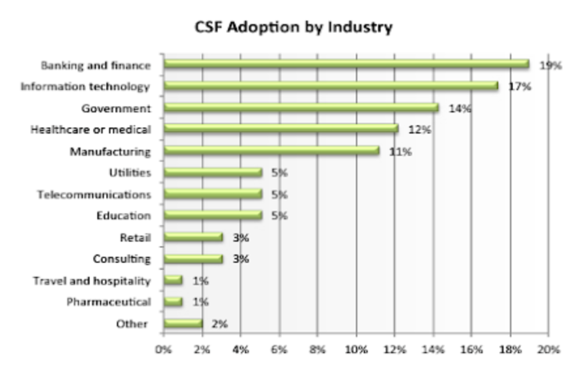
Cyber attacks can occur within any organisation in any industry. However, it is most common for organisations that adopt higher critical success factors (CSF) to implement the NIST Cybersecurity framework. Graph 6 indicates which industries have the highest CSF. Which helps identify which industries will need a strict cyber security framework such as NIST in place.
Graph 6
Security Technologies

Security technologies “refers to the components and policies used to protect data”[10] are essential for safeguarding IT security systems as the threat of cyberattacks are growing. As cyber attacks are more common today, organisations must use advanced security technologies such as Firewalls, NAC’s, VPNs and IDS/IPS. These technologies are the backbone of modern cyber security strategies, which help business prevent unauthorised access to their systems. To ensure that an organisations network is secure, it needs to include these technologies.

Firewalls

A firewall is a well known security software that monitors traffic whether that’s inbound or outbound based on its security measures “Firewalls can be viewed as gated borders or gateways”[11] This is because they act as a controlled entry and exit point for any network traffic which is filtered based on IP addresses and port numbers. There are three types of firewalls:

Packet filtering firewall: This is the most common firewall which examines the data packets based on specific criteria, such as their destination IP addresses and ports. They are relatively fast firewalls but are also simple and lack thd ability to inspect the data within a packet.

Stateful inspection firewall: Stateful inspection firewalls monitor active network connections by analysing the state of the connections. They use the information to make more informed decisions about whether the traffic is safe or not. This more in depth analysis provides more security than packet filtering firewalls

Next generation firewall: Next generation firewalls combine both advanced and traditional firewall capabilities with intrusion prevention, deep packet analysis and malware detection. This firewall is more of an industry standard to be used in organisations worldwide.

IDS/IPS

IDS and IPS are network security tools that are used to detect any malicious activity. They do this by “identifying possible incidents and logging information about them.”[12] By doing this, the security admins have documented attacks that can be used to further enhance their network security.

IDS: Intrusion Detection Systems is a monitoring system that is designed to identify potential breaches. This is done by analysing the system logs or network traffic for any malicious activity in real time. It then alerts admins of the threats that have been detected to ensure that they can deal with it appropriately.

IPS: Intrusion prevention system is a proactive security system that goes one step further than IDS by not only detecting the malicious activity, but then blocks it. This prevents any harmful packets entering their intended destination without human interaction.

Network Access Control and VPN

Network Access control is defined as “the process of restricting unauthorised users and devices from gaining access to a corporate or private network”[13]. By developing NAC it enables organisations to prevent malware spreading and secure their systems against malicious activity. This ensures organisations have strict access into their system as only authorised users can access their systems.

A Virtual private network (VPN) is an encrypted network connection. It secures data transmissions over public network. “VPNs are a one way to guarantee the security of data in transit across an untrusted network” [14] This implies that VPNs offer a reliable method in safeguarding sensitive information while it is being transmitted over an insecure or public network. The implementation of a VPN guarantees no traceable trails are left behind.

Real World Application of Security technologies

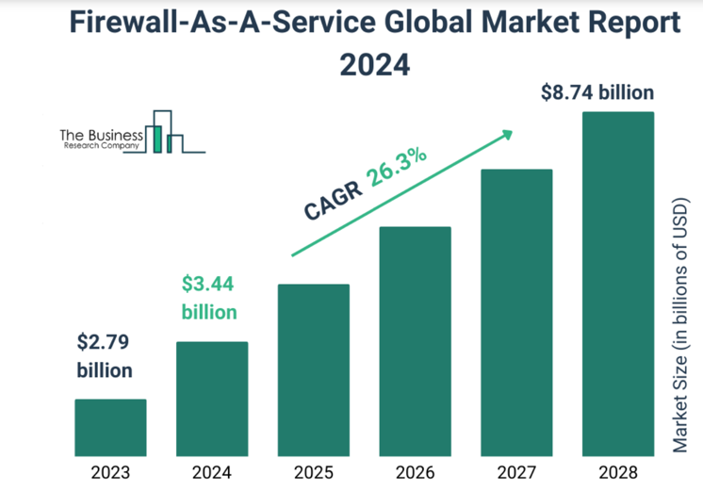
Graph 7 shows the growing implementation of firewalls around the world. With a projected increase of 26.3% growth in market, it emphasises the critical role that they play in keeping organisations secure and protecting netwiorks against cyber threats in todays digital industry.
Graph 7

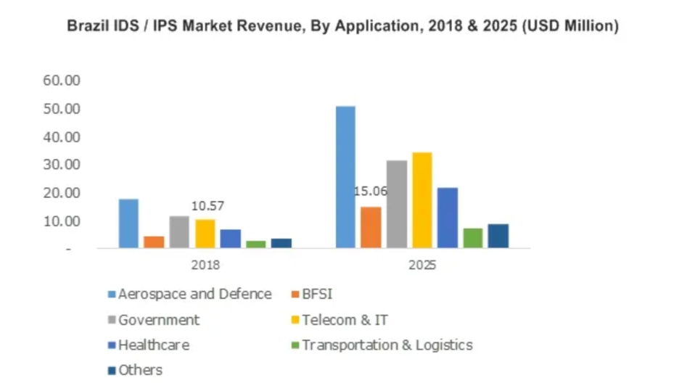

Graph 8 shows the importance and the growth of usage in IDS/IPS from 2018 within different industries. The telecoms and IT are predicted to receive the second highest rise in revenue which implies more organisations within the IT industry are implementing it into their network security. By doing this they are enhancing their security against cyber threats, ensuring the protection of sensitive data.
Graph 8
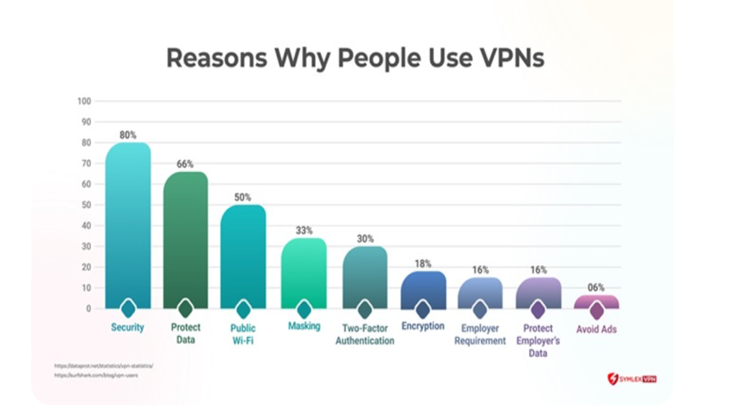

Graph 9 shows the key reasons people use VPNs, with security (80%) and data protection (66%) being the top priorities. This highlights the importance of VPNs in safeguarding sensitive information. With the rise in cyber crimes, organisations must ensure that VPN is being implemented as one of their security technologies to protect internal and external communications, maintain privacy and keep sensitive data secure.
Graph 9
Summary

The research conducted in task 1 highlights the importance of adopting strong security frameworks and technologies to ensure organisational data is kept secure and cyber security risks are kept to a minimum. ISO 27000, ISO 27001 and NIST cybersecurity framework all have different but structured approaches when managing security risks. And can all help to improve any security unit. Aswell as frameworks, security technologies also play a crucial part in keeping systems safe, with tools such as firewalls, IDS/IPS, NAC and VPNs providing additional protection can ensure that the system has a layered defence strategy which is essential for modern organisations.

Task 2: Case Scenario

Introduction

CyStresSolution (CSS) is a rapidly growing threat intelligence ad consultancy company, which helps businesses in combatting against attacks to other organisations networks. As a part of its services, CSS provides consultancy on cybersecurity, risk management, data recover, business continuity and cloud services. CSS is creating a new information security unit in order to address both internal and external security needs. The unit will be required to effectively implement frameworks, policies, and security measures to ensure security resilience. This report will outline the approach needed to ensure all of CSS’s requirements are integrated into its security unit.

- Organisational Structure

In order to support the implementation of information security protocols and frameworks. The Information security unit at CSS will be structured with a main focus on risk management, compliance and continuous improvement. Based on the research conducted, it has been identified that it is essential to have a strong security framework and to demonstrate its commitment to information security. This is why the primary goal of the unit is to complete ISO 27001 certification.

Key roles and Responsibilities

Chief Information Security Officer (CISO):
The CISO will take the lead in the development and implementation of the ISMS. Playing a crucial role in overseeing the ISO 27001 process, ensuring continuous improvement of CSS’s security policies.

Compliance and Risk Manager:
The Compliance and risk manager will be responsible for undertaking regular risk assessments and implementing the risk treatment plans required by ISO 27001. This ensures that CSS security practices comply with regulations such as GDPR, and effectively managing potential cyber threats.

Data Protection and Privacy Officer:
The Data protection officer makes sure that CSS adheres to GDPR. This involves safeguarding sensitive customer information. This role aligns with ISO 27001s focus on maintaining the confidentiality and integrity of data.

Incident Response and Threat Intelligence Team:
The Incident response and threat intelligence team will focus on detecting, addressing and minimising security incidents. And will play a key role in the ISO 27001 objective of ensuring that the organisation is prepared to address potential cyber threats.

Training and Awareness Coordinator:
The training and awareness coordinator is responsible for promoting security awareness and ensuring that there is ongoing employee training, to ensure that all staff are knowledgeable about security policies and practices to complete ISO 27001 certification.

Diagram of roles
Chief Information Security Officer (CISO)

Compliance and Risk Manager
Incident Response and Threat intelligence team
Data Protection and Privacy Officer

Training and Awareness Coordinator

This structure will support the effective implementation of ISO 27001 certification, ensuring that CSS has the right team and processes to maintain a strong security posture.

- Policies and Procedures

CSS must establish a comprehensive set of policies and procedures in order to safeguard sensitive data, maintain efficiency and mitigate risks. Doing this will serve as a foundation for CSS’s security unit, ensuring that the relevant actions are taken to comply with regulations and also achieve business goals.

Data Protection Policy: Implementing a Data protection policy will ensure that all personal information and sensitive data is kept secure and processed correctly. The data protection policy should align with GDPR standards and other international data protection regulations.

Access Control Policy: The implementation of an Access control policy ensures that access to various systems and data is specified based on role based access control (RBAC). The policy will be essential in implementing Network Access Control (NAC) measures to prevent malicious activity and unauthorised access.

Incident Response Plan: Based on the research conducted, it is evident that implementing an incident response plan is critical for managing cybersecurity incidents. The approach aligns with the NIST Cybersecurity Frameworks “Respond” and “Recover” functions, which focuses on minimising the impact of security incidents if they occur, also making sure that there is a quick recovery. By establishing an incident response plan it will provide CSS with a structured process for detecting, containing, mitigating and recovering from a cyber attack. However, regular testing will need to be completed to maximise the effectiveness of the response plan.

Business Continuity and Disaster Recovery Plan: The implementation of this will ensure that CSS can continue operating and recover quickly from any attacks. This should include regular back up practices and data recovery procedures

Security Awareness Training: Regular training will be required for all members of staff in order to raise awareness of new trends of threat and phishing and social engineering.

These listed policies will need to be reviewed on a regular basis to ensure that they remain relevant and effective to any new threats that come to light. This will protect both client, customer, and internal data. There will also need to be internal audits to ensure compliance and effectiveness, which is aligned with the ISO 27001 requirements on continuous improvement.

- Compliance (Laws and Ethics)

CSS’s security unit must adhere to several law and ethical guidelines to protect sensitive data. Compliance is a fundamental aspect of maintaining the integrity and credibility of the organisation. By using implementing these practices with legal frameworks such as HIPAA for health-related information in the US, or GDPR for data privacy in the EU. This ensures that CSS avoids any legal repercussions and also builds trust with clients. Some compliance areas include:

ISO 27001: ISO 27001 is internationally recognised as “the global standard for effective information management”[3] which requires that CSS implements an Information security management system (ISMS), ensuring data protection practices, continuous monitoring and in depth risk assessments.

HIPAA (Health Insurance portability and accountability act): If CSS work with healthcare clients. It must comply with national laws in healthcare. The Implementation of HIPPA will enable CSS to “establish federal standards, protecting sensitive health information from disclosure without patients consent” [15] which will ensure that they are meeting all regulations and protecting patient data.

General Data Protection Regulation (GDPR): As CSS will be holding sensitive client information it must adhere to the GDPR guidelines. These guidelines are set “for the collection and processing of personal information from individuals who live in the European Union” [16] Compliance with these guidelines will not only protect customer and client information but will also enforce trust with CSS clientele.

Cybersecurity Act: EU organisations are required to follow the EU cybersecurity act which provides requirements for ensuring the protection of infrastructure which includes the protection of personal data that is processed in the cloud.

To maintain compliance, the CSS information security unit should undertake regular updates and audits to internal policies which will align with everchanging laws and regulations. It is advised to have regular consultations with legal advisors to remain informed on all of the updates in the data protection legislation and cybersecurity standards.

- Governance and Strategic Planning for Security

Efficient and effective governance is very important when aligning security strategies with business objectives and making sure that security measures follow the organisations objectives. This means that clear performance metrics are set, making adjustments when and where necessary and tracking security initiatives.

Governance approach:

Governance Structure: The CISO will report to the CEO or the board of directors to ensure that all information security delegated accordingly and prioritised to the highest level.

Strategic Planning: Create long term plans that integrate security trends, emerging technologies, and threat intelligence. Based on research the NIST Cybersecurity framework would be particularly useful in this process, especially its ‘identify’ and ‘protect’ functions, which focus on recognising threats and help establish protection measures for a secure infrastructure.

Security Metrics and KPIs: CSS must define key performance indicators (KPIs) to assess the effectiveness of its security posture. Some of these examples include tracking the number of cyber attacks that have been successfully prevented, time taken to detect and mitigate threats, and the user compliance with security training policies

- Risk Assessment

The ability to identify, assess and mitigate risks is at the heart of any information security unit. Effective risk management is critical for safeguarding CSS’s assets, reputation, and operations. By implementing risk assessment, CSS can reduce vulnerabilities and minimise the impact of potential security incidents. The following components outline CSS’s risk management strategy:

Risk assessments: CSS should employ both qualitative and quantitative methods to evaluate any potential risks, including cyber attacks, data breaches, and system vulnerabilities. The purpose of this is to have a thorough understanding of both likelihood and the impact of certain threats.

Risk Treatment Plans: Once the risks are identified, CSS must then determine the appropriate strategy, this could be mitigating, transferring, accepting or avoiding the risk. This can be done by implementing Multi factor authentication (MFA) which is an effective way of monitoring access.

Penetration testing: It is a good idea to regularly test the internal and external systems in order to identify any vulnerabilities that the system has which could be exploited by attackers.

Continuous monitoring: Real time monitoring of networks, systems and user activities can be achieved by using both Intrusion Detection System (IDS) and Intrusion Prevention Systems (IPS) which work together to strengthen security network defence. The implementation of the IDS and IPS also help CSS maintain compliance with industry standard frameworks like IS0 27001 and GDPR.

- Contingency Planning

Every organisation needs to be prepared fir unexpected cyber attacks and must ensure that there are measures put in place to ensure operations are smooth, data is protected, and systems are restored after attacks. In order to do this a contingency plan must include:

Incident Response Plan (IRP): A comprehensive and detailed plan designed to ensure a rapid response in the event of a cyber attack. The plan should include the outline of procedures for identifying, responding to, and recovering from security breaches or attacks.

Disaster Recovery: Establish backup systems and solutions for critical data and services. Disaster recovery procedures should be regularly tested to reduce downtime and validate effectiveness.

Business Continuity: Implement measures to ensure critical business functions can continue to operate during a cyber crisis. The use of tools such as data replication, cloud based backups and failover systems need to be implemented to minimise interruptions and support seamless functionality.

- Protection Mechanisms

CSS must implement advanced security technologies to ensure that the systems sensitive data and networks are protected. To do this these key technologies must be included:

Firewalls: Based on research, it has been identified that next generation firewalls (NGFW) would be the most suitable choice for CSS network system. NGFW provide more capabilities to block modern threats than other firewalls such as “advanced malware and application layer attacks”[17] these functions will allow CSS to maintain protection against new threats while safeguarding its network.

IDS/IPS: The Intrusion Detection System (IDS) and Intrusion Prevention Systems will be essential for the real time monitoring and protection for the security unit against any unauthorised and malicious acitivity. It is essential to have both as “organisations shouldn’t necessarily consider choosing one solution over another”[18]. By implementing IDS and IPS it means that CSS can ensure all systems are secure in its operations

VPNs: Virtual Private networks would benefit CSS’s security unit. By using VPN’s it means that there will be encrypted tunnels which ensure that any data transmitted between users and systems remain protected from anyone unauthorised. This reduces the risk of any data breaches.

Encryption: Safeguarding sensitive data is made easier by encryption. By encoding information it ensures that even if data is either sent to the wrong person or is intercepted, it cannot be accessed without the correct encryption key. Advanced encryption standards such as AES-256 can be used for encryption. “Advanced Encryption Standard (AES) 256 is a virtually impenetrable symmetric encryption algorithm that uses 256-bit key to convert text or data into a cypher” [19] ensure CSS to maintain data integrity.

Conclusion

The creation of a high standard Information security unit at CyStresSolution (CSS) is an essential step towards safeguarding sensitive client and customer information, maintaining compliance with international laws and regulations, and ensuring business continuity. From the research and report the unit will implement frameworks such as ISO 27001 as the foundation of its information security management system (ISMS) which emphasises on the role of continuous improvement and uses a proactive threat management.

The security unit will also include policies and procedures such as access control, data protection, disaster recovery and incident response, which will all play a large part for the framework. Compliance with ethical and legal regulations, including GDPR, HIPAA and ISO 27001 will all protect the organisation from any legal problems while instilling trust to its clients.

Security technologies will be the final implementations to the security unit to ensure that the defence mechanisms are robust in mitigating cyber attacks. These technologies include VPNs, Firewalls, IDS/IPS’s and encryption systems which will all work together to sustain long term resilience.

In summary, this approach enables CSS to establish itself as a secure threat intelligence consultancy company, who are able to address and mitigate evolving cyber threats in an ever changing industry.

Bibliography
[1]
NI Business Info, “Impact of cyber attack on your business,” nibusinessinfo.co.uk, Mar. 07, 2019. https://www.nibusinessinfo.co.uk/content/impact-cyber-attack-your-business (accessed Dec. 04, 2024).

[2]
kinza Yasar, “What is information security management system (ISMS)? - Definition from WhatIs.com,” WhatIs.com, Sep. 2022. https://www.techtarget.com/whatis/definition/information-security-management-system-ISMS (accessed Dec. 05, 2024).

[3]
ITGovernance, “ISO 27001 Benefits | IT Governance UK,” Itgovernance.co.uk, 2016. https://www.itgovernance.co.uk/iso27001-benefits (accessed Dec. 05, 2024).

[4]
S. Karthik, “5 Benefits of ISO 27001 Certification,” Sprinto, Mar. 31, 2023. https://sprinto.com/blog/benefits-of-iso-27001-certification/ (accessed Dec. 05, 2024).

[5]
J. Doering, “Top 3 key problems of an ISO 27001 certification,” www.secfix.com, 2024. https://www.secfix.com/post/the-3-key-problems-of-getting-an-iso-27001-certification (accessed Dec. 05, 2024).

[6]
C. Biscoe, “ISO 27001 certification figures increase by 20%,” IT Governance UK Blog, Sep. 27, 2017. https://www.itgovernance.co.uk/blog/iso-27001-certification-figures-increase-by-20 (accessed Dec. 05, 2024).

[7]
Balbix, “What is the NIST Cybersecurity Framework?,” Balbix, Dec. 16, 2020. https://www.balbix.com/insights/nist-cybersecurity-framework/ (accessed Dec. 05, 2024).

[8]
Federal Trade Commission, “Understanding the NIST cybersecurity framework,” Federal Trade Commission, 2024. https://www.ftc.gov/business-guidance/small-businesses/cybersecurity/nist-framework (accessed Dec. 05, 2024).

[9]
E. Bresnahan, “What Are the Benefits of the NIST Cybersecurity Framework,” www.cybersaint.io, 2022. https://www.cybersaint.io/blog/benefits-of-nist-cybersecurity-framework (accessed Dec. 11, 2024).

[10]
Aviglion, “Security Technology Overview & Industry Trends for 2023 + PDF,” Avigilon, 2024. https://www.avigilon.com/blog/security-technology (accessed Dec. 11, 2024).

[11]
kaspersky, “What Is a Firewall?,” www.kaspersky.com, 2024. https://www.kaspersky.com/resource-center/definitions/firewall (accessed Dec. 11, 2024).

[12]
“What is IDS and IPS? | Juniper Networks,” www.juniper.net, 2023. https://www.juniper.net/gb/en/research-topics/what-is-ids-ips.html (accessed Dec. 11, 2024).

[13]
Fortinet, “What Is Network Access Control (NAC) ?,” Fortinet. Available: https://www.fortinet.com/uk/resources/cyberglossary/what-is-network-access-control#:~:text=Network%20access%20control%20(NAC)%20is. [Accessed: Dec. 01, 2024]

[14]
NCSC, “Virtual Private Networks (VPNs),” www.ncsc.gov.uk, Jun. 29, 2021. https://www.ncsc.gov.uk/collection/device-security-guidance/infrastructure/virtual-private-networks (accessed Dec. 08, 2024).

[15]
CDC, “Health insurance portability and accountability act of 1996 (HIPAA),” Public Health Law, Sep. 10, 2024. https://www.cdc.gov/phlp/php/resources/health-insurance-portability-and-accountability-act-of-1996-hipaa.html (accessed Dec. 11, 2024).

[16]
J. Frankenfield, “General Data Protection Regulation (GDPR),” Investopedia, May 04, 2020. https://www.investopedia.com/terms/g/general-data-protection-regulation-gdpr.asp (accessed Dec. 11, 2024).

[17]
Cisco, “What Is a Next-Generation Firewall (NGFW)?,” Cisco, 2018. https://www.cisco.com/c/en/us/products/security/firewalls/what-is-a-next-generation-firewall.html (accessed Dec. 11, 2024).

[18]
J. Ledesma, “IDS vs. IPS: What is the Difference?,” Inside Out Security, Oct. 23, 2018. https://www.varonis.com/blog/ids-vs-ips (accessed Dec. 11, 2024).

[19]
V. Kananda, “What is AES 256 Encryption & How Does it Work?,” Progress Blogs, Jun. 22, 2022. https://www.progress.com/blogs/use-aes-256-encryption-secure-data (accessed Dec. 11, 2024).

Index

Pictures

[1]
M. Adams, “ISO 27001 Certification: Understanding the Process and Costs - Businesstechweekly.com,” BusinessTechWeekly, Apr. 07, 2021. Available: https://www.businesstechweekly.com/legal-and-compliance/iso27001-certification/iso-27001-certification-process-costs/. [Accessed: Dec. 11, 2024]

[2]
M. Adams, “ISO 27001 Certification: Understanding the Process and Costs - Businesstechweekly.com,” BusinessTechWeekly, Apr. 07, 2021. Available: https://www.businesstechweekly.com/legal-and-compliance/iso27001-certification/iso-27001-certification-process-costs/. [Accessed: Dec. 11, 2024]

[3]
“NIST Cybersecurity Framework 2.0 | NIST,” NIST, 2024. Available: https://www.nist.gov/image/nist-cybersecurity-framework-20. [Accessed: Dec. 11, 2024]

Graphs

[1]
“ISO 27001 Certification Requirements,” Planet 9 Inc., Nov. 26, 2024. Available: https://planet9security.com/iso-27001-certification-requirements/. [Accessed: Dec. 11, 2024]

[2]
“Typical ISO 27001 certification costs,” Itgovernance.co.uk, 2016. Available: https://www.itgovernance.co.uk/iso27001-certification-costs. [Accessed: Dec. 11, 2024]

[3]
C. Biscoe, “ISO 27001 certification figures increase by 20%,” IT Governance UK Blog, Sep. 27, 2017. Available: https://www.itgovernance.co.uk/blog/iso-27001-certification-figures-increase-by-20. [Accessed: Dec. 11, 2024]

[4]
N. Jagozinska, “Implementing Information Security Management Systems in Transport Industry Organizations,” ResearchGate, May 2019. Available: https://www.researchgate.net/figure/Awareness-of-risk-identification-and-documentation-before-and-after-implementation-of-ISO_fig6_349033174. [Accessed: Dec. 11, 2024]

[5]
admin, “Stealthlabs Inc,” Stealthlabs, Apr. 05, 2021. Available: https://www.stealthlabs.com/blog/what-is-nist-compliance-key-steps-to-becoming-nist-compliant/. [Accessed: Dec. 11, 2024]

[6]
Cyvatar, “What is the NIST cybersecurity framework (CSF)?,” CYVATAR.AI, Nov. 30, 2021. Available: https://cyvatar.ai/understanding-nist-cybersecurity-framework/. [Accessed: Dec. 11, 2024]

[7]
T. ResearchCompany, “Firewall-As-A-Service Global Market Report 2024,” Thebusinessresearchcompany.com, 2024. Available: https://www.thebusinessresearchcompany.com/report/firewall-as-a-service-global-market-report. [Accessed: Dec. 11, 2024]

[8]
P. Wadhwani, “Intrusion Detection System / Intrusion Prevention System (IDS / IPS) Market Size By Component (Solution [Physical Appliances, Virtual Appliances], Service [Managed Service, Training and Consulting Service, Integration Service]), By Type (Network-based, Wireless-based, Host-based), By Deployment Model (On-Premise, Cloud, Hybrid), By Application (Aerospace and Defense, BFSI, Government, IT & Telecom, Healthcare, Transportation & Logistics) Industry Analysis Report, Regional Outlook, Growth Potential, Competitive Market Share & Forecast, 2019 - 2025,” Global Market Insights Inc., 1970. Available: https://www.gminsights.com/industry-analysis/intrusion-detection-prevention-system-ids-ips-market. [Accessed: Dec. 11, 2024]

[9]
Mirajul, “Symlex VPN | A Complete Guide on VPN: All You Need to Know,” Symlex VPN, Jan. 17, 2024. Available: https://symlexvpn.com/what-is-a-vpn/. [Accessed: Dec. 11, 2024]

