Database Design
(The Book Store)

Prepared by: Dominik Tomasz Kania
Student Number: 1702026

Preparation for University of Wales Trinity Saint David

Lecturer: Beverley Holland
Module: Information Engineering (ACCB4012)
Course: Computing (Games Development)

28th April 2020
Table of Contents
Tables 2
Queries 8
Forms 13
Reports 19
Macros 21
Relationships 23
Structured Query Language 24

Tables

Figure 1 – Successfully created tables for the City Book Store database.
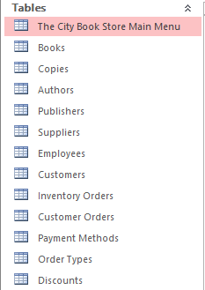

Figure 2 – Books table.
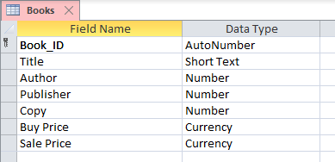
Book_ID - Primary Key with AutoNumber data type.
Title - Short Text with field size up to 255.
Author – Foreign Key with a Combo Box allowing to select data from the Authors table.
Publisher - Foreign Key with a Combo Box allowing to select data from the Publishers table.
Copy - Foreign Key with a Combo Box allowing to select data from the Copies table.
Buy Price – Currency set to Pound Sterling.
Sale Price – Currency set to Pound Sterling.

Figure 3 – Copies table.
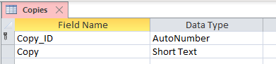
Copy_ID - Primary Key with AutoNumber data type.
Copy - Short Text with field size up to 255.

Figure 4 – Authors table.
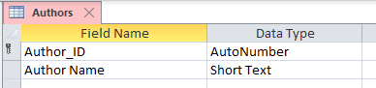
Author_ID - Primary Key with AutoNumber data type.
Author - Short Text with field size up to 255.

Figure 5 – Publishers table.
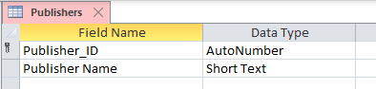
Publisher_ID - Primary Key with AutoNumber data type.
Publisher Name - Short Text with field size up to 255.

Figure 6 – Suppliers table.
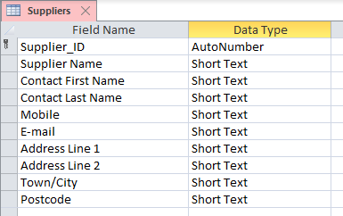
Supplier_ID - Primary Key with AutoNumber data type.
Supplier Name, Contact First Name, Contact Last Name, E-mail, Address Line 1, Address Line 2, Town/City - Short Text with field size up to 255.
Mobile - Short Text with Input Mask set to 00000\ 000000;0;_.
Postcode - Short Text with Input Mask set to >LL00\ 0LL;0;_.

Figure 7 – Employees table.
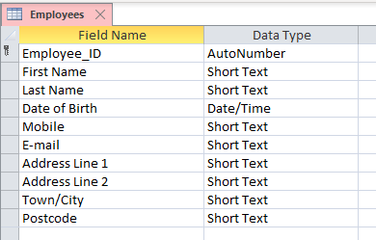
Employee_ID - Primary Key with AutoNumber data type.
First Name, Last Name, E-mail, Address Line 1, Address Line 2, Town/City - Short Text with field size up to 255.
Date of Birth – Date/Time with Input Mask set to 00/00/0000;0;_.
Mobile - Short Text with Input Mask set to 00000\ 000000;0;_.
Postcode - Short Text with Input Mask set to >LL00\ 0LL;0;_.
Figure 8 – Customers table.
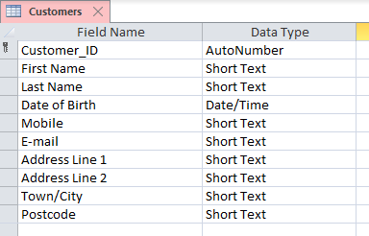
Customer_ID - Primary Key with AutoNumber data type.
First Name, Last Name, E-mail, Address Line 1, Address Line 2, Town/City - Short Text with field size up to 255.
Date of Birth – Date/Time with Input Mask set to 00/00/0000;0;_.
Mobile - Short Text with Input Mask set to 00000\ 000000;0;_.
Postcode - Short Text with Input Mask set to >LL00\ 0LL;0;_.

Figure 9 – Payment Methods table.
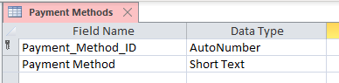
Payment_Method_ID - Primary Key with AutoNumber data type.
Payment Method - Short Text with field size up to 255.

Figure 10 – Order Types table.
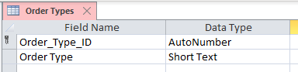
Order_Type_ID - Primary Key with AutoNumber data type.
Order Type - Short Text with field size up to 255.
Figure 11 – Inventory Orders table.
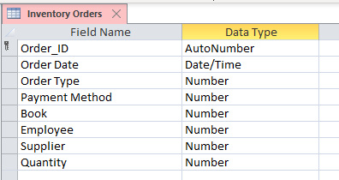
Order_ID - Primary Key with AutoNumber data type.
Order Date - Date/Time with Input Mask set to 00/00/0000;0;_.
Order Type – Foreign Key with a Combo Box allowing to select data from the Order Types table.
Payment Method – Foreign Key with a Combo Box allowing to select data from the Payment Methods table.
Book – Foreign Key with a Combo Box allowing to select data from the Books table.
Employee – Foreign Key with a Combo Box allowing to select data from the Employees table.
Supplier – Foreign Key with a Combo Box allowing to select data from the Suppliers table.
Quantity – Number with field size set to Long Integer.

Figure 12 – Discounts table.
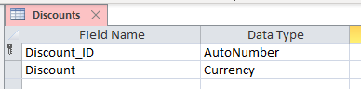
Discount_ID - Primary Key with AutoNumber data type.
Discount - Currency set to Percent.

Figure 13 – Customers Orders table.
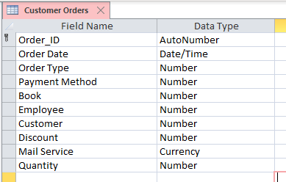
Order_ID - Primary Key with AutoNumber data type.
Order Date - Date/Time with Input Mask set to 00/00/0000;0;_.
Order Type – Foreign Key with a Combo Box allowing to select data from the Order Types table.
Payment Method – Foreign Key with a Combo Box allowing to select data from the Payment Methods table.
Book – Foreign Key with a Combo Box allowing to select data from the Books table.
Employee – Foreign Key with a Combo Box allowing to select data from the Employees table.
Customer – Foreign Key with a Combo Box allowing to select data from the Customers table.
Discount – Foreign Key with a Combo Box allowing to select data from the Discounts table.
Mail Service – Currency set to Pound Sterling.
Quantity – Number with field size set to Long Integer.

Queries

Figure 14, 15, 16 – Inventory Orders Total Price Query.
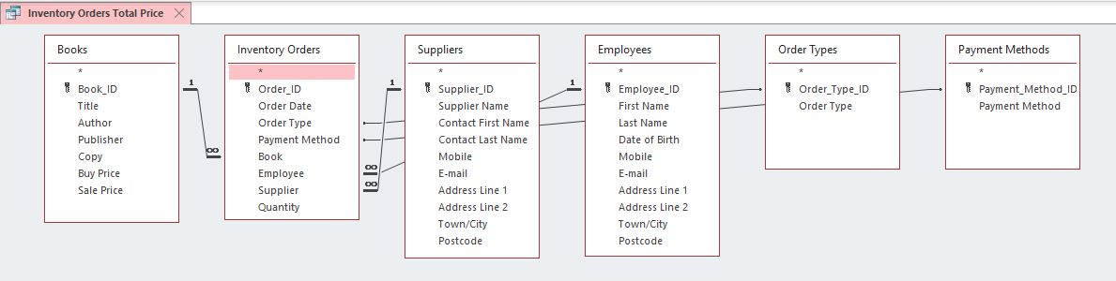
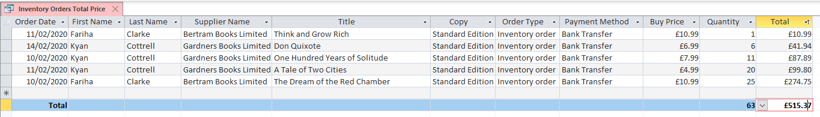
Books, Inventory Orders, Suppliers, Employees, Order Types and Payment Methods were added in order to output data shown in figure 16. Formula below was used to calculate total price for each book ordered for the inventory stock:
Total: [Books]![Buy Price]*[Inventory Orders]![Quantity].

Figure 17, 18, 19, 20, 21 – Customer Orders Total Price Query.
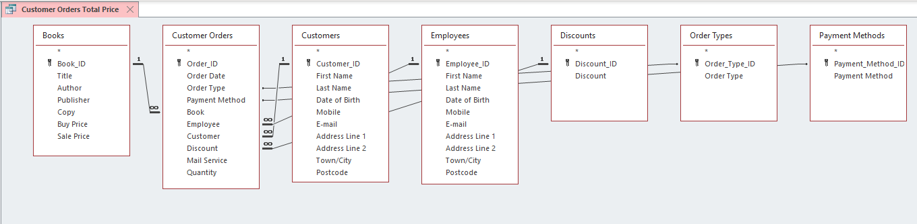
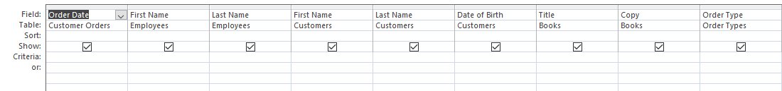
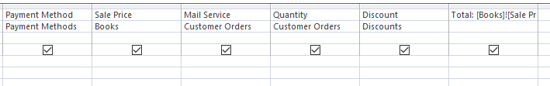
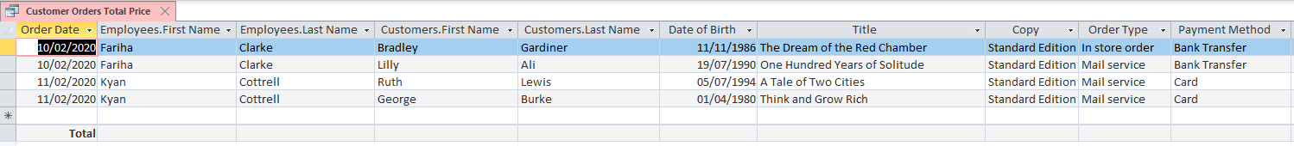
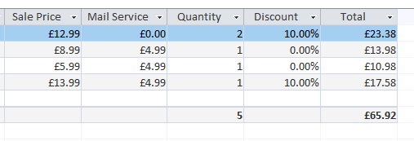
Books, Customer Orders, Customers, Employees, Discounts, Order Types and Payment Methods were added in order to output data shown in figure 20. Formula below was used to calculate total price for each book ordered by the customer:
Total: [Books]![Sale Price]*[Customer Orders]![Quantity]*(1-[Discounts]![Discount])+[Customer Orders]![Mail Service].

Figure 22, 23, 24 – Profit From Sales Query.
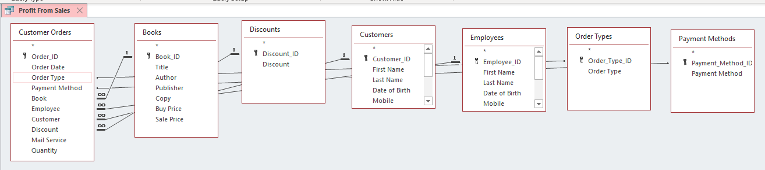
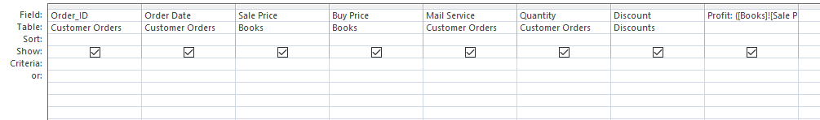
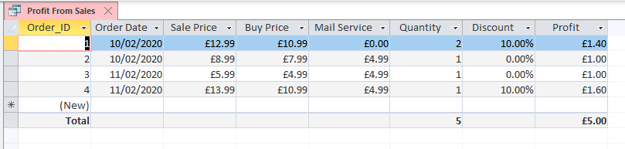
Books, Customer Orders, Customers, Employees, Discounts, Order Types and Payment Methods were added in order to output data shown in figure 24. Formula below was used to calculate profit from sales:
Profit: ([Books]![Sale Price]*[Customer Orders]![Quantity]*(1-[Discounts]![Discount])+[Customer Orders]![Mail Service])-([Books]![Buy Price]*[Customer Orders]![Quantity])-[Customer Orders]![Mail Service].

Figure 25, 26 – Newsletter For The Three Months Query.
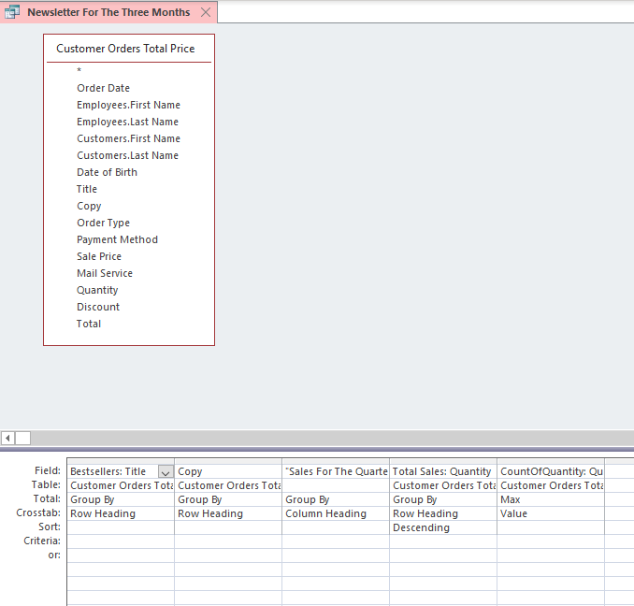
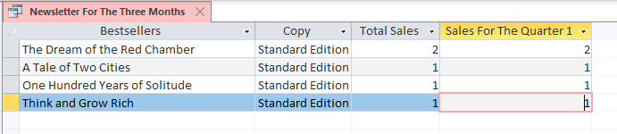
Customer Orders Total Price Query was added in order to output data shown in figure 26. SQL below was used to show total sales and 3 months sales:
TRANSFORM Max([Customer Orders Total Price].Quantity) AS CountOfQuantity SELECT [Customer Orders Total Price].Title AS Bestsellers, [Customer Orders Total Price].Copy, [Customer Orders Total Price].Quantity AS [Total Sales] FROM [Customer Orders Total Price] GROUP BY [Customer Orders Total Price].Title, [Customer Orders Total Price].Copy, [Customer Orders Total Price].Quantity ORDER BY [Customer Orders Total Price].Quantity DESC PIVOT "Sales For The Quarter " & Format([Order Date],"q");
Figure 27, 28 – Current Inventory Query.
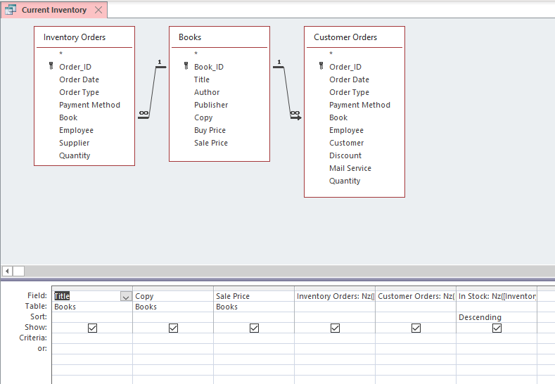
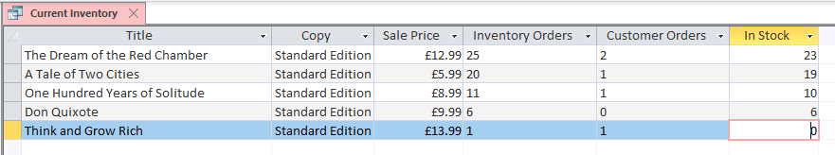
Inventory Orders, Books and Customer Orders were added in order to output data shown in figure 28. SQL below was used to show current stock:
SELECT Books.Title, Books.Copy, Books.[Sale Price], Nz([Inventory Orders].[Quantity],0) AS [Inventory Orders], Nz([Customer Orders].[Quantity],0) AS [Customer Orders], Nz([Inventory Orders]![Quantity],0)-Nz([Customer Orders]![Quantity],0) AS [In Stock] FROM (Books LEFT JOIN [Customer Orders] ON Books.Book_ID = [Customer Orders].Book) INNER JOIN [Inventory Orders] ON Books.Book_ID = [Inventory Orders].Book ORDER BY Nz([Inventory Orders]![Quantity],0)-Nz([Customer Orders]![Quantity],0) DESC;

Forms

Figure 29 – The City Book Store Main Menu Form.
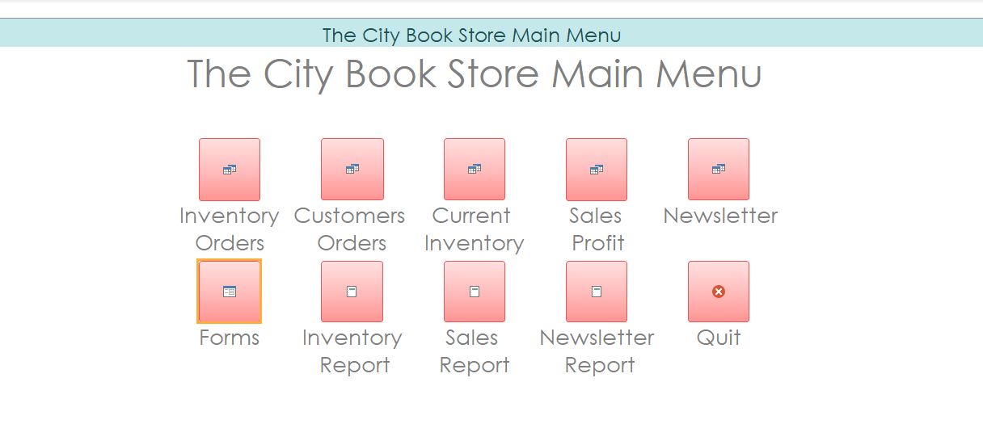
Main Menu was created and buttons were added to help users navigate through the records.

Figure 30 – Books Form.
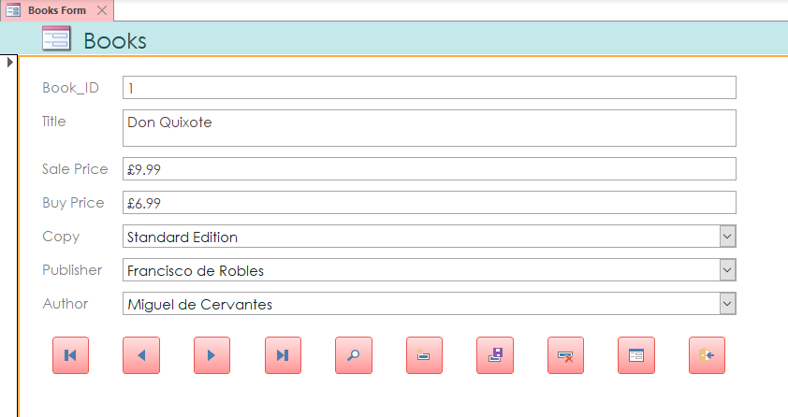
Books Form with buttons allowing to navigate through the records, add new records, delete records, save records, find records, close form and go to the next form.

Figure 31 – Copies Form.
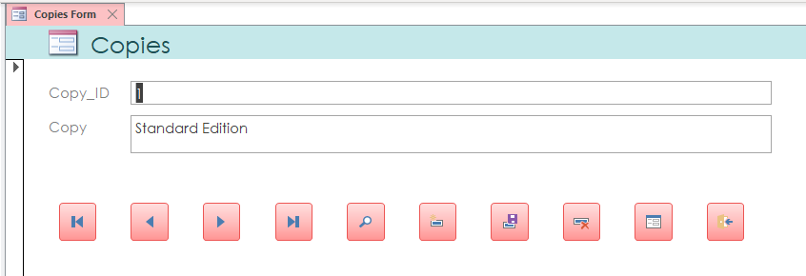
Copies Form with buttons allowing to navigate through the records, add new records, delete records, save records, find records, close form and go to the next form.

Figure 32 – Authors Form.
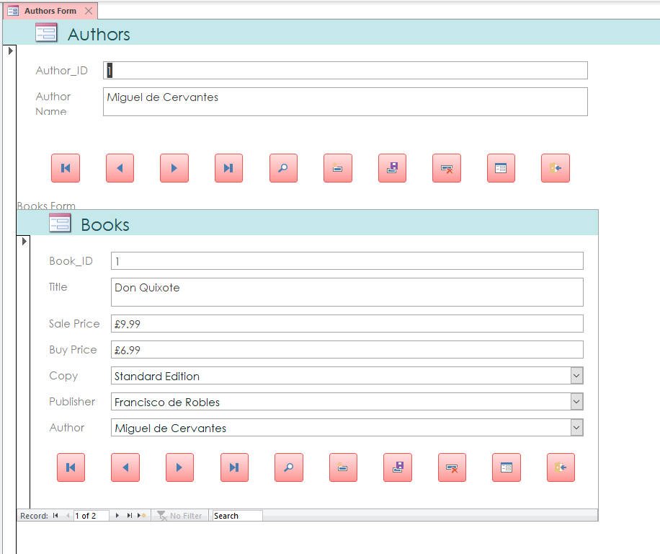
Authors Form with buttons allowing to navigate through the records, add new records, delete records, save records, find records, close form and go to the next form.
Subform was created to show all the books written by the selected author.

Figure 33 – Publishers Form.
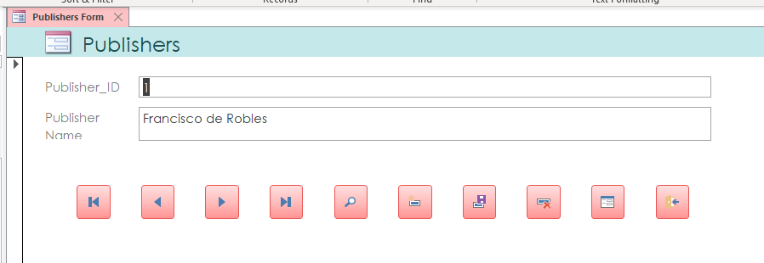
Publishers Form with buttons allowing to navigate through the records, add new records, delete records, save records, find records, close form and go to the next form.

Figure 34 – Suppliers Form.
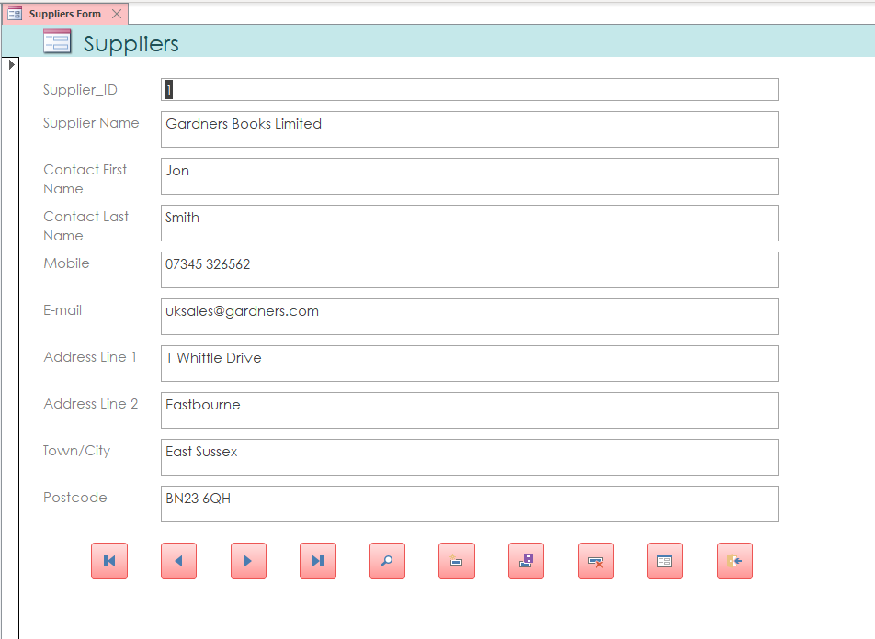
Suppliers Form with buttons allowing to navigate through the records, add new records, delete records, save records, find records, close form and go to the next form.

Figure 35 – Employees Form.
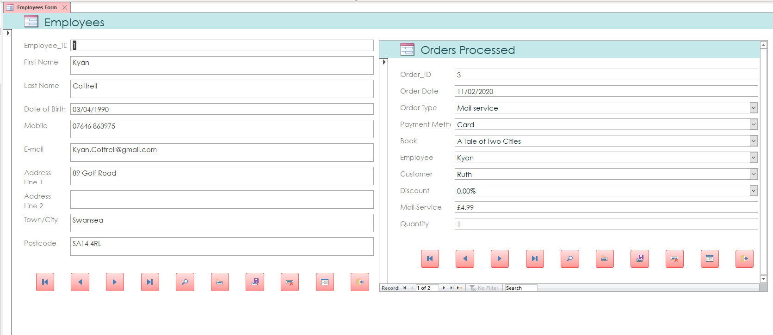
Employees Form with buttons allowing to navigate through the records, add new records, delete records, save records, find records, close form and go to the next form.
Subform was created to show all the orders processed by the selected employee.

Figure 36 – Customers Form.
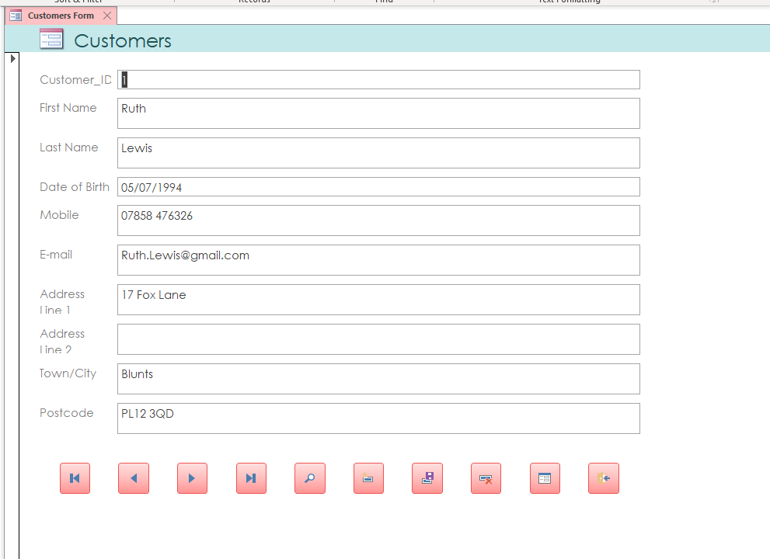
Customers Form with buttons allowing to navigate through the records, add new records, delete records, save records, find records, close form and go to the next form.
Figure 37 – Inventory Orders Form.
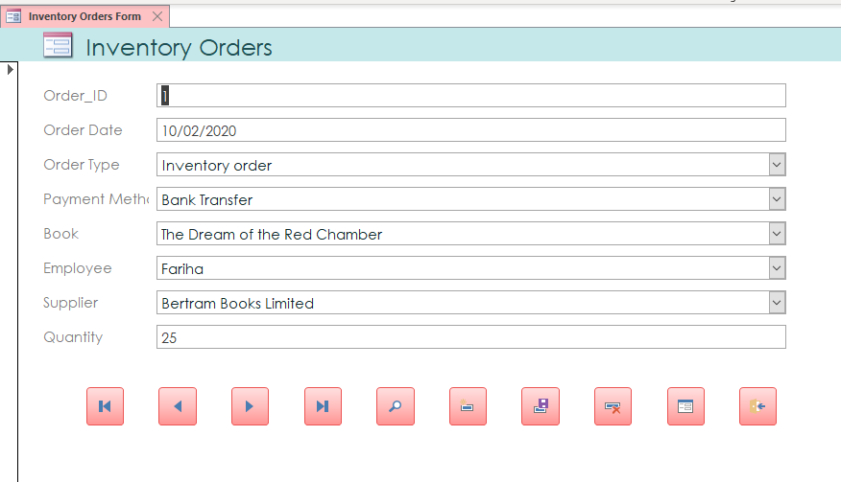
Inventory Orders Form with buttons allowing to navigate through the records, add new records, delete records, save records, find records, close form and go to the next form.

Figure 38 – Orders Processed Form.
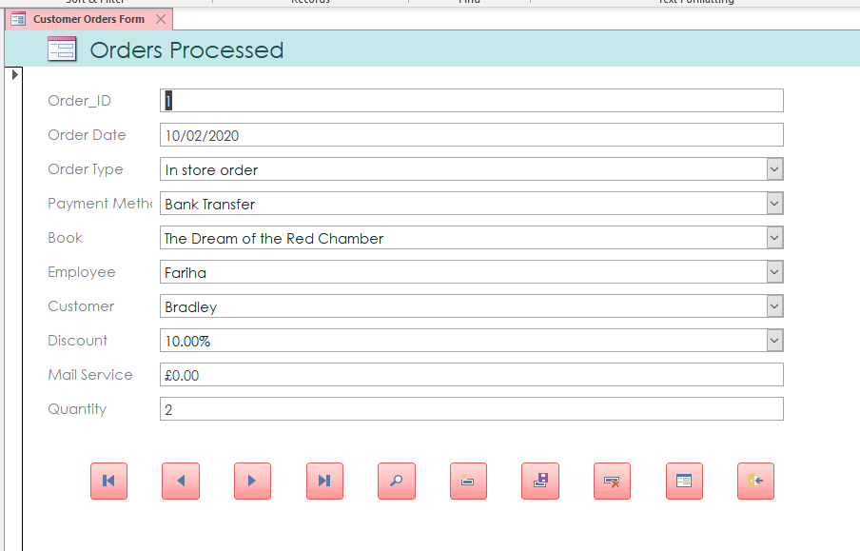
Orders Processed Form with buttons allowing to navigate through the records, add new records, delete records, save records, find records, close form and go to the next form.
Figure 39 – Payment Methods Form.
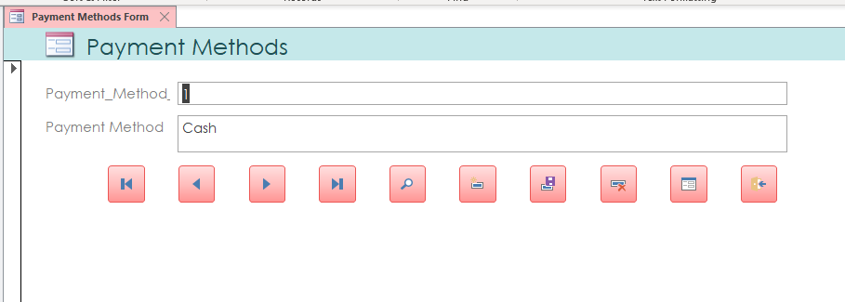
Payment Methods Form with buttons allowing to navigate through the records, add new records, delete records, save records, find records, close form and go to the next form.

Figure 40 – Order Types Form.
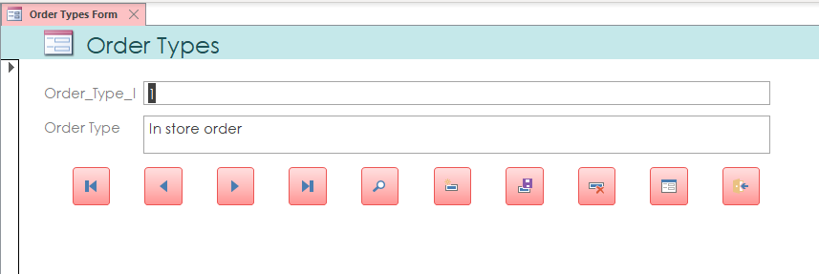
Order Types Form with buttons allowing to navigate through the records, add new records, delete records, save records, find records, close form and go to the next form.

Figure 41 – Discounts Form.
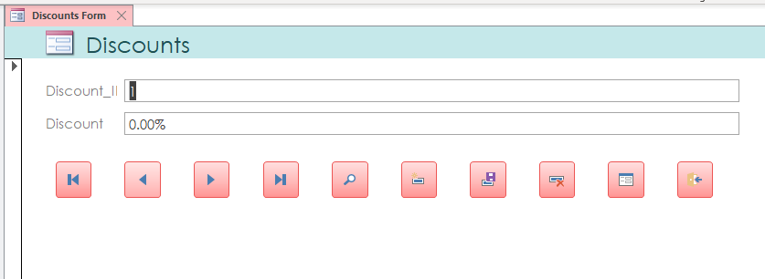
Discounts Form with buttons allowing to navigate through the records, add new records, delete records, save records, find records, close form and go to the next form.

Reports

Figure 42 – Current Inventory Report.
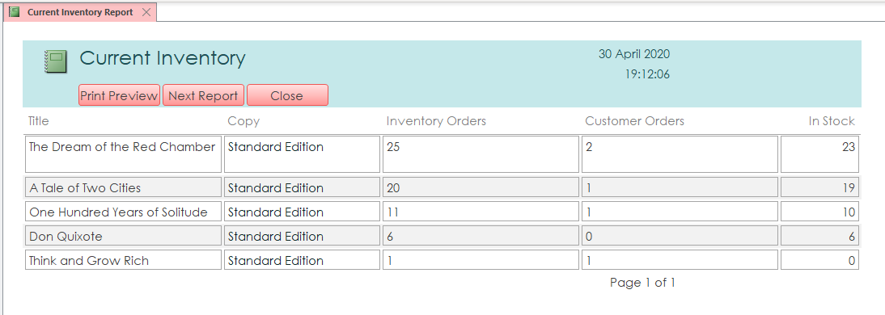
Current Inventory Report shows items ordered for inventory, by clients and current stock.
Print Preview, Next Report and Close buttons were added to allow user to go to the next report, close current report or view the print preview before printing the report.

Figure 43 – Newsletter For The Three Months Report.
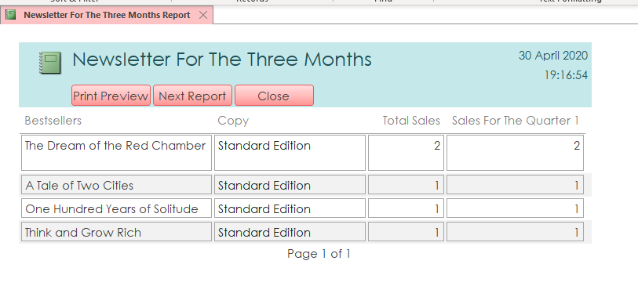
Newsletter For The Three Months Report shows total sales and sales for the first quarter.
Print Preview, Next Report and Close buttons were added to allow user to go to the next report, close current report or view the print preview before printing the report.

Figure 44 – Profit From Sales Report.
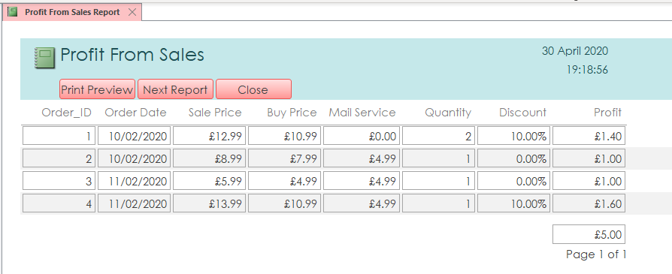
Profit From Sales Report shows profit from each order and total profit. Total profit was calculated in the report using =Sum([Profit]) formula.
Print Preview, Next Report and Close buttons were added to allow user to go to the next report, close current report or view the print preview before printing the report.

Macros

Figure 45 – Autoexec Macro.
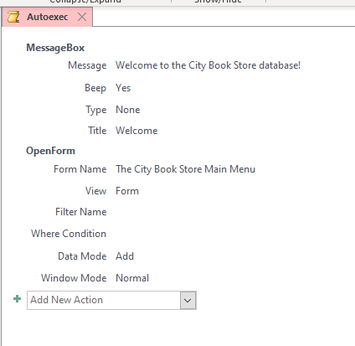
Autoexec Macro was created to output Welcome Message and open Main Menu Form when user opens database. Macros named as Autoexec are executed at the start of the database.

Figure 46, 47, 48 – Embedded Macros.
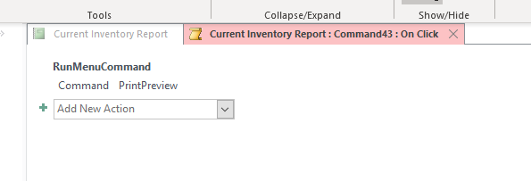
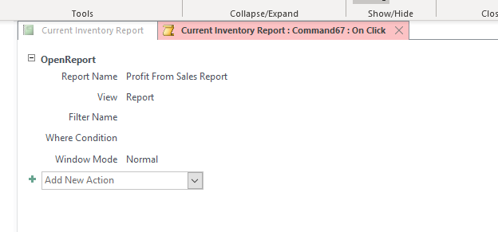
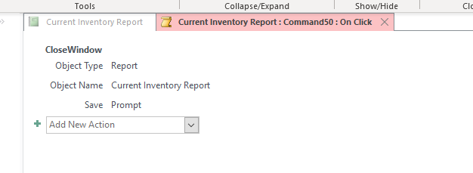
Embedded Macros were added to the buttons which are allowing to:
- View the print preview.
- Go to the next report.
- Close the current report.

Relationships

Figure 49 – Relationships.
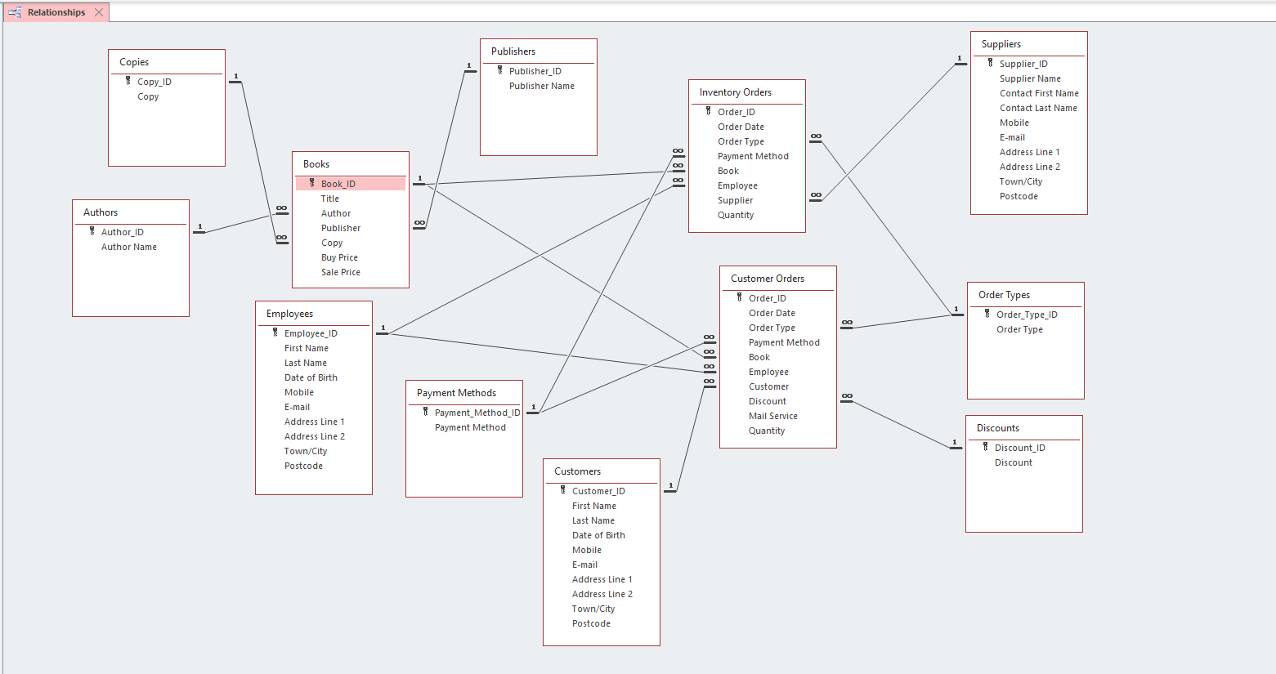
Relationships between the tables were created to establish a connection between the tables that are logically related. It also allows for data lookup from multiple tables simultaneously.

Structured Query Language

Figure 50, 51, 52 – Structured Query Language.
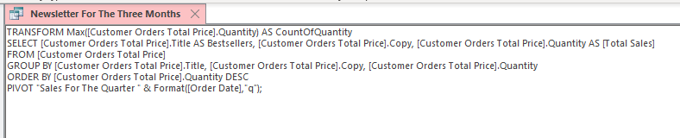
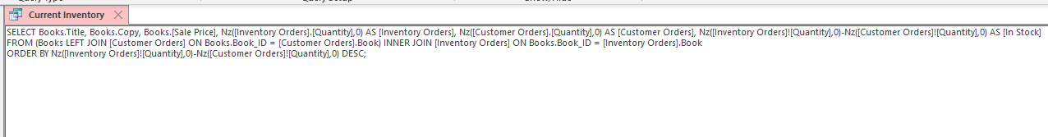
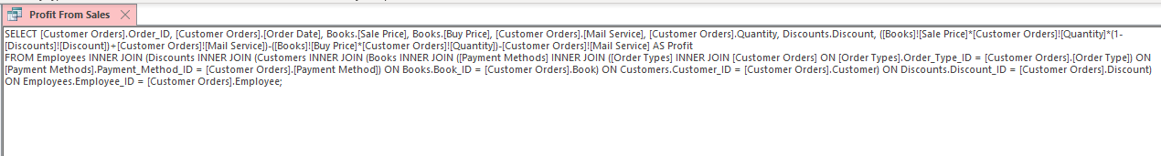
SQL used in the queries allowed to calculate the data, merge tables and set the new names to the columns. INNER JOIN and LEFT JOIN were used in order to show data needed for the Query.

Figure 53 – Employees Table.
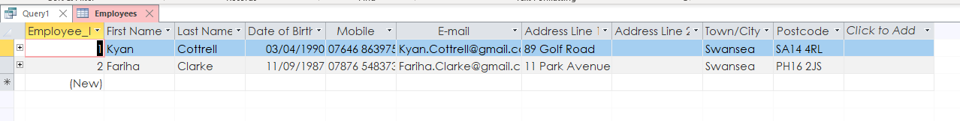
Employees Table before adding new record.

Figure 54 – SQL statement.
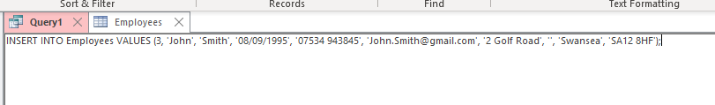
SQL statement to add new record.

Figure 55 – Adding new records using SQL.
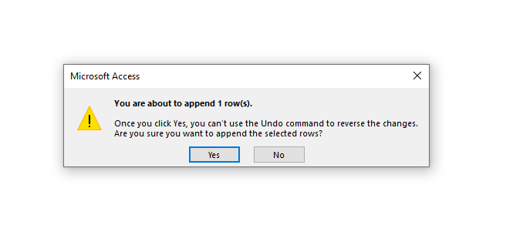
Run statement.

Figure 56 – Employees Table.
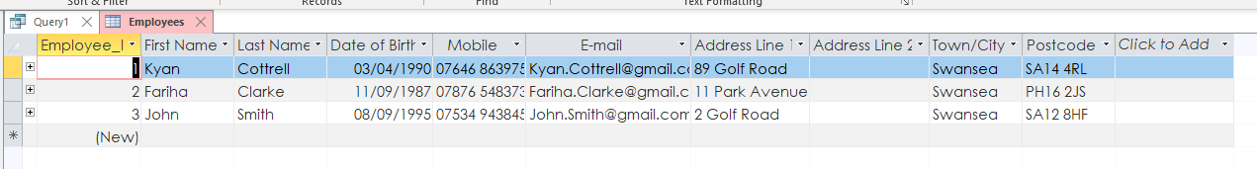
Employees Table after adding new record using SQL.
[1] [2] [3] [4]

References

[1] | B. Beitler, Microsoft Access : How to Build an Access Database.
[2] | B. Beitler, Microsoft Access 2016: Understanding Access Database Relationships.
[3] | S. D. Press, SQL Guide for Microsoft Access: SQL Basics, Fundamental & Queries Exercise.
[4] | T. X. Tran, How to Use Microsoft Access 2016: A basic guide with step-by-step instructions for the complete beginner.

