Series Hybrid Vehicle Part-02
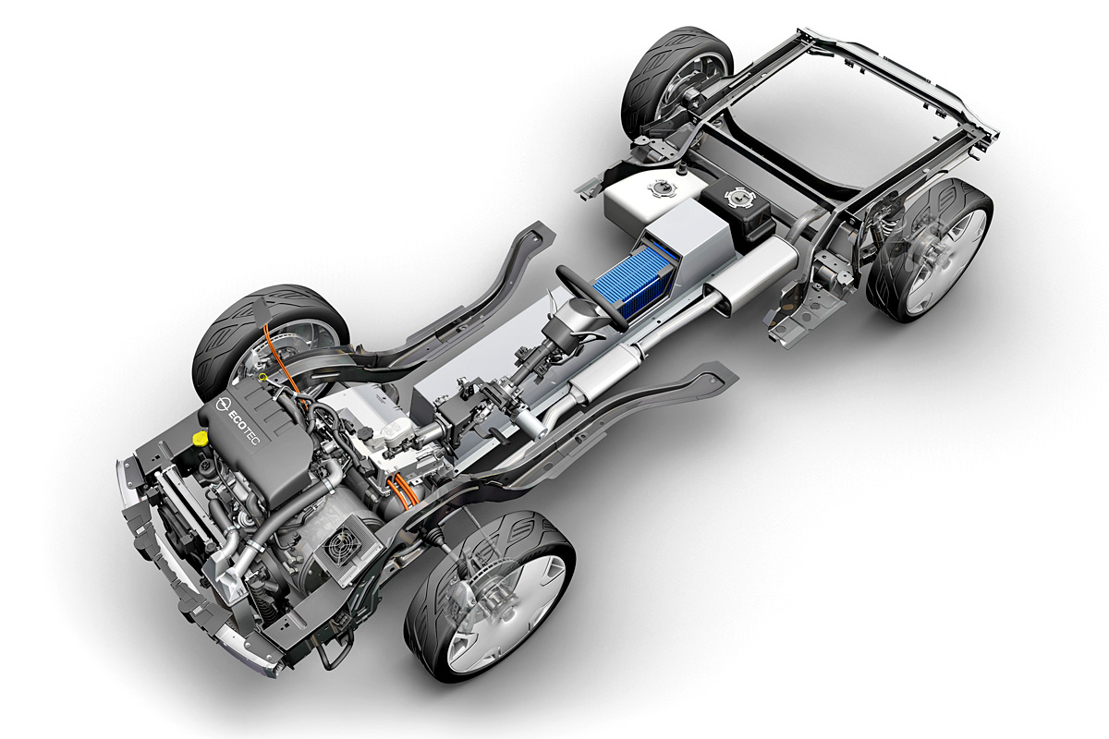
By
YOUSOUF BOUKRA
1700055
Submitted to the Faculty of Engineering
Automotive/Motorsport Department
University of Wales Trinity Saint David

An assignment for Alternative Powertrain Technology Module
March 2020.

Table of Content
1. Introduction 3
2. Hybrid Electric Vehicle: 3
3. Theoretical Application of Series Hybrid Technology: 4
3.1 Final Drive Ratio: 4
3.2 Electric motor: 5
3.3 Controller: 7
3.4 Generator: 8
3.5 Battery: 9
3.6 IC-Engine: 9
3. Cost Consideration: 10
4. Conclusion: 10
References 12

Table of Figures
Figure 1 Series Hybrid System (Ehsani, Gao and Miller, 2007). 4
Figure 2 EMRAX 228 CC Efficiency Map (emrax.com). 5
Figure 3 Off-Road Buggy, Power required curve Versus time (Yousouf, 2020). 6
Figure 4 EMRAX-228 Motor (emrax.com). 6
Figure 5 EMRAX-188 Twin Set-up (emrax.com). 7
Figure 6 EMRAX-228 Power and Torque Curves (emrax.com). 7
Figure 7 SD-100 Controller (evwest.com). 8
Figure 8 Controller's Specifications (evwest.com). 8
Figure 9 LG CHEM Battery (lgchem.com). 9
Figure 10 Emrax motors Prices (emrax.com). 10

Introduction
As a continuous paper of the previous report regarding the completion of an off-road buggy duty cycle, which was determined based on a designed track for the recreational and corporate entertainment sector. This part of the research will consider the implementation of a series hybrid system for the previously selected buggy, as requested by the company.
This research will investigate the suitable components needed for the conversion of internal combustion drive train, to hybrid drive train, which will be chosen with regards to the duty cycle spread sheet completed in part-1 and further revised in this part of the research.

Hybrid Electric Vehicle:
There are variety of methods to achieve an electric – internal combustion hybrid system. These multiple ways can be differentiated through the linkage of the electric and the combustion portions of the vehicle’s powertrain. The two major and commonly used ways of achieving an Electric-ICE hybrid design are through; series hybrids and parallel hybrids (Emadi and Eshani, 2000). In this research, only the series hybrid system will be considered as it is the method chosen for the application investigated here.
In a series hybrid technology, the combustion engine does not power directly the drive train, rather it drives the electric generator which is linked to the electric motor that powers the drive trains. This type of hybridisation provides a flexible advantage, due to the lack of mechanical connections between the wheels and international combustion engine. Series hybrids have better efficiency in comparison to parallel system in term of driving cycles that encompass of many stops and starts, such as buses, delivery vehicles, and city driving (Momoh and Omoigui, 2009).
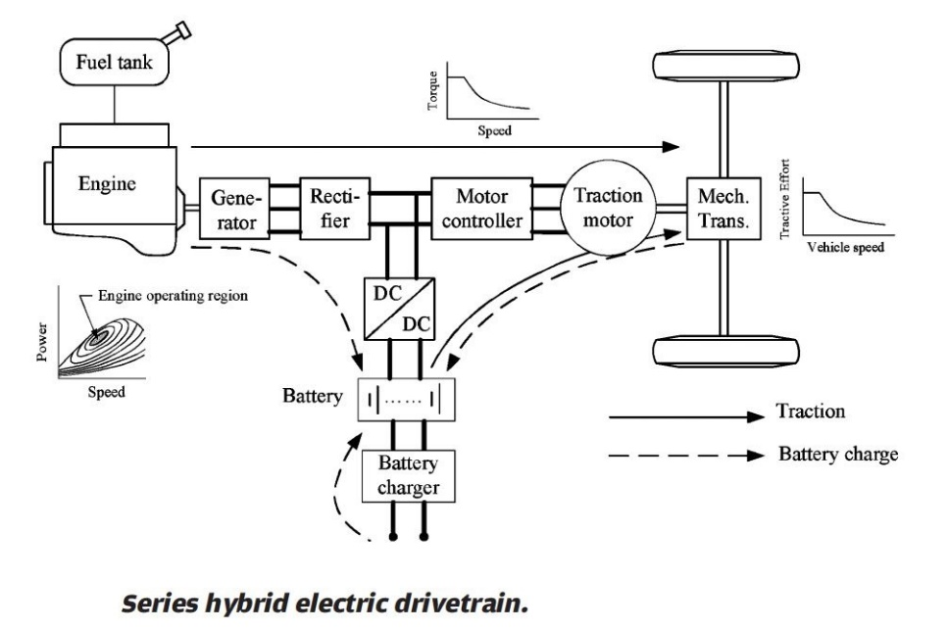
Similarly, Ehsani, Gao and Miller, 2007, described the series hybrids as advantageous technology due to the mechanical decoupling between the IC engine and the wheels. Furthermore, the electric motor offers a simplified single source of torque to the driven wheels, which is controlled by the speed controller. Figure-1 below demonstrates that the series hybrid system has a simple structure and drivetrain control and easy packaging of the engine, generator, motor, controller, and the storage system, as everything is connected through electric cables as indicated by Ehsani, Gao and Miller.
Figure 1 Series Hybrid System (Ehsani, Gao and Miller, 2007).
Another study conducted by Gutmann, 1999, stated that with series HEV, the equivalent zero emissions vehicle level of tail pipe emissions can be controlled. It was also highlighted that fuel consumption is not massively decreased compared to conventional ICE vehicles, if the performance is kept at the same level. Gutmann continued his discussion and indicated that the costs are considerably high, due to the high-power electric parts, in addition to a substantial increase in the overall vehicle weight. Meanwhile, the author trade-off revealed better emissions control for series hybrid systems, with higher efficiency and optimum performance level.
- Theoretical Application of Series Hybrid Technology:
In order to deploy the series hybrid technology within the buggy application studied in part-01 of this report, an electric motor, suitable controller, generator, and a storage system need to be identified. The scrutinising of these necessary components, will be detailed in the following section.

3.1 Final Drive Ratio:
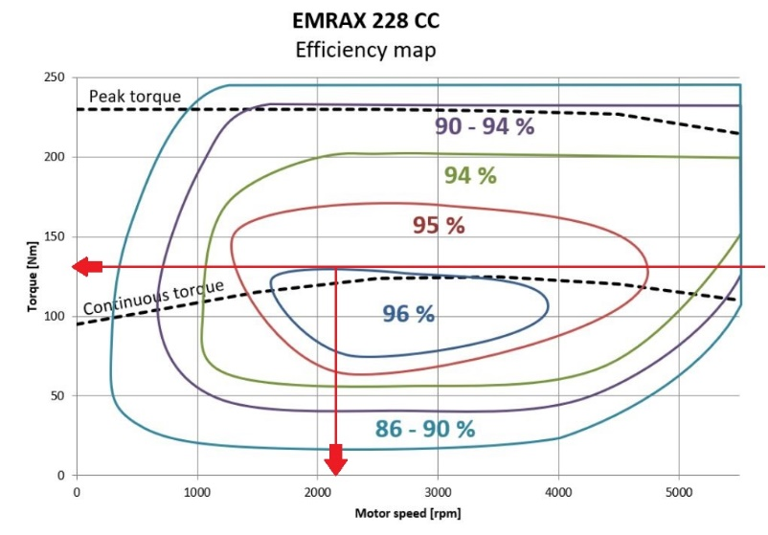
Calculating final drive ratio of the selected buddy, will be the first step towards implementing the hybrid series technology in the investigated application.
Figure 2 EMRAX 228 CC Efficiency Map (emrax.com).
Rolling Radius or Tire Radius (meter) | 0.32 m
Rolling Circumference (meter) | 0.32 x 2 x π = 2.01 m
Maximum Velocity on Track (meter per second) | 16 m/s
Drive Wheels revolution per second at Max Speed | 16 $÷$ 2.01 = 7.96 rev/s
Drive Wheels revolution per minute at Max Speed | 7.96 x 60 = 477.6 rpm
Based on the performance characteristics of the selected buggy, which are calculated and listed in the table above, supported with the motor efficiency map obtained from EMRAX supplier, the final drive can be found as follows:
Motor rpm at full efficiency $÷$ Max wheel rpm = 2200 $÷$ 477.6 = 4.6:1 = Final Drive Ratio

3.2 Electric motor:
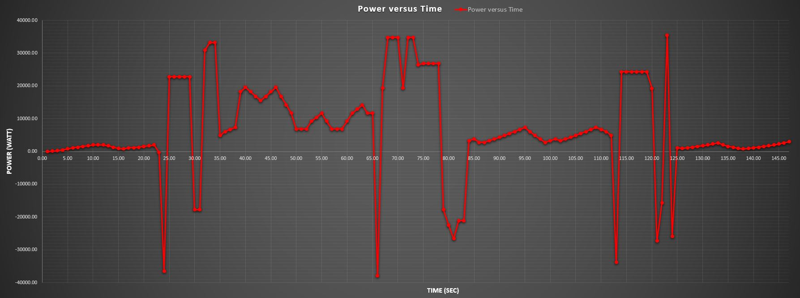
In order to choose the right motor to fit the application and deliver the required power, the drive-cycle spread sheet of the buggy around the designed track, which was established in part-01 of this study will be utilised.
Figure 3 Off-Road Buggy, Power required curve Versus time (Yousouf, 2020).
The power graph presented above, indicates that the maximum power curve required for the buggy during a complete lap is 3549watt (35.49 Kw), for a maximum period of 2 seconds. The graph also shows a certain section within the track where high power is required; 23kw for 5sec, 33kw for 3sec, 34kw for 4sec, and 24kw for 6sec. However, the average power required over one complete lap is 9.01kw.
EMRAX is the company which will supply the motor required for this hybrid buggy application. However, the supplier has a variety of motors which can meet the assigned requirement, but at different costs. The two suitable setups are described below:
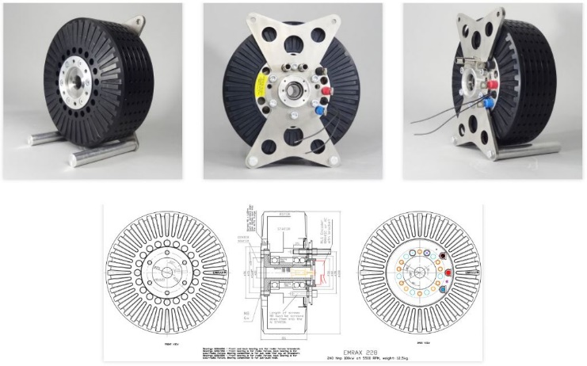
Option one: a single motor Emrax 228 capable to deliver 50kw continuous power and 96N.m continuous torque when it is Air-Cooled; and 62kw with 120N.m at Combine-Cooling (Air + Liquid Cooling System).
Figure 4 EMRAX-228 Motor (emrax.com).
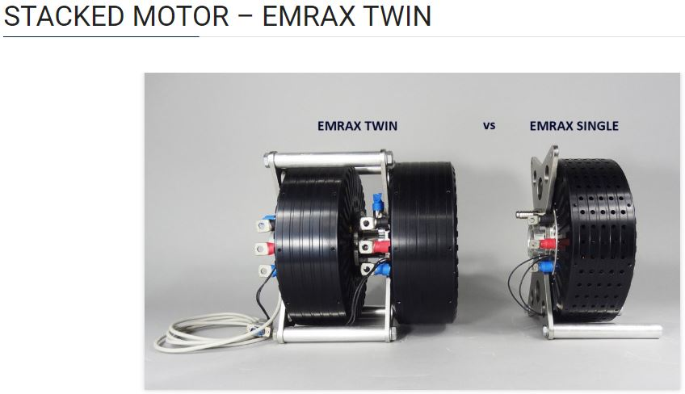
Option two: a twin stacked set-up, which combines two Emrax 188 motors. The twin set-up (both motors) is capable to deliver 46kw continuous power and 80N.m continuous torque when it is Air-Cooled.
Figure 5 EMRAX-188 Twin Set-up (emrax.com).
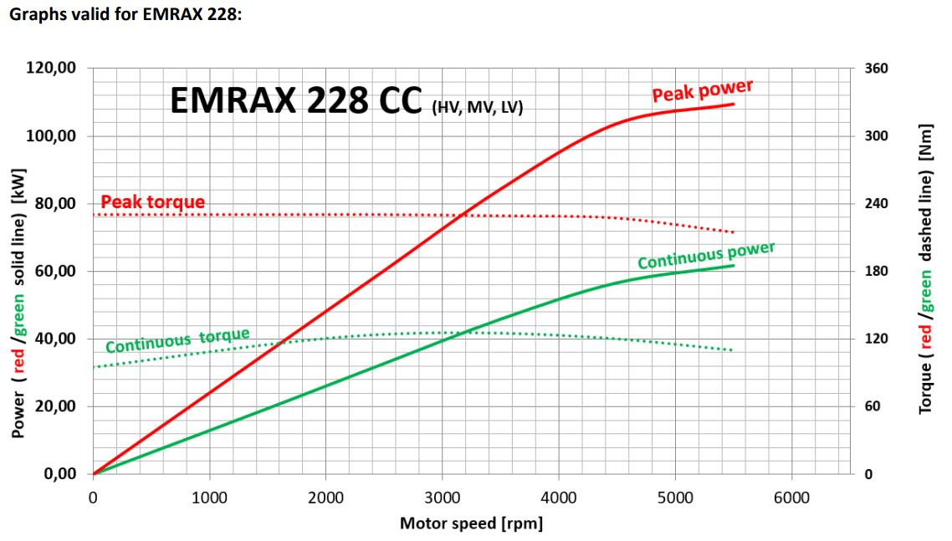
Both options are a perfect fit for the investigated case. However, Emrax 228, was the motor chosen for this application when comparing cost efficiency of both systems (more details discussed further down regarding cost efficiency).
Figure 6 EMRAX-228 Power and Torque Curves (emrax.com).
Figure-6 which was obtained from the technical data of EMRAX dynamometer test, emphasises that the motor 228 is capable to perform as declared above (50kw power and 96N.m torque) when coupled with an air-cooling system. Again, due to cost consideration the air-cooling system was chosen instead of the combined cooling system. The efficiency of the selected motor range between 92-98%, assuming that the efficiency is at its minimum, the power losses at the motor will be as follow:
50 x 0.08 = 4 kw (motor power losses).
Furthermore, the losses through the belt drive need to be conjointly considered. As mentioned by Dereyne et al, 2015, in the efficiency measurement campaign on belt drives. And by Waide and Brunner, 2011: the efficiency of a traditional belt drive (V-belt) is around 95% to 98% when its new and then drops to 93%, due to the higher friction forces. However, synchronous belts have a better efficiency than V-belt as they reach and maintain 98% efficiency (Gates corporation, 2020 [online]). Therefore, this last one will be installed for power transmission and the losses can be calculated as follow: 50 x 0.02 = 1 kw (Belt power losses).

3.3 Controller:
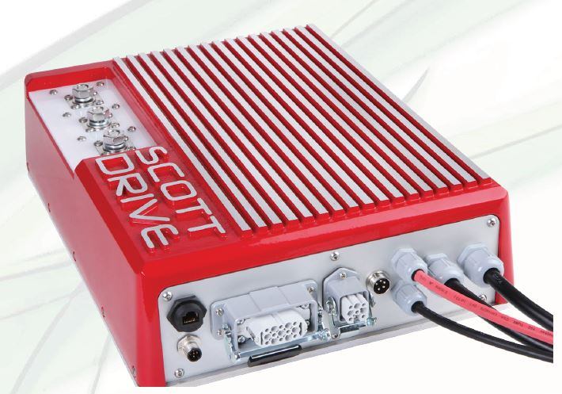

Figure 7 SD-100 Controller (evwest.com).

Scott-Drive-100 is the controller which has been chosen for this application to fit with EMRAX-228 motor, and it is obtained from EV-WEST supplier (evwest.com).
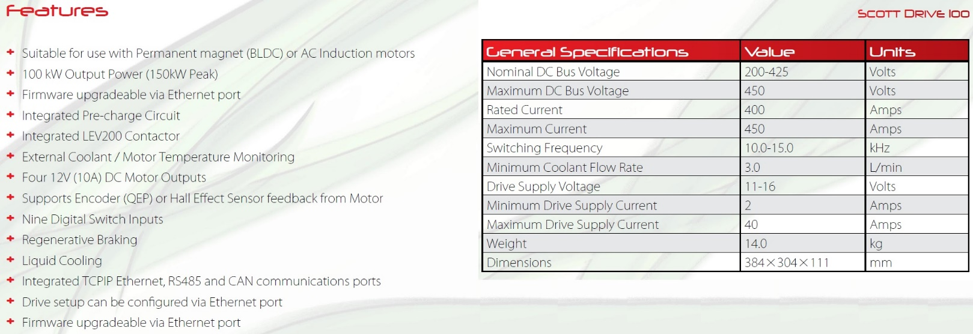
SD-100 controller is provided with an EPIC HD15 connector for all Analog and digital control inputs, which guarantee a full protection from both dirt and EMI (Electromagnetic Interference). The controller weighs 14kg which is slightly heavier compared to other suppliers, but it was selected because of its cost efficiency considering its high-performance capabilities which can be summarised in figure-8 below:
Figure 8 Controller's Specifications (evwest.com).
According to a recent article regarding motor controller’s performance and efficiency, a typical controller efficiency is around 95% (Laskay, 2015). From here the energy losses can be calculated and are: 50 x 0.05 = 2.5 kw (Controller power losses).

3.4 Generator:
Denso Motor Generator was chosen for the buggy application, Denso is a well-established company which supply systems for hybrid vehicle technology. The motor generator obtained from Denso is the component which will be used to convert the kinetic energy obtained from the combustion engine into electric power. The generator is also capable to convert the kinetic energy at braking to electric power, which will be stored at the battery system. The efficiency of the generator is around 95% as by the company specifications, thus, the generator will contribute to 2.5 kw of power lost during the operation.
The total losses which will be occurred within the application of series hybrid technology will be as follow:
4kw (motor) + 1kw (belt) + 2.5kw (controller) + 2.5 (generator) = 10kw (total power losses)
Therefore, the net energy which will be used from the 50kw EMRAX-288 motor is 40kw which will be enough to drive the buggy around the track as the maximum power needed is 35.49kw (based on the calculated drive cycle).

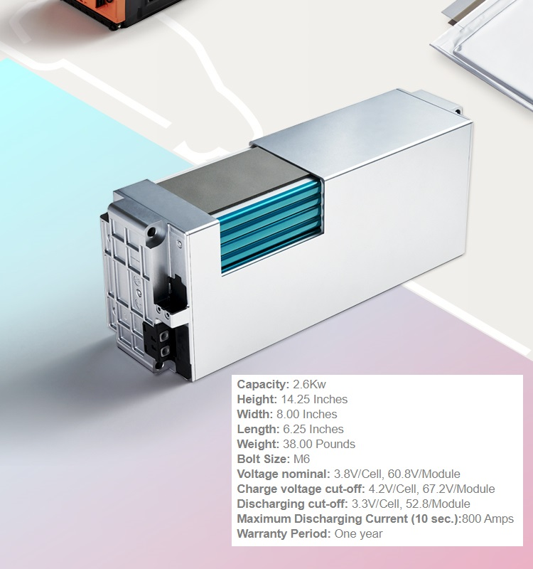
3.5 Battery:
Figure 9 LG CHEM Battery (lgchem.com).
For the energy storage system, LG-Chem automotive battery will be used. LG-Chem is a lithium-ion battery type which incorporates separator film for reinforced safety, the Nano-ceramic coating reinforces the durability and heat resistance of the battery cell units, battery specifications can be found in Figure-9 (lgchem, 2020 [online]).
Based on the battery specification above, the system needs 3 battery modules to reach a nominal voltage of 182.4 Volt, which will be enough to power the chosen motor that runs at 160 volts at maximum rpm. A single battery module weigh 17kg, which means the total storage system will weigh 51kg.

3.6 IC-Engine:
The 812cc 3-cylinder engine produced by Cherry automotive company, generates a maximum of 39kw at 6000rpm (StormBuggies, 2016). This engine is considered to be suitable for the series hybrid application due to its light-weight, in comparison to alternative 4-cylinder engines. The light weight of the engine will compensate for the additional hybrid system weight, specifically the heavy battery pack.

Cost Consideration:
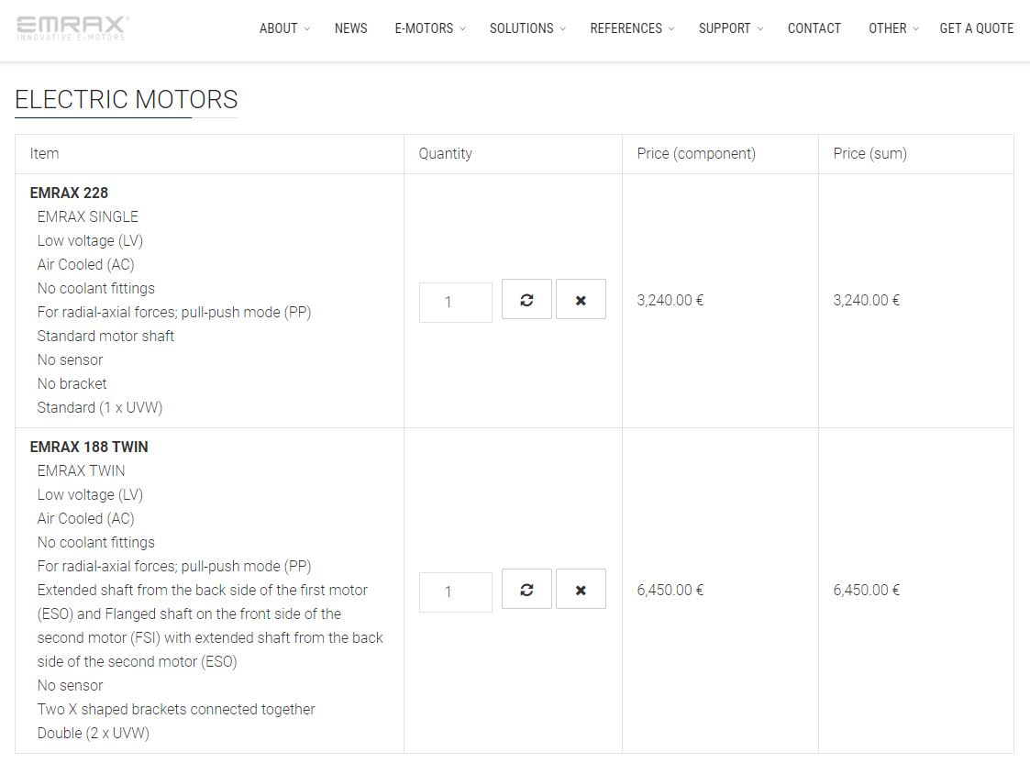
Choosing the most cost-efficient system was a requirement for the application of the series hybrid technology in the off-road buggy. Considering the motor, there were two options available from EMRAX supplier, which were previously discussed. The cost of both setups can be seen in the quote below which was requested directly from the supplier.
Figure 10 Emrax motors Prices (emrax.com).
The single Emrax-228 motor was chosen because it costs 33% less than the twin Emrax-188 set-up.
Both controller and energy storage system were supplied by EVWEST and their prices are highlighted below:
SD-100 Controller = £3887.
3 LG-Chem battery modules = £1752 (£584 each).

Conclusion:
To summarise, the application of the series hybrid technology in the off-road buggy encompassed the following parts:
- An EMRAX-228 motor delivering 50kw continuous power and 96N.m continuous torque.
- SD-100 controller which was obtained directly from EVWEST supplier.
- A motor generator obtained from DENSO.
- 3 LG-Chem lithium-ion battery to build the energy storage system.

References
DENSO (2020) Denso Motor Generator. Available at: https://www.denso.com/global/en/products-and-services/powertrain/pick-up/mg/ (Accessed: 10th March 2020).
Dereyne, S., Defreyne, P., Algoet, E., Derammelaere, S, and Stockman, K. 2013 ‘An efficiency measurement campaign on belt drives’, EEMODS.
Ehsani, M., Gao, Y, and Miller, J. 2007 ‘Hybrid Electric Vehicles: Architecture and Motor Drives’, IEEE Transactions on Vehicular Technology, 4(95), PP 719-728.
Emadi, A, and Eshani, M. 2000 ‘Aircraft Power Systems: Technology, State of the Art, and Future Trends’, IEEE Aerospace and Electronics Systems Magazine, 1(15), PP 28-32.
EMRAX (2020) E-MOTORS. Available at: https://emrax.com/e-motors/ (Accessed: 10th March 2020).
EVWEST (2020) LG CHEM Lithium Ion Battery. Available at: https://www.evwest.com/catalog/product_info.php?cPath=4&products_id=481&osCsid=kunl2hak096jtrritrmhrd5jj6 (Accessed: 10th March 2020).
EVWEST (2020) Scott Drive 100 AC Controller. Available at: https://www.evwest.com/catalog/product_info.php?cPath=1&products_id=293&osCsid=kunl2hak096jtrritrmhrd5jj6 (Accessed: 10th March 2020).
Gates Catalogue (2020) Synchronous Belts. Available at: https://www.gates.com/us/en/power-transmission/synchronous-belts.html (Accessed: 10th March 2020).
Gutmann, G. 1999 ‘Hybrid electric vehicles and electrochemical storage systems: a technology push-pull couple’, ELSEVIER Journal of Power Sources, 84, PP 275-279.
Laskay, D. 2015 ‘BLDC Motor Controllers … for Maximum Performance & Efficiency’, DDC Connectivity Power Control.
Momoh, O, and Omoigui, M. 2009 ‘An overview of hybrid electric vehicle technology’, IEEE Vehicle Power and Propulsion Conference, PP 1286-1292.
StormBuggies (2016) NEW 2016 JOYNER 800i SPORTS ROAD LEGAL BUGGY. Available at: https://www.stormbuggies.com/products/new-2016-joyner-800i-sports-road-legal-buggy/ (Accessed: 28th November 2019).
Waide, P and Brunner, C. 2011 ‘Energy-Efficiency Policy Opportunities for Electric Motor-Driven Systems’, International Energy Agency.

