LEVEL 4 ASSESSMENT SPECIFICATION

Student name: | PETAR ARTYUHOV | Student ID number: | 2123090
Programme: | BA (Hons) Business Management
Module: | Accounting fundamentals
Module code: | LCBB 4001 | Contribution to Overall Module Assessment (%): | 50%
Lecturer: | Isaiah Oino | Internal Verifier: | Eric Osei
Assignment Title: | Essay on Accounting fundamentals | Word count for report (or equivalent): | 2500 + 10%
Submission deadline: | 05/03/22 – 3pm | Return date of provisional marks & written feedback:
Submission method: | All written assessments, where practical and possible, must be submitted via Turnitin unless otherwise instructed by the Lecturer. (Please DO NOT put ther assessment specification into Turnitin or it will match many similarities with other students’ submissions.)  Alternative submission method (if applicable):  Late submission of the assessment will result in a late penalty mark. Penalties for late submission: Up to one week late, maximum mark of 40%. Over one week late, 0%. Only the Extenuating Circumstances Panel may approve a change to submission dates.
Academic honesty / referencing: | Academic honesty is required. In the main body of your submission you must give credit to authors on whose research and ideas your work is based. Append to your submission a reference list that indicates the books, articles, etc. that you have used, cited or quoted in order to complete ther assessment.

Table of Contents
Introduction 4
Answer 1. 4
a) Adjustment of the trial balance with the use of additional information 4
b) Preparation of Income statement 6
c) Preparation of balance sheet 7
Answer 2. 7
Discussion on various accounting principles 7
Consistency principle 7
Materiality Principle 8
Monetary unit principle 9
Going concern principle 9
Conclusion 10
References 11

Introduction
In this following assignment, a detailed analysis is prepared on the nature, behavior and purpose of the cost accounting in a company and focuses on the various applications of the cost accounting concepts, methods and techniques in the business operation. Along with that, the study also included basic principles related to accounting that included use of financial software that is used in today’s business environment. In addition, preparations of financial statements are also carried out with the use of initial data, understand the use of these statements, and develop an analysis.

Answer 1.

a) Adjustment of the trial balance with the use of additional information
Particulars | Debit (£) | Credit (£)
Finance Income | - | 4,000
Finance expense | 16,000 | -
Share Capital | - | 347,900
Bank | - | 2,000
Opening Inventory | 90,000 | -
Machinery at cost | 120,000 | -
Buildings at cost | 750,000 | -
Provision for Depreciation - Buildings | 32 500 | 100,000 +32 500
Provision for Depreciation – Machinery | 30 000 | 25,000 +30 000
Legal expenses | 7,000 | -
Heating and Lighting | 10,000 | -
Long Term Loans | - | 200,000
Rent and Rates | 24,780+322=28 000 | -
Prepaid Insurance | 17,520-16000 =1520 | -
Insurance | 16 000 | -
Postage and Stationery | 6,000 | -
Share Premium | - | 100,000
Sales Revenue | - | 900,000
Retained Profits | - | 50,000
Travelling Expenses | 5,000 | -
Motor Running Expenses | 8,700 | -
Salaries and Wages | 150,000 | -
Bad Debt | 4,000 + 1000 | -
Purchases | 560,000 | -
Revaluation Reserve | - | 100,000
Provision for bad debts | - | 3,000 + 1000
Taxation | 12,900 | -
Trade Receivables (debtors) | 400,000 | -
Trade Payables (creditors) | - | 350,000+3220 = 353 220
 | 2,181,900 | 2,181,900
 | 2 248 620 | 2 248 620

b) Preparation of Income statement
The preparation of income statement helps in knowing the various incomes and expenditures that took place during the business operation. The primary motive of preparing the income statement is that it helps in knowing whether the company is generating profits or losses. Below show the income statement of General Supplies Ltd for the year 2021(Charitou et al. 2018).
General Supplies Ltd
Income Statement
12 months ended 31 December 2021
Sales |  | 900 000
Opening inventory | 90 000
Purchases | 560 000
Closing inventory | - 125 000
Cost of sales |  | 525 000
Gross profit |  | 375 000
Expenses
Travelling Expenses | - 5 000
Heating and Lighting | - 10 000
Expenses
Rent and rates | - 28 000
Bad debt | - 5 000
Salaries and wages | - 15 0000
Insurance | - 16 000
Depreciations | - 62 500
Postage and Stationery | - 6 000
Motor running expenses | - 8 700
Legal expense | - 7 000
 | - 375 000
Total expenses |  | 298200
Operating profit | 76 800
Finance income | 4 000
Finance expense | 16 000
Profit before tax |  | 64 800
Taxation |  | 12 900
Net profit |  | 51 900

As per the above income statement, it can be established that the company has been able to earn a significant net profit at the end of the year. The company has been able to earn revenue of about 900000 in the following year and incurred cost of sales of about £ 525000 that comprises of opening inventory, purchases and closing inventory. Cost of sales in referred to the expenses that are being incurred for manufacturing of the products and services. Cost of sales plays a vital role in ensuring that company earns a handsome profit at the end of the year. Next, the various types of expenses are been mentioned that included depreciation cost, office expenses, travelling cost and many more (Sawyer, 2015).
These are the costs that are incurred during the course of the business, as companies needs to take keep certain budgets for smooth functioning of the business. Then the operating profit of £ 76800 is recorded along with the finance income and expenses amounted to £ 4000 and £ 16000 respectively. After adjusting it with the profit after subtracting the expenses Profit before tax is estimated at £ 64 800, after the tax of £ 12900 is subtracted from Profit before tax, the Net profit result in £ 51900 (Clausing, 2020).

c) Preparation of balance sheet
A balance sheet is prepared to display the financial position of the company at the end of the financial year. The statement reports on the assets, liabilities, and shareholder’s equity of the company (Campiglio et al. 2017).
General Supplies Ltd
Balance sheet Statement
12 months ended 31 December 2021

Non-current assets
Machinery 120 000-55 000 = 65 000
Buildings 750 000-132 500 = 617 500
Current Assets
Closing inventory = 125 000
Trade receivables 400 000- 4 000 = 396 000
Prepayments = 1 520
Total assets = 1 205 020

Equity and liabilities
Current liabilities
Bank 2 000
Trade payables 353 220
Equity
Share Premium 100 000
Share Capital 347 900
Revaluation reserve 100 000
Retained Profit 50 000 + (51 900 Net Profit)
Non-current liabilities
Long term loan 200 000
Total equity and liabilities = 1 205 020

Above show the balance sheet of the company, it established on the position of the assets and liabilities of the company at the end of the year. In the asset section, the depreciation are adjusted from the machinery and building. Along with that, retained earnings are also adjusted after valuing of thee income statement of the company and adding it with the earlier earnings. Overall, the statement displays a true and fair picture of the various liabilities and assets of the company that will help in taking crucial business decision in the coming financial year (Dichev, 2017).

Answer 2.

Discussion on various accounting principles
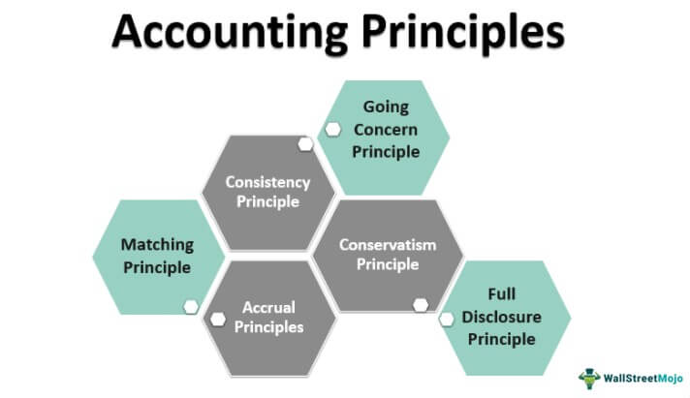
Figure 1: various accounting principles
(Source: Wall street Mojo, 2021)
Accounting principles are generally referred to as the set of guidelines that are usually followed by the companies while recording their financial data. There are several international organizations like the FASB (Financial Accounting Standards Board) that issues a standardization related to the practising of various accounting principles that is referred to as the GAAP (generally accepted accounting principles (Weygandt et al. 2019). The main objective of following the accounting principles is that companies are engaged in reporting their financial statements in much complete, consistent and comparable manner. This ensures that investors that are looking for potential investment can easily access the financial statements, use them for easy comparison between companies, and establish a trend analysis that can is easier for taking important business decisions (investopedia.com). The use of accounting principles can help in mitigating short terms and frauds through increasing transparency and early identification of any issues (Camfferman and Detzen, 2018). Some of the fundamental accounting principles that are included are given below,

Consistency principle
The adaptation of this principle is highly regarded as it helps a company to adopt an accounting principle that provides instruction to its accounting department, bookkeeper to record every financial information in a consistent method that can be used consistently moving forward (stewardingram.com). The use of this principle can be used in the line items of the various statements of the company that includes cash flow statement, balance sheet statement, profit and loss statement and accounts payable or accounts receivables accounts (Lyngstadaas and Berg, 2016).
The application of the consistency principle ensures that the information recorded in various statements is comparable and it will help in developing trends and extracting accurate information if needed. However, there are a few challenges that may be faced while implementing this principle is that when many individuals are involved in the recording of financial information in a company it becomes challenging but management must ensure that proper record-keeping procedures are followed that compiles with the standardization lay down by the GAAP (Bentley et al. 2018). Another challenge that is certainly encountered by the investors on analyzing the companies is that often companies tend to take advantage of the loopholes in the accounting reporting and manipulate the data to show a better position of the company. Few “accounting software” is used for ensuring that this principle is followed effectively in the recording of the information (Sela et al. 2015).
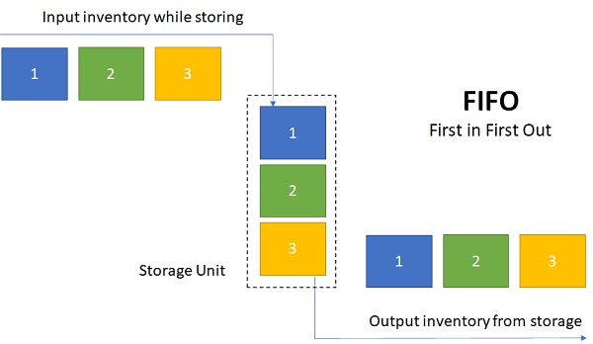
Figure 2: First In and First Out (FIFO)
(Source:Sfu.ca, 2021)
First In and First Out (FIFO) is one of the widely used accounting software that is developed for taking care of inventory management in a company. This cost flow assumption mechanism works by identifying the oldest cost of the inventory to come out first and the recent costs to stay in. The use of this mechanism helps in showing net income. A similar type of software Last In and First Out (LIFO) is where the recent cost of the inventory comes out first and the oldest costs stay in. The use of this mechanism helps in lowering the net income, which often helps the company to minimize the taxes. It is entirely up to the companies to choose any of the processes or can use them alternatively. However, often change in this to can create a complex situation and will not be useful for developing any analysis trend (Sembiring et al. 2019).
The advantage of this principle is that,
- It eases the auditing work of the third party. In fact, as per the guidelines of GAAP, an auditor can reject the statements if the consistency principle is not implemented.
- The use of this principle help in minimizing time consumption as the individuals are following one consistent way of reporting and that is why it does not involve training of individual in different ways.
- The most important use of this principle is that helps in developing trend analysis. The importance of trend analysis is immense for the companies as it helps in establishing comparison and taking crucial decisions for the company.

Materiality Principle
The concept of the Materiality Principle is based on an accounting principle that outlines the practices of the accountants on reporting as per the GAAP guidelines. However, it is also mentioned in that guideline that accountants can ignore differences in the accounting reporting that makes no sense and ignore rules. If the Materiality Principle is followed and found out that in certain cases the accounting principle is ignored, certainly, the net income of the company will not be affected (Torelli et al. 2020). The main point of implementing this principle is that if the amount of the transaction is small in terms of the higher transaction taking place in the company then it can be ignored. An example of the Materiality Principle concept can be, a customer payment of a company having net assets of 500 million got 100 dollars defaulted will not affect the company’s finances, however, if the default amount was 200 million then it would have affected the company (Giorgino et al. 2017).
The importance of this principle is that it allows the users to take an effective decision that makes the financial reporting more effective. The users that take financial decisions are related to the relevance of material information. The use of these principles also improves reliability. In case the financial statements do not include financial information completely then it will not offer a fairer picture of the company and will lose the reliability of the financial statements. For any business, it is important to understand materiality and immateriality factors that can help in maintaining the stability of the business (Machado et al. 2021). This concept is very crucial for businesses because understanding the concept of this principle helps in the application of practices that are set by the International Financial Reporting Standards (appvizer.com, 2021).

Monetary unit principle
The concept of the Monetary unit principle is based on the recording of the business transactions that are expressed in the currency form. Therefore, it can be established that a business should not record any non – quantifiable items, this can include, the quantity of customer service, employee skill level or the ingenuity of engineering staff. Along with that, the company also cannot record the monetary value of any kind of speech given to the customer or employees that can be related to engagement in innovative activities (Weygandt et al. 2018). With the inclusion of this concept in the business, the operation can help the users to easily acquire data and make an analysis of a company using the financial information provided in the monetary units. With this principle comparison between two companies becomes very easy and trend analysis can be made effectively. Along with that, the information that is recorded in the monetary units can be acquired by the users of a certain period and determine the profitability of the business, also can use for taking crucial business decisions for future endeavours (Jasinski et al. 2015).

Going concern principle
The term “Going concerned” in the accounting terms refers to the expected to operate for a foreseeable period or can be for at least 12 months. This concept is established under GAAP. For determination of the going concern is the primary responsibility of the owner of the company and understand whether the company will be able to operate in the foreseeable future. In case the business is found to be stable then the statements are prepared as per the going concern basis, the advantage of this is that it allows some prepaid expenses to get deferred until a later date. The role of the financial auditor plays a crucial role in this principle (Krasnov and Kozmenkova, 2017). A financial auditor is hired to understand and evaluate the financial statements to determine the stability of business operations.
With the implementation of this principle, companies can identify certain red flags beforehand. Some of the concerns can be the low current ratio of the company. The current ratio is referred to the relation between the Current Assets and Current Liabilities of the company. For any company the ideal current ratio should be more than 1, in case it is lower than 1 then it will indicate that the company does not have enough disposal of current assets that can pose a significant problem during the mitigation of any financial emergency (Nuryani and Sunarsi, 2020). Another red flag can be the inability to obtain a business loan from a financial institution can be due to low confidence shown by the lender to the company; this can be due to less credit score. Furthermore, if the company is losing out on experienced employees can pose a significant challenge for the company.
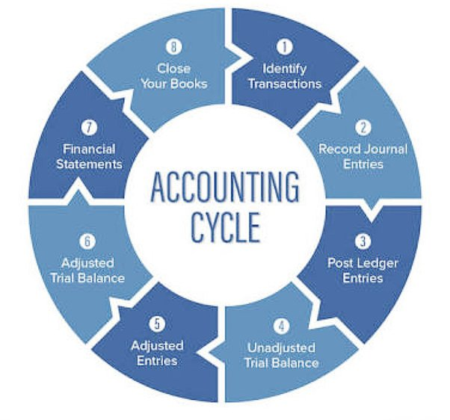
Figure 3: Accounting cycle
(Source: Scale factor, 2021)
The importance of accounting principles is immense in terms of investment; investors usually look for financial statements of the company to take an investment decision. The application of proper accounting standards will pose as a standardized model of doing business. If the companies are not following proper formats and presenting whatever format can lead to a fault and deceiving reporting practices. Therefore, companies must work on the implementation of accounting principles for better reporting and decision-making (Nikolova, 2016).

Conclusion
From the above-discussed study, it can be understood that effective implementation of accounting standards is very crucial for running any business. The right implementation of accounting principles that companies are engaged in reporting of their financial statements helps in developing a complete and comparable report that can be used for analysis and other evaluation. Investors that are looking for potential investments can easily access the financial statements, use them for easy comparison between companies, and establish a trend analysis that can be easier for taking an important investment decision.

References
Appvizer (2021).Retrieved from https://www.appvizer.com/magazine/accounting-finance/accounting/principle-of-materiality . (Assessed on 18/03/2022)
Bentley, J.W., Christensen, T.E., Gee, K.H. and Whipple, B.C., 2018. Disentangling managers’ and analysts’ non‐GAAP reporting. Journal of Accounting Research, 56(4), pp.1039-1081.
Camfferman, K. and Detzen, D., 2018. “Forging accounting principles” in France, Germany, Japan, and China: A comparative review. Accounting History, 23(4), pp.448-486.
Campiglio, E., Godin, A. and Kemp-Benedict, E., 2017. Networks of stranded assets: A case for a balance sheet approach. AFD Research Papers, 54.
Charitou, A., Floropoulos, N., Karamanou, I. and Loizides, G., 2018. Non-GAAP earnings disclosures on the face of the income statement by UK firms: The effect on market liquidity. The International Journal of Accounting, 53(3), pp.183-202.
Clausing, K.A., 2020. Profit shifting before and after the Tax Cuts and Jobs Act. National Tax Journal, 73(4), pp.1233-1266.
Dichev, I.D., 2017. On the conceptual foundations of financial reporting. Accounting and Business Research, 47(6), pp.617-632.
Giorgino, M.C., Supino, E. and Barnabè, F., 2017. Corporate disclosure, materiality, and integrated report: An event study analysis. Sustainability, 9(12), p.2182.
Investopedia .Retrieved from https://www.investopedia.com/terms/a/accounting-principles.asp . (Assessed on 18/03/2022)
Jasinski, D., Meredith, J. and Kirwan, K., 2015. A comprehensive review of full cost accounting methods and their applicability to the automotive industry. Journal of Cleaner Production, 108, pp.1123-1139.
Krasnov, V.D. and Kozmenkova, S.V., 2017. Going concern principle: The essence and economic conditionality. International Accounting, 20(19), pp.1147-1162.
Lyngstadaas, H. and Berg, T., 2016. Cash Flow and the Consistency Principle in Working Capital Management Calculations. Journal of Applied Management Accounting Research, 14(2), p.65.
Machado, B.A.A., Dias, L.C.P. and Fonseca, A., 2021. Transparency of materiality analysis in GRI-based sustainability reports. Corporate Social Responsibility and Environmental Management, 28(2), pp.570-580.
Nikolova, G., 2016. On Accounting Principles In The Context Of The New Accounting Law. Journal of Academic Research in Economics (JARE), 8(2), pp.191-218.
Nuryani, Y. and Sunarsi, D., 2020. The Effect of Current Ratio and Debt to Equity Ratio on Deviding Growth. JASa (Jurnal Akuntansi, Audit dan Sistem Informasi Akuntansi), 4(2), pp.304-312.
Sawyer, T.Y., 2015. Cost of Sales and Marketing Model: Calculate the Cost of Doing Business. In Financial Modeling for Business Owners and Entrepreneurs (pp. 127-155). Apress, Berkeley, CA.
Sela, I., Ashkenazy, H., Katoh, K. and Pupko, T., 2015. GUIDANCE2: accurate detection of unreliable alignment regions accounting for the uncertainty of multiple parameters. Nucleic acids research, 43(W1), pp.W7-W14.
Sembiring, A.C., Tampubolon, J., Sitanggang, D. and Turnip, M., 2019, November. Improvement of inventory system using first in first out (FIFO) method. In Journal of Physics: Conference Series (Vol. 1361, No. 1, p. 012070). IOP Publishing.
Steward ingram. Retrieved from https://stewardingram.com/what-is-the-consistency-principle/ . (Assessed on 18/03/2022)
Torelli, R., Balluchi, F. and Furlotti, K., 2020. The materiality assessment and stakeholder engagement: A content analysis of sustainability reports. Corporate Social Responsibility and Environmental Management, 27(2), pp.470-484.
Weygandt, J.J., Kieso, D.E., Kimmel, P.D., Trenholm, B., Warren, V. and Novak, L., 2019. Accounting Principles, Volume 2. John Wiley & Sons.
Weygandt, J.J., Kimmel, P.D. and Kieso, D.E., 2018. Financial Accounting with International Financial Reporting Standards. John Wiley & Sons.

