A comparison of the marketing methods of two multinational hotel brands.
Sabrina Manuela Janicka
2239817
Marketing Essentials BMIH4005
Gayathri Mudiyanselage
Written Essay (1500 words -/+ 10%)

The purpose of this essay is to compare the marketing methods of two multinational brands. In this essay marketing methods of Six Senses and Holiday Inn will be compared. Six Senses is a self-sustainable luxurious hotel mainly situated in exotic locations outside of UK such as Fiji and Singapore. Whereas Holiday Inn branches are mostly situated within the UK including several branches in cities such as Edinburgh and London. Holiday Inn is more affordable and accessible than Six Senses. Holiday Inn uses strategies that are more appealing to businessman, couples or families with children whereas Six Senses is appealing more to wealthy customers that are more attracted to organic and self-sustainable hotels and people who are looking for a once a lifetime experience (Saglam,2021 and Six Senses, 2019).Various frameworks such as SWOT & PESTLE, the Marketing Mix and Similar web tool will be used in order to compare the marketing methods of two different brands.
SWOT analysis has been used in order to examine the strengths and weaknesses of both hotels. It also aims to examine the opportunities and threats of the brands. Table has been added to appendix 2.
PESTLE analysis has also been used for the comparison, which looks at factors such as political, economic, sociocultural, technological, legal and environmental in order to compare two brands.
Brexit has had a very big impact on the political factor of hotel industry. It has affected hotels such as Holiday Inn and Six senses. It has impacted the flow of international tourists and businessmen which has decreased the demand for both hotels.
One of the economic factors which affected Holiday Inn and Six Senses was covid 19. It has affected the whole hospitality sector worldwide including hotels. It has caused a huge drop in revenue due to the restrictions and lockdown. Brand reputation and change in trends can also have a negative impact on both hotels.
Technological advancements and change of trends can have a positive and negative impact on sociocultural factor for Holiday Inn and Six Senses. Travel behaviour can also be affected by growth and aging of population. (Stainton,2019)
Privacy concerns and data protection can be affected while using technology within the hospitality sector. Both Holiday Inn and Six Senses hotel should invest in cybersecurity in order to protect their customers privacy. Breach of data protection can have a very negative impact on each of the hotels. (Holiday Inn hotels hit by cyber-attack, 2022)
Covid 19 has had a huge impact on the legal side of hospitality sector, both Six Senses and Holiday Inn have been affected and it has caused laying off staff and applying for government assistance during the pandemic.
Environmental factors such as consumption of high amount of water and electricity can have a very negative impact on Holiday Inn and Six Senses. Investing in obtaining LED lights and using eco-friendly products can be very beneficial for both hotels. Self-sustainability is a money and environment saver. (blogmarketing9113BC_10.3,2019)
According to the SWOT and PESTLE analysis it has come to our attention that even though the brands are very different, Holiday Inn is a traditional hotel and Six Senses is a self-sustainable hotel, from the Political, Legal and Threats perspective both brands are facing very similar issues. Even though they are very similar they can differ due to the locations of the hotels. For example, Six Senses hotel will be more affected by climate change than Holiday Inn because it is a holiday resort and there will be less customers if there is a climate change whereas business trips are not very often postponed or cancelled due to climate change. Both brands have been affected negatively by covid 19 and Brexit.
The marketing mix has become a dominant framework used in marketing, originally founded in the 1960s. For Brands such as Holiday Inn and Six Senses an extended marketing mix is used. It is comprised of 7ps. (Product, Price, Place, Promotion, People, Process and Physical Evidence. It has been used for the comparison of each brand.
A comparison table has been added to the appendix 1.
According to the marketing mix both hotels use similar advertising and booking techniques. The location and prices differ. The décor and physical experience also differ. Six senses décor is very antique and luxury whereas Holiday Inn take pride in their modern décor and cleanliness. Six Senses owner is very strict with employees and gives them the best opportunities for development. (Bing, n.d.) Six Senses hotel takes pride in creating a very luxury and sustainable nature themed experience whereas Holiday Inn’s goal is to create a welcoming and homelike feeling for their customers. The two brands use two different strategies and assumptions have been confirmed. Six Senses hotel is using strategies to target wealthy and clients who are attracted to self-sustainability whereas Holiday Inn is targeting customers who are interested in accessibility and affordability and mainly attract customers with discounted prices and packages.
According to the similar web analysis Holiday Inn is used more in the United Kingdom and the United States rather than Six Senses whereas in countries such as Spain, France and China Six Senses is used more. From the demographical point of view, there are more male customers visiting Six Senses hotels and more female customers visiting Holiday Inn. The largest percentage of customers for both hotels are within the age range from 25-34. According to the charts, younger population from the age of 18-44 are most likely to visit Six Senses hotels rather than Holiday Inn whereas the older population from the age of 44-65+ are most likely to use Holiday Inn. (SimilarWeb,2023)
Evidence added to appendix 3 – 10.
Similar web tool also analyses and compares the website performance and traffic, social platform usage as well as marketing channels usage. The findings identified using the similar web tool can be linked to the findings from marketing mix and are very similar to each other.
Bowman’s strategy clock has been used to compare the two brands. Please refer to appendix 13. According to the strategy clock, the two brands are on two separate sides of the clock with Holiday Inn being a number 2 which is low priced and Six Senses a number 6 risky high margin. Other brands such as Ibis and Travelodge which are classed as competition for Holiday Inn and Marriot which can be classed as a comparison for Six Senses hotel.
A perceptual positioning map has also been used for comparison. Table has been added to appendix 14.
After completing various marketing checks, initial thesis has been found true and accurate. The main points that have been discovered are as follow; both brands are owned by InterContinental Hotels Group Plc which is a British owned multinational hospitality company. Holliday Inn is targeting people on a lower income and mostly used but not limited for business trips or short stay holidays for couples or families. It is mostly used in the United States and United Kingdom. Six Senses Hotels are self-sustainable and located in exotic locations. It is targeting first class costumers looking for a once a lifetime experience. Most likely male customers in the age range from 25-34 are most likely to use Six Senses whereas more women in the same age range are most likely to visit Holiday Inn. Both hotels use social media platforms such as Facebook, YouTube and Instagram etc but Facebook has had a bigger impact on customer traffic of Holiday Inn rather than Six Senses. Also, Holiday inn has been using display ad companies more frequently than Six Senses. It has also been concluded overall that both hotels are advertising their services on social media platforms, their formal websites and using third party travel agencies as well as still using traditional advertising such as billboards and posters. Six Senses is using strategies to target people that are on a high income looking for a luxurious experience and might advertise their services in magazines or expensive or similar third-party companies such as airlines, restaurants etc. Six Senses hotels are in tourist locations and are using luxurious décor, organic products and the most beautiful locations to attract costumers whereas Holiday Inn is using strategies to target people on a lower income that are looking for something affordable and easy to get to locations. Most of the hotels are near airports and city centre. They are using strategies such as special packages, discounts and deals that will attract families or businessmen or women, they are advertising special deals such as kids stay and eat free. The décor also has a very big impact on customer traffic, they are trying their very best to create a feeling at home atmosphere. Holiday inn is very affordable and almost cheaper than paying actual rent. It should be highlighted that Six Senses and Holiday Inn are not in competition because they target different groups of people. The closest competition for Holiday Inn would be Travelodge and Ibis whereas for Six Senses it would be Four Seasons, Hyatt, Mandarin oriental etc.

Six Senses (2019). Luxury Resorts, Five Star Hotels, Luxury Spa Resorts | Six Senses. [online] Sixsenses.com. Available at: https://www.sixsenses.com/en.
Six Senses (2019). Luxury Resorts, Spa Escapes - Six Senses About Us. [online] Sixsenses.com. Available at: https://www.sixsenses.com/en/about-us.
IHG. (n.d.). Holiday Inn® Hotels | Book Family Friendly Hotels Worldwide | Official Site. [online] Available at: https://www.ihg.com/holidayinn/hotels/us/en/reservation.
HowandWhat.net (2019). SWOT analysis of Holiday Inn. [online] howandwhat. Available at: https://www.howandwhat.net/swot-analysis-holiday-inn/.
IHG Development. (n.d.). Six Senses. [online] Available at: https://development.ihg.com/hotel-brands/six-senses.
Saglam, B. (2021). Interview: The Story of Six Senses. [online] Travelinsightpedia. Available at: https://www.travelinsightpedia.com/interview-the-story-of-six-senses.
Mawji, F. (2023). Hospitality industry impacted by the cost of living crisis. [online] IBB Law. Available at: https://www.ibblaw.co.uk/insights/hospitality-cost-of-living.
‌ Makortoff, K. (2020). Holiday Inn hotel group revenue falls as Covid-19 keeps people at home. The Guardian. [online] 23 Oct. Available at: https://www.theguardian.com/business/2020/oct/23/holiday-inn-hotel-group-sees-revenue-fall-as-covid-19-keeps-people-at-home.
Stainton, H. (2019). Social impacts of tourism. [online] Tourism Teacher. Available at: https://tourismteacher.com/social-impacts-of-tourism/.
Zigu (2018). Holiday Inn SWOT Analysis | Competitors & USP | BrandGuide | MBA Skool-Study.Learn.Share. [online] MBA Skool-Study.Learn.Share. Available at: https://www.mbaskool.com/brandguide/tourism-and-hospitality/2170-holiday-inn.html.
Holiday Inn hotels hit by cyber-attack. (2022). BBC News. [online] 6 Sep. Available at: https://www.bbc.co.uk/news/technology-62814943.
SimilarWeb (2023). SimilarWeb Identity. [online] secure.similarweb.com. Available at: https://pro.similarweb.com/#/digitalsuite/websiteanalysis/audience-demographics/.
Saglam, B. (2021). Interview: The Story of Six Senses. [online] Travelinsightpedia. Available at: https://www.travelinsightpedia.com/interview-the-story-of-six-senses.
blogmarketing9113BC_10.3. (2019). Six Senses Marketing Strategy. [online] Available at: https://sixthsense513094188.wordpress.com/2019/10/06/six-senses-marketing-strategy/.
Bing. (n.d.). six senses staff training opportunities. [online] Available at: https://www.bing.com/search?q=six+senses+staff+training+opportunities&qs=NW_XFC&pq=six+senses+staff+training+opport&sc=1032&cvid=C233B10D01A84E28A88D25A178344A0A&FORM=QBRE&sp=1&ghc=2&lq=0 [Accessed 17 May 2023].
amplifyxl.com. (2022). The Holiday Inn Target Market: Who’s Their Ideal Customer? | AMPLIFY XL. [online] Available at: https://amplifyxl.com/holiday-inn-target-market/ [Accessed 17 May 2023].
PRODUCT – Holiday Inn offers a variety of comfortable and affordable rooms, with amenities such as plasma tv’s and free Wi-Fi. Holiday Inn also offers facilities such as meeting rooms, restaurants, fitness suites and swimming pools. | PRODUCT – Six Senses offers luxurious accommodations that offer guests a unique experience. These hotels are well known for their self-sustainability, sun harvesting and use of organic products for the spa and kitchens. It offers amenities such as spa facilities and fine dining options.
PRICE- Holiday Inn offers competitive prices based on the quality of accommodation and service. They offer a variety of rate options such as normal rates, extended stay discounts and seasonal rates. | PRICE – Six Senses have established themselves as premium luxury accommodations with prices reflecting their exceptional experience they offer. Price rates vary depending on room types and packages as well as additional costs for additional facilities such as spa treatments.
PLACE- Holiday Inn is strategically placed in cities and tourist locations across the UK and United States. Holiday Inn is placed in locations near to the airports, city centre and tourist attractions. It has been made as easily accessible as possible to attract customers. | PLACE – Six Senses hotels are in locations around the world such as Fiji and Vietnam. They choose the locations that accentuate their natural beauty and are known for its heritage. The main goal of Six Senses is to offer the customers a tranquil and calm experience.
PROMOTION – Holiday Inn employs a variety of online advertising strategies to reach its target audience. This includes marketing through websites, social media platforms and travel agencies. They also use and explore traditional advertising such as billboards and print media distribution. In addition, Holiday Inn also work in partnership with different airlines and travel agencies and offer package deals and promotions. | PROMOTION – Six Senses hotels take a multi-channel approach to advertising. They focus on digital marketing through websites, social media platforms and third-party agencies. They may also target their costumers by advertising in luxury magazines, special events and world class travel agencies.
PEOPLE- Holiday Inn takes customer service very seriously. The staff is well trained to make sure that the customers have a peaceful and memorable stay. Their focus is on hiring acknowledgeable, friendly and attentive members of staff. | PEOPLE- Six Senses hotels pride itself on employing talented and personable staff who provide a memorable experience for guests. Employees complete an extensive training in hospitality and sustainability as well as beauty treatment to make sure they can satisfy customer needs.
PROCCESS- Holiday Inn is focused on providing their guests with a seamless and efficient reservation process. They offer online booking through their website, mobile app and other third-party booking platforms. | PROCESS – Six Senses hotel is focused on providing guests with a seamless and personalised experience. They offer online booking through their website and have a dedicated booking team to assist with any customer enquiries. They also have excellent concierge service and easy and quick check in, check out service.
PHYSICAL EVIDENCE – Holiday Inn hotels strive to provide their guests with a warm and welcoming experience. They ensure their facilities are well always maintained and clean. The premises décor is very modern and appealing to the public. | PHYSICAL EVIDENCE – Six Senses hotels are known for their stunning architecture and interior design. The main goal is to create a sustainable, luxury and inspired by nature atmosphere.
Appendix 1 Marketing Mix Analysis
Holiday Inn Six Senses

Appendix 2
Holiday Inn Six Senses
according to IHG formal website, the main strengths of Holiday Inn are as follow; Holiday Inn is a hotel chain first founded in 1952 by Kemmons Wilson. As of 2018 it has 1,100 locations including areas in the heart of City Centre and near the Airports. This is very beneficial to customers as the hotel is very accessible and affordable. Holiday Inn is one of the best hotel options for short stays, business trips and family gatherings. (Wikipedia, 2023) (IHG, n.d.) | the main strength of Six Senses hotel is that it is a self-sustainable hotel which uses organic products for the spa’s as well as the food. Harnessing of the sun takes place in sites such as Vietnam. Each site has its own organic garden which provides the resorts with fresh herbs, vegetables and fruit. It is very well known for its Heritage and self-sustainability. The hotels operate in 20 countries and there are 3350 employees working within the company. (Saglam, 2021)
according to Trustpilot the main weakness of Holiday Inn hotels is the customer service, there has been many bad reviews due to poor communication and lack of English spoken by the customer service. (HowandWhat.net, 2019) | the main weakness of Six Senses hotel is that it’s very expensive, and due to increase in cost of living, it is not accessible nor affordable to any kind of customers. Six senses visit is a once a lifetime opportunity only. It is very less likely that the same customers will come back to visit. (Mawji, 2023)
the main area for opportunities for Holiday Inn could be improving customer service, investing more money in employees to make sure that the customers have the best experience possible. This will help them keep existing customers and gain new ones. Expansion of premises would be also beneficial for Holiday Inn because customers are always attracted to new destinations. (Zigu,2018) | the area for opportunities expanding into new areas within the emerging market can help capture a larger group of customers. It will be very beneficial for six senses to collaborate and work in partnership with different luxury brands. (IHG Development, n.d)
the main threat for Holiday Inn was covid-19 which caused a huge decrease in earnings due to customers not being able to travel. Another present treat would be a huge number of competitors such as Travelodge. (HowandWhat.net, 2019 and Makortoff.2020) | the main threats for Six senses hotel would be distributions such as pandemics, international lockdowns and increase in cost of living around the world.

Appendix 3
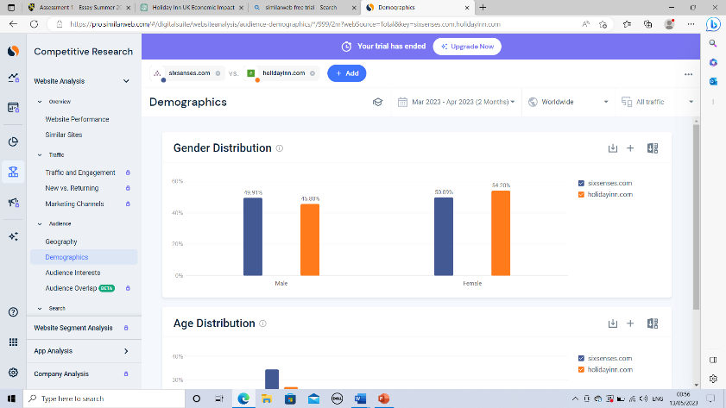

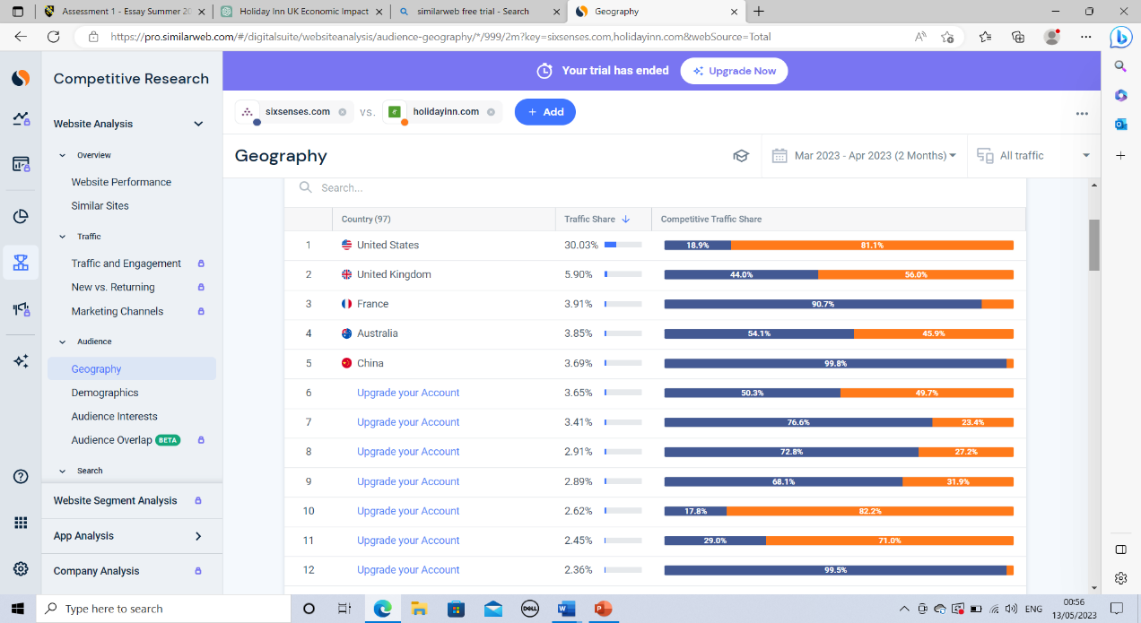
Appendix 4

Appendix 5
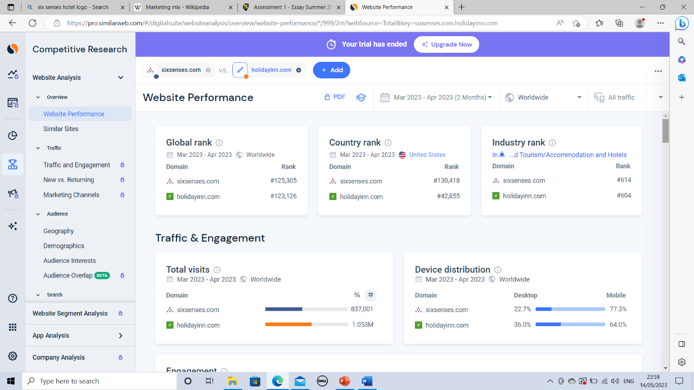
Appendix 6
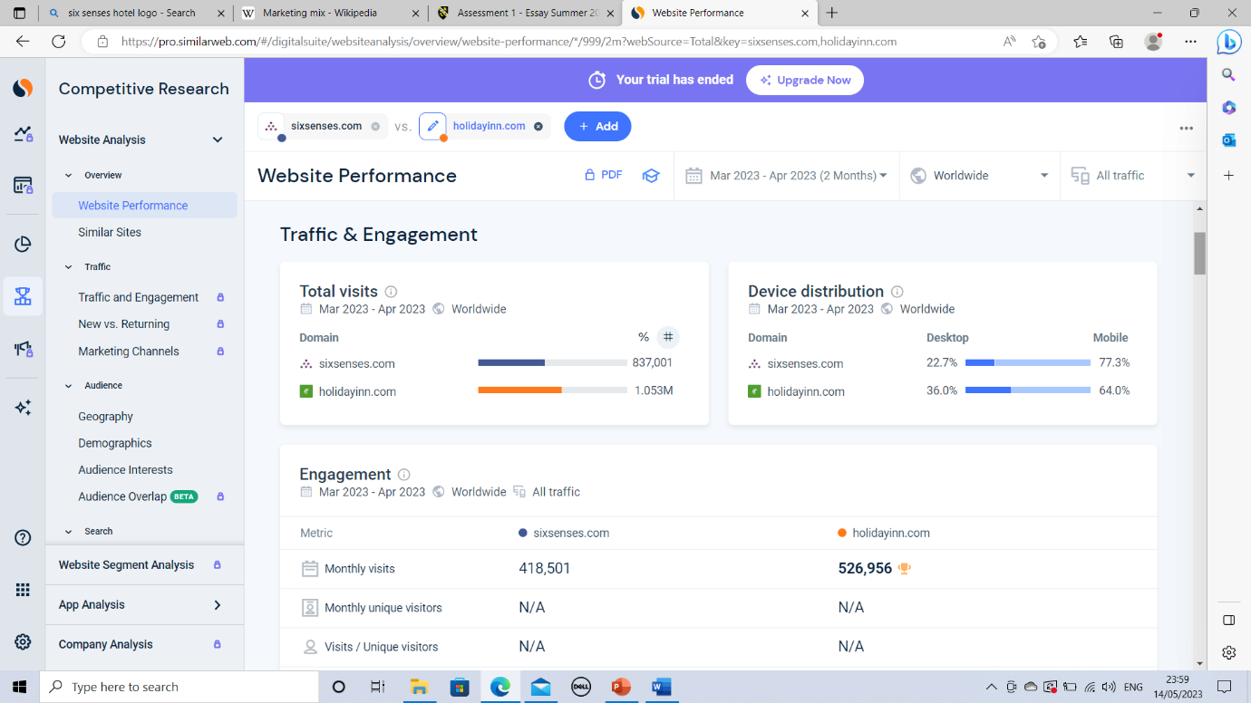
Appendix 7
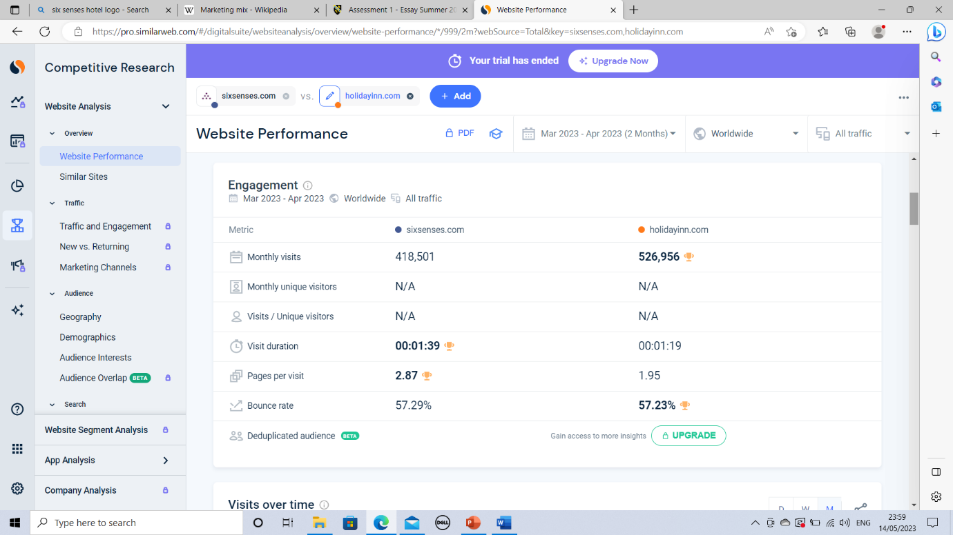
Appendix 8
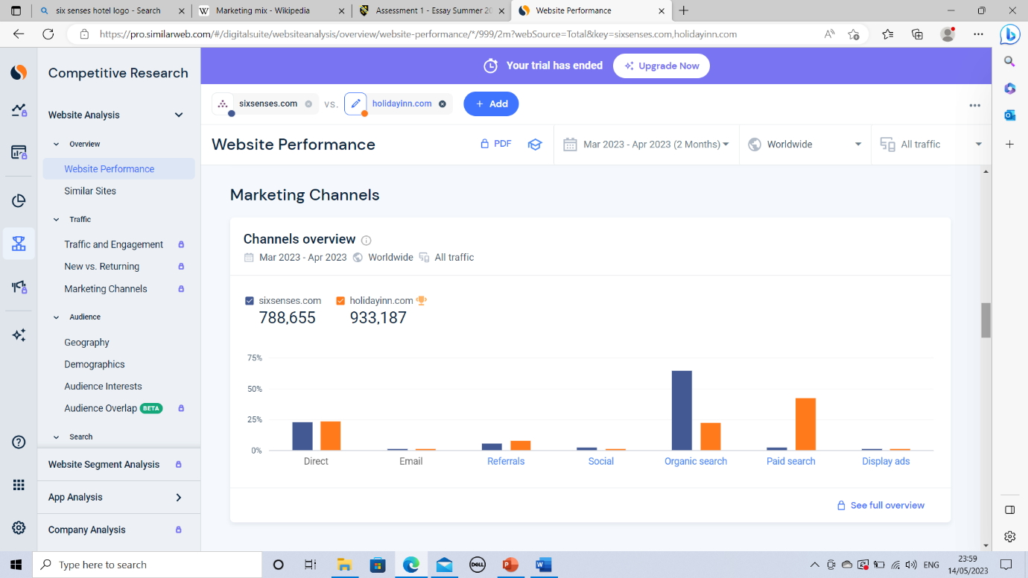
Appendix 9
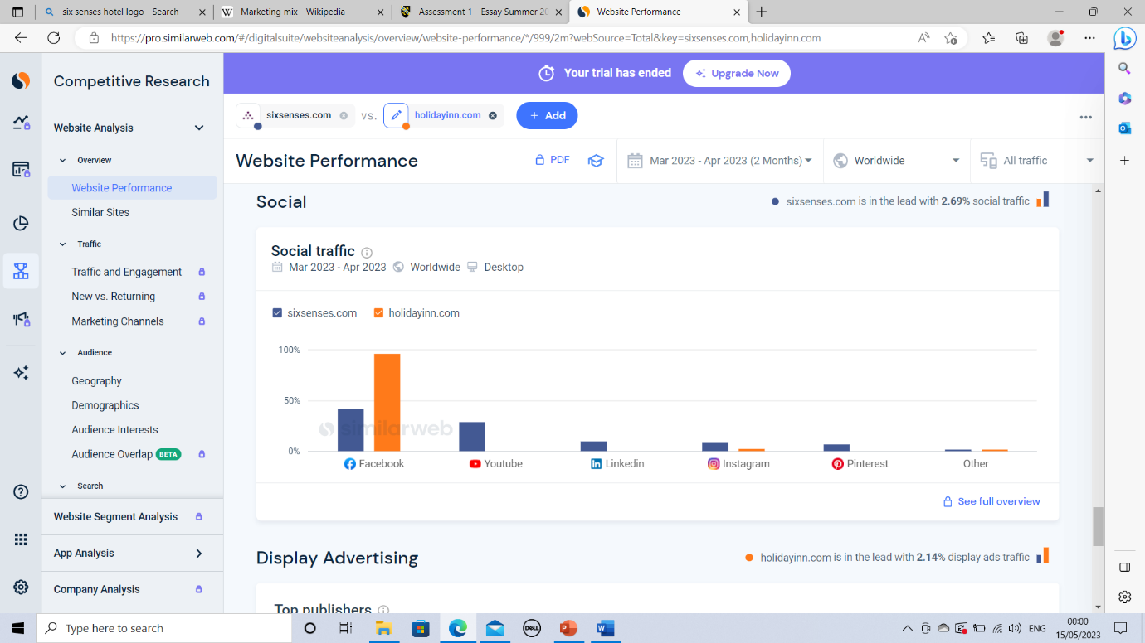
Appendix 10
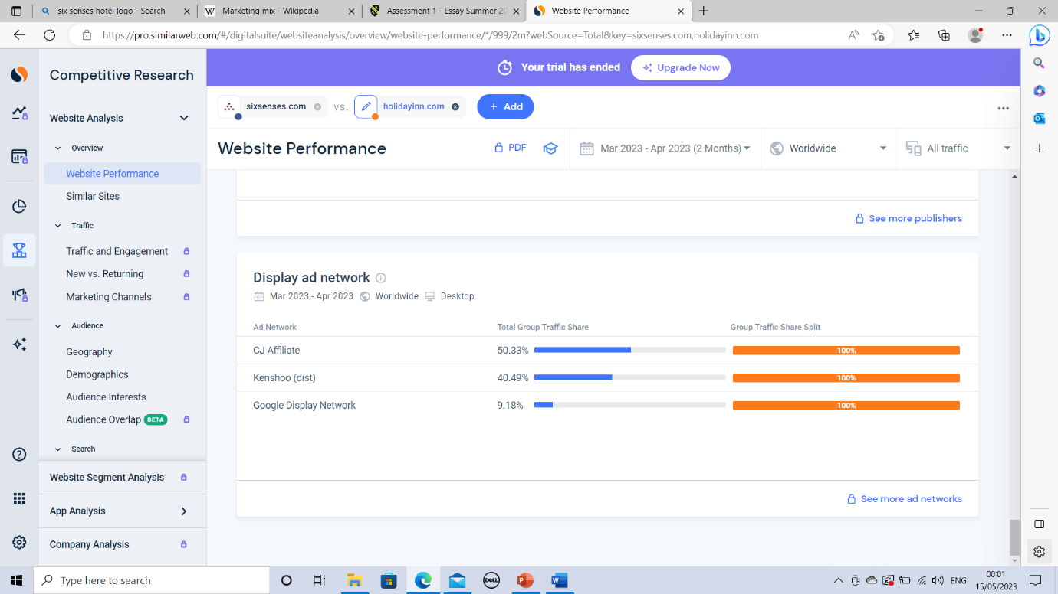
Appendix 11 Appendix 12
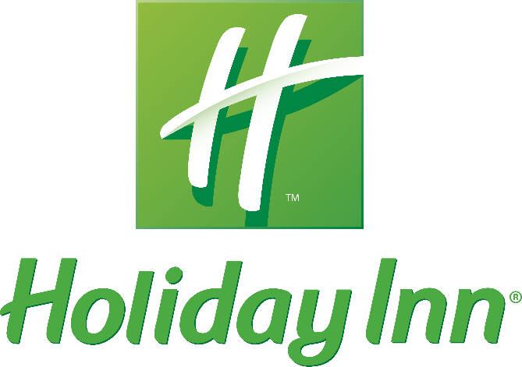
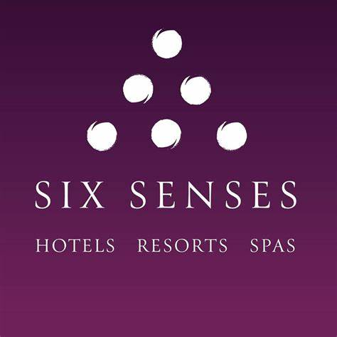

Appendix 13


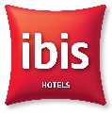

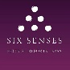
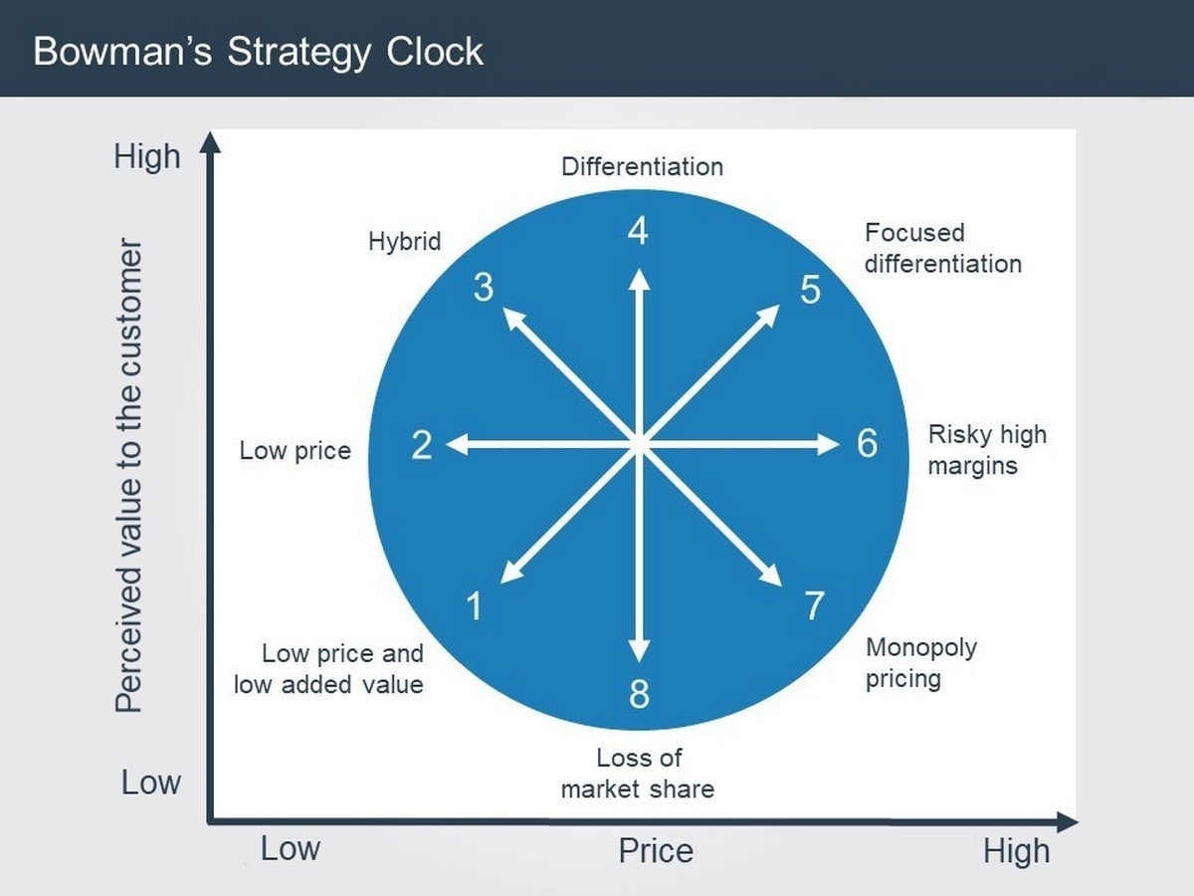
Appendix 14
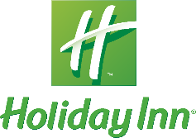
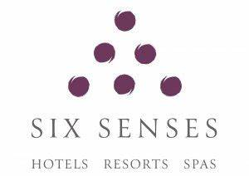
Self-sustainable hotel
Low price
High price
Traditional hotel

