BMIH6007--- International Meetings Management for the Hotel Industry
Assignment 1.
Feasibility Plan for an International Meeting
Event Theme: Winter
Event: New Year
Name: Mohammed Abdul Bathen
ID: 2212002
Lecturer: Kathryn Flynn

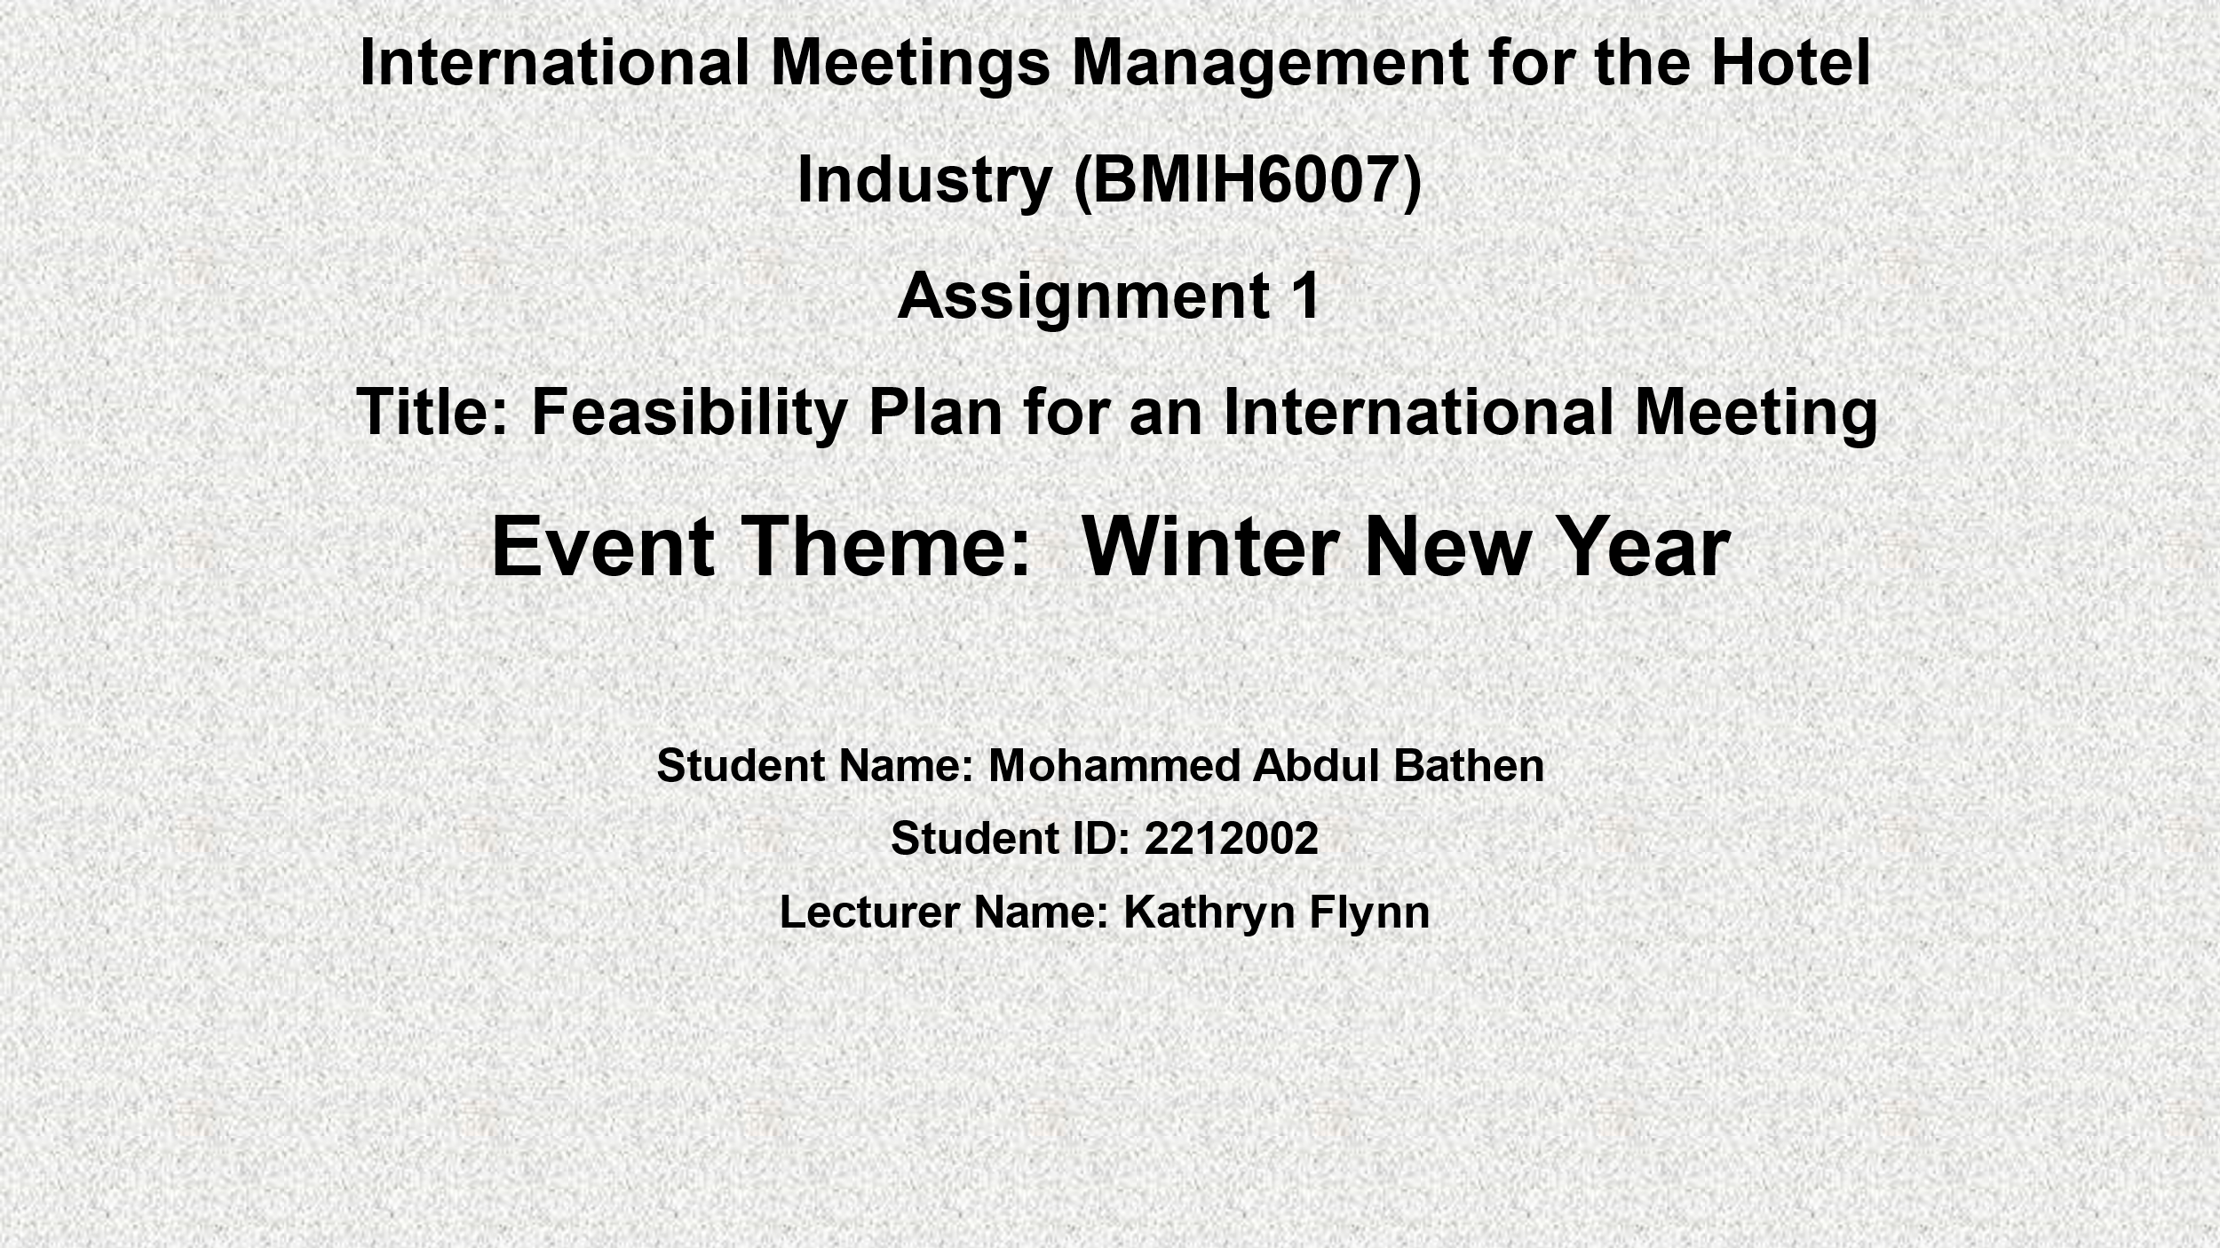
Slide 1- Good morning, my name is Mohammed Abdul Bathen and, in the presentation, I will be explaining the feasibility plan for the International new year’s winter event held at the Premier Inn Hotel.
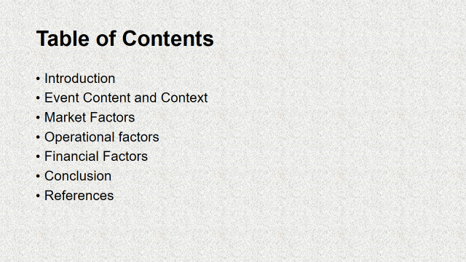
Slide 2 – Here are my table of contents.
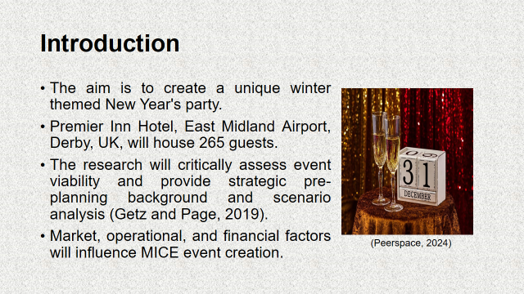
Slide 3 -- This analysis is about a New Year's celebration event. The Premier Inn Hotel at East Midland Airport in Derby, UK, will host 265 people. This number will be determined by ticker sales. Corporations can celebrate the year with employees, partners, and clients in a professional but pleasant setting. Event feasibility depends on background, scenario analysis, and operational, market, and financial factors. MICE events will advise on event strategy and management (Smith, 2012). Conferences, exhibits, and business events foster collaboration and employee engagement. Event content, target market, venue selection, operations, and financial preparedness are report themes.
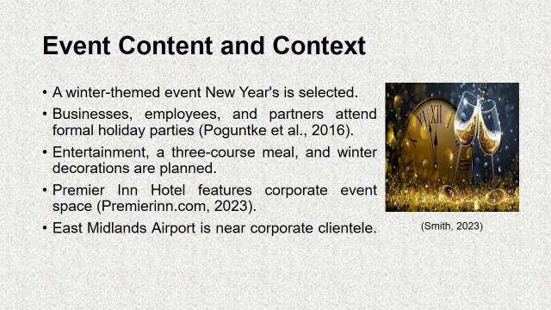
Slide 4 -- The winter-themed corporate New Year's party is joyful for employees and partners. Supper, entertainment, and festivities will be enhanced by winter decor, music, and lighting (Shone and Parry, 2019). The Premier Inn Hotel, East Midland Airport, known for its convenience and corporate function facilities, will host the event. MICE clients wanting luxurious year-end celebrations will attend. Near East Midlands Airport, the hotel is popular for corporate events.
A business speech, live entertainment, and a three-course formal dinner are given. Live music, a dance floor, and winter decor will make the party fun. This location may appeal to corporate clients seeking a unique and refined end-of-year atmosphere (Jones, 2018).
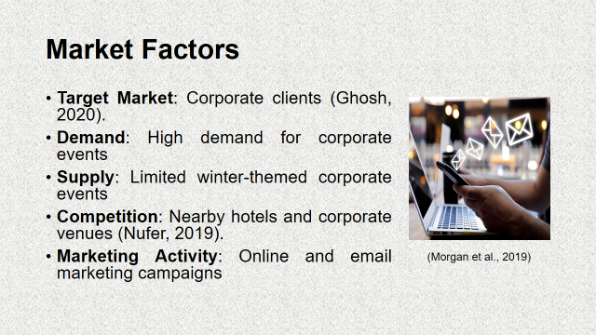
Slide 5 -- This event targets local corporations' year-end parties (Kim and Jun, 2016). Companies must connect with employees and clients in a formal but festive manner to build relationships and enhance employee satisfaction through social contact, hence this focus on corporate clientele. Company winter and New Year's parties are common to thank and honour employees (Morgan et al., 2019). This event fills that need, especially for companies without the resources to host one. For medium-sized business meetings, Hotel Premier Inn holds 265 persons.
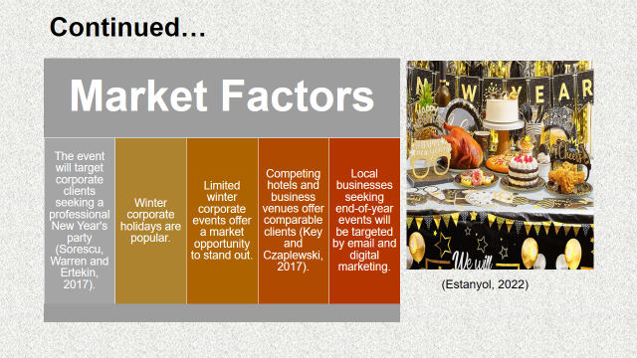
Slide 6 -- Corporate clients might choose local hotels and event rooms. Winter theme and location distinguish Premier Inn near East Midland Airport. Event quality and accessibility make the facility competitive (Krasniak, 2019). Regional companies will benefit from email, social media, and corporate event planner networking. A systematic marketing plan will promote the event and its unique services to potential clients.
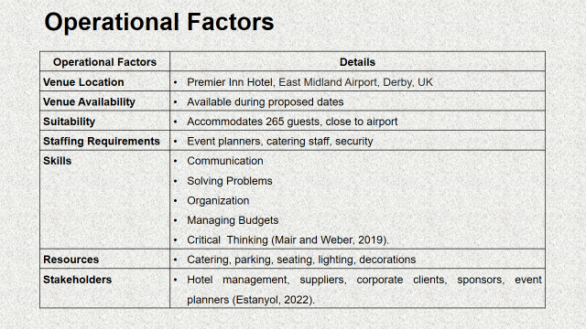
Slide 7 -- Premier Inn was chosen for its suitability, availability, and East Midlands Airport accessibility. Foreign and local visitors can readily reach this site. A 265-person dining hall, on-site parking, food, and multimedia technology make it appropriate for large business functions.
Check the venue's New Year's availability to avoid scheduling complications (Jepson and Stadler, 2017). Several parties impact event success. The hotel management will provide the venue and coordinate with event organisers; the catering team will provide food and beverage service; entertainment providers, such as live musicians or DJs, will create the desired atmosphere; sponsors or corporate partners may provide funding or additional resources; and the event planning team will coordinate and execute (Wu and Ai, 2016). Event coordinators, caterers, security, and technical staff operate lighting, sound, and audio-visual equipment. Event success depends on food, parking, seating, and illumination. Event success and corporate client pleasure require meticulous planning.
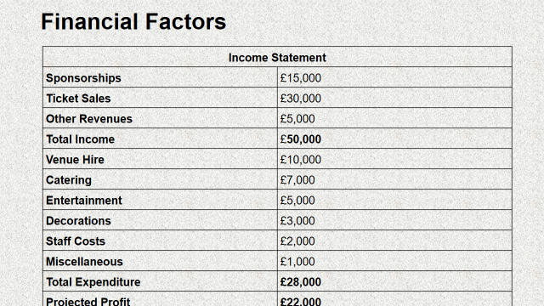
Slide 8 -- Budget and revenue determine event profitability. Minimum event budget: £28,000 for venue, food, entertainment, décor, crew, and incidentals. A 265-person Premier Inn Hotel three-course dinner costs £7,000 and venue hire £10,000.
Decorations and theming cost £3,000, while live music or a DJ costs £5,000. Planning, security, and technicians cost £2,000; parking, lighting, and audio-visual equipment £1,000.
Tickets, sponsorship, VIP, and product sales will fund the event. Ticket sales should reach £30,000, averaging £113 each (Knardal and Bjørnenak, 2020). VIP packages, event merchandise, and corporate sponsorships cost £5,000–£15,000. The event is expected to earn £50,000 and cost £28,000. Profitability should be £22,000.
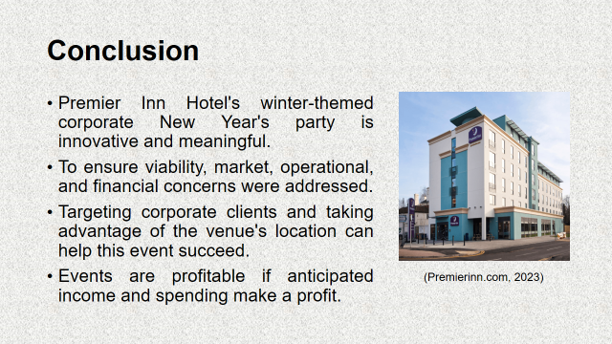
Slide 9 – So, this winter-themed Premier Inn Hotel, East Midland Airport, corporate New Year's event lets clients celebrate professionally and festively. The event can succeed in a competitive market by targeting corporate clients and exploiting the venue's strategic location and resources. The Financial forecasts indicate the event will be profitable, and site and resource distribution have been extensively examined to ensure smooth implementation.
This Unique event idea enabled by strategic pre-planning and commercial, operational, and financial investigations.
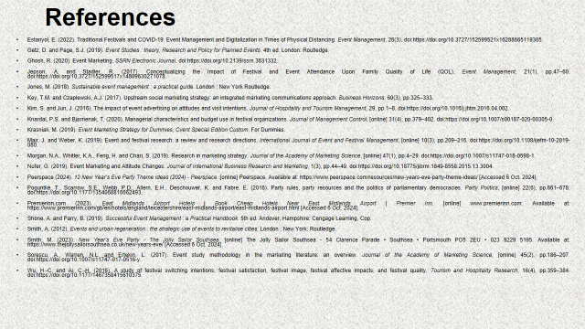
Slide 10 – References
These are the references used to create this presentation. Thanks for listening. Any questions are welcomed.

- Estanyol, E. (2022). Traditional Festivals and COVID-19: Event Management and Digitalization in Times of Physical Distancing. Event Management, 26(3). doi:https://doi.org/10.3727/152599521x16288665119305.
- Getz, D. and Page, S.J. (2019). Event Studies : theory, Research and Policy for Planned Events. 4th ed. London: Routledge.
- Ghosh, R. (2020). Event Marketing. SSRN Electronic Journal. doi:https://doi.org/10.2139/ssrn.3631332.
- Jepson, A. and Stadler, R. (2017). Conceptualizing the Impact of Festival and Event Attendance Upon Family Quality of Life (QOL). Event Management, 21(1), pp.47–60. doi:https://doi.org/10.3727/152599517x14809630271078.
- Jones, M. (2018). Sustainable event management : a practical guide. London ; New York Routledge.
- Key, T.M. and Czaplewski, A.J. (2017). Upstream social marketing strategy: an integrated marketing communications approach. Business Horizons, 60(3), pp.325–333.
- Kim, S. and Jun, J. (2016). The impact of event advertising on attitudes and visit intentions. Journal of Hospitality and Tourism Management, 29, pp.1–8. doi:https://doi.org/10.1016/j.jhtm.2016.04.002.
- Knardal, P.S. and Bjørnenak, T. (2020). Managerial characteristics and budget use in festival organizations. Journal of Management Control, [online] 31(4), pp.379–402. doi:https://doi.org/10.1007/s00187-020-00305-0.
- Krasniak, M. (2019). Event Marketing Strategy for Dummies, Cvent Special Edition Custom. For Dummies.
- Mair, J. and Weber, K. (2019). Event and festival research: a review and research directions. International Journal of Event and Festival Management, [online] 10(3), pp.209–216. doi:https://doi.org/10.1108/ijefm-10-2019-080.
- Morgan, N.A., Whitler, K.A., Feng, H. and Chari, S. (2019). Research in marketing strategy. Journal of the Academy of Marketing Science, [online] 47(1), pp.4–29. doi:https://doi.org/10.1007/s11747-018-0598-1.
- Nufer, G. (2019). Event Marketing and Attitude Changes. Journal of International Business Research and Marketing, 1(3), pp.44–49. doi:https://doi.org/10.18775/jibrm.1849-8558.2015.13.3004.
- Peerspace (2024). 12 New Year’s Eve Party Theme Ideas (2024) - Peerspace. [online] Peerspace. Available at: https://www.peerspace.com/resources/new-years-eve-party-theme-ideas/ [Accessed 6 Oct. 2024].
- Poguntke, T., Scarrow, S.E., Webb, P.D., Allern, E.H., Deschouwer, K. and Fabre, E. (2016). Party rules, party resources and the politics of parliamentary democracies. Party Politics, [online] 22(6), pp.661–678. doi:https://doi.org/10.1177/1354068816662493.
- Premierinn.com (2023). East Midlands Airport Hotels | Book Cheap Hotels Near East Midlands Airport | Premier Inn. [online] www.premierinn.com. Available at: https://www.premierinn.com/gb/en/hotels/england/leicestershire/east-midlands-airport/east-midlands-airport.html [Accessed 6 Oct. 2024].
- Shone, A. and Parry, B. (2019). Successful Event Management : a Practical Handbook. 5th ed. Andover, Hampshire: Cengage Learning, Cop.
- Smith, A. (2012). Events and urban regeneration : the strategic use of events to revitalise cities. London ; New York: Routledge.
- Smith, M. (2023). New Year’s Eve Party - The Jolly Sailor Southsea. [online] The Jolly Sailor Southsea - 54 Clarence Parade • Southsea • Portsmouth PO5 2EU • 023 9229 5195. Available at: https://www.thejollysailorsouthsea.co.uk/new-years-eve/ [Accessed 6 Oct. 2024].
- Sorescu, A., Warren, N.L. and Ertekin, L. (2017). Event study methodology in the marketing literature: an overview. Journal of the Academy of Marketing Science, [online] 45(2), pp.186–207. doi:https://doi.org/10.1007/s11747-017-0516-y.
- Wu, H.-C. and Ai, C.-H. (2016). A study of festival switching intentions, festival satisfaction, festival image, festival affective impacts, and festival quality. Tourism and Hospitality Research, 16(4), pp.359–384. doi:https://doi.org/10.1177/1467358415610375.

