Research Project Report

Module: BMIH6008 Hotel Placement Research Project
Student: Candelaria Stevenson
Student ID: 2123564
Project Supervisor: Christopher Wilkin

Abstract

The research discusses the acute staffing problems faced by the Ibis Styles Birmingham NEC and Airport Hotel, a hotel complex near one of Britain's major travel and events hubs, and explains the operational implications of staff shortages further exacerbated by post-pandemic labor market shifts, Brexit-induced workforce limitations, and increased service demands. Precisely, it assesses the influence of employee turnover and recruitment difficulties, as well as external pressures from travel and event venues in proximity to the hotel itself, in maintaining service quality and operational efficiency. The dissertation identifies strategic interventions that can help improve the stability of staffing and the resilience of operations through SWOT, PEST, and competitor analysis. Suggestions include having competitive pay and benefits, training and career development for employees, flexible staffing models, and integrating appropriate technology to streamline operations. Recognition programs and employee well-being initiatives could help nurture the culture of the workplace, which, in turn, might boost morale and reduce attrition among workers. The conclusion from this study is that proactive workforce management approaches lie at the heart of Ibis Styles Birmingham meeting the challenges it presently faces, developing guest experience, and enforcing its market position. This ensures that all staffing-related issues are resolved effectively to establish a workable, sustainable, and resilient operation that can cope with the demands of an extremely competitive hospitality environment. The present study add much value to workforce dynamics in the hospitality industry and provides actionable recommendations that may inform management practices in similar settings.
Contents
1. Introduction 5
1.1 Aim 5
1.2 Research Questions 5
1.3 Research Objectives 6
2. Literature Review 7
2.1 The Hospitality Industry's Workforce Challenges in a Post-Pandemic Era 7
2.2 Economic and Regulatory Factors 7
2.3 Employee Turnover and Retention in the Hotel Industry 8
2.4 Strategies to Mitigate Staffing Challenges in the Hospitality Sector 8
3. Research Methodology 10
3.1 Research Design 10
3.2 Data Collection Methods 10
3.3 Research survey 10
3.4 Ethical Considerations 10
3.5 Data Analysis 11
4. Case Study Discussion and Analysis 12
4.1 Descriptive Information 12
4.2 SWOT ANALYSIS 12
4.3 PEST ANALYSIS 14
4.4 Competitor Analysis 16
4.5 Netnography 16
5. Theme Exploration in Staffing and Workforce at Ibis Styles, Birmingham 18
5.1 Workforce Stability in the Hospitality Industry 18
5.2 Staffing issues at Ibis Styles Birmingham 18
5.3 Areas of Development and Improvement 19
5.3.1 Enhanced compensation package and fringe benefits 19
5.3.2 Training and Career Development Programs 19
5.3.3 Flexible Staffing Models and Workforce Planning 20
5.3.4 Employee Recognition and Well-being Programs 20
5.3.5 Leveraging Technology to Improve Staffing Efficiency 21
5.4 Case Examples and Evidence from IBIS Styles Birmingham 21
6. Survey Findings 23
6.1 Discussion 23
6.2 Conclusive Analysis 30
7. Conclusions and Recommendations 31
8. Reflective Account 33
8.1 Overview of Staffing Challenges and Employee Retention 33
8.2 Guest experience and service quality 33
8.3 Technology Integration and Operational Efficiency 34
8.4 Improvement Strategic Recommendations 34
8.5 Personal and Professional Development 35
9. References 36

1. Introduction
The acute shortage of staff has confronted Ibis Styles Birmingham NEC and Airport because it is proximate to the NEC and airport in Birmingham. This forms part of the broader trend that has lately affected the hospitality industry in the UK, where demand has shot upward after the pandemic, while labor supply has shrunk. Also, with more and more guests arriving and departing from the hotel, the operational pressure has become highly heightened, coupled with the restriction of the workforce, thus putting additional stress on the capability of the hotel to maintain its service standards. This labor shortage is resulting from conditions such as reduced workforce levels arising from Brexit, COVID-19 restrictions on the mobility of available labor, and increased job demands that make both the recruitment and retention of staff more difficult.
At Ibis Styles, the insufficient level of personnel directly influences the current state of operations: check-in time, room readiness, guest satisfaction, and quality of service. Business customers could include business travelers, conference delegates, and tourists; the ability to maintain a high level of service is crucial to thrive in the competitive environment. This thesis examines the causes and consequences of personnel shortage for the Ibis Styles Birmingham NEC and Airport. The approach: For this research effort, a mixed-method approach will be employed to identify the strategies that effectively respond to the mentioned shortages and improve workforce stability, and enhance guest satisfaction, and operational resilience.

1.1 Aim
To investigate the major factors that contribute to staffing difficulties and operational efficiency at Ibis Styles Birmingham focusing on employee turnover, recruitment challenges, and pressure from external events and travel hubs.

1.2 Research Questions
Q1: What is the major reason for staff shortages at Ibis Styles Birmingham especially concerning its proximity to NEC and Birmingham Airport?
Q2: How might Ibis Styles Birmingham address these identified staffing challenges in order to enhance recruitment, improve retention rates, and augment operational efficiency?
Q3: How would the staffing shortage at Ibis Styles Birmingham impact the ability of the hotel to meet expectations during peak events and travel periods?

1.3 Research Objectives
To conduct a literature review in order to outline the challenges that are associated with staff shortage and other key factors in the hospitality industry.
To identify the level of staff shortages at Ibis Styles, Birmingham, through primary data collection with the help of a survey of the hotel’s employees and management.
To investigate how the proximity of NEC and Birmingham Airport impacts the hotel’s challenges of recruitment issues and employee turnover rates among others.
To recommend ways in which the recruitment and retention for Ibis Styles Birmingham could be improved and operational efficiency enhanced in respect of particular location-specific staffing challenges.

2. Literature Review

2.1 The Hospitality Industry's Workforce Challenges in a Post-Pandemic Era
The COVID-19 pandemic severely disrupted the hospitality industry, specifically in workforce management, amid all the travel restrictions that forced many hotels either to shut down or drastically reduce their staff. According to Wang et al. (2023), the pandemic forced a turn toward shifting expectations among employees, who have sought sectors that offered them much better job security and flexibility. Similarly, Dzia-Uddin et al. (2023) mentioned that meeting the challenges of the post-pandemic scenario requires hotels to rely increasingly on technological innovations that can provide quality service despite the reduced workforce. Hao et al. (2020) focused their analysis on the hotel industry in China and stated that hoteling businesses near high-contact areas, like airports, were more vulnerable to disruption of services and manpower. For instance, approaches to recovery strategies for Vietnam were suggested by Chunga and Phuca (2024) in light of flexibly staffed models, so that seasonal demand variations could be catered to. In fact, "The Great Resignation," in the words of Formica and Sfodera (2022), has imposed challenges such as aligning hospitality jobs with new values and expectations of workers in a post-pandemic scenario.

2.2 Economic and Regulatory Factors
This had been exacerbated by the situation after the UK's exit from the European Union, with workers in the hospitality industry particularly hard to access now that previous posts were filled largely by that segment of the workforce. As Codling et al. (2022) emphasized, there is an increasing reliance on retaining local talent, but with pay and benefits within the sector falling behind compared with competing sectors, which is especially challenging in cities with acute cost-of-living considerations such as Birmingham. Hadjisolomou et al. (2022) identified that fair work practices are fundamental to retaining employees in the post-Brexit environment. Kumar and Chansoria, 2021, talked about gaps in hospitality training and mentioned that UK institutions need to give practical training key importance in order to meet this shortage and to make the local workforce competitive. In the intervening period, El Hajal and Rowson (2021) indicated for their part that gig and part-time positions have become the norm as a counter to staffing deficits, even though these latter positions are generally unstable with no benefits and thus less desirable over the longer term. Abhari et al. (2022) concluded that this is all the more dangerous for small businesses since the pandemic has accentuated these problems incentives are thus required simply to keep staffing intact.

2.3 Employee Turnover and Retention in the Hotel Industry
The hotel industry is characterized by a high rate of turnovers, which is coerced by demanding working conditions and relatively low wages. Dwesini, (2019), discussed factors that contribute to turnover: limited career growth and job-related stress, which are specifically inherent in demanding locations like airport hotels. Ghani et al. (2022) developed this further by suggesting that retention strategies should enhance work-life balance and professional development since these factors are superior determinants of job satisfaction and retention. On the other hand, Edirisinghe and Manuel (2019) stressed that one should look at competitive wages in tandem with establishing a supportive work environment as the best way to lower turnover. As Adula et al. (2022) add, with an appropriate human resource management strategy, organizational performance can be developed through better stabilization of the most active human resources. Ibrahim (2024) went on to add that, with organizational attachment, the rate of turnover can be minimized for when employees are considered valuable and part of an organization, they will definitely make sure to stay on.

2.4 Strategies to Mitigate Staffing Challenges in the Hospitality Sector
Various solutions have been proposed to assist the hospitality industry in surmounting such crises: flexible shifts, competitive salaries, and opportunities for professional growth. In this respect, Davahli et al. (2020) cited the call for the implementation of technological solutions capable of supporting hotel operations and easing staff workload; such a solution will be effective, especially for those hotels that are maintaining business with skeletal staff. Giousmpasoglou (2024) highlighted the need for a "Fair and Decent Work Agenda," citing decent earnings and a healthy work environment as vital ingredients in attracting and retaining employees. Khatter (2023) addressed environmental sustainability as a long-term approach to staff engagement where he advanced the proposition that those hotels with their core competence in sustainable practices had less difficulty in retaining staff who valued environmental responsibility. Islam, (2021), suggested hiring freshers because they bring fresh vision and dynamism to the field which would help bridge the staffing gaps. Kravariti et al. (2022) gave a presentation on a Holistic Talent Management Approach to staffing shortage; there is an efficient framework for recruitment and retention which all together would build an adversity-resilient workforce.

3. Research Methodology
The aim of this study is to identify the challenges related to staffing problems in the hospitality sector, and then narrow it down to the Ibis Styles Birmingham hotel in order to find out the possible factors that contribute to staff shortages and their potential solution.

3.1 Research Design
The study shall adopt a descriptive research design since the nature of the research suits explaining specific factors that contribute to staffing shortages and retention issues within the hotel industry (Kim et al., 2017). This will help the research to obtain precise details from those who are experiencing such challenges directly for the in-depth analysis of the factors involved.

3.2 Data Collection Methods
The structured survey will be the major method of collecting data from employees and managers at Ibis Styles Birmingham. It is designed to produce quantitative data on variables causing staff shortages and point out the measures that may alleviate such problems (Mosadeghrad et al., 2011). Online questionnaires will be issued via Google Forms, and distributed through e-mail to eligible people. On the other side, in the case study analysis, data will be gathered with the support of annual reports or the documentation issued by the organization (Runeson et al., 2009).

3.3 Research survey
A purposive sampling strategy will be employed to select survey participants from Ibis Styles in Birmingham (Campbell et al., 2020). The study has targeted respondents from different strata of the hotel to ensure that it captures various dimensions of how hotel operations are affected by staffing challenges. The sample size targeted is between 30 and 50 participants for statistical significance and substantial data analysis. This sample size would therefore be expected to yield reliable and diverse responses that would be useful in deeply analyzing staffing issues within the hotel.

3.4 Ethical Considerations
- The research grants first priority to ethical integrity and the rights of participants. Informed consent will be obtained from all respondents prior to their undertaking the survey.
- Participants will be informed clearly about the objectives of the research study, how data from them will contribute, and be assured of confidentiality and anonymity (Wiles et al., 2008).
- Consequently, no sensitive or personal data will be collected; the subject of this survey deals only with professional experience and perceptions related to staffing challenges.

3.5 Data Analysis
The thematic analysis would be used in order to analyze different aspects associated with human resources management as well as the business development process of Ibis Style by considering different factors (Khan et al., 2021). Thematic analysis will also be done from the survey questions of the research participants. In this way, an evaluation of common patterns and trends in responses could be assessed (Terry et al., 2017). The qualitative data that is collected from open-ended responses will be coded and categorized to identify major themes and give insight into staffing challenges that employees and management face at Ibis Styles Birmingham. Such a combination of data will indeed yield a comprehensive overview of staffing challenges and thereby help in proposing some area oriented interventions.

4. Case Study Discussion and Analysis
This section should critically and deeply examine the chosen business organization, Ibis Styles Birmingham, and provide descriptive background information on brand identity, structure, staffing, turnover, and competitive context.

4.1 Descriptive Information
Ibis Styles Birmingham is part of the renowned Ibis Styles brand under the Accor Hotels Group, a global hospitality leader in accessible and cost-effective hospitality. Operating within the midscale hotel market, Ibis Styles Birmingham has pitched itself as an affordable accommodation option with style for travelers who want a comfortable place to stay but with no hefty price tag (DP and Riana, 2020). The annual turnover for this hotel is at par with industry standards in the midscale category (IFR, 2024). However, it still records an escalation in operational costs due to increased competition from the rising Airbnb market and growing demand for unique and experience-driven offers. Despite all these financial pressures, Ibis Styles Birmingham maintained its steady growth through its brand identity and strategic location in Birmingham's city center.
Staffing at the Ibis Styles Birmingham is a high-scale operation, from front desk to housekeeping to food and beverage services up in total around 60 staff. The staffing policy at the hotel reflects the brand's concern with customer service and comfort. Indisputably, recruitment and retention are difficult for the hotel; this can be common in the hospitality industry and is typical for industries featuring high turnover and marked seasonality (Wang et al., 2022). Regarding the location, Ibis Styles Birmingham is advantageously situated close to cultural attractions, transportation linkages, and business establishments, making it quite attractive to leisure and business customers (Latip et al., 2022). The hotel's strategic placement within Birmingham allows it to tap into diverse customer demographics, further fostered by the cultural vibrancy and economic growth of the city. This immediately provides both a geographical advantage and competition from a range of accommodation options, from boutique hotels to short-term rentals.

4.2 SWOT ANALYSIS
4.2.1 Strengths
The key strengths of Ibis Styles Birmingham include brand reputation and value for money, believed to be the critical areas of success in this category of midscale hotels. Under the globally recognized Accor Hotels Group, Ibis Styles has a strong brand image associated with style at an affordable cost of accommodation that attracts leisure and business customers alike. This is further supported by the Accor loyalty program, which tends to ensure high repeat bookings and customer loyalty through the promotion of a system that rewards frequent guests for their repeated patronage with exclusive deals and special offers (Accor, 2023). This supportive nature promotes the retention of guests, hence providing the competitive advantage of valuable customers who value brand consistency at affordable comfort (Othman et al., 2021).
4.2.2 Weaknesses
In balance, there are some weaknesses Ibis Style Birmingham faces, definitely in its areas of staffing and consistency of services. While high employee turnover is experienced quite frequently in the hospitality sector, for Ibis Styles specifically, it has raised problems as to the sustainability of high standards of service and maintaining the consistency in the experience provided to guests (Bardukova , 2023). These fluctuations in staffing often relate to gaps in training and operational inefficiencies, sometimes causing delays in service delivery, especially during peak occupancy periods (Wandelt and Wang, 2024). More often, these staffing problems result in inconsistency with room maintenance, along with customer service quality, and could affect the hotel's reputation. For long-term stability and satisfaction of guests, internal issues must be solved (Sergeevna, 2024).
4.2.3 Opportunities
Ibis Styles Birmingham has abundant opportunities to further solidify its market position by developing digital transformation and local partnerships. Improved online and mobile booking services to enhance guest convenience and improve operational efficiency can develop the expansion of the company's digital services. Integration technology solutions like mobile check-in, virtual concierge service, and personalized booking experience have topped the demand list of modern travelers for digital accessibility and efficiency (Arapou and Kapiki, 2023). Furthermore, the partnerships with local businesses would create opportunities to make the guests' stays more complete and interesting, adding exclusive discounts and curated activities involving locals (Taecharungroj and Prasertsakul, 2023). Such teaming could appeal to tourists and business travelers alike and foster a local experience that is unique and differentiates it from the competition.
4.2.4 Threats
It also faces significant threats through increasing competition and interest in Birmingham's hospitality segment, as well as an increasing trend towards alternative types of accommodation such as Airbnb (Leick et al., 2022). With continued new entries in the midscale and boutique hotel sectors, the market is thick with contenders all Ibis Styles will have to compete against moderately budgeted travelers. Other competitors, local boutique hotels among them, may offer a tailored and experience-oriented stay attracting guests who seek unique and personalized accommodations (Ramadan et al., 2023). Besides, travelers increasingly use other platforms, such as Airbnb, for more flexible stays tailored to their individual needs. It's all about the alternative way of staying, which has been a challenge to traditional notions of hotels (Farmaki and Miguel, 2022). This requires Ibis Styles Birmingham to make its services meet the changing expectations concerning authenticity and personalized experience among the guests.

4.3 PEST ANALYSIS
4.3.1 Political Factors
The Ibis Styles Birmingham operates in one of the very closely regulated industries in the UK, with enforcement of the government's health, safety, and environmental standards being extremely strict. Government policies on employment, such as minimum wages and labor laws, have a direct impact on staffing costs for the hotel (Garnero and Lucifora, 2022). Political stability within the UK means that the business environment is conducive to the overall tourism and hospitality industry (Duan et al., 2022). Changes in regulations, particularly environmental ones, will involve further investment in sustainability initiatives if the hotel is to remain compliant.
4.3.2 Economic Factors
The performance of the hotel greatly depends on the economic climate. Inflation and consumer spending are critical to the hotel operation (Ozdemir et al., 2022). Inflation squeezes the spending power of the consumers and increases the operational costs, hence decreasing the hotel demand as the guest seeks to cut down on their budget (Weerathunga et al., 2020). Changes in relative currency values can affect the flow of international tourists, hence having some effects on hotel occupancy (Alrawabdeh, 2021). On the positive side, the hotel enjoys an increase in occupancy during periods of economic growth as consumers are willing to spend their money on leisure and business travel.
4.3.3 Social Factors
Social trends reshape consumer expectations about hospitality. Growing environmental awareness translates into more travelers going for eco-friendly hotels, a line of business to which Ibis Styles Birmingham can adapt by embedding sustainability. Changes in guest preferences toward personalized and authentic experiences also exist (Pelet et al., 2021). Today's travelers, especially younger demographics, prefer accommodations that illustrate local culture and unique experiences (Fan et al., 2023).
4.3.4 Technological Factors
These changes in technology bring in both opportunities and challenges for the company, Ibis Styles Birmingham. Digital booking platforms, mobile check-in systems, and CRM technologies have completely changed the paradigm of interactions with guests and operational processes alike (Chankaew and Kiattisin, 2023). It thus requires the hotel to keep investing in the same so as to ease processing regarding booking and check-in and make operations smoother to enhance guest experiences. CRM systems allow for personalized marketing and services, hence giving an opportunity to the hotel to create better customers (Ibrahim and Rasheed, 2024).

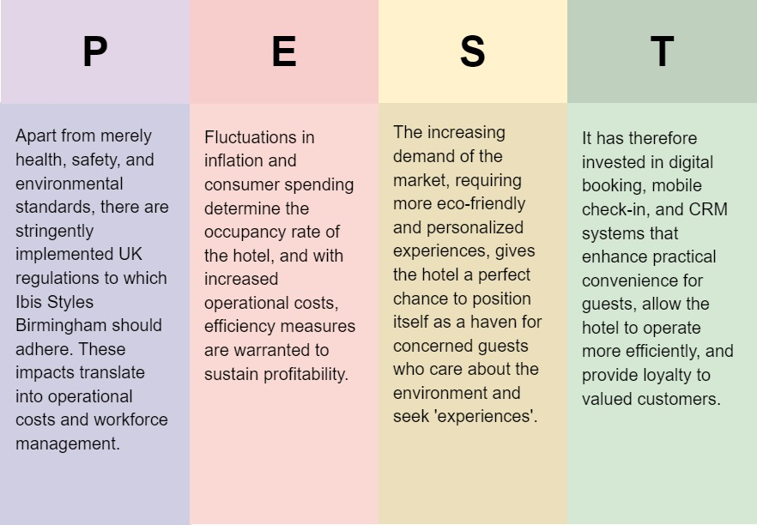
Figure 1 PEST Analysis
Source: (Self, 2024)

4.4 Competitor Analysis
Price versus Quality Ibis Styles Birmingham finds itself within a very competitive market mid-scale and budget hotel providers in the city are strong, as are the alternative and quirky players like Airbnb. Given its competitive price without quality compromise, Ibis Styles can certainly attract budget travelers in need of comfort and convenience. Performing well when value for money in the midscale category is considered, this is where the hotel finds a more certain place (O’Neill et al., 2023). Its main competitors were other similar brands in a comparable price range that offer similar facilities, such as Holiday Inn Express and Premier Inn. In such a situation, Ibis Styles manages to carve a niche for itself with its distinctive brand identity and design sensitivity for young, style-conscious travelers. Nevertheless, the chain remains under pressure to achieve some balance between cheapness and quality, especially as expectations among consumers increase (Grabs, 2023). Thus, by looking at the response of customers towards competitors, one can realize that indeed Ibis Style may be in a position to improve several aspects of its service, such as training and basic room maintenance, to achieve competitive advantages in quality.

4.5 Netnography
Through a netnographic analysis of the most common themes in consumer opinion regarding Ibis Style Birmingham reviews that were accessible online and through social media, one reads of a central location with the stylish decor at an affordable price. The guests very much appreciate the convenience in terms of being within walking distance of leading local attractions and transportation links (Abrudan et al., 2020). On the other hand, there are recurring criticisms related to staffing and inconsistencies in service. Some guests have complained about delays in check-in and some slips in housekeeping; they usually attribute this to a case of understaffing. The online reviews also seem to cry for greener practices, with suggestions for waste management and energy conservation. This review evidences claims of staffing challenges and environmental trends that need communicating, as these are numbered areas of priority that have effects on customer satisfaction and brand perception (Prabhu and Aithal, 2023). The broad-based case study on Ibis Styles Birmingham shows the strengths and challenges faced by the hotel within the competitive mid-scale segment of hospitality. Based on the development of frameworks such as SWOT, PEST, and netnography, this examination allows for interrogation at a critical level of issues within the hotel's internal environment and the general external environmental context. The most significant theme coming out relates to challenges in staffing and correctly addresses gaps in current strategies for recruitment, retention, and supporting employees (Puspita et al., 2023). These issues could be improved, and the service quality augmented with the recommended measures being implemented. This will place Ibis Styles Birmingham in an advantageous position in the market. The strategic focus on holistic employee welfare and sustainability behavior will eventually pave the way for this hotel to create a phenomenal reputation among a broad range of customers and ensure long-term success within the hospitality industry.

5. Theme Exploration in Staffing and Workforce at Ibis Styles, Birmingham
In the hotel industry in particular, proper staffing is essential to ensuring high levels of service quality and guest satisfaction, as well as operational efficiency. Similar to other hotels, Ibis Styles Birmingham also suffers from specific issues of staff turnover, recruitment challenges, and employee retention that could directly impinge on service delivery and customer experience. The following discussion throws light upon workforce challenges in Ibis Styles Birmingham, critically sets the topic within an academic perspective, and provides examples in the Placement Hotel. It also gives recommendations for certain avenues through which workforce stability, employee satisfaction, and overall service standards can be improved.

5.1 Workforce Stability in the Hospitality Industry
Workforce stability in the hospitality industry is crucial in ensuring that profits are maximized by maintaining service quality and keeping operational costs as low as possible (Adanse et al., 2024). High turnover rates, considered to be one of the challenges, have been blamed on a number of causes such as limited opportunities for growth in career, intensive working conditions, and relatively low wages. This disruption not only affects service quality but also increases the costs associated with recruitment and training. Heimerl et al. (2020) emphasize that the issues discussed above could be aggravated by poor morale and engagement among the employees, as low satisfaction normally makes employees contemplate seeking employment elsewhere.
Indeed, it is supported by research that those hotels that invest in employee development and career growth have a higher chance of retaining skilled and experienced workers (Al-Ansi et al., 2023). The practices lead to job satisfaction, organizational loyalty, and decreased costs due to the constant need to recruit. In addition, the studies conducted by Manzoor et al., (2021) have also emphasized recognition and reward of employees that enhance motivation and performance levels. Addressing employee needs and maintaining a good work environment are well-documented as important to service consistency and guest satisfaction.

5.2 Staffing issues at Ibis Styles Birmingham
Ibis Styles Birmingham faces some of the challenges highlighted in the literature. These are about low employee retention and an inability to attract or retain qualified personnel within this setting. The operational model of the hotel focuses on providing affordable options without sacrificing comfort and customer service (Ali and Anwar, 2021). However, this further raises expectations for the number of people that should be employed. High employee yields, especially among operational employees such as housekeeping and reception, result in operational gaps and discrepancies in customer service (Dafillin and Wijoyo, 2024). Additionally, turnover causes greater reliance on temporary or part-time staff; this means fluctuations in the guest experience since new employees must be trained and acclimatized to their work.
The internal survey conducted within the establishment revealed that Ibis Styles Birmingham compensation, career not starting, and recognition were good valid reasons stated for dissatisfaction; this agrees with work by El-Said and Aziz, (2022), where they establish the actual need for hotels to provide better pay and in-service promotion opportunities. Second, there are those participants who stress that increases in personnel stress were reported because of understaffing during peak periods, which once again affects morale and job satisfaction. As a result, retention becomes hard, and many look elsewhere for better conditions in the workplace or just better career advancement (Ledi et al., 2023).

5.3 Areas of Development and Improvement

5.3.1 Enhanced compensation package and fringe benefits
Ibis Styles Birmingham can use compensation and benefits packages for the hotel to decrease high turnover rates and attract skilled workers. The hotel could be offering affordable accommodation; it is of utmost importance that wages are competitively paid to support retention in the workforce to enable them to be motivated at work. For instance, studies indicate a good pay structure as one of the essential aspects of employee retention, particularly at the operational level of the organization, such as among line employees (Kurdi and Alshuridehm 2020). Offering benefits, including health insurance, performance-based bonuses, and retirement savings plans, can also work toward increasing job satisfaction and loyalty. In addition, financial incentives might promote continued higher levels of performance and longer organizational tenures, reducing turnover and decreasing any associated training costs.

5.3.2 Training and Career Development Programs
Most problems in career progression and job satisfaction can be curtailed by investing in employee development programs. For Ibis Styles Birmingham to enhance the level of competence among its employees, for instance, it should implement a relevant training program in this regard; this shall focus on areas such as customer service, problem-solving, and management skills. This would ensure a clear career path in the organization and boost their morale as well, while at the same time ensuring that the hotel is adequately equipped with qualified and experienced manpower to meet operational demands. Research carried out by Elsafty and Oraby, (2022) suggests that companies that have solid internal advancement and training programs have better employee engagement and retention levels. Ibis Styles Birmingham can identify how a culture of development and growth within its workforce may lead to a more devoted and efficient team (Sepahvand and Bagherzadeh, 2021).

5.3.3 Flexible Staffing Models and Workforce Planning
Due to the seasonal nature of hotel demand, Ibis Style Birmingham might find it helpful if it allowed a flexible staffing model. During peak season, owing to high demand for their services, the hotel usually suffers from insufficient staff where the current staff is overworked hence compromising the quality of service. Therefore, the hotel can develop strategic relations with employment agencies for the supply of temporary personnel when needed. In other ways, multi-role cross-training of staff could facilitate workforce management by possibly having more viable alternatives to reallocate a workforce according to occupancy levels. Similarly, Stylos et al. (2021) add that flexible staffing models are very important in service industries such as the hotel industry. This is because these models facilitate hotels to keep their service level high without over-stressing the workforce.

5.3.4 Employee Recognition and Well-being Programs
A supportive work environment lends itself to improved job satisfaction and morale, when employee performance and contributions are recognized (Kim et al., 2021). Recognition programs, such as "Employee of the Month" awards, performance-based incentives, and team-building exercises, have various alternatives that could be considered in developing pride and belonging among the staff. It is supported by literature that recognition significantly influences motivation, performance, and turnover (Chaichi et al., 2023). Besides, the hotel may provide flexible working hours, fitness programs, or even mental health counseling services to help professionals overcome common stressors in the hospitality line of business. Such an approach to caring for employee welfare will create a friendly working atmosphere at Ibis Styles Birmingham, attract new employees, and contribute much to retaining existing ones (Silic et al., 2020).

5.3.5 Leveraging Technology to Improve Staffing Efficiency
It can help in workforce efficiency and an improved guest experience. In the way technologies have taken over the world, digital solutions to automated scheduling, mobile check-ins, and communications can thereby facilitate smooth and less time-consuming operations from the front-line employees (Najafi, 2024). Additionally, it provides insights from technology on visitor feedback and areas of improvement so the hotel can proactively address the issues. Technology investments achieve efficiency and a better work environment because the repetitive tasks reduce the task load and increase the employee's time for engagement in customer service. According to Vahdat, (2022), technology application in human resourcing and operation is critical in bringing mechanisms for enhancing employee satisfaction and so quality service.

5.4 Case Examples and Evidence from IBIS Styles Birmingham
Workforce challenges at Ibis Styles Birmingham provide practical illustrations of workforce literature. For example, the utilization of temporary employees during peak periods in the hotel has resulted in an inconsistency in the experiences of guests because temporary employees may not have been trained or conversant with standards put in place by the hotel to ensure consistency in service delivery. The labor turnover of housekeeping and front-desk employees has affected service quality because new employees take more time to learn the job for expected performance (Alhassan, 2020).
A formal employee recognition program would therefore help to optimize such problems by ensuring the improvement of workers' morale and encouraging them towards long-term devotion (Kyalo, 2023). Besides that, investing in training and development programs would reduce the learning curve of new recruits and minimize disruptions to service provision. It is through the enhancement of wages, the introduction of benefits, and the creation of opportunities for career growth that ibis Styles Birmingham could better position itself to attract and retain a skilled workforce.
Issues with staffing and workforce challenges at Ibis Styles, Birmingham are symptomatic of wider issues that beset the hospitality industry. High labor turnover, coupled with relatively limited opportunities for career development and operational stress in peak periods, means service delivery can be inconsistent, and overall satisfaction for guests may well suffer (Bukhari et al., 2024). This critical analysis has identified some areas for improvement supported by a literature review and practical standpoint: improved remuneration, career development programs, flexible staffing models, employee recognition, and integrated technology. Overcoming these challenges will be important if Ibis Styles Birmingham is to continue protecting its quality-service reputation and remaining competitive within the hospitality market in Birmingham. By investing in its workforce and fostering a supportive work environment, this hotel will be able to reduce employee turnover and engage its people even further for an even happier stay experience and position long-term success against increasing competition.

6. Survey Findings

6.1 Discussion
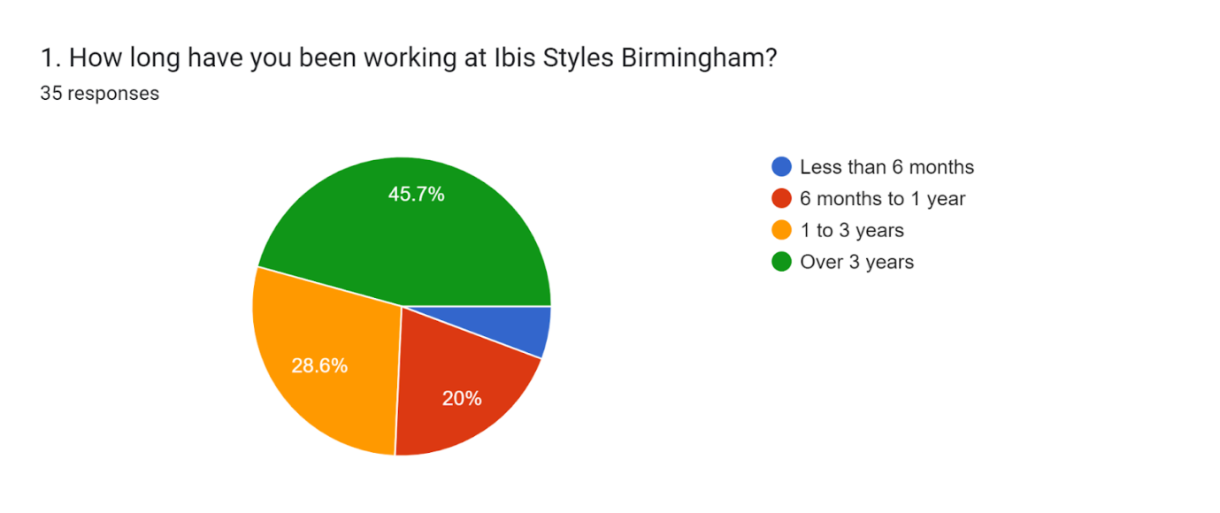
The results obtained from the questionnaires provide an insight that nearly half of the workflow has been with Ibis Styles Birmingham for more than three years trend that could indicate good retention and probably even a stable work environment. Furthermore, 28.6% of the participants reported that they have been part of the company for between 1-3 years, showing a mix of long-term and mid-term participants. About 20% are with the company for 6 months to 1 year, while only 5.7% are staying less than 6 months, which might indicate a lower rate of recent hires or that new employees tend to stay on for an extended period.

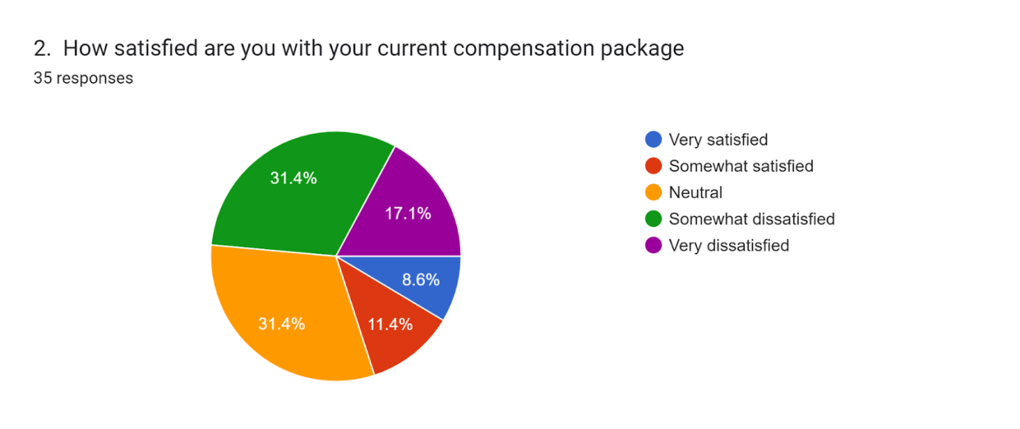
These enable combined responses: of the total package, only 8.6% are "very satisfied," while 11.4%, a sum total of just 20%, can profess to be "somewhat satisfied." An overwhelming 31.4% fall into the category of neutral responses, which, if interpreted, could mean indifference or an absence of a strong opinion. However, a whopping 31.4% show themselves to be "somewhat dissatisfied" and another 17.1% "very dissatisfied," meaning about half the employees view their remuneration negatively. points to some scope for improvement in the compensation package to improve employee satisfaction more effectively.

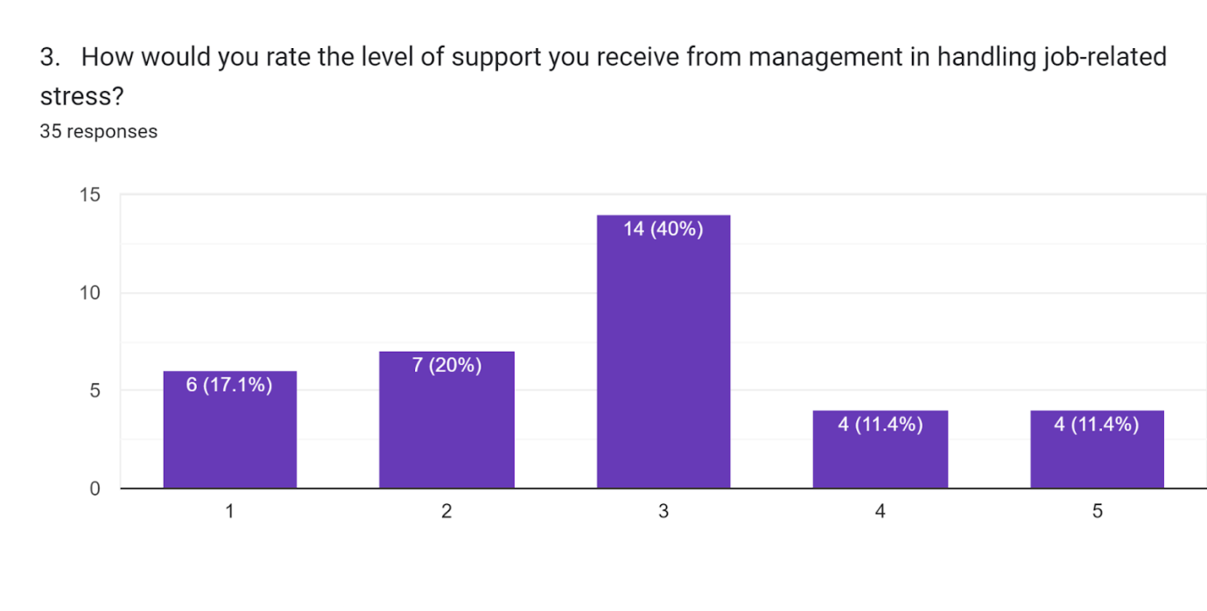
The survey shows that feelings are mixed among employees regarding how much support management provides to handle their job-related stress. The majority, 40% rated the level of support as a '3', representing the middle position, but substantial dissatisfaction with this area of support was reflected in the 37.1% who rated it low, at either '1' or '2'. Only 22.8% rated the level of support positively, at either '4' or '5', which shows the minority feel well supported. Overall, the findings indicate that management's role in supporting employees regarding stress management still leaves much to be desired.

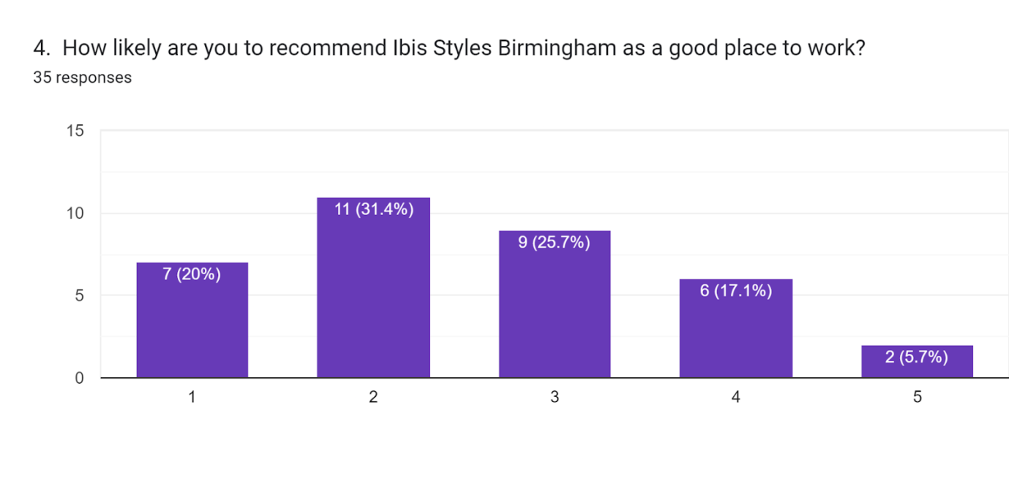
The results indicate that most are unwilling to recommend Ibis Styles Birmingham as a good place to work. A full 31.4% gave their likelihood as 2 out of 5, while 20% gave the lowest rating of 1. Only 5.7% gave the highest rating of 5, showing overall dissatisfaction and/or lack of enthusiasm. Due to the fact that over half of the responses are bunched at the low end of ratings 1 and 2, this would tend to indicate areas of improvement either in the workplace environment or in employee satisfaction.

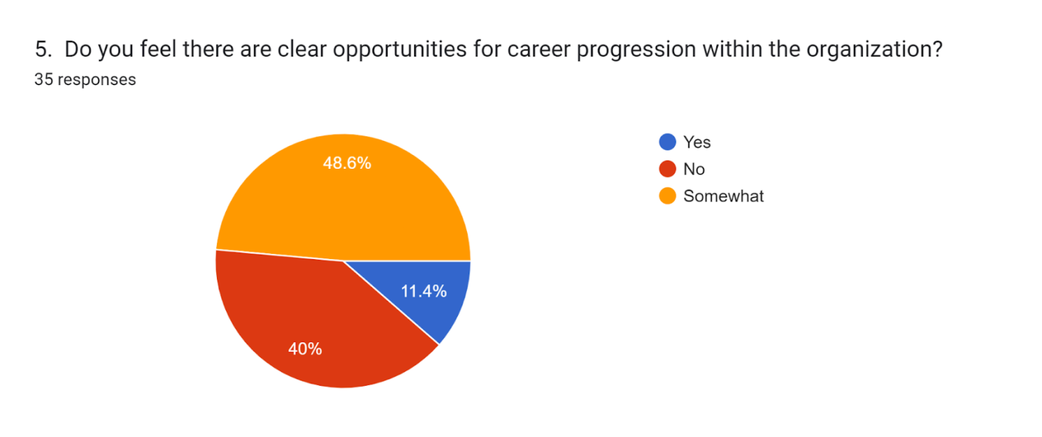
The overwhelming responses of the employees that were compatible had something to do with discontentment with the training and development provided. 40% rated it as "Poor," while 8.6% rated it as "Very poor." Even though 31.4% rated the opportunities as "Average," only 14.3% and 5.7% were rated as "Good" and "Excellent," respectively. This therefore brings into focus that there is considerable scope for improving the training and development programs in respect to enhancing the associated skills and satisfaction of the employees within an organization.

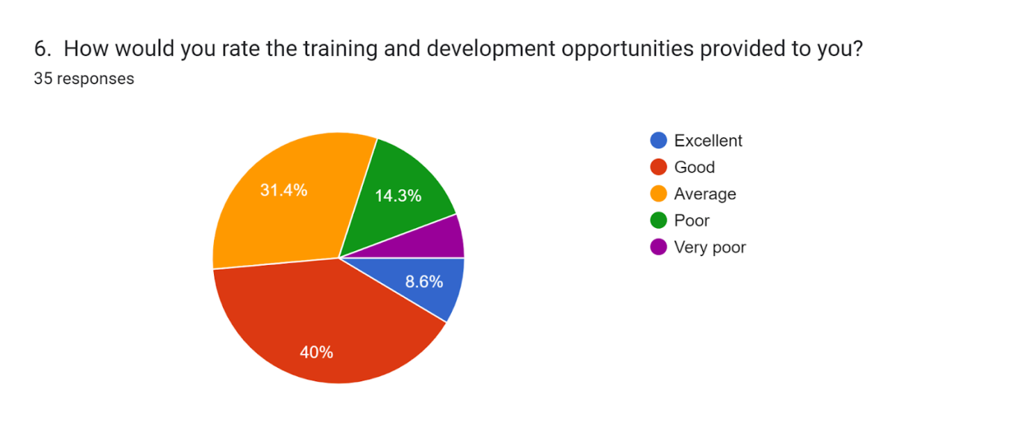The outcomes of the survey suggest a rather negative perception of training and development opportunities. Out of 35 respondents, the rating is only 8.6% for "Excellent" opportunities and 14.3% for "Good." Nevertheless, 40% rated them as "Poor," 31.4% as "Average," and 5.7% rated them as "Very Poor." This means that the majority of the respondents are dissatisfied with training opportunities. Therefore, this can illustrate a potential demand for increasing the quality, availability, or relevance of the training and development programs offered.

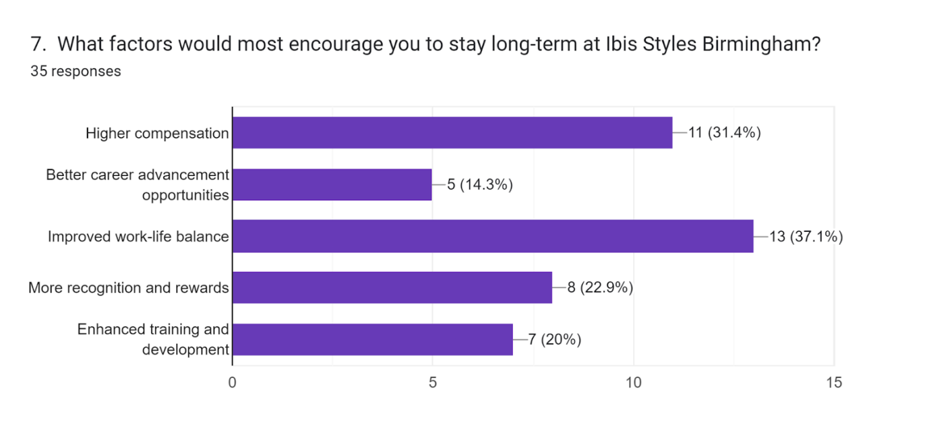
By the survey, it can be ascertained that the key drivers for long-term retention at Ibis Styles, Birmingham, are: improved work-life balance at 37.1%, increased compensation at 31.4%, more recognition and rewards at 22.9%, improved training and development at 20%, while better career advancement opportunities remain at a low of 14.3%. That means employees value a balanced life and reasonable remuneration over promotion opportunities.

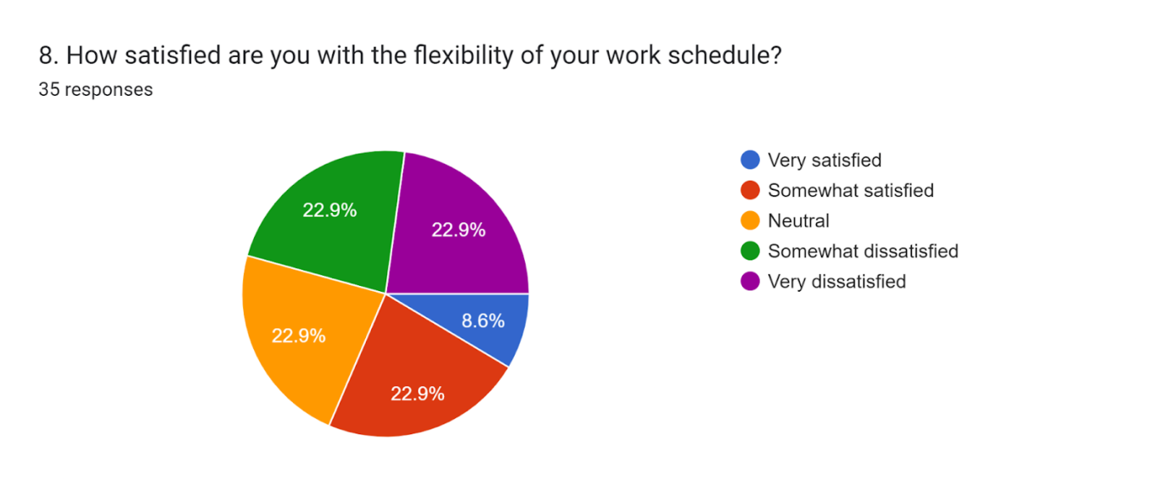
The data indicates a mixed response to work schedule flexibility at Ibis Styles Birmingham. A combined 45.8% of employees are either somewhat satisfied (22.9%) or neutral (22.9%) about schedule flexibility, while 22.9% feel somewhat dissatisfied and another 22.9% are very dissatisfied. Fully 8.6% are very satisfied, which would show only limited contentment with the present scheduling. The high level of dissatisfaction suggests that changes and improvements in scheduling flexibility are still called for to help improve employee satisfaction, as quite a large number of employees remain dissatisfied with current arrangements.

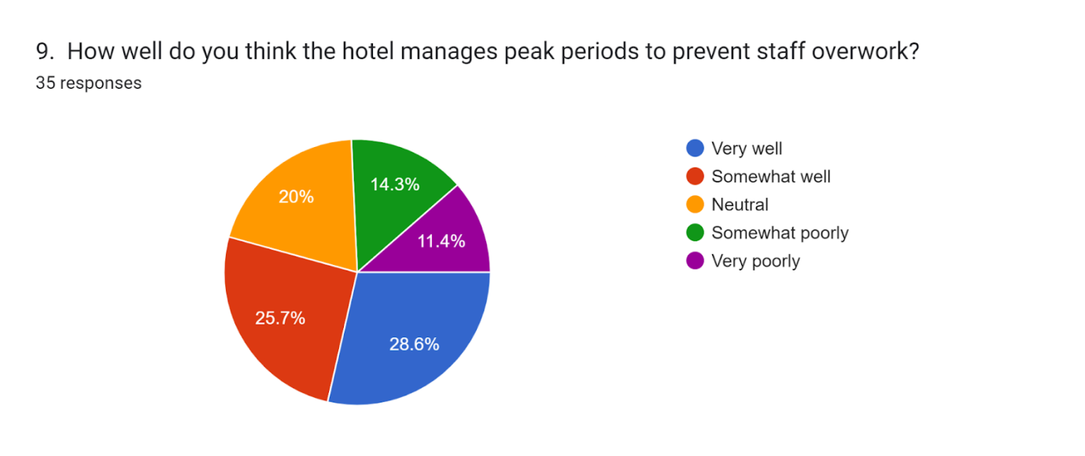This graph shows mixed responses about how Ibis Styles Birmingham manages peak periods in order to avoid staff overwork. While 28.6% think the hotel handles it extremely well, and another 25.7% feel it was handled quite well, a total of 34.3% of respondents believe it was handled poorly-20% somewhat poorly and 14.3% very poorly. The remaining percentage is neutral, which accounts for 11.4%. These results would therefore tend to suggest that some employees are satisfied, but a significant number of them view the management of peak periods as being inadequate, thus providing scope for improvement in terms of support given to staff during these periods of high demand.

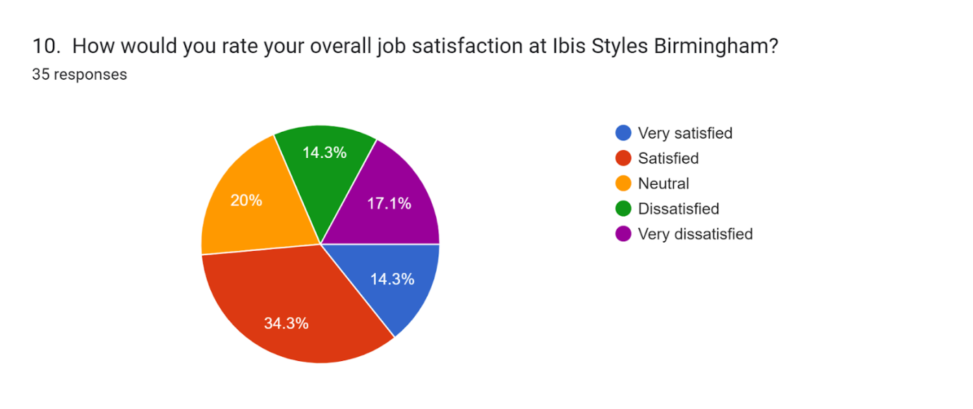This Ibis Styles Birmingham job satisfaction survey depicts a mixed trend in terms of levels of satisfaction among employees. Most, 34.3%, attribute themselves as "Satisfied," while 20% are "Neutral." About 17.1% are "Very Dissatisfied," while equal portions-14.3%-are either "Very Satisfied" or "Dissatisfied." The spread would therefore be considered relatively balanced, with some room for improvement, most notably among the ones showing dissatisfaction. Actions taken to resolve complaints or concerns expressed by less-than-satisfied employees may have the desired impact of pushing more responses into the satisfied categories.

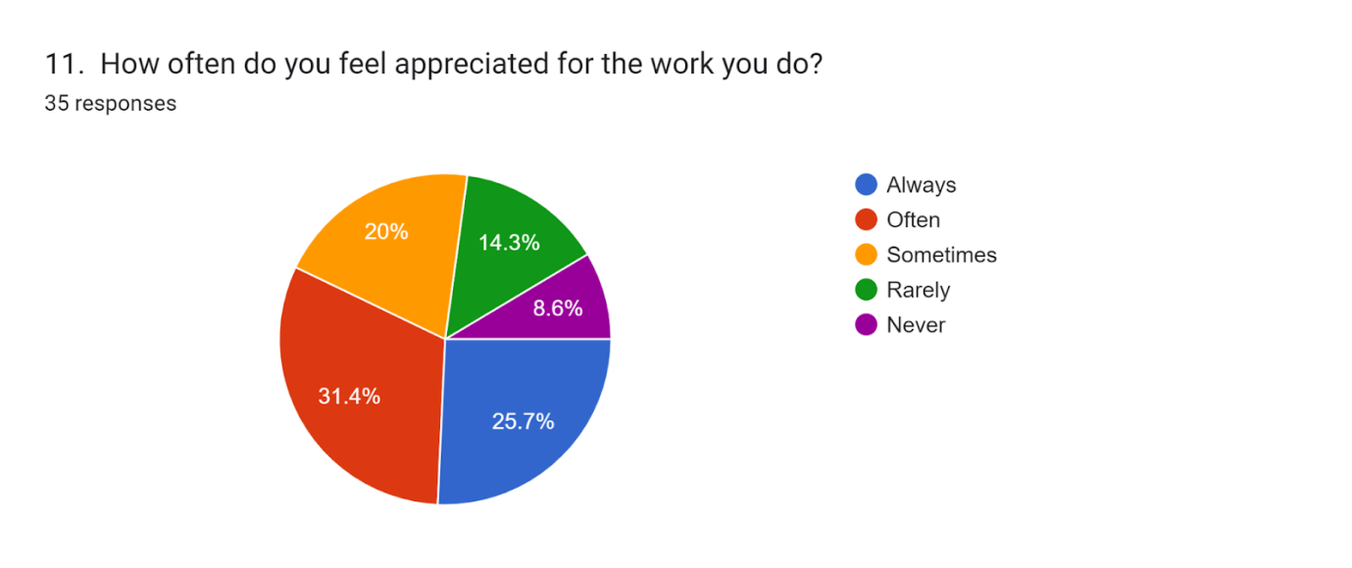
In the employee appreciation research instrument at Ibis Styles Birmingham, the results are varied: although 31.4% reported that they feel appreciated "Often" and 25.7% feel appreciated "Always," fully 20% feel appreciated only "Sometimes," and 14.3% "Rarely." Only 8.6% feel "Never" appreciated. While regular appreciation is realized by the majority, the presence of employees who do feel rarely or never recognized indeed suggests direct room for improvement. Increasing the level of recognition might have an overall positive effect on employee morale and job satisfaction.

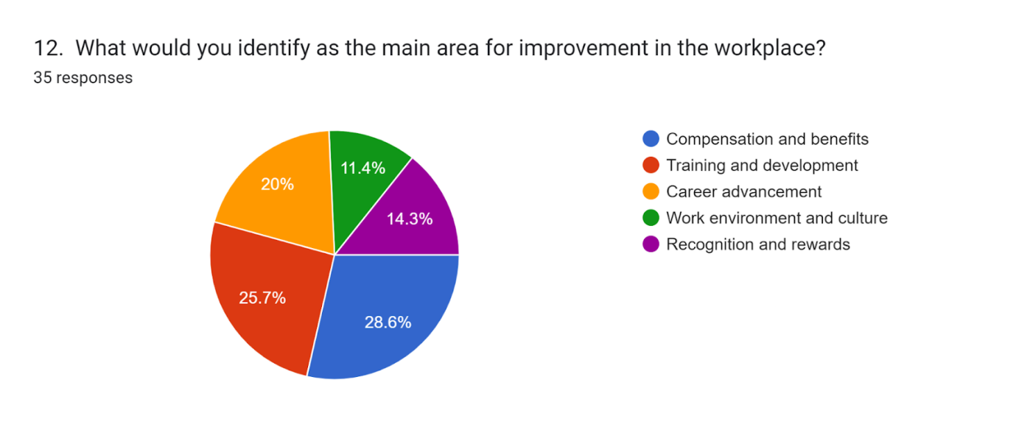
Compensation and benefits was the highest chosen workplace improvement areas, chosen by 28.6% out of the total surveyed. Training and Development was the critical area that came first in precedence in 25.7% of the cases, while 20% was taken by Career Advancement. Work environment and culture scored 11.4%; Recognition and Rewards scored 14.3%. Hence, better compensation, career growth opportunities, and skill development are the key areas for improvement. Addressing these areas could lead to higher employee satisfaction and retention.

6.2 Conclusive Analysis
The responses from Ibis Styles Birmingham indicate various factors that influence job satisfaction and retention. One of the major areas for improvement was found to be in providing training and development opportunities since the ratings about this aspect were generally low. The retention factors indicate that work-life balance and competitive pay mean more than career advancement to employees. Work schedule flexibility also received mixed responses, in that many employees were dissatisfied with it. Though responses are varied regarding managing peak periods to prevent overwork, a significant portion felt that it was poorly managed. In general, the feelings of job satisfaction are mixed; a majority feel somewhat satisfied, while some report dissatisfaction. Appreciation Very generally, the level of appreciation is good, though there is still feelings from some employees that they are not appreciated. Elements to work on would include: better compensation, training, career development, and work-life balance; all these could generally improve satisfaction and retention.

7. Conclusions and Recommendations
The key findings and recommendations from this report highlight, and summarize major insights into the Ibis Styles Birmingham staffing predicament while outlining actionable steps for improvement. Some of the main issues here have been identified as employee turnover rates being high, staffing shortages, pressures of competition, and integrating new technologies that affect operational efficiency in running the hotel and the overall guest experience.
One such finding is the high turnover of employees, which has always adversely reflected service quality and operational stability in the hotel. In fact, some grounds for turnover and dissatisfaction include limited perspective in career building, short training, and less managerial support. Prompt staffing shortages, with the momentum increasing in work and the amount of stress this entails, might suffer from burnout. Consequently, lower staffing levels have resulted in reducing the quality of the guest experience, in that there may not be sufficiently available employees to attend to guest needs. The competitive landscape also adds to the woes of alternative accommodation options such as Airbnb, which are attracting guests to alternative experiences that are more personalized, for instance. Political and regulatory standards in the UK hospitality sector also pressure the hotel to keep employee welfare, safety, and operational compliance at high standards.
Relieving these challenges necessitates an all-encompassing approach to employee retention. This includes systematic career development courses, flexible working conditions, and frequent training sessions. The clear mapping out of defined career tracks within the hotel and the Accor Group will result in higher staff satisfaction and engagement, cultivating growth and opportunity. Their recruitment process today can be improved by an even more stringent and focused approach. This will, in turn, make the onboarding process more engaging and allow for better articulation of the benefits at the hotel. The management should focus on increasing employee engagement through open communication and recognition. Early detection can be achieved through periodic employee satisfaction surveys, results from which would give management ample time to react.
This could hugely improve operational efficiency and enhance guest convenience through investment in technology. Examples include digital check-in kiosks, mobile booking capability, sophisticated HR software to roster employees, and save administrative burdens while simplifying internal processes and enhancing the guest experience. Growing digital capabilities can also support the personalization of guest interactions, noted to reinforce guest loyalty and repeat business. Improvement in workplace culture and work-life balance goes hand in glove. Creating a supportive environment that emphasizes well-being, team-building activities, and competitive compensation packages can enhance staff morale and reduce turnover. Offering performance-based incentives recognizes high-performing employees, motivating them to remain with the organization.
The second area of huge importance is strengthening the brand. This would be able to attract regular guests with regular guests using a loyalty program of Accor, Tic offers, and personalized service. In developing such a process, an investment in Customer Relationship Management tools would need to be made to help the hotel establish a long-term relationship with travelers. Furthermore, this practice of incorporating sustainability into daily operations meets consumer interest in traveling to environmentally-friendly destinations, taken as a tool to feed back into the brand image, meeting environmental expectations. It might continue to include strengthening its brand appeal in the market by way of partnering with local businesses for guest amenities that are sustainable, furthering the cause of eco-conscious tourism in Birmingham.
Outcome The Ibis Styles Birmingham hotel exists in a very aggressive environment, which calls for proactive solutions to the challenges of staffing, technology, and guest expectations. Such areas would be improved by emphasizing employee retention, improving recruitment, digital transformation of processes, and workplace culture. This shall critically improve the quality of service and operational effectiveness. Such recommendations provide a way through which Ibis Styles Birmingham can improve their competitive advantage to ensure long-term growth that enhances employee engagement, operational effectiveness, and customer satisfaction.

8. Reflective Account
During my placement at Ibis Styles Birmingham, I obtained very valuable first-hand experience in the hospitality industry, observing such inner details of the hotel operation process and staffing challenges that came along and impacted service quality and guest satisfaction. This reflective account goes into my personal observation, exploring the particular challenges found in relation to employee retention, customer experience, and possible strategic improvements within the hotel.

8.1 Overview of Staffing Challenges and Employee Retention
One of the most flagrant issues faced was a remarkably high turnover ratio, which is prejudicially problematic in terms of operational consistency and morale in many areas of the departments. While engaging various staff members, the same complaints of limited opportunities for career growth, work pressures due to understaffing, and a lack of necessary training support seemed to arise time and again. Most members themselves felt that their roles in the team were enjoyable but very demanding, which often led to burnout during peak seasons. This observation underlined the need for a more formalized approach toward employee retention, especially in terms of career development pathways and even management support for employees by reducing stress and increasing job satisfaction.

8.2 Guest experience and service quality
During my placement, I also fully realized how staffing levels directly impact the quality of the experiences of guests. I noticed many times how staff shortages would lead to delayed responses to the inquiries of guests, delayed check-in times, and delays in room service. Guests often expect prompt and quick service, especially in a competitive market where alternatives are freely available. This challenge works to effectively balance meager resources against high service standards. In practice, this placed me at an operational perspective whereby the pressures experienced by hotel staff could be understood. It consequently placed demands for systematic improvements that included cross-training and flexible scheduling to ensure that even during busy periods, the hotel could maintain its standards of service without burdensome employees.

8.3 Technology Integration and Operational Efficiency
This placement highlighted the importance of technology in enhancing operational efficiencies. Indeed, I noticed that integrated digital tools, such as an online booking engine or automated check-in kiosks, would greatly alleviate tasks from the front desk and enable staff to engage in more personalized ways with guests. However, I equally noticed that some of the technological systems were either outdated or not being utilized to their best advantage with consequential inefficiencies and extended administrative burdens. Manual scheduling procedures, for example, apart from taking so much time on the management's part, needed optimization with an automated HR software solution. These observations furthered my conviction in the need for digital transformation within the hospitality sector. I believe that investment in more recent technologies would surely enable Ibis Styles Birmingham to perform better and make the guests' experience even smoother and hassle-free. Also, such advancements might ease some pressure off the staff and could reduce turnover by improving their day-to-day work environment.

8.4 Improvement Strategic Recommendations
Looking back at my placement, some of the strategic areas that I thought improvements could be realized to help address the observed challenges include such areas as employee retention. These can be addressed through an organized career development program, mentorship opportunities, and regular colloquia, which can be used as pathways to nurture an environment of growth and stability. Encouraging supportiveness among employees-a sense that all are cared about and valued should hopefully retard turnover and boost morale. Other important suggestions include offering flexible shifts and interdepartmental training so that enough staff are retained for peak seasons to cope with customer demand. The cross-training of employees can assist in many tasks, therefore, maintaining a flexible workforce and reducing special operation complications that arise due to unexpected absences or volumes of guests.
Lastly, technology improvements must be pursued: efficient management systems, from automating the scheduling process to digital check-in, would minimize administrative hassles and free resources to interact better with guests. Technology can be used to acquire valuable insights into the guest's preferences, which would be beneficial for the hotel in offering a more personalized and enjoyable time to its guests.

8.5 Personal and Professional Development
This placement in Ibis Styles Birmingham gave me an excellent opportunity to explore in real-time how the hospitality industry works, thus fostering personal and professional growth. In close contact with the staff of all departments, I had to develop empathy towards the challenges they have to put up with in order to realize the significance of effective management strategies that would protect the welfare of all employees. This experience instilled in me an even greater awareness of human resources and operational strategy that I am now prepared to execute in future roles. On the professional level, I acquired a sense of how meaningful it is to fit any situation and proactively solve a problem in such a timely environment. This placement has allowed me to comprehend how management decisions at every level affect daily work and employee satisfaction and thus thoughtful, evidence-based practices while trying to resolve staffing and operational challenges. I feel better equipped now to make a positive contribution to the hospitality industry and be an advocate for sustainable, employee-centered practices that benefit the workforce and the organization.
All in all, this placement has provided me with a wide-angle view of the challenges and avenues for improvement that exist internally at Ibis Styles Birmingham. It has again underpinned employee satisfaction, integration of technology, and strategic planning as very key in any hospitality business. I feel working at firsthand with the real effects of turnover, operational demands, and technological limitations has prepared me for more effective approaches to dealing with these challenges in my future career, advocating for holistic strategies beneficial to employees and guests alike. This placement has solidified my commitment to finding ways that would stabilize the workforce, streamline operations, and, by doing so, bring excellence to the guest experience.

9. References
Abhari, S., Jalali, A., Jaafar, M. and Tajaddini, R., 2022. The impact of Covid-19 pandemic on small businesses in tourism and hospitality industry in Malaysia. Journal of Research in Marketing and Entrepreneurship, 24(1), pp.75-91. https://doi.org/10.1108/JRME-07-2020-0091
Abrudan, I.N., Pop, C.M. and Lazăr, P.S., 2020. Using a general ordered logit model to explain the influence of hotel facilities, general and sustainability-related, on customer ratings. Sustainability, 12(21), pp.1-22. http://dx.doi.org/10.3390/su12219302
Accor (2023). ALL - Accor Live Limitless lifestyle loyalty programme. [online] all.accor.com. Available at: https://all.accor.com/loyalty-program/reasonstojoin/index.en.shtml
Adanse, J., Khayiya, R. and Maranga, V., 2024. Influence of optimal room occupancy strategies on revenue maximisation during slack periods in selected 3-to 5-star hotels in Ghana. Research in Hospitality Management, 14(1), pp.57-69. https://doi.org/10.1080/22243534.2024.2357035
Adula, M., Kant, S. and Birbirsa, Z.A., 2022. Systematic Literature Review on Human Resource Management Effect on Organization Performance. Annals of Human Resource Management Research, 2(2), pp.131-146. https://doi.org/10.35912/ahrmr.v2i2.1418
Al-Ansi, A.M., Jaboob, M. and Awain, A.M.S.B., 2023. Examining the mediating role of job satisfaction between motivation, organizational culture, and employee performance in higher education: A case study in the Arab region. Education Science and Management, 1(1), pp.30-42. https://doi.org/10.56578/esm010104
Alhassan, S., 2020. An assessment of the role of hotel front desk on customer satisfaction a case study of two selected hotels in Tamale Metropolis, UnEW, pp.1-140. http://ir.uew.edu.gh:8080/bitstream/handle/123456789/2101/An%20assessment%20of%20the%20role%20of%20hotel%20front%20desk%20on%20customer%20satisfaction%20%20a%20case%20study%20of%20two%20selected%20hotels%20in%20Tamale%20Metropolis.pdf?sequence=1&isAllowed=y
Ali, B.J. and Anwar, G., 2021. An Empirical Study of Employees’ Motivation and its Influence Job Satisfaction. International Journal of Engineering, Business and Management, 5(2), pp.21-30. https://doi.org/10.22161/ijebm.5.2.3
Alrawabdeh, W., 2021. Seasonal balancing of revenue and demand in hotel industry: the case of Dubai City. Journal of Revenue and Pricing Management, 21(1), pp.1-14. https://doi.org/10.1057/s41272-021-00290-6
Arapou, D. and Kapiki, S., 2023. Enhancing the Guest Experience in Hospitality Through Technology: An Outlook of the Future, pp.1-24. https://ssrn.com/abstract=4660192
Bardukova, L., 2023. Navigating the Hospitality Horizon: Current Trends and Strategies for Customer Attraction and Retention in the Hotel Industry. Economics and computer science, 2, pp.88-103. https://eknigibg.net/Volume9/Issue2/spisanie-br2-2023_pp.88-103.pdf
Bukhari, M., Sattar, S., Nawaz, S., Ijaz, S., Al-Sulaiti, K. and Abbas, J., 2024. Customers incivility, country-of-origin effects on the tourism sector, job satisfaction, and organizational citizenship behavior: testing a mediational model. Journal of Excellence in Management Sciences, 3(4), pp.1-19. https://doi.org/10.69565/jems.v3i4.342
Campbell, S., Greenwood, M., Prior, S., Shearer, T., Walkem, K., Young, S., Bywaters, D. and Walker, K., 2020. Purposive sampling: complex or simple? Research case examples. Journal of research in Nursing, 25(8), pp.652-661. https://doi.org/10.1177/1744987120927206
Chaichi, K., Trupp, A., Ranjanthran, M. and Thirumaran, K., 2023. Robotic life of casino employees: exploring well-being dimensions in the gambling industry in Malaysia. Equality, Diversity and Inclusion: An International Journal, 42(4), pp.512-529. https://doi.org/10.1108/EDI-02-2022-0051
Chankaew, K. and Kiattisin, S., 2023. Development And Psychological For Digital Transformation In The Service Industry And Its Impact On Information Technology Management. Journal for ReAttach Therapy and Developmental Diversities, 6(4s), pp.504-512. https://doi.org/10.53555/jrtdd.v6i4s.2549
Chunga, T.T.K. and Phuc, H.M., 2024. Recovery of human resources in the hospitality industry post COVID-19 in Vietnam: Current situation and solutions. DTU Journal of Science and Technology, 03(64), pp.52-62. https://files02.duytan.edu.vn/svruploads/dtu-duytan/upload/file/638582042056598852-7(64).-Recovery-of-human-resources-in-the-hospitality-industry-post-COVID-19-in-Vietnam-(Tr%E1%BB%8Bnh-Th%E1%BB%8B-Kim-Chung).pdf
Codling, S., Pinnock, J., Barrett, E., Gayle, S., Stephenson, N., Sibblies, N. and Sinclair-Maragh, G., 2022. Factors contributing to staff turnover in the hotel industry: A literature review. People Management-Highlighting Futures, pp.. https://www.intechopen.com/chapters/84110
Dafillin, M. and Wijoyo, T.A., 2024. Elevating Guest Experience: Enhancing Order Taker Services At The Sunan Hotel. Journal of International Multidisciplinary Research, 2(5), pp.132-138. https://doi.org/10.62504/jimr442
Davahli, M.R., Karwowski, W., Sonmez, S. and Apostolopoulos, Y., 2020. The hospitality industry in the face of the COVID-19 pandemic: Current topics and research methods. International Journal of Environmental Research and Public Health, 17(20), pp.1-12. https://doi.org/10.3390/ijerph17207366
DP, N. and Riana, I.G., 2020. The influence of physical work environment and organizational culture on work motivation and employee performance at Ibis Styles Bali Denpasar Hotel. American Journal of Humanities and Social Sciences Research (AJHSSR), 4(8), pp.43-51. https://www.ajhssr.com/wp-content/uploads/2020/08/F20484351.pdf
Duan, J., Xie, C. and Morrison, A.M., 2022. Tourism crises and impacts on destinations: A systematic review of the tourism and hospitality literature. Journal of Hospitality & Tourism Research, 46(4), pp.667-695. https://doi.org/10.1177/1096348021994194
Dwesini, N.F., 2019. Causes and prevention of high employee turnover within the hospitality industry: A literature review. African Journal of Hospitality, Tourism and Leisure, 8(3), pp.1-15. https://core.ac.uk/download/pdf/200897091.pdf
Dzia-Uddin, D.N., Anuar, J., Fahmi, N.M.Z.N.M. and Kamarudin, W.N.B.W., 2023. A Review Paper on Technological Innovation of Hotel Industry in Post-Pandemic. International Journal of Business and Technology Management, 5(S1), pp.9-25. https://myjms.mohe.gov.my/index.php/ijbtm/article/view/23575
Edirisinghe, S.D. and Manuel, S., 2019. Factors affecting sales employee turnover in hotel & travel industry: A literature review. Journal of Humanities and Social Science, 24(5), pp.35-54. https://doi.org/10.9790/0837-2405073554
El Hajal, G. and Rowson, B., 2021. The future of hospitality jobs: The rise of the gig worker. Research in Hospitality Management, 11(3), pp.185-190. https://doi.org/10.1080/22243534.2021.2006938
Elsafty, A. and Oraby, M., 2022. The impact of training on employee retention: An empirical research on the private sector in Egypt. International Journal of Business and Management, 17(5), pp.58-74. https://www.researchgate.net/profile/Ashraf-Elsafty/publication/359742966_The_Impact_of_Training_on_Employee_Retention_An_Empirical_Research_on_the_Private_Sector_in_Egypt/links/624c63fccf60536e2343e116/The-Impact-of-Training-on-Employee-Retention-An-Empirical-Research-on-the-Private-Sector-in-Egypt.pdf?trk=public_post_comment-text
El-Said, O. and Aziz, H., 2022. Job satisfaction and potential opportunities for career growth among hotel employees: The case of Oman. Tourism and Hospitality Research, 22(4), pp.488-507. https://doi.org/10.1177/14673584221074925
Fan, A., Shin, H.W., Shi, J. and Wu, L., 2023. Young people share, but do so differently: an empirical comparison of peer-to-peer accommodation consumption between millennials and generation Z. Cornell Hospitality Quarterly, 64(3), pp.322-337. https://doi.org/10.1177/19389655221119463
Farmaki, A. and Miguel, C., 2022. Peer-to-peer accommodation in Europe: Trends, challenges and opportunities. The sharing economy in Europe: Developments, practices, and contradictions, pp.115-136. https://openarchive.usn.no/usn-xmlui/bitstream/handle/11250/3047996/2021LeickExploring_POSTPRINT.pdf?sequence=4
Formica, S. and Sfodera, F., 2022. The Great Resignation and Quiet Quitting paradigm shifts: An overview of current situation and future research directions. Journal of Hospitality Marketing & Management, 31(8), pp.899-907. https://doi.org/10.1080/19368623.2022.2136601
Garnero, A. and Lucifora, C., 2022. Turning a ‘blind eye’? Compliance with minimum wage standards and employment. Economica, 89(356), pp.884-907. https://doi.org/10.1111/ecca.12421
Ghani, B., Zada, M., Memon, K.R., Ullah, R., Khattak, A., Han, H., Ariza-Montes, A. and Araya-Castillo, L., 2022. Challenges and strategies for employee retention in the hospitality industry: A review. Sustainability, 14(5), pp.1-26. https://doi.org/10.3390/su14052885
Giousmpasoglou, C., 2024. Working Conditions in the Hospitality Industry: The Case for a Fair and Decent Work Agenda. Sustainability, 16(19), pp.1-12. https://doi.org/10.3390/su16198428
Grabs, J., 2023. A theory of credible cross‐temporal corporate commitments as goal‐based private sustainability governance. Business Strategy and the Environment, 32(8), pp.5146-5160. https://doi.org/10.1002/bse.3423
Hadjisolomou, T., Booyens, I., Nickson, D., Cunningham, T. and Baum, T., 2022. Fair work for all? A review of employment practices in the Scottish hospitality industry, pp.1-31. https://strathprints.strath.ac.uk/89231/
Hao, F., Xiao, Q. and Chon, K., 2020. COVID-19 and China’s hotel industry: Impacts, a disaster management framework, and post-pandemic agenda. International Journal of Hospitality Management, 90, pp.1-12. https://doi.org/10.1016/j.ijhm.2020.102636
Heimerl, P., Haid, M., Benedikt, L. and Scholl-Grissemann, U., 2020. Factors influencing job satisfaction in hospitality industry. SAGE open, 10(4), pp.1-12. https://doi.org/10.1177/2158244020982998
Ibrahim, A.M., 2024. Organizational attachment in hospitality organizations: a review. Research in Hospitality Management, 14(1), pp.94-99. https://doi.org/10.1080/22243534.2024.2357032
Ibrahim, M. and Rasheed, A., 2024. Exploring the Link Between Customer Relationship Management and Hotel Performance. Journal of Policy Options, 7(1), pp.1-10. http://resdojournals.com/index.php/jpo/article/view/348
IFR (2024) 2024 Interim Financial Report of ACCOR Group. Available at: https://group.accor.com/-/media/Corporate/Investors/Documents-financiers/2024/07-25-H1/Interim_Financial_Report_2024_Accor.pdf?rev=0890df5b8f3740fa916726a8d3168bcb#:~:text=Premium%2C%20Midscale%20and%20Economy%2C%20which,current%20weakness%20of%20leisure%20demand
Islam, M.T., 2021. Recruitment of fresh graduates in the hospitality industry: an overview. Hospitality and Tourism: Emerging Practices in Human Resource Management, pp.30-37. https://www.researchgate.net/publication/348916554_E-Recruitment_of_Fresh_Graduate_in_the_Hospitality_Industry_An_Overview
Khan, N.U., Wei, H., Yue, G., Nazir, N. and Zainol, N.R., 2021. Exploring themes of sustainable practices in manufacturing industry: Using thematic networks approach. Sustainability, 13(18), pp.1-25. https://doi.org/10.3390/su131810288
Khatter, A., 2023. Challenges and solutions for environmental sustainability in the hospitality sector. Sustainability, 15(15), pp.1-10. https://doi.org/10.3390/su151511491
Kim, H., Sefcik, J.S. and Bradway, C., 2017. Characteristics of qualitative descriptive studies: A systematic review. Research in nursing & health, 40(1), pp.23-42. https://doi.org/10.1002/nur.21768
Kim, S., Wang, Y. and Boon, C., 2021. Sixty years of research on technology and human resource management: Looking back and looking forward. Human Resource Management, 60(1), pp.229-247. https://doi.org/10.1002/hrm.22049
Kravariti, F., Voutsina, K., Tasoulis, K., Dibia, C. and Johnston, K., 2022. Talent management in hospitality and tourism: a systematic literature review and research agenda. International Journal of Contemporary Hospitality Management, 34(1), pp.321-360. https://doi.org/10.1108/IJCHM-03-2021-0365
Kumar, P. and Chansoria, M., 2021. Assessment of Hospitality education in terms of Lacking Skill Development in Meeting the demand of Industry: An Integrative review. Revista de turism-studii si cercetari in turism, (31), pp.1-12. http://www.revistadeturism.ro/rdt/article/view/493
Kurdi, B. and Alshurideh, M., 2020. Employee retention and organizational performance: Evidence from banking industry. Management Science Letters, 10(16), pp.3981-3990. http://dx.doi.org/10.5267/j.msl.2020.7.011
Kyalo, J., 2023. Effect of short course training on service delivery in the hospitality industry in housekeeping and laundry department of Kenya Utalii College. Journal of Hospitality and Tourism, 3(1), pp.14-30. https://doi.org/10.47672/jht.1386
Latip, S.N.N.A., Latip, M.S.A., Tamrin, M. and Nawi, M.Z.M., 2022, September. The perspective of work ergonomics on employee task performance in hotel and tourism industry, Malaysia. In Proceedings, 82(1), pp.1-7. https://doi.org/10.3390/proceedings2022082007
Ledi, K.K., Ameza-Xemalordzo, E.B. and Owusu Ansah, M., 2023. Mediating role of work intentions in the relationship between workplace spirituality and service quality delivery of hotels in Ghana. Journal of Quality Assurance in Hospitality & Tourism, pp.1-26. https://doi.org/10.1080/1528008X.2023.2231147
Leick, B., Kivedal, B.K., Eklund, M.A. and Vinogradov, E., 2022. Exploring the relationship between Airbnb and traditional accommodation for regional variations of tourism markets. Tourism Economics, 28(5), pp.1258-1279. https://doi.org/10.1177/1354816621990173
Manzoor, F., Wei, L. and Asif, M., 2021. Intrinsic rewards and employee's performance with the mediating mechanism of employee's motivation. Frontiers in psychology, 12, pp.1-13. https://doi.org/10.3389/fpsyg.2021.563070
Mosadeghrad, A.M., Ferlie, E. and Rosenberg, D., 2011. A study of relationship between job stress, quality of working life and turnover intention among hospital employees. Health services management research, 24(4), pp.170-181. https://doi.org/10.1258/hsmr.2011.011009
Najafi, V., 2024. Exploring Front Desk Employees' Perceptions of Technology in Hotel Information Systems: An Integration of Technology Acceptance and Self-Efficacy Models, pp.1-61. https://www.theseus.fi/handle/10024/862750
O’Neill, J.W., Zhao, J., Liu, P. and Caligiuri, M.D., 2023. Benchmarking Hotel Investment Risk: Differences Based on Types of Hotels. Cornell Hospitality Quarterly, 64(4), pp.485-502. https://doi.org/10.1177/19389655231164061
Othman, B., He, W., Huang, Z., Xi, J. and Ramsey, T., 2021. The effects on service value and customer retention by integrating after sale service into the traditional marketing mix model of clothing store brands in China. Environmental Technology & Innovation, 23, pp.1-13. https://doi.org/10.1016/j.eti.2021.101784
Ozdemir, O., Han, W. and Dalbor, M., 2022. Economic policy uncertainty and hotel occupancy: the mediating effect of consumer sentiment. Journal of Hospitality and Tourism Insights, 5(2), pp.253-273. https://doi.org/10.1108/JHTI-08-2020-0149
Pelet, J.É., Lick, E. and Taieb, B., 2021. The internet of things in upscale hotels: its impact on guests’ sensory experiences and behavior. International Journal of Contemporary Hospitality Management, 33(11), pp.4035-4056. https://doi.org/10.1108/IJCHM-02-2021-0226
Prabhu, G.N. and Aithal, P.S., 2023. Inbound corporate social responsibility model for selected Indian banks and their proposed impact on attracting and retaining customers–A case study. International Journal of Applied Engineering and Management Letters (IJAEML), 7(3), pp.55-74. https://supublication.com/index.php/ijaeml/article/view/472
Puspita, N.K.D., Nadra, N.M., Suparta, I.K. and Anggraheni, R.R.R., 2023. Analysis of Work Skills and Work Discipline in Improving Hotel Employee Performance. International Journal of Glocal Tourism, 4(4), pp.360-373. https://ejournal.sidyanusa.org/index.php/injogt/article/view/584
Ramadan, Z., Farah, M. and Al Rahbany, N., 2023. Boosting customized and personalized interactive livestreaming experiences. Is Amazon Explore competing or complementing the hospitality industry?. Qualitative Market Research: An International Journal, 26(5), pp.473-493. https://doi.org/10.1108/QMR-12-2021-0148
Runeson, P. and Höst, M., 2009. Guidelines for conducting and reporting case study research in software engineering. Empirical software engineering, 14, pp.131-164. https://doi.org/10.1007/s10664-008-9102-8
Sepahvand, R. and Bagherzadeh R., K., 2021. Strategic human resource management practices and employee retention: A study of the moderating role of job engagement. Interdisciplinary Journal of Management Studies (Formerly known as Iranian Journal of Management Studies), 14(2), pp.437-468. https://doi.org/10.22059/ijms.2020.291391.673843
Sergeevna, T.V., 2024. Examining the Effects of Organizational Culture on Guest Satisfaction in the Hotel Industry, The Ritz-Carlton Hotel Company Case, pp.1-72. https://dspace.spbu.ru/bitstream/11701/46781/2/Temnikova_VKR.pdf
Silic, M., Marzi, G., Caputo, A. and Bal, P.M., 2020. The effects of a gamified human resource management system on job satisfaction and engagement. Human Resource Management Journal, 30(2), pp.260-277. https://doi.org/10.1111/1748-8583.12272
Stylos, N., Zwiegelaar, J. and Buhalis, D., 2021. Big data empowered agility for dynamic, volatile, and time-sensitive service industries: the case of tourism sector. International Journal of Contemporary Hospitality Management, 33(3), pp.1015-1036. https://doi.org/10.1108/IJCHM-07-2020-0644
Taecharungroj, V. and Prasertsakul, D., 2023. Placeful business: Reimagining a small business concept that embraces and enriches places. Sustainability, 15(12), pp.1-19. https://doi.org/10.3390/su15129370
Terry, G., Hayfield, N., Clarke, V. and Braun, V., 2017. Thematic analysis. The SAGE handbook of qualitative research in psychology, 2(17-37), pp.1-56. https://uwe-repository.worktribe.com/preview/888534/terry%20et%20al.%20in%20willig%20and%20stainton%20rogers.pdf
Vahdat, S., 2022. The role of IT-based technologies on the management of human resources in the COVID-19 era. Kybernetes, 51(6), pp.2065-2088. https://doi.org/10.1108/K-04-2021-0333
Wandelt, S. and Wang, K., 2024. Towards solving the airport ground workforce dilemma: A literature review on hiring, scheduling, retention, and digitalization in the airport industry. Journal of the Air Transport Research Society, pp.1-12. https://doi.org/10.1016/j.jatrs.2024.100004
Wang, C.N., Tran, K.M., Huang, C.C., Wang, Y.H. and Dang, T.T., 2022. Supporting Luxury Hotel Recovered in Times of COVID-19 by Applying TRIZ Method: A Case Study in Taiwan. Systems, 10(2), pp.1-17. https://doi.org/10.3390/systems10020033
Wang, P., Chen, S., Cuifang, A.L. and Xiuxi, S.Z., 2023. The post-pandemic workplace: issues and insights for future research and action. Elgar Companion to Managing People Across the Asia-Pacific, pp.19-46. https://doi.org/10.4337/9781802202250.00008
Weerathunga, P.R., Xiaofang, C., Samarathunga, W.H.M.S. and Jayathilake, P.M.B., 2020. The relative effect of growth of economy, industry expansion, and firm-specific factors on corporate hotel performance in Sri Lanka. Sage Open, 10(2), pp.1-21. https://doi.org/10.1177/2158244020914633
Wiles, R., Crow, G., Heath, S. and Charles, V., 2008. The management of confidentiality and anonymity in social research. International journal of social research methodology, 11(5), pp.417-428. https://doi.org/10.1080/13645570701622231

