

Programme: Master of Business Administration
Module: International Marketing: Principles and Practices
Assignment
Module Code: LCMB7026

Title: Assessment component 1: Individual report
International Marketing Analysis of Zara in Spain and the host country, India

Student Name- Harikrushna Patel
Student ID: 2432869

Table of Contents
Section 1 4
1. Introduction 4
2. Background of ZARA 4
3. The Macro environment 5
3.1. PESTLE Analysis 5
4. STP Strategy 10
4.1 Segmentation 10
4.2 Targeting 11
4.3 Positioning 12
5. Marketing Mix 7Ps 16
6. Ansoff matrix 20
7. Ethical Issues in India 21
8. Recommendations 22
9. Conclusion 23
Section 2: Reflective Account 24
1.1 Description 24
1.2 Feelings 25
1.3 Evaluation 25
1.4 Analysis 26
1.5 Conclusion 26
1.6 Action Plan 26
References 28
Appendices 36
Appendix 1: Spain People's Trust in National Government 36
Appendix 2: Political Stability in Spain 36
Appendix 3: Economic Growth of Spain 37
Appendix 4: Customer Spending in Spain 37
Appendix 5: Innovation Index of Spain 38
Appendix 6: Political Stability Index of India 38
Appendix 7: Economic Growth of India 39
Appendix 8: Consumer Spend in India 39

Section 1

1. Introduction
Understanding the requirements of international marketing, particularly beginning with identifying that success demands strategies. It needs deep insights into the consumer behaviour, cultural context, regulations, and competitive landscape as well. This report will analyse how the firm originates from its home country, Spain, and has expanded its branches into the host country, India. The study will compare both the country's significance using the PESTLE framework, Hofstede's model, STP analysis, marketing mix and growth strategies. And this report also hold Gibb’s Reflective cycle, The report will discuss what are the strategies used by Zara in its home country, Spain, and host country, India.

2. Background of ZARA
Zara is a Spanish fast-fashion retailer company founded in 1975 by Amancio Ortega and Rosalia Mera, known as one of the world's leading companies (Roll, 2021). Zara is owned by Inditex, which is the largest fashion retailer throughout the world, and it runs a strong chain, and it includes Pull & Bear and Massimo Dutti too (Simpson, 2025). Zara has accounted for almost 70% of Inditex’s €35.9 billion and accounts for around 73% of the EBIT of the group (Lindner, 2025). Zara has generated high sales as compared to other segments of Inditex, as the sales to third parties by Zara are 27,959 (Inditex, 2024). Zara is also operating a huge global retail network, and the number of stores it has is around 2,150. The revenue of Zara is US$8,747 m as of the year 2025, which represents a change of around 5 to 10% from the last year (Ecdb, 2026). Zara is further expected to see a slightly higher rate of growth in 2026 as compared to the year 2025.
- Mission: Zara aims to meet customer fashion needs by delivering trendy, affordable products quickly and efficiently.
- Vision: Zara seeks to support sustainable development in society while reducing its environmental impact and promoting responsible fashion.

3. The Macro environment

3.1. PESTLE Analysis
A PESTEL analysis is a framework or tool used by marketers for the analysis and monitoring of the macro environment or the external marketing environment of the organisation, company, or industry (Segura et al., 2023) (Refer to Figure 1). PESTEL analysis is used for the identification of weaknesses and threats, which are further used in the SWOT analysis.
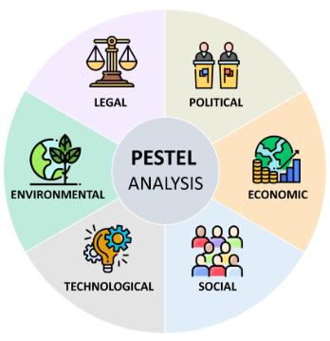
Figure 1: PESTLE Analysis
(Source: Segura et al., 2023)
Political
Spain: In Spain, 37% of people trusted their government to a great or moderately high extent (OECD, 2025) [Refer to Appendix 1]. The majority of people (57%) reported being satisfied with the administrative services they received. The political stability index decreased from 0.15 points to 0 in 2024, which shows an unstable political situation in Spain (The Global Economy, 2025c) [Refer to Appendix 2]. [Unfavourable]
India: In the year 2025, the Budget on Union increased the sectoral cap of the insurance sector from 74% to 100%. (Pib, 2025). India’s political stability index is highly unstable, -7.9 points (The Global Economy, 2025a) [Refer to Appendix 6]. In 2025, the Political right index is the same as in 2024, that is, 2 points (The Global Economy, 2025a). [Unfavourable]

Economic
Spain: Spain has a stable but slow growth in the fashion market (Suarez-Visbal et al., 2023). Spain’s economic growth is 2.6%, which is a decrease from 2.7% in the previous quarter of the year, and the inflation rate has also decreased from the previous value (The Global Economy, 2025b) [Refer to Appendix 3]. [Unfavourable]
India: India experienced high economic growth (Suarez-Visbal et al., 2023). The economic growth of India increased in 7.34% from 6.89% in 2025 (The Global Economy, 2026a) [Refer to Appendix 7]. The inflation rate decreased (0.25%) in 2025 compared to the previous value (The Global Economy, 2026b). [Favourable]

Social
Spain: In Spain, consumer spending has increased from €230663 Million to €235827 Million in the fourth quarter of 2025 (Trading Economics, 2026c) [Refer to Appendix 4]. High consumer spending increases consumer spending intention, which positively increases the fashion business's growth. [Favourable]
India: Consumer spending in India increased to 104.46 points in January from 104.10 points in December 2025 (Trading Economics, 2026b) [Refer to Appendix 8]. Population growth in India was reported at 0.89071 % in 2024 (Trading Economics, 2026a). [Favourable]

3.2 Cultural Analysis using Hofstede Model
Hofstede’s Cultural Dimension theory, developed by Geert Hofstede in 1980, can be used to identify the influence of cultural values, beliefs and behaviours in a workplace (Piotrowska and Piotrowski, 2023). This theory can also help to acknowledge the cultural differences between Spain and India to analyse the international marketing aspects of Zara. Figure 2 evaluated the cultural differences between India and Spain, which may highlight an impact on the business strategy of Zara in both markets.
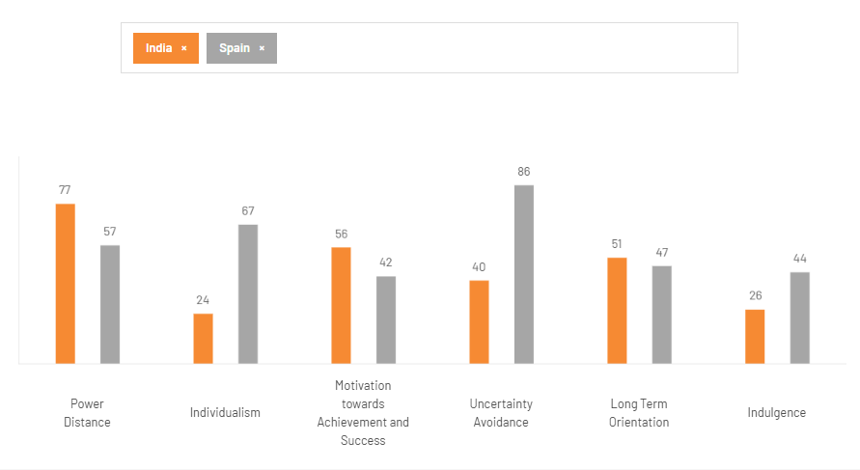
Figure 2: Cultural Differences Between India and Spain
(Source: The Culture Factor, 2020)
Power Distance:
The dimension of power distance describes that a country with a high score in this dimension expresses their perspectives and attitudes towards inequalities. The high score of 77 for Indian people in this dimension indicates that these people support inequalities more (The Culture Factor, 2020). On the other hand, Spain highlights a score of 57, which indicates a lower rate of inequalities in Spanish culture. Zara in Spain operates a more horizontal structure, which fosters effective communication between the store managers and the headquarters (Inditex, 2020). On the other hand, this company in India is more likely to adopt an authoritative approach.
Individualism:
The dimension of individualism indicates that a country with a high score in this dimension prefers an individualistic culture. The Indian people prefer a collectivist society to an individualistic one in Spanish culture (The Culture Factor, 2020). This may have an impact on the operations of Zara. The company changed its marketing strategy in India by adapting to India's collectivist culture and tradition (Jangid, 2022). This company valued the family and occasion wear with climate-appropriate clothing.
Motivation towards Achievement and Success:
A high score in this dimension indicates that the country is considered a decisive society. The Culture Factor (2020) discussed that India is also considered a decisive society which prefers more emphasis on its traditional aspects rather than achievement and success, such as Spain. Zara identified that Spanish people prefer fast fashion models with some short-term trends (Li, 2021). On the other hand, Indian people prefer a combination of their traditional and modern outfits during festive seasons.
Uncertainty Avoidance:
India usually accepts imperfection, unlike Spain, which indicates that India scored lower than Spain’s 66 score in the dimension of uncertainty avoidance (The Culture Factor, 2020). According to Jonwal (2025), Zara fostered strong local store management to strengthen its business in India efficiently.
Long Term Orientation:
Indian culture believes in ‘karma’, which is a religious and philosophical concept. On the other hand, Spain introduced the whole world to the meaning of ‘fiesta’ (The Culture Factor, 2020). Zara also identified that the consumers of India prefer durable, versatile and traditional clothing (Zhang et al., 2021). Zara offers value-conscious and cheaper products in India by focusing on the price-sensitive market of India.
Indulgence:
Indian people are considered cynical and pessimistic, with a very low score of 26 in the indulgence dimension (The Culture Factor, 2020). On the other hand, Spain scored high with a score of 44 in this dimension. Zara in India is considered a ‘luxury’ and ‘premium’ brand, whereas in Spain, this brand is more accessible (Bhandari et al., 2022). Zara operates its functions in India differently from how it operates in Spain due to the cultural differences and preferences of the customers.
Advantages and disadvantages
One major advantage is that Zara in Spain operates a more horizontal structure, which assists them in fostering effective communication between the store managers and the headquarters. Additionally, Indian people prefer an accurate combination of their traditional and modern outfits, mainly during festive seasons, which creates an opportunity for Zara. The blend of traditional with modern aspects is leading to great opportunities for the growth of Zara in both India and Spain. While the disadvantage is that Zara cannot use a single strategy in both countries due to behavioural and cultural differences. Zara needs to use different strategies and optimistic practices to run businesses in the mentioned countries, which requires careful investigation of the market and funding as well.

Technological
Spain: Spain has engaged with AI and virtual tools due to e-commerce expansion. The innovation index in Spain decreased by 44.6 points from 44.9 points in 2025 (The Global Economy, 2026c) [Refer to Appendix 5]. [Unfavourable]
India: India has engaged with virtual tools and AI due to e-commerce expansion. The innovation index of India increase in the 38.20 in the 2025 financial year (The Global Economy, 2026b). [Favourable]

Legal
Spain: Spain has strong labour laws (Lerouge and Trujillo Pons, 2022). Spain has various laws, including Organic laws, Ordinary laws, Legislative decrees, Degree-laws, and Case-laws (Europa, 2024). [Favourable]
India: India follows a complex compliance system (Lerouge and Trujillo Pons, 2022). India has incorporated various legal factors in the fashion industry, such as the Designs Act 2000 (protecting aesthetics), Copyright Act 1957 (designs), Trademarks Act 1999 (branding), and Consumer Protection Act 2019 (Khurana, 2024). [Unfavourable]

Environmental
Spain: Greenhouse gas emissions in Spain were 293.8 MtCO2-eq in 2022, which is an increase from 2021 (Europa, 2023). Carbon emission decreases in 2023 are 217 Mt CO2 eq from 235 Mt CO2 eq in 2022 (The Global Economy, 2024). [Favourable]
India: India has increased its awareness about eco-conscious shopping behaviour. In India in 2020, Greenhouse Gas emission reduced in 7.93% compared to 2019 (Pib India, 2025). [Favourable]
Analysis:
The above 2 table discusses the external environmental factors of Spain and India through PESTLE analysis. Both Spain and India have unfavourable political factors; Spain’s political index is 0.15, whereas India's political index shows -7.9 points. The economic factor of Spain is unstable; therefore, for India, this is favourable. The social factor is favourable for both the country and consumer spending is high. The technological factor is unfavourable for Spain, but favourable for India. In terms of legal factors, Spain has a strong labour law, but in India there is a complex compliance system. However, for both countries, the environmental factor is favourable.

4. STP Strategy

4.1 Segmentation
Segmentation in Spain
Psychographic
The Spanish Luxury Fashion & Lifestyle Market is valued at approximately USD 15 billion, mainly based on the last five-year historical analysis (Kenresearch, 2024). This growth is particularly driven by the constantly increasing incomes, an increasing number of customers and a growing inclination towards the luxury and premium products.
Geographic
Barcelona is considered a vibrant metropolis on Spain’s Mediterranean coast that has further emerged as a significant global fashion hub (Wad, 2026). 50% of all items of Zara are manufactured within Spain, and the factories use almost flexible manufacturing systems for instant operations (Scmglobe, 2020).
Demographic
The fashion market of Spain can be categorised mainly based on end users, including both men and women, along with children. The women's segment is dominating the market, which is ultimately driven by a high propensity for luxury spending, which is among female consumers (Kenresearch, 2024).
Behavioural
There is an increasing brand consciousness and prestige demand along with the impact of social media as well as celebrity endorsement among consumers in Spain (Mordorintelligence, 2026). Around 65% of the luxurious consumers are willing to pay for sustainable products, which ultimately indicates purchasing behaviour (Kenresearch, 2024).

Segmentation in India
Psychographic
The apparel market of India is expected to hit around USD 130 to 150 B by the end of the year 2030 (Bhatnagar, 2025). The fashion landscape of India is changing, and the consumers are demanding many choices and styles, and they have a trend-first mind-set.
Geographic
In Bengaluru, the brand Zara has introduced a tech-first store format with specific features like cash options and even self-checkouts, along with fitting room reservations (Apparelresources, 2025). Zara stores operate in different places in India, including Delhi, Mumbai, Pune, Surat, Jaipur, Kolkata and many more (Trentlimited, 2026).
Demographic
In India, for millennials and Gen Z, fast fashion has provided affordability, which is combined with constant access to multiple trend styles (Ibef, 2024). The Indian apparel market is valued at approximately USD 68 billion, which is mainly driven by the rising consumer spending, urbanisation, and the expansion of the retail and e-commerce platforms (Kenresearch, 2026).
Behavioural
Western influence is greatly found in the purchasing habits of the Indian middle-class as well as upper-class urban consumers, specifically among the ladies (Chaure et al., 2024). Within India, there is a positive attitude towards Western trends, and it is on the rise as consumers are more adventurous and have become open-minded within India.

4.2 Targeting
Spain
Name: Diaz Valentino
Story & Profile: Diaz Valentino is a young professional woman who lives in Madrid, located in Spain. She runs a business and constantly attends multiple professional meetings and different social events. She is stylish and prefers elegant clothing that reflects her personality and modern trends. She buys products from Zara as the brand is offering fashionable designs that are ultimately inspired by global trends.
Demographics
Age: 28
Income: €3,500
Gender: Female
Occupation: Businesswoman
Needs: She requires stylish, along with professional clothing that is appropriate for her social occasions. She wants high-quality fashion that is at an affordable cost.
Motivation: She wants to maintain a fashionable image in the industry where she works. She prefers brands that follow global trends and provide elegant designs
Pain Points: She does not have proper time for shopping, mainly because of her busy schedule. She faces issues in finding a cloth set that follows teen style and looks professional.
India
Name: Niya Gupta
Story & Profile: The home of Niya Gupta is located in Delhi, India. She is working as an HR manager within a corporate organisation. She follows emerging trends on social media, and she also follows a trendy lifestyle that suits her job role. It also helps her to present a better personality in society. Nia Gupta prefers to shop at Zara because of the international fashion styles which are available at Zara. This allows her to maintain a trendy and model look.
Demographics
Age: 29
Income: ₹65,000
Gender: Female
Occupation: HR manager
Needs: She is in need of trendy and fashionable clothing that is suitable for the office as well as social events. She needs different styles that impact the fashion trends globally.
Motivation: She has a desire to stay up to date with the modern trends. She has been influenced by social media platforms.
Pain Points: There is a limited Zara store that is outside the major cities. Constant trends are creating huge pressure to update the wardrobe.

4.3 Positioning
Spain
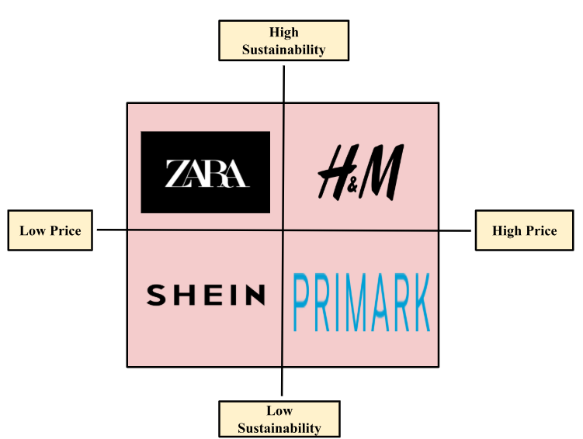
Figure 3: Positioning Map
In Spain, Zara has positioned itself within the upper left quadrant, which ultimately represents a high sustainability along with a low price as compared to other brands, including H&M, SHEIN, and Primark. This positioning is further showing that Zara is offering fashion clothing while also focusing on sustainable practices while also managing its affordability for the customers. The company is also looking to provide the consumer with an affordable range (Simpson, 2025). However, it is quite difficult to provide the consumer fashion that is required to be inspirational.
India
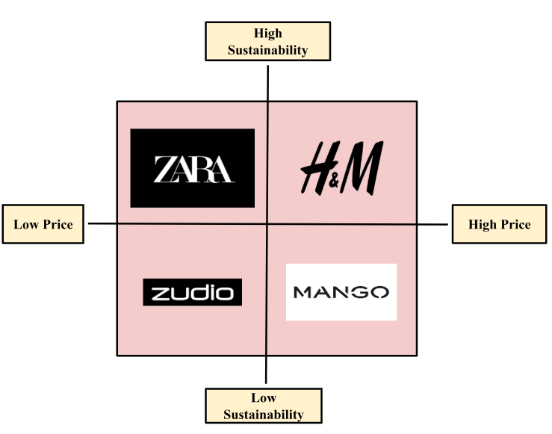
Figure 4: Positioning Map
Within the upper positioning map, Zara has been positioned within the upper-left quadrant, which further represents high sustainability with low prices as compared to different premium brands such as Zudio, MANGO, and H&M. The Join Life Collection of Zara is a significant part of the sustainability strategy of Zara which is offering clothing that is mainly made from different eco-friendly products such as organic cotton and recycled polyester. The parent company of Zara has been committed to ambitious sustainability goals that include gaining carbon neutrality by 2040 (Srivastava, 2024). Zara has also accurately implemented water-saving tech within its production processes.

New STP Strategy
Zara's Pricing Strategy: High-Low Pricing with Market-Based Elements
Primary Strategy: Zara employs high-low pricing—premium initial prices for new trendy items (capturing early adopters), then markdowns for remaining inventory. This supports their fast-fashion model where items sell out quickly.

Key Components:
- Market-based pricing: Prices reflect local competition and willingness-to-pay (Spain: competes with Mango/H&M; India: positioned above local brands like Zudio)
- Dynamic pricing: Adjusts based on demand, seasonality, and store performance
- Cost leadership: Vertically integrated supply chain enables competitive pricing vs. luxury brands

The new STP strategy of Zara mainly focuses on enhancing its strategies in India in order to move beyond fast fashion to sustainable and even high-tech fashion. This is essential for responding to its major competitors in India, such as H&M and local e-commerce, in order to increase its advantages. This will target fashion-conscious and environmentally aware individuals, along with Gen Z, in developed cities where technology is gaining significance. The youth will be targets and it will maintain the reduction of the global trend within India.
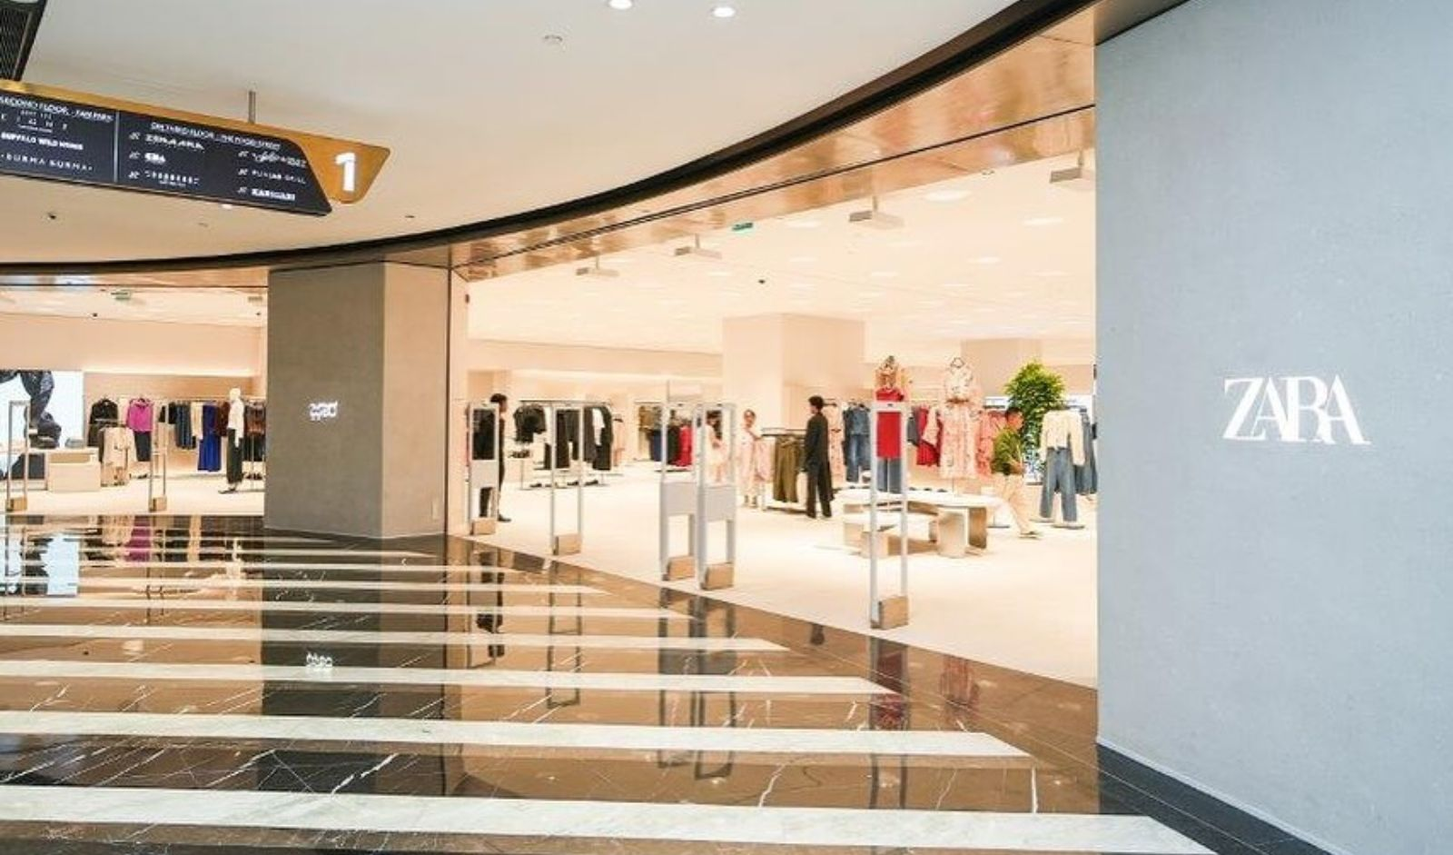
Figure 5: Zara Store in India
(Source: Indian Retailer, 2026)

5. Marketing Mix 7Ps
The marketing mix is a combination of tactical decisions that helps an organisation design, price, distribute, and promote its offerings to satisfy customer needs effectively.
Product: In Spain, Zara is mainly focusing on trend-driven as well as sustainable fashion collections, which ultimately reflect the European fashion preferences (Inditex, 2025). In contrast to India, Zara is offering global fashion designs that are adapted to the cultural preferences, such as lightweight fabrics, and help them to wear affordable global brands’ products (Shukla, 2024). In India, Zara sells tops, dresses, sweatshirts, joggers, skirts, co-ord sets, shoes, accessories, and even perfumes (Zara, 2026). In Spain, the design of the product mainly reflects specific fashion trends related to Europe. Zara sells perfumes, accessories, jeans, tops and other categories in Spain (Zara, 2025). On the other hand, in India, Zara is adjusting the overall collection as per the consumer taste of the local people.
Zara's Product Strategy (Spain): In Spain, Zara offers European-cut clothing including slim-fit jeans, tailored blazers, linen shirts, and trend-driven dresses in regular to longer lengths (e.g., 28-32" inseam for trousers) to suit Mediterranean body types and seasonal layering needs.
Zara's Product Strategy (India): In India, Zara adapts with lightweight fabrics like cotton kurtas, flowy maxi dresses, breathable Co-Ord sets, and fusion wear in petite to regular lengths (e.g., 24-28" inseam, shorter sleeves) for tropical climate and diverse body shapes

Price: The price of Zara's product is not found to be an advantage anymore, as they are offering the latest fashion lines, which are at a reasonable price. The pricing strategy of Zara in both Spain and India is similar, and the affordable ranges are continuing to be a strategic benefit for Zara (Martinroll, 2026). The brand Zara was born with a keen eye on its consumer and about its ability to get a clear understanding, predict, and deliver on the preferences of consumers for trendy fashion at reasonable prices.
Place: Madrid and Barcelona are the major cities dominated by Zara, and Zara is going to combine its men’s and women’s collections within the same space in Barcelona. This type of specific fusion can be installed within its particular Apartment concept that is in Madrid (Modaes, 2026). The entity of Zara Store is operating in Indian cities, including Mumbai, Pune, Surat, Bangalore, Kolkata, and Chennai (Trentlimited, 2026). In major cities of Spain and India, Zara has established its stores.
Distribution Channels
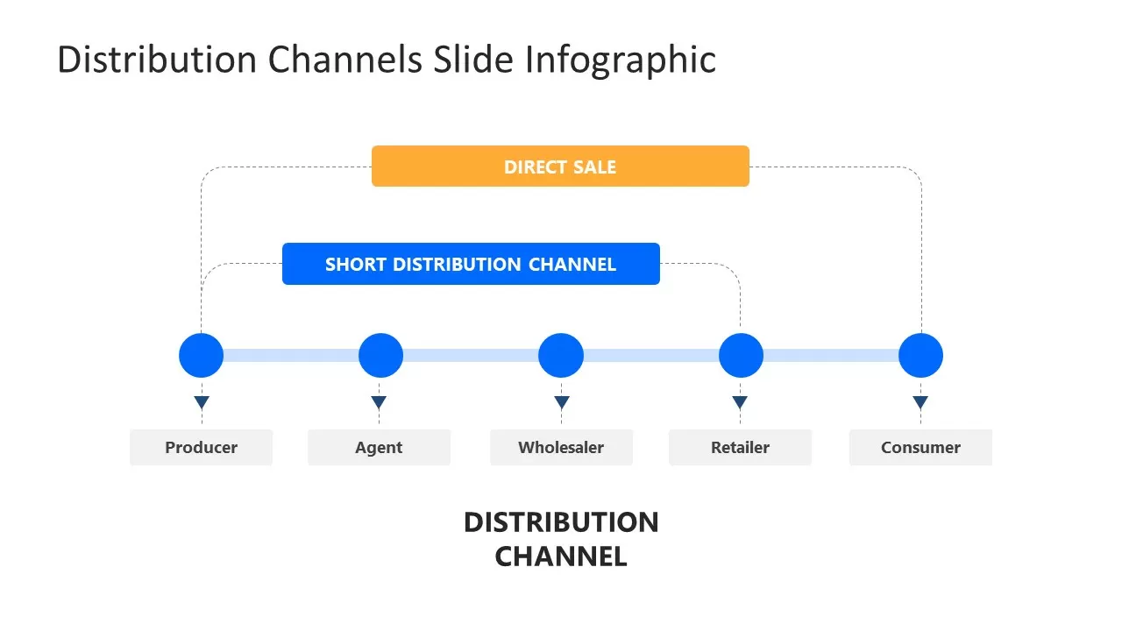
Figure 12: Marketing distribution channel structure
(Source: Model, 2022)
Spain (Home Market)
- Primary Channel: Company-owned flagship stores in prime city-center locations (Madrid, Barcelona)
- Secondary: Omnichannel with app-based click-and-collect, self-checkout, and fitting room reservations
- Distribution Speed: 24 hours from Cube to stores
India (Host Market)
- Primary Channel: 22 franchised stores via Trent Ltd. joint venture in Tier-1 cities (Mumbai, Delhi, Bangalore)
- Secondary: Strong e-commerce platform with nationwide delivery
- Distribution Speed: 48-72 hours via air from Spain
Key Strategic Difference: Spain uses direct ownership for full control; India leverages local partnerships to navigate regulations while maintaining Zara's rapid replenishment model
Promotion: Zara employs a minimalist IMC approach that prioritises experiential marketing over traditional advertising, spending less than 0.3% of sales on promotion compared to industry averages of 3-4%. In Spain, the brand leverages prime store locations and professionally curated window displays as its primary communication tools, creating urgency through scarcity and rapid inventory turnover. In India, Zara adapts this strategy through digital channels and influencer partnerships, utilising Instagram lookbooks and tech-enhanced stores with self-checkout and app-based services to appeal to tech-savvy urban consumers. This integrated approach maintains brand exclusivity while fostering word-of-mouth advocacy, positioning Zara as an aspirational yet accessible fashion leader in both mature (Spain) and emerging (India) markets.
People: There are around 47,761 employees of Zara in Spain, that is representing almost 30% of the overall workforce (Inditex, 2024). While in India, there are 1,691 employees of Zara which is less from many other countries where Zara is operating. Spain is contributing more to the workforce of Zara in comparison to India.
Training Programs:
- Spain: Comprehensive onboarding through Zara Retail Academy covers product knowledge, customer service, sales techniques, and leadership development. Store managers create custom training plans for promotions.
- India: Focuses on cultural adaptation training plus digital tools (self-checkout, app services) alongside standard product and service training.
Motivation Strategy:
Zara uses performance-based incentives with 50% variable pay tied to store targets, plus quarterly promotions and salary increases. Non-financial motivators include international store transfers, feature in company magazine, and flat hierarchy empowering young talent

Process: Zara is for studying equality, diversity and inclusion, which is mainly among the workers within their supply chain. In this particular regard, the brand has also implemented workers at the Centre 2023, 2025 strategy (Inditex, 2024). This strategy mainly focuses on the most vulnerable groups and fosters respectful environments for them. The environment will be totally free from discrimination, abuse or any harassment in both countries’ stores, which are in Spain and India.
(Customer Complaint Handling): Zara's customer complaint process follows a structured omnichannel approach ensuring complaints are tracked and resolved within legal timeframes.
Standard Complaint Process:
- Store Level (Immediate): Customers approach staff → logged via POS system → resolved on-site (exchange/return) or escalated to manager
- Digital Channels: Live chat (24/7), contact form, app → assigned unique complaint ID for tracking complaint
- Email: contact.co@zara.com (formal complaints) → response within legally mandated period
- Social media: @Zara_care (Twitter/FB) for public complaints

Physical Evidence: The flagship of the Inditex brand has opened the special doors to the new flagship store in Spain. Zara is using different strategies in order to strengthen its presence within Barcelona, where it is already operating almost 10 company-owned stores (Fashionnetwork, 2025). In contrast, in India, Zara is operating 22 stores, which is along with its own online platforms (Apparelresources, 2025). It indicates that Zara is mainly focusing on the places in which it already exists in Spain. While in India, it mainly focuses on the new opportunities in the market.
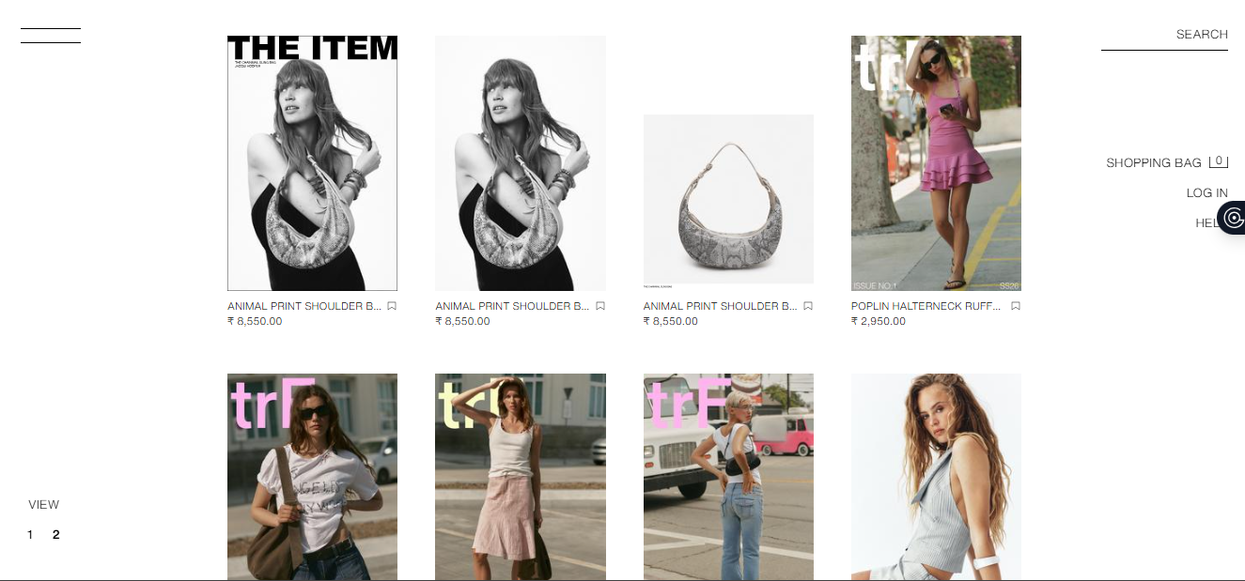
Figure : Zara India
(Source: Zara, 2026)
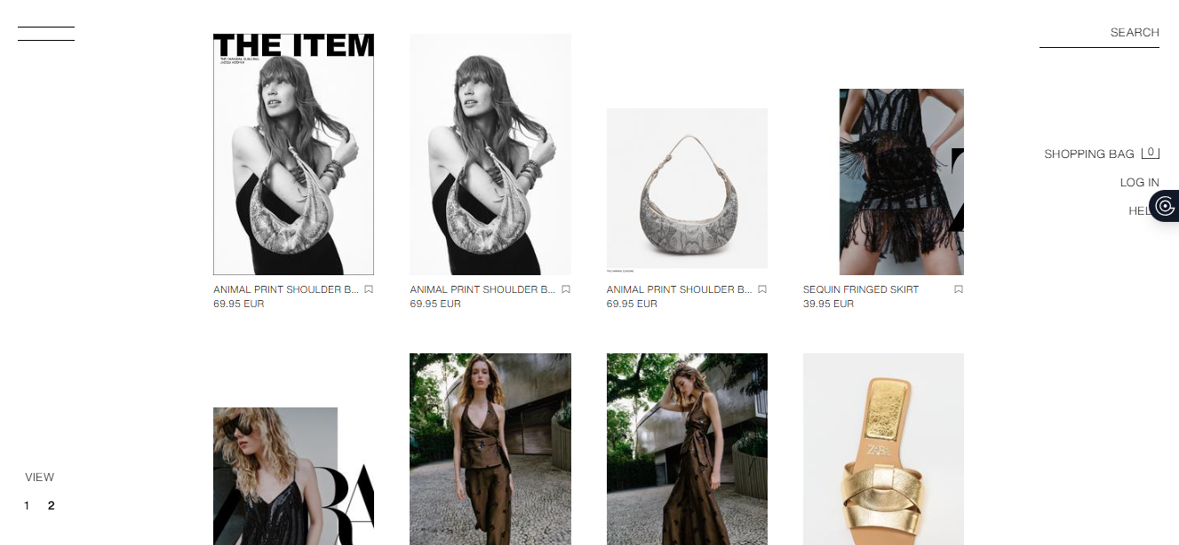
Figure : Zara Spain
(Source: Zara, 2026)

6. Ansoff matrix
Ansoff Matrix is a business tool that was introduced by H. Igor Ansoff in 1957 to help businesses explore growth opportunities (The Strategy Institute, 2024) (Refer to Figure 6). Here, all the aspects of the Ansoff matrix are discussed regarding the context of Zara’s business expansion and growth technique in India.
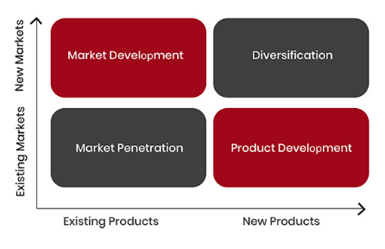
Figure 6: Ansoff Matrix
(Source: The Strategy Institute, 2024)
Market Penetration: Zara entered India in 2010 in collaboration with Trent Limited. Zara’s market penetration strategy is based on premium positioning (Apparel Resources, 2025). It is not focused on mass market penetration, has 22 stores in 13 cities, and has an online presence as well. Despite the small number of stores, the company has achieved significant brand recognition and revenue growth, which has reached over ₹2,500 crores in terms of yearly sales (Malviya, 2023). Zara adds space in large cities, focuses on online sales, offers products that are specific to the Indian market, engages in price rivalry, and offers fast supply chains, thereby increasing their market share in the existing Indian fashion market. Zara entered the Indian market by partnering with Trent Limited in a joint venture.
Product Development: Zara’s product development in India is focused on adapting the global fast fashion concept by fitting the product according to the Indian body type and climate.
Market development: Zara has been successful in developing the Indian market since 2010 through a joint venture with Tata (Inditex Trent), with 22-23 premium stores in 13-15 major cities (Apparel Resources, 2025).
Diversification: Zara is diversifying its Indian operations through an emphasis on the concept of an omnichannel model, which combines physical store development with digital, app store, and virtual store concepts to combat slower growth in the premium segment.

7. Ethical Issues in India
Zara has faced various ethical issues in India, such as child labour, store shut down in the south Mumbai, and others.
Child Labour: An investigation up to January 2025 has found Inditex, the parent company of Zara, to be involved in child labour in cotton farms in the state of Madhya Pradesh, India. According to reports by the non-profit organisation, children as young as six years old are employed in these farms under unfavourable conditions (Impact International, 2021). There were claims of massive "wage theft" in factories in Karnataka towards the end of 2021 (Kelly, 2021). This has caused the families of the employees to not be able to afford basic commodities, hence their children suffer from hunger.
Store Shut Down in South Mumbai: Located in the 119-year-old Ismail Building at Flora Fountain in the Fort area of Mumbai, the flagship stores of the Spanish luxury fashion brand, covering 51,300 square feet, was opened in 2017 after a two-year restoration period (Kaur, 2025). After 8 years in a pre-colonial structure in South Bombay, the ‘iconic’ 5-storey flagship Zara store has closed its doors as the brand could not afford the ₹3 crore in monthly rent (Kaur, 2025). After this, Zara shifted their focus to the other remaining stores in Mumbai, including Phoenix Market City (Kurla), Phoenix Palladium (Lower Parel), and Viviana Mall (Thane), and their online platform.

8. Recommendations
Strengthen Supply Chain by rules to manage the workforce: One good suggestion is to strengthen the monitoring of the supply chain and the protection of the workforce. For example, Patagonia was able to raise the standard for labour conditions through the adoption of Fair Labour Association standards (Patagonia, 2024). Such openness would help in detecting labour practices that are not ethical and ensure that labour is being compensated fairly. Zara could also consider conducting thorough audits by third parties, enforcing the payment of living wages, and investing in various initiatives that ensure that children in the communities where it operates stay in school.
Opening stores in High-traffic Mall Location: Zara can adopt a hybrid strategy that focuses on high-traffic mall locations and e-commerce to minimise the high rental costs. For example, Nike has closed some of its high-cost flagship stores in some cities worldwide and focused on digital stores and premium locations (Thomas, 2020). Through the optimisation of the size of the stores, the renegotiation of the terms of the lease, and the integration of the online and offline channels, Zara can thus ensure that the brand remains visible in the market of Mumbai while at the same time improving its profitability and adapting to the changing consumer behaviour for shopping.
Spain: Zara should accelerate omnichannel integration across all stores with self-checkout and app reservations to counter declining innovation, launch "Zara Essentials" at 20% lower prices (€25-50) for budget-conscious consumers, and expand sustainable "Join Life" collection to 40% of inventory by 2027.
India: Zara should expand to 15 Tier-2 city stores via Trent Ltd., launch festive fusion collections (Diwali/Wedding wear with traditional fabrics), and partner with Fair Labour Association for supplier audits to address child labour allegations.

9. Conclusion
The above report has analysed the marketing strategies of Zara in its home country, Spain and the host country, India. Multiple strategic frameworks, such as PESTLE Analysis, Hofstede’s Cultural Dimensions, STP Strategy, and the Ansoff Matrix model, have been applied. As per the PESTLE Analysis, it discusses that there are different external environments in Spain compared to India. Spain has experienced low economic growth and a decline in technology, whereas India has strong economic and technological opportunities. The above report has highlighted that Zara is successfully using a set of strategies in order to provide good quality, fashionable products at an affordable price to its customers. In order to Ansoff Matrix, Zara’s expansion in India shows an effective penetration strategy with product adoption and omnichannel development. However, ethical issues such as child labour charges and high operational costs underscore the importance of supply chain management and flexibility in retail operations in terms of sustainable growth in India.

Section 2: Reflective Account
The Gibb’s Reflective Cycle
The Gibbs’ Reflective Cycle is considered a straightforward framework that assists an individual in making a strong sense of experiences. The most important thing about this framework is that it assists in learning new things about one's own experiences. This straightforward framework was developed by Graham Gibbs in the year 1988. It is considered a very useful framework for all professionals who are desiring for consistent improvement within their practices. The reflective cycle stages mainly consist of six different stages, and these stages are description, feelings, evaluation, analysis, conclusion and action plan (Refer to Figure 7). The strength of the Gibbs Cycle mainly lies in its simplicity and the applicability, which is across different fields.
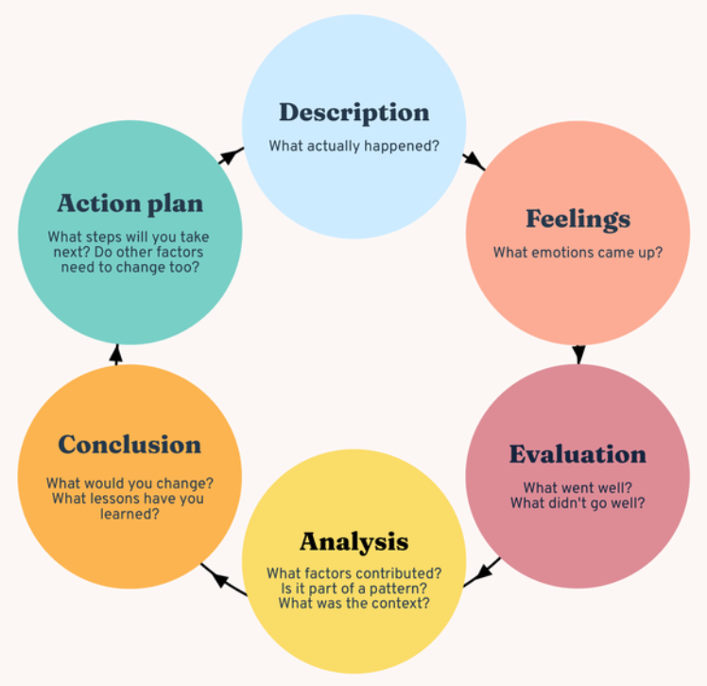
Figure 7: The Gibbs’ Reflective Cycle
(Source: Bitesizelearning, 2024)

1.1 Description
In the above assignment, I have evaluated the international marketing strategies of the brand Zara within its home country, which is Spain, and the host country, which is India. The main purpose behind writing the report was to have a clear understanding of how the different multinational companies are adapting their marketing strategies while entering the international market. In order to complete this assignment, I have applied different strategic frameworks like PESTLE analysis, cultural analysis through using the Hofstede model, the Marketing mix 7ps strategy, the Ansoff Matrix, and the STP strategy. By using this process, I have researched the different reports and the industry data that have assisted me in evaluating how the brand Zara is operating in both countries, India and Spain.

1.2 Feelings
While writing this assignment, I felt really excited at the beginning of the assignment because the topic was really interesting. The topic was very interesting as I have to use different frameworks used by the company in two countries. I felt it was quite challenging to get an understanding of the different marketing frameworks and felt very problematic while connecting those frameworks to Zara’s business strategies. In addition to that, I also feel interested mainly in analysing the cultural differences that exist in these two countries. It has assisted me in knowing how the behaviour of the consumer and the culture of the country can directly impact the marketing and strategies of any international brand.

1.3 Evaluation
This assignment has been the key area that has assisted me in developing several important academics as well as professional skills. One major strength that I found in myself was using multiple marketing frameworks to analyse the strategies of the brand Zara. With the assistance of PESTLE analysis, I have been able to understand how different external factors of Spain and India are impacting the business practices. While using Hofstede’s cultural model, I have been able to evaluate that cultural differences exist between two countries, and the brand has to make strategies according to them.
Reflecting on my past experiences while doing this assignment. I have identified both strengths and weaknesses within my process of learning. I was able to effectively conduct basic research and gather relevant information, and pursue the ability to learn new concepts and enhance my academic knowledge. However, I have also noticed a few gaps that exist in me and these gaps were time management skills. As I was feeling really difficult in completing the task on time, that led to delays in work. Next, I have identified that I was nervous while asking for assistance from another person. Next, I also feel very problematic while understanding the critical concepts due to the lack of critical thinking skills.

1.4 Analysis
Throughout the assignment, I have used my knowledge and skills in order to make the assignment properly. However, a few gaps that exist in me were the critical thinking skills, poor time management skills, and a lack of public speaking, and all these skills have been the major drawbacks. The poor time management skills have resulted in the time being close to the deadlines, which ultimately increases my stress. While the lack of public communication was also another gap in me from clearly communicating about my knowledge and skills in meetings or during any group presentations. However, I came to know that describing the strategy of the company is not enough, but it is essential to interpret it. It is also crucial to know how multiple factors are directly affecting the overall business performance. This assignment has also been the key area in accurately developing my analytical mind-set that may also be helpful in future work. Identifying all these gaps and working on it are very crucial that may allow me to deal with any future challenges that may hinder the process of learning.

1.5 Conclusion
This reflective exercise has been the key area that has assisted me in getting a clear understanding and insights into my personal learning process. In addition to that, this reflective report has also assisted me in getting a clear understanding of the areas that need to be improved for future work. I have strengths like research on basic things, motivation, and the willingness to do something new. But apart from these strengths, I must focus on developing a few. competencies to enhance my academic as well as professional aspects for any future work role. Due to this, I need to accurately follow a well-structured action plan in order to address all these gaps that have been identified while doing this assignment.

1.6 Action Plan
Areas need to be improved | Actions Required for Improvement | Responsible Person in Supporting Activities | Time Needed
Time Management Skills | Create a proper timetable or Schedule and strictly follow it, set deadlines by myself | Self-Monitoring | 4 months
Public Communication Skills | Participate in different group presentations, participating in different topics | Classmates and Tutor | 6 months
Critical Thinking Skills | Read different case studies and actively participate in class discussions | Mentor and Course Lectures | 4 months
Table 1: Action Plan

Gibb’s Reflective Cycle has been used in order to gain insights from past experiences. This model represented the overall learning that has been obtained while doing the report. This has been the key area in highlighting both strengths and weaknesses. In addition to that, an action plan has been made in order to fill existing gaps and enhance the skill that may assist in future job roles.

References
Apparel Resources (2025). Zara expands India presence with new stores, refurbishments and tech-driven formats | Retail News India. [online] Apparel Resources. Available at: https://apparelresources.com/business-news/retail/zara-expands-india-presence-new-stores-refurbishments-tech-driven-formats/ [Accessed 9 Mar. 2026].
Apparel Resources, (2025). Zara expands India presence with new stores, refurbishments and tech-driven formats. https://apparelresources.com/business-news/retail/zara-expands-india-presence-new-stores-refurbishments-tech-driven-formats
Apparel Resources, (2025). Zara expands India presence with new stores, refurbishments and tech-driven formats. Available at: https://apparelresources.com/business-news/retail/zara-expands-india-presence-new-stores-refurbishments-tech-driven-formats/
Bhandari, N., Reyes, J.A.G., Lona, L.R., Kumar, A., Naz, F. and Joshi, R. (2022). Barriers to sustainable sourcing in the apparel and fashion luxury industry. Sustainable Production and Consumption, 31(31), pp.220–235. doi:https://doi.org/10.1016/j.spc.2022.02.007.
Bhatnagar, K., 2025. Fashion Forward: Winning in India’s fast-growth Apparel Market. https://redseer.com/articles/fashion-forward-winning-in-indias-fast-growth-apparel-market/
Bitesizelearning, (2024). The Gibbs Reflective Cycle, explained. Available at: https://www.bitesizelearning.co.uk/resources/gibbs-reflective-cycle-explained-diagram-examples
Chaure, T., Gautam, S. and Husain, B.T., 2024. Consumer Buying Behaviour: Selection of Fashion Apparels. Advances in Consumer Research, 1(1). https://jier.org/index.php/journal/article/view/1282/1081#
Ecdb, (2026). Zara Company & Revenue. Available at: https://ecdb.com/resources/sample-data/retailer/zara
Europa (2023). Climate Action Progress Report 2023. [online] Europa. Available at: https://climate.ec.europa.eu/document/download/c9c92d31-1ffa-4639-8e78-cd4dc64e6b86_en?filename=es_2023_factsheet_en.pdf [Accessed 9 Mar. 2026].
Europa (2024). National legislation | European e-Justice Portal. [online] Europa.eu. Available at: https://e-justice.europa.eu/topics/legislation-and-case-law/national-legislation/es_en [Accessed 9 Mar. 2026].
Fashionnetwork, 2025. Zara opens a new Spanish flagship in Barcelona. Available at: https://ww.fashionnetwork.com/news/Zara-opens-new-spanish-flagship-in-barcelona,1786884.html
Ibef, (2024). The Indian fast fashion industry is poised to reach over US$ 50 bn by FY31. Available at: https://www.ibef.org/news/indian-fast-fashion-industry-poised-to-reach-over-us-50-bn-by-fy31-redseer
Impact International (2021). Fast Fashion at a Human Cost - Zara Fashion Retailer Chooses Sales over Ethics. [online] ImpACT International. Available at: https://impactpolicies.org/news/226/fast-fashion-at-a-human-cost-zara-fashion-retailer-chooses-sales-over-ethics [Accessed 9 Mar. 2026].
Indian Retailer. (2026). IndianRetailer.com. Available at: https://indianretailer.com/news/retail-india-news-zara-opens-its-24th-retail-store-india-bengalurus-phoenix-mall-asia [Accessed 18 Apr. 2026].
Inditex (2020). Inditex Group Annual Report. [online] Available at: https://static.zara.net/static/joinlife/2020_Inditex_Annual_Report.pdf [Accessed 9 Mar. 2026].
Inditex, (2024). 7 Social. Available at: https://static.inditex.com/annual_report_2023/en/Social.pdf
Inditex, (2024). Annex 1: Composition of the Inditex Group. Available at: https://www.inditex.com/itxcomweb/api/media/604197b9-50de-4f4f-ab84-c1e379cb3fd0/Inditex_Group_Annual_Report_2024.pdf?t=1741989136588
Inditex, (2025). ZARA, PULL&BEAR, MASSIMO DUTTI, BERSHKA, STRADIVARIUS, OYSHO, ZARA HOME AND LEFTIES CELEBRATE STYLE, SELF-EXPRESSION AND THE POWER OF FASHION TO MAKE A CHANGE. Available at: https://www.inditex.com/itxcomweb/bd/en/home
Jangid, M. (2022). Zara’s Case Study -the Strategy of the Fast Fashion Pioneer the Strategy of the Fast Fashion Pioneer. [online] ResearchGate. Available at: https://www.researchgate.net/publication/362568585_ZARA [Accessed 9 Mar. 2026].
Jonwal, S. (2025). Zara Case Study 2025: The Fast Fashion Giant’s Winning Strategy. [online] Young Urban Project. Available at: https://www.youngurbanproject.com/zara-case-study/ [Accessed 9 Mar. 2026].
Kaur, A. (2025). Zara shuts down its flagship store in South Mumbai; here’s why it was iconic. [online] mint. Available at: https://www.livemint.com/news/zara-shuts-down-flagship-store-in-south-mumbai-heres-why-it-was-iconic-11740454459355.html [Accessed 9 Mar. 2026].
Kelly, A. (2021). ‘Worst fashion wage theft’: workers go hungry as Indian suppliers to top UK brands refuse to pay minimum wage. [online] the Guardian. Available at: https://www.theguardian.com/global-development/2021/dec/16/worst-fashion-wage-theft-workers-go-hungry-as-indian-suppliers-to-top-uk-brands-refuse-to-pay-minimum-wage [Accessed 9 Mar. 2026].
Kenresearch, (2024). Spain Luxury Fashion & Lifestyle Market. Available at: https://www.kenresearch.com/spain-luxury-fashion-lifestyle-market
Kenresearch, (2026). India Apparel Market Outlook to 2030. Available at: https://www.kenresearch.com/industry-reports/india-apparel-market
Khurana, K.A. (2024). Legal Issues Faced In Fashion Industry. [online] Khurana And Khurana. Available at: https://www.khuranaandkhurana.com/2024/08/27/legal-issues-faced-in-fashion-industry [Accessed 9 Mar. 2026].
Lerouge, L. and Trujillo Pons, F., 2022. Contribution to the study on the ‘right to disconnect’from work. Are France and Spain examples for other countries and EU law?. European labour law journal, 13(3), pp.450-465. https://shs.hal.science/halshs-03697415/document
Li, Y. (2021). How Should Zara Optimize Its Marketing Strategies to Cater to the Needs of New Generations – Gen Z and... [online] ResearchGate. Available at: https://www.researchgate.net/publication/354875129_How_Should_Zara_Optimize_Its_Marketing_Strategies_to_Cater_to_the_Needs_of_New_Generations_-_Gen_Z_and_Millennials [Accessed 9 Mar. 2026].
Lindner, J., (2025). Zara Fast Fashion Statistics. Available at: https://rawshot.ai/statistic/zara-fast-fashion
Malviya, S. (2023). World’s biggest fashion brand Zara’s India sales increase 40% in FY23. The Economic Times. [online] 15 May. Available at: https://economictimes.indiatimes.com/industry/cons-products/fashion-/-cosmetics-/-jewellery/zaras-india-sales-increase-40-in-fy23/articleshow/100234517.cms [Accessed 9 Mar. 2026].
Martinroll, 2026. The Secret of Zara’s Success: A Culture of Customer Co-creation. Available at: https://martinroll.com/resources/articles/strategy/the-secret-of-zaras-success-a-culture-of-customer-co-creation/
Modaes, (2026). Zara Steps into Luxury: Unveiling Exclusive Designs at New Barcelona Flagship. Available at: https://www.modaes.com/global/back-stage/zara-in-the-luxury-league-design-and-exclusivity-in-its-new-flagship-store-in-upper-barcelona
Mordorintelligence, (2026). SPAIN LUXURY GOODS MARKET SIZE & SHARE ANALYSIS - GROWTH TRENDS AND FORECAST (2026 - 2031). Available at: https://www.mordorintelligence.com/industry-reports/spain-luxury-goods-marke
Muzaffer, F., 2024. Sustainable Sourcing The case of the Fashion Industry. https://www.theseus.fi/bitstream/handle/10024/859506/Muzaffer_Farhan.pdf?sequence=2
OECD (2025). Government at a Glance 2025: Spain. [online] Oecd.org. Available at: https://www.oecd.org/en/publications/government-at-a-glance-2025-country-notes_da3361e1-en/spain_57f4ebd0-en.html [Accessed 9 Mar. 2026].
Patagonia (2024). Fair Labor Association® - Patagonia. [online] www.patagonia.com. Available at: https://www.patagonia.com/our-footprint/fair-labor-association.html [Accessed 9 Mar. 2026].
Pib India (2025). 7.93% Drop in GHG Emissions. [online] Pib.gov.in. Available at: https://www.pib.gov.in/PressReleaseIframePage.aspx?PRID=2092311®=3&lang=2 [Accessed 9 Mar. 2026].
Piotrowska, M. and Piotrowski, J. (2023). Hofstede’s Cultural Dimensions Theory. [online] ResearchGate. Available at: https://www.researchgate.net/publication/371822907_Hofstede [Accessed 9 Mar. 2026].
Pub (2025). India offers a transparent, predictable and comprehensive FDI Policy Framework for investments. [online] Pib.gov.in. Available at: https://www.pib.gov.in/PressReleasePage.aspx [Accessed 9 Mar. 2026].
Roll, M. (2021). The secret of Zara’s success: A culture of customer co-creation. [online] Martin Roll. Available at: https://martinroll.com/resources/articles/strategy/the-secret-of-zaras-success-a-culture-of-customer-co-creation/.
Scmglobe, (2020). Zara Clothing Company Supply Chain. https://www.scmglobe.com/zara-clothing-company-supply-chain/
Segura, E., Belmonte, L.M., Herrera, R.M. and Somolinos, J.A. (2023). A Strategic Analysis of Photovoltaic Energy Projects: the Case Study of Spain. Sustainability, 15(16), pp.12316–12316.
Shukla, A., (2024). How Ratan Tata started India’s romance with Zara. Available at: https://timesofindia.indiatimes.com/life-style/fashion/buzz/how-ratan-tata-started-indias-romance-with-zara/articleshow/114105630.cms
Simpson, E., (2025). Inside the secretive world of Zara. Available at: https://www.bbc.com/news/articles/c62j2dxe9zyo
Simpson, E., (2025). Inside the secretive world of Zara. Available at: https://www.bbc.com/news/articles/c62j2dxe9zyo
Srivastava, V., (2024). Zara: Fashion Forward, Responsibly?. Available at: https://divyanshusriv96.medium.com/zara-fashion-forward-responsibly-946b9323e517
Suarez-Visbal, L.J., Carreón, J.R., Corona, B. and Worrell, E., 2023. The social impacts of circular strategies in the apparel value chain; a comparative study between three countries. Circular economy and sustainability, 3(2), pp.757-790. https://link.springer.com/content/pdf/10.1007/s43615-022-00203-8.pdf
The Culture Factor (2020). Country comparison tool. [online] Theculturefactor.com. Available at: https://www.theculturefactor.com/country-comparison-tool?countries=india%2Cspain [Accessed 9 Mar. 2026].
The Global Economy (2024). Spain Carbon dioxide (CO2) emissions - data, chart. [online] TheGlobalEconomy.com. Available at: https://www.theglobaleconomy.com/Spain/Carbon_dioxide_emissions/ [Accessed 9 Mar. 2026].
The Global Economy (2025a). India economic indicators. [online] TheGlobalEconomy.com. Available at: https://www.theglobaleconomy.com/India/ [Accessed 9 Mar. 2026].
The Global Economy (2025b). Spain Economic growth, percent change in quarterly real GDP, September, 2022 - data, chart. [online] TheGlobalEconomy.com. Available at: https://www.theglobaleconomy.com/Spain/gdp_growth/ [Accessed 9 Mar. 2026].
The Global Economy (2025c). Spain Political stability - data, chart | TheGlobalEconomy.com. [online] TheGlobalEconomy.com. Available at: https://www.theglobaleconomy.com/Spain/wb_political_stability/ [Accessed 9 Mar. 2026].
The Global Economy (2026a). India Economic growth, percent change in quarterly real GDP, September, 2021 - data, chart. [online] TheGlobalEconomy.com. Available at: https://www.theglobaleconomy.com/India/gdp_growth/ [Accessed 9 Mar. 2026].
The Global Economy (2026b). India economic indicators. [online] TheGlobalEconomy.com. Available at: https://www.theglobaleconomy.com/India/ [Accessed 9 Mar. 2026].
The Global Economy (2026c). India Inflation, annual percent change in the CPI, October, 2021 - data, chart. [online] TheGlobalEconomy.com. Available at: https://www.theglobaleconomy.com/India/inflation_annual/ [Accessed 9 Mar. 2026].
The Global Economy (2026d). Spain: Innovation index. [online] Theglobaleconomy.com. Available at: https://www.theglobaleconomy.com/Spain/GII_Index/ [Accessed 9 Mar. 2026].
The Strategy Institute (2024). The Ansoff Matrix: a Powerful Tool for Business Strategy and Growth. [online] The Strategy Institute. Available at: https://www.thestrategyinstitute.org/insights/the-ansoff-matrix-a-powerful-tool-for-business-strategy-and-growth [Accessed 9 Mar. 2026].
Thomas, L. (2020). Nike is closing all of its stores in the US because of the coronavirus outbreak. [online] CNBC. Available at: https://www.cnbc.com/2020/03/15/nike-is-closing-all-of-its-stores-in-the-us-because-of-coronavirus.html [Accessed 9 Mar. 2026].
Trading Economics (2026a). India - Population Growth (annual %) - 1960-2018 Data | 2020 Forecast. [online] tradingeconomics.com. Available at: https://tradingeconomics.com/india/population-growth-annual-percent-wb-data.html [Accessed 9 Mar. 2026].
Trading Economics (2026b). India Consumer Price Index (CPI) | 2011-2020 Data | 2021-2022 Forecast | Historical. [online] tradingeconomics.com. Available at: https://tradingeconomics.com/india/consumer-price-index-cpi [Accessed 9 Mar. 2026].
Trading Economics (2026c). Spain Consumer Spending | 1995-2020 Data | 2021-2023 Forecast | Historical | Chart. [online] tradingeconomics.com. Available at: https://tradingeconomics.com/spain/consumer-spending [Accessed 9 Mar. 2026].
Trentlimited, 2026. Zara and Massimo Dutti. Available at: https://trentlimited.com/pages/subsidiaries-associates
Wad, (2026). Where Culture, Art + Fashion Meet. Available at: https://wwd.com/business-news/business-features/barcelona-where-culture-art-fashion-meet-1236743520/
Zara (2025). ZARA España | Nueva Colección Online. Available at: https://www.zara.com/es/. [Accessed on 18th April, 2026].
Zara (2026). Women’s New In Clothes | Explore our New Arrivals | ZARA India. Available at: https://www.zara.com/in/en/woman-new-in-l1180.html [Accessed on 18th April, 2026].
Zhang, B., Zhang, Y. and Zhou, P. (2021). Consumer Attitude Towards Sustainability of Fast Fashion Products in the UK. Sustainability, [online] 13(4), pp.1–23. doi:https://doi.org/10.3390/su13041646.

Appendices

Appendix 1: Spain People's Trust in National Government
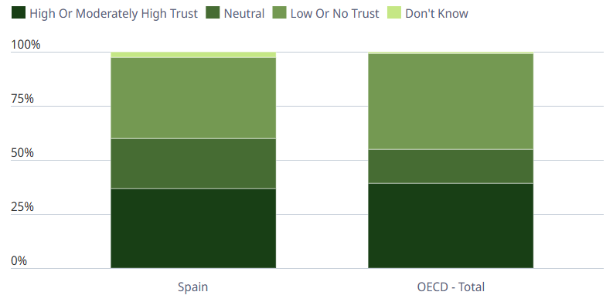
Figure 7: Spain People's Trust in National Government
(Source: OECD, 2025)

Appendix 2: Political Stability in Spain
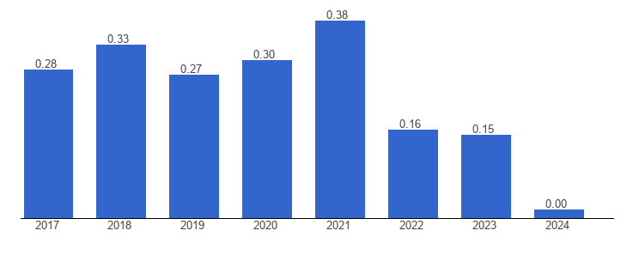
Figure 8: Political Stability in Spain
(Source: The Global Economy, 2025c)

Appendix 3: Economic Growth of Spain
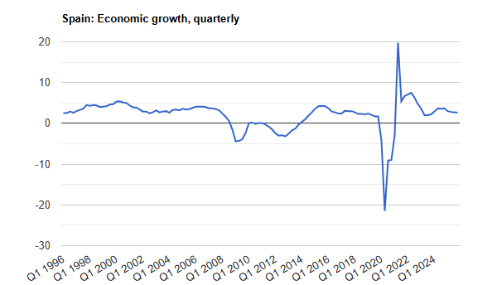
Figure 9: Economic Growth of Spain
(Source: The Global Economy, 2025b)

Appendix 4: Customer Spending in Spain
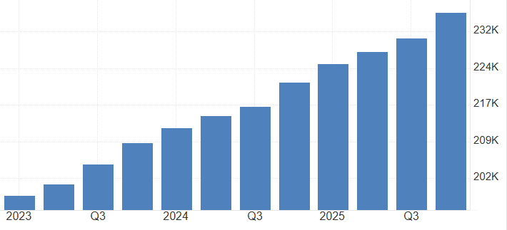
Figure 10: Customer Spending in Spain
(Source: Trading Economics, 2026c)

Appendix 5: Innovation Index of Spain
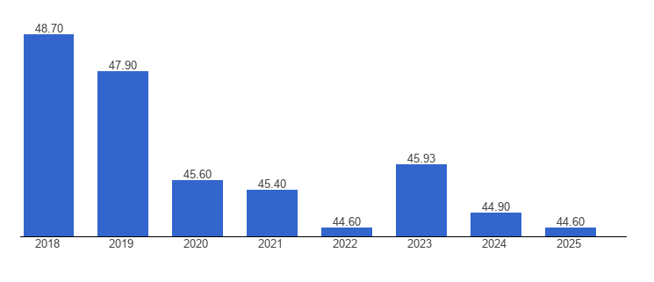
Figure 11: Innovation Index of Spain
(Source: The Global Economy, 2026c)

Appendix 6: Political Stability Index of India
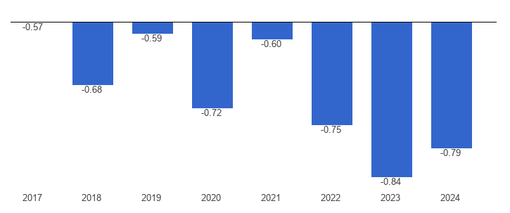
Figure 12: Political Stability Index of India
(Source: The Global Economy, 2025a)

Appendix 7: Economic Growth of India
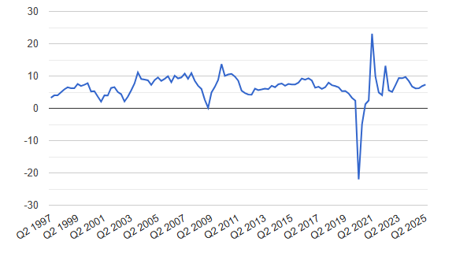
Figure 13: Economic Growth of India
(Source: The Global Economy, 2026a)

Appendix 8: Consumer Spend in India
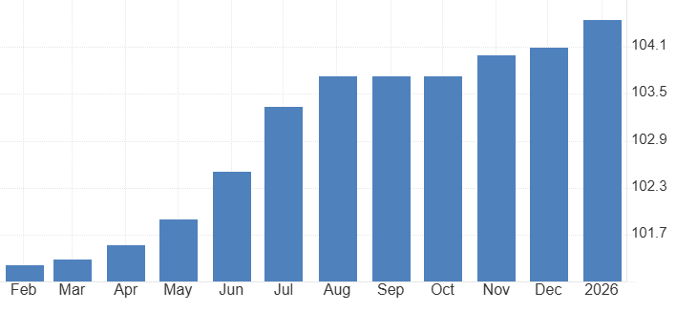
Figure 14: Consumer Spending in India
(Source: Trading Economics, 2026b)

