

University of Wales Trinity Saint David
School of Engineering

Calum McGowan Franklin
1803213
Transmission Matching
Motorsport Engineering/HNC/HND
Date: 17/04/2020
Module code: M4X02196

Contents
Introduction 3
Aims 3
Research 4
Experimental procedure 6
Equipment 6
Method 6
Results 8
Analysis 9
Calculating transmission efficiency 10
Calculating Torque at the wheels 10
Calculating tractive effort 10
Confirmation of final drive ratio 11
Calculating maximum tractive effort available in each gear. 11
Calculating the speed ratio. 12
Calculating the theoretical intermediate gear ratios. 12
Calculating maximum road speeds 12
Calculating maximum road speed for each gear 13
Discussion 16
Conclusion 18
References 19
Appendices 21

Introduction

A vehicle drive train system provides the thrust and tractive forces needed to induce motion (Bosch, 2000, p588). In order to evaluate the efficiency of the system and determine vehicle performance characteristics tests must be undertaken (Zammit, 1996, p270). Typically, drive train systems are tested using a chassis dynamometer, a device that simulates load conditions throughout different driving parameters (Yang et al., 2018). This allows the forces imposed on a vehicle whilst traveling to be simulated and analysed, such as rolling resistance, frictional losses and aerodynamic drag (Vibin, 2017).

Aims
This report will be analysing the performance and efficiency of a BMW S1000RR using an eddy current chassis dynamometer to collect basic performance data from which further engine characteristics can be derived.

Research

In order to manage and control the power generated in a vehicles engine, a transmission and final drive system must be implemented, thus is could be said that the performance and character of a vehicle are defined by its powertrain system (Crolla, Mashadi, 2011).
Bosch (2000) denotes that “to be successful in its application the drive train must perform functions such as; Allow stationary engine running, transition from static to mobile, convert torque and rotational speed, provide forward and reverse motion, compensate wheel speeds in corners and ensure the power unit remains within a range on the operating curve commensurate with minimum fuel consumption an exhaust emissions”. To achieve these endeavours the drive train is made up of mechanical components that characterise the arrangement.
The clutch system is responsible for jobs such as stationary running, and power transmission interruption, as to achieve gear selection and transition to motion, the operation of which is achieved by the smooth engagement and detachment of the drivetrain system and the engine (Bosch, 2000, p590). Motorcycles typically operate with a dry clutch system consisting of a pressure plate which compresses and decompresses a series of friction and steel plates that interlock with the outer clutch basket, driven by the engines crankshaft (tvsmotor, 2018).
The transmission system is a series of shafts and gears that allows the engines torque to be altered to the vehicles immediate tractive requirements (Bosch, 2000, p590). The meshing of teeth allows motion to be transferred from gear to gear, within which gear ratios are achieved. The gear attached to the power input is called the driver gear and the other the driven gear (Zammit, 1996, p159). This assembly allows that the required power can be delivered from the engine to the final drive.
Vehicle systems need a method to transmit the demanded engine torque to the wheels, within rear wheel systems a drive shaft accommodates this, along with the application of a differential that allows the wheels to rotate at different speeds as is applicable within cornering (Bosch,2000, p590). Front wheel drive assemblies use a transaxle system that incorporate the transmission and power splitting capability in one unit (Grayen, 2020) and a motorcycle on the other hand uses a chain to transmit final drive power to the rear wheel.
Throughout the entirety of the system friction occurs in the mechanical components which converts portions of the energy into heat, this equates to a loss of power in the system. The final power delivered is the difference between the input power and the power losses (x-engineer, 2020), by understanding and analysing these losses, the mechanical efficiency of the system can be calculated.
To analyse and evaluate these system characteristics a chassis dynamometer is used to collect baseline data such as torque and power by monitoring the moment of force and rotational speed simultaneously. The operation of a chassis dynamometer is to create a calculated resistive force against that of the vehicle wheels in order to determine the force exerted by the engine (Lish,2015). This resistive force is employed through variable electromagnets that alter the strength of the magnetic field and create more resistance against the rotational force of the engine tested (Dynamometers,2020).

Experimental procedure
To gain further understanding of these concepts the following practical experiment was undertaken.
Testing was performed at the rolling road facility at the UWTSD and overseen by Abi and Mark.

Equipment
-Eddy current chassis dynamometer
-MAHA software
-BMW S1000 RR

Method
-Open up software and data.
-Measure the bikes rolling radius.
-set up the dynamometer software for the BMW S1000 RR data.
-Set rolling road rig up, motorcycle must be strapped firmly into position with the rear wheel over the roller and the extraction system attached to the exhaust.
The OBD is plugged into the motorcycle, this brings up variables such as RPM, coolant temperature, throttle position and ignition timing on the console.
-Safety checks must be considered before testing commences, fire exits must be known and accessible, room door is shut considering noise levels and ear defenders are worn.
-The software allows options for two different tests. “discrete test” that will run the engine from one determined engine speed to another and a “sweep test” that runs the engine through the entire rev range. The sweep test is selected for this study and the load and duration of test are installed into the software.
-5th gear is selected on the bike. A 1:1 gear ratio is endeavoured for testing, 5th gear was best compromise for the vehicle.
-Mark straddles the motorcycle as to keep control during testing and the sequence commences.
- The engine travels through the rev range starting at 1000RPM, as the system is cold it starts lumpy but clears at approximately 2000RPM and continues to ascend smoothly until maximum engine speed, following this drag is calculated by the clutch being applied whilst deaccelerating, this measures the frictional values of components that are behind the clutch plates. This allows overall power to be calculated as well as analyse sources of major drag such as tyres, chains etc.
-Upon completion of testing raw data is collected and tabulated.

Results
Table 1. Collected test data for engine speed (RPM), engine power (KW), engine torque (Nm), wheel power (KW), drag power (KW) and velocity (km/h), values from 1960 RPM through to 13920 RPM. Full table available in appendix.
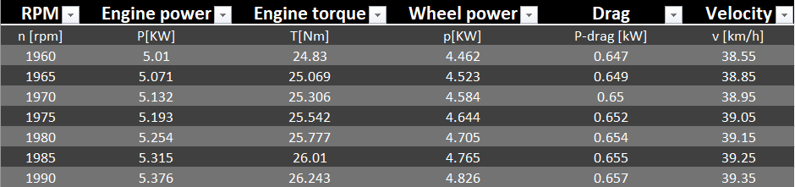
Table 2. Maximum values for engine power (KW), Wheel power (KW) and drag power (KW) at 13190 RPM at a velocity of 264.8 km/h.
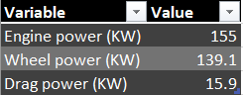
Table 3. maximum torque value (Nm) at 10565 RPM at a velocity of 212.1 km/h.
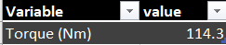

Analysis
In addition to the data collected from testing, further variables must be identified for precise calculations to be made.
This consist of gear ratios, the vehicle rolling radius, air density, coefficient of drag, frontal area and the mass of bike, fuel and rider.
Table 4. Gear ratios.
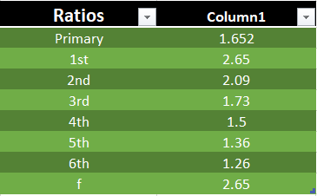
Table 5. Rolling radius (m), mass (kg), air density (kg/m^3), coefficient of drag and frontal area (m^2)
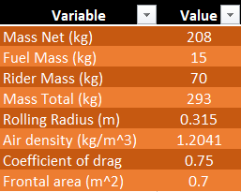

With variables considered and vehicle data collected from the chassis dynamometer, further system characteristics can be determined from calculations using the found data.

Calculating transmission efficiency
Transmission efficiency is the ratio of output to input power within a system (Merriam-Webster,2020) this allows engine losses to be calculated and considered within further calculations. This represents the overall effectiveness of the system.
$ƞ=\frac{power at wheels}{power at engine}$ For a known RPM.
$ƞ=\frac{139.1 }{155}$ at 13190RPM
$ƞ=$0.897419355

Calculating Torque at the wheels
Wheel torque is a derivative of engine torque whilst accounting for the variables of the transmission system (x-engineer,2020).
Therefore,
$T_{W }$=$T_{E}×p ×f ×n ×ƞ$
$T_{W }$= Torque at wheel (KW)
$T_{E}$= Torque at engine (KW)
$p$= primary drive ratio (1.652:1)
$f$= final drive ratio (2.65:1)
$n$= Gear ratio used (5th -1.36:1)
$Ƞ$= Transmission efficiency

Calculating tractive effort
Tractive effort is considered as the force available at the contact patch of the vehicle (Kett,1982) and is calculated from the torque available at the wheel divided by the rolling radius.
$Tractive effort={T_{W}}/R$
$R$=Rolling radius (m)

Confirmation of final drive ratio
The final drive ratio is the last gearing ratio between the transmission system and the vehicles contact patch (Viayenthiran,2017). To confirm a final drive ratio of $2.65:1$ variables that must be considered are rolling radius, RPM, velocity, selected gear ratio (5th) and the primary gear ratio of the vehicle.
$f={2π×R ×N}/{60 ×v ×n ×p}$

$2π×R$= Takes the circumference of the rolling radius
$N=RPM$
$60$ = dividing by 60 gives the number of rotations in one second.
$v$= Velocity (m/s)
$n$= Selected gear ratio (5th-1.36:1)
$p$= Primary gear ratio (1.652:1)

Calculating maximum tractive effort available in each gear.
To achieve the demanded torque to sustain the tractive requirements of the conditions imparted to the vehicle we must employ gear ratios to stay within peak torque parameters (Elleray,2010), calculating the maximum tractive effort available for each gears allows the parameters of each gear ratio to be analysed.

${TE}_{M}$=$T_{M}×P×F×n×ƞ$ / $R$
${TE}_{M}$=Maximum tractive effort
$T_{M}$=Maximum engine Torque
$n$= Selected gear ratio, changes for selected gear (1-6)

Calculating the speed ratio.
The speed ratio can be defined as the ratio between the rotational speed of the input gear to that of the output gear (Gillespie, 2019), this is taken as the maximum torque engine speed over the maximum power engine speed.
$$Speed ratio={10565}/{13190}$$
$$speed ratio=0.80099:1$$

Calculating the theoretical intermediate gear ratios.
To calculate the intermediate gear ratios the speed ratio is used, the gear to be found is then multiplied by the speed ratio to the power of the gear in question minus one. Hence;
$$1st gear=n1$$
$$2nd gear=n1 ×speed ratio$$
$$3rd gear=n1×{speed ratio}^{2}$$
$$4th gear=n1×{speed ratio}^{3}$$
$$5th gear=n1 × {speed ratio}^{4}$$
$$6th gear=n1 × {speed ratio}^{5}$$

Calculating maximum road speeds
To calculate the maximum road speed, firstly the drag power must be calculated. This was found as follows.
$$Drag power=0.5×ρ × C_{d}×A ×V^{3}/ 1000$$
$ρ$=Air density
$C_{d}$=Coefficient of drag
$A$=Frontal area
$V^{3}$= Velocity cubed- as the velocity is squared then multiplied by initial velocity
$/ 1000$ =As to get the calculation into KW
With drag power calculated graphs can be generated against velocity to find maximum road speed. See figure 3.

Calculating maximum road speed for each gear
Maximum road speed achievable in each gear is calculated using the maximum engine speed of 14200RPM.
The calculation is as follows;
$$maximum road speed for each gear=2π×R ×14200 ÷60 ×p ×f ×n$$
$2π×R$= Takes the circumference of the rolling radius
$14200$ = maximum engine speed
$60$ = dividing by 60 gives the number of rotations in one second.
$n$= Selected gear ratio, changes for selected gear (1-6)

The above calculations are used in conjunction with the raw data from testing to generate the following tables and graphs.
Table 6. Calculated data for wheel torque (Nm), Tractive effort (N), drag power (KW) and final drive gear ratios through all speeds to find an average. Full table see appendix.
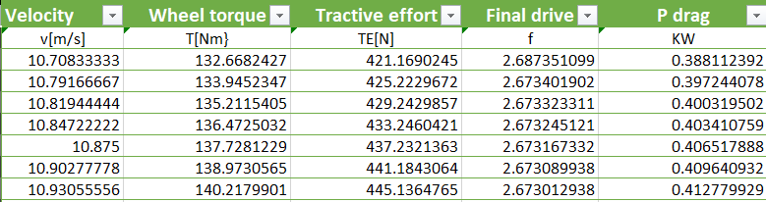
Final drive calculated average- 2.698247835
Table 7. Calculated data for maximum tractive effort (N), theoretical gear ratios and maximum road speed available in each gear (m/s).
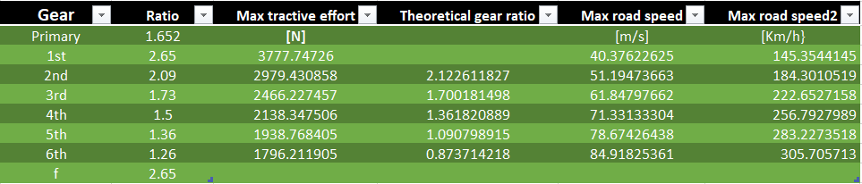

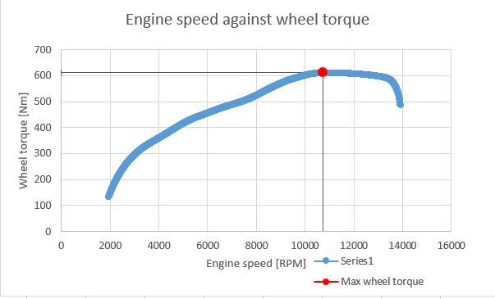
Figure 1. Wheel torque against engine speed.

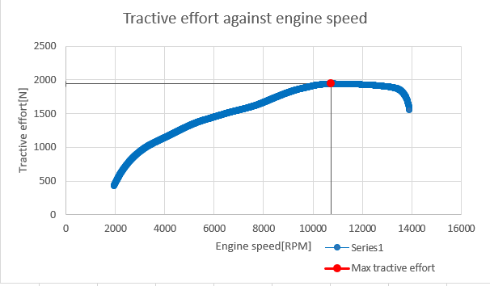
Figure 2. Tractive effort against engine speed.

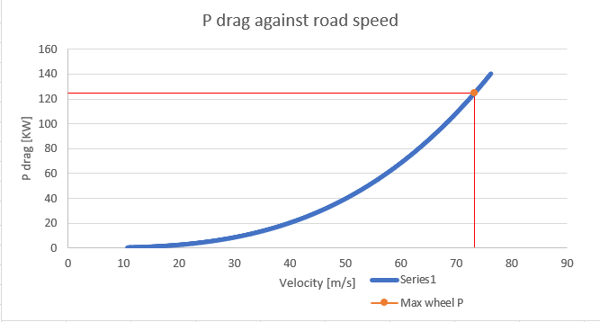
Figure 3. Drag power and maximum wheel power against velocity. Maximum road speed found at intersection.

Discussion
Figure 1 demonstrates that wheel torque ascends with rising engine speed until peak value is achieved of approximately 610Nm at 10500 RPM, following this torque decreases, this is due to the decreasing volumetric efficiency of the engine at higher engine speeds. The efficiency in which cylinders are replenished with fresh charge (Zammit, 1996).
Figure 2 illustrates a similar pattern to the torque curve found in figure 1, this would be accurate as tractive effort is a derivative of wheel torque. As engine speed rises tractive effort will rise until peaking at approximately 1900N before falling. This negative slope after peak value depicts that if the engine is taken to maximum speed a point will be reached where less tractive effort is produced, where the next hypothetical gear would be selected (Saric, 2011). The maximum tractive effort achievable within each gear is also calculated, defining the parameters available. As expected, the lower gear ratios have a much higher tractive effort. As this gears down the system, lowering the rotational speed of the output shaft necessary to induce motion or overcome steep gradients where more torque is needed (Saric, 2011). Alternatively, higher gear ratios rotate the output shaft at higher speeds but at the detriment of available torque. Subsequently, the parameters of each gear ratio allow the driver to select the gear appropriate to that of the immediate driving scenario.
Drag opposes the motion of an object and is proportional to the function of the velocity of the object among other variables such as the coefficient of drag, the cross sectional are and the density of the air (Openstax, 2020). Figure 3 illustrates drag power against velocity. The graph clearly defines a positive gradient that becomes exponential, this would be correct as drag force is calculated as ${Velocity}^{2}$ with the addition of other variables. To achieve the power needed to overcome this drag force, the drag force is multiplied by the velocity which is expressed as ${Velocity}^{3}$, hence the exponential pattern. Maximum road speed is also calculated within the graph, maximum wheel power is represented on the Y axis and is then followed to the point of intersection depicting where available power is equal to drag power therefore establishing maximum road speed achievable, noted as 73.375 m/s.
There is a stark contrast in the values calculated for drag power against the values recorded for drag power on the dynamometer. The reason for this is the recorded values calculated the drag experienced within the system due to frictional losses from mechanical components, whereas the calculated drag power modelled aerodynamic variables such as air density drag coefficient and cross-sectional area. Ultimately, by combining both sets of data, complete drag power experienced by the vehicle can be calculated.
The theoretical intermediate gear ratios are also calculated and compared to that of the actual gear ratios. As seen in table 7, the calculated ratios are close but not exact replicas of the actual gearing ratios and the higher the gear the further the calculated values stray. A reason for this could be that the maximum torque and power speeds used for the speed ratio within which gear ratios are calculated are slightly lower than manufacturer specifications. Upon testing the data was returning 20bhp less than specification that could lead to differences. Alongside this, testing parameters such as chain adjustment and tyre pressures could also have an impact on the results found.
Another difference identified between specification and calculated data is the final drive ratio. The calculated ratio being 2.69:1 and the specification being 2.65:1. A reason for this could be slight differences in the value for rolling radius used within the calculation, this can change due to tyre brands, pressure and age. Additionally, the rolling radius was taken as a static measurement but when in motion there can be expansion which would again change the values found (Taylor, 2020).

Conclusion
Gear ratios are fundamental in delivering the appropriate amount of power for the driving condition imparted on a vehicle and ultimately make up the characteristics of the vehicle. By using a chassis dynamometer, a range of system features can be identified and evaluated. By identifying these fundamental parameters such as maximum values and transmission losses the arrangement can be made more efficient and set up more consistent. Transmission optimisation is also key in racing series where engine power is matched as small gains from drag reduction can provide significant gains over competition (Butcher,2014).

References

Bosch. R (2000). Automotive handbook. Germany: Bentley.
Butcher L. (2014). Transmission dynamometers. Available: https://www.highpowermedia.com/Archive/category/transmission/transmission-dynamometers. Last accessed 17/04/2020.
Crolla D and Mashadi B. (2011). Vehicle Powertrain Systems. Available: https://www.researchgate.net/publication/289605631_Vehicle_Powertrain_Systems. Last accessed 17/04/2020.
Elleray P. (2010). Tractive effort. Available: https://www.highpowermedia.com/Archive/tractive-effort. Last accessed 17/04/2020.
Gillespie C. (2019). How to Calculate Speed Ratio. Available: https://sciencing.com/calculate-speed-ratio-7598425.html. Last accessed 17/04/2020.
Grayen M. (2016). The Difference Between A Transaxle And A Transmission more details on - https://www.carid.com/articles/transaxle-vs-transmission.html. Available: https://www.carid.com/articles/transaxle-vs-transmission.html. Last accessed 17/04/2020. #
Kett P.W. (1982). Tractive effort and tractive resistance. Motor Vehicle Science. 1 (2), 234-259.
Lish T. (2015). What is a Dynamometer and How Does it Work?. Available: https://www.setra.com/blog/test-and-measurement-dynamometer. Last accessed 17/04/2020
Merriam W. (2020). transmission efficiency. Available: https://www.merriam-webster.com/dictionary/transmission%20efficiency. Last accessed 17/04/2020.
Openstax. (2020). Drag Force and Terminal Speed. Available: https://openstax.org/books/university-physics-volume-1/pages/6-4-drag-force-and-terminal-speed. Last accessed 17/04/2020.
Saric I. (2011). Tractive Effort Curves in Gearbox Analyse. Available: https://www.researchgate.net/publication/235618460_Tractive_Effort_Curves_in_Gearbox_Analyse. Last accessed 17/04/2020.
Taylor C. (2020). How to Calculate Rolling Radius. Available: https://itstillruns.com/calculate-rolling-radius-7761935.html. Last accessed 17/04/2020.
tvsmotor. (2018). How A Typical Motorcycle Clutch Works, And How To Make It Last Longer. Available: https://www.tvsmotor.com/blog/how-a-typical-motorcycle-clutch-works-and-how-to-make-it-last-longer/. Last accessed 17/04/2020.
Viayenthiran V. (2017). Learn what a final drive ratio is and how it affects your car. Available: https://www.motorauthority.com/news/1108398_learn-what-a-final-drive-ratio-is-and-how-it-affects-your-car. Last accessed 17/04/2020.
Vibin J. (2017). Dyno theory (chassis dynamometer) and road load equation. Available: https://www.linkedin.com/pulse/dyno-theory-chassis-dynamometer-road-load-equation-vibin-jacob. Last accessed 17/04/2020.
x-engineer. (2020). Drivetrain losses (efficiency). Available: https://x-engineer.org/automotive-engineering/drivetrain/transmissions/drivetrain-losses-efficiency/. Last accessed 17/04/2020.
Yang Z et al. (2015). An Overview of Chassis Dynamometer in the Testing of Vehicle Emission. MATEC Web of Conferences. 1 (175), 1-3.
Zammit S.J (1996). motor vehicle engineering science. Harlow, United Kingdom: longman.

Appendices
Table 1. Collected test data for engine speed (RPM), engine power (KW), engine torque (Nm), wheel power (KW), drag power (KW) and velocity (km/h), values from 1960 RPM through to 13920 RPM.
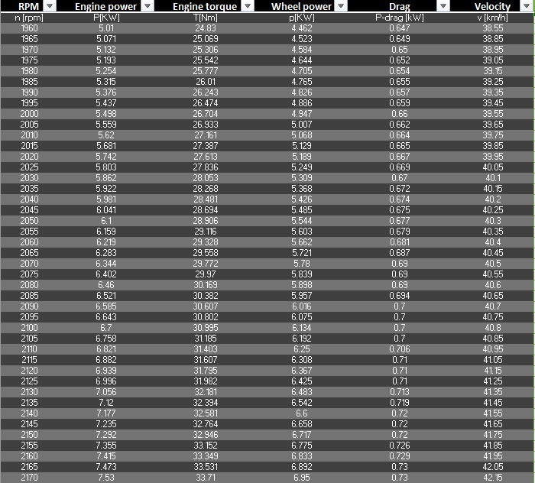
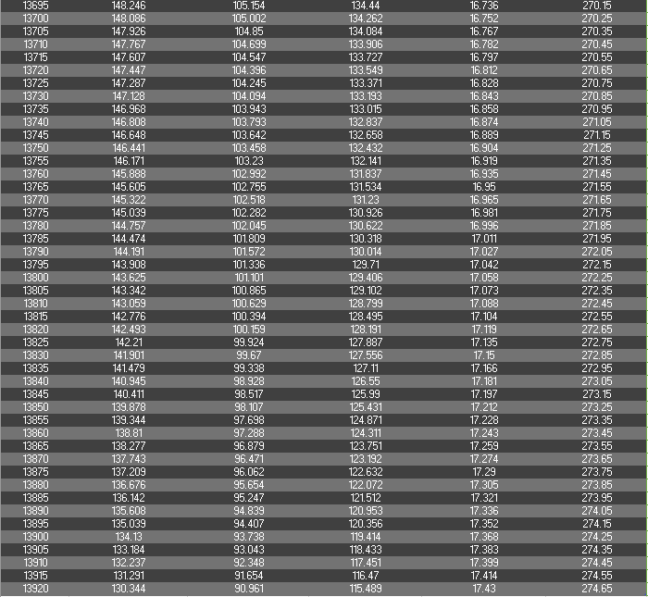

Table 6. Calculated data for wheel torque (Nm), Tractive effort (N), drag power (KW) and final drive gear ratios through all speeds to find an average.


