Generating Business Data and Analysis BMSP 4004 Tutor: Dr Roisin Mullins
Honorata Sieczych
Student no.1708007

Rethinking Conference

Abstract

The Carmarthen Business School organise once a year a Rethinking Conference. In 2018 a business analyst was appointed for its purpose to find a potential location for a conference. The research shows that Pendine beach was the most appropriate location for a convention that complied with the Future Well Being of Generation Act. During the process of searching for a location a database was created to collect, store and retract all information for its purpose.

Contents
Abstract 1
Contents 2
2.0 Main Findings 3
2.1 Procedures and Methodology 3
2.2 Purpose of database 5
2.3 Functions of a database 5
2.4 Role of the Business Analyst 5
2.5 Database Design Lifecycle 6
3.0 Conclusion 6
4.0 The terminology of a database 7
5.0 Database tools 7
5.1 Advantages and disadvantages of database tools. 8
5.2 Data tools trends. 8
5.3 Conclusion 8
References 9
Appendices 10

1.0 Rationale

The Rethinking Conference is run on a year by year basis by Carmarthen Business School and must establish a sustainable location for its purpose, aligning with the Future Well Being of Generations Act. This report investigates potential locations for a conference. It will focus on many counties alongside the Wales Coastal Path, towns within those counties and suitable locations for this convention. Moreover, the report examines specific locations in each town, range of choice and innovative thinking about potential venues.
This Well Being Act is first and unique across the globe. According, to the Welsh Government (2015) and Future Generations Commissioner for Wales (2018), the Welsh Government created 7 sustainable goals to protect its society and promote sustainability.
“A Resilient Wales” maintains as well as enhances biodiverse natural environment with healthy functions ecosystems that protect and support social economic, and ecological resilience” (Future Generations Commisioner for Wales, 2018).

The Rethinking Conference is supported by the Institute of Sustainable Practise, Innovation and Resources Effectiveness (INSPIRE) within the University of Wales Trinity Saint David. The delegates and any public interested in gaining knowledge status can register to INSPIRE courses at the University of Wales Trinity Saint David, across all campuses. Nonetheless the research shows that anyone who is interested in INSPIRE courses can get the certificate only through the University of Wales at this time (University of Wales Trinity Saint David, 2018) (figure 1 in appendices).

2.0 Main Findings

2.1 Procedures and Methodology

To obtain all information for creating a database for a conference, the map of Wales Coastal Path was uploaded (figure 2 in appendices).
The business analyst appointed to this task researched all information regarding potential location and venue date. The primary research showed that there are eight counties alongside The Wales Coastal Path (Natural Resources Wales, 2015) (Welsh Government, 2018). The business analyst chose two towns for each county and selected three different options of location for a conference within each town. This resulted in potentially forty-eight conference venues. One of the prime criteria for its conference was to comply with the Well Being of Future Generations Act (Future Generations Commisioner for Wales, 2018) and the sustainable goal must be chosen for its purpose of the conference.
As analysis shows “A resilient Wales” goal is appropriate for this conference venue with accordance to this assignment (Future Generations Commisioner for Wales, 2018) (Welsh Government, 2015). The Business analyst focused on outdoor venues. Furthermore, those locations consisted of beaches, campsites, picnic sites, football fields, gardens and parks. In result fifteen out of forty-eight venues aligned with the criteria for a conference.
Moreover, outdoor locations were discovered in each county along the Wales Coastal Path. Nevertheless, the venue query 1 shows only an outdoor conferences category but doesn’t include some of different venues such as beaches as potential locations (figure 3 in appendices). The most expensive cost for an outdoor venue was Mumbles Pier which would be in the region of £350. However, two out of fifteen locations attracted the attention of the business analyst with the lowest cost for a venue in the region of £50. “Resilient Wales” goals support ecology as well as sustainable economy, thus the business analyst focused on Pembrey Country Park and Pendine beach. Both locations have access for disabled people to the beach as well as toilets. However, Pembrey park has only a few toilets compared with the park size. Therefore, Pendine is smaller than Pembrey Country Park and has restricted parking spaces, but for a small amount of people it’s a reasonable location for the conference. To gather all information, the database was created to support its research and a verification of collected data was needed. The website www.RC2018.com was generated to gather all information regarding the database. The Carmarthen Business School decided that the conference will be launched on 1st of June 2018 between 13.00 and 16.00 on Pendine Beach. The delegates will need to bring blankets and their own foldable chairs as well as provide their own food for a picnic conference. The chosen date for the conference is a Friday as that can be advantageous for delegates because Pendine is a popular tourist destination and delegates may stay for longer to explore this location. Pendine is a small town well connected with Laugharne, St Clears, Carmarthen and Saundersfoot. The town has a few shops, cafes and restaurants therefore it would be suitable for delegates and satisfy their needs (UK Beach Guide, 2018) (Carmarthenshire County Council, 2017) (figure 4 in appendices).
Carmarthenshire County Council gave permission to the organisation (Carmarthen Business School) for the Rethinking Conference with a small charge of £10 and the facilities cost will be in the region of £20 in addition to the council charge. The cost of the conference was assumed by the business analyst. However, this might be too innovative for some people and delegates might be reluctant to attend. The older generation are used to conferences of a high standard and located in hotels or business centres. However, the rationale is that Carmarthen Business School promotes and maintains sustainability across the curriculum therefore provides lower costs for organisations as well as participants, aligning with the organisation’s ethos.

2.2 Purpose of database

As Steven (2002) claims, the purpose of a database is the transformation of data into information and to enhance data management as well as define specific approaches for data usage. Different approaches are used to different types of database known as entity relationships. Data is put into the Access Database and can be retrieved, retracted or modified avoiding data duplication. Steven stated that the data must be accurate and valid (Steven, 2002). However, poor design of databases can lead to managerial errors and can lead to consequences for its organisation (Steven, 2002; Dowling, 2002). The main advantage of a database over a spreadsheet is the ability to set up and maintain relationship between the tables.
Analysis shows that the purpose of creating a database is important. The analysist collected all related information into one database. However, information stored individually can be lost within the process and this is time consuming. The purpose of the Rethinking Conference database is to capture the data to make decisions about a choice of conference venue.
The database consists of three tables, four queries, three forms and two reports (figure 5 in Appendices).

2.3 Functions of a database

A database software tool makes it possible to organize data in a database, moreover the functions of a database include concurrency, security, back up, integrity and data descriptions. Also, it allows data modifications and presentation and furthermore captures data, records, queries, forms and reports and enables complexity of relationships within a database (Steven, 2002). Therefore, the database will be a useful tool to build a database assignment of Pendine Beach.

2.4 Role of the Business Analyst

A business analyst is brought in at an early stage of the process. According to Cadle (2010) “they investigate ideas and problems” and find solutions as well as ways to move forward. Business analysts construct business cases then leaves conclusions and recommendations”. Moreover, they generally work on senior managerial level.
The responsibilities for an analyst are to comply with the objective of an organisation, as well as being responsible for development of the business strategy. However, in this assignment the business analyst is restricted to the responsibility of determination of a sustainable conference venue through recording and storing data in a database.
(Cadle, Paul, & Turner, 2010).

2.5 Database Design Lifecycle

According to Rob and Coronel (2006) a database’s lifecycle is divided into “five stages: planning, analysis, conceptual design, implementation and maintenance”. The first and second stages involve collection of all information relating to the project with consideration of an applicable budget for the process and determine a timescale of its process as well as examination of possible venues. With relevance to the assignment all data was collected from several places, the Well Being Act was studied, and a time scale was set out for the task. The various websites were checked for the assignment and information was retracted and stored into a database. The Rethinking Conference venue was examined for potential locations with consideration of all factors. At the third stage of the database’s life cycle an entity relationship diagram was created (figure 6 in Appendices).
This assignment is restricted to three tables however, in the future more tables can be added such as ‘payment types’. In a database there are three main entities such as county, town and venue. The first entity called ‘county’ has a ‘primary key’, a ‘county code’. Also, attributes are an ‘English county name’ and ‘Welsh county name’. The second entity called ‘town’ has a ‘primary key’ and a ‘town code’ and the attributes are ‘town name’ and ‘county code’. Additionally, a ‘foreign key’ is a ‘county code’ because it establishes a link between tables. The third entity called ‘venue’ has a primary key called ‘venue code’ and the ‘foreign key’ is ‘town code’ which is connected to both tables, moreover there are fifteen attributes. The relationship in the ERD are one to many, furthermore an example of it would be that each county has many towns within its region or each town has many conference locations. The purpose of keys is division between relations such as one to many.
In the third stage the database was created using Microsoft Access and during the fourth stage all relevant data was stored in the database. The final stage required maintenance and monitoring as well as updating the data.

3.0 Conclusion

The location of the venue was selected based on the area that provided and maintained wildlife and various species and habitat to this specific region, aligning with the Well Being of Future Generations Act. Looking seawards from Pendine’s sandy beach the wide expanse of Carmarthen Bay can be seen.
Pendine beach is accessible to disabled people and toilets are provided, but parking spaces are restricted. 25 delegates approved their attendance to the conference. Every document produced for the Rethinking Conference will be provided only electronically to reduce the carbon footprint as well as promote sustainability and “Resilient Wales” goal.

4.0 The terminology of a database

Entity is a table that contains the central point for one or more pieces of information and stores all data (Harrington, 1998).
An attribute is defined as a piece of information as well as a field group of characters. There are two types of attributes such as identifier and might be a key or descriptor which is non-key (Teorey, 1999) .
Relationships in databases are instances between entities and their types such as one to one, one to many and many to many (Harrington, 1998).
According, to Carter (2003) form is described as “a rectangular screen object used to input and display database data” (Carter, 2003).
As suggested by Dowling (2002), “queries are very powerful tools that can be used to convert the raw data held in a table into information.”
Primary key is a unique identifier which identifies each record (Harrington, 1998).
Tables are a collection of information- rows recorded as well retrieved and retracted for a relevant purpose or task (Dowling, 2002).
An ERD known as an Entity Relationship Diagram is a form of Data Model. Also, the graphical tool identifies entities or systems and logical relationships among entities. Additionally, ERDs capture the data elements in a system and from ERDs a relation database can be created.
Logical Data Structure (LDS) is used to define a conceptual view of the system. Moreover, it is an abstract view of data that will be used later in the physical files of an IS. Therefore, an ERD diagramming technique is used to represent the conceptual LDS
(Teorey, 1999).

5.0 Database tools

There are various tools within a database. Primarily Microsoft Access is a software tool to create databases from the very beginning. Microsoft Open Office such as Word helps to write down findings as regards the database. One Drive or Dropbox is a cloud service that provides and maintains all data in one virtual space on the internet instead of generating space on a computer. The Cloud service is very popular these days and Microsoft Excel creates charts and graphs. An email box is used instead of traditional post and reduces the carbon footprint. All data is stored on the internet which is the most efficient and fast way of communicating. A library helps to store information to gain knowledge that can be applied to an assignment. Readers such an e-book collects electronic versions of books and has easy access for users. An electronic map supports a knowledge about the Welsh Coastal Path. The functions of database tools are “to insert, retract, display, transfer and summarise all data in printed or electronic form” (Coronel & Rob, 2006).

5.1 Advantages and disadvantages of database tools.

Advanced technology helps society to improve their communication and it’s easy to use. Database tools can protect society and even predict crimes that might occur in the future. The information in database tools can be controlled and secured as well as being able to be used by multiple users. Also, social media can be an advantage to business by generating data that they can use for their own advantage.
However, advanced crimes occur often, and criminals have faster and easier ways to obtain any data about people. Some people don’t consider carefully what kind of information they share on Facebook or other social media. This can be very dangerous and can lead to serious consequences including putting their lives at risk as well as their associates. A burglary can happen after information being shared about potential holidays on social media, for instance. Furthermore, internet crime - when data is not protected and stored properly by a user can even lead to more serious cases such as kidnapping, if kids share data with a stranger. However, to increase safety for the public, security and intelligence services must work in coordination.

5.2 Data tools trends.

There are many different data tools and trends and society uses them daily. Tableau is a data visualization software tool with various types. This tool transforms data into visual concepts. It is connected to different data servers and improves understanding of data. An example of a transformation would be a spreadsheet into a visual version (Tableau, 2018).
Social media focuses on communication worldwide and helps collect the data for businesses and organisations in terms of understanding people’s needs.
Structured Query Language known as SQL as suggested by Teorey is “standard data definition language and data manipulation language for relational database management system” (Teorey, 1999). To simplify this definition of SQL, it is a tool to communicate within database language.

5.3 Conclusion

This report shows that various tools within databases are commonly used daily, not only by professionals. Advances in technology and growth of the internet help people to improve communication. Also, this report shows that information within databases can be controlled and secured. However, the research found that data can be used by criminals and unsecured social media can put people’s lives at risk. Overall, databases and social media help to improve productivity and communication and connect in a faster and cheaper way worldwide.

References
Cadle, J., Paul, D., & Turner, P. (2010). Business Analysis Techniques. British Informatics Society Limited.
Carmarthenshire County Council. (2017, n.d. n.d.). Discover Carmarthenshire. Retrieved from www.discovercarmarthenshire.com: http://www.discovercarmarthenshire.com/places/pendine/
Carter, J. (2003). Database Design and Programming. London: Mc Graw -Hill Education.
Coronel, C., & Rob, P. (2006). Database System Design Implementation & Management. Course Technology.
Dowling, N. (2002). Database Design and Management. London: Thomson.
Future Generations Commisioner for Wales. (2018, n.d. n.d.). Future Generations Wales. Retrieved from www.futuregenerations.wales: https://futuregenerations.wales/about-us/future-generations-act/
Harrington, J. (1998). Relational Database Design. London: Academic Press.
Natural Resources Wales. (2015, n.d. n.d.). Wales Coast Path. Retrieved from www.walescoastpath.gov.uk: http://www.walescoastpath.gov.uk
Steven, R. (2002). Access Database Design and Programming. O'Reilly Media.
Tableau. (2018, n.d. n.d.). www.tableau.com. Retrieved from Tableau: https://www.tableau.com/
Teorey, T. (1999). Database Modelingand Design. San Diego: Academic Press.
UK Beach Guide. (2018, n.d. n.d.). UK Beach Guide Pendine. Retrieved from www.thebeachguide.co.uk: https://www.thebeachguide.co.uk/south-wales/dyfed/pendine-sands-photos.htm
University of Wales Trinity Saint David. (2018, n.d. n.d.). University of Wales Trinity Saint David. Retrieved from www.uwtsd.ac.uk: http://www.uwtsd.ac.uk/inspire/
Welsh Government. (2015, nd nd). The Wales We Want. Retrieved from www.thewaleswewant.co.uk: http://thewaleswewant.co.uk/sites/default/files/Guide%20to%20the%20WFGAct.pdf
Welsh Government. (2018, n.d. n.d.). Visit Wales. Retrieved from www.visitwales.com: http://www.visitwales.com/things-to-do/activities/walking-hiking/wales-coast-path

Appendices

Figure 1 Inspire Course (Screenshot of computer)
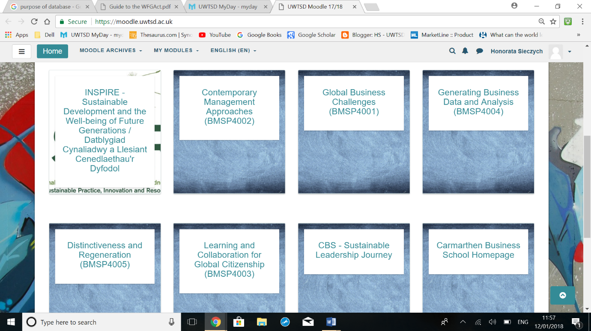

Figure 2 Map of Wales Coastal Path (Screenshot of computer)

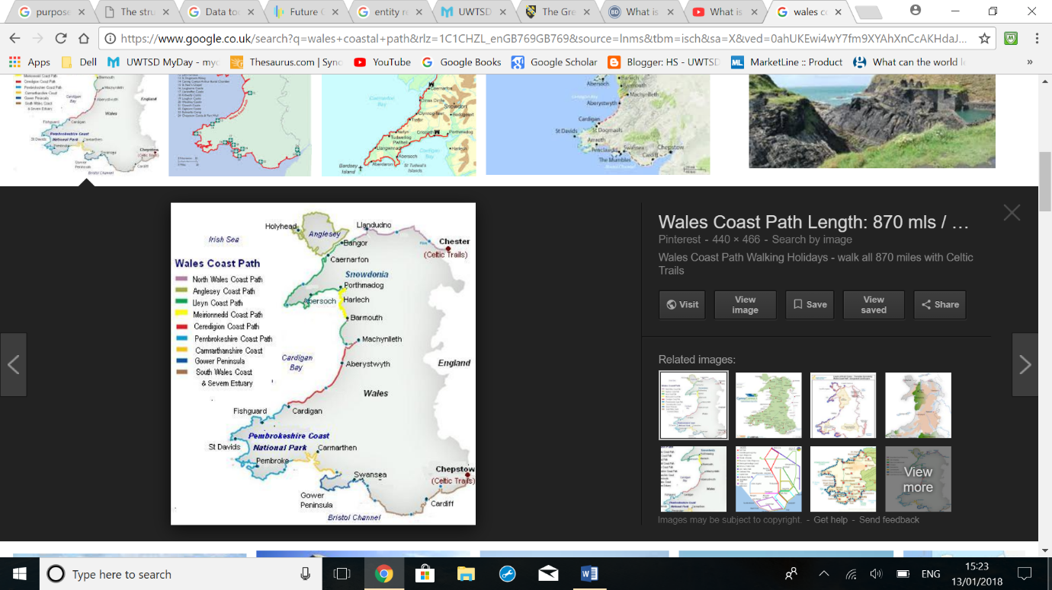

Figure 3 Venue Query 1 (Screenshot of database)

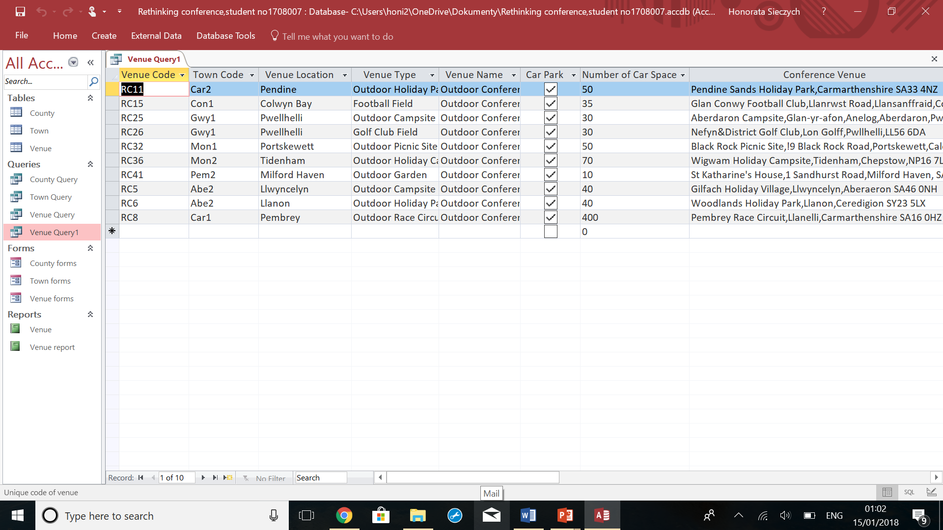

Figure 4 Pendine

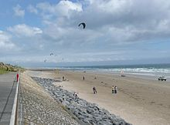
This Photo by Unknown Author is licensed under CC BY-SA
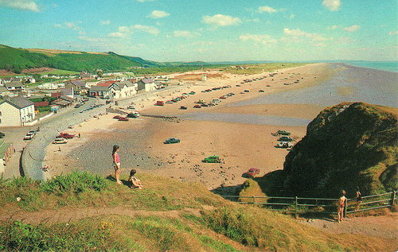
This Photo by Unknown Author is licensed under CC BY-NC-ND
Figure 5 Tables of database (Screenshot of database)

Figure 6 ERD Relationships (Screenshot of database)


