



Bridging Guidance
BA2
ECAD5007 – The Learner: who am I teaching?

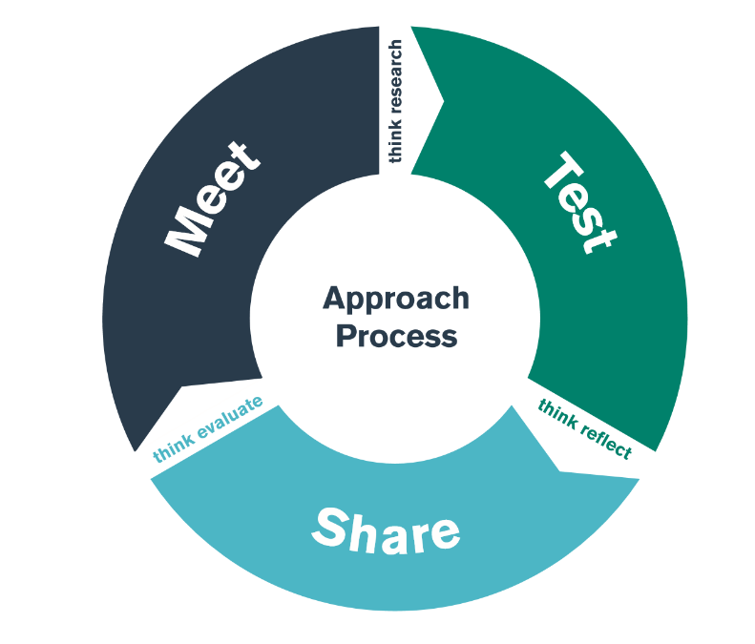

Student /Staff Guide
2023-2024

Introduction

What is bridging?

Bridging is a key part of the APLP model for transforming practice and takes place at carefully chosen points in the timetable. The model has been co-constructed with colleagues from Lead Schools.

Bridging is one way of linking theory and practice. It involves the student-teacher, practicing teacher and University Tutor (Curriculum/Professional) in three phases of practice, each one followed by a period of reflection and revision.

This process is shown in the following diagram:

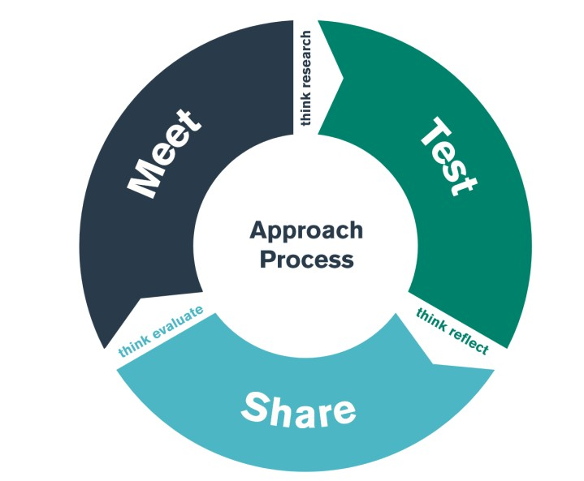

These phases can be adapted for different contexts, but broadly involve:

- Meet the ideas either in the university, school or the community and plan for testing;

+ Think research – what has been written about this area?

- Test the ideas in the classroom;

+ Think reflect – what was learnt about the strengths and challenges of the test phase?

- Share the ideas in a professional context with peers and the teaching practice community;

+ Think evaluate – how will personal practice be transformed for the better?

As student-teachers engage with this cyclical process and are supported in setting personal targets for development, their practice of teaching and learning is transformed and they are encouraged to become enquiring contributors of the teaching profession.

When student-teachers work within a school, they are always under the supervision of a class teacher. As part of their experiences, the student-teachers will be required to evaluate classroom practice, which may take the form of a written evaluation or assessment of children's work, and may also involve asking staff and children about their views. These activities do not differ from usual classroom practice.

What makes successful bridging?

From the pilot activity, some key points related to successful bridging are noted in the following table:

Meet (university) | Test (School) | Share (University)
Strong theoretical input that can be applied to different contexts e.g. classroom management or assessment for learning;  Clear and manageable pieces of reading;  Being responsive to ‘hot topics’ that have been identified during Professional Teaching Experience.  Clarity of expectation for the test and sharing phases. | Support from Class/Subject  Mentor in testing/experimenting with ideas;  Opportunities to see experienced teachers modelling idea to be tested;  Supported discussions by Class/Subject Mentor in reflecting and refining testing phase;  Link to existing action plans and practice – needs to support PTE, rather than being an add-on. | Clarity of expectation – what is  expected in the sharing session?  Open to critique – more than just reporting but engagement in critical thinking and shared reflection;  Discussion supported by teacher educators – an expert voice in the role of discussant;  Clear target-setting for personal practice – feeding forward;  Feedback to Class/Subject Mentor.

Clarification of Roles in Bridging

In the true spirit of the Partnership, bridging is co-constructed and co-delivered. Materials and guidance will be sent to Lead Schools, however, each Lead School will consider its own context when deciding how best to deliver the sessions. It is for this reason, that it is vital for school and university staff to liaise in order to ensure the sessions are effectively co-planned and co-delivered. The roles of the key stakeholders in bridging are outlined below:

Placement School
- Read guidance for each bridge and suggested readings sent by university.
- Consider how the Lead School’s context best demonstrates the focus of each bridge.
- Liaise with Curriculum Tutor at least two weeks in advance to co-construct the sessions.
- Organise the practical arrangements for the sessions based in the Placement School (rooms, timetable, availability of relevant staff etc).
- Attend university held “meet” sessions (optional).
- Ensure that student-teachers have clarity of the expectations of the “test phase” and “share day”.
- Together with the Curriculum Tutor, act in the role of discussant during the “share day” to:
- develop the student teachers’ critical thinking and reflection;
- guide their thinking in terms of reimagining what they have learnt for their own context;
- ensure that each student-teacher has articulated a personal target from the session.
- Allocate time during the “share day” for student-teachers to up-date the relevant sections of their PLP. Where time does not allow, direct student-teacher to do so within 48 hours.
- Contact Professional Tutor with any issues relating to student-teachers’ lack of engagement/professionalism.

Module Lead
- Prepare bridging documentation (STEER, PPT, Guidance, One page Summary) using templates provided by Operational Lead for Bridging (KG)
- Present documentation to Curriculum Tutors and Network Leads in walk-through meeting in order to clarify expectations for the MEET, TEST and SHARE phases of the bridge.
- Upload documentation to Moodle for students
- Upload documentation to the BA/PGCE Bridging and Network Team

Curriculum Tutor
- Read guidance for each bridge and suggested readings.
- Liaise with Network Lead at least two weeks in advance to co-construct the sessions.
- Co-deliver the “meet day” with the Network Lead (if held at Lead School).
- Inform Network Leads when university-based “meet” sessions are being held so that they can attend if they wish.
- Ensure that student-teachers have clarity of the expectations of the “test phase” and “share day”.
- Together with the Network Lead, act in the role of discussant during the “share day” to:
- develop the student teachers’ critical thinking and reflection;
- guide their thinking in terms of reimagining what they have learnt in their own context;
- ensure that each student-teacher has articulated a personal target from the session.

Professional Tutor
- Add a layer of quality assurance by attending bridging sessions across their Lead Schools.
- Provide cover for the Curriculum Tutor if they have teaching commitments or are absent.
- Where more than one Curriculum Tutor is not available for a given bridging activity within their networks, to arrange for another university-based colleague to attend.

Student Teachers
- Engage with pre-readings.
- Arrive punctually to Lead School for bridging sessions.
- Be professionally attired.
- Conduct themselves in a professional manner at all times.
- Engage with Lead School and university bridging sessions.
- Complete STEER documentation.
- Brief the Class/Subject Mentor in the placement school on the “Test Phase” expectations.
- Engage with the “Test Phase” at their placement schools.
- Share their ideas, experiences and reflections from the “test phase” with their peers, the Network Lead and the Curriculum Tutor in the “share day”.
- Be open to critique to develop critical thinking and reflection.
- Set a personal target from the bridge to further develop their own practice.
- Complete the relevant section of the PLP within 48 hours of “share day”. This must include Tab 4 (Research) but may also provide assets for Tab 7 (Standards).

Class/Subject Mentors in Placement Schools
- Arrange meeting time with student within 48 hours of “meet phase” to discuss “test phase” expectations.
- Support student-teacher in testing the ideas introduced during the “meet phase”.
- Where appropriate, arrange meetings for the student-teacher with key stakeholders to deepen their understanding of the bridge focus within the context of the Placement School.
- Meet with the student-teacher to discuss their findings and support their reflections.
- Ensure that the focus of the bridge is linked to targets set in the student-teacher’s Learning Journal.
- Review PLP updates in PLP during the End of Week Review

How does the Year 2 bridging TEST phase support the learning taking place within the university?

At the university, the student-teachers will MEET the theoretical content of the module ECAD5007 – Cycle 2 Core Studies: The Learner: who am I teaching? The overall aim of the module is to provide student-teachers with a variety of experiences that will allow them to engage further with the knowledge and understanding of child development and the external factors that influence learning, progression, well-being and development.

Although this module builds on the knowledge and understanding gained within the ECAD4007 – Cycle 1 Core Studies: The Learner: who am I teaching module, the emphasis here is on learners in Key Stage Two. Throughout the module student-teachers develop a deeper understanding of the background, theoretical thinking and research that underpins child development, well-being and learning from 0-19 years and how these relate to teaching and learning. They also identify and reflect on professional and legal responsibilities of working with children, including their own personal beliefs and assumptions and how this may impact on their own professional practice. It also identifies effective approaches for meeting the diverse needs of all learners in different settings and how this relates to the role of the professional teacher.

How many bridging TEST days are there connected to the module ECAD5007 – Cycle 2 Core Studies: The Learner: who am I teaching?

School based TEST phase in Key Stage Two is required for this module.
This will take place between 19/02/24 – 08/03/24.

Where do the SHARE days happen?

Student-teachers will engage in critical thinking and shared reflection regarding the TEST experience at University. Here close connections are drawn to the MEET content from university and conclusions and personal targets are identified with regards to moving forward with the focus of their assignment.

How does the bridging activity support the module assessment?

By the end of the module, student-teachers will complete a 4,000 word assessment where they will choose an intervention that supports the learning and development of a pupil or group of pupils. The focus for the intervention is based on their personal and professional interest but it is expected that their discussion is linked to relevant theories of child development met within this module and in their previous ECAD4007 – Cycle 1 Core Studies: The Learner: who am I teaching module, as well as evidence from effective practice in schools. They are also required to engage in critical reflection on the potential of their chosen intervention for ensuring pupil progression and the possible challenges that may arise in its implementation. In doing so they need to consider the following:

- Identify a specific individual or group of children aged between 7 and 11 years. Provide an overview of their background e.g. age, gender, level of development, any other relevant information.
- Explain which aspect of learning or development they would like to target and why e.g. language and literacy, physical, emotional, social, cognitive, behaviour, wellbeing, a specific ALN, cultural diversity etc.
- Demonstrate their knowledge and understanding of what is meant by 'progress' in learning and development and why it is important to support this aspect of this particular child's/group’s learning or development. This aspect should be underpinned with relevant theory and research.
- Choose a suitable intervention for a child / group of children and explain why they specifically chose this intervention, how they would implement it and who would be responsible for that. Critically evaluate the intervention, considering the positive qualities and negative aspects that can arise in its implementation. Justify their choice by reflecting on good practice observed during the TEST phase, during PTE, or from research e.g. Estyn etc.
- Demonstrate sound knowledge and understanding of child development, why it is important to support progress in learning and development and the implications for teachers, school staff and other stakeholders.
- Support their views throughout the assignment with references to background reading and current research.
- Adhere to ethical considerations as outlined in the BERA guidelines throughout the process and ensure anonymity for all pupils, staff and the schools.

TEST PERIOD GUIDANCE

It is important to note that this bridging activity is focused on Key Stage Two

What will the student-teachers MEET in university before returning to the Placment school for the TEST phase?

The student-teacher will MEET the following theoretical content before engaging in the TEST phase:

- The historic and contemporary learning theories that underpin the holistic development of children in Key Stage Two.
- The concept of progression and how this is evidenced within Curriculum for Wales.
- The learning development debate – ‘age versus stage’ and ‘nature versus nurture’.
- An introduction to implementing interventions to support learning and development.
- A reminder of the guidelines regarding ethical conduct of undertaking observation in schools.

Linked reading activity:
Beckett, C. and Taylor, H. (2010) Human Growth and Development. 2nd Edn. London: Sage. (Chapter 3)
Meadows, S. (2018) Understanding child development. Abingdon: Routledge. (Chapter 8)
https://educationendowmentfoundation.org.uk/evidence-summaries/teaching-learning-toolkit/
https://afaeducation.org/free-dt-resources/explore-our-resources/interventions-in-the-classroom/

What is the purpose of this bridging activity?

By the end of the TEST phase, student-teachers should have an understanding of the ‘What? Who? Why? Where? and How?’ of providing interventions to support learning and progression, especially within Key Stage Two.

TEST phase in Placement School

The plan is based activities to completed during the test period, content is flexible.

Activity | Staff | Notes/ suggestions for possible activities
Introductions and expectations for the day e.g. cameras on if online/phones off i fin school, engagement in discussions etc.  General introduction to the day, the school context and professional responsibilities | Headteacher (or ALNCo, Well-being/Literacy/  Numeracy Co-ordinators or other relevant members of staff) | - Remind student-teachers of the need for  professional interactions with both staff  and pupils in live online sessions, i.e. use of  appropriate language and  behaviour.  - Emphasise that student-teacher/s should not make judgements of staff and their teaching.  - Provide an overview of the school context, e.g. number of pupils, socio-economic background, percentage of pupils with ALN, EAL, MAT, eFSM etc. and key issues considered within the school in providing additional support. Explain class and group structures.
Outlining the purpose, aims and outcomes of the Bridging activity | Headteacher (or ALNCo, Well-being/Literacy/  Numeracy Co-ordinators or other relevant members of staff) | - Ensure student-teacher/s understand that by the end of the test phase they should have an understanding of the range of intervention strategies used by the school to bridge the attainment gap and to support further learning and progression and how these are implemented.  - Reiterate the importance of trying to make connections with the child development aspects and concepts of progression explored during MEET (university) and what is observed and discussed on TEST.  - Student-teacher/s will be expected to undertake tasks that require them to collect information that will contribute to their knowledge and understanding of the aims, purpose, advantages and limitations of various interventions.  - Group discussion of possible key questions that need to be explored during the test period.
An overview of interventions utilised within the school | Headteacher (or ALNCo, Well-being/Literacy/  Numeracy Co-ordinators or other relevant members of staff) | - The Placement School to provide student-teacher/s with information about its approaches to interventions and the evidence base for implementing these. This might include how pupils are identified, an outline of staff involved in delivering or supporting the intervention and any issues regarding resources, grouping, timing, location etc.  - Provide an overview of key stakeholders involved in supporting the interventions including engagement with learners themselves, parents/ carers and a range of outside agencies.  - Explain the advantages and limitations (if any) of various interventions.
Observation of interventions in action | Headteacher (or ALNCo, Well-being/Literacy/  Numeracy Co-ordinators or other relevant members of staff) | - The Placement School to provide student-teachers with opportunities to observe 3-4 different individual or small group interventions to support pupil progression.  - Student-teacher/s to make observational notes for discussion regarding examples of best practice and the possible limitations involved e.g. time, space etc. Notes can be recorded in the Student- Teacher Enquiry Evidence Record (STEER) document provided.  - Opportunities for Q&A
Time for reflection | Headteacher (or ALNCo, Well-being/Literacy/  Numeracy Co-ordinators or other relevant members of staff) | - Discussion where student teacher/s critically reflect on their observations.  - Opportunity to further complete the Student- Teacher Enquiry Evidence Record (STEER) document provided by the university in the MEET session.
Tracking progression in learning | Headteacher (or ALNCo, Well-being/Literacy/  Numeracy Co-ordinators or other relevant members of staff) | - The Placement School to share examples of how learning and development is monitored and recorded with a specific focus on key interventions utilised within the school.  - Explain how this information is used to inform and support further learning.  - Opportunities for Q&A.  - This can be organised as a small group dicussion via Breakout rooms if practical to do so.
Plenary | Student teacher | - Student-teachers to identify an intervention to research further for SHARE activity in University.

