Plant, water and soil testing report
By
Alex Sage
Biodiversity and ecosystem services
Dr. Mike Goodfellow-Smith
02/12/2022

Introduction
In this report I will be presenting and analyzing data I have collected from a local ecological site in Swansea in order to determine the condition of the site, the range of biodiversity within the site and what could be done to increase and manage biodiversity in the future.
In order to do this, I took plant, soil and water samples from my selected site and carried out at home and in lab tests in order to get fundamental data about the site. A baseline amount of data is essential to formulating a management plan as managing a site without this essential data could result in a drop in biodiversity due to unfavorable conditions caused by using the incorrect management solutions for the fauna or flora on the site.
Furthermore, the data collected must be as accurate as possible and tested under strict lab conditions in order to get the best results I can and paint a clear picture of the level of biodiversity on my selected site. To ensure this was the case, I preemptively selected a sampling technique that I would stick to throughout the data collection process and testing methods for the soil, plant and water samples. For soil I decided to test for soil type, pH and organic matter content; For water I tested for pH, turbidity, and bacteria; and finally for plants I collected samples and identified them.

Methodology
As discussed above, methodology is extremely important when it comes to collecting data for ecological management as incorrect sampling or testing methods can lead to inaccurate data which, in turn, can end up damaging the site from which the samples were taken as incorrect management plans may do more harm than good to biodiversity levels. In order to mitigate this risk, I researched the correct methodology for each of the tests I wanted to carry out before collecting my samples and decided on a sampling method that would give me the most accurate results.
The area of my sample site was roughly 12 meters by 6 meters giving me a total area of roughly 72 meters squared. I decided to use a cross sampling method with 1 sample being taken from the center of the site with 3 more samples being taken on each arm away from the center at 45 degrees and with a sample being taken every 2 meters. This ensured that samples were evenly spread out and far enough apart to get a range of data.

Soil
pH – Knowing the pH level of the soil being managed is essential as it is one of the key factors that determines where plants can and can’t grow and whether they will be healthy if they do. To test the soils pH level, I first dug a small hole a few inches into the soil using the sampling method described above to collect samples equal distances apart across the site. I then removed any organic matter in the soil like twigs and any stones or pebbles and placed a scoop of soil from each hole into a sperate sealed container. Next, I added distilled water to each container and waited until the soil and water had combined to form muddy water. At this stage pH testing strips were placed into the top of the container and left for 2 minutes, at which point the pH strips changed colour telling us the rough pH of each sample of soil (Bob Vila, 2020). Considering my sample site was not very large and had similar flora throughout, I expected the pH to be consistent throughout the samples.
Type – Similarly to the pH of the soil being managed, knowing what type of soil you are managing is just as important. This is because, at a microscopic level soil can be structurally very different. For example, a sand-based soil will drain water and nutrients a lot faster than a clay based soil that retains water a lot easier; This means that plants in sandy soils need to be watered a lot more often while plants in clay based soils can survive without fresh water or nutrients for longer.
In order to test the soil type, I collected samples from across the site, again using the sampling method mentioned above, weighing roughly 200 grams each. I then took each of these samples and placed them into separate, clean mason jars and filled each jar to the top with water. Each jar was then shaken for roughly 3 minutes before being left to settle for 6 hours. After 6 hours I examined each of the jars and recorded as a rough percentage the amount of sand at the bottom of the jar, silt in the middle and clay at the top. Using these percentages, I then used the soil texture triangle to determine which soil type my site contained. Again, due to the small scale of my sample site I expected each sample to be a similar or identical type of soil (ROBERSON, 2014).
Organic matter content – Whilst not as crucial to know as the pH or soil type, the organic matter content of soils can be a good insight into the biodiversity of a site. Soil with high organic matter within it tells us that there is a healthy life cycle of flora and fauna in the area which means there is food and nutrients ready to be broken down and used by other living organisms.
To test for organic matter content, I took several 100-gram soil samples from across my sample site and placed them into separate containers. I then took each sample and placed them into a heatproof crucible and placed in on top of a heatproof stand and lit a Bunsen burner below it. After turning the flame to high, I left each crucible on the heat for 10 minutes each. After each sample had been on the heat for 10 minutes I took them off and weighed them individually. I then subtracted the post-heat sample weight from the initial 100 grams weight to determine how much, as a percentage, of the initial sample was organic matter that burnt away.
Organic matter can vary quite a lot even across a relatively small site so I was expecting more variation between these results than any of the previous soils tests I did.

Water
pH – Similar to soil pH, the pH level of water is also an important bit of data to know as both flora and fauna that resides near water sources will need to use it yet can be very sensitive to even small changes to pH levels.
To test the pH of water on my sample site I collected 3 250ml bottles of water from a small stream that ran down the embankment on one side of the site. I then took the water and filtered it through filter paper to remove any sediment or organic matter. After which, I left a pH testing strip partially submerged in each bottle and left them for a few minutes (Sensorex, 2020). Since there was only 1 water source on my site and all 3 samples were collected from it, I expect to see almost identical results across the board.
Turbidity – This is useful for determining the quality of the water being tested. A higher turbidity score indicates pollution of the water as there are particles in the water causing the light to scatter, a lower score indicating cleaner, purer water. Unfortunately, I did not have access to an electronic turbidity meter so I did a visual test giving each water sample a score out of 100 depending on how much light shone through the sample when I placed a torch behind it. Despite not being scientifically accurate, a qualitative score can still be useful in determining the rough quality of water being tested.
Bacteria – A very important set of data to know as bacteria content has a direct impact on the health of flora or fauna using the water. A high bacteria content indicates high levels of pollution and potentially unsafe water to consume or touch. To test for bacteria, I again got 3 more samples from the stream, filtered them through filter paper and placed the samples into separate bacteria testing kits. After being left for 48 hours the water changed colour to indicate the presence, or lack thereof, of bacteria (Cairncross, 2017). I expected a presence of bacteria from these tests as the stream on site ran through muddy ground.

Flora
Identifying which types of flora grows in the area being managed can be extremely useful as it tells us the current condition of the site and which type of living organisms it primarily caters to. In order to find this out, I took some leaf samples that had dropped to the ground from the trees, bushes and some grass on site and then compared them to images I found on the National Plant Monitoring Scheme’s plant identification guide (NPMS, 2015).

Results

Soil - pH
Sample # | 1 | 2 | 3 | 4 | 5 | 6 | 7
Colour | Dark Green | Dark Green | Green | Green | Dark Green | Green | Dark Green
As the table above shows, 8 out of 13 samples returned a dark green colour indicating alkaline soil whilst 5 out of 13 returned a lighter green colour indicating a neutral soil. This suggests that the soil from the sample site is somewhere between a neutral and alkaline pH. This aligns with the visual review of the site as it mainly comprises of grass with a few trees and bushes dotted throughout. Grass can grow well in neutral soil so it is no surprise it covers the majority of the site and now that we know the pH level of the soil we can narrow down the species of flora that are found there.
Sample # | 8 | 9 | 10 | 11 | 12 | 13
Colour | Dark Green | Green | Dark Green | Green | Dark Green | Dark Green

Soil – type
Using the diagram on the next page I was able to match the rough percentage amount of sand, silt and clay that settled in the glass jars to the soil type. My results from each sample is shown in the table below.

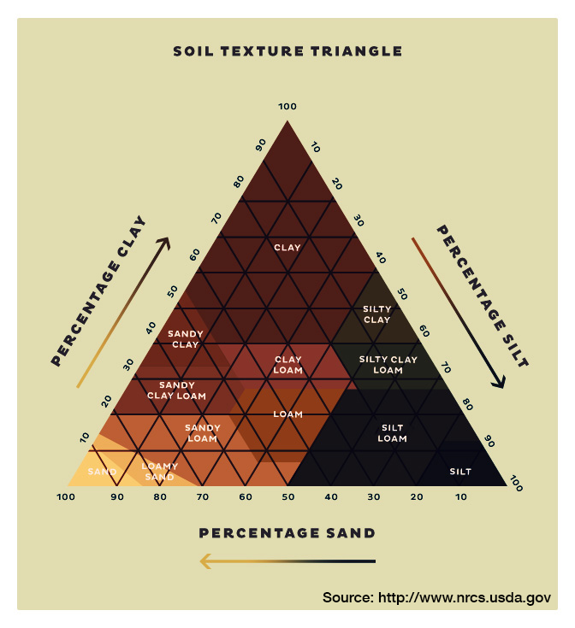
Using the chart to the left and the results we can determine that the soil from my sample site is silty clay loam as it contains all 3 types of soil but is overwhelmingly silt and clay with the sand content being minimal. This suggests that this soils retains water and nutrients very well but may be prone to flooding during winter seasons and therefore this may limit the species of flora that is able to grow in this soil.

Soil – Organic matter content
The table above shows my results for the percentage of organic matter found in each of my 100 gram samples. As the average shows, roughly 13.3% of the soil in my sample site is organic matter from dead flora or fauna. This is a relatively high average which means that there is a lot of nutrients being recycled mostly from plant and tree matter falling to the ground and decaying into the soil.
This indicates the site is able to support flora and fauna and that the soil likely contains invertebrates that will also help support the ecosystem.
Sample # | 1 | 2 | 3 | 4 | 5 | 6 | 7 | 8 | 9 | 10 | 11 | 12 | 13 | Avg. %
Organic matter content (%) | 16.7 | 14.5 | 15.5 | 20.8 | 9.1 | 10.1 | 14.2 | 10.6 | 13.3 | 13.7 | 14.5 | 9.4 | 10.9 | 13.33

Water - ph
Sample # | 1 | 2 | 3
Colour | green | green | green

Water - Turbidity
As expected, the results from my pH water tests were identical. This is unsurprising as all 3 samples were taken from then same place, but the results do line up with other results seen in the soil pH tests. However, ideally more samples would be taken and from different areas across the sample site in order to paint a clearer picture.
sample # | 1 | 2 | 3
Visual score (%) | 50 | 50 | 50

The results from the water turbidity tests were purely qualitative as I was unable to use the proper equipment and the limitations of this method are clear from the results. It was difficult to differentiate clearly the sample results as they all seemed to allow a very similar amount of light through. When observing the light through the samples, it was clear there were particles still floating around in them but a lot of light still shone through. This suggested to me a result of about 50% turbidity but using scientific equipment would be more suitable as it would give more accurate results and again ideally more than 3 samples would be taken from multiple water sources across the site.

Water - Bacteria
Sample # | 1 | 2 | 3
Colour | Pink/red | pink | Pink/red
The results from the water bacteria tests were again expected. The results came back a mixture of pink and red which, according to the colour chart provided with the kits indicates the presence of bacteria in the water. I expected this as the samples were taken from a stream running downhill and through mud suggesting it picks up bacteria from upstream and carries it down.

Flora
Finally, I used samples from 3 different species of flora on site and compared them to the National Plant Monitoring Schemes Species identification guide to identify each species.
From those images I determined that the 3 species present on site were:
- Deschampsia flexuosa or ‘wavy hair grass’
- Quercus tree or oak
- Quercus shrubs or oak shrubs

Conclusion
In conclusion, my results tell me that the overall condition of the site is good; it has a small variety of flora species present and the types of species found are fairly common, but the vast amount of grass, high percentage of organic matter content in the soil and presence of older trees and new shrubs suggests that the site is actively recycling nutrients in a way that allows for constant new growth. On top of that, the structure of the soil allows water and nutrients to be retained for a long period of time and the pH of both the soil and water is ideal for plant growth.
However, more research should be done on the soils respiratory properties as well as nutrient content of the water and soil on site. This additional information will make it clearer whether the site is able to become more biodiverse or whether it is at its upper limit. However, this could be challenging due to the sites close proximity to urban developments as well as the physical limitations of the site such as its size and limited number of water sources.
As it stands, I this site were to be actively managed, it would be best to try to maintain the current site conditions in order to promote the growth of flora species already found there. If additional research is done that proves room for increased biodiversity, such as an abundance of minerals in the soil, then I believe it could prove beneficial to introduce new flora species to the site.

Bibliography
Bob Vila. (2020, October 10). How To Test Soil pH. Retrieved from Bob Vila: https://www.bobvila.com/articles/how-to-test-soil-ph/
Cairncross, S. (2017). Bacteriological testing of water. Retrieved from WEDC-Knowledge.lboro.ac.uk: https://wedc-knowledge.lboro.ac.uk/resources/e/mn/006-Bacteriological-testing-of-water.pdf
NPMS. (2015). National Plant Monitoring Scheme Species Identification Guide. Retrieved from NPMS: https://www.npms.org.uk/sites/default/files/PDF/NPMS%20ID%20GUIDE_WEB_0.pdf
ROBERSON, K. (2014, July 18). Sifting Through The Soil. Retrieved from Fix.com: https://www.fix.com/blog/sifting-through-the-soil/
Sensorex. (2020, August 31). Water pH Test Kit. Retrieved from Sensorex: https://sensorex.com/2020/08/31/water-ph-test-kit/

