Bogdan Halinga (1715162)

ACCC5004 Web Development
Report

Contents
1. Introduction 2
2. Introducing in “University of Bogdan” 2
3. Planning the website 3
4. Database 3
5. Design 6
5.1. Header 7
5.2. Navigation menu 7
5.3. The main 7
5.4. Footer 7
5.5. Pages 8
6. Functionality of the website 9
7. Testing 12
8. Conclusion 16
9. References 17

Introduction

According with www.techopedia.com “web development broadly refers to the tasks associated with developing websites for hosting via intranet or internet. The web development process includes web design, web content development, client-side/server-side scripting and network security configuration, among other tasks.”
Web development is a complex process to design and develop a website. That means the developer must to create the design for the website, create a suitable database, make the connection between the website and the database and the last thing to create a code or a program that enables the website functionality.

Introducing in “University of Bogdan”

The main task for this module is to develop a website for a university, which should could allow the students to enrol on course and receive grades for each module. The university should have courses with two or more modules and only a lecturer teaches each module. As well should be an administrator managing data (add, edit or delete records). The students can only enrol on one course and to complete de course she/he must pass all the modules. In case that of failure, the students can re-sit a module maximum, two times.
My first step was to do a small research about universities. For my research, I have studied very well the websites of “University of Wales Trinity Saint David” and “Roehampton University”
With all information given and founded, I have created “University of Bogdan”. On this university are three different types of users: ADMIN, LECTURER and STUDENT. The university has six courses, three undergraduate and three postgraduate. The undergraduate courses has six modules each and the postgraduate courses have only two modules.
All users can access the university website, where they can find information about our courses and us. If anyone is interested in a course, he/she can apply for it. The admin verify all applicants and decide if they are accepted or rejected. The accepted applicants become students, they can access their own account where they can see their profile, and the grades received. As well the admin can add course, modules and lecturer anytime is needed.

Planning the website

After I decide how my website will work and what function I need, I choose what programming languages I will use. As I said in introduction, web development is a complex process, which include many techniques and languages. Therefore, for my website, obviously, I used HTML and CSS creating and designing the website. I choose to use an online host, so for database I used MySQL Database to crate the database and PHP MyAdmin to modify it, using SQL language. To connect the website with the database I used PHP and JSON. Because I used PHP for connecting database, I continued to use it for programming the website and I used JavaScrip as well.

Database

The next step in my development plan was to design a suitable database. My database contain four tables: accounts, courses, grades and modules. The accounts table (Fig.1) is the most complex and has more data that another three. It has 14 columns: user_id – which is PRIMARY KEY and integer with a maximum of 11 characters, username – varchar (255), first_name and last_name – both with varchar (255), date_of_birth –with date type, nationality, phone, email, address, password, course_id – which is foreign key from courses table, module_id – which is foreign key from modules table, type and active. In this table is stored data about the users (contact details, username and password, course and module studied or taught) of the website like student, lecturer or admin.

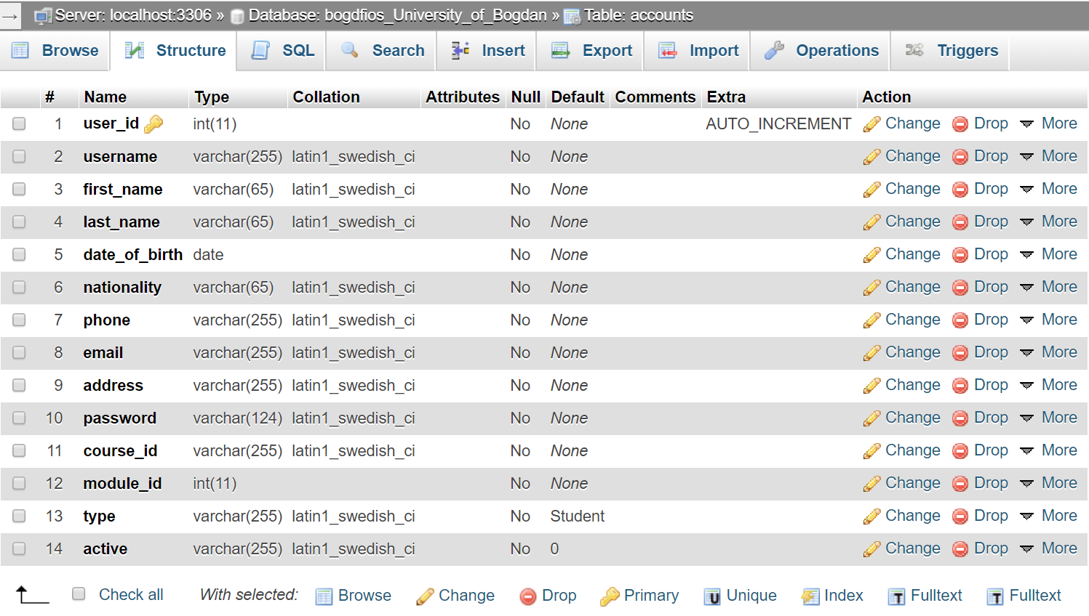
Fig.1 – ‘accounts’ table
The next table is courses table. Here are only four columns: course_id – PRIMARY KEY, course name, course type and course length (Fig.2). All the information needed about a course is stored here (name of course, type of course and length of course).

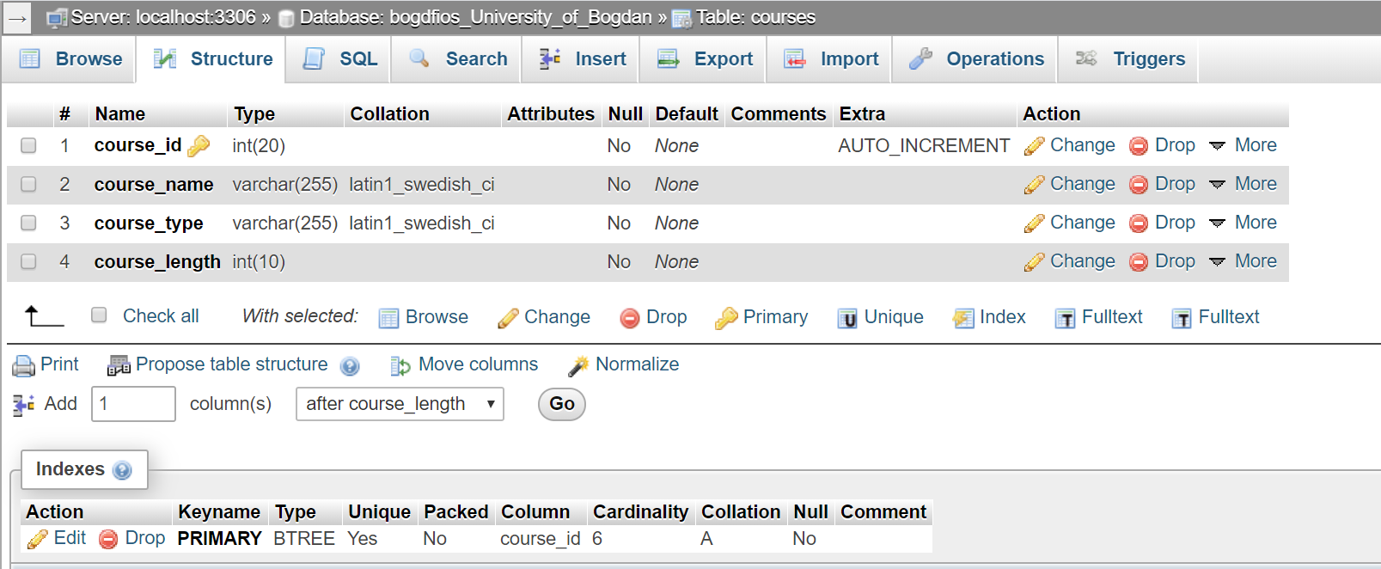
Fig. 2 – ‘courses’ table
In modules table we will find four columns as well: module_id – PRIMARY KEY, module_name, course_id – which is FOREIGN KEY from course_id table and module_year (Fig.3). With this information we know how is named the module, which course it belongs and the year of study.

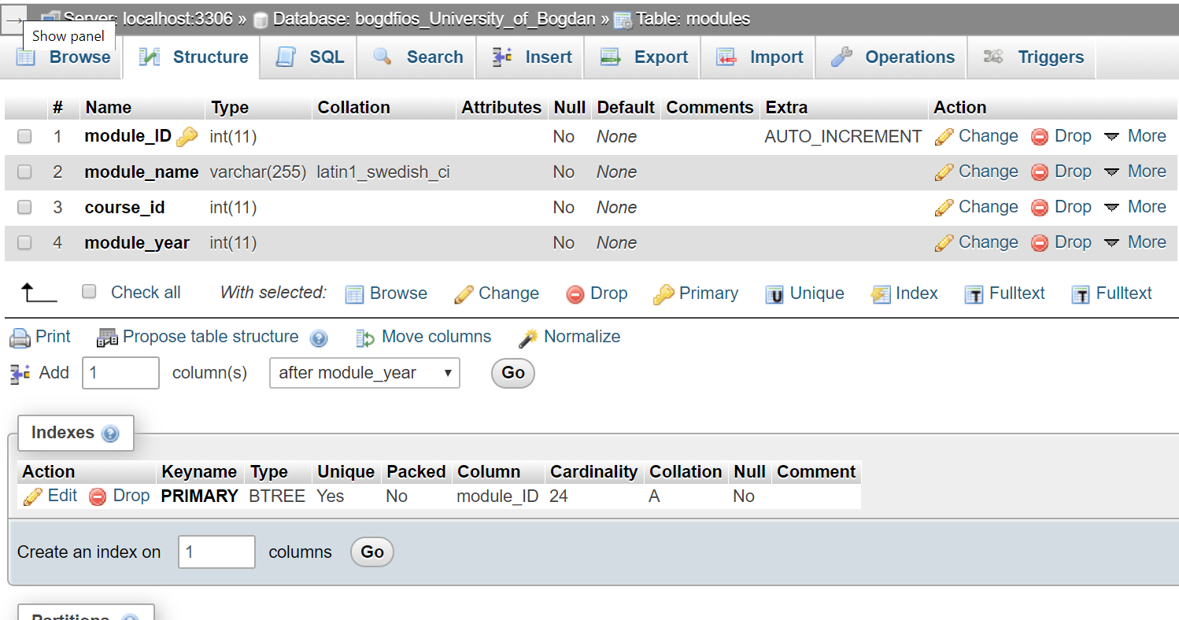
Fig. 3 – ‘modules’ table

The last table is grades. Here I have four columns: grade_id – PRIMARY KEY, user_id – FOREIGN KEY from accounts table, module_id – FOREIGN KEY from module table and theGrade (Fig.4). With this information we can find how received the grade, on which module and he’s/she’s grade.
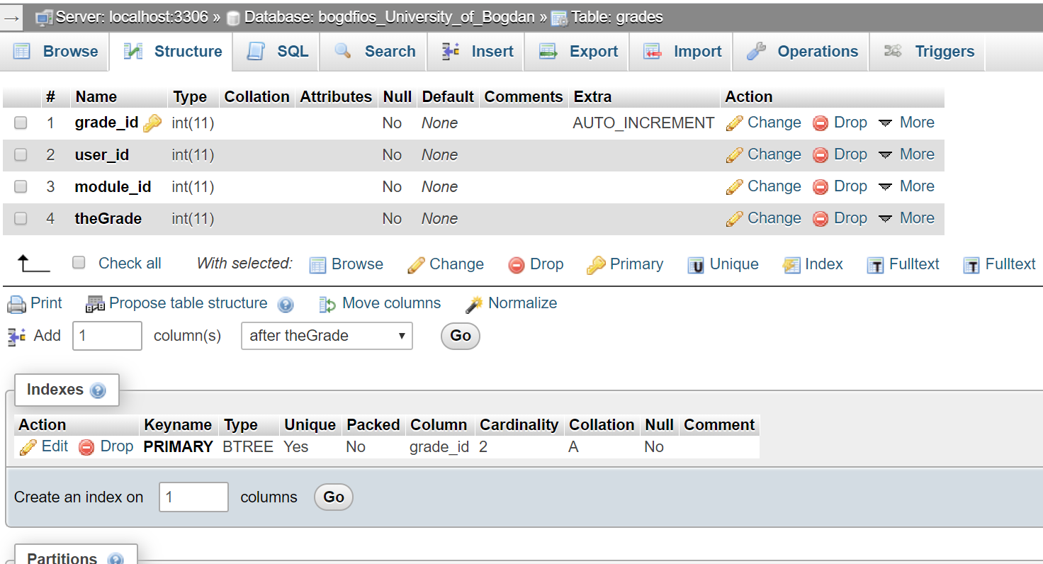
Fig. 4 – ‘grades’ table

Design

All websites must have a file named index, which represents the home page of the website. I will start with another kind of design. Firstly, I will present how I structured the folder of my work (Fig.5). As you can see in Fig. 5, I have created a folder, inside of that folder I create the index page – the home page of my website or the first pages that the server open when somebody access the website, and two files named style.css and style2.css. Then, I created other folders that helped me to organize better. First folder is .vscode, which contain the JSON file, core folder – where I stored the functions, img folder where I stored all the images displayed in the website, include folder where I stored the template of my website and pages folder where I stored all the pages of website.
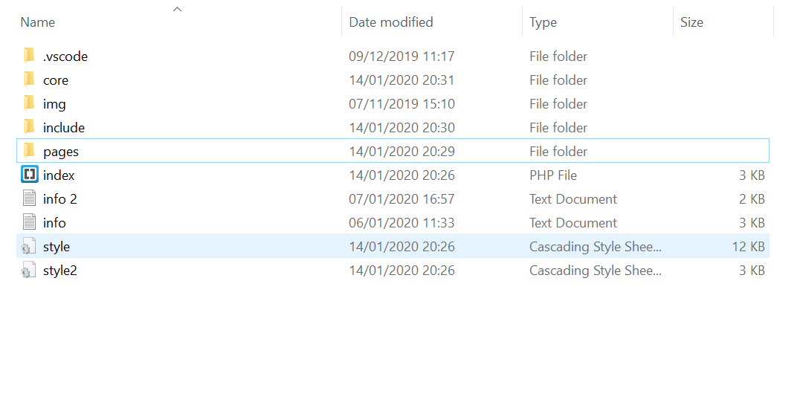
Fig.5 – website folder structure
Now, let’s talk about the design. My website has four main sections: header, navigation menu, main and footer, all those section are inside of a container, which has width of 90% of the page and the edge of it are rounded (Fig.6). As a background, I used a photo with a library full of books and no margin is set for the whole html file.
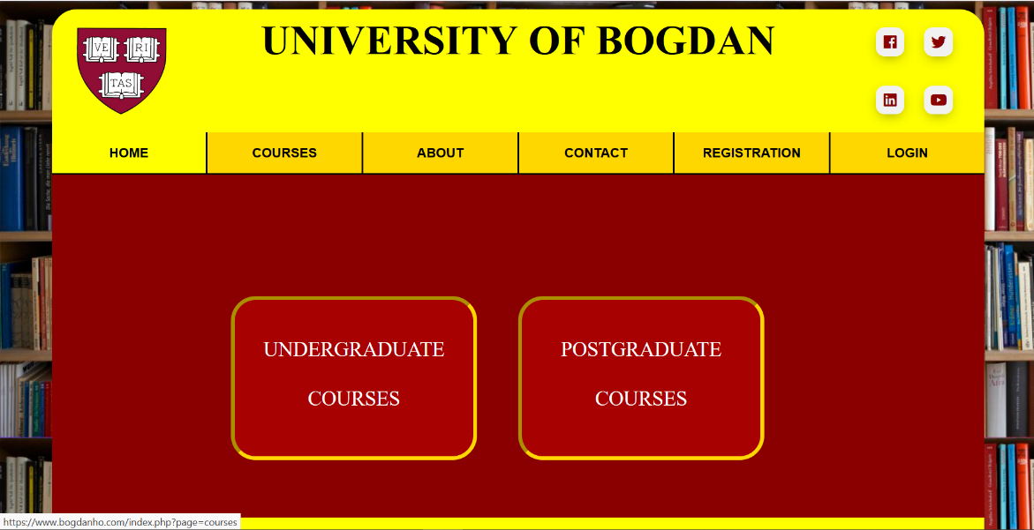
Fig.6 – Design of the website

Header
The header is divided in 3 vertical sections. The first one is “header-logo” where is situated the logo of the university. The second section represent the title of the page (the name of university). The last section represent the social media of our university. There you can find four animated buttons that redirect to our Facebook, Twitter, LinkedIn and YouTube pages.

Navigation menu
The navigation menu is situated just below the footer and it help the users to find the correct pages through the website. To design it I used the list tags (ul – unordered list and li –list item). Using same technique and :hover in css I was able to design a drop down menu (Fig.7).
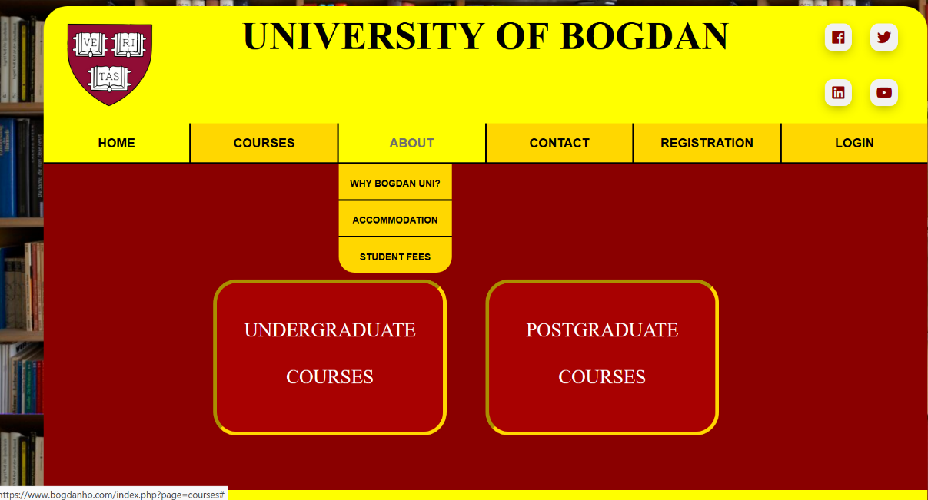
Fig.7 – Drop Down menu

The main
The main is the burgundy rectangle. In this section will be displayed all the information accessed by the user. The main attribute of this section is minimum height of 400 pixels. I used this attribute because in this section will be displayed different kind of information, like a short description of a course or a very large table with students.

Footer
The footer is in the bottom of the page, as you can see in Fig. 8 and there, the user can find quickly our contact information.

Fig. 8 – Website footer

Pages
When a user access www.bogdanho.com for first time, without having an account, he/she can find information about our courses (Fig. 9), contact details (Fig.10), a registration form (Fig.11) in case that is interested in any course and more information about our university (fees, accommodation, etc.)

Fig.9 – Course information with ‘Apply now’ button
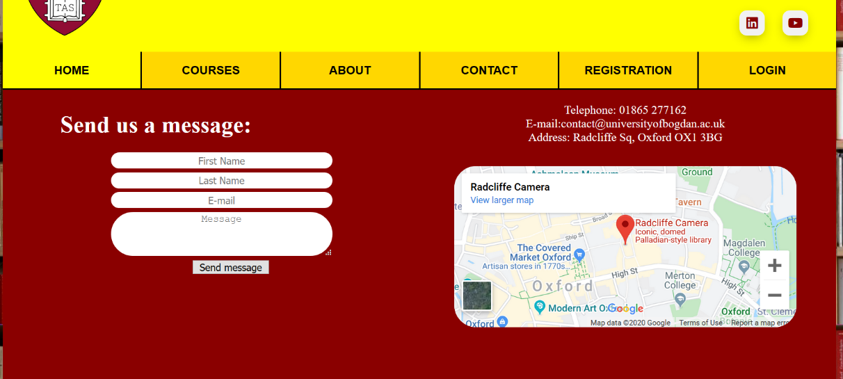
Fig.10 – Contact information with send message form
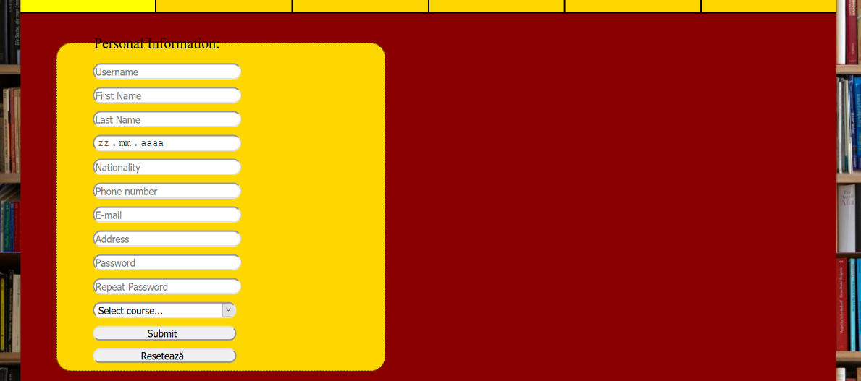
Fig.11 – Registration Form

Functionality of the website

To make the website dynamic I used PHP and JavaScrip. One of the most useful and important is the switch statement used in the index page (Fig.12). This help me to avoid writing the code on every file. Firstly, I saved a part of my html index page (from beginning to <main>) in a file named header.php and the rest (which start with </main> and continue until the end) in a file named footer.php. Therefore, when my index.php is accessed, it require firstly header.php, then I create a switch case for each page and in the end require footer.php. In this way, I only need to create only the containing body for each file and avoid type every time the design code.
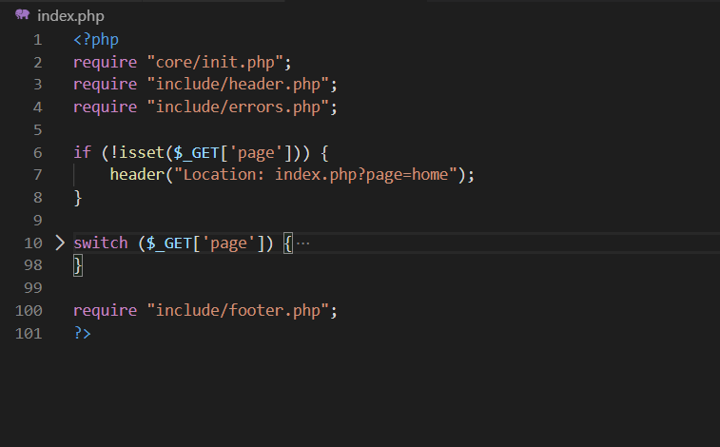
Fig.12 – Index.php
Inside of a Project class, I created function ‘connection’ that connect the website with the database.
One of most important function of the website is to help users to apply for courses. In this case, every time when a user complete the registration form, the website should sent that information in ‘accounts’ table in database. By default all accounts created are inactive and the admin must to accept it to became active or refuse it to delete from the table. As you can see in Fig. 13, there is a list of applicants, which an admin can accept or reject. This table is created using PHP and SQL statements that are extracting all information from ‘accounts’ table where the active column is equal with 0.
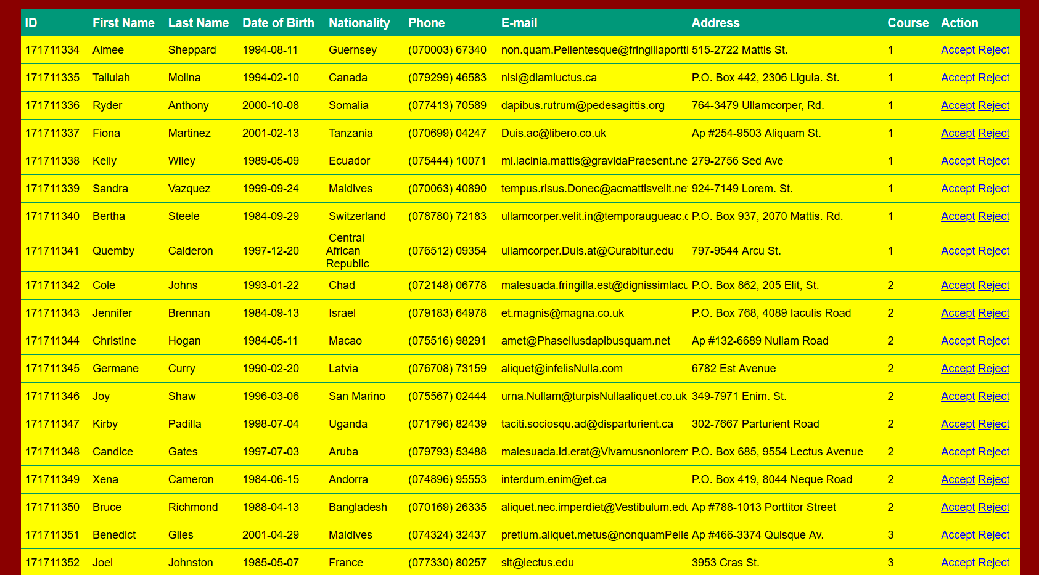
Fig.13 – Applicants table
Once the admin reject a user, his information is deleted from ‘accounts’ table. If the user was accepted, it became a student. Once he become a student, he can access his account using the username and the password set when he completed the registration form. Every student can login into his account and see his profile and his grades (Fig.14).
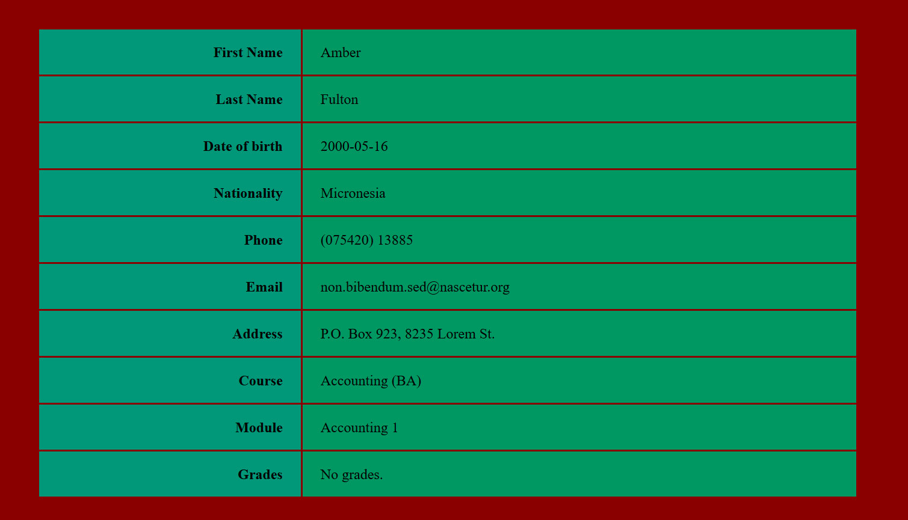
Fig.14 – Student Profile
The admin can see and create courses and modules. As well, he can create lecturer accounts. All lecturers must have an account to login in the system and grade the students. A lecturer can taught only one module and grade only the students that study that module (Fig.15).
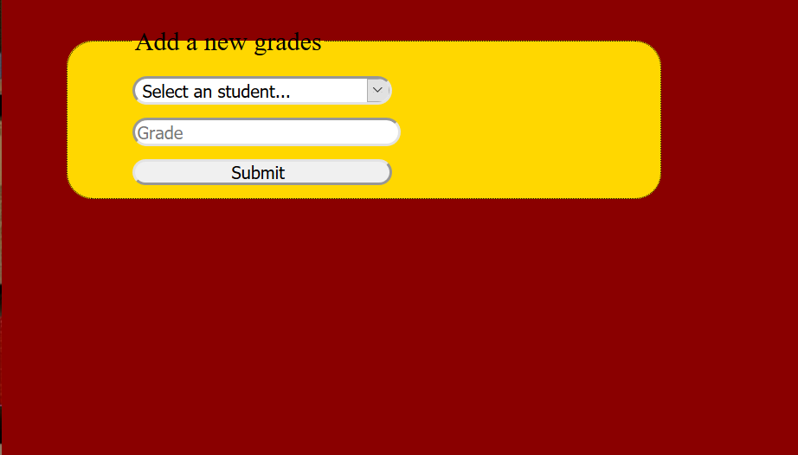
Fig.15 – Adding a new grade.
Another function that helps is ‘getStudents’. This function help the admin to display a whole list of students and filter it by course studied (Fig.16).
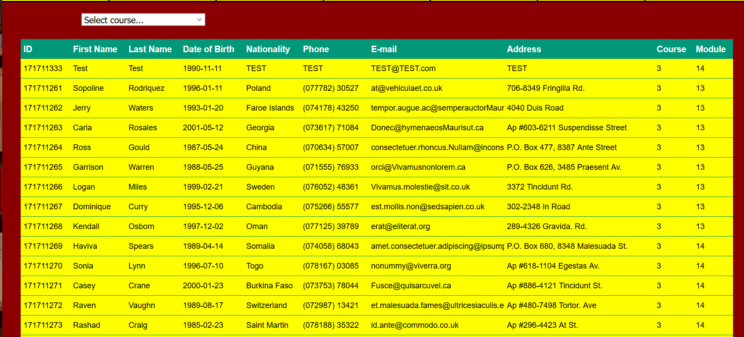
Fig.16 – Admin filtering student list

Testing

For a better understanding of my website, I will test it and provide screen shoots. Firstly, I will create a test account for Accounting course (course_id = 1) and will start with module Accounting 1 (module_id = 1). The Accounting course has 6 modules (Fig.17).
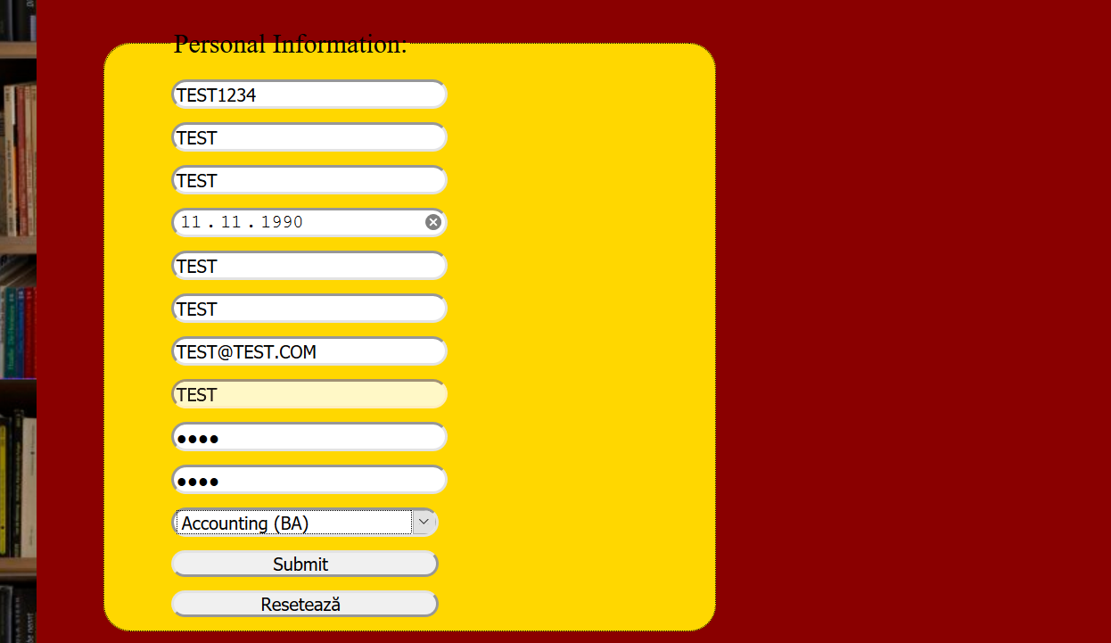
Fig.17 – Creating testing account
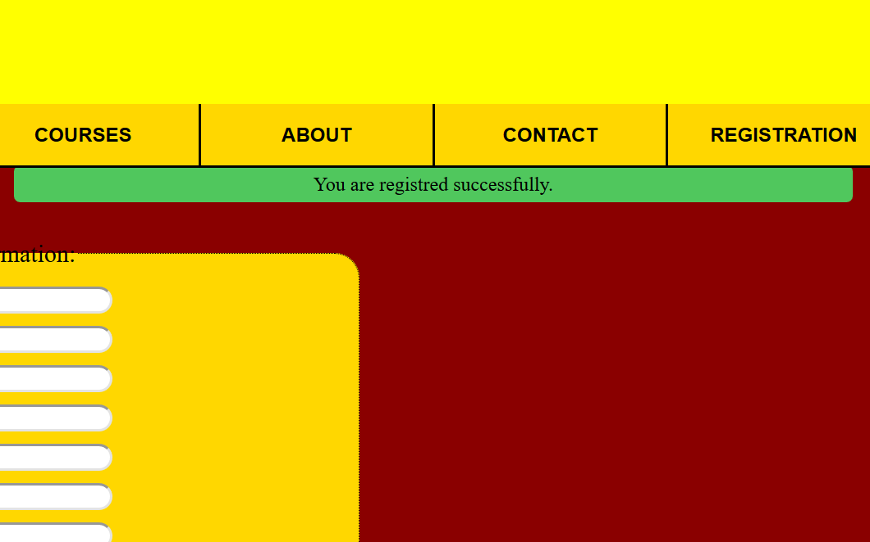
Fig.18 – Successful message
Now, let’s login as ADMIN and check the applicants list if the user TEST1234 applied for our university. As you can see in Fig.19, the user TEST appears in our applicants list. Now, the admin will accept it and his account will become active.
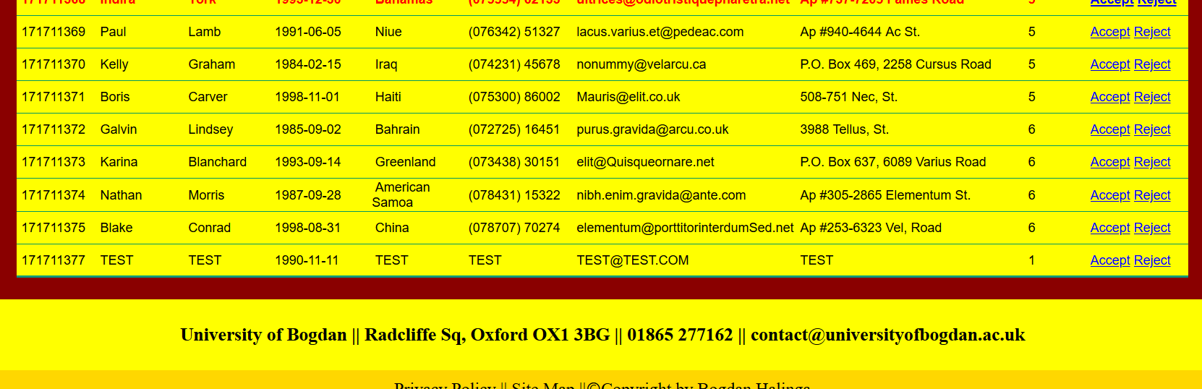
Fig.19 – TEST account on applicants list
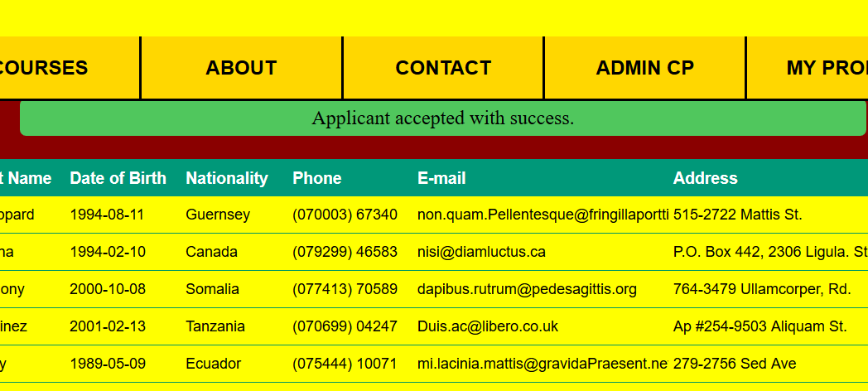
Fig.20 – Applicant accepted successful
As you can see in Fig.20, once the admin accept a student or reject it, he receive a successful message or unsuccessful one. Now, I will try to login into TEST student account.
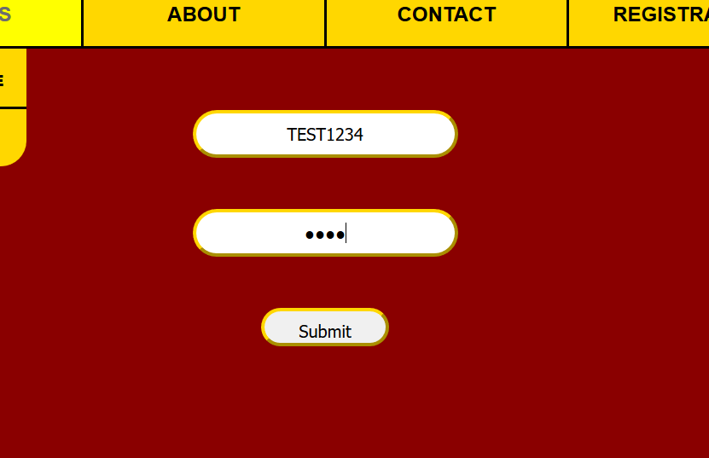
Fig.21 – login into TEST account
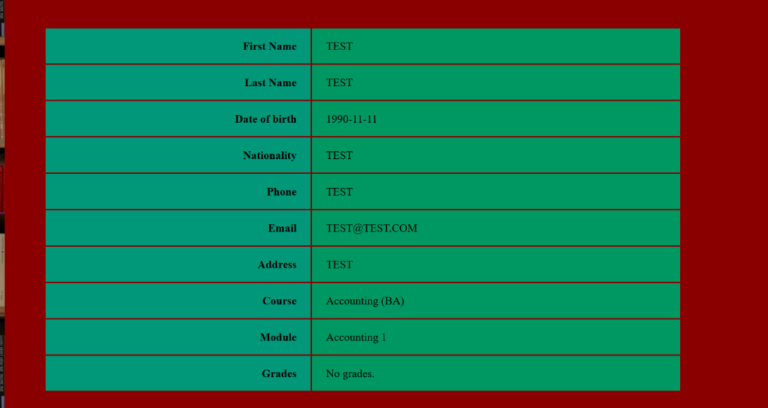
Fig.22 – Accessing ‘my profile’ from test account
As you can see in Fig.21 and Fig.22, I successful connect to test account. Here I can see that he enrolled to Accounting (BA) course and, obviously, he start with the first module of this course (Accounting 1). Now, I will login as admin again and check the list of student that are studying Accounting (BA) to see if the course and module coincide (Fig.23).
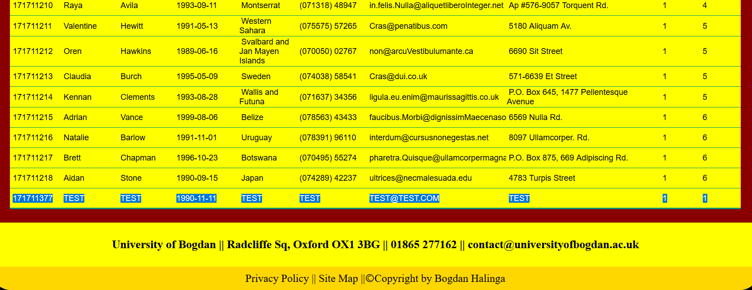
Fig.23 – Test account is part of student list
Now, I will find the lecturer that taught the module 1 and grade the test account (Fig.24).
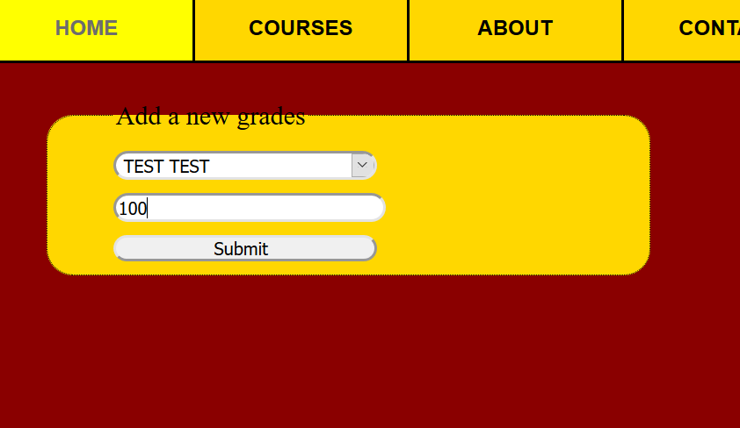
Fig.24 – The lecturer that taught module 1 grades test account with 100 marks
Now, after test account obtained a pass grade, he should pass to the next module, which is Accounting 2. Let’s look in student list to check if it updated (Fig.25).
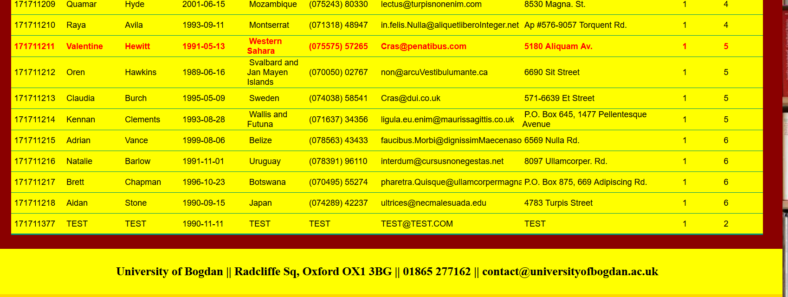
Fig.25 – test account is now studying module 2
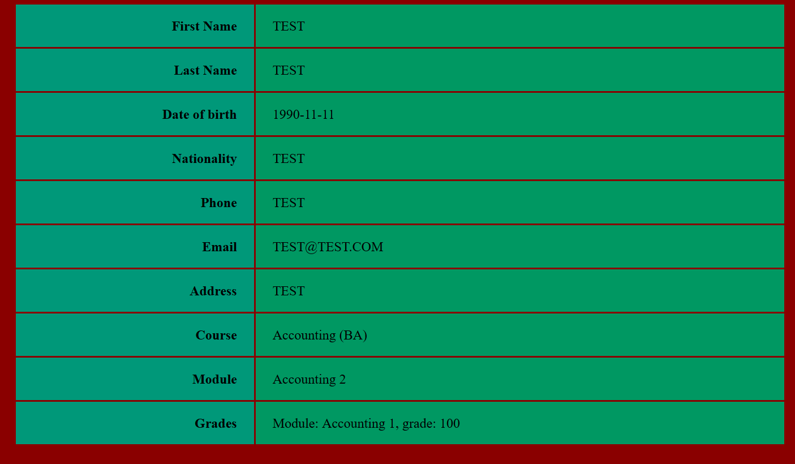
Fig.26 – ‘my profile’ of test account after grade
In Fig.26, we are again in test account ‘my profile’, but now the module changed from Accounting 1 to Accounting 2 and the grade from first module is displayed as well.
OBSERVATION: when a student is graded with a pass grade and he/she should pass to the next module, the database has a small delay (1-2 minutes) and may need a refresh or logout and login again for displaying the change.

Conclusion
In conclusion, I can say that I am satisfy with the result of testing. The website is displayed without errors and all the functions are working properly. As I said on the beginning, web development is a combination between web design, database and programming. In my case I combined HTML, CSS, PHP, JAVASCRIP and SQL for a successful website.

References

- ATKINSON, Leon. Core PHP programming: using PHP to build dynamic Web sites. Pearson Education, 2000.
- DATE, Chris J.; DARWEN, Hugh. A Guide to the SQL Standard. New York: Addison-Wesley, 1987.
- DUCKETT, Jon. HTML & CSS: design and build websites. Indianapolis, IN: Wiley, 2011.
- GOODMAN, Danny. Dynamic HTML: The Definitive Reference: A Comprehensive Resource for HTML, CSS, DOM & JavaScript. " O'Reilly Media, Inc.", 2002.
- https://www.roehampton.ac.uk/ - accessed on 21.10.2019
- https://www.techopedia.com/definition/23889/web-development - accessed on 21.10.2019
- https://www.uwtsd.ac.uk/- accessed on 21.10.2019
- https://www.w3schools.com/css/default.asp- accessed on 22.10.2019
- https://www.w3schools.com/html/default.asp- accessed on 24.10.2019
- https://www.w3schools.com/js/default.asp- accessed on 22.10.2019
- https://www.w3schools.com/js/js_json_intro.asp- accessed on 14.12.2019
- https://www.w3schools.com/php/default.asp- accessed on 11.11.2019
- https://www.w3schools.com/sql/default.asp- accessed on 1.12.2019
- LERDORF, Rasmus; TATROE, Kevin; MACINTYRE, Peter. Programming Php. " O'Reilly Media, Inc.", 2006.
- MURUGESAN, San, et al. Web engineering: A new discipline for development of web-based systems. In: Web Engineering. Springer, Berlin, Heidelberg, 2001. p. 3-13.
- NIELSEN, Jakob. Designing web usability: The practice of simplicity. New Riders Publishing, 1999.
- POWELL, Thomas. Web design. McGraw-Hill Professional Publishing, 2002.
- ROBBINS, Jennifer Niederst. Learning web design: A beginner's guide to HTML, CSS, JavaScript, and web graphics. " O'Reilly Media, Inc.", 2012.
- SCOLLO, Chris; SHUMANN, Sascha. Professional PHP programming. Wrox Press Ltd., 1999.
- SELINGER, P. Griffiths, et al. Access path selection in a relational database management system. In: Proceedings of the 1979 ACM SIGMOD international conference on Management of data. ACM, 1979. p. 23-34.
- SRIPARASA, Sai Srinivas. JavaScript and JSON essentials. Packt Publishing Ltd, 2013.
- WELLING, Luke; THOMSON, Laura. PHP and MySQL Web development. Sams Publishing, 2003.

