I confirm that I have not used any AI tools in the research and creation of this

Assignment. I confirm that I have not presented any AI generated materials as my own

Work. I confirm I have copies of my drafts, notes, and other resources I used, which I

May be asked to provide in evidence.

Report on Perceptions of the Potential Effects of Social Exclusion on Older People and How they might be Ameliorated

Shadan Zeinelabdien Taha Elsherif 2436823
BSc Psychology
ECPS5014
Dr Judith Marshall
21 April, 2026

- Introduction
Autism Spectrum Disorders or ASD is term which covers multiple neurodevelopmental disorders such as Autism disorder and Asperger’s syndrome (World Health Organization, 2019). They are caused by abnormal brain development and function, according to the World Health Organisation (2019). Roestorf et al. (2019) label them as lifelong disorders, affecting social and intellectual abilities, psychological function, and quality of life in general. Additonally, difficulty in social communication, interactions and repetitive behaviours were also mentioned by Trimmer et al. (2017) as characteristics of ASD. In the case of older adults, age-related functional decline may worsen the effects of ASD, where the decline in executive functions, memory, and loss of social skills may lead to a decrease communication (Roestorf et al., 2019). Due to the decrease in communication and social interaction, isolation may occur. They lack of research on the effects of ASD on older adults is also highlighted by Roestorf et al. (2019). Therefore, this study aims to answer the questions: how do undergraduate students perceive the risk of social exclusion on older people with autism, and how do they think negative effects might be improved?
2.0 Method
2.1 Participants
One partcipant was interviewed by each group member. The participants were undergraduate psychology students in their second year, who were also fellow students conducting this research from different groups. Furthermore, two interview transcripts were used, where the participant in the first interview, “J”, was 36 years old, and the second participant, “P”, was 20 years old.

2.2 Design
This study was conducted through a semi-structured interviews for the data collection. Semi-structured interviews were deemed the most suitable method as they allow the researcher to have both an organised guide of questions and themes, as well as flexibilty to ask follow up questions based on the feedback from the participant. Furthermore, this study uses a case study of an older autistic man as a base for the questions to guide the particpants before venturing into generalized questions surrounding older autistic individuals. The questions and forms used in this study were created by the group members together; however, interviews and analysis were conducted individually, where transcripts were shared among the group members after full anonymisation. Moreover, Braun and Clarkes thematic analysis was used for a detailed and clear understanding of the results, as it would filter important findings from extensive interviews.

2.3 Data Collection
Before the data was collected, particpants were provided with an information sheet outlining the purpose of the study and what it might entail. Once they finished reading the information sheet, they were asked to sign a consent form, followed by a short demoghraphic form. The participants were also informed of their right to withdraw from the interview at any time without penalty. Then, the data was collected through audio only for confidentiality. After the interview, the particpants were provided with a debrief form and reminded that they can withdraw their recording. If they did not choose to withdraw, their data was transcripted, anonymized, and shared with group members.

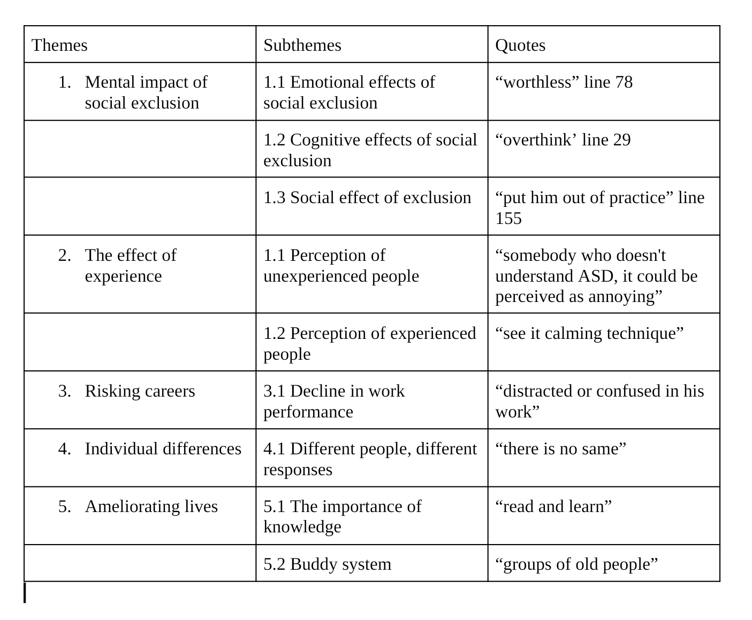
3.0 Data analysis

Theme 1: The negative impact of social exclusion
Social exclusion has many negative effects on people in general and is even more commonly found occurring to those with ASD. The effects highlited in the interviews include the emtional, cognitive, and social effects the particpants perceive may occur to older adults with ASD. Of course, the negative impact is not limited to these 3 effects; however, they were deemed as the most common ones to affect older adults with ASD generally by the particpants.
Subtheme 1.1: Emotional effect
J(36) suggests the social exclusion Alan faces may lead to the emotional consequences of feeling “isolated” as she mentions twice in lines 23 and 28. J(36) then mentions he might also find this situation “upsetting” (line 77), where he may begin to think of himself as “worthless” (line 78) and “not good enough” (line 79). Similarly, P(20) also mentions that he may begin doubting his self-worth and feel left out, affecting his mental health. Furthermore, P(20) suggests that his mood may be affected, where he may also feel “anxious” and that “he's not accepted by the community, he's not accepted by his own circle”, as she mentions in line 59. P(20) also suggests he may be “grumpy” and “sad” with prolonged social exclusion (line 89). Moreover, the emotional effects may also extend beyond the workplace as J(36) suggests he might not reach out to new people as he may lack “that safe feeling with somebody else to be able to communicate with them” in lines 173-175.
Subtheme 1.2: Cognitive effects
Self-perception or the way Alan might see himself may also change as J(36) reluctantly suggested that the way Alan may think of himself may change, as she mentions it may “not definitely” (line 105) alter how he “sees himself” (line 105) in addition to assuming and generalizing how others perceive him due to his experience at work. On the other hand, P(20) simply states the constant exclusion he notices may lead him to “overthink” in line 29. Additionally, P(20) also mentions that the cognitive impact may worsen with age in the case of autistic individuals. In addition, J(36) also repeatedly hints to a risk of job, where when prompted with a question about the relationship of job loss and the cogntive effects, J(36) suggests it could lead to distraction and confusion at work, where she adds that people generally “tend to put things off” (line 122) and focus on upsetting events rather than tasks, which may lead them to “fall behind to work” (line 124).
Subtheme 1.3: Social Impact
As the older adult with ASD, or Alan, is socially excluded and isolated, it may also lead self-isolation due to the “work environment” (line 90) he might not want to be a part of. Therefore, it might “put him out of practice” when it comes to social interactions, where he might get accustomed to a routine of simply working and going home with little to no social interactions, J(36) mentions in lines 155-159. Similarly, P(20) also mentions decreased social interactions slowing down social skills with lack of practice in line 68-70. Furthermore, When asked about effects beyond the workplace, J(36) also added that Alan’s social circle may “smaller” (line 172) as time goes by, where she suggests he might not “reach out to anybody else” (line 173) due to not feeling safe communicating with new people as previously mentioned. On a similar note, P(20) suggests he may build a “wall around him” (line 93) due to constant social exclusion.
Theme 2: Ameliorating Lives
There are ways to promote inclusivity both inside and outside the work place, the most commonly known one being knowledge of the topic, as mentioned by both particpants. Knowledge may reduce the fear of the behaviours that may be classed as unsual. However, knowledge alone isn’t enough if action isn’t taken, therefore, inclusive space are also essential.
Subtheme 2.1: Awareness
Both participants highlight the importance of knowledge. This is also highlighted in the difference in the reactions and perceptions of experienced and non-experienced people J(36) predicts. J(36) mentions those with experience would not be intimidated by self-soothing behaviour as they are aware of the reason behind the actions of those with ASD, unlike those who lack the knowledge and hence react with judgemental stares. Therefore, to promote awareness of common ASD behaviours and how to “integrate” (line 195) people with ASD into their community, J(36) mentions workplace training programs as well as community centre staff training for staff to be able to recognise ASD in older adults that might have gone “unnoticed” (line 200). Furthermore, P(20) also highlights the importance of being open minded and taking time to read and learn to gain “awareness” (line 104) on the topic.

Subtheme 2.2: Inclusive spaces
Despite lacing experience of working in an office, J(36) predicts there would be constant noise with phones ringing and people talking on phone calls. Hence, she suggests “accomodations” (line 225) be made for them, with things such as a “quiet corner” (line 226), and regular wellbeing check ups to ensure they enjoy their workplace.

Social exclusion affects everyone negatively, and people with ASD, older adults in this case, may find themselves in this situation more often than those without ASD. It can impact their mental health by decreasing their self-esteem and alter the way they think by constantly believing they will be judged and excluded wherever they go. This may lead to a decrease in social interactions, only worsening the social exclusion as they forget how to communicate socially. This may be avoided to an extent with proper awareness on ASD behaviour and communication styles through training programs in agencies for exmaple. Inclusive spaces should also be implemented to create a comfortable workplace, as mentioned by the particpants.
4.0 Discussion
The points raise by the particpants align with the literature existing quite often. They both mentions the negative impact of social exclusion on mental health on people with or without ASD. Similarly, Jones et al. (2021) also state that social inclusion is detrimental to mental health regardless of whether they have a disability or not. Moreover, the most common emotional effects the particpants mentioned of social exclusion were feeling isolated, unwlecome, and unworthy. In support of this claim, Trimmer et al. (2017) also mention loneliness, depressed mood, and anxiety to be associated with exclusion. As for the cognitive effects, the most important points raised by the participants were altered perception of self and others, where people with ASD might begin to think everyone is the same and that they’ll be excluded by everyone. In relation to this, Jones et al. (2021) mention a study where non-autistic people were likely to make negative judgements about autistic individuals based on audio-visual social presentation, which were unchanged with frequent exposure, and absent in the absence of audio-visual cues, such as trancripts. Furthermore, Jones et al. (2021) also mention research showing that both autistic and non-autistic participants adults make found autistic conversation partners to be unattractive and awkward as well. One of the particpants also grazes upon the effects of aging worsening the cogntive effects. Roestorf et al. (2019) mention this in detail, with examples of decreased executive function, memory, and even dementia, coexisting with conditions such as anxiety and ADHD as factors which may affect older individuals with ASD . Morever, the last subtheme mentioned under this theme, social effects, also bares similarity with existing literature as Jones et al. (2021) mention that autistic adults often hesitate to leave their house and have social interactions due to the negative treatment as they notice people staring, actively avoiding them, and even becoming aggresive. Their study often highlight the how uncomfortable those without autism are with interacting with those with ASD (Jones et al., 2021). The improvements suggested by the participants focus on gaining more knowledge and spreading awareness. This is also mentioned by (Jones et al., 2021) as they mention the importance of the general public being aware of the challenges people with ASD face.
4.1 Strengths and Limitations
The main limitation of this study was the limited sample consisting of classmate with pre-existing knowledge on the topic and the assignemnt specifically. The insights gathered are not those of the general public but psychology students who share the same case study to work on. However, despite that, the data collected was vastly different perhaps due to the differences in experience and age of the participants. There was an imbalance in the amount of data provided by the particpants, where J(36) provided much more quotes to worl with than P(20). Nevertheless, this also shows the importance of awareness as they highlight the difference in perspective between those with and without experience. For example, P(20) had reffered to those without autism as “normal”, no due to prejudice, but simply due to the lack of knowledge for a different word. There were not enough mentions of the affect on older adults specifically as well. Moreover, the strength of this study was the case study which greatly aided both participants in imagining the situation and predicting the impact of it on Alan.
4.3 Future research
Future research should also look into the cultural aspects of the importance of social interactions. Many countries depend on social interaction for things such as bonuses and promotions, which puts those with ASD at a larger disaadvantage. They may be seen as pretentious for not trying as hard as the others to interact socially, which put under more pressure. The change in awareness should also be considered as the new generations are often deemed as more open-minded due to the abudnace of resources and awareness of the topic, yet this does not eliminate the prejudice taught by older generations.

5.0 Conclusion
Social exclusion affects everyone negatively, whether they are with or without a disability. However, those with ASD may be subjected to exclusion more often than their neurotypical counterparts. Moreover, older adults with ASD may be isolated or self-isolate and find little opportunities for social interactions, reduction their social skills as they are rarely put to use. This exclusion may affect them emotionally and cognitively as they begin to feel anxious with social interactions, worthless, upset at noticing exclusion, and even think everyone is perceiving them negatively as well. In the workplace, this may be ameliorated through training programs and inclusive spaces which make people with ASD feel safe away from the noise of the office. In conclusion, everyone should have basic knowledge and understanding of ASD symtopms and refrain from making them feel burdensome and excluded due to ignorance.

References
Jones, S. C., Gordon, C. S., Akram, M., Murphy, N., & Sharkie, F. (2021). Inclusion, Exclusion and Isolation of Autistic People: Community Attitudes and Autistic People’s Experiences. Journal of Autism and Developmental Disorders, 52(3). https://doi.org/10.1007/s10803-021-04998-7
Roestorf, A., Bowler, D. M., Deserno, M. K., Howlin, P., Klinger, L., McConachie, H., Parr, J. R., Powell, P., Van Heijst, B. F. C., & Geurts, H. M. (2019). “Older Adults with ASD: The Consequences of Aging.” Insights from a series of special interest group meetings held at the International Society for Autism Research 2016–2017. Research in Autism Spectrum Disorders, 63, 3–12. https://doi.org/10.1016/j.rasd.2018.08.007
Trimmer, E., McDonald, S., Kelly, M., & Rushby, J. A. (2017). The Physiological and Psychological Effects of Ostracism in Adults with ASD. Journal of Autism and Developmental Disorders, 47(8), 2326–2335. https://doi.org/10.1007/s10803-017-3146-9
World Health Organization. (2019). Autism spectrum disorders. World Health Organization. Regional Office for the Eastern Mediterranean.

Appendix
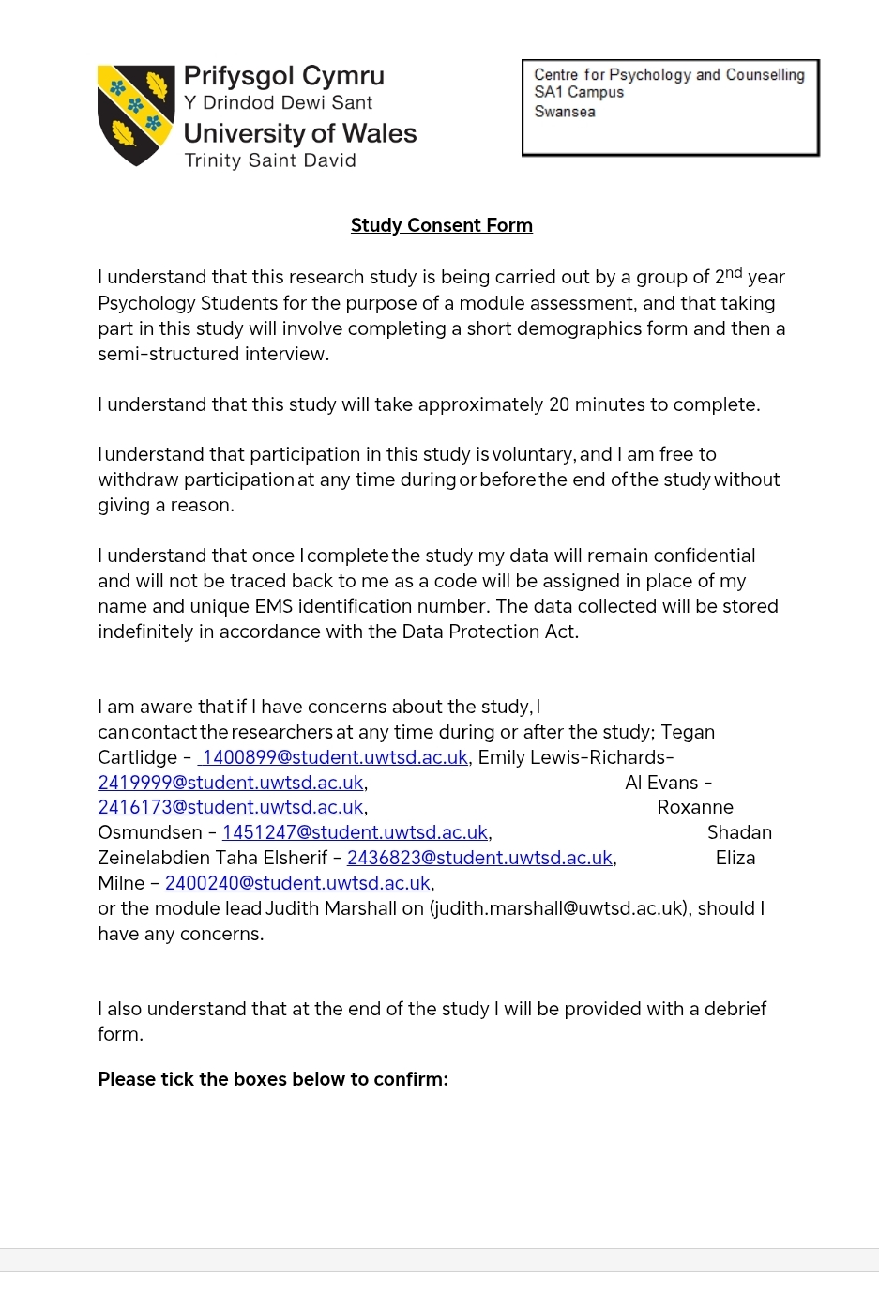
Appendix A: Consent form

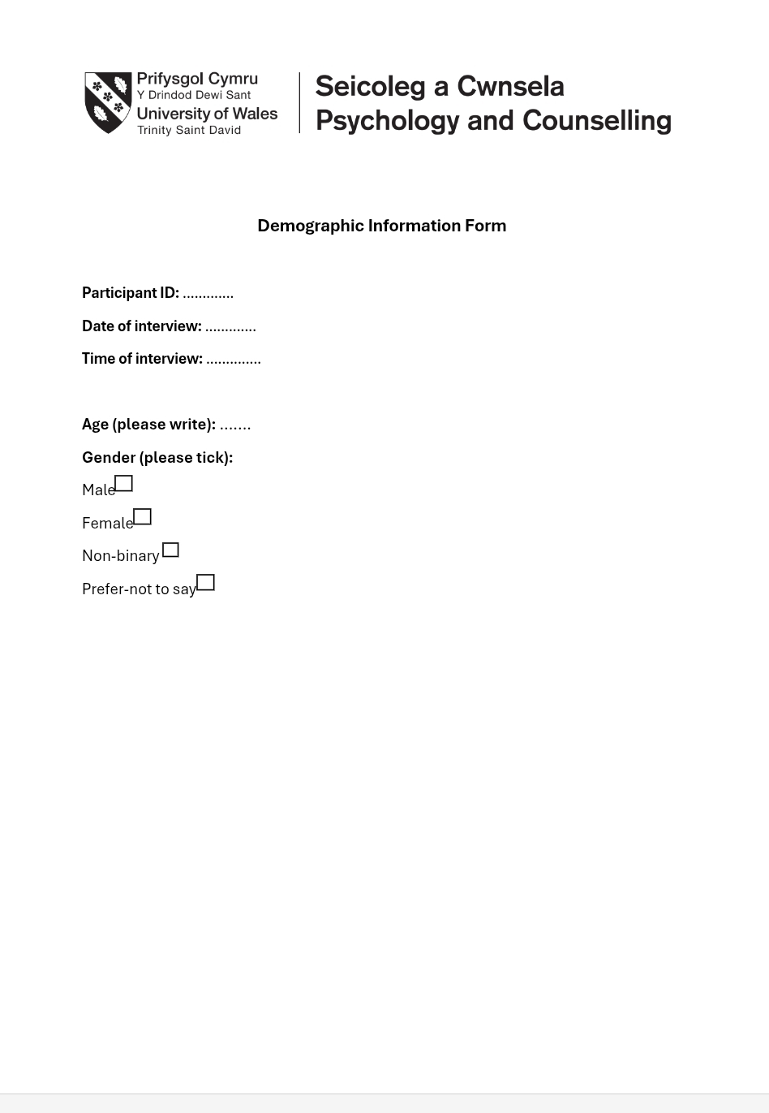
Appendix B: Demoghraphic sheet
Appendix C: information sheet
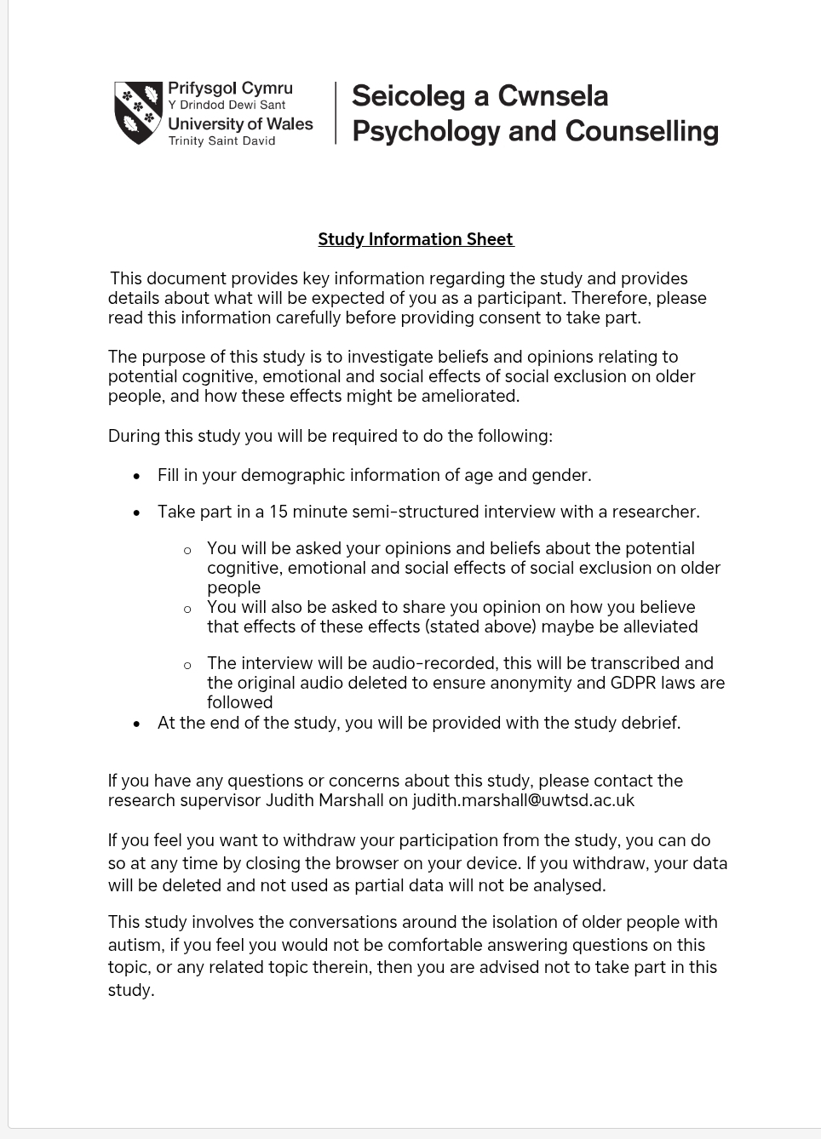

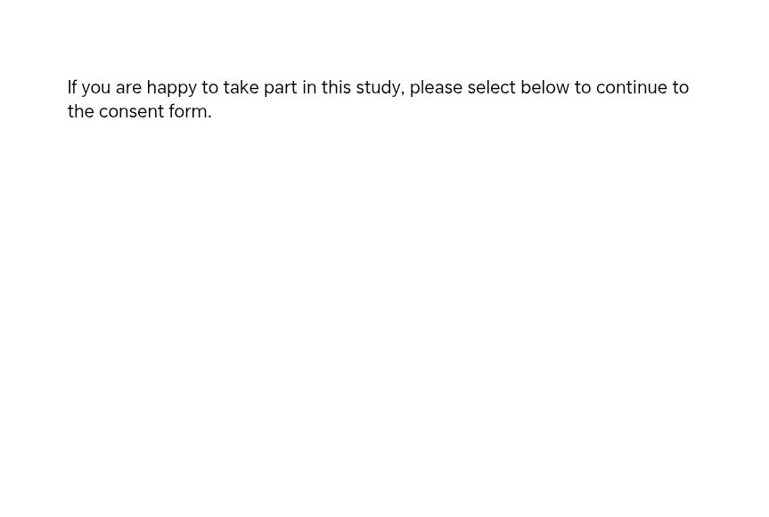

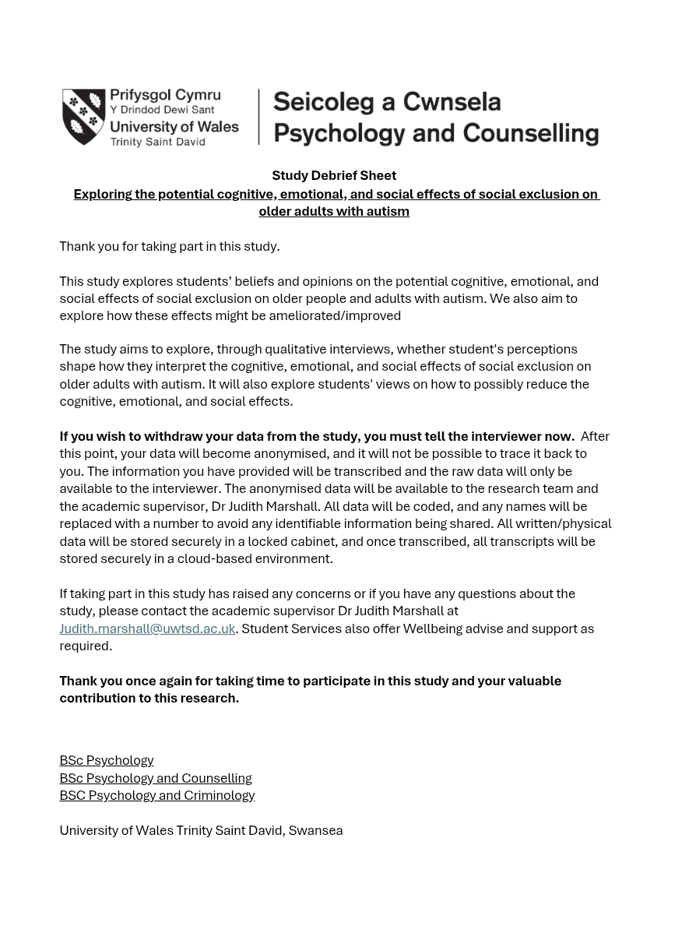
Appendix D: debrief form

Appendix E: Question paper with case study
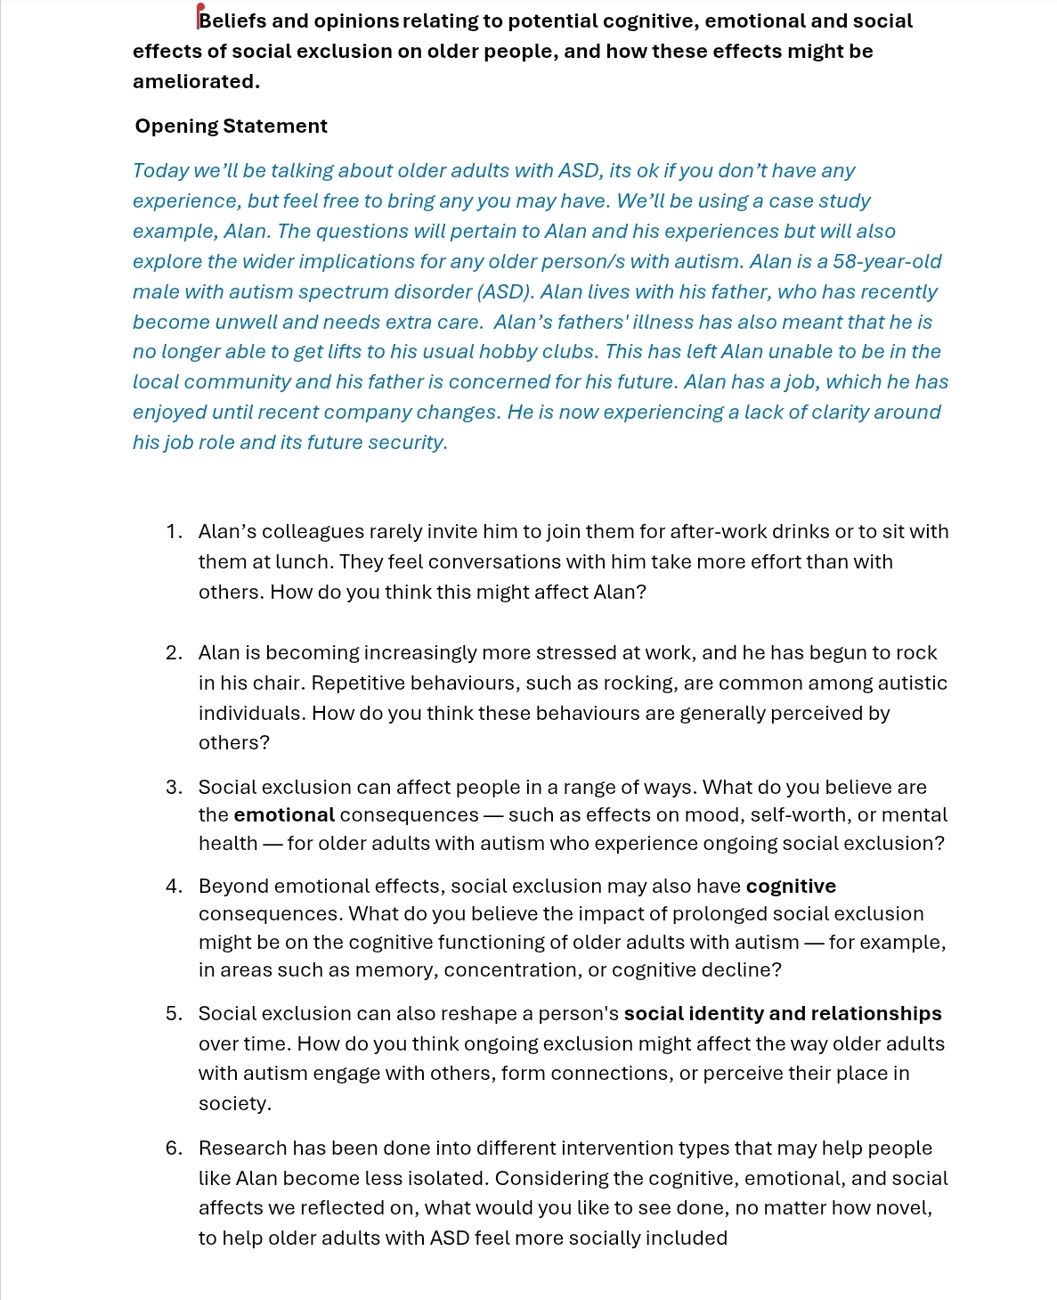

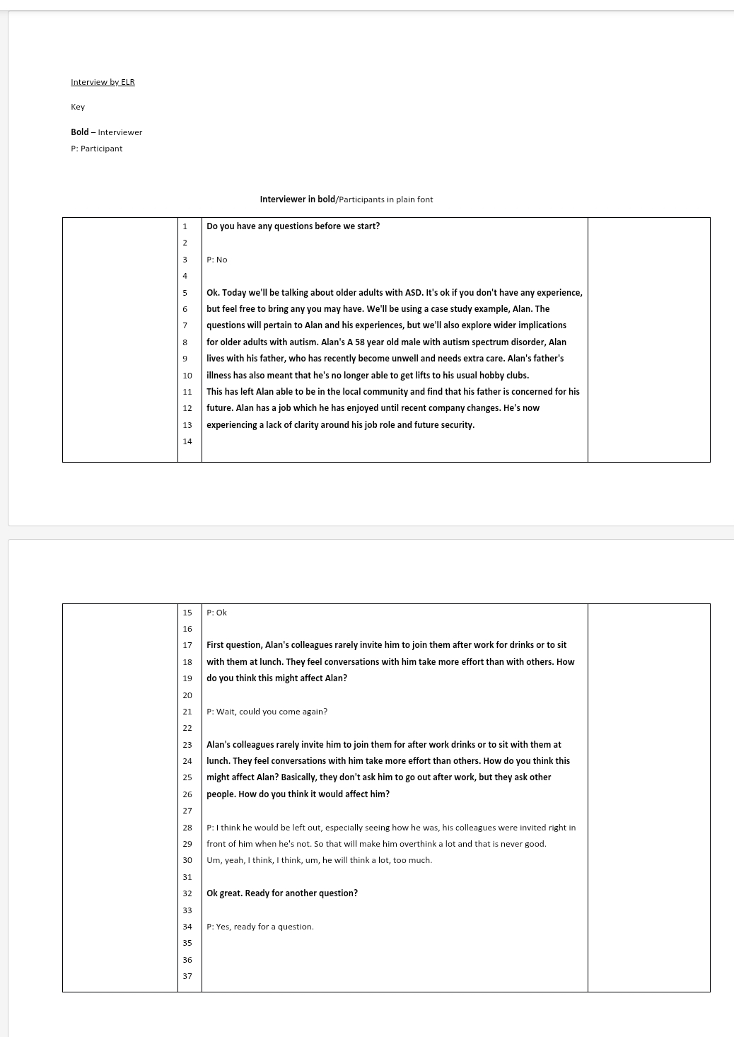
Appendix F: Trancripts 1
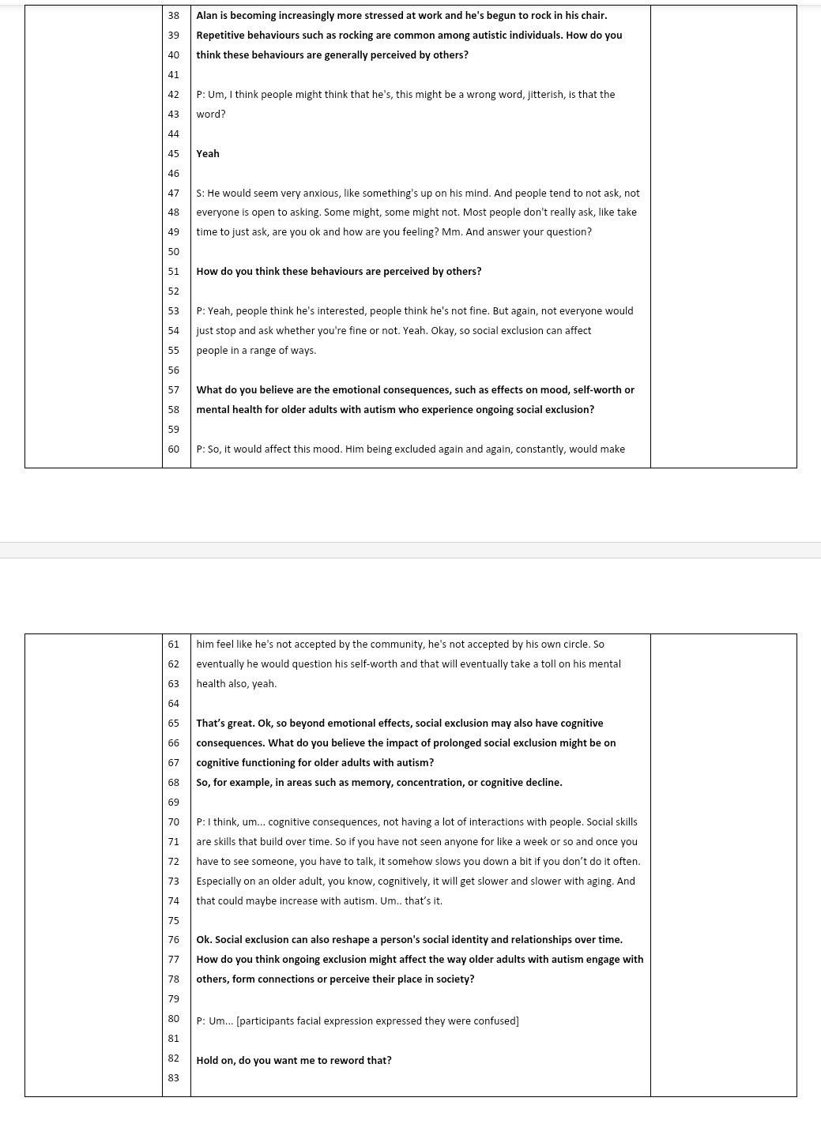
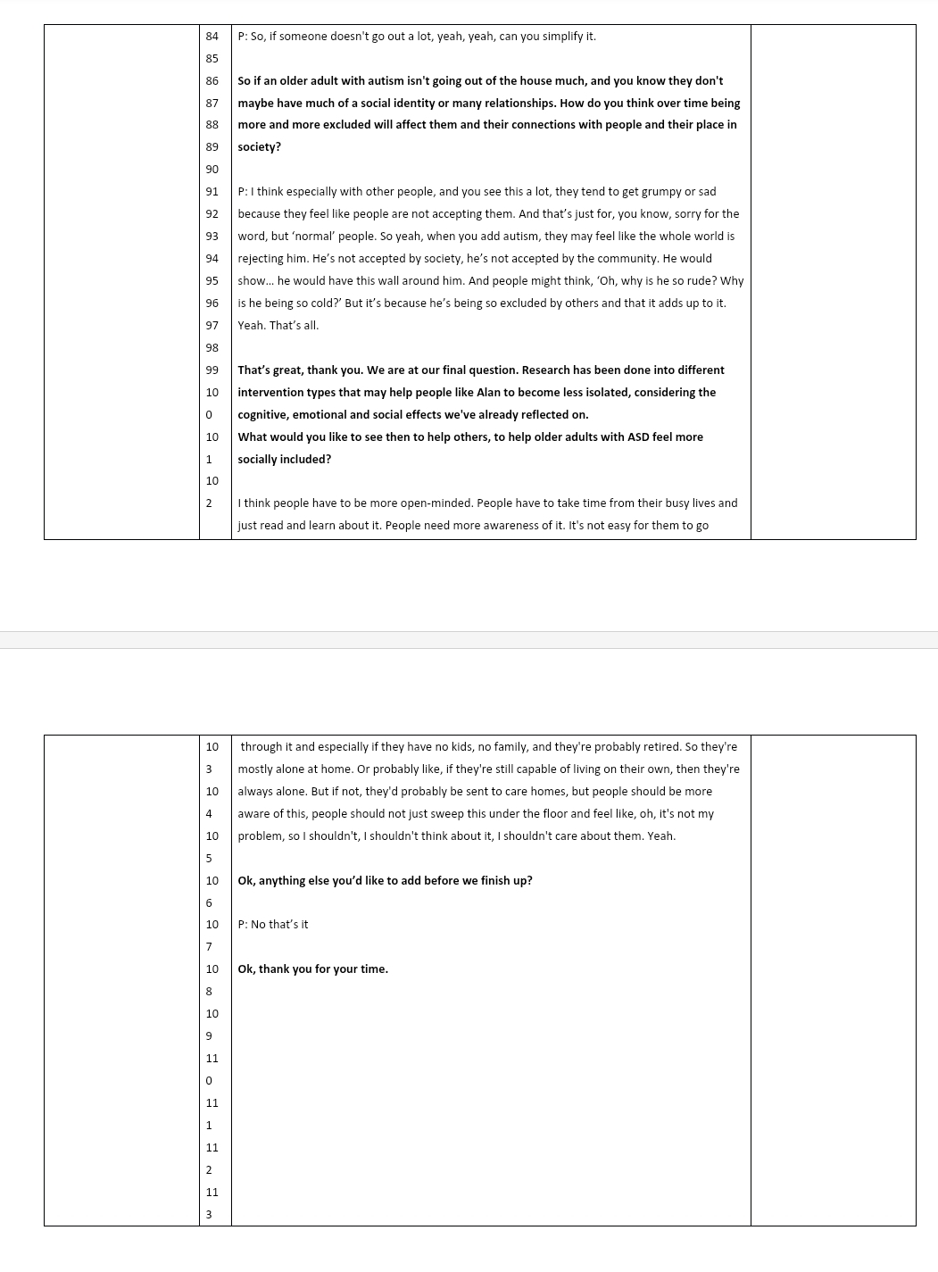
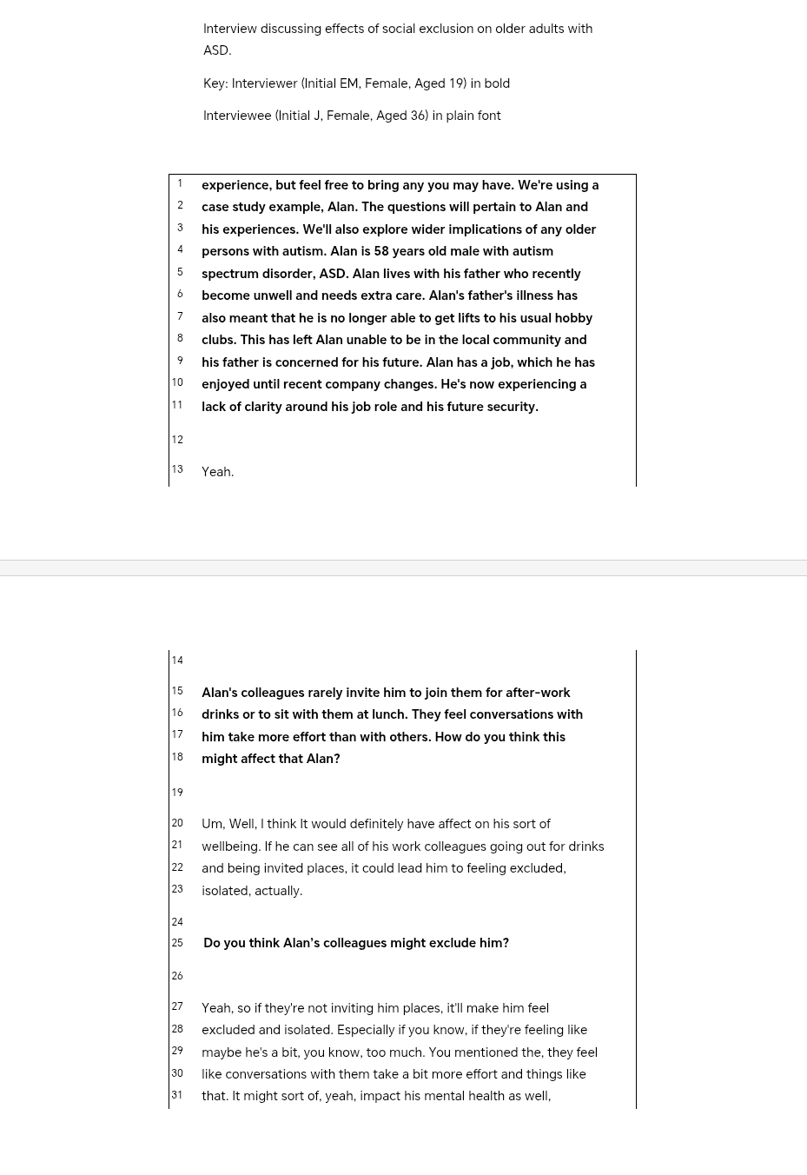
Appendix G: transcript 2:



