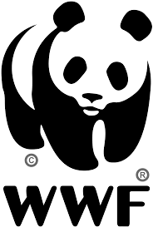

(www.worldwildlife.org, n.d.)
Introduction
“Never doubt that a small group of thoughtful, committed citizens can change the World; indeed, it’s the only thing that ever has.” American cultural anthropologist, Margaret Mead.
Using this quote, here we are going to explore how the WWF work towards tackling the ongoing issue regarding the deforestation of our rainforests, and how this has had a permanent and long-lasting impact on the habitats of many of the World’s wildlife species.
It is estimated that within a hundred years, the entire World’s rainforests could disappear due to deforestation, which has been caused by numerous factors such as logging, land being cleared for agricultural farming, the rapid increase of palm oil plantations and natural factors that have occurred such as overgrazing and wildfires.
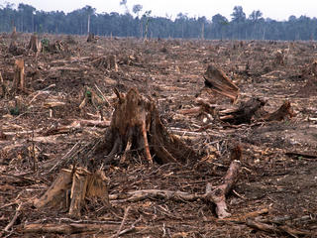
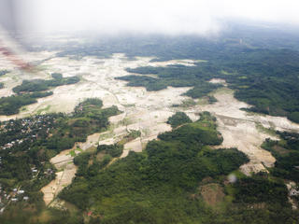
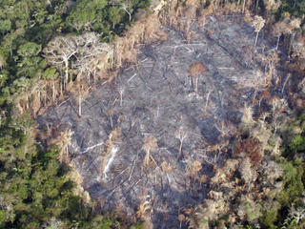
The Amazon Borneo Sumatra
The work of the WWF
The World Wildlife Fund focuses much of its work on tackling how much of the forests are available for conservation, whilst actively encouraging governments, agribusinesses and other groups to hit their targets concerning deforestation.
Park officials are trained to learn how to manage forests responsibly; they are able to carry this teaching out through the creation of multi-million-dollar funding, as well as the close monitoring and radio tracking of forest wildlife using GPS collars.
Most of WWF’s work is carried out in tropical rainforests in areas such as the Greater Mekong, the Congo Basin and the Amazon, although they do also work in regions of the US and the Russian Far East. It has been found that the Amazon rainforest has lost “at least 17% of its forest cover in the last half century due to human activity.” (https://www.worldwildlife.org/initiatives/forests, 2018)
The main reason for this devastating loss and mass culling of trees is due to ranches and farms being built or extended within the rainforest.
A further method that the WWF have adopted to tackle the issue of deforestation is to address the problem of unsustainable and illegal logging. Their solution is to ensure that the Lacey Act of 1900 is fully abided by; this is a US law which prohibits the distribution and trade of illegal timber and timber products into the US market, as well as that of plants, fish and wildlife trafficking.
The WWF is aware that as an organisation, they cannot solve this enormous issue solely by themselves; therefore they work closely with other stakeholders to come up with new ideas and solutions together to accommodate the “vast resource challenges facing a world of over seven billion people.” (http://wwf.panda.org/our_work/forests/, n.d.)
The WWF have created the Global Forest & Trade Network. The GFTN brings together many entrepreneurs, non-governmental organisations, companies and communities that are dependent on the forests, with the focus being set on creating a market for environmentally responsible forest products. Working at both national and regional levels, the GFTN has an aim to enlarge areas of forest that have both responsible and credibly certified forest management in place. They have successfully protected habitats of animals such as orangutans and Bornean pygmy elephants as a result of the efforts they have put in to encourage well- managed forests.
There is also a programme which has been set up by WWF called REDD+, which aims to reduce the amount of carbon emissions being created through deforestation and forest degradation worldwide.
A further example of WWF’s continued success is that they have set up protected areas of forest to safe guard and preserve endangered and vulnerable plant and animal species, such as East African mountain gorillas.
WWF actively encourage the use of sustainable bioenergy to reduce greenhouse gas emissions from materials such as oils, fats, sugar and starch crops, wastes and residues and scrap wood. Their vision is that “by 2050, 100% of the world’s energy will come from sustainable, renewable sources, including bioenergy.” (https://www.worldwildlife.org/habitats/forest-habitat, n.d.)

Conclusion
It would be fair to say that the WWF are doing what they can to address the issues of deforestation and the consequent effects it currently has and has had on the environment, from habitats to communities and to the destructive and negative global effect is has on the World which we live in today.

Works Cited
(n.d.). Retrieved from www.worldwildlife.org.
(n.d.). Retrieved from www.worldwildlife.org/initiatives/forests.
(n.d.). Retrieved from http://wwf.panda.org/our_work/forests/.
(n.d.). Retrieved from https://www.worldwildlife.org/habitats/forest-habitat.
(n.d.). Retrieved from https://www.worldwildlife.org/habitats/forest-habitat.
(2018). Retrieved from https://www.worldwildlife.org/initiatives/forests.

