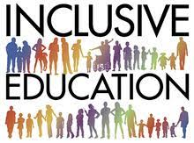
Additional Needs in Context ECIE4003
Sophie Lea Blackadder (2008875)

(School Education Gateway, 2016)

1
Contents

- Cover page ……………………………………………………………………. Page 1
- Contents ………………………………………………………………………. Page 2
- Introduction …………………………………………………………………… Page 3
- Element 1 (Poster) ……………………………………………………………. Page 4
- Poster references ……………………………………………………………… Page 5
- Element 2 ……………………………………………………………………... Page 7
- Element 3 ……………………………………………………………………... Page 9
- Element 4 ……………………………………………………………………... Page 11
- Conclusion ……………………………………………………………………. Page 13
- References ……………………………………………………………………. Page 14
- Appendices …………………………………………………………………… Page 18

Action Points:
1. Introduce theory earlier
2. Use more than one theoretical approach and link them to each other and to policy

Introduction

The meaning of disability has been regarded differently over time. The Equality Act 2010 definition is, ‘if you have a physical or mental impairment that has a ‘substantial’ and ‘long-term’ negative effect on your ability to do normal daily activities’ (Gov.uk, n.d, p1). Scope (2020) states there are 14.1 million disabled people in the UK, with 8% of them being children. Therefore, the promotion of equality and inclusivity within education is vital. According to Haegele and Hodge (2016) there have been several models of disability throughout history. Some have adjusted to change, while others have been rejected due to the prejudice they convey. However, there are two main models of disability, the medical and social model. The author will look at how these two models have influenced expectations, behaviours, and interactions, while also describing the different policies and legislations that have been influenced by them.
All children who encounter disability have the right to develop to their fullest potential, with appropriate resources to enable their success (Rose, 2021). The author will identify and analyse the support provided by her setting, in establishing inclusive practise. Developed for a child with an additional learning need, Global Developmental Delay, who is also described as a ‘Child in Care’, she will be referred to as Child A. The author will continue to reflect on how her setting provides this support in line with policies and good practises of inclusive education, setting being referred to as School A, for the purpose of this assignment.

What is a Model of disability?
- It defines impairment
- Devise strategies/meets the needs of individuals
- Useful to develop frameworks
- Illustrates provisions or limitations in accessing work, goods, and services
- Insight into attitudes and behaviours
(Alaska Mental, 2021)

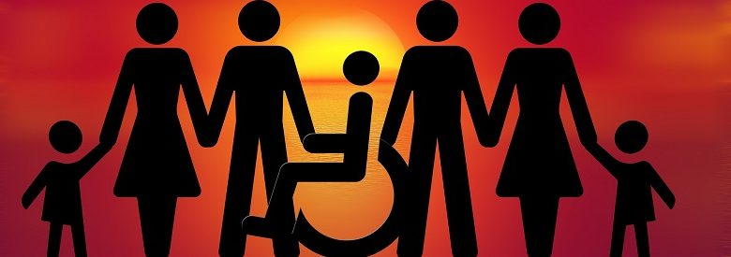
The Medical Model
This model was created in response to how medicine defined disability. It ‘views disability in terms of an individual deficit/problem that has to be fixed, rehabilitated or prevented’ (Berghs, et al. 2016, p8).
- Society remained unaffected
- Individual seen as inferior or abnormal
- Designed for diagnosing and labelling
- Segregation or alternative services
(Berghs, et al. 2016) (UK Disability History Month, 2021)
(

(Disability Horizons, 2019)
The Moral/ Religious Model
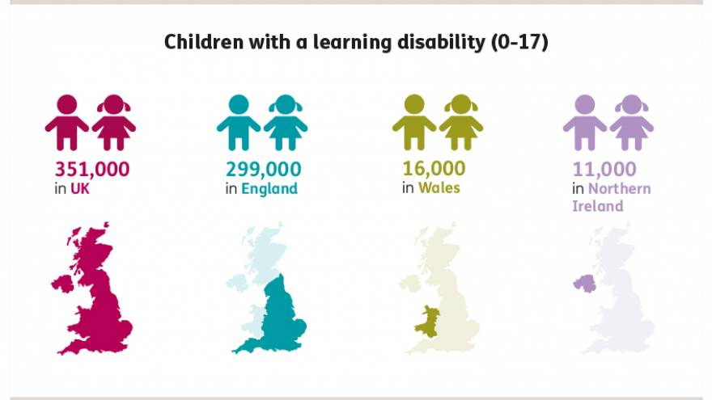
The Medical Model
The Models of Disability
(Mencap, 2019)
The Social Model
(Inclusion London, 2021b)
The Social Model
Civil rights movement in the 1970s
led the way for crucial change altering
people’s perceptions and views of disability,
and disabled people.
It is society which disables physically impaired people. Disability is something imposed on top of our impairments by the way we are unnecessarily isolated and excluded from full participation in society (UPLAS, 1975, p3).
- Society as the cause of the disability
- The individual is valued
- Identify, remove, or minimise barriers
- Diversity welcome
- Relationships supported
- Training and resources provided
(Inclusion London, 2021a) (UK Disability History Month, 2021)
The Identity Model
The Education Act 1944
The Human Rights Model
The Warnock Report 1978
The Salamanca Statement 1994
The Cultural Model
Policies, Legislation, and Frameworks
UNCRC 1991
4
(Retief and Letsosa, 2018)
The Economic Model
The Charity Model
The Limits Model
Additional Learning Needs and Educational Tribunal (Wales) Act 2018
The Equality Act 2010
The Code of Practice 1994, 2001, 2015

References

Alaska Mental (2021) Models of Disability: keys of perspectives. Available at: https://www.theweb.ngo/history/ncarticles/models_of_disability (Accessed: 15th August 2021).

Berghs M, Atkin K, Graham H, et al. (2016) ‘Scoping models and theories of disability’, Implications for public health research of models and theories of disability: a scoping study and evidence synthesis, 4(8), Ch. 3. Available at: https://www.ncbi.nlm.nih.gov/books/NBK378951/#s3-1 (Accessed: 15th August 2021).

Disability horizons (2019) The Social Model of Disability: who, what and why [image]. Available at: https://disabilityhorizons.com/2019/05/social-model-of-disability-who-what-and-why/ (Accessed: 17th August 2021).

Inclusion London (2021a) The Social Model of Disability. Available at: https://www.inclusionlondon.org.uk/disability-in-london/social-model/the-social-model-of-disability-and-the-cultural-model-of-deafness/ (Accessed: 17th August 2021).

Inclusion London (2021b) The Medical Model of Disability [diagram]. Available at: https://www.inclusionlondon.org.uk/disability-in-london/social-model/the-social-model-of-disability-and-the-cultural-model-of-deafness/ (Accessed: 17th August 2021).

Mencap (2019) Children with a learning disability (0-17) [image]. Available at: https://www.mencap.org.uk/learning-disability-explained/research-and-statistics/how-common-learning-disability (Accessed: 17th August 2021).

Retief, M. and Letsosa, R. (2018) ‘Models of disability: A brief overview’. HTS Teologiese Studies / Theological Studies, 74(1) DOI: https://doi.org/10.4102/hts.v74i1.4738 (Accessed: 15th August 2021).

UK Disability History Month (2021) The Social Model. Available at: https://ukdhm.org/what-is-ukdhm/the-social-model/ (Accessed: 17th August 2021).

5
UPLAS 1975, ‘THE UNION OF THE PHYSICALLY IMPAIRED AGAINST SEGREGATION and THE DISABILITY ALLIANCE discuss Fundamental Principles of Disability’, in Priestley, M. Finkelstein, V. and Davis, K. 1997 (eds). Available at: https://disability-studies.leeds.ac.uk/wp-content/uploads/sites/40/library/UPIAS-fundamental-principles.pdf (Accessed: 15th August 2021).

How do policies, legislation, and frameworks link to the different models of disability.
According to Retief and Letsosa (2018) there are several models of disability, developed to try to address various types of impairment. For example, the charity model, suggesting disability should be cured, in which individuals are perceived as victims that deserve pity. Alaska mental (2021) suggests, that models of disabilities can help define what an impairment is. It considers an insight into attitude's, prejudice, and misconceptions to devise strategies to meet the needs of individuals, whether for work, education, services or economically. Two main philosophies can be regarded in the models of disability. Firstly, a disabled individual is viewed as dependent upon society, which can cause segregation and discrimination, known as the medical model. Secondly, what is known as the social model, sees the individual first and regards their disability in terms of what society has to offer. Given the correct provisions and support this can empower individuals, providing equality of their human rights. The author has chosen to evaluate the medical and social models of disability and how policies, legislation, and frameworks link to them.
The Education Act 1944 comprised of 11 categories to help identify a disability. Under this act, disabled children were placed in non-educational settings that emphasised on cure, rather than education. Defined as a medical model, this act gave no inclusion, or parent involvement with its process (Crutchley, 2018). The medical model deems the individual as the problem, whereby, cure would be the end result, this can be seen in the work of GP’s, speech therapist and educational psychologists, using this model as a way of diagnosing and labelling (Parliamentary and Health Service Ombudsman, n.d). ‘Critics of this approach claimed that it fails to recognise the way that society impairs individuals with disabilities’ (Crutchley, 2018, p.7). This gave way to a shift from the medical to the social model, in 1978 the Warnock report, along with the Education Act 1981, transpired significant change. Lindsay et al. (2020) states that this report considered a child’s individual needs and sought to integrate them into mainstream provisions. This report advocates professional and parent involvement which is still very much relevant today. Although there was criticism, suggesting the importance was on functioning skills and not academic attainment, with parent involvement not been as straight forward (Crutchley, 2018).
The Warnock report (1978) included the social model of disability, whereby, it regards society as the problem, individuals hindered by consequences of their environment and negative attitudes. With this model it helped to establish change, it identified barriers and aim to create an all-inclusive society. The United Nations Convention on the Rights of the Child (UNCRC, 1991) sought children with disabilities to have the right to a dignified and independent life, to be fully interacted with communities and receive an education that develops their talents and abilities to the fullest (UNICEF, 2021). The Salamander Statement (UNESCO, 1994) was extremely significant in promoting the social model of disability. With over 300 representatives from 92 different countries and 25 organisations, their objective was to achieve ‘Education for All’. They believed children should be given the right opportunities to reach their full potential, with their individual needs and abilities supported. Adapting the educational system to allow for inclusion and celebrating differences, through a change of attitudes and perspectives (UNESCO, 1994). Hills (2012) suggests, that under the Equality Act 2010 reforms were made in the educational sector which brought about the following, allowing concepts of reasonable adjustments and of less favourable treatment. The act gave schools until April 2012 to publish their equality objectives, which would give information on issues, such as, how to eliminate discrimination and harassment. This act reviewed the role of Special Educational Needs Coordinator (SENCo) and revised the Statements of Special Education Needs (SEN), also developing upon professionals working in partnership. Lindsay et al. (2020) suggests the Code of Practices 1994, 2001, 2015 promoted higher aspirations on children with disabilities, therefore, aiming to achieve greater outcomes. With parents/carers given significantly more involvement in providing advice, along with contributing their ideas. The Code of Practice 2015 places more accountability on the classroom teachers and interventions provided than ever before.
Entering a new stage of reform with the Additional Learning Needs and Education Tribunal (Wales) Act 2018 (ALNET ACT 2018), effective of September 2021 with a three-year phased approach. Along with the newly named Additional Learning Needs Coordinator (ALNCo), they have introduced an Individual Development Plan (IDP) which will replace Statement of SEN, Individual Education Plans (IEP’s) and A Learning and Skills plan (post 16). This new act will cover children and young people from 0 – 25 years and will focus on Person-Centred Practice (PCP) highlighting the strengths and capabilities of the child, with parents and children being part of all decisions, with their views, wishes, and feelings considered.

Identify how your setting supports the development of a pupil or a group of pupils with an additional learning need/additional learning needs.
The next two elements will analyse an early year’s learning environment with the support that is in place, for a Looked After Child (LAC) who has an additional learning need of Global Developmental Delay (GDD), and the policies, legislations and frameworks that guide our education system. According to Hodges (2020) there are 6,845 LAC in Wales with 600 of those children registered as disabled.
Child A is a three-year-old female who has an older brother in comprehensive school. Their mother has been known to children’s services since the birth of the first child. She is known for substance and alcohol abuse, leaving her physically and emotionally unavailable. Their maternal grandmother took on the responsibility of maintaining the welfare of the children, until recently becoming unwell and requiring surgery. As a result, the children have been removed from their mother’s care, after failing a drug test and having concerns raise by the grandmother while in hospital. The children have since been placed into the care of foster parents under the local authority (LA). Child A is vulnerable and at high risk of poor outcomes, the author’s LA adopts the framework of Continuum of Needs, she has been placed in level 4, targeting complex needs, this level offers services and support required for early interventions, targeted services, and a whole family approach (LA, gov.uk, n.d). The LA is aware that many children’s statuses change frequently, likely to cause instability in school placements and their educational outcomes. As of 2019 the LA reported that over a three-year period, LAC foundation phase learners were 21.9 points behind their peers, and by key stage 4, they were 44.4% behind (Howells, 2019). In the author’s setting there is a designated teacher for LAC, she adopts these measures by working alongside and in partnerships with many multi agencies. School A’s (2020a) policy states ‘A Better Education for Children in Care’, to do so the designated teacher accesses services and support that is needed, ensures the Personal Education Plan (PEP) is in place, liaises with carers, contributes to social services plans and attend LAC reviews. Before attending these meetings, the class teacher provides information by completing a core group sharing sheet (See Appendix 1), describing the child’s strengths, weakness, what should be in place, and any concerns.
Child A has also undergone a Ruth Griffiths assessment and has suspected GDD, she is being referred to specialists in health, language, social and communications for assessments. According to Pietrangelo (2020), GDD is a delay in reaching milestones compared to peers, such as, speech and language, social, or fine and gross motor skills. Child A has little to no speech, occasionally mimicking simple words, although it is not uncommon for children to reach milestones at their own pace, most children are able to speak in brief sentences by the age of three, therefore Child A would require early interventions. Such as, early literacy skills, prosocial skills, and self-regulatory activities (Evans et al., 2017). School A participates in nursery Read Write Inc. (RWI), story time, group, and individual oracy sessions. Advocating conversations about feelings and using innovative ways of promoting this. For example, with the use of masks, spoons, and behaviour books (See Appendices 2, 3 and 4). Pietrangelo (2020) continues to suggest, factors that can cause GDD, for example, it may be hereditary, complications during pregnancy or a medical condition such as, ASD, cerebral palsy or foetal alcohol spectrum disorders.
For young children that may have dealt with trauma and any number of adverse childhood experiences, this may have lasting effects on their global development (Cairns and Staney, 2004). Child A has limited facial expressions and a reduced awareness of personal space, also unaware that whole class instructions would include her. Child A has a one-to-one which is there to support her day-to-day routines, offering emotional and academic support. Child A is not toilet trained and in nappies, she is unaware when wet or soiled. At present School A has in place a designated changing area, which does require a carer to attend the setting twice a day or as when needed.
The experience of being removed from the family home and placed into care, can have a detrimental effect on a child’s emotional well-being (Mannay et al., 2017). Child A has difficulties playing imaginatively, re-enacting scenes, and exploring toys. When child A has engaged in play with others, behaviours such as pushing, pulling, and hitting can be observed. Behaviour management techniques would be implemented under these circumstances. Children that have been separated from family members, will have been for the right reasons, yet children can continue to suffer from stress and trauma in relation with absent family members, which in turn can lead to an academic disadvantage with their achievements not as great as their peers (Cairns and Stanway, 2004). The most important part schools can play in supporting the learning of children in public care is, ‘To believe in them, to think the very best of them, and to want the very best for them’ (School A, 2020a, p.4).
Discuss the support provided to your chosen pupil or a group of pupils and compare with the key principles approaches and policies that guide inclusive practise.
UNCRC 1991 states the rights of the child; every child has the right to an inclusive, free, and quality education. That develops on a curriculum that reflects every child’s personalities, talents, and abilities to the full (UNICEF, 2021). School A is Rights Respecting, encouraging children’s voice. Promoted by the use of a class charter and student council. Wishing for the children to be happy, healthy and feel safe, this is realised through their involvement in projects such as, Healthy and Eco School, and the use of restorative practise.
NSPCC (2021) states that, the Children Act 1989 introduced the responsibility of safeguarding children and promoting their welfare on the LA. The current child protection system is based on this act, giving children the protection needed from abuse and exploitation (Evans, 2013). The Children and Young Persons Act 2008 states, in safeguarding and promoting the welfare of Children, the duty has been placed on the school to allocate a designated teacher for this purpose. Child A’s designated teacher is also the ALNCo, whereby, she has produced the PEP which will also include an IEP. This will contain details of what needs to happen in order for her to fulfil her full potential and will reflect her additional learning needs. Evans (2013) suggests that due to the failing of the Children Act 1989, in promoting information sharing and partnership cooperation, led to the reports known as Keeping Children Safe 2003 and Every Child Matters 2003, and subsequently the Children Act 2004. This placed a significant importance on inter-professional work, in promoting well-being for children. Government initiatives proceeded, such as, Sure Start which works with families and children from birth. Multi agency collaboration can be observed in School A, by the attendance of LAC reviews. Agencies present for Child A, would include Social Services, Team Around the Family, Health Services, GP, and foster carers. The designated teacher will provide information using PEP and together will discuss background information, ongoing child protection investigations and continuing assessments.
UNESCO, 1994 recognised the urgency for change, to allow for inclusivity in education. This was reinforced by the Special Needs and Disability Act 2001, stating that children with SEN must be allowed to attend mainstream schools (Armstrong and Squires, 2012), advocating the social model of disability. As mentioned previously, Child A is in nappies, as an early year setting, they have made reasonable adjustments under the Equality Act 2010, putting into place a designated changing area. At present, unfortunately, School A does not have the staffing levels in place to change individual children, requiring carers to do so. The Children and Families Act 2014 places a statutory duty on schools to support pupils with medical conditions including, bladder and bowel problems (ERIC, 2021). The author believes that School A’s ALN budget needs to be reviewed to allow for more funding for staffing in early years, to ensure that individual needs are met under this act.
The Social Services and Well-being (Wales) Act 2014 has replaced part 3 of the Children Act 1989, referring to the support that LA’s provide children and their families. Evidently, by focusing on prevention and early interventions to reduce the effect of a disability. Child A has a dedicated one-to-one to help with her daily needs. As a setting we provide daily RWI lessons, differentiation of work, Wellcomm, and observations are regularly completed. Child A’s one-to-one helps to promote her speech and language, achieving this with the use of modelling language, clear specific instructions using simplified communications, encouraging eye contact, and demonstrating routines with the use of PECS (See Appendices 5 and 6). Child A can find the morning routine stressful and upsetting, this can be managed with the use of fidget and sensory toys (See Appendix 7). Used through carpet time, they can have a calming and soothing effect on Child A. Additional support is offered for her fine motor skills, such as, object manipulation, scissors, pencils, pens, and painting. With plenty of outdoors opportunities to develop gross motor skills, such as running, climbing and bike riding.
Around 21% of Welsh school aged learners have SEN, and their overall attainment is poor compared to the rest of learners (Welsh Parliament, 2021). With the introduction of the ALNET ACT 2018, this can help to change these outcomes. With increasingly more participation with multi agencies, Child A will benefit from support until she is 25. The principle of this act exists for children to be at the heart of all decision making, taking a Person-Centred Approach. School A’s (2020b) policy states they are fully inclusive, and ALN provisions are an integral part of the school, providing access to a broad, balanced and differentiated curriculum, which promotes effective learning and achieving full potential.

Conclusion

In summary, according to Haegele and Hodge (2016) the medical model has been used as an expert way of diagnosing, treating, and curing individuals with an illness. However, efforts of disability activists believed that there are many shortcomings in this model, and how it created another oppressed group in society, generating low expectations, loss of independence and choice on how they live their lives (UPLAS 1975). Advocating the generally preferred social model of disability, which aims to remove unnecessary barriers and focuses on people’s attitudes. Parliamentary and Health Service Ombudsman, (n.d) suggests that in most organisations they can be seen to use aspects of both medical and social models, on how they interact with individuals with disabilities
With multiple acts throughout history, promoting inclusion in education is ever changing, owing to new challenges that arise continuously, in addition, allowing for the most recent the ALNET ACT 2018. Reflected in the support Child A receives, in overcoming her barriers to learning, with collaboration with multi agencies and specialists support, that can continue into adulthood.
The best interests and the rights for the child/young person should always be paramount and central to everyday practise by all who work with the children and young people. Communication is not a luxury; it is a necessity (Dunhill et al., 2009, p.7).
School A has implemented a designated changing area for Child A, and suitable learning challenges, reinforced by her one-to-one. Support is offered for ways in managing her emotions and behaviours, this is achieved in a safe and secure environment, alongside promoting better outcomes, and for a happier, healthier child.

References

Additional Learning Needs and Education Tribunal (Wales) Act 2018. Available at: https://gov.wales/sites/default/files/publications/2018-02/additional-learning-needs-and-education-tribunal-wales-act-2018-explanatory-memorandum.pdf (Accessed: 20th August 2021).

Alaska Mental (2021) Models of Disability: keys of perspectives. Available at: https://www.theweb.ngo/history/ncarticles/models_of_disability (Accessed: 4th August 2021).

Armstong, D. and Squires, G. (2012) Contemporary Issues in Special Education Needs considering the whole child. Berkshire: Open University Press.

Cairns, K. and Stanway, C. (2004) Learn The Child Helping looked after children to learn. 1st Ed. London: British Association for Adoption and Fostering.

Crutchley, R. (2018) Special Needs in Early Years, Partnership and Participation. Available at: https://uk.sagepub.com/sites/default/files/upm-assets/88482_book_item_88482.pdf (Accessed: 10th August 2021).

Dunhill, A et al. (2009) Effective Communication and Engagement with Children and Young people, their Families and Carers. London: SAGE Publications Ltd.

ERIC (2021) Help at school: FAQs. Available at: https://www.eric.org.uk/help-at-school-faqs (Accessed: 30th August 2021).

Evans, M. (2013) Policy guide: Children Act 1989 Amended 2004. Available at: https://www.nurseryworld.co.uk/features/article/policy-guide-children-act-1989-amended-2004 (Accessed: 26th August 2021).

Evans, R. et al. (2017) ‘Systematic review of educational interventions for looked‐after children and young people: Recommendations for intervention development and evaluation’. British educational research journal. 43(1), pp. 68–94. DOI: org/10.1002/berj.3252
Gov.uk (n.d) Definition of disability under the Equality Act 2010. Available at: https://www.gov.uk/definition-of-disability-under-equality-act-2010 (Accessed: 1st September 2021).

Haegele, J, A. & Hodge, S. (2016) ‘Disability Discourse: Overview and Critiques of the Medical and Social Models’. Quest-Illinois- National Association for Physical Education in Higher Education. 68(2), pp. 193-206. DOI: 10.1080/00336297.2016.1143849

Hills, G. (2012) The Equality Act for Educational Professionals, A simple guide to disability inclusion in schools. Oxon: Routledge.

Hodges, H. (2020) Children looked after in Wales: Trends. Available at: https://www.wcpp.org.uk/wp-content/uploads/2020/09/Children-looked-after-in-Wales-Trends.pdf (Accessed: 22nd August 2021).

Howells, H. (2019) Performance of Looked After Children. Available at: http://democracy.swansea.gov.uk/documents/s54097/Schools%20Scrutiny%20Performance%20Panel%20-%20Performance%20of%20Looked%20After%20Childre.._.pdf?LLL=0 (Accessed: 26th August 2021).

Lindsay, G., Wedell, K. and Dockrell, J. (2020) ‘Warnock 40 Years on: The Development of Special Educational Needs Since the Warnock Report and Implications for the Future’. Front. Educ., 4, pp. 164-178. Available at: https://doi.org/10.3389/feduc.2019.00164

Mannay, D. et al. (2017) ‘The consequences of being labelled ‘looked‐after’: Exploring the educational experiences of looked‐after children and young people in Wales’. British educational research journal. 43(4), pp. 683-699. DOI: org.ezproxy.uwtsd.ac.uk/10.1002/berj.3283

NSPCC (2021) looked after children. Available at: https://learning.nspcc.org.uk/children-and-families-at-risk/looked-after-children (Accessed: 25th August 2021).

Parliamentary and Health Service Ombudsman (n.d) Introduction to the Social and Medical Models of Disability. Available at: https://www.ombudsman.org.uk/sites/default/files/FDN-218144_Introduction_to_the_Social_and_Medical_Models_of_Disability.pdf (Accessed: 4th September 2021).
Pietrangelo, A. (2020) What You Need to Know About Developmental Delay. Available at: https://www.healthline.com/health/developmental-delay (Accessed: 30th August 2021).

Retief, M. and Letsosa, R. (2018) ‘Models of disability: A brief overview’. HTS Teologiese Studies / Theological Studies, 74(1) DOI: https://doi.org/10.4102/hts.v74i1.4738 (Accessed: 10th August 2021).

Rose, L. (2021) Understanding the Principles of Inclusion. Available at: https://inclusiveschoolcommunities.org.au/resources/toolkit/understanding-principles-inclusion (Accessed: 29th August 2021).

[School A] (2020a) [School A] LAC Policy. Swansea: [School A]. Unpublished

[School A] (2020b) [School A] ALN Policy 2018. Swansea: [School A]. Unpublished

School Education Gateway (2016) Inclusive education and special needs, the Italian experience of overcoming students’ segregation [Logo] Available at: https://www.schooleducationgateway.eu/en/pub/teacher_academy/catalogue/detail.cfm?id=53794 (Assessed: 30th June 2021).

Scope (2019-2020) Disability facts and figures. Available at: https://www.scope.org.uk/media/disability-facts-figures/ (Accessed: 28th August 2021).

Swansea.gov.uk (n.d) Appendix B – Context and Background to Early Intervention Services. Available at:https://democracy.swansea.gov.uk/documents/s33740/12%203%20of%209%20-%20Appendix%20B.pdf (Accessed 25th August 2021).

The Children and Young Persons Act 2008, c.23. Available at: https://bills.parliament.uk/bills/194 (Accessed: 28th August 2021).

The Salamanca Statement and Framework for Action on Special Needs Education (1994) World Conference on Special Needs Education: Access and Quality. Available at: https://www.european-agency.org/sites/default/files/salamanca-statement-and-framework.pdf (Accessed: 14th August 2021).
The Social Services and Well-being (Wales) Act 2014, p.3. Available at: https://gov.wales/sites/default/files/publications/2019-05/part-3-code-of-practice-assessing-the-needs-of-individuals.pdf (Accessed: 26th August 2021).

UNICEF (2021) How We Protect Children’s Rights With the UN Convention on the Rights of the Child. Available at: https://www.unicef.org.uk/what-we-do/un-convention-child-rights/ (Accessed: 21st August 2021).

UPLAS 1975, ‘THE UNION OF THE PHYSICALLY IMPAIRED AGAINST SEGREGATION and THE DISABILITY ALLIANCE discuss Fundamental Principles of Disability’, in Priestley, M. Finkelstein, V. and Davis, K. 1997 (eds). Available at: https://disability-studies.leeds.ac.uk/wp-content/uploads/sites/40/library/UPIAS-fundamental-principles.pdf (Accessed: 15th August 2021).

Welsh Parliament (2021) Additional Learning Needs Code: the next step in a “complete overhaul” of a system “no longer fit for purpose”. Available at: https://research.senedd.wales/research-articles/additional-learning-needs-code-the-next-step-in-a-complete-overhaul-of-a-system-no-longer-fit-for-purpose/ (Accessed: 5th September 2021).

Appendices

Appendix 1
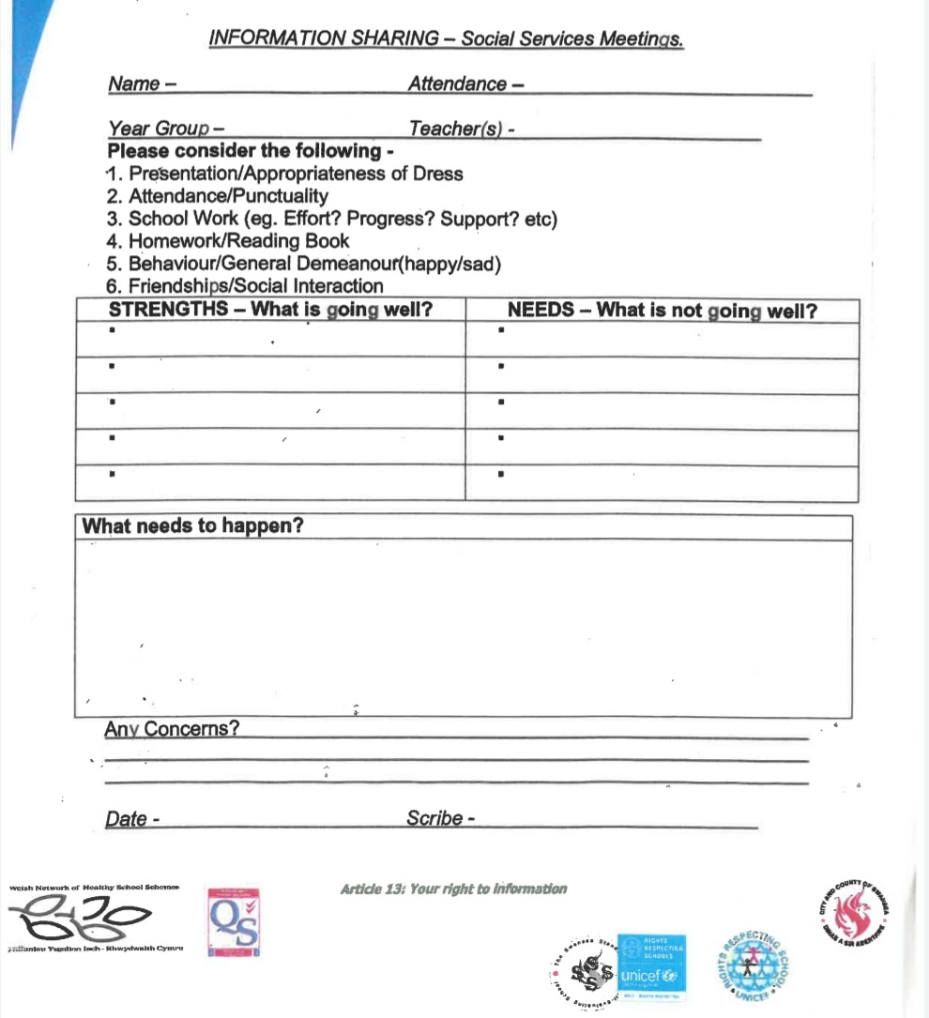

(School A, 2021).

Appendix 2
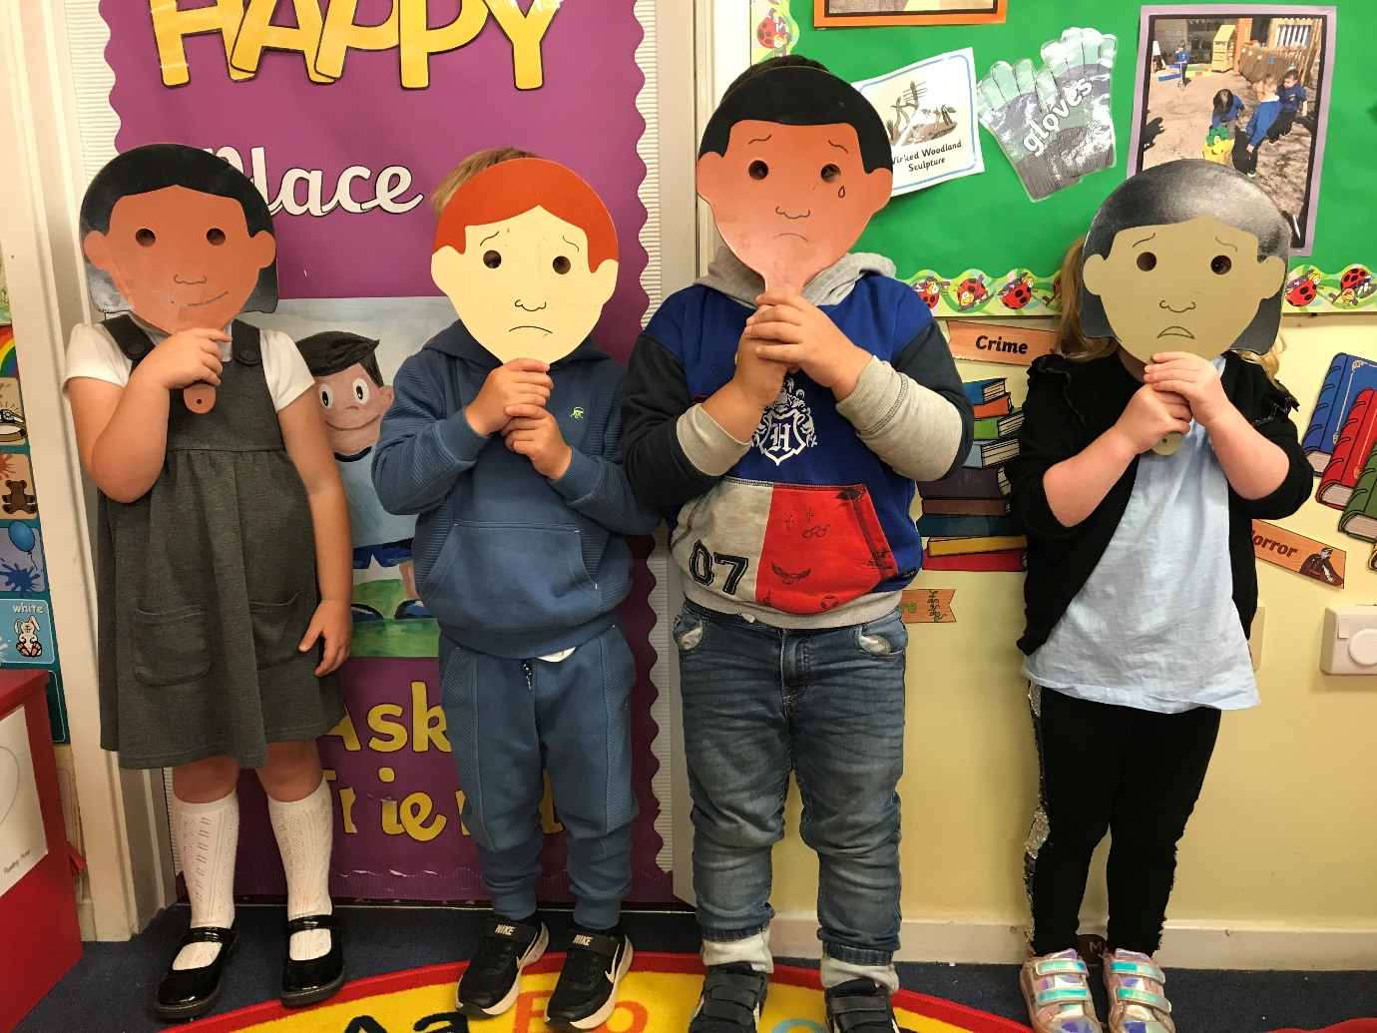
(Author’s own, 2021).

Appendix 3
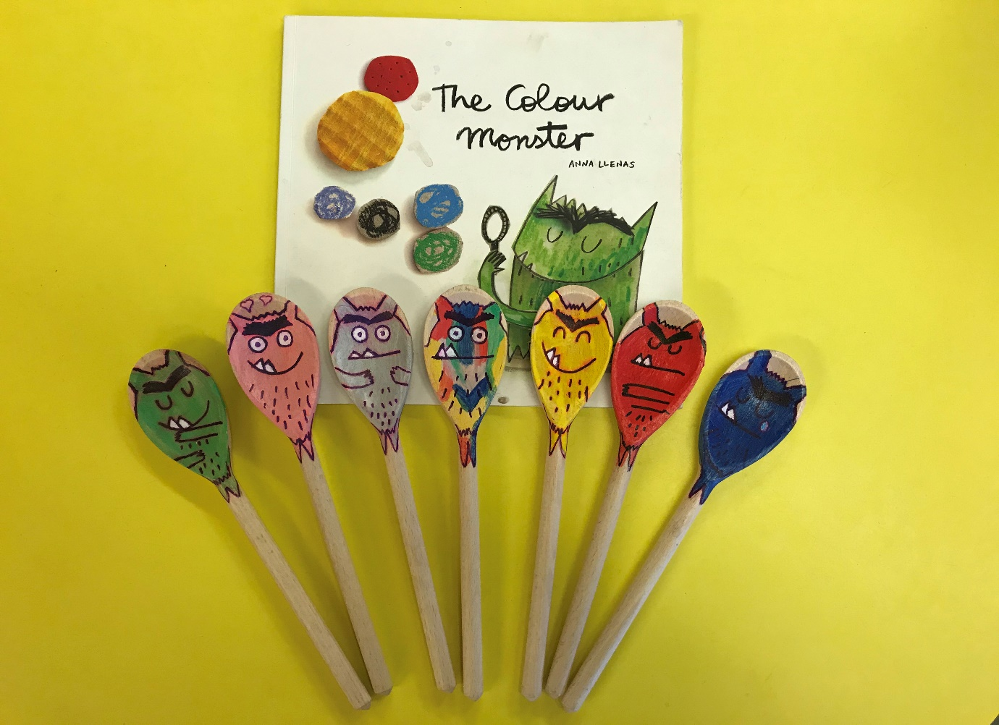
(Author’s own, 2021).

Appendix 4
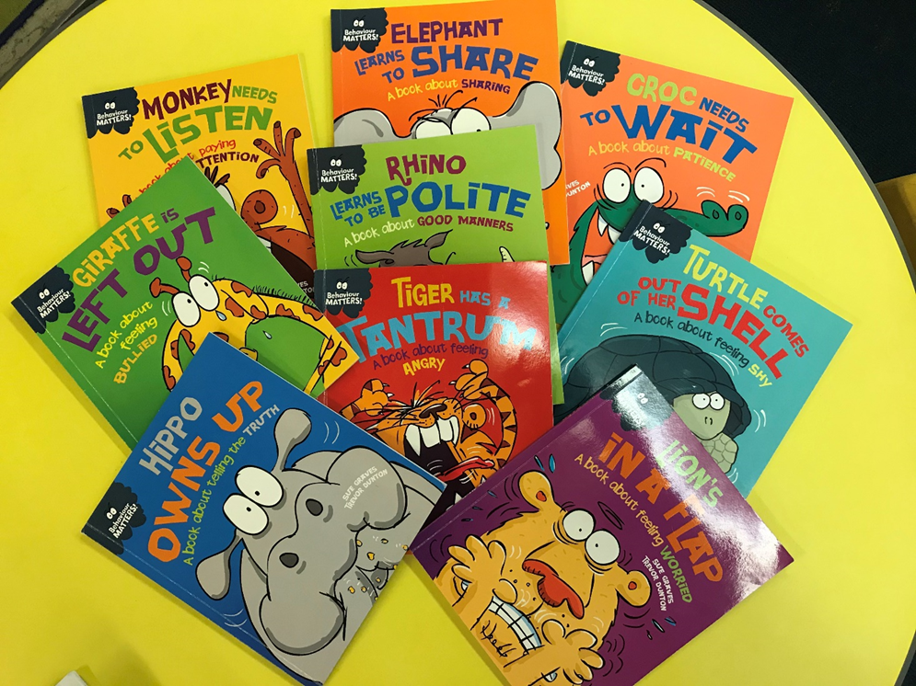
(Author’s own, 2021).

Appendix 5
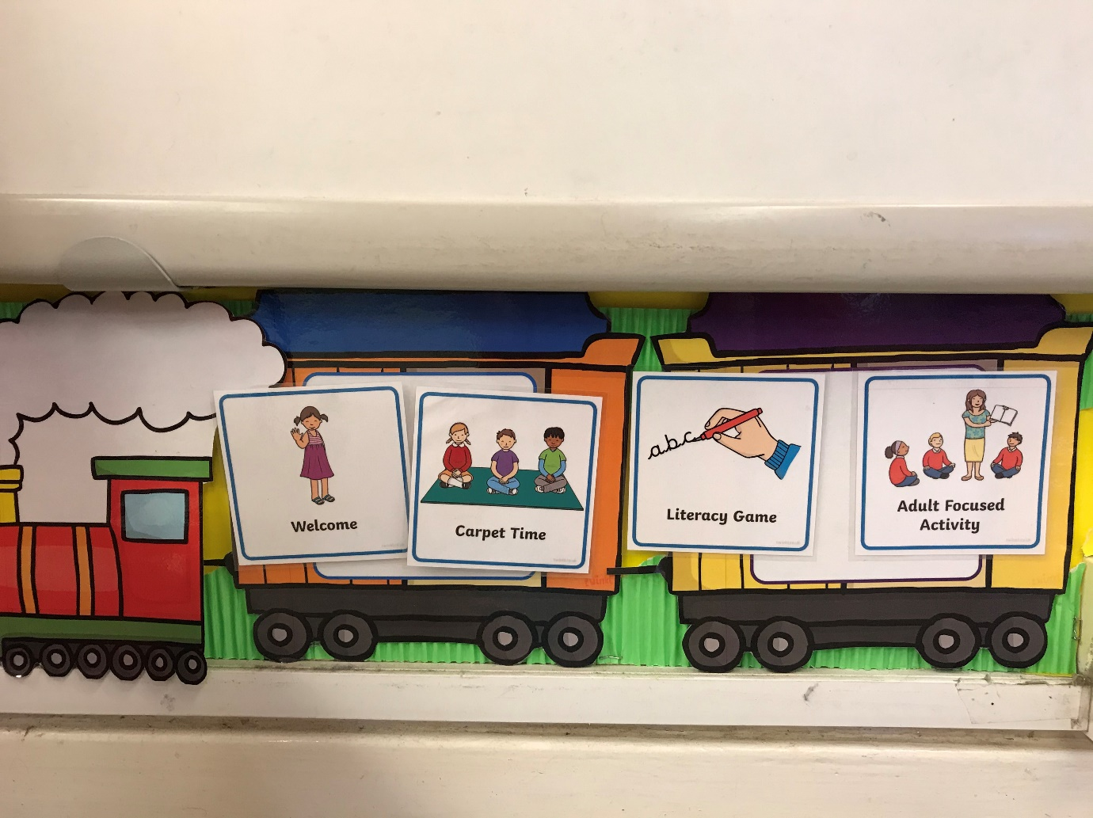
(Author’s own, 2021).

Appendix 6
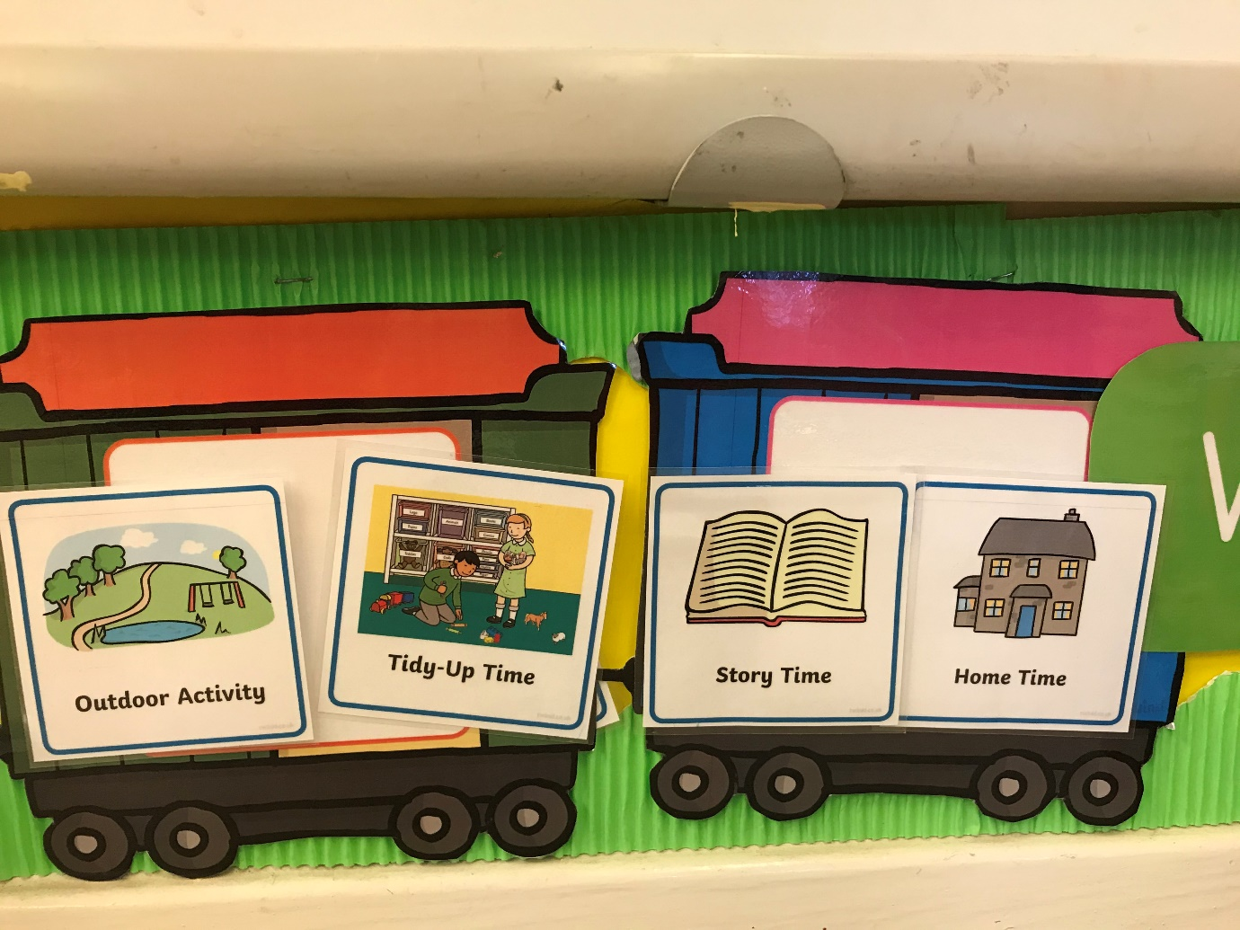
(Authors own, 2021).

Appendix 7
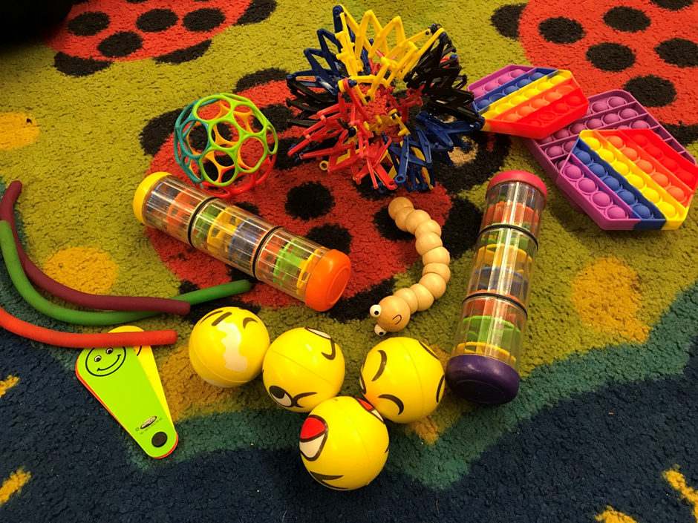
(Authors own, 2021).

