Job Dissatisfaction (Case Study Analysis)

Vania Da Costa

ID number: 2030889

Module Name: Professional Career Development

Module Code: BMSW4005

Lecturer: Akinseye Aluko

06/09/2022

Executive Summary
The purpose of this report is to highlight the issues related to job dissatisfaction and present possible solutions based on problem solving and decision-making skills. In addition, this report has presented causes and effects related to job dissatisfaction in the UK environment, which was then supported with PESTLE analysis. Furthermore, possible solutions were presented regarding job dissatisfaction in UK organizational environment. From the implementation and evaluation phase, it has been identified that background checks and qualifications are essential. Background exploration is one of the essential activities of HRM. It cannot merely ignore occupational hazards, but further eradicate the relevant costs of recruitment, training and retraining, choose appropriate talent for the organisation, evade negative effects to the organisation and consumers, and contribute to the firm’s greater advantages.

Table of Contents
Executive Summary 2
Introduction 4
Problem Nature and Scope 4
Causes and Effects 5
PESTLE Analysis of UK Business Environment 7
Political Factors 7
Economic Factors 7
Social Factors 7
Technological Factors 8
Legal Factors 8
Environmental Factors 8
Possible Solutions 8
Defining Organisational Objectives based on Core Regulations 9
Provision of Fun-time at the Workplace 10
Improving Compensation Packages 10
Conducting Surveys to Determine the Opinions of the Workforce 10
Encouraging Telecommuting 10
Implementation and Evaluation of Possible Solutions 11
Conclusion 12
References 13
Appendix 14

Introduction
Job dissatisfaction is one of the UK's biggest issues. The UK is one of the top ten European countries facing this challenge. One of the core reasons behind job dissatisfaction is long working hours in the UK. Long commutes, low pay, poor organisational culture and lack of career development are other causes of job dissatisfaction in the UK (Senek et al., 2020). On the contrary, the UK industry has been facing an extreme financial recession for the last three years. The longer working hours in the UK have negatively impacted the country's employees' personal and professional lives (Bessa, Charlwood and Valizade, 2021).
However, there are a large number of workers who are unhappy with the collective agreement because they have to work longer hours regardless of any increase. The number of disaffected workers in this area is increasing, which is frustrating for the business world (Travers and Cooper, 2018). There is, therefore, a probable threat of unemployment in the UK as disgruntled staff may be inclined to leave. The issue has a detrimental effect on the UK economy and requires proper attention from the relevant establishments to tackle issue. Disgruntled workers imply a likely risk to business organisations, which they fear is a serious challenge to the UK economy (Cohidon, Wild and Senn, 2019).

Problem Nature and Scope
The contemporary business environment creates recurrent issues for business organisations worldwide. Likewise, the ever-changing modern business environment in the UK presents many challenges for organisations in the region. One of the most complex issues facing the UK is the problem of job dissatisfaction among workers employed in the UK (Sadiq, 2022). The issue of job dissatisfaction is bad for the country as well as the workers working in the UK. Dissatisfaction with jobs could damage the country's economy on a large scale. Workers dissatisfied with their jobs are more likely to quit and lose their jobs (Halder, 2018).
It has been observed that the economy of the United Kingdom is already experiencing the adverse impacts of unemployment (Arvan et al., 2019). The government and the authorities are striving to produce a skilful workforce for the future, but the challenge may harm the efforts of the government and authorities. It may divert the attention of policymakers to eliminate unemployment in the country (McCarthy and Dragouni, 2021). On the other hand, the problem of job dissatisfaction has adverse effects on employees as well as they may lose their jobs and opportunities for career progression. Consequently, the problem needs timely and appropriate solutions for economic growth and development sustainability (Muntz, Dormann and Kronenwett, 2019).

Causes and Effects
Employees in the UK are facing the issue of job dissatisfaction. A study conducted by NatCen Research shows that many employees consider their work dull and boring (Hanaysha and Tahir, 2016). They find no interest in their jobs because the organisations did not define the organisational goals and did not clearly explain job expectations to workers.
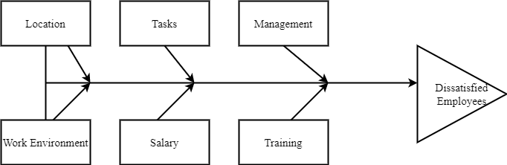
Figure 1: Causes and Effects of Dissatisfied Employees
One of the most prominent reasons for job dissatisfaction is that employees consider the working hours substandard. Business organisations across the United Kingdom are just focusing on productivity and profitability (De Clercq, Haq and Azeem, 2020). Consequently, employees have no opportunities to enjoy or have fun in the workplace. One of the most significant factors contributing to increased job dissatisfaction in the United Kingdom is the low compensation packages of labour while comparing those packages with other European countries. On the other hand, United Kingdom employees have to work longer than the labour in other European countries (Rukh et al., 2020).
Consequently, low compensation packages adversely influence employees' motivation and satisfaction (Kuraa and Abubakarb, 2018). Another reason that contributes to the problem is that employees are not valued in business organisations. Consequently, they feel insecure about their jobs. A long commute is another reason behind job dissatisfaction. Employees have to commute long to reach their workplaces. Technological advancements have changed the business environment across the globe. Numerous business organisations worldwide are altering their business operations to allow workers to work from home (Andersen, Pedersen and Waldorff, 2018).
Maintaining corporate image and communicating values is reflected not only at the top level but also at the grassroots level. Because grassroots leaders deal with employees daily, their words and actions are more likely to reflect whether the corporate values are implemented, or it is easier for them to experience corporate values from corporate values grassroots quality (Campbell et al., 2018). Grassroots leaders who involve in favouritism in private, including taking particular care of their relatives and friends, collaborating with relatives and friends or former ministries for reporting false narratives and avoiding those in close relationships which violate discipline and rules, will not stop education and punish them. In addition, no matter how effective the corporate ideal is, it can merely be agreed upon in written form or discussed verbally. Most grassroots workers are from rural regions and have not acquired much cultural education. They consider what they see with their own eyes. Thereby, the favouritism of management units does not merely influence the organisation's reputation but other influences the entire organisation's reputation.

PESTLE Analysis of UK Business Environment

Political Factors
Political factors influencing business in the UK are of significant importance. The stability of the political atmosphere is the strength of the country. On the other hand, Brexit is causing uncertainty for the businesses in the sector that will influence the country's business environment for a long time. The political uncertainty after Brexit may prevent the government from taking action against the case study challenges (Senek et al., 2020).

Economic Factors
The economy of the United Kingdom is one of the strongest economies in the world (Bessa, Charlwood and Valizade, 2021). However, the economic recession has adversely influenced its economic growth. The recent outbreak of COVID-19 has also adversely influenced the global economy. Consequently, the government must take careful measures against business issues.

Social Factors
The United Kingdom has a multicultural population. The region has a huge consumer market for businesses. Numerous multinational companies work in the country because of its big consumer market. Any change in working hours may influence social factors to deal with such a huge consumer market; companies need more time to operate to sustain profitability (Travers and Cooper, 2018).

Technological Factors
The United Kingdom is one of the most technologically developed nations in the world (Cohidon, Wild and Senn, 2019). Businesses across the country are practising innovative ways and technology to drive their benefits in the market. The technological factors may positively impact the issue of job dissatisfaction as businesses are ready to shift business operations to telecommuting.

Legal Factors
It has been observed that legal factors are in the form of unfair practices and policies in organizations, and they are majorly associated to payment issues. In addition, promotion and increments are disseminated to employees based on social connections with the top management.

Environmental Factors
With respect to environmental factors, the overall environment becomes suffocated and exhausted in the presence of unsupportive management. The irrelevant scolding sessions adversely affected the employees and let them to quit their jobs.
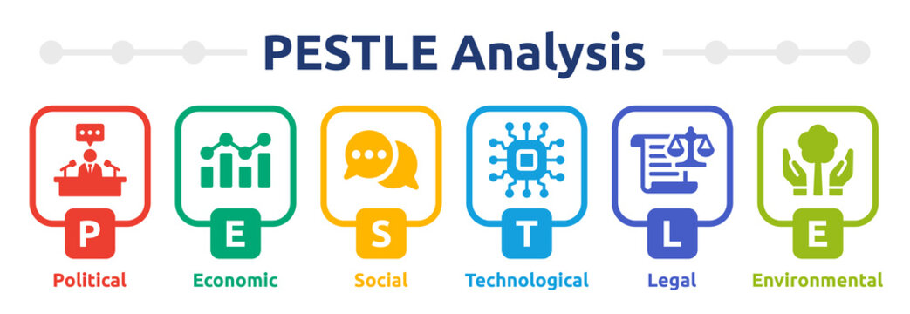
Figure 2: PESTLE Analysis

Possible Solutions
Following are the possible solutions that the UK government can implement to resolve the issues of job dissatisfaction:
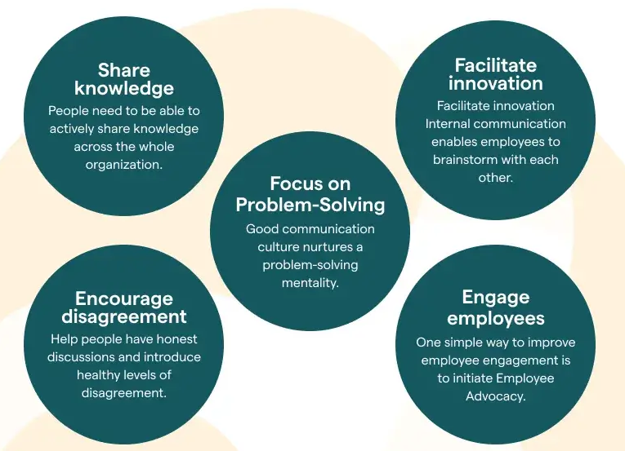
Figure 3: Solutions toward Employee Satisfaction

Defining Organisational Objectives based on Core Regulations
The UK government must regulate these organisations to clearly define the scope and objectives of the company. Organisations across the UK must clarify the nature of the work to employees to avoid questions about job dissatisfaction in the future. In order to achieve the "simplification of communication", a company must reduce nepotism throughout the company, since nepotism not merely influences the confidence and counter team’s efficiency but other influences the dissemination of corporate culture and consequently influences the ongoing development of the company (Sadiq, 2022). It is believed that management teams at all stages will do a better job of self-examination, proactively collaborate with the HR department, move relatives, friends, roommates and other individuals who are closely related to the department out of the department, and establish a real "transparency of information and simple communication" throughout the organisation (Halder, 2018).
The organisation suggested that management teams "dare to ask, understand requirements and meet requirements". It has been observed that “Dare to ask” needs management teams to enhance their professional competencies and needs management teams to act from the perspective of "ethics". The prerequisite for "dare to ask" is to be able to straighten up and be "tough enough” (Arvan et al., 2019).

Provision of Fun-time at the Workplace
The government of the United Kingdom must develop a strategy to ensure a fun time for employees in the business organisation. Fun time at the workplace would not only ensure the job satisfaction of employees, but it will also provide business organisations with an opportunity to have enhanced organisational productivity (McCarthy and Dragouni, 2021).

Improving Compensation Packages
The government should revise employee compensation packages and bound the business organisations to pay employees according to working hours. Companies across the country must pay overtime to employees to enhance their job satisfaction (Holly and Mohnen, 2012).

Conducting Surveys to Determine the Opinions of the Workforce
The government and administrations need to survey labour markets frequently to determine market trends and opinions of labour regarding job satisfaction (Parvin and Karbin, 2011).

Encouraging Telecommuting
Business organisation in the United Kingdom should attempt to shift their possible business operations to telecommuting. Consequently, employees would have an opportunity to work from their homes, and they will not have to travel long to reach the workplace. Consequently, job satisfaction may be enhanced.

Implementation and Evaluation of Possible Solutions
The most critical phase of implementing possible solutions is defining the problem. The United Kingdom is facing the challenge of job dissatisfaction. It is essential to plan before the implementation of the possible solutions (Muntz, Dormann and Kronenwett, 2019). The government of the United Kingdom must plan and investigate the root causes of the problem that is faced by employees in the country. The government and administration should define the scope and nature of the problem and investigate the problem to determine the factors that contributed to the problem. All possible solutions must be taken into consideration for solving the issue of job dissatisfaction.
With respect to recruitment and to deal with the adverse effects of nepotism, as an HR manager, background checks and qualifications are essential. Background exploration is one of the essential activities of HRM. It cannot merely ignore occupational hazards, but further eradicate the relevant costs of recruitment, training and retraining, choose appropriate talent for the organisation, evade negative effects to the organisation and consumers, and contribute to the firm’s greater advantages (De Clercq, Haq and Azeem, 2020). Additionally, background monitoring can prevent the adverse impacts of nepotism. In this regard, an HR manager must have an apparent accountability of each employee's background and be aware of them. When selecting, promoting and engaging staff, avoid people who are closely related to the department. The department should firmly integrate the interview and qualification process for selection, promotion and transfer of positions.
On the other hand, grid analysis and fishbone analysis would assist to determine the causes and to determine most appropriate solutions for the problem (Rukh et al., 2020). The government should develop proper key performance indicators to determine the efficacy of proposed solutions. Several surveys should be conducted across the country to monitor the effects of government policies on the issue of job dissatisfaction. Robust planning in both implementation and monitoring is essential to resolve the issue permanently. The government and authorities should make timely and appropriate decisions to resolve the issues. Otherwise, the issue of job dissatisfaction would have adverse effects on the economy of the United Kingdom.

Conclusion
The United Kingdom is facing an adverse issue of job dissatisfaction that may have potential risks and challenges for its economy in the future. The culture of long working hours, low compensation packages, lack of career progression, dull routine at the workplace, and long commuting are the primary causes of increased job dissatisfaction in the country. The government of the United Kingdom must take practical steps to resolve the issue of job dissatisfaction. Job dissatisfaction can harm the economy of the United Kingdom in the form of unemployment.

References
Andersen, M.K., Pedersen, L.B. and Waldorff, F.B., 2018. Retirement, job satisfaction and attitudes towards mandatory accreditation: a Danish survey study in general practice. BMJ open, 8(8), p.e020419.
Arvan, M.L., Pindek, S., Andel, S.A. and Spector, P.E., 2019. Too good for your job? Disentangling the relationships between objective overqualification, perceived overqualification, and job dissatisfaction. Journal of Vocational Behavior, 115, p.103323.
Bessa, I., Charlwood, A. and Valizade, D., 2021. Do unions cause job dissatisfaction? Evidence from a Quasi‐Experiment in the United Kingdom. British Journal of Industrial Relations, 59(2), pp.251-278.
Campbell, M.R., Mann, K.D., Moffatt, S., Dave, M. and Pearce, M.S., 2018. Social determinants of emotional well-being in new refugees in the UK. Public Health, 164, pp.72-81.
Cohidon, C., Wild, P. and Senn, N., 2019. Practice organization characteristics related to job satisfaction among general practitioners in 11 countries. The Annals of Family Medicine, 17(6), pp.510-517.
De Clercq, D., Haq, I.U. and Azeem, M.U., 2020. When does job dissatisfaction lead to deviant behaviour? The critical roles of abusive supervision and adaptive humour. Australian Journal of Management, 45(2), pp.294-316.
Halder, N., 2018. Investing in human capital: Exploring causes, consequences and solutions to nurses’ dissatisfaction. Journal of Research in Nursing, 23(8), pp.659-675.
Kuraa, K.M. and Abubakarb, R.A., 2018. Towards a Better Understanding of the Mechanism Linking Perceived Workload to Counterproductive Work Behaviour: Does Job Dissatisfaction Matter?. WARM REMARKS, p.9.
McCarthy, D. and Dragouni, M., 2021. Managerialism in UK business schools: capturing the interactions between academic job characteristics, behaviour and the ‘metrics’ culture. Studies in Higher Education, 46(11), pp.2338-2354.
Muntz, J., Dormann, C. and Kronenwett, M., 2019. Supervisors’ relational transparency moderates effects among employees’ illegitimate tasks and job dissatisfaction: A four-wave panel study. European Journal of Work and Organizational Psychology, 28(4), pp.485-497.
Rukh, G., Dang, J., Olivo, G., Ciuculete, D.M., Rask-Andersen, M. and Schiöth, H.B., 2020. Personality, lifestyle and job satisfaction: causal association between neuroticism and job satisfaction using Mendelian randomisation in the UK biobank cohort. Translational psychiatry, 10(1), pp.1-9.
Sadiq, M., 2022. Policing in pandemic: Is perception of workload causing work–family conflict, job dissatisfaction and job stress?. Journal of Public Affairs, 22(2), p.e2486.
Senek, M., Robertson, S., Ryan, T., King, R., Wood, E., Taylor, B. and Tod, A., 2020. Determinants of nurse job dissatisfaction-findings from a cross-sectional survey analysis in the UK. BMC nursing, 19(1), pp.1-10.
Travers, C.J. and Cooper, C.L., 2018. Mental health, job satisfaction and occupational stress among UK teachers. In Managerial, Occupational and Organizational Stress Research (pp. 291-307). Routledge.

Appendix

Vania: Good afternoon Saleha.
Please sit down.
I received your letter about your dissatisfaction with the company.

Manager(Vania): Employee dissatisfaction is often a common occurrence in some companies as many internal and external factors overwhelm employees. As a manager or consultant, I would say that employee dissatisfaction should be spent to improve the company's resources and income because resources are the residents that keep the process going.

Employee(Saleha): There are many complaints about the company, the job, the conditions of co-workers, and the changed work environment. There are many problems that come in the form of environmental problems. The tone of the boss is often very harsh, which hinders the building of confidence.

Manager(Vania): Changing the office environment is not easy.

Employee(Saleha): Yes, but we have examples like "wolf culture" that gives workers more overtime. As a result, employees over the age of 35 can easily feel ostracized, exhausted and disillusioned with their work and life in such a company.

Manager(Vania): I think the most important thing is the company's value strategy and its effect on all aspects of the workforce. Handling small departments can divide the work better and of course there are many other possibilities.

Employee(Saleha): You don't think that employee turnover, particularly the voluntary termination of important employees, will bring many drawbacks to the organization.

Manager(Vania): Obviously, loss of business secrets, reduction in customer referral benefits, increased turnover costs, switching and training costs, etc.

Employee(Saleha): Employee dissatisfaction tends to form an endless cycle. The environment makes them unhappy and they choose to leave the company.

Manager(Vania): Remember that when it thrives again, the company will miss out on growth opportunities due to a lack of key talent.

Employee(Saleha): In the case of substandard work, how to eradicate the turnover intention of important employees in the case of substandard work has become a fundamental problem that majority of the organizations urgently need to resolve.

Manager(Vania): What I am talking about is that “empirical research and practical experience have shown that employee creativity can promote organizational innovation, improve business efficiency and core competitiveness”. Thereby, improving the creativity of employees and the innovative capacity of enterprises should become a common concern of academics and practitioners.

Employee(Saleha): This negative sense of work can have a negative impact on information processing, problem solving and personal behaviour, making their creativity ineffective.

Manager(Vania): The factors that influence employee creativity are multidimensional, with emotions being an important factor.

Employee(Saleha): Another aspect you're missing here is that work communities promise to improve employee creativity and performance through increased job satisfaction. But we hardly worked on it, so my dissatisfaction made me have a negative view of my job.

Manager(Vania): I agree. Greater job dissatisfaction robs employees of all opportunities to show a positive attitude towards their work, as well as recognition and loyalty to the organization. Employees do not get to know their work better and focus more on their work. But there are also solutions.

Employee(Saleha): And what`s that?

Manager(Vania): High interest, greater willingness to invest and their motivation can increase the likelihood of job satisfaction.

Employee(Saleha): It has been observed that various political factors influence job satisfaction. Political parties have changed and few authorities have tried to prioritize their own appointed staff. Others also experience discrimination and unnecessary bullying, which often makes them dissatisfied with their jobs.

Manager(Vania): I tell you that jobs like sales and graphic design are rare and success is always valued in goal work. Business issues have changed as they prepare their employees for the challenge. Once they reach their goals, the company will continue to reward them.

Employee(Saleha): There are some of the social aspects important to be considered.

Manager(Vania): What are they?

Employee(Saleha): Bad relationships in the workplace tend to be ingrained in the minds of employees. Teams often experience bullying, betrayal, leadership and disrespect by newcomers. This behaviour turns their motivating energy into a negative vibe that they receive every time they enter the workplace.

Manager(Vania): A portal should be established to report all complaints and management should take action on them on a weekly basis. In the interest of your employees, you are advised to take professional action and stop responding to wrongdoing.

Employee(Saleha): Another factor that will be a big factor is the lack of work-life balance. Due to workload at workplace, they have little time to solve problems at home and therefore they mix workload with family life.

Manager(Vania): Can you specify on the legal factors?

Employee(Saleha): Legal factors are in the form of unfair practices and policies in organizations, and they are majorly associated to payment issues. In addition, promotion and increments are disseminated to employees based on social connections with the top management.

Manager(Vania): What do you think of environmental factors?

Employee(Saleha): With respect to environmental factors, the overall environment becomes suffocated and exhausted in the presence of unsupportive management. The irrelevant scolding sessions adversely affected the employees and let them to quit their jobs.

Manager(Vania): Sometimes the physical environment is also suffocating, with dim lighting, cramped cubicles, low ceilings, poor ventilation, limited parking, and factors such as criticism of employees, unsupportive bosses, condescending teammates, and familiar people. Backstab. These factors will play out appropriately, but keep in mind that there is always a way out of this situation.

Employee(Saleha): And that should be advised to bosses for mending their ways.

Manager(Vania): Of course, another way to foster a friendly workplace is to get feedback from team members on a specific strategy or strategic growth area.

Employee(Saleha): Hope all companies start using these solutions.

Manager(Vania): In conclusion, I just want to say that if all these methods are applied, it is easy to achieve the set goals because working with the resources is the most effective since their input values are infinite.

Employee(Saleha): Thank you very much for the clarification Ms Vania.

Summary
The most critical phase of implementing possible solutions is defining the problem. The United Kingdom is facing the challenge of job dissatisfaction. It is essential to plan before the implementation of the possible solutions (Muntz, Dormann and Kronenwett, 2019). The government of the United Kingdom must plan and investigate the root causes of the problem that is faced by employees in the country. The government and administration should define the scope and nature of the problem and investigate the problem to determine the factors that contributed to the problem. All possible solutions must be taken into consideration for solving the issue of job dissatisfaction.
With respect to recruitment and to deal with the adverse effects of nepotism, as an HR manager, background checks and qualifications are essential. Background exploration is one of the essential activities of HRM. It cannot merely ignore occupational hazards, but further eradicate the relevant costs of recruitment, training and retraining, choose appropriate talent for the organisation, evade negative effects to the organisation and consumers, and contribute to the firm’s greater advantages (De Clercq, Haq and Azeem, 2020). Additionally, background monitoring can prevent the adverse impacts of nepotism. In this regard, an HR manager must have an apparent accountability of each employee's background and be aware of them. When selecting, promoting and engaging staff, avoid people who are closely related to the department. The department should firmly integrate the interview and qualification process for selection, promotion and transfer of positions.
On the other hand, grid analysis and fishbone analysis would assist to determine the causes and to determine most appropriate solutions for the problem (Rukh et al., 2020). The government should develop proper key performance indicators to determine the efficacy of proposed solutions. Several surveys should be conducted across the country to monitor the effects of government policies on the issue of job dissatisfaction. Robust planning in both implementation and monitoring is essential to resolve the issue permanently. The government and authorities should make timely and appropriate decisions to resolve the issues. Otherwise, the issue of job dissatisfaction would have adverse effects on the economy of the United Kingdom.

