

Assessment 1 – Reading Task Template
PART 1: Upload your photo of your A3 in-class notes here:
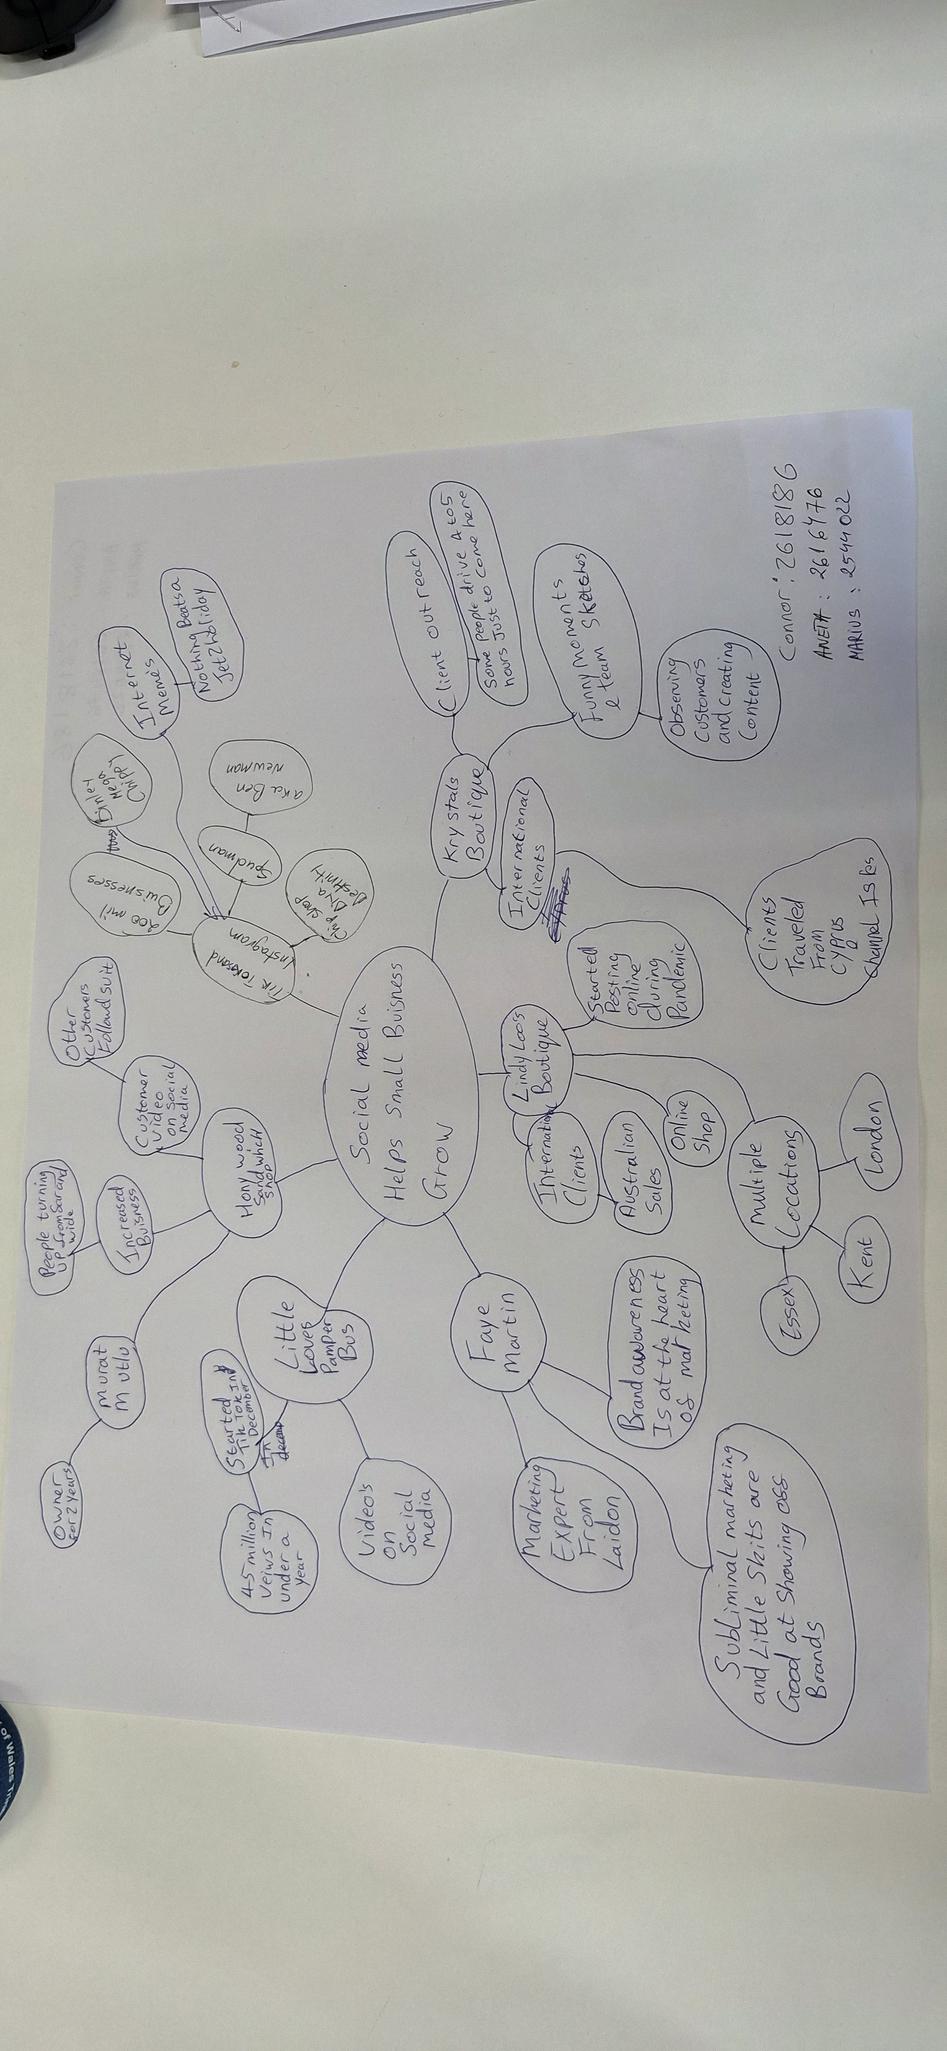

PART 2
- What is the main idea of the whole text?

To talk about how social media platforms help small business grow. And provide evidence to support this statement.

- What is one key point that supports the main idea, and which specific example from the text shows this?
A key point is that posting videos on social media is that people from further away will be able to see your products and want to come to get them, example that Krystals boutique had people from Cyprus travel all the way to the UK just to buy a dress.

- What is a different key point that supports the main idea, and which specific example from the text shows this?
More businesses are using social media to boost their brand recognition and sales via social media this is shown in the paragraph which says, “About 1.5 million UK businesses operate on TikTok, according to figures shared by the social media platform last year”.
- Which part of the text do you think is most important, and why?
I think that Faye martins statement is an important part of the text to back up the main idea of this text she says “the way marketing has adapted over the last few years is that brand awareness is at the heart of it”, some people don’t like to sit and watch tv all the time some people get more enjoyment out of social media and people have realised this and that’s why more people have come to social media to promote and help there businesses.

Reflection:
- What did you find difficult in this task (including in-class components), and why was it difficult?
I found that deciding what was important and what wasn’t, in the text was harder than I thought as I see it as a matter of opinion and working in the 3 was harder for me as they both had different opinions to me,

- What helped you with this difficulty, and how did it help you?

I listened to the other persons opinions and discussed them with them and realised that they where important to them but not me because of this they still went on our mind map and helped me understand it more after coming back to the mind map and text when completing this assessment.

