Consumer Behaviour and the Customer Journey
BMBM5002
1900519
Jasper MacCall

Consumer behaviour should be at the center of marketing strategies as it will drastically improve the chances of success. The differences in business to business (B2B) and business to customer (B2C) is that B2C consumer make purchases out of emotional responses, whereas B2B purchasing is base on rationale. This means that BMW should differ its marketing approaches depending on the buyer to get the best result. Decision making can be manipulated by customers knowledge of a product, brand image and neurological processing which can be capitalize on by the marketing strategy. BMW has a strong image and need to use it to their advantage because customers will buy from them because they know and trust them. Moreover, when customers are faced with innovations such as an electric car they can be hesitant to purchase it. This means the marketing needs to educate and inform consumers about the product to get the mass market to adopt it thus make profit. Additionally, demographics have a role in consumer behaviour this report found that men are more likely to buy cars. However, if BMW are using to use stereotypes as part of their marketing strategy this needs to be done with vigilance vas it can cause offense and damage the brands image.
1 Introduction
The primary target of a marketing campaign is to sell. This means that understanding consumer behavior is critical to create a successful strategy. BMW need to consider the differences in business to business (B2B) and business to customer (B2C) behavior to succeed in both marketplaces, this report will discuss the key differences and how best to market to them. Furthermore, decisions are influenced by the customers knowledge of a product, brand image and neurological processing, these need to be considered when developing an effective marketing strategy. Lastly, demographics has a role in consumer behavior. The social class effects how much knowledge customers have and therefore how they make decisions. Moreover, the gender of customers effects what products they are likely to buy and this could be used to shape marketing campaigns.
2 Differences in B2B and B2C
A difference in behaviour between B2B and B2C is that when B2B customers are making decisions based on rationale, which means the marketing needs to centre around technical aspects as written by Rėklaitis and Pilelienė (2003), “the rationality factor is fundamental in B2B sales; therefore, it directs the choice of all the further actions of marketing communication in latter type of market.” In the perspective of BMW this means when they are marketing leases to companies, they should focus marketing on the price and quality of the product rather than the emotions associated with the brand.
In contrast B2C, marketing is centred round the customers emotions and values as stated by Rėklaitis and Pilelienė (2003), “B2C market can be characterized as being based on customers’ emotions to be touched and irrationality of purchase decision.” When marketing to consumers, BMW should focus on the emotions attached to their high brand reputation. This is because B2C consumers are susceptible to psychological and social influences and can be manipulated into buying out of their emotion needs.
Moreover, when a consumer purchases a product they have little knowledge about they often favour familiar brand names as explained by Brown Al (2007) “that the likelihood of choosing an “underdog” brand will be low when a consumer enters a new category” This means that BMW can use this to their advantage because of the trust they have accumulated, which means customers will come to them because they trust them and they are more likely to buy their first electric car with a well-known brand.
One aspect of Maslow’s Hierarchy Of Needs is the self-esteem and this combined with the pressure to need sustainable means that the environmental factor is important in the buying process as “an individual with high level of self-esteem, the individual might want to purchase environmentally-friendly electric vehicles to receive social respect or good recognition from others” (Cui Al, 2010). BMW need to capitalise on the psychological need for reassurance that a purchase matches consumer values. This means that the environmental impacts of electric cars should feature in the marketing strategy to persuade consumers that it is a sustainable product and meets their needs to be seen as ethical.
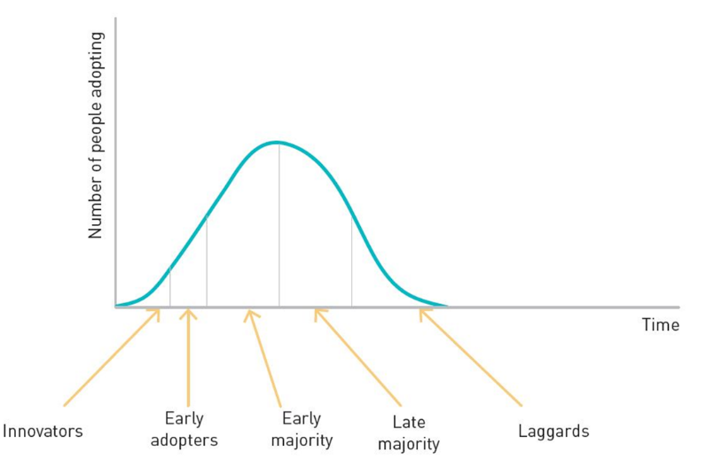
According to Rogers (1958) there are different types of consumers who adopt innovations at various stages, the first 2.5% are called innovators as seen in figure 1. This means that when BMW launch a driverless car they should focus the marketing campaign on the safety and the benefit of the car to overcome the stigma and attract a mainstream audience. Moreover, BMW need to let consumers trial the new technology as this will mitigate some of the controversy about driverless cars and increase sales.
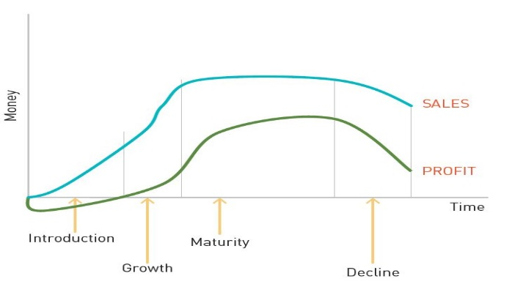
Customer past experience is factor in innovation adoption as “consumers who once have adopted the eco-innovation are likely to be much more open for adoption of future improved eco-innovations” (Jansson al, 2010). The marketing strategy for a new electric car should be focused on customers that have experiences of the product and do not require teaching about the product. This is an important stage for innovations because as shown in figure 2, new products lose money. Thus, BMW need to penetrate the market to get early adopters and majority to buy the car before it is a profitable endeavor, else it will fail to sell in the quantity needed to be financially sustainable.
Figure 1
Figure 2

3 Decision making
Moreover, BMW need to concentrate their marketing strategy on giving customers knowledge about the product as this helps gain sales as “the higher the consumer's product knowledge, the higher the impulse buying behavior” (Liang, 2012). Despite cars being a high involvement purchase there is scope for the consumer to buy on impulse. Even if a customer is an experienced car buyer, they can be upsold extra features without learning how they operate. Furthermore, when consumers have knowledge of a product area they are more likely to purchase innovations, for example, electric or driverless cars.
A technique that BMW could use in their strategy is subliminal marketing, which influences consumers to make unconscious decisions as defined by Riener (2012), “subliminal persuasion as communication that is not intended to be understood consciously but to influence thoughts, feelings, and/or behavior at the subconscious level.” This encourages autonomy in the buying process and means that the likelihood of a sale increases. However, this is not effective for high value purchases because the level of autonomy is low and the customer will consider the sale more and will make rational decisions.
Additionally, if BMW use this in their marketing strategy it could go against their corporate social responsibility policy as this is an unethical way to advertise as Hejase Al (2013) states that “subliminal messages are considered unethical and deceptive”. Although this method of marketing can increase sales it is looked upon to be an immoral way to market products. Moreover, as BMW has pledged to be a corporate social responsible company and could receive backlash for implementing this strategy.
Decisions are made as a result of brand image and can cause consumers to become loyal and want to be affiliated with the brand as said by Bernd and Gesus (2006), “brand image, in particular, exercises a strong direct influence on current brand-loyal purchase behavior.” This shows that BMW need to maintain their respected reputation to keep their customer base. Furthermore, with a good brand image BMW can launch new products and rely on consumer behaviour to buy into the brand name thus be open to innovations.
However, well developed brand images can be hindrance when releasing a new product. This is because the consumer has learnt to expect a certain type of product, BMW could suffer when they release electric cars because it goes against the consumer expectation of the brand.
Additionally, decisions are made by neurological processes in the Ventromedial Prefrontal Cortex (vmPFC) which is responsible for self-perception, emotional processing and decision making. This is associated with brand preference, as stated by Plassmann and Karmarkar (2010), “favoured brands activated significantly more the vmPFC compared to other brands from the same category that were less liked.” In BMW’s marketing strategy it should have strong branding to capitalize on the neurological influence that establish brands have on the decision making process.
Customers make decisions in six steps as seen in figure 3, the first of the steps is recognition. The consumer needs to identify a problem to think about purchasing an item as said by Sethna and Blythe (2016)“People need to be able to justify their decisions, both in terms of cost and of the usefulness of the products they buy.” When releasing an electric car BMW should offer test drives to persuade customers that it is a worthwhile purchase. Furthermore, this will lower the chances of consumers experiencing dissatisfied with the product after they have bought it.
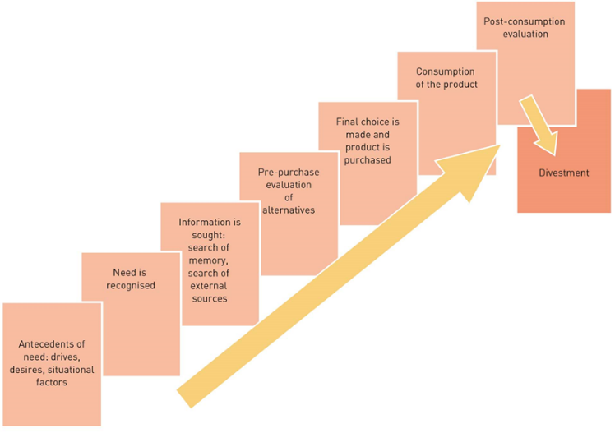
Another aspect of the decision process is the post consumption evaluation. This is important as customers with negative experiences are more likely to share their dissatisfaction as said by (Kotler Al,2016)“the average satisfied customer tells three others about good experiences, the average dissatisfied customer tells 10 others of his or her bad experiences.” This means BMW need to offer proactive customer service that will resolve issues and assist in making consumers satisfied thus maintaining their brand representation.
Figure 3

4 Demographics
Moreover, demographics need to be considered when marketing. This is because it can affect customers behaviour as “middle and upper-status households, information search appears to increase with social class, education, and income” (Schaninge and Sciglimpaglia,1981). This should inform BMW’s marketing strategy to make their campaign as educational as possible to satisfy the needs of the high status of their audience.
Gender can have an important role in dictating consumer behaviour and this is critical for the automotive market as explained by Kumar (2017), “men still make most purchasing decisions relating to automobiles, TVs, refrigerators, cameras, and other consumer durables.” This means that BMW should advertise primarily to a male audience to get the maximum interest. Furthermore, the advertising ought to have men driving the car as this will resonate with the target customer.
However, this way of marketing can have a negative effect on consumers and can discourage people from the brand as “the use of too many gender stereotypes or a negative portrayal of these stereotypes can also lead to a backlash and potentially harm a company’s reputation” (Ionos, 2017). Although BMW could use stereotypes to link people to the brand it could have the reverse effect on some customers. This method of marketing should be used cautiously to not cause offense to consumers and damage the brand reputation.
Moreover, consumers behave differently depend whether they have an extrovert or introvert personally, extroverts are driven by external factors as stated by Pelau (2018), “extroverted, feeling-based decision-makers and perception oriented persons have more frequently an impulsive buying behavior at shopping sessions”. This can be used to inform the marketing strategy which could present that their cars as driven by professionals to exploit the aspirational side of the product.
In contrast, introverts don’t stride for social approval and make decisions based on information. Shank and Langmeyer (1994) describe introverts as those “who consider things thoughtfully and are often reflective” and “tend to be more rational, information oriented consumers.” The marketing strategy should incorporate details about the car so people can make rational decision, this will stop customers being dissatisfied with purchases which could cause a negative experience of the brand.

5 Conclusion
BMW need to create marketing campaigns that are informed by consumer behaviour as it can help their advertisings efficiency and effectiveness. When marketing in the B2B environment, BMW should promote the quality and pricing on their leases to attract customers because they have a rational agenda. However, B2C marketing is based upon the emotions and psychological factors therefore BMW need to use their brand status and reputation to exploit consumers behaviour. Moreover, for BMW to succeed at launching a new car they must focus on the safety to encourage the mainstream to buy the product thus make profit.
Decisions are predominantly influenced by social perception and psychological factor. This means that BMW should capitalize on their brand image in marketing campaigns to persuade consumers to buy the car through their trust they have accumulated. However, BMW’s reputation could have a negative impact as they are not associated with electric vehicles therefore a brand overhaul is required to get people to buy their innovations.
Lastly, demographics are a crucial part in consumer behaviour as it can inform the marketing strategy depending on the product. BMW’s target market is the upper class due to the high value of their cars. Research shows that this segment requires information before they buy as they make rational decisions. Additionally, cars are a gender bias purchase as men are more likely to buy durable goods, this informs BMW that they should target advertising towards men. However, this could be seen as stereotypical and could damage the brand if it is not executed with caution.

References
Jansson, J., Marell, A. and Nordlund, A., 2010. Green consumer behavior: determinants of curtailment and eco‐innovation adoption. Journal of consumer marketing.
Shank, M.D. and Langmeyer, L., 1994. Does personality influence brand image?. The Journal of psychology, 128(2), pp.157-164.
Hejase, H., Hamdar, B., Farha, G., Boudiab, R. and Beyruti, N., 2013. Subliminal marketing: An exploratory research in Lebanon. Journal of Business & Management (COES&RJ-JBM), 1, pp.112-135.
Karmarkar, U.R. and Plassmann, H., 2019. Consumer neuroscience: Past, present, and future. Organizational Research Methods, 22(1), pp.174-195.
Riener, A., 2012. Subliminal persuasion and its potential for driver behavior adaptation. IEEE Transactions on Intelligent Transportation Systems, 13(1), pp.71-80. 7
Schaninger, C.M. and Sciglimpaglia, D., 1981. The influence of cognitive personality traits and demographics on consumer information acquisition. Journal of Consumer research, 8(2), pp.208-216.
Pelau, C., Serban, D. and Chinie, A.C., 2018, May. The influence of personality types on the impulsive buying behavior of a consumer. In Proceedings of the International Conference on Business Excellence (Vol. 12, No. 1, pp. 751-759). Sciendo.
Bernd, H.S. and Geus, H.S.P., 2006. Are brands forever? How brand knowledge and relationships affect current and future purchase. Journal of Product & Brand Management, 15(2), pp.98-105.
Brown, B.P., Bellenger, D.N. and Johnston, W.J., 2007. The implications of business-to-business and consumer market differences for B2B branding strategy. Journal of business market management, 1(3), pp.209-230.
Cui, L., Wang, Y., Chen, W., Wen, W. and Han, M.S., 2021. Predicting determinants of consumers' purchase motivation for electric vehicles: An application of Maslow's hierarchy of needs model. Energy Policy, 151, p.112167.
Liang, Y.P., 2012. The relationship between consumer product involvement, product knowledge and impulsive buying behavior. Procedia-Social and Behavioral Sciences, 57, pp.325-330.
Kotler, P., Armstrong, G., Harris, L.C. and Piercy, N., 2013. Principles of marketing. 6th European edition. Essex: Pearson Education Limited.

(Figure 1,2 and 3)Sethna, Z. and Blythe, J., 2016. Consumer behaviour. Sage.

