Leadership and Management, Theory and Practice

(SBUS6114)

Assignment 1

Analysis of leadership approach taken by Steve Jobs

1704346
Shaotong Shi
Executive Summary
Leadership can be described as a combination of behaviors that will motivate people to follow. Leadership exists around us, such as organization, classroom, government, military, multinational company, even family. A title or position does not automatically create a leader. We can see leadership at all levels. It is a core of finishing any tasks. <How does Drucker define leadership> 27th Jan 2016. This assignment will concentrate on a leader of a business organization, Steve Jobs-----the initiator of Apple Company. I will introduce his historical and current leadership, analyze the leadership approaches by him, evaluate the strengths and weaknesses of his leadership approach, then draw a conclusion. Finally, I will provide an adaptable recommendation for leadership about how to maximize the strengths and minimize the weaknesses according to specific example taken by Steve Jobs in business.
Introduction
Former U.S Secretary of State Henry Kissinger once said “The task of the leader is to get his people from where they are to where they have not been.” Leadership refers to ability to make full use of human and objective conditions within the scope of jurisdiction to improve the efficiency of the whole group at minimum cost. Leadership is to bring someone’s vision to a higher level, to raise someone’s achievements to a higher standard, to refine personality beyond usual limitations. Then you can develop employees’ potential and continuous innovation ability, and make them achieve something they have not considered before. The definition of a leader is someone who follows others. If someone follows you, you will be a leader. What the most important thing is which direction the leader decided, how effective the team could be, which goals the team will achieve according to leader’s direction.
Overview of Steve Jobs
Steve Jobs is considered to be the computer industry and entertainment industry icon. He experienced rise and decline in Apple Company for several decades. Apple has launched the Macintosh computer, i mac, iPod, iPhone, and some other global electronic products, profoundly changed the modern communication, entertainment and the way of life. Jobs was also the chairman and chief executive of the former Pixar animation company. <Job’s management lesson outstanding leadership> 18th Jan 2018.
The legend of Jobs has been widely praised as entrepreneur mythology. In 1976, he and his friends established Apple Company in parents’ garage; In 1985, he was dismissed by company which has been established by himself; In 1997, he returned when Apple was on the verge of bankruptcy; In 2011, Apple has already been the most valuable enterprise in the world. In this course of life, Jobs lead changes in seven enterprise fields: personal computer, animation film, records, mobile telecommunication, tablet computers, retail and digital publishing. Therefore, he was able to join Thomas Edison, Henry Ford and Walt Disney, among the greatest innovators in American history. In order to commemorate his devotion, the state California regards October 16th as “Jobs day”.
Main Findings:
Steve Jobs Leadership
1 Adaptive Leadership: As for adaptive leadership, the leader transform role between technical works and adapt works. An organization will inevitably encounter technical shocks from the same domain. Leader must identify adaptive challenges, make decision and give work to employees. Such as Jobs’ choice----Simplify: In 1979, Jobs first saw mouse when he visited the Xerox Corporation (an American global corporation that sells print and digital document solutions, and technology products in more than 160 countries). He told designers to copy mouse immediately when he was back to Apple. But the mouse that Jobs required Apple designers to product must have only one key, not as complicated as Xerox, which have three keys. Later, he paid 40 thousand dollars to purchase patent of mouse from Xerox. Making mouse become standard of all computers by merging it with“Lisa”and “Macintosh” these two computer brand which had been produced by Apple. Simplicity is ultimate target -- this is from Apple's first announcement brochure. Steve Jobs was conscious of the value of simplicity during his night shift at Atari (an American computer company). Atari has never provided manuals in published games. There was a classic minimalist design as well---Home button on apple mobile phone. Anytime you cannot operate iPhone, press the Home button, it will return to original interface again. Home button is absolutely useful for children to manipulate Apple mobile phone. During the design of the iPod interface, Jobs tried to get rid of excess things. He insisted that the new interface should allow him to reach any place he wanted within three clicks.
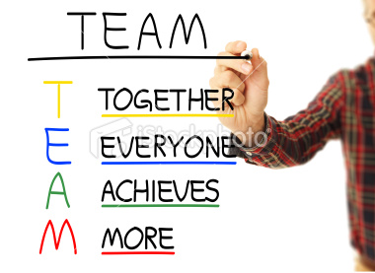
2 Team Leadership: This is the other one significant leadership types. Being an effective leader means understanding the nature of leadership as it applies to leading teams. Some researchers (Zaccaro, Rittman, & Marks, 2001) suggest that leadership may be the most important element in whether teams succeed or fail. <Team Leadership> by Frank LaFasto and Carl Larson. As for team leadership, usually we can divide it into four parts: T----means together, E----everyone, A----achieves and M----more. Jobs’ team leadership was mainly concentrate on focusing team jobs, he confirmed a specific goal and allocated task to employees. Jobs returned to Apple in 1997. At the time, apple was producing difference series of computers and peripherals, including more than dozens versions of the Macintosh, and overall layout was very messy. Jobs was finally fed up after a week of product summing up meeting. He grabbed a marker, wrote “consumer” and “professional” at the top of the two columns and “desktop” and “portable” in front. He told team that their job was to produce four great products, each of which he wrote represented a product, and anything else should be canceled. Jobs successfully saved the company by keeping apple focused on producing four computers. Deciding not to do anything is as important as deciding what to do. The theory applies to enterprise and products. In 1999, four major Apple products were being researched, developed and sold in succession, which are respectively desktop computer iMacG3 for mass consumer, desktop computers for professional users, laptops Power Macintosh G3 & Power-book and portable computer - classic color shells machine iBook.
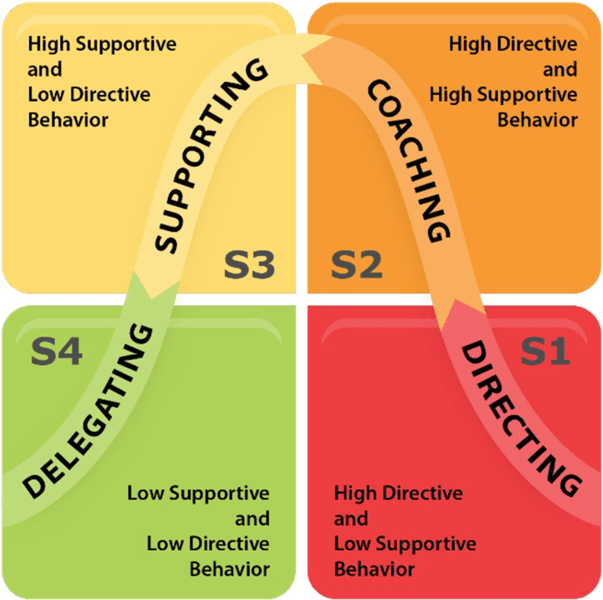
3 Situational Leadership: When Jobs first spoke any new ideas to his employees, even some of people thought it is not very good. But it is an enormous success that most of people in the world use electronic products from Apple Company today. Jobs gave lots of support to producing goods. He followed an important rule from the beginning to the end-----Products outweigh profits: Some words such as profit maximization and cost balance do not exist in Jobs’ dictionary. "Don't worry about the price," he told development team. "Just make it useful." He struck a balance between products and profits: focusing on creating great products, profits came naturally. Jobs brought Apple's focus back to product innovation, they developed the iMac and PowerBook in vigorous effort, followed by iPod, iPhone and iPad. What he pursued was building an enduring company whose employees are aiming to develop great products consistently. Profit is absolutely an influencing thing that can allow company to innovate great products. But for Apple Company, product is a driving force, not profit. If company focus on profit, which seems to be slightly different, it will eventually make everything different such as company hire what kind of person, who can get a promotion, as well as what we talk about at the meeting.

Analyze (The differences between leadership and management)
The capable of managing is not equal to leadership. Leadership includes the capable of managing. Management is a process of acquiring effectiveness and achieving objective by planning, organizing, leading and controlling all kinds of resources in organization. Then leadership is to inspire workers, arouse their enthusiasm by organizational and personal influence. <The differences between management and leadership> 24th Dec 2012.
Jobs’ secret of his management is his keen sense and ability, which can transform technology into ordinary consumers demand. Stimulating consumers to become a member of Apple product club called "Cold-play" by all kinds of market selling means. Some effective managing strategies, such as highly focused on product, strict process control, breakthrough innovation and ongoing marketing were put into new digital world by Steve Jobs. Apple stay away from the requirement that products with lower quality satisfy market demand, and never expand near market that they cannot occupy a dominant position within this management strategy implementation.
For leadership, Jobs had his distinctive personal opinion about how to lead workers to produce. As what we said in difference between management and leadership, Jobs put forward a perfectionism, which means employees’ works are either success or rubbish in his view according to market demand. Jobs had so strict requirement for products even harsh, and it was common to hear his reprimands in Apple. When workers have only two choices, they usually chose the best----success. This is one of reasons why Apple can be successful under Jobs’ leadership.
Evaluate the strengths and weaknesses of this particular approach to leadership
Strengths
Steve Jobs once said‘If a person is not willing to make perfect products, then he is a fool.’Jobs’ perfectionism motivated his employees very well. Workers often choose to make the best products to avoid to be scolded, which virtually reflects the employee's own value, encourages employees and achieve their high standards satisfaction. This kind of perfectionism may seem extreme, but it can inspire more new producing ideas and provide a constant source of motivation for Apple's product innovations, thereby increasing the company's competitiveness. This persistent pursuit of perfection influenced every employee in Apple, making them strive for the perfect product all the time. Jobs had great passion for product excellence. He insisted on elegant design and simplicity. Unlike many other CEO’s he became extremely engrossed in the details, especially when it came to the product and how it was marketed. <The big lesson about Leadership From Steve Jobs>by Jack Zenger August 22nd 2013
Weaknesses
In fact, Jobs weaknesses were as significant as his strengths. He was suspicious, defiant, arrogant, paranoid, and sometimes violent. <Jobs’ glamour and leadership> by Xiaoyao Lu. In his early days, Jobs was often criticized as stubborn, headstrong. When it came to work, some of employees in Apple were a bit scared or afraid to take the elevator with him in case of they would dismissed. As for his perfectionism, Jobs used to despise employee who cannot produce the best merchandise. Even a new worker who cannot do very well would be dismissed because of his headstrong mood. Those employees who were said as an idiot by Jobs stay away from Apple Company because they could not stand Jobs’ strange emotion, which lost most of outstanding talented person to a certain degree. Steve Jobs was not the one who would care about the emotions of other, he knew what he wanted from his workers, and made them do it without considering their feeling. He would yell at people and tell them what he thought. For the most part he was using methods that were completely opposite from ethical. <Strengths and weaknesses of Steve Job’s leadership approach.>
Conclusion
A successful leader can never lose hope and confidence. When a leader encounter problems, he should be hopeful and find a way to get over difficulties from haze, calmly and objectively analyze reasons for adversity and change himself to perfection. In period of departing from Apple Company, Steve Jobs transformed to be a realist from a pure idealist in strategies and kept perfectionism in technology, design, marketing and managing. True leaders is some one who dare to face setbacks in life , face own mistakes and can completely correct their defects. <Analyzing Leadership from Job’s Success>
Probably we can say that Job’s life was made up of his strong self-confidence, desire perfection and a kind of glamour which could surpass ordinary people. Steve Jobs was a charismatic team leader who always pursue perfectionism. Undoubtedly, Apple had consistently produced amazing products that have been leading electronic product industry under his leadership. Not everyone is suitable for such kind of leadership style, different people have their own unique style of leadership. Jobs just had strong confidence and courage to try new things. The idea of changing the world inspired him to instantly research new products and lead every employee in Apple to devote themselves to the development of new products.
Recommendations
What we can see in Job’s Leadership was that he trusted employees who can devote to the best production. It is necessary for a leader to believe employees, but some of them were ignored or dismissed by Steve Jobs because of lower skills. This is the reason why some employees selected to leave Apple Company during that period. Sometimes the word “encouragement” was replaced by “criticism”in Steve Job’s managing dictionary. So the first thing that recommend for a leader is to give full trust and equal treatment to employees. Employees’ loyalty to work environment and enterprise will be promoted by trust and care from leader. Get employees interested in working in the company. Don't snoop on others privacy, but a leader can get along well with each other by caring for your employees' daily life, discussing career plans with subordinates on a regular basis. When employees make mistakes, don't berate or severely correct their mistakes. Instead, leader should explain or give positive encouragement, and point out what they should do. Every great leader has enough courage to face all kinds of challenges and deal with them properly.
The second important thing for a leader is good ability of dealing with emergency. Every great leader must have enough courage to face all kinds of challenges and be able to deal with it suitably. Steve Jobs probably can be the representative in this respect. Apple Company had faced lots of competition from other enterprise in same market before Steve Jobs came back secondly. He seized the opportunities to make adaptable strategies for company, chose the best employees to produce some other electronic goods, purchase other company and improve Apple’s market position. All these things he did was a typical example for any leaders now. Some strategies such as seizing chances, clarifying market situation show a leader’s strong ability of enterprise management. On the other hand, establishing good relationship with employees, keeping employees informed of company good news and challenges regularly. These will help a leader acquire more trust and manage company effectively.

Reference List
<How does Drucker define leadership> 27th Jan 2016
<Job’s management lesson outstanding leadership> 18th Jan 2018
https://baike.so.com/doc/4591967-4803526.html
<Job’s glamour and leadership> by Xiaoyao Lu
https://baike.so.com/doc/5334509-5569947.html
<The differences between management and leadership> 24th Dec 2012
<How to view Jobs management philosophy> by feng niao 26th May 2016
<Analysis of Jobs Leadership> by YingChen University of LiaoNing
<Steve Jobs---A Great Situational Leader: Read different leadership style of Steve Jobs > by Jibran Bashir April 18th 2017
<Analyzing Leadership from Jobs’ Success> https://www.wenku1.com/news/.html
<Five key elements for improving Leadership> by Nicole June 28th 2013
<Team Leadership> by Frank LaFasto and Carl Larson
<The big lesson about Leadership From Steve Jobs>by Jack Zenger August 22nd 2013
<Strengths and weaknesses of Steve Job’s leadership approach.>
https://zh.scribd.com/document/218773258/Strengths-and-weakness-of-Steve-Job-s-leadership-approach

