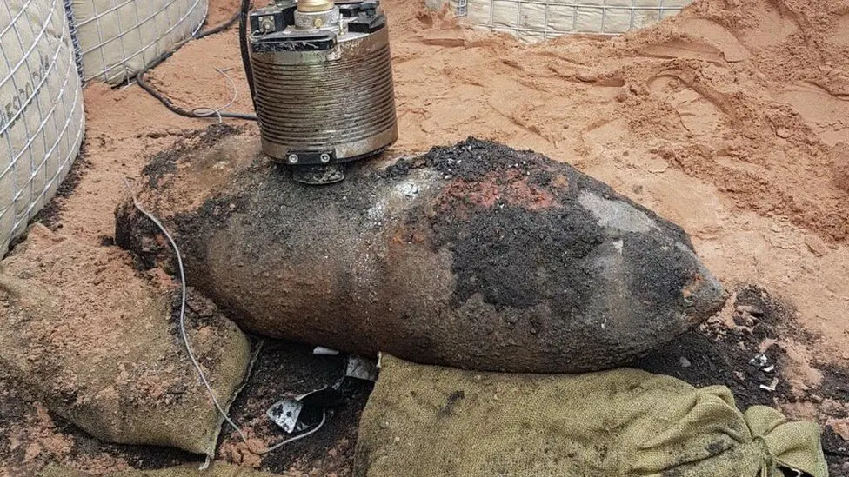 (BBC News, 2018)

ACBA5024
The impact of Unexploded Ordnance on construction projects in South Wales.
Callum Griffiths | Research Project Design | 05/11/2025

Abstract Proposal
South Wales has a long history of unexploded ordnance (UXO) discoveries due to extensive World War Two bombing, its use as a major military training area and the part South Wales played in helping the outcome of World War Two. An example of this is Bridgend which was home to one of the largest munition factories during World War 2 and the area is still finding discoveries from its past history (Zetica UXO, 2025).
The presence of UXO poses significant hazards on construction sites which means potential findings can lead to project delays, increased costs, and heightened safety measures. With the growing number of development and regeneration projects across South Wales, it is important to understand how UXO risks influence project planning, management, and budgeting (Business News Wales, 2025). This study will explore the extent to which UXO affects construction processes throughout South Wales and the long term impact they can have on the overall project.

