“The Impact of Virtual Learning Environment (Moodle) On the learning Experience of Students at UWTSD London Campus”

Georgiana Mirela Spuma
UNIVERSITY OF WALES TRINITY SAINT DAVID
Student ID:2123450
Submission Date:04/05/2022
BMSW4003

Lecture: Koushik Modak
Abstract
VLEs are widely used in education and a number of other disciplines to disseminate instructional information and foster cooperation. Students were asked how their educational experience was changed by using the college's virtual learning environment (Moodle). In this research, both qualitative and quantitative methodologies were used. The information was gathered via a questionnaire, and the results were analysed using descriptive analysis. VLEs have been demonstrated to offer a number of favourable advantages in a variety of circumstances, according to the research.
Table of Contents
Introduction 1
Rationale 1
Research Objective 2
Literature Review 2
Research Methodology 3
Research Methods 3
Data Type 3
Data Collection Process 4
Sample and Sample Size 4
Ethical Considerations 5
Findings, Analysis and Discussion 5
Primary Data Analysis 5
Secondary Data Analysis 11
Summary of Findings 12
Conclusion and Recommendations 12
References 13
Appendix 16

Introduction
Students have access to a variety of tools in a virtual learning environment (VLE) to assist them in studying and demonstrating their knowledge. Students may do homework in class or individually as time allows; they may also participate in parallel and unusual dialogues to help their learning (Hizam et al., 2021). In recent studies, it has been shown that virtual learning environments (VLEs) enhance student achievement, facilitate self-directed learning, and increase student passion for learning. Using a positivistic approach, the hypotheses associated with these claims were examined in a sixth-form college (SFC) in England, which served as the study environment (Larmuseau, Desmet and Depaepe, 2018). Instructors and teacher educators may benefit from the results of this study since they provide recommendations based on students' opinions of the VLE's use and its effect on their learning.

Rationale
In addition to reduced rates and more schedule flexibility, online learning offers a number of other benefits. It is vital to identify the features that contribute to the success of online learning environments, especially in light of the growing popularity of online learning environments today (Casquero et al., 2013). Many academics feel that the quality of online courses may be impacted by the quality of the teaching they do in their traditional classroom settings. Online learning success is contingent upon quality indicators that attract students to engage actively. As a result, the present research examined how a virtual learning environment impacted students' learning experiences at the UWTSD London Campus.

Research Objective
A study will be done to determine the effect of a virtual learning environment such as Moodle on student learning at UWSTD's London campus.

Literature Review
Virtual learning environments (VLEs) have been around for an unknown amount of time. In the year 2000, the Open University of the United Kingdom received a patent for Blackboard, a virtual learning environment (VLE) based on business PCs. Until the end of 2010, Blackboard software was used by over 3700 educational institutions in 60 countries. Moodle has grown to become the world's second most popular virtual learning environment (VLE) since its launch in 2001. In 2011, the firm serviced a total of 212 countries and 49,365 active locations in over 75 languages (Supriadi et al., 2020). Only 58 per cent of post-mandatory schools in the United Kingdom had access to a virtual learning environment in 2003-04, according to the most currently available data.
An investigation by the Office for Standards in Education (Ose) examined the impact of virtual learning environments (VLEs) on student learning, based on data from 34 schools. The UK government's 2005 arrangement report Harnessing Technology - Transforming Learning and Children's Services prompted the review's inception and execution. More than half of the schools that conducted evaluations between September 2005 and December 2007 examined the impact of VLEs on student learning and instruction in great detail (Ramlee, Rosli and Saleh, 2019).
Many firms have been forced, as a result of the global epidemic, to adopt a more innovation-centred mindset in order to survive. Virtual learning environments have totally replaced traditional study halls and labs in the education industry, making it one of the most beneficial sectors. It was only those who were ready to accept the change via advanced expertise development (for example, teachers, students, and organisations) who were involved in this unplanned upheaval (Hasan, Nat and Vanduhe, 2019). The ability to stay alert in a fast-paced work environment while still participating in the learning and development process is often a matter of personal preference.
All instructors have been educated and prepared for the VLE since there are no prerequisites or learning topic scenarios, and this has had a wide influence on the adequacy of virtual learning environments (VLEs). The long-term viability of the educational system relies heavily on the advanced skills of instructors (such as those of educators, speakers, and other professionals) (Badia, Martn, and Gómez, 2018). Using a virtual learning environment, students may study and demonstrate their skills (VLE). Instructors' usage of virtual learning environments (VLEs) affects their capacity to teach successfully from home, as academic institutions provide the stage.

Research Methodology

Research Methods
The term "technique de recherche" relates to the "how" of an investigation. This talk will focus on the strategies researchers employ to ensure the accuracy of their results (Patten and Newhart, 2018). Methodologies of research are classified as either quantitative or qualitative. Both methods are used in this investigation.

Data Type
Primary and secondary are the two kinds of data that are used in studies. Primary data is the kind of data that is collected by the researcher through various data collection techniques such as interviews or survey questionnaires. This is the kind of data that is freshly conducted by the researcher to meet the study objectives. On the other hand, secondary data is the kind of data that is previously collected by any organisation or researcher (Lowry, 2015). This kind of data is used in the study to avoid authentication and filtration of data and can easily be used in any study for research purposes only. In the current study, both primary and secondary data are utilised to conduct the study. In order to understand the impact on the learning experience of students primary data was collected from students on the London campus of UWTSD. For secondary data, previous studies in the form of the literature review were incorporated.

Data Collection Process
Apart from just gathering information, surveys are an excellent tool for learning about people's attitudes and behaviours. Many other ways may be used to perform surveys, including questionnaires, in-depth interviews, observations, and other types of research (Wolf et al., 2016). Surveys are characterised by the nature of their results as well as the technique that is used to collect them. In order to acquire data for the research's data collection aims, the researchers used a questionnaire that participants completed themselves.

Sample and Sample Size
With the aim of eliminating bias when selecting the study sample, randomization is employed in quantitative research to choose a representative sample from which data may be collected and analysed. It is a non-probability sampling strategy in which the researcher selects a sample of the study that he or she believes will give relevant data for the analysis (Berndt, 2020). Because the present research focused on the learning experience of students in particular, a purposive sample approach was used in order to choose participants. The questionnaire was distributed to 100 students online for data collection, however, only 28 responses were received out of which only 23 were considered to be used for analysis. For qualitative data, past studies conducted in similar regard in the last five years were incorporated for analysis.

Ethical Considerations
Considering ethical issues is an essential part of any study. In the last decade, scholars have paid a lot of attention to the ethics of the study. Ethical considerations were taken in mind when performing the research in this study. The information acquired from the participants was kept private and anonymous in order to conduct this study (Siti Roshaidai Mohd Arifin, 2018). In order to obtain data, no one was hurt or coerced into participating in the study. Finally, in order to maintain the integrity of the research findings, no misleading or altered data was used.

Findings, Analysis and Discussion

Primary Data Analysis
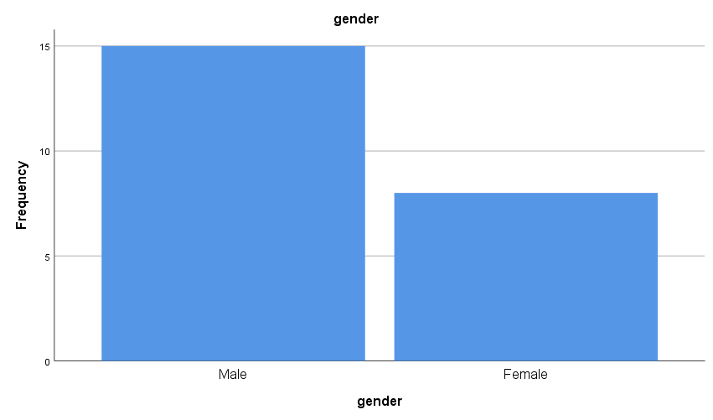
The above graph has illustrated the gender of the respondents who participated in the study. As it can be seen in the above graph 15 out of 23 respondents were male participated in the study while 8 respondents were female.
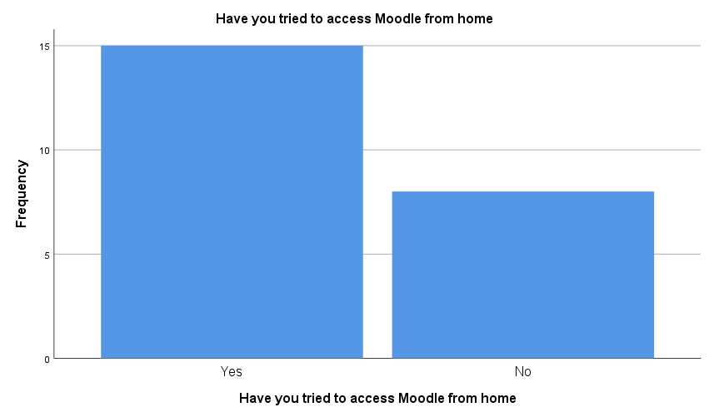

In the response to accessing the Moodle from home, 15 respondents, the majority of whom have accessed Moodle at home, and 8 respondents stated that they do not access Moodle at home as can be observed in the above graph.
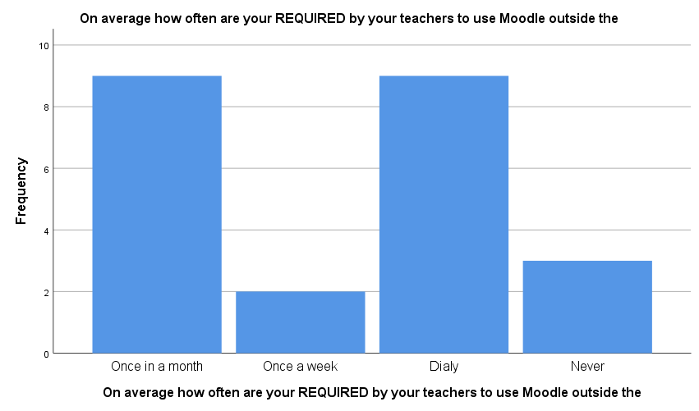
In the above graph, it can be observed that an equal number of respondents stated that either they access Moodle once a month or on a daily basis. It can be illustrated that the usage of Moodle by students is moderate as per their feasibility which consequently impacts their learnings.
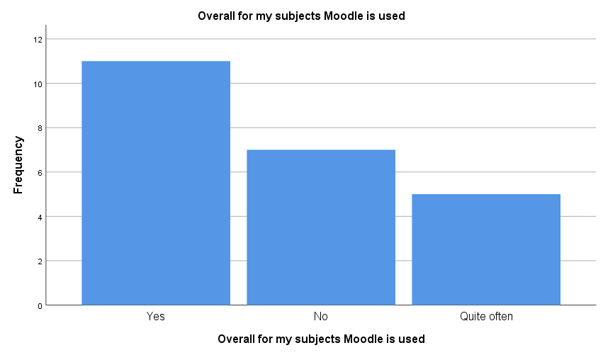
In the above graph, it can be observed that the majority of respondents stated yes when asked regarding their usage of Moodle for their subjects.
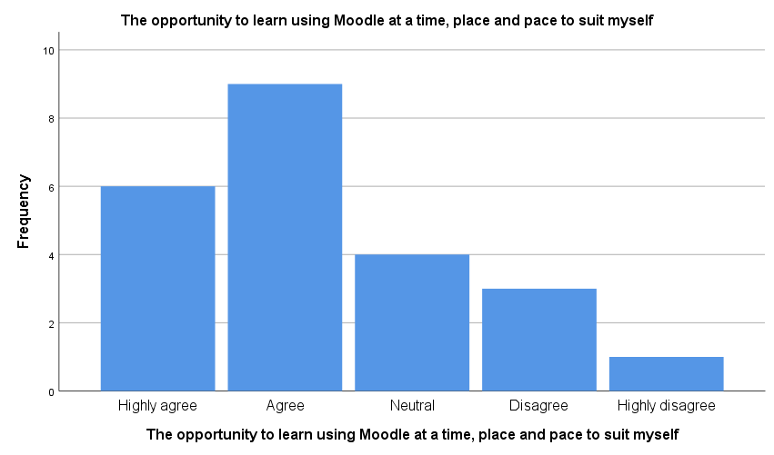
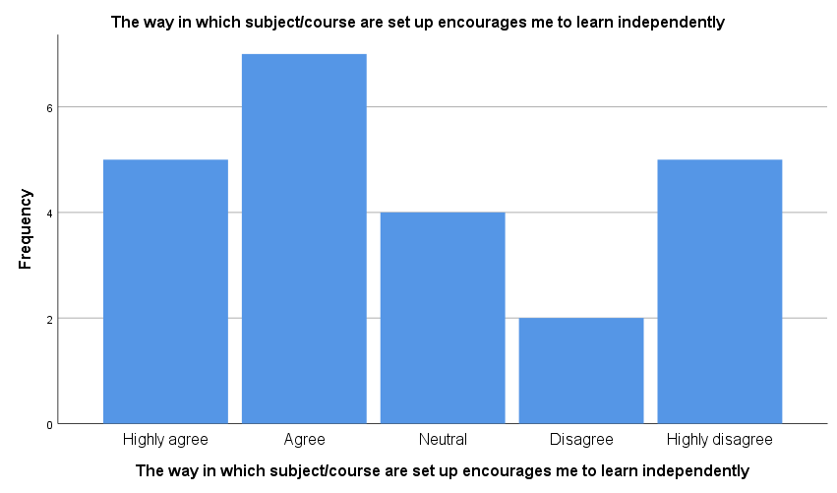
In the above graph it can be observed that the majority of the respondents agree that they have access to Moodle as per their feasibility for learning.
The above graph illustrates that the majority of the students feel encouraged to learn independently due to the setup of the course on Moodle. It shows that they feel at ease while using Moodle for their learning independently.
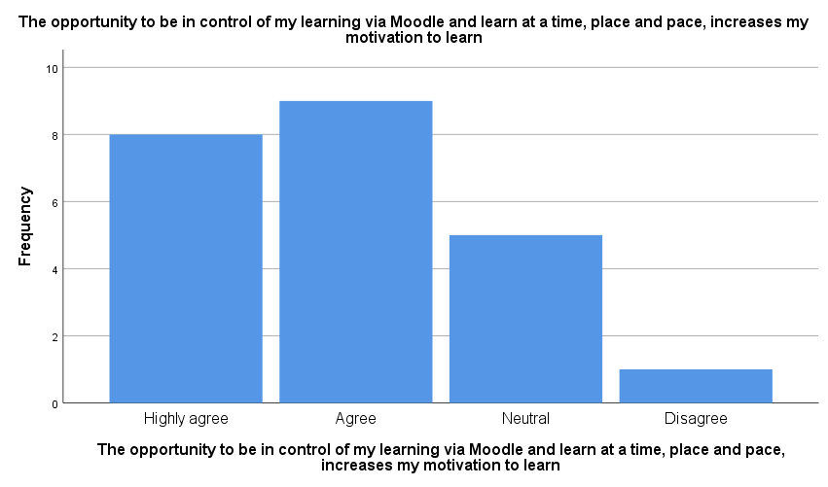
In the above graph, it can be observed that the majority of the respondents agreed that they can control their learning and feel motivated by the fact that they can learn anywhere and anytime as per their comfort which consequently creates an impact on their learning in a positive manner.
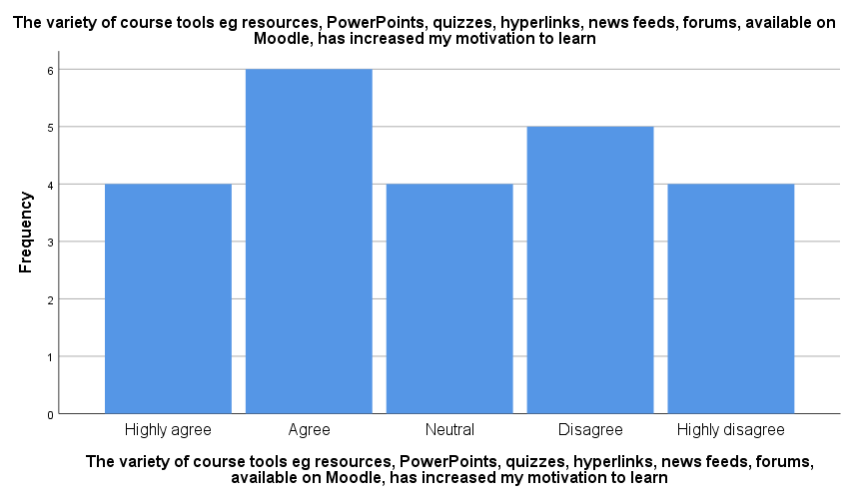
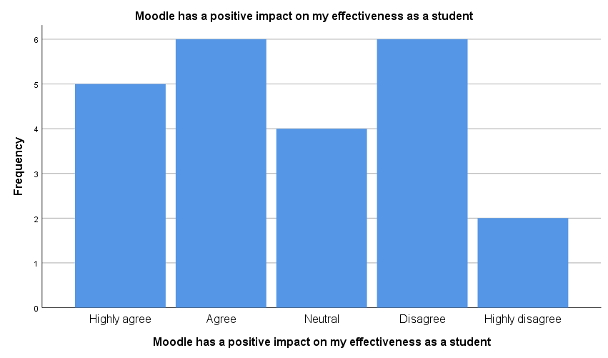
The above graph has shown that the majority of the respondents agreed that the accessibility of different kinds of tools motivates them to learn.
In the above graph, it can be stated that an equal number of respondents stated that they have a positive impact on their effectiveness through the usage of Moodle. It can be stated that respondents' moderate effect is observed among students on their effectiveness due to usage of Moodle.

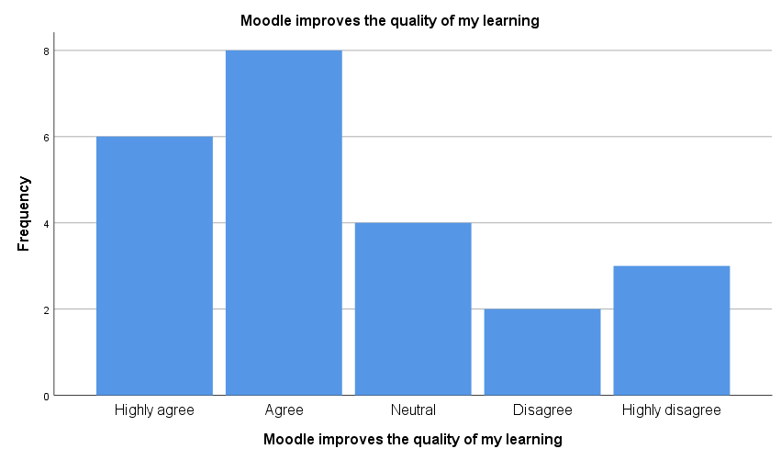
The above graph illustrates that the majority of the respondents agreed that Moodle has improved their quality of learning.

Secondary Data Analysis
Empirical research serves as a foundation for the research questions and provides partial support for the hypotheses that have been proposed. However, the evidence implies that the use of a VLE has an influence on student accomplishment, that the use of a VLE supports autonomous learning, and that the use of a VLE boosts students' desire to study, although the evidence is unclear on these points (Gulbinskienė, Masoodi and Šliogerienė, 2017). The outcomes may be impacted in this manner, for example, the social desirability response or the need to utilise the product. According to the findings, students' approval has little effect on the number and quality of usage. However, the present study highlights the significant beneficial effect of perceived instructional quality on the quality of usage in terms of course achievement, as opposed to previous research (Gulbinskienė, Masoodi and Šliogerienė, 2017). As a result, this research underlines the necessity of a well-considered instructional design in terms of student acceptability and the quality of usage of the technology.

Summary of Findings
VLEs has been shown to have a variety of good benefits in a variety of settings, according to a study. Reflection, accommodating students' requirements, increasing passion and confidence, greater willingness to learn, and most all, better course evaluation performance may be achieved via the use of these tools.

Conclusion and Recommendations
The research questions and hypotheses are based on empirical research that has been published in the literature. With this data, it's clear that using a VLE promotes self-directed learning by giving students the freedom to complete coursework on their own schedule, whenever, wherever, and at whatever speed they choose. It has been shown that using a virtual learning environment (VLE) increases students' motivation to study, fosters communication and collaborative learning via the use of forums, chat rooms, and email, and provides students with fast feedback (Roliak, 2021). According to the mentioned empirical research, VLEs boost student enjoyment, retention, and success. According to this research, students who utilise a virtual learning environment (VLE) and study at their own speed are more likely to feel in charge of their education. Pedagogical considerations and the overall quality of course design and learner assistance are crucial to the effectiveness of VLEs, according to published research.

References
Badia, A., Martín, D. and Gómez, M. (2018). Teachers’ Perceptions of the Use of Moodle Activities and Their Learning Impact in Secondary Education. Technology, Knowledge and Learning, 24(3), pp.483–499.
Berndt, A.E. (2020). Sampling Methods. Journal of Human Lactation, [online] 36(2), p.089033442090685. Available at: https://journals.sagepub.com/doi/full/10.1177/0890334420906850.
Casquero, O., Ovelar, R., Romo, J., Benito, M. and Alberdi, M. (2013). Students’ personal networks in virtual and personal learning environments: a case study in higher education using learning analytics approach. Interactive Learning Environments, 24(1), pp.49–67.
Gulbinskienė, D., Masoodi, M. and Šliogerienė, J. (2017). Moodle as Virtual Learning Environment in Developing Language Skills, Fostering Metacognitive Awareness and Promoting Learner Autonomy. Pedagogika, 127(3), pp.176–185.
Hasan, H.F., Nat, M. and Vanduhe, V.Z. (2019). Gamified Collaborative Environment in Moodle. IEEE Access, 7, pp.89833–89844.
Hizam, S.M., Akter, H., Sentosa, I. and Ahmed, W. (2021). Digital competency of educators in the virtual learning environment: a structural equation modeling analysis. IOP Conference Series: Earth and Environmental Science, 704(1), p.012023.
Larmuseau, C., Desmet, P. and Depaepe, F. (2018). Perceptions of instructional quality: impact on acceptance and use of an online learning environment. Interactive Learning Environments, 27(7), pp.953–964.
Lowry, L. (2015). Bridging the Business Data Divide: Insights into Primary and Secondary Data Use by Business Researchers. IASSIST Quarterly, 39(2), p.14.
Patten, M.L. and Newhart, M. (2018). Understanding research methods : an overview of the essentials. New York ; Abingdon: Routledge, Cop.
Ramlee, N., Rosli, M.S. and Saleh, N.S. (2019). Mathematical HOTS Cultivation via Online Learning Environment and 5E Inquiry Model: Cognitive Impact and the Learning Activities. International Journal of Emerging Technologies in Learning (iJET), [online] 14(24), p.140. Available at: http://eprints.utm.my/id/eprint/91808/1/NorainiRamlee2019_MathematicalHOTSCultivation.pdf [Accessed 3 Jan. 2022].
Roliak, A. (2021). MOODLE AS INNOVATIVE TOOL IN ENGLISH LANGUAGE TEACHING FOR STUDENTS OF ECONOMIC SPECIALTIES. InterConf, pp.226–230.
Siti Roshaidai Mohd Arifin (2018). Ethical Considerations in Qualitative Study. INTERNATIONAL JOURNAL OF CARE SCHOLARS, [online] 1(2), pp.30–33. Available at: https://journals.iium.edu.my/ijcs/index.php/ijcs/article/view/82.
Supriadi, F., Agreindra Helmiawan, M., Yan Sofiyan, Y. and Guntara, A. (2020). A Model of Virtual Learning Environments Using Micro-Lecture, MOODLE, and SLOODLE. [online] IEEE Xplore. Available at: https://ieeexplore.ieee.org/abstract/document/9268785 [Accessed 12 Apr. 2022].
Wolf, C., Joye, D., Smith, T.E.C., Smith, T.W. and Fu, Y. (2016). The SAGE Handbook of Survey Methodology. [online] Google Books. SAGE. Available at: https://books.google.com.pk/books?hl=en&lr=&id=g8OMDAAAQBAJ&oi=fnd&pg=PA3&dq=survey+methodology&ots=DzpOpzR-nW&sig=_qJXzR5WrJIgmD_J4PzQIsD6MrU&redir_esc=y#v=onepage&q=survey%20methodology&f=false [Accessed 12 Apr. 2022].

Appendix
In-Class exercise: Questionnaire Design
Student Name: Georgiana Mirela Spuma Student ID: 2123450
Module Name: Digital Skills and Research Methods (SFTW) Group: 2

Question 1:

Have you tried Moodle from home?

YES NO
⃝ ⃝

Question 2:

On average how often are you required by your teachers to use MOODLE outside from the classroom?

ONCE A MONTH ONCE A WEEK DAILY NEVER
⃝ ⃝ ⃝ ⃝

Question 3:

Is MOODLE useful for the topics you are studying?

YES NO QUITE OFTEN
⃝ ⃝ ⃝

Question 4:
You think that MOODLE have to be improved ?

YES NO
⃝ ⃝
Question 5:
If YES, what you think they can improve ?

Question 6:
Do you think MOODLE is easy to use ?

YES NO
⃝ ⃝

Question 7:
In a scale of 1 to 5 MOODLE is important for you?
①②③④⑤

Question 8:
The variety of course tools available on MOODLE increased your motivation to learn ?
YES NO
⃝ ⃝

Question 9:
MOODLE improve the quality of your learning?

Answers:
1. Have you tried Moodle from home?
YES |  | NO
 | 15 |  | 2
2.On average how often are you required by your teachers to use MOODLE outside from the classroom?
ONCE A MONTH | ONCE A WEEK | DAILY |  | NEVER
3 | 2 |  | 12 |  | 0
3.Is MOODLE useful for the topics you are studying?
YES |  | NO |  | QUITE OFTEN
 | 14 |  | 2 | 1
4.You think that MOODLE have to be improved ?
YES |  | NO
 | 1 |  | 16
5.If YES, what you think they can improve ?
1 | THE LAYOUT
6.Do you think MOODLE is easy to use ?
YES |  | NO
 | 17 |  | 0

7.In a scale of 1 to 5 MOODLE is important for you?
1
2
3
4 | 1
5 | 16

8.The variety of course tools available on MOODLE increased your motivation to learn ?

YES |  | NO
 | 17 |  | 0

HIGHLY AGREE | AGREE |  | DISAGREE | HIGHLY DISAGREE
15 |  | 2 | 0 | 0

9.MOODLE improve the quality of your learning?

