

Eye-tracking Data Analysis (Eye Gaze tool)

By
Nathan Kyle Hudson

Supervisor: Dr Nik Whitehead
Second Marker:

Project submitted as part of the requirements for the award of BSc (Hons) Computing

April 2024

DECLARATION
I, Nathan Kyle Hudson declare that I am the sole author of this Project; that all references cited have been consulted; that I have conducted all work of which this is a record, and that the finished work lies within the prescribed word limits.

This work has not previously been accepted as part of any other degree submission.

FORM OF CONSENT

I, Nathan Kyle Hudson hereby instils permission for my project, which I submitted in support of my candidature for the B.Sc. (Hons) Applied Computing degree, to be available for photocopying or interlibrary loan (subject to copyright laws), and for the title and abstract to be made available to outside organisations, should it be accepted

Abstract

Eye tracking technology had become a potent instrument for comprehending human behaviour, cognitive functions, and user interactions in diverse fields, including psychology, neuroscience, marketing, and human-computer interaction. This project aimed to utilize the Tobii Eye Tracker 4c to effectively capture and analyse complex eye movement patterns, thereby harnessing the full potential of eye tracking technology.

The project's initial objective was to collect data from three individuals, including parameters such as pupil dilation, corneal reflection, pupil location, and movement dynamics. However, the data capture phase encountered difficulties as the eye tracker did not effectively fulfil the project's objectives. An inventive resolution was formulated in reaction to this obstacle. A new method was implemented that involved generating synthetic raw data using a custom script, instead of solely relying on the hardware for data acquisition.

The script was carefully designed to replicate authentic eye movement patterns, including variations in fixations, saccadic movements, and pursuit motions. The project overcame the limitations of the eye tracker and ensured a strong dataset for analysis by creating synthetic data. Later on, the attention turned towards creating an advanced Python algorithm specifically designed for analysing eye movements.

The algorithm was created to analyse the raw data generated by the script and extract important measurements, such as the length and frequency of fixations, properties of saccadic and pursuit movements, and the exact x and y coordinates of gaze points. The algorithm's efficacy in accurately interpreting eye movement patterns and deriving meaningful insights was demonstrated through meticulous analysis and validation.

Through the implementation of this ground-breaking approach, the project successfully surmounted technical obstacles and will hopefully make significant contributions to the progress of eye tracking research methodologies. The use of data generated by scripts demonstrates the versatility and adaptability of computational methods in dealing with practical limitations encountered in experimental configurations. Moreover, the knowledge obtained from examining synthetic data provides significant implications for improving eye tracking methods and enhancing the precision of gaze behaviour analysis in various applications.

In summary, this project highlights the significance of innovation and analytical thinking in advancing eye tracking research.

Table of Contents
DECLARATION 2
FORM OF CONSENT 2
Abstract 3
Table of Contents 4
Chapter 1 – Introduction 7
1.1 Aim of Study 7
1.2 Scope 7
1.2.1 Objectives 7
1.2.2 Benefits of the Project 7
1.3 Report Structure 7
Chapter 2 - Research & Literature Review 8
2.1 Introduction 8
2.2 Definition and Anatomy of the Human Eye 8
2.3 Movement of the Eye 9
2.4 How Eye Movements are Measured 10
2.5 What Influences Eye Movements 11
2.6 How to Analyse Eye Movements 11
2.7 Importance of Eye Movements 12
2.8 Types of Eye Movements 13
2.9 Uses of Eye Tracking Technology 14
2.10 Conclusion 15
Chapter 3 - Research and/or Development Methodology 16
3.1 Research Methodology 16
3.1.1 Philosophy 16
3.1.2 Approach 16
3.1.3 Strategies 17
3.1.4 Risks & Limitations 17
3.1.5 Ethical Issues 17
3.1.6 Validity, Reliability & Generalisability 17
3.1.7 Data Evaluation Methods 17
3.2 Development Methodology 18
3.3 Resources 18
3.3.1 Hardware Resources 18
3.3.2 Software Resources 18
3.3.3 Information Resources 18
3.3.4 Human Resources 18
Chapter 4 – Design & Requirements 19
4.1 Design 19
4.1.1 Approach 19
4.1.2 Design Justification 19
4.1.3 Hardware justification 23
4.2 Requirements 23
4.2.1 MoSCoW Criteria 24
4.2.2 Device Specifications 25
4.2.3 Hardware and Software Requirements 25
Chapter 5 – Development 26
5.1 Implementation 26
5.1.1. Tobii Eye Tracker 4c Calibration 26
5.1.2 Eye Data Capture 27
5.1.2.1 Code Fragments 27
5.1.3 Solution 29
5.1.4 Data Analysis 34
5.2 Testing 35
Chapter 6 – Evaluation 40
6.1 Evaluation 40
6.1.1 Project Results 40
6.1.2 Aims and Objectives 46
6.1.3 Data conclusion 46
6.1.4 Links to literature 47
6.2 Discussions 47
6.2.1 Comparison 47
6.2.2 Implications 48
6.2.3 Limitations 48
6.2.4 Future Directions 48
Chapter 7 - Conclusion & Recommendations 49
7.1 Conclusion 49
7.2 Recommendations 49
Chapter 8 – Personal Reflections 51
Chapter 9 – References 52
9.1 Bibliography 52
9.2 Appendices 55

Figure 1. Eye Anatomy 9
Figure 2. Movement Anatomy 10
Figure 3. Eye Capturing 11
Figure 4. Types of Eye Movements 13
Figure 5. Initial Class Diagram 20
Figure 6. Eye tracking capture 21
Figure 7. Data analysis of eye capture 22
Figure 8. Calibration of Tobii Eye Tracker. 26
Figure 9. Enhanced Calibration of Tobii Eye Tracker 27
Figure 10. Tobii_Research library 27
Figure 11. CSV file creation 27
Figure 12. Blank .csv file 28
Figure 13. Capturing code. 28
Figure 14. Tobii_Research library error 28
Figure 15. Runtime calibration error 29
Figure 16. Data generation parameters 30
Figure 17. Dataset 1 31
Figure 18. Dataset 2 32
Figure 19. Dataset 3. 33
Figure 20. Analysis libraries 34
Figure 21. Testing 1. 35
Figure 22. Incorrect code. 35
Figure 23. Testing 2 36
Figure 24. Incorrect code 36
Figure 25. Incorrect code 36
Figure 26. Testing 3 37
Figure 27. Incorrect code 37
Figure 28. 2-minute results 38
Figure 29. Duration change 38
Figure 30. 30 seconds results 39
Figure 31. Fixations 40
Figure 32. Saccadic movements 41
Figure 33. Move pursuit 41
Figure 34. Pupil Dilation 42
Figure 35. Heatmap 43
Figure 36. Corneal reflection 43
Figure 37. X, Y coordinates 44
Figure 38. WindowID 44
Figure 39. User 1 results 45
Figure 40. User 2 results 45
Figure 41. User 3 results 46

Chapter 1 – Introduction

1.1 Aim of Study

The aim and purpose of this project is to develop software that will capture and track eye movements using the Tobii Eye Tracker 4c device. Additionally, an algorithm will be created to analyse and present the collected data in multiple formats.

1.2 Scope

This project intends to achieve multiple objectives and deliverables by studying eye-tracking, which will enhance our comprehension of visual attention and cognitive processing. The initial task is to develop an algorithm that can accurately detect and track various aspects of the eye, such as the pupil, eye position, corneal reflection, pupil dilation, and different eye movements. This algorithm will be designed to work specifically with the Tobii Eye Tracker 4c device but will have compatibility with other devices. The second task involves developing an additional algorithm to analyse the collected data and generate results for fixations, saccadic and pursuit movements, as well as x and y coordinates.
1.2.1 Objectives

- Investigate literature of the eye, eye tracking and technologies.
- Design a software tool to capture the eye and its movements.
- Design an algorithm to analyse the captured data and output fixations, type of movement and coordinates
- Testing of the analysis tool with data collected from Tobii eye tracker.

1.2.2 Benefits of the Project

- Captures data for deeper understanding of human visual perception and behaviour.
- Provides accurate eye movement analysis, detecting fixations, saccades, and pursuit movements.
- Aids in diagnosing and monitoring conditions like autism spectrum disorder, ADHD, traumatic brain injury, and neurological disorders.
- Useful in training scenarios, providing targeted feedback to improve skills and decision-making processes.
- Empowers individuals with disabilities by enabling hands-free interaction with computers and other devices.
- Contributes to scientific research advancements in cognitive science, linguistics, and education.

1.3 Report Structure

To commence the report, the author will provide an overview of the existing literature and research pertaining to this particular field of study. Subsequently, they will discuss the research on development methodology. Afterwards, they will create and execute the chosen approach, analyzing the outcomes and offering recommendations to improve project completion methods.

Chapter 2 - Research & Literature Review

2.1 Introduction
For this project it is important for this researcher to conduct thorough research on the anatomy of the eye and the process of analysing eye tracking data in order to gain a comprehensive understanding of the subject matter. Following a comprehensive investigation of the eye and analysis of eye tracking data, it is now necessary to examine the existing literature on the components of the eye, the methods used to measure it, and the data analysis techniques associated with it, which are relevant to this project.

The human eye is a remarkable organ, enabling us to perceive the world around us through the complex process of vision. Central to this process are the intricate movements of the eye, which allow us to focus on specific objects, track moving targets, and gather information about our surroundings. Understanding the anatomy, mechanics, and measurement of eye movements is crucial in various fields such as psychology, neuroscience, human-computer interaction, and marketing. This literature review aims to explore the key aspects of eye movements, including their anatomy, measurement techniques, influencing factors, analysis methods, and practical applications.

2.2 Definition and Anatomy of the Human Eye

What is the definition of the eye? The eye is a sophisticated sensory organ consisting of multiple distinct structures that collaborate to enable the experience of sight. The primary constituents of the eye comprise the cornea, iris, lens, retina, and optic nerve [1]-[5]. The structures in question are thoroughly examined and analysed in Duke-Elder's extensive publication [1], offering in-depth understanding and knowledge.
The cornea and lens bend incoming light rays in order to concentrate them onto the retina, where photoreceptor cells transform light stimuli into neural signals, as explained in the recent review by Meek and Knupp [2]. Subsequently, these signals are conveyed through the optic nerve to the brain for the purpose of cognitive processing. The study conducted by Carpenter and Cowey [3] explores the pivotal function of the optic nerve in the transmission of visual information. The extraocular muscles, which encompass the muscles surrounding the eye, have a vital function in regulating its movements. Gaining knowledge about the structure of the eye is crucial for comprehending its functionality and the coordination of its movements. The human eye is a sophisticated and intricate organ that is essential for our visual perception and interaction with the surrounding environment. Comprehending the anatomy of the eye is crucial for understanding its functioning and the impact of different factors on its performance. The cornea, as outlined in Meek and Knupp's recent review [2], is the transparent and curved anterior portion of the eye responsible for refracting light onto the retina. The structure consists of multiple layers, namely the epithelium, Bowman's layer, the stroma, Descemet's membrane, and the endothelium. The iris, as described in Remington's article [4], is the pigmented portion of the eye that encircles the pupil. The pupil, which is the aperture through which light enters the eye, is regulated by two sets of muscles. The size of the pupil can change based on the level of light, with the iris expanding the pupil in dim lighting and narrowing it in bright lighting. The research conducted by Nickla and Wallman [5] investigates the lens, a transparent and flexible structure situated behind the iris. This structure undergoes a process called accommodation, where it changes shape in order to focus on objects at varying distances. The retina, as described in Carpenter and Cowey's research [2], is the photosensitive layer located at the posterior part of the eye, housing photoreceptor cells known as rods and cones. These cells transform light into electrical signals, which are subsequently conveyed to the brain through the optic nerve, allowing us to perceive visual information. The optic nerve, as explained by Carpenter and Cowey [3], is the collection of nerve fibres that transports visual information from the retina to the brain. The function of this structure is to convey the electrical signals produced by the photoreceptor cells to the visual cortex, where they undergo processing and interpretation.

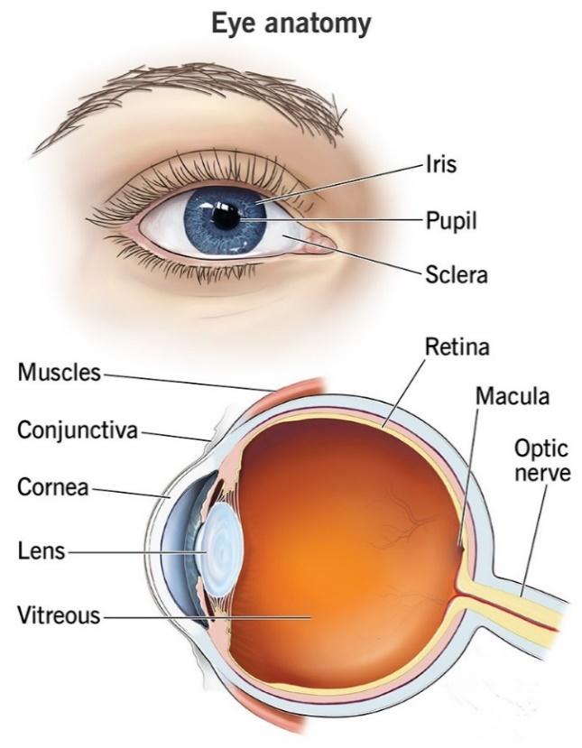
Figure 1. Eye Anatomy

2.3 Movement of the Eye

The eye's movements are controlled by an intricate interaction of muscles, nerves, and mechanisms that provide feedback. The main categories of eye movements consist of saccades, smooth pursuit, and fixations. Saccades, as defined in [ [6], are swift and deliberate movements that redirect the line of sight from one location to another. They play a crucial role in examining our visual surroundings and effectively transitioning our attention to various points of interest. Smooth pursuit movements, as explained by S. G. Lisberger, E. J. Morris, and L. Tychsen [7], occur when the eyes smoothly and accurately track a moving object. This is important for tasks like observing a moving vehicle or following a flying bird, as it helps maintain a stable image of the object on the retina. Fixations, as described by K. Rayner [8], are defined as periods of steady gaze where visual information is analysed and coordinated by the brainstem and different neural circuits. This enables accurate control of eye position and orientation.

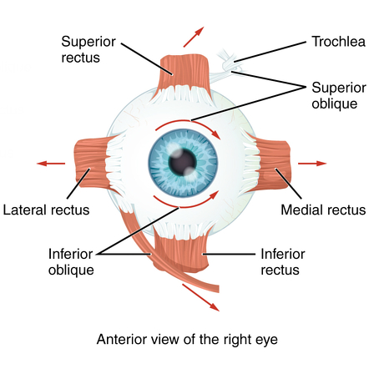
Figure 2. Movement Anatomy
Several unmentioned eye movements include vergence eye movements, which are employed to adjust the focus of the eyes when transitioning between objects at varying distances [9]. When we focus on a nearby object, our eyes move inward to converge, and when we focus on a faraway object, our eyes move outward to diverge. Additionally, the Vestibulo-ocular reflex (VOR) is an eye movement mechanism that aids in stabilising visual perception when the head and body are in motion, and this is mentioned by A. M. Bronstein [10]. The vestibular system governs this reflex by detecting the motion and orientation of the head. Optokinetic nystagmus is a form of eye movement that occurs when the eyes follow a moving visual stimulus, like a rotating drum or a moving train [11]. This reflex, known as the vestibulo-ocular reflex, plays a crucial role in stabilising the image on the retina and is essential for preserving visual stability while an individual is in motion.

2.4 How Eye Movements are Measured

Accurately measuring eye movements necessitates the use of specialised equipment and techniques that can capture precise data. An frequently employed technique is eye tracking, which entails capturing the gaze location of the eyes over a period of time [12]. Eye trackers employ various technologies, including infrared cameras, video-based systems, and electrooculography (EOG), to observe and track eye movements [13]. These systems have the capability to monitor parameters such as the direction of gaze, the size of the pupil, and the duration of fixations with a high level of accuracy in terms of both time and space [14]. Additional methods, such as electroretinography (ERG) [15] and electroencephalography (EEG) G. Pfurtscheller [16], offers supplementary insights into the functioning of the retina and the brain's cortex during visual processing tasks. Corneal topography is a non-invasive imaging method that accurately depicts the curvature of the cornea [17]. This data is utilised for the purpose of diagnosing and tracking conditions like keratoconus, as well as for the fitting of contact lenses and the planning of refractive surgery. Optical coherence tomography (OCT) is a non-invasive imaging technique that utilises light to obtain detailed, cross-sectional images of various structures within the eye, such as the retina, optic nerve, and cornea [18]. Ophthalmology extensively employs this technology for the diagnosis and treatment of diverse eye conditions.

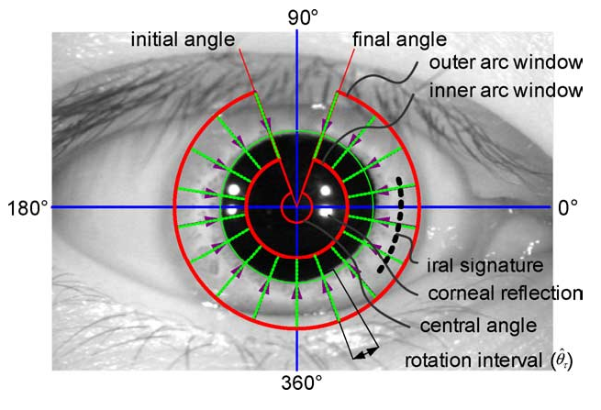
Figure 3. Eye Capturing

2.5 What Influences Eye Movements

Eye movements are affected by various factors, including visual, cognitive, physiological, and task-related aspects. Visual stimuli, such as contrast, luminance, and motion, have a strong impact on the way our eyes move. Our eyes are naturally drawn to areas that have high contrast or are visually interesting [19]. Attention, memory, and task demands have a significant influence on how visual attention is allocated and timed [20]. Furthermore, variations in characteristics such as age, gender, and neurological conditions can influence how eye movements are made. This means that personalised methods are required in eye tracking research [21]. Physiological conditions such as fatigue, stress, and arousal also influence eye movements. Heightened stress or fatigue can result in less effective eye movements, while increased arousal can promote more concentrated attention [22]. In addition, the eye movement patterns are greatly influenced by the particular task being carried out. For example, the way a driver scans their surroundings is noticeably different from how a person reading a book focuses their gaze, as mentioned by D. S. Karatekin, A. B. Bingham, and E. C. White [23].

2.6 How to Analyse Eye Movements

The process of analysing eye movement data entails the manipulation and interpretation of the recorded gaze patterns in order to derive significant insights. Typically, this process includes preliminary steps like data cleansing, calibration, and artefact correction to guarantee the data's quality [24]. Afterwards, one can calculate various metrics to describe different aspects of eye movement behaviour, such as the duration of fixations, the distance covered by saccades, and the reactions of the pupil [25]. Statistical analyses, such as regression models, cluster analysis, and machine learning algorithms, can be utilized to detect patterns, relationships, and outliers in the data [26]. Visualization methods such as heatmaps, gaze plots, and dynamic scans are employed to depict eye movement patterns and aid in interpretation [27]. Fixations, defined as periods during which the eyes remain focused on a specific location or region of interest for a minimum duration, typically ranging from 100 to 200 milliseconds [8], are fundamental to understanding visual attention and cognitive processes. The duration of fixations can be precisely determined by calculating the time between the commencement of one fixation and the onset of the following fixation [33]. Researchers often aggregate fixation durations across individuals and situations to explore various aspects of attention and cognition [61]. To analyse fixation data, statistical methods such as ANOVA or regression analysis are commonly employed to test hypotheses regarding factors influencing fixation patterns [62]. However, it's essential to acknowledge that the process of calculating fixations can vary in complexity depending on the specific research setting and objectives [63]. Fixation analysis is a method that examines the specific points where the eyes come to a halt and concentrate on a particular region of the visual field according to J. M. Findlay and I. D. Gilchrist [28]. Examining the length, regularity, and position of fixations can offer valuable understanding of the user's focus, curiosity, and mental processing. Saccade analysis investigates the swift eye movements that redirect the focus from one point to another [29]. Examining the attributes of saccades, such as their speed, distance, and response time, can provide insights into the user's visual exploration techniques and cognitive functioning. An analysis of pupil diameter measures fluctuations in the size of the pupil, which can be affected by various factors such as cognitive load, emotional state, and physiological arousal [30]. Examining the size of the pupil can offer valuable information about the individual's cognitive and emotional functioning. Scan path analysis is a method that investigates the order and arrangement of eye movements when a user is observing a visual scene or completing a task found in the study from R. Yarbus [31]. This analysis can provide valuable information about the user's visual search strategies, decision-making processes, and cognitive processing.

2.7 Importance of Eye Movements

Previous research has emphasised the importance of eye tracking and the complex process of analysing the data. Therefore, in my project, I am focusing on more precise elements, such as Fixations. Fixations refer to periods of steady gaze where the eyes remain relatively still, allowing for thorough examination and processing of visual information [32]. The length of fixations varies based on factors such as task requirements, the complexity of the stimulus, and individual differences, providing valuable information about the cognitive processing involved [25]. Extended periods of fixation may indicate more complex cognitive processing, whereas briefer periods suggest efficiency or automaticity [8]. In addition, the frequency and locations of fixations reveal users' visual search strategies and levels of attention towards different visual fields [34]. Fixation locations are determined by the saliency of stimuli, with more prominent objects attracting longer and more frequent fixations [35]. Examining the order and arrangement of fixations uncovers fundamental perceptual and cognitive tactics, as well as attentional predispositions [36]. Through the analysis of the dataset, patterns of fixation become apparent, providing insight into how attention is allocated, decisions are made, and the extraction of environmental meaning occurs [37].

Another crucial subject of investigation is the measurement of the diameter of the pupil. Pupil diameter is an indicator of eye activity that indicates variations in arousal, cognitive load, and emotional states [38]. The pupil undergoes dilation in response to heightened cognitive effort, arousal, or emotional arousal, and experiences constriction in situations of low arousal or relaxation [39]. The measurement of pupil size can be achieved through the use of infrared eye trackers or specialised pupillometry devices. These tools offer a continuous measure of cognitive and affective processing [40]. Upon capture, the analysis of pupil responses will be conducted alongside other eye movement parameters to examine the interaction between attention, cognition, and emotion [41]. Pupillometry is utilised in various fields including psychology, neuroscience, marketing, and human-computer interaction. Its purpose is to evaluate mental workload, engagement, and user experience [42].
Elevations in cognitive load, such as those experienced during problem-solving or memory tasks, can result in alterations in pupil diameter [43]. Increased pupil sizes are frequently linked to greater cognitive load, as the brain necessitates additional resources to process the information [44]. Pupil diameter can also be influenced by emotional states, such as fear, excitement, or stress [45]. For instance, the widening of the pupil is frequently linked to heightened arousal or emotional intensity [46]. Pupil diameter can be influenced by physiological arousal, which includes alterations in heart rate or blood pressure [47]. Pupil dilation is a common occurrence when arousal levels rise.

2.8 Types of Eye Movements

Studies on eye movements have clarified the existence of two primary types: saccadic motion and smooth pursuit motion. Saccades are quick and forceful movements of the eyes that help us quickly scan our surroundings and focus on specific objects [40]. Smooth pursuit movements, in contrast, entail the uninterrupted monitoring of a moving object, facilitating the maintenance of focus and the meticulous analysis of its path [48]. The various categories of eye movements are controlled by distinct neural pathways and can be affected by factors such as the speed of the stimulus, its predictability, and the requirements of the task at hand [49]. An in-depth comprehension of the dynamics of saccadic and smooth pursuit movements provides insights into the mechanisms that govern visual attention, perception of motion, and coordination between sensory and motor functions.

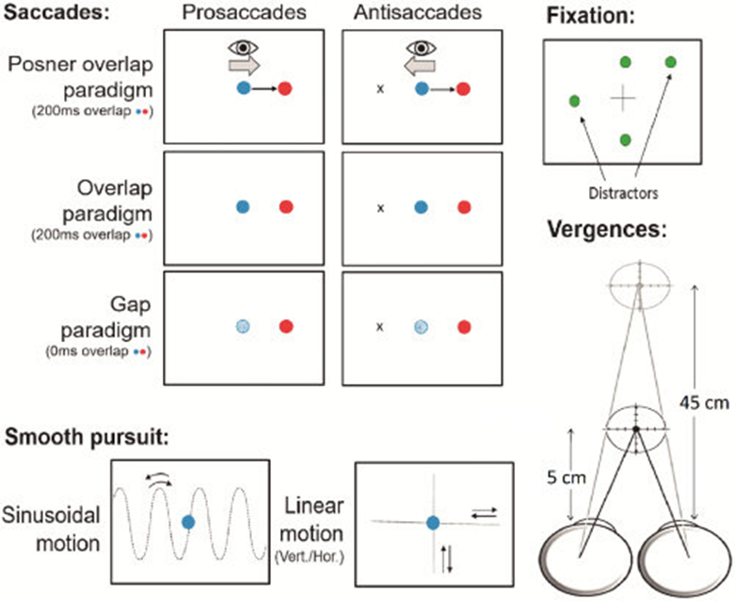
Figure 4. Types of Eye Movements

Each type of movement has their own characteristics. These are outlined below:
Characteristics of Saccadic Motion
- High velocity (up to 700 degrees per second)
- Short duration (typically 20-200 milliseconds)
- Rapid shifts in gaze direction
- Serve to bring the fovea (the area of highest visual acuity) to a new point of interest

Characteristics of Smooth Pursuit Motion
- Slower velocity (typically less than 100 degrees per second)
- Continuous, smooth tracking of a moving object
- Allows for the stabilization of the moving object's image on the retina
- Requires the object to be moving at a predictable speed and direction

Our visual perception and interaction with the world depend on our ability to execute both saccadic and smooth pursuit movements. Saccadic motion facilitates rapid redirection of our visual focus towards points of interest, while smooth pursuit motion enables us to track and pursue moving objects, ensuring that their visual representations remain steady on the retina [50]. Comprehending the attributes and processes of these two forms of eye movement is essential for a diverse array of purposes, such as human-computer interaction, visual attention research, and the identification and tracking of different neurological and ophthalmological disorders [51].

2.9 Uses of Eye Tracking Technology

In recent years, eye tracking technology has gained considerable attention for its ability to reveal deep insights into human behaviour, cognition, and interaction with technology [52]. This technology utilises eye tracking to analyse an individual's eye movement, revealing their focal point, the length of their attention on specific stimuli, and the patterns of their gaze [25]. There are two main methods of eye tracking: remote (or non-invasive) and invasive techniques [53]. Remote eye tracking utilises cameras or sensors to observe eye movements without any physical contact, making it a widely preferred option due to its non-invasive nature and ease of use [54]. On the other hand, invasive methods require direct engagement with the eye, using electrodes or contact lenses to record eye movements. Nevertheless, remote eye tracking is the prevailing method in both research and application fields because it is easy to implement and does not disrupt natural behaviour to a large extent [55].

Eye tracking technology finds applications in diverse fields, including:
- Market Research and Advertising: By analysing where and for how long individuals focus their attention, marketers can assess the effectiveness of advertisements, product packaging, and store layouts. Eye tracking studies help businesses understand consumer behaviour and make informed decisions about product placement and design [56].
- User Experience (UX) Design: In UX design, eye tracking is used to evaluate the usability and effectiveness of websites, software interfaces, and mobile applications. Designers can identify areas of a user interface that attract the most attention, as well as elements that may cause confusion or frustration [57].
- Gaming: Eye tracking is increasingly being integrated into gaming technology to enhance the gaming experience. Players can control aspects of the game using their gaze, such as aiming in first-person shooters or navigating menus. Eye tracking can also be used to analyse player behaviour and improve game design [58].
- Medical and Psychological Research: Eye tracking has applications in understanding various neurological and psychological conditions, such as autism spectrum disorder, attention-deficit/hyperactivity disorder (ADHD), and schizophrenia. Researchers use eye tracking to study patterns of visual attention and gaze behaviour in order to better understand these conditions and develop effective interventions [25].
- Assistive Technology: Eye tracking enables individuals with disabilities, such as paralysis or motor impairments, to control computers, communication devices, and other assistive technologies using only their eyes. This technology opens up new possibilities for independence and communication for people with severe disabilities [59].
- Training and Simulation: Eye tracking can be used in training simulations for tasks that require visual attention and awareness, such as driving, aviation, and surgery. By analysing gaze behaviour, trainers can identify areas where trainees may need additional instruction or practice [60].

2.10 Conclusion

In conclusion, the study of eye movements is a multifaceted endeavour that encompasses the anatomy, mechanics, measurement, analysis, and applications of eye behaviour. As our understanding of eye movements continues to evolve, so too will our ability to harness this knowledge to improve human performance, communication, and well-being. Therefore, in this project I plan to help in this subject area, by creating software to capturing datasets with all aspects of eye movements, by tracking them with technologies available, to then analyse and output certain parameters, such as heatmaps, movement lines etc. Before continuing the creation of this software, I will next produce my methodologies for this project.

Chapter 3 - Research and/or Development Methodology

3.1 Research Methodology

The option to employ the research onion as a structure for this project methodologies. The following list comprises each layer within the research onion. The researcher has selected philosophy as the initial layer. They selected a positivist philosophy for this study. Positivism prioritises the use of empirical observation and scientific methodology, which aligns well with our objective of objectively capturing and analysing eye movement data through the creation of algorithms and software. The second layer refers to the approach. They have employed a deductive approach. Using established theories of eye movement behaviour as a starting point, they will create hypotheses and algorithms that will be tested through a process of iterative software development and improvement. The third layer pertains to strategies. The main approach is focused on software development. Using the iterative development process, they will design algorithms and scripts to collect, process, and analyse eye movement data. The researcher’s main objective is to develop software solutions that are both reliable and efficient. The fourth category is methods. In this approach, they will employ a range of techniques including software engineering practices, programming languages such as Python, and algorithm design principles to create the essential software elements for analysing eye tracking data. The fifth factor is time horizons. The project primarily emphasises development, but it also takes into account time horizons, especially when it comes to project milestones and iteration cycles for software development. The sixth element pertains to various methodologies or approaches. During the software development process, they have utilised agile methodologies to facilitate iterative development, version control systems to effectively manage code changes, and testing frameworks to ensure the reliability of the software. The final layer is comprised of procedures. They will adhere to meticulous protocols throughout the software development lifecycle, encompassing activities such as gathering requirements, designing, implementing, testing, and deploying. Furthermore, the researcher will meticulously record the code and procedures to ensure that they can be replicated and referred to in the future.

3.1.1 Philosophy

For the eye tracking project, a positivist philosophy is chosen due to its focus on observable phenomena and the belief in an objective reality. This philosophy aligns with the project's goal of capturing and analysing eye movement data objectively. The advantage of this philosophy lies in its emphasis on empirical evidence, facilitating the development of reliable algorithms for eye data analysis. However, a potential disadvantage is the possibility of overlooking subjective aspects of eye movement behaviour. To mitigate this, qualitative insights can be incorporated where necessary to complement quantitative findings.

3.1.2 Approach

The approach for this project will be deductive, as it involves the development of algorithms based on existing theories and empirical observations. This deductive approach allows for hypothesis testing and structured experimentation. Its advantage lies in its systematic process, facilitating the development of precise algorithms for eye movement analysis. However, a potential limitation is the risk of overlooking novel patterns or phenomena that may emerge during the analysis. To address this, the deductive approach will be complemented by an inductive exploration of the data to identify potential new insights.

3.1.3 Strategies

The primary strategies employed in this project are software development. Secondary (optional) strategy can also use an experiment employment.

Software Development: The software development strategy focuses on creating algorithms and scripts for capturing, processing, and analysing eye movement data. This involves programming tasks with eye tracking technologies, in this case the Tobii Eye tracker 4c, to implement algorithms for fixation detection, saccade identification, pupil dilation measurement, and heatmap generation.

(Optional) Experiment: The experiment strategy involves designing and conducting controlled studies to collect eye movement data under various conditions. This approach allows for the systematic manipulation of variables to understand their effects on eye behaviour.

3.1.4 Risks & Limitations

Risks and limitations of the eye tracking project include technical challenges in data collection and analysis, potential biases in participant recruitment, and constraints in hardware resources.
To mitigate these risks, thorough testing of the eye tracking system will be conducted prior to data collection, and efforts will be made to recruit a diverse participant pool from within the university of my studies to minimize biases. Additionally, contingency plans will be in place to address any unforeseen technical issues during the project.

3.1.5 Ethical Issues

Ethical considerations for the project include ensuring informed consent from participants, protecting their privacy and confidentiality, and minimizing any potential discomfort or harm during the experiment. Measures will be taken to obtain consent, anonymize data, and provide participants with the option to withdraw from the study at any time without penalty.

3.1.6 Validity, Reliability & Generalisability

Validity will be ensured through the use of established eye tracking protocols and rigorous data analysis techniques. Reliability will be assessed by conducting pilot studies to evaluate the consistency of data collection and analysis procedures. Generalizability of findings will be addressed by conducting experiments with diverse participant groups and validating results across different experimental conditions.

3.1.7 Data Evaluation Methods

Data collection will involve capturing eye movement data using eye tracking equipment, in this case the Tobii Eye Tracker 4c, during experimental tasks. Data evaluation will include quantitative analysis of fixations, saccades, pupil dilation, and qualitative examination of heatmaps generated from eye movement data. Statistical analysis techniques regression analysis will be used to test hypotheses and identify significant effects.

3.2 Development Methodology

The development methodology that will be used will be a software development and feature driven development methodology. This methodology will be agile, allowing for iterative development and continuous improvement based on feedback and evaluation. Agile methodology is chosen for its flexibility and responsiveness to changing requirements, which is essential for developing robust algorithms for eye movement analysis. Tools such as Python programming language and specialized eye tracking software packages will be utilized for software development.

3.3 Resources

3.3.1 Hardware Resources

Hardware resources include eye tracking devices, such as the Tobii Eye Tracker 4c, along with standard networked PCs for data processing and analysis.

3.3.2 Software Resources

Software resources include programming tools such as Python for algorithm development, along with specialized eye tracking software packages for data collection and visualization. Additionally, statistical analysis software will be used for quantitative data analysis.

3.3.3 Information Resources

External data sources may include scientific literature, research papers, and online repositories for accessing relevant information on eye movement patterns, algorithms, and experimental methodologies.

3.3.4 Human Resources

Human resources may include participants for the experiment, collaborators for data collection and analysis, and project advisors for guidance and support throughout the research process. Efforts will be made to recruit participants representative of the target population for the study, and appropriate protocols will be followed for ethical conduct and participant welfare.

Chapter 4 – Design & Requirements

4.1 Design
The initial design of this project was to capture visual attention by utilizing an eye tracking device, specifically the Tobii Eye Tracker 4c, in order to gather data. The capturing process involved three distinct individuals but could be modified to more or fewer participants if required, and recorded the pupil, eye location, corneal reflection, pupil dilation, and movements. After capturing this information, the data was analysed to generate specific parameters. An algorithm was developed in Python to generate fixations, saccadic and pursuit movements, as well as x and y coordinates.

The project prioritized the acquisition of crucial parameters necessary for comprehending visual attention and eye movement behaviours. The parameters encompassed the pupil, eye location, corneal reflection, pupil dilation, and different eye movements. Through the collection of data on these parameters, our objective was to establish a strong basis for our analysis, allowing us to extract significant insights into human visual behaviour.

4.1.1 Approach

An iterative approach will be employed throughout the project to consistently enhance and optimise the processes and methodologies utilised.

Input from project supervisors was integrated to tackle any problems or difficulties encountered and to improve the thoroughness and accuracy of the project deliverables.

These processes collectively ensured that the design decisions made in the project were systematically implemented and aligned with the objectives of capturing, analysing, and interpreting eye-tracking data. Through the utilisation of systematic procedures, any possible mistakes, contradictions, and deficiencies in the project execution were recognised and resolved, resulting in a strong and dependable analysis framework.

4.1.2 Design Justification

Several crucial procedures will be employed in the design of the eye tracking analysis project to guarantee its thoroughness, uniformity, and accuracy during implementation.

Prior to commencing the project, a comprehensive analysis of the requirements will be carried out. This will entail comprehending the project's goals, the functionalities of the Tobii Eye Tracker 4c, and the specific parameters that needed to be recorded for analysis.

This process guaranteed that the project objectives will be precisely determined and matched with the capabilities of the selected hardware and software tools.

In order to provide a comprehensive justification for all aspects of the design in this project, I have opted to create class diagrams for each stage of the development process. These diagrams will facilitate the comprehension of how the hardware and software components will work together to accomplish the project's objectives and meet its requirements.
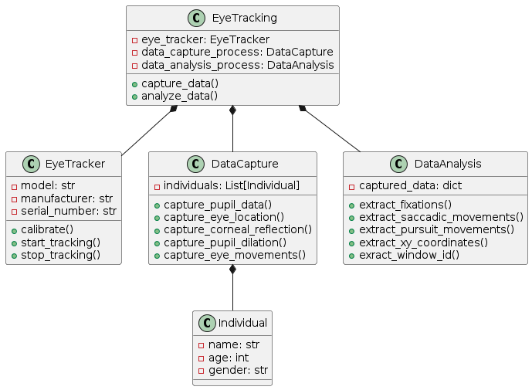
Figure 5. Initial Class Diagram

Figure 5 displays the initial class diagram. This demonstrates each fundamental step of the project. This encompasses the components of the individual, data capture, the eye tracker, data analysis, and the ultimate result known as "Eye Tracking". Each class displays the vital information needed for each segment of the projects process.

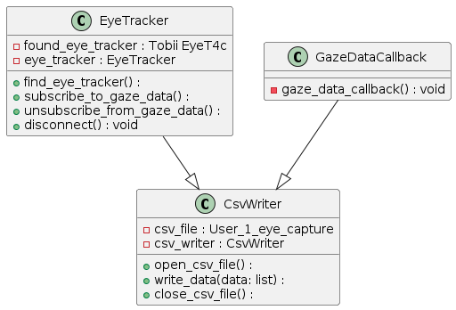
Figure 6. Eye tracking capture

Figure 6 depicts the class diagram of the software designed to record eye data and save it in a csv file. This diagram illustrates each sequential step of the process and visually displays the various components of the device, as well as the gaze data and csv file.
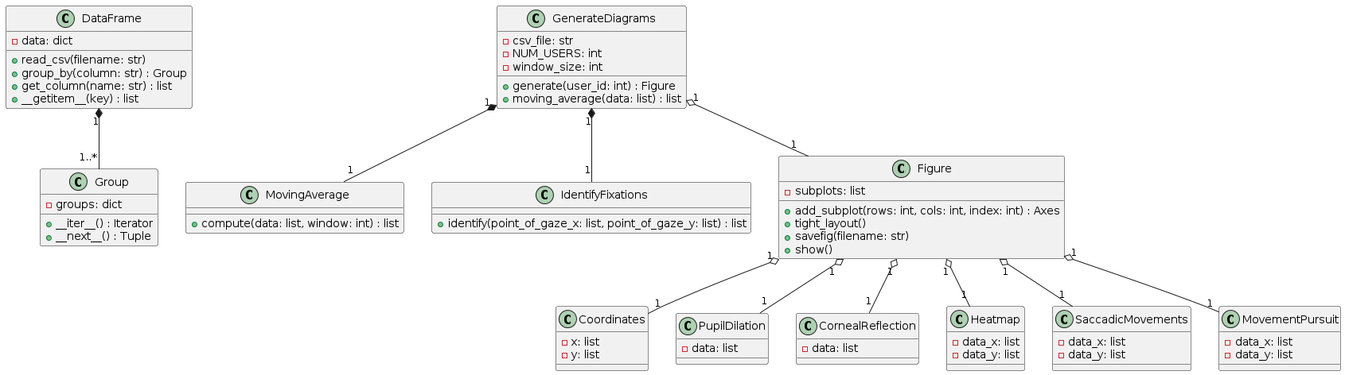
Figure 7. Data analysis of eye capture

Figure 7 displays the class diagram of the analysis of the captured eye data. This demonstrates each fundamental step of the analysis for fixations. This encompasses the components of the individual, data capture, the eye tracker, data analysis, and the ultimate result known as "Eye Tracking". Each class displays the vital information needed for each segment of the projects process.
Class diagrams are essential for eye tracking technology projects, providing a graphical representation of the system's structure, enabling all parties interested in understanding the various elements involved.
They facilitate modularity and encapsulation by establishing distinct classes for various system components, such as EyeTracker, DataCapture, DataAnalysis, and Individual. This helps manage project complexity by focusing on fundamental elements and their interconnections. Class diagrams also serve as a communication tool among the project individual, supervisors, and researchers, enabling discussions on the design, specifications, and duties of various system components. They also serve as an implementation blueprint, providing guidance to developers during the implementation process. Class diagrams advocate for Object-Oriented Programming principles, such as inheritance, encapsulation, and polymorphism, which aim to enhance reusability, maintainability, and scalability of the code.
Overall, class diagrams are vital for validating the eye tracking project's design, providing a clear representation of the system structure, promoting modularity and encapsulation, abstract complexity, facilitating communication, guiding implementation, and supporting object-oriented programming principles.

4.1.3 Hardware justification

The Tobii Eye Tracker 4c was selected due to its demonstrated precision, dependability, and ease of use. Being a commonly utilised eye-tracking device, it possesses the requisite capabilities to capture crucial parameters needed for our analysis. The system's capability to monitor changes in pupil size, eye motion, and reflections on the cornea allows for thorough data gathering, perfectly aligning with the goals of the project.

4.2 Requirements

In order for this project to achieve success, it is imperative to address several crucial requirements. The requirements must be in accordance with the project's aim and objectives.
Firstly, the hardware must be acquired, specifically a Tobii Eye Tracker 4c in this instance. After acquiring the designated hardware, we will guarantee its correct installation and calibration to accurately capture data.

Furthermore, it is necessary to select suitable software for this task. In this instance, we will utilise Python along with any supplementary libraries. These will consist of PIP libraries such as Pandas, Matplotlib, Seaborn, and others.
Next, data collection. We will record and analyse the spontaneous movements of the eyes.

Following that, data analysis will be conducted. Our objective is to create algorithms that can analyse unprocessed eye tracking data and extract important measurements, including fixations, saccadic movements, pursuit movements, and x and y coordinates.
Finally, validation. We will implement validation protocols to evaluate the precision and dependability of the created algorithms. This may entail the comparison of algorithmic outcomes with established eye tracking metrics or ground truth data acquired through alternative methods.

Furthermore, during the algorithm design process, we will ensure its compatibility with various devices and software. I will undertake this task to advance the research and development of eye tracking technologies and data analysis in my scientific field.

4.2.1 MoSCoW Criteria

The MoSCoW method is an optimal strategy for effectively managing the requirements of the eye tracking analysis project, thanks to its well-organized prioritisation framework. The method of categorising project requirements into Must-Have, Should-Have, Could-Have, and Won't-Have allows for the clear identification of critical components that are necessary for achieving project objectives. The method enables effective allocation of resources, ensuring that crucial features are given priority while also allowing for adaptability to accommodate changing project requirements. In addition, the MoSCoW method facilitates transparency and communication among all interested parties, allowing them to comprehend and synchronise project priorities and expectations. In summary, the MoSCoW method's systematic prioritisation guarantees that this eye tracking analysis project concentrates on delivering the most crucial elements initially, thereby enhancing the probability of project success.
Below includes each section of the MoSCoW method for this project:
Must Have
- Device Selection: Choose the Tobii Eye Tracker 4c for data capture because of its established precision and dependability.
- Parameter Capture: Collect crucial parameters such as pupil dilation, eye movements, and corneal reflection to ensure thorough data collection.
- Algorithm Development: Create a Python algorithm to analyse the collected data and extract important measurements such as fixations, saccadic movements, pursuit movements, and x, y coordinates.
Should Have
- Calibration Process: Establish a rigorous calibration procedure to guarantee precise and dependable collection of eye-tracking data.
- Data preprocessing involves the application of techniques to clean and improve raw eye-tracking data, such as reducing noise and filtering signals.

Could Have
- Iterative Improvement: Embrace a methodical approach to consistently enhance and perfect processes and methodologies employed throughout the entirety of the project's duration.
- Integration of feedback: Integrate input from interested parties to resolve any problems or difficulties encountered and improve project outcomes.

Won’t Have
- Advanced Analysis Techniques: Investigate and apply sophisticated analysis methods that go beyond basic examination of fixations and movements, as a result of time limitations and project scope restrictions.
- Interfacing with External Systems: Due to resource constraints and the complexity involved, it is necessary to connect the eye-tracking system with external systems or platforms in order to visualise or interact with real-time data.

4.2.2 Device Specifications
This section includes the device specifications of the Tobii Eye Tracker 4c.

Size: 17 x 15 x 335 mm (0.66 x 0.6 x 13.1 in)
Weight: 95 grams (0.21 lbs)
Recommended Max Screen Size: 27 inches with 16:9 Aspect Ratio 30 inches with 21:9 Aspect Ratio
Operating Distance: 20 - 37" / 50 - 95 cm
Track Box Dimensions: 16 x 12" / 40 x 30 cm at 29.5" / 75 cm
Tobii EyeChip: Yes
USB Cable Length: 80 cm
Head Tracking: Yes (not powered by EyeChip)
CPU Load: Averagely 5% (Core i7, 9th Gen)*
Power Consumption: 2.0 Watt**
USB Data Transfer Rate: 100KB/s
Image sampling rate: 90 Hz
Illuminators: Near Infrared (NIR 850nm) Only
Tracking Population: 97%

Sourced from Tobii

4.2.3 Hardware and Software Requirements

Recommended system specifications for Tobii Eye Tracker 4c (for capturing eye movements)

OS: Windows 10 or higher (64-bit only)
CPU: 2.0 GHz Intel i5 or i7
RAM: 8 GB
USB Connectivity: USB 2.0 (integrated cord, USB 2.0 BC 1.2)
Recommended system specifications for Python (for data analysis)

Windows 7 or higher
Mac OS X 10.11 or higher, 64-bit
Linux: RHEL 6/7, 64-bit (almost all libraries also work in Ubuntu)
x86 64-bit CPU (Intel / AMD architecture). ARM CPUs are not supported.
4 GB RAM
5 GB free disk space
Sourced from Tobii

After the design and requirements have been clearly defined, we can now move forward to the development phase of this project. This will encompass all advancements that the project will pursue and outline how the hardware and software will be utilised. The next section will provide the conclusion.

Chapter 5 – Development

5.1 Implementation

This section of the report will encompass the execution of the design. This will encompass all of the necessary criteria, while adhering to the intended aim and objectives. In this phase, I will showcase my development of the eye data capturing software and the algorithm for analysing the data. The objective is to identify fixations, types of movements, and other relevant factors.
As I carry out the designs presented earlier in the report, I will also provide documentation on the operational procedures for both the hardware and software components. I will incorporate this information to enhance the reader's comprehension of how the aims and objectives are accomplished, making it accessible to anyone in this scientific field.

5.1.1. Tobii Eye Tracker 4c Calibration
The next step in this project is to calibrate the Tobii Eye Tracker 4c in order to ensure accurate and reliable collection of eye-tracking data. The calibration procedures outlined on the official Tobii website were followed meticulously for this particular eye tracker to ensure the elimination of errors and inconsistencies in data capture. This will enhance the accuracy and reliability of the analysis.

Below is the process of calibration:



Figure 8. Calibration of Tobii Eye Tracker.

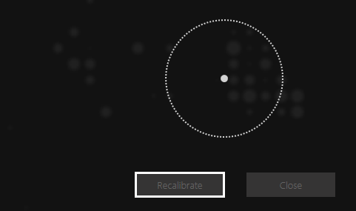

Figure 9. Enhanced Calibration of Tobii Eye Tracker

Once the device is calibrated, we can then proceed to develop the software to capture the necessary data.

5.1.2 Eye Data Capture

The next stage will be installing the necessary drivers and framework for the eye tracker to be fully functional. This needs to be done by the official Tobii website and following their setup guides. Once this is complete, we can move onto the capturing process.

5.1.2.1 Code Fragments
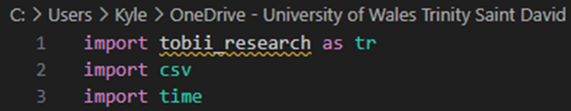

Figure 10. Tobii_Research library
In order to successfully capture the required data, it is essential to properly install Python and the PIP library for accessing the Tobii_Research SDK.
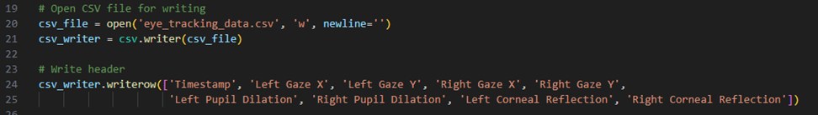

Figure 11. CSV file creation
Once the appropriate libraries are properly implemented, we can write in our algorithm a set of code to create a blank .cvs for the data to be written too.

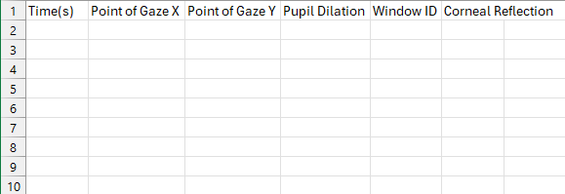

Figure 12. Blank .csv file
Next, we can start to implement the code to tell the eye tracker to capture each eye and then write this into the .csv file.

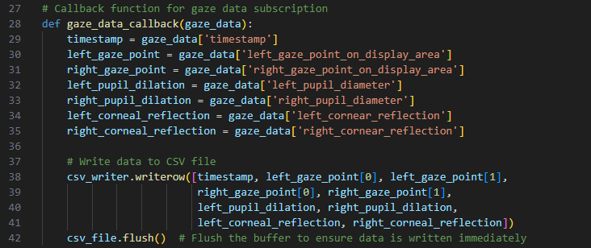


Figure 13. Capturing code.

Figure 14. Tobii_Research library error
While attempting to install pip and set up the Tobii library, I encountered unresolved issues. Despite conducting extensive research, I was unable to resolve these issues within the given project timeframe.
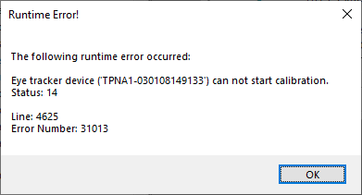

Figure 15. Runtime calibration error
An additional problem arose when attempting to operate the Tobii eye tracker using code obtained from online repositories. The task was not completed due to an error encountered during the calibration process of the device.
Hence, it is imperative to identify an alternative viable approach for acquiring datasets in order to ensure the project's progress towards its goals and objectives. I will present a resolution in the subsequent section of this report.

5.1.3 Solution

During the implementation phase of this project, we were unable to continue in the direction of the chosen design phase. This was due to unforeseen circumstances that were out of my control and during the timeframe of the project, we were unable to resolve the issue.

The current framework of the Tobii Eye tracker 4c and the algorithm developed to capture the eye movement data resulted in issues. This was due to issues with python libraries and the Tobii SDK framework.

To accomplish the goals and objectives of this project, I devised a solution by creating a script that would generate the required eye movement data for further analysis. This would be optimal as it would produce precise data for analysis.
This solution eliminates the need to use stimuli to reference each dataset from the generated data. This is due to the fact that the generated results are random and do not consider any specific stimuli that we can refer to. Despite this, the generated data remains derived from accurate and authentic data.

5.1.3.1 Dataset Generation
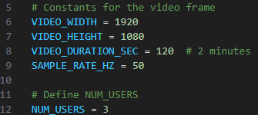

Figure 16. Data generation parameters

I have opted to utilise a screen with a resolution of 1920x1080p, which is most commonly used by the average population. I have opted to collect data for a duration of 2 minutes and to configure the sample rate to 50Hz. This will be equally precise to using the Tobii eye tracker initially.

The script would subsequently generate a dataset that is filled with information for each individual user. There will be a total of three users in this case.

5.1.3.2 CVS Dataset

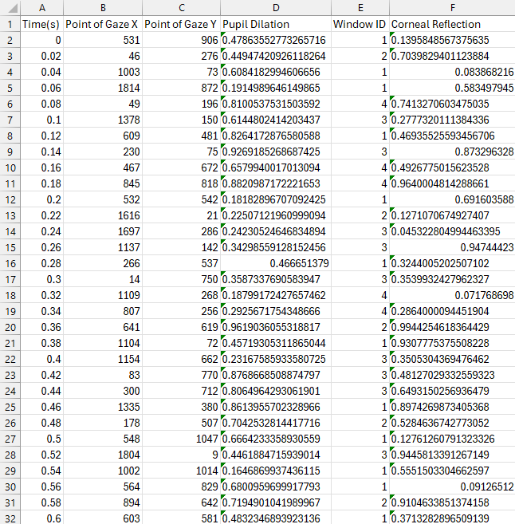
Figure 17. Dataset 1
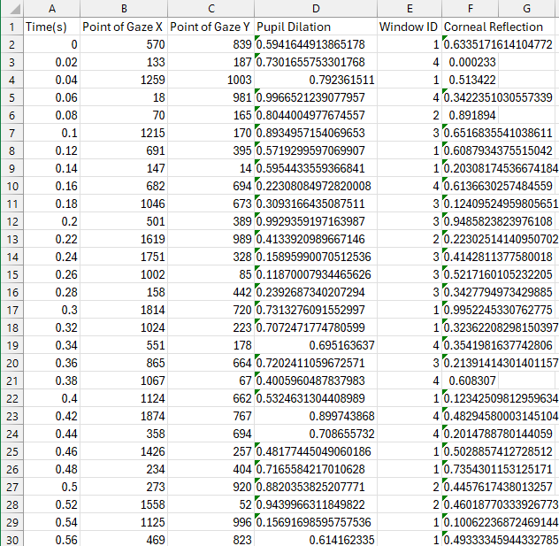

Figure 18. Dataset 2

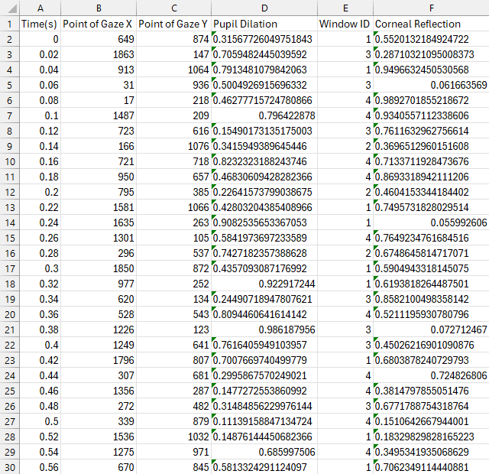

Figure 19. Dataset 3.

By setting the appropriate parameters, we can now observe that the dataset has been successfully generated. Now, we can commence with the examination of our data.

5.1.4 Data Analysis

In order to efficiently analyse the collected data, we will create a Python algorithm. The selection of Python was based on its simplicity, versatility, and extensive libraries for data analysis. The algorithm will be developed to analyse the unprocessed eye-tracking data and extract pertinent measurements such as fixations, saccadic movements, pursuit movements, and x, y coordinates. This Python-based methodology guarantees the effective handling of data, enabling comprehensive analysis and interpretation.

The selection of the Tobii Eye Tracker 4c, with the chosen solution and the design of the analysis approach took into account important factors such as accuracy, reliability, and ease of implementation. Moreover, the selection of Python for algorithm development was motivated by its extensive utilisation in data analysis and its compatibility with various tools and software.
The Python-based algorithm was developed through a systematic process that included designing, coding, testing, and refining.


Figure 20. Analysis libraries
When conducting the analysis, I have import different libraries to successfully achieve fixations, saccadic movements, pursuit movements, x, y coordinates and other important information.
We examined and assessed different algorithms and techniques to derive significant metrics, including fixations, saccadic movements, pursuit movements, and x, y coordinates, from the collected data.

The algorithm's output was rigorously tested and validated to ensure its correctness and consistency across various datasets and scenarios. This can be shown in the next section of the report.

5.2 Testing

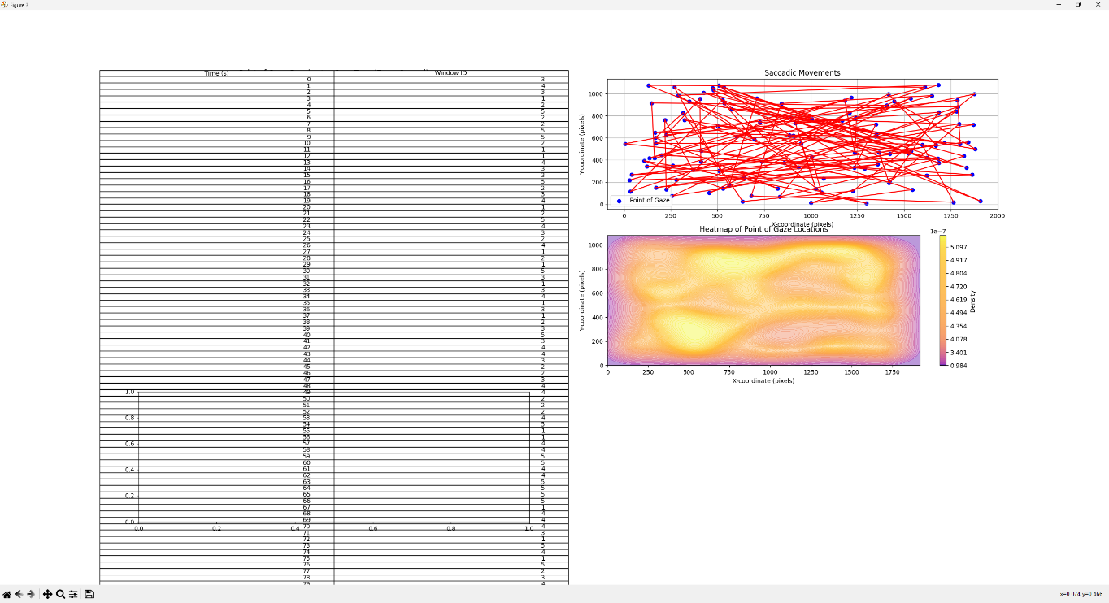
Throughout every stage of development, we encountered numerous errors and incorrect outputs that failed to meet our intended goals and objectives

Figure 21. Testing 1.

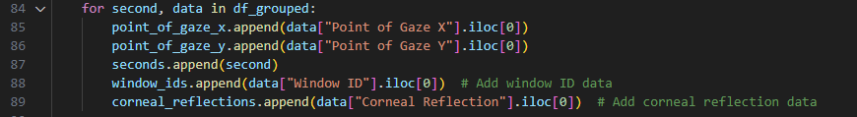

Figure 22. Incorrect code.
As seen above, the output of the window ID table shows too many instances and has gone over multiple graphs.
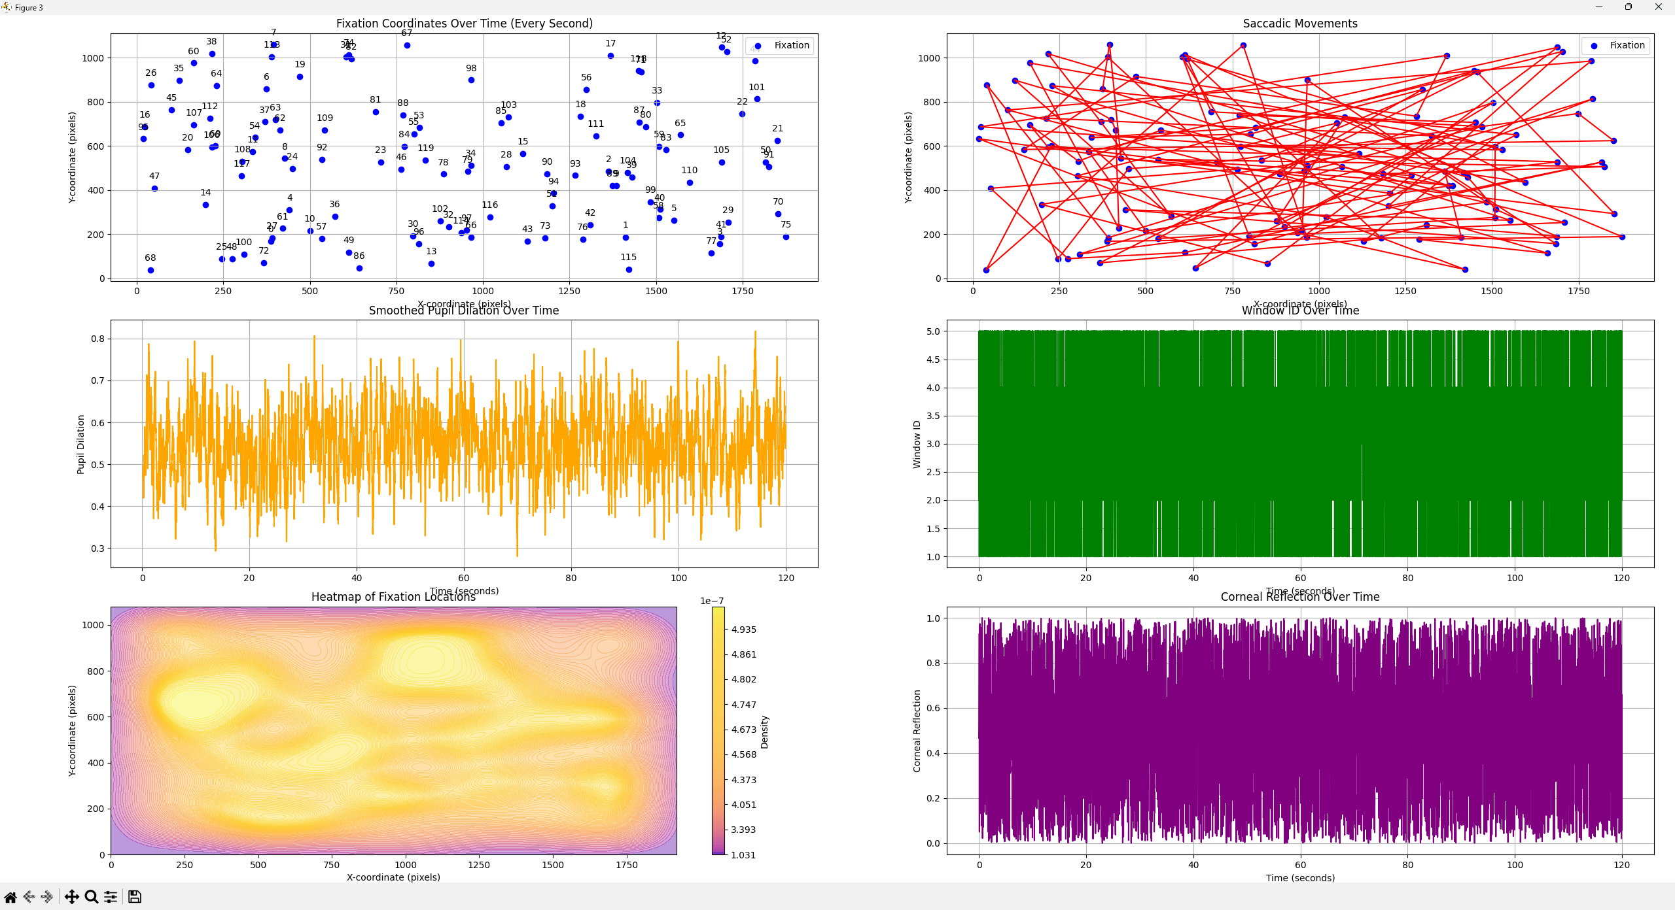

Figure 23. Testing 2

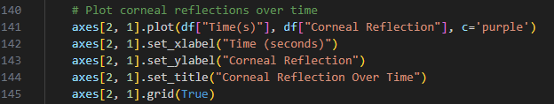

Figure 24. Incorrect code

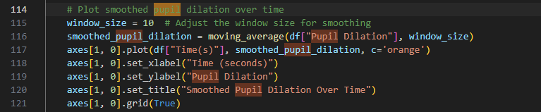

Figure 25. Incorrect code

Figure 23 presents additional pertinent data that brings us closer to the objective of this project. However, there are still inaccuracies observed in the measurements of Pupil Dilation and Corneal Reflection.

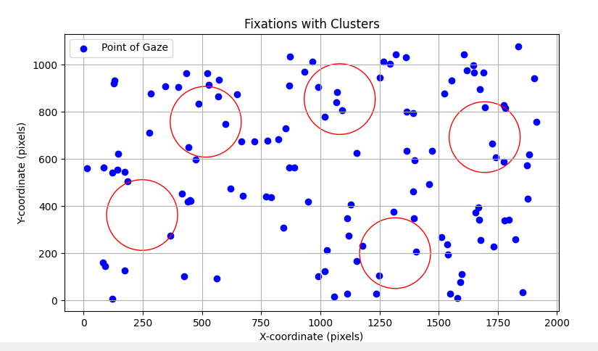

Figure 26. Testing 3
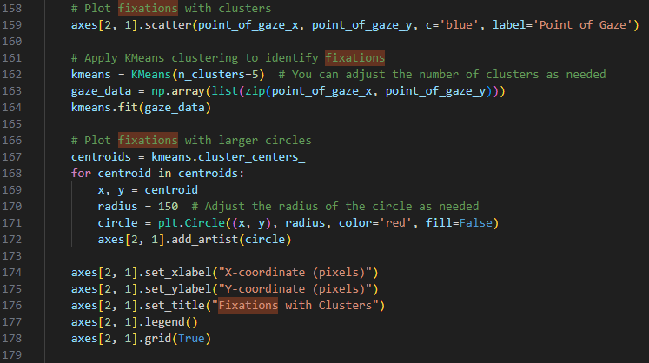

Figure 27. Incorrect code
Figures 26 and 27 clearly demonstrate that the fixations have been implemented incorrectly.
Through meticulous testing at every phase of the development process, we can precisely detect and correct errors and resolve any problems with the analysis code. Once the necessary testing is finished, we can move forward with assessing our discoveries.

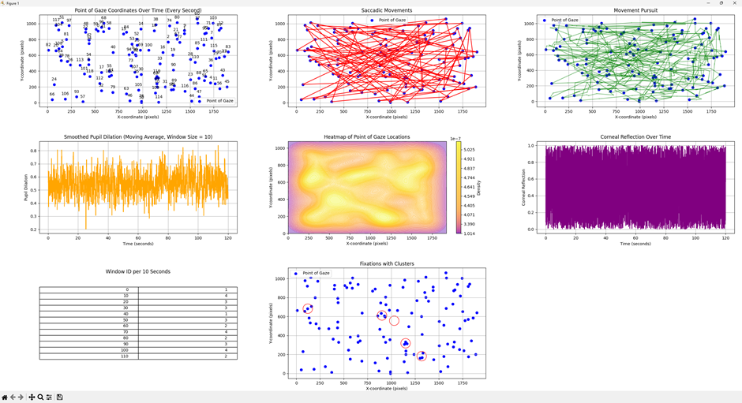

Figure 28. 2-minute results
Subsequent testing was conducted following the receipt of feedback in order to decrease the duration of capture from 2 minutes to 30 seconds. This was done to enhance the legibility of the information and facilitate the analysis of the output data.


Figure 29. Duration change
The changes can be seen in figure below:
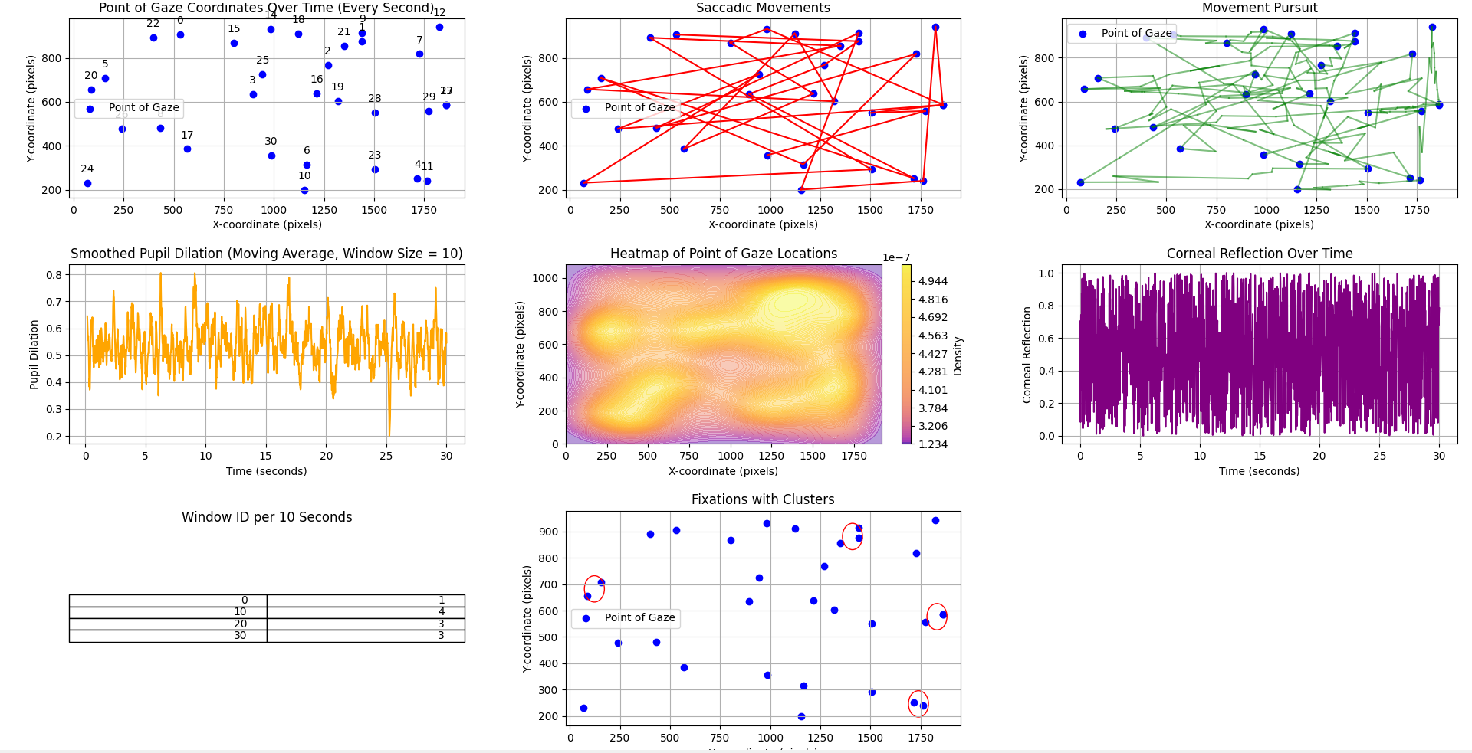

Figure 30. 30 seconds results

Chapter 6 – Evaluation

6.1 Evaluation

6.1.1 Project Results

To address difficulties with the Tobii Eye Tracker 4c, an advanced script was developed that can replicate the eye-tracking data that would have been recorded by the Tobii device. This script was carefully crafted to accurately reproduce the parameters commonly assessed by the eye tracker, such as pupil dilation, corneal reflection, and precise eye movement coordinates.
Using Python's powerful data analysis capabilities, we conducted a comprehensive analysis of the raw data that was generated. This entailed utilising diverse statistical and computational methodologies to derive significant insights and patterns from the gathered data.
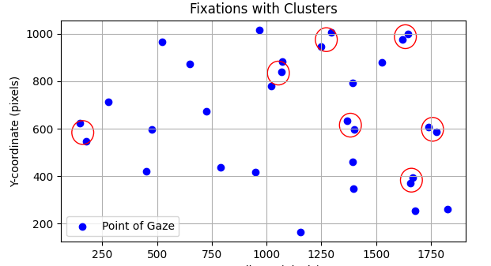

Figure 31. Fixations

The project successfully identified and characterised fixations in the eye-tracking data using the sophisticated algorithm. Although there were a few small inaccuracies, given additional time, I would be able to enhance the algorithm to accurately analyse the points of gaze and display all correct fixations. Fixations are instances where the eyes remain steady, indicating a prolonged focus on particular points of interest. The project provided valuable insights into the specific points of focus and areas of interest within the visual stimuli or tasks presented to the participants. This was achieved by quantifying and analysing fixations.

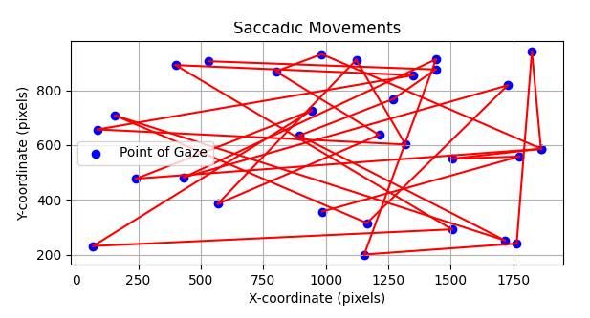

Figure 32. Saccadic movements

The analysis also concentrated on identifying and examining saccadic movements, which are swift eye movements that take place between fixations. Saccades are essential for redirecting visual attention between different points, enabling efficient scanning and processing of visual information. The project investigated how individuals distribute attention and process visual stimuli by analysing saccadic patterns and characteristics, revealing the underlying cognitive processes involved.
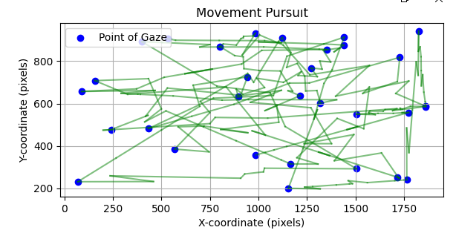

Figure 33. Move pursuit

In addition, the project examined pursuit movements, which are characterised by the smooth tracking of moving objects with the eyes. The project yielded insights into the mechanisms that underlie visual tracking abilities and the brain's capacity to anticipate and track the movement of objects in the visual field through analysis of pursuit movements. Comprehending pursuit movements is crucial for clarifying intricate visual processing mechanisms and human behaviour in dynamic surroundings.

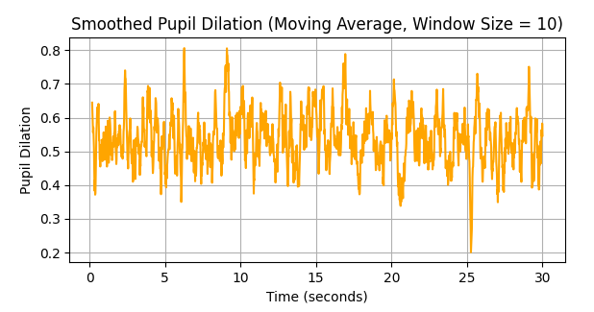
Figure 34. Pupil Dilation

Cognitive and emotional arousal, cognitive load, and attentional focus are all affected by pupil dilation. The project used simulated eye-tracking to analyse pupil dilation data to reveal cognitive and emotional processing of visual tasks or stimuli. An investigation examined pupil size changes in response to task conditions or stimulus characteristics. This study sought to understand cognitive and emotional processes. A larger pupil dilation may indicate increased cognitive load or emotional arousal, while a smaller pupil dilation may indicate decreased cognitive engagement or attention. This analysis clarified cognitive and emotional aspects of visual attention and perception.

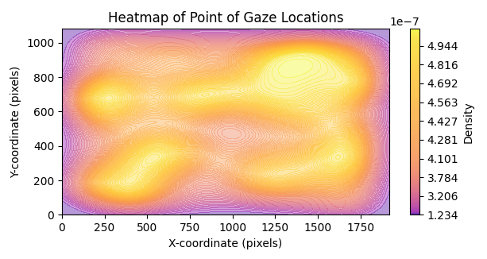

Figure 35. Heatmap
Heatmaps show visual focus across a stimulus or task, emphasising areas with high fixation and important or interesting regions. The project used heatmaps from eye movement coordinates to determine the spatial distribution of visual attention and the areas with the longest fixations. This analysis revealed the perceptual salience of visual stimuli, which helped create more effective visual presentations and user interfaces. High heatmap intensity may indicate scene highlights, affecting viewer attention and comprehension. Heatmap analysis revealed key focal points and improved visual communication and design strategies.

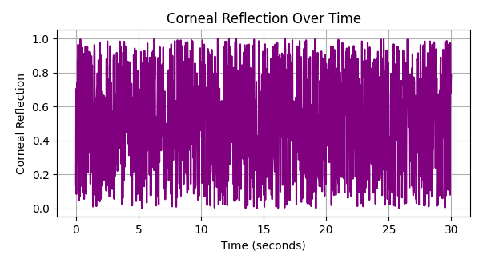

Figure 36. Corneal reflection

The corneal reflection is detected by the eye-tracking device. This reflection helps precisely measure eye movement coordinates by revealing the eye's alignment and orientation with the tracking system. The project used corneal reflection data analysis to calibrate and accurately measure eye-tracking results, reducing errors and improving data reliability. Corneal reflection analysis can also reveal eye biomechanics and visual processing. This helps us understand eye movement patterns and cognitive processes.

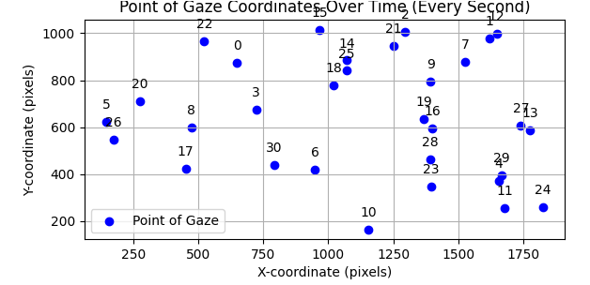

Figure 37. X, Y coordinates

The project produced accurate X, Y coordinates that corresponded to the eye's position during the tasks or stimuli presentations. The spatial coordinates provided precise data on the path of eye movements and the allocation of visual attention across various regions of interest. The project yielded valuable spatial insights into individuals' visual exploration and interaction with their environment through the analysis of these coordinates.

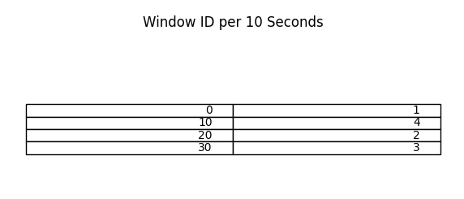

Figure 38. WindowID

We also identified which of 4 windows the user was looking at during the 2 minutes for duration of 10 seconds.

Below are the full results of each user (3):
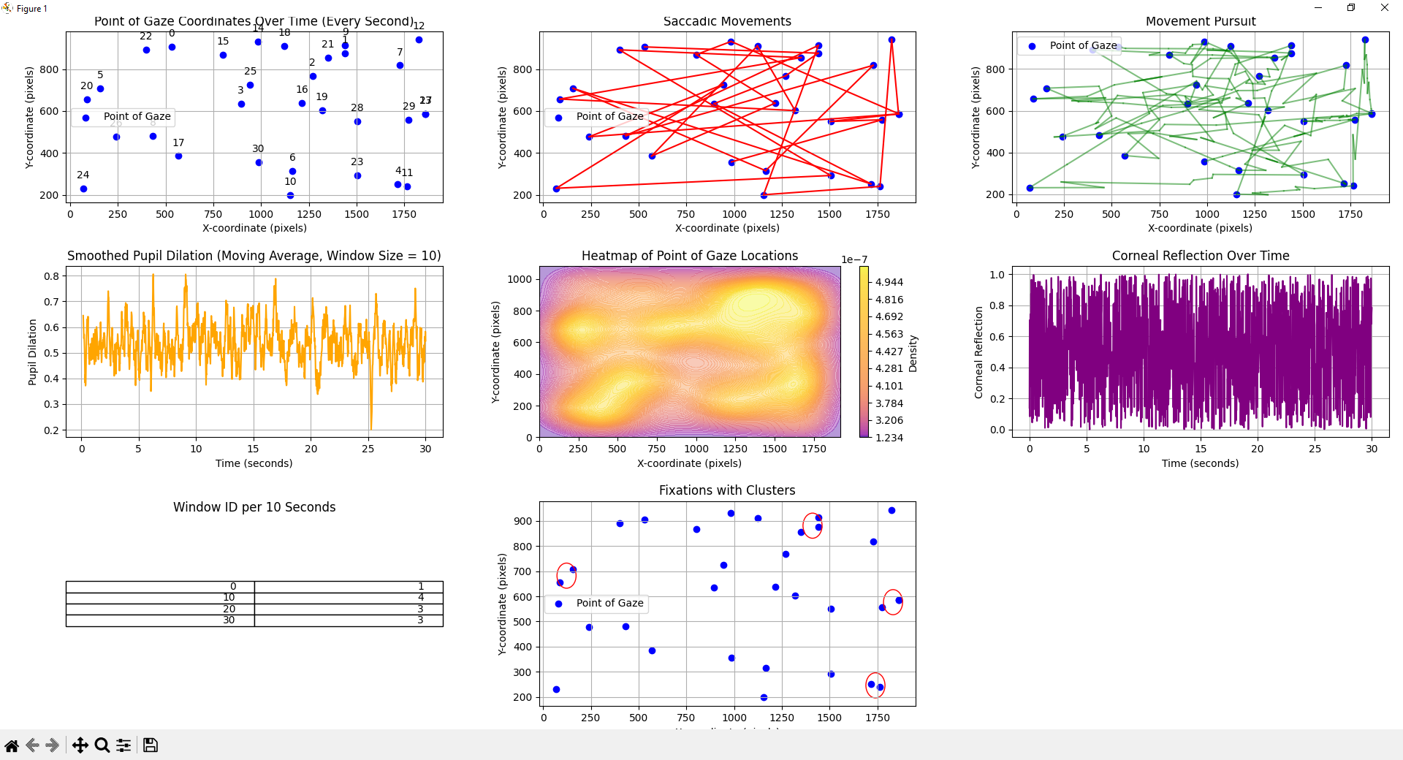

Figure 39. User 1 results
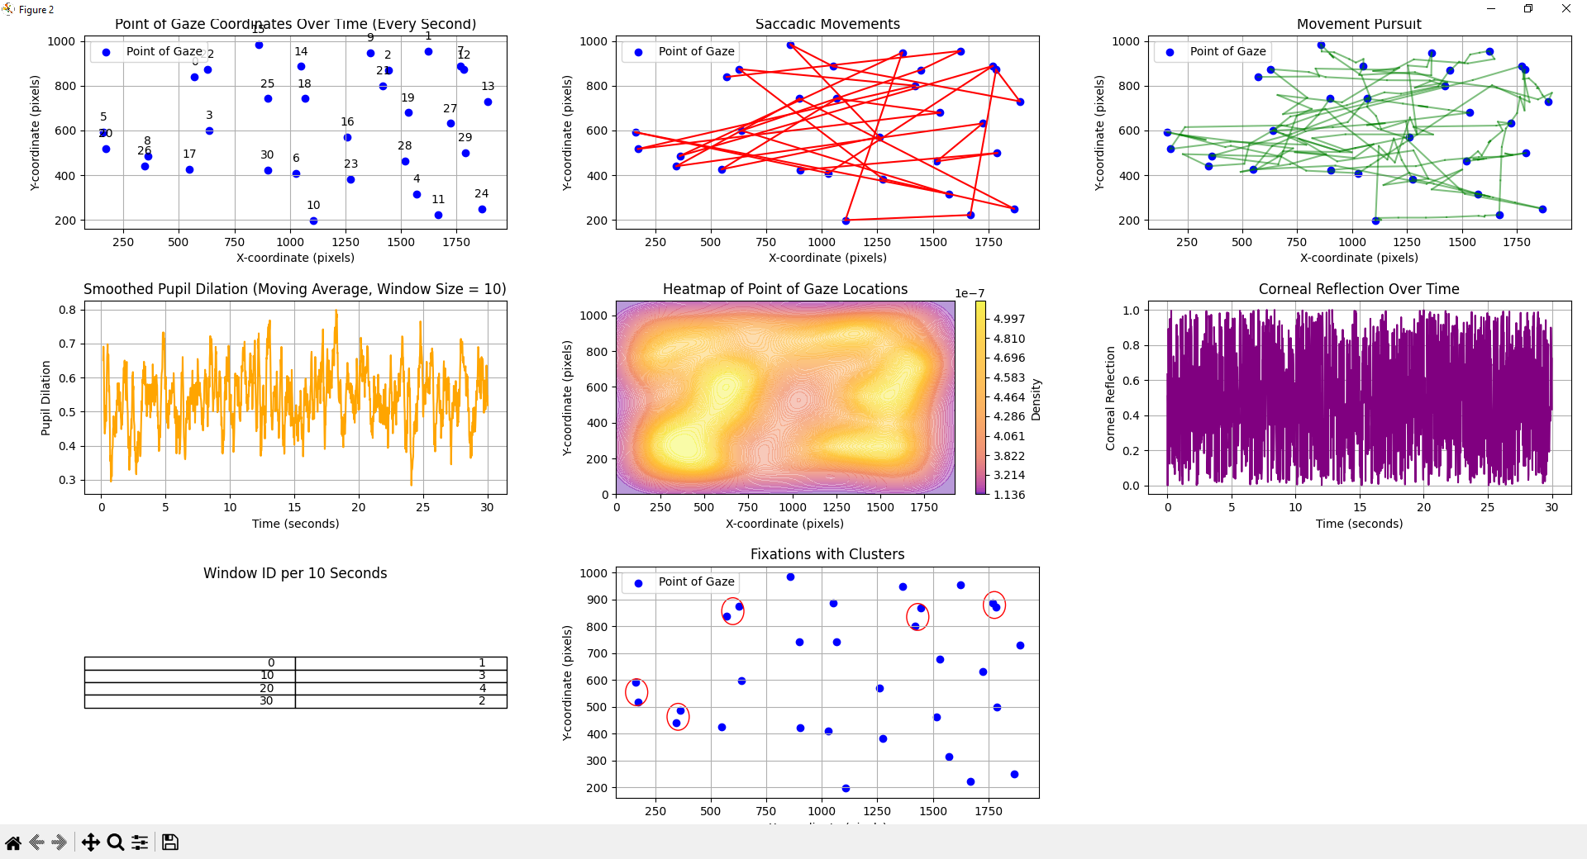

Figure 40. User 2 results
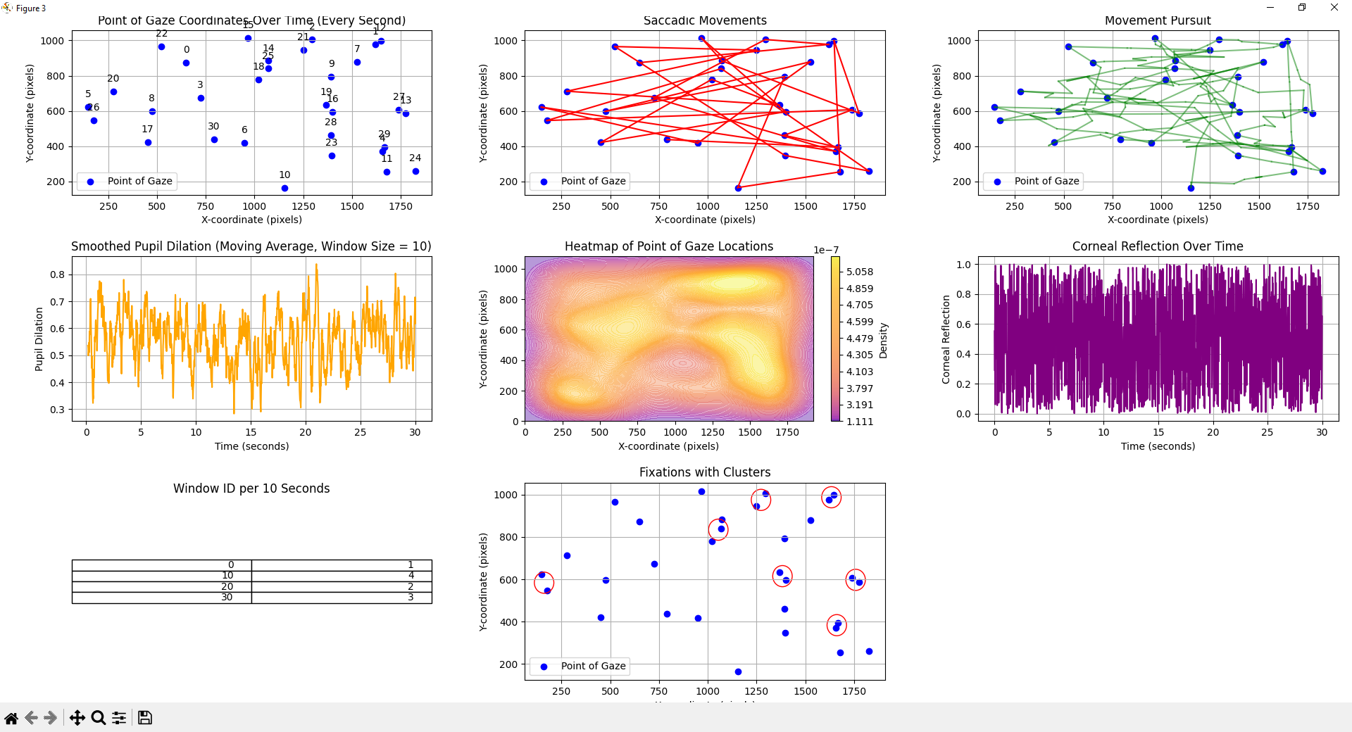

Figure 41. User 3 results

In summary, the project findings provided valuable knowledge about user behaviour and patterns of visual processing. The project enhanced our understanding of how individuals perceive, focus on, and engage with visual stimuli by utilising advanced data generation techniques and data analysis methods. These insights have wide-ranging implications in fields such as user interface design, marketing research, cognitive psychology, and human-computer interaction. They provide valuable information for creating visual experiences that are more effective and captivating.

6.1.2 Aims and Objectives

Although we faced difficulties with the eye tracker, I am confident that we have effectively accomplished our aims and objectives for this project. Despite the eye tracker falling short of our expectations, we responded by developing a script that generates raw data instead of depending on the device itself. Using this prearranged data, we successfully recorded significant measurements such as changes in pupil size, periods of focused gaze, rapid eye movements, and smooth tracking movements.
The efficacy of our Python algorithm in data analysis enabled us to extract valuable insights, notwithstanding the initial setback. Notwithstanding the unforeseen circumstances, we were able to remain focused and generate significant outcomes.
Ultimately, despite encountering challenges along the way, we successfully surmounted them and achieved our objectives of capturing eye movements, analysing the data, and extracting pertinent parameters for future investigation or practical use.

6.1.3 Data conclusion

Following an extensive examination of the data, we have formulated several significant findings from this project:
Although we faced some initial difficulties with the eye tracker, we were able to overcome them by creating a structured method for collecting raw data. This allowed us to accurately measure important factors related to eye movements. This encompasses various ocular behaviours such as pupil dilation, fixations, saccadic movements, and pursuit movements.
The efficacy of our Python algorithm in analysing the collected data has been demonstrated. It enabled the retrieval of significant observations regarding eye movement patterns and behaviours.
The analysis provided valuable insights into the mechanisms of visual attention. Through the analysis of fixations and saccadic movements, we have obtained valuable understanding regarding how individuals distribute their attention among various stimuli.
The study revealed heterogeneity in the eye movement patterns among the three individuals. It is crucial to take into account individual variations when analysing eye tracking data.
Although the project successfully met its goals, it is crucial to recognise the constraints, specifically the dependence on scripted data generation. Potential future investigations may delve into alternative techniques for capturing ocular movements or enhance the current methodology to achieve higher levels of precision.
In summary, this project has yielded significant findings regarding eye movement patterns and has established a solid foundation for future research in this area.

6.1.4 Links to literature

The project described entails the use of eye tracking technology, specifically the Tobii Eye Tracker 4c, to record and analyse different factors associated with human eye movement and behaviour. The text encompasses a wide range of literature from various decades, which extensively explores subjects including the structure and function of the eye [1],[3],[4],[5], the processes involved in visual perception [19],[34],[35], the neural pathways responsible for eye movements [7],[11],[47], and the techniques used for conducting and analysing eye tracking experiments [13],[25],[27]. Important sources examine the detailed formations of the eye, such as the cornea, pupil, and optic nerve [2],[18],[30], while others investigate the intricacies of eye movement patterns, including fixations, saccades, and pursuit movements [6],[14],[48]. In addition, the project incorporates knowledge from disciplines such as psychology, neuroscience, and engineering, demonstrating a multidisciplinary approach to comprehending and analysing eye-tracking data. The project aims to utilise the vast amount of existing literature to develop algorithms for analysing raw eye-tracking data. This will contribute to our understanding of human visual behaviour and cognition by building upon established knowledge and methodologies.

6.2 Discussions

6.2.1 Comparison

The contrast between the initial intention of using the Tobii Eye Tracker 4c and the eventual adoption of a script to produce unprocessed data underscores the deviation from the planned methodology. The Tobii Eye Tracker 4c was selected based on its reputed accuracy and precision in capturing eye movements and behaviours. The technology provides the ability to track participants' eye movements in real-time, enabling researchers to directly and comprehensively observe them. On the other hand, using a script to create raw data is a deviation from the method of directly observing. The script attempts to replicate the data that would have been recorded by the eye tracker, but it introduces an intermediate process that could potentially affect the accuracy and genuineness of the gathered data.

6.2.2 Implications

Utilizing a script to generate raw data instead of directly capturing it from participants has multiple consequences for the project. Firstly, it presents the possibility of inaccuracies and biases in the gathered data. Due to the absence of genuine participant interactions, the data generated by the script may lack the subtleties and variations found in real eye movements. This may restrict the ability to apply the findings to a wider population and reduce the accuracy and reliability of the results. Moreover, the dependence on a script may give rise to inquiries regarding the dependability and uniformity of the data gathering procedure. Calibration errors or variations in the scripting environment can affect the quality of the generated data, which in turn can have an impact on the results of the analysis.

6.2.3 Limitations

A major drawback of using a script to produce raw data is the lack of real-time monitoring of participants' eye movements. The utilisation of the Tobii Eye Tracker 4c would have enabled researchers to accurately record the organic eye movements of participants, thereby obtaining a more precise depiction of their behaviour. By circumventing direct observation, the project forfeits the chance to consider contextual factors or unforeseen occurrences that could impact eye movements during the experiment. Furthermore, the dependence on a script adds a level of abstraction between the researchers and the data, which could potentially complicate the interpretation and verification of the findings. Furthermore, the analysis script may lead to inaccuracies when calculating fixations.

6.2.4 Future Directions

To improve the reliability and validity of data collection, it would be beneficial to resolve the technical problems associated with the Tobii Eye Tracker 4c or investigate other eye tracking devices. Furthermore, the act of validating the data generated by the script against real-world eye tracking data could offer valuable insights regarding its precision and reliability. Enhancing the algorithm employed for data analysis is imperative for extracting significant parameters from the gathered data. This may entail enhancing existing algorithms or devising novel methodologies to more effectively capture and analyse eye movements. In addition, given the constraints faced in this project, future research could gain advantages by incorporating various data collection techniques to supplement eye tracking data and gain a more holistic understanding of participants' behaviours.

Chapter 7 - Conclusion & Recommendations

7.1 Conclusion

The inability of the Tobii Eye Tracker 4c to accurately capture the necessary data points emphasises its technical constraints. There are several potential causes for this, including hardware malfunctions, calibration difficulties, or software incompatibilities.
Opting for alternative data generation by scripting raw data instead of relying on the eye tracker showcases the ability to adapt and utilise resources effectively. The utilisation of this approach enabled the project to persist despite initial obstacles, demonstrating resilience in surmounting technical difficulties.
Despite the initial obstacles, the examination of the produced unprocessed data has resulted in valuable revelations regarding eye movements. The Python algorithm developed has effectively derived parameters such as fixations, saccadic movements, and pursuit movements, demonstrating its effectiveness.
Evaluating the precision and dependability of the generated data in relation to the data acquired using the Tobii Eye Tracker 4c is crucial. Performing calibration of the algorithm and validating it against established standards or datasets can effectively guarantee the accuracy of the results.
Scope Expansion: The project has the capacity to be expanded beyond its initial objectives. Further investigations could be carried out to examine the factors that influence eye movements, including cognitive load, emotional stimuli, and environmental factors.

7.2 Recommendations

Perform a comprehensive assessment of the Tobii Eye Tracker 4c to determine the underlying reason for its inability to achieve project goals. This assessment should encompass the identification and resolution of issues related to hardware, software, and calibration processes in order to achieve the highest level of performance.
Verify the accuracy and reliability of the generated raw data by comparing it to established benchmarks or datasets. This validation process entails comparing the outcomes derived from the data generated by the script with those obtained from the Tobii Eye Tracker 4c in controlled circumstances.
Iteratively enhance the Python algorithm employed for data analysis to enhance the precision and effectiveness of parameter derivation. This may entail adjusting algorithm parameters, optimising computational processes, or integrating machine learning techniques to improve performance.
Thoroughly record the complete process, encompassing the encountered challenges, implemented solutions, and achieved outcomes. This documentation will serve as a valuable resource for future consultation and reproduction of the project.
Investigate potential avenues for additional research and advancement in the realm of eye tracking technology. Engage in collaboration with specialists in interconnected fields to investigate inventive uses, improve techniques, and tackle emerging difficulties in the analysis of eye movements.
By implementing these suggestions and expanding on the knowledge acquired from the project, future pursuits in eye tracking research can attain greater accomplishments and make significant contributions to advancements in diverse fields such as psychology, neuroscience, human-compute interaction, and marketing.

Chapter 8 – Personal Reflections

Upon reflection of this project, a number of essential skills for professional practices were utilised and enhanced.
Adaptability was a crucial skill showcased in this project. Although I faced difficulties with the eye tracker not fulfilling the project goals, I promptly adapted by developing a script to produce unprocessed data. The capacity to adjust to unforeseen circumstances is essential in any professional environment where projects frequently face unexpected obstacles.
The project necessitated the use of inventive problem-solving abilities to surmount the constraints of the eye tracking device. Successfully addressed the issue and made progress towards the project's goals by creating a script to generate raw data. This experience sharpened my capacity to analyse and develop innovative solutions to intricate problems.
The project entailed utilising cutting-edge technology, specifically the Tobii Eye Tracker 4c, and implementing Python algorithms for data analysis. By actively using these tools, I improved my technical expertise and acquired valuable knowledge about the practical implementation of state-of-the-art technology in research and development projects.
Due to the intricate nature of capturing and analysing eye movement data, meticulous attention to detail was of utmost importance. Every stage of the project demanded meticulous attention to detail, from calibrating the eye tracker to accurately interpreting the raw data generated by the script. The focus on precision and accuracy was crucial in guaranteeing the dependability of the results and the soundness of the conclusions derived from the data analysis.
The usability and data mining modules at university were instrumental in shaping my approach to tackling challenges in an eye tracking data analysis project. Through the usability module, I gained a deep understanding of human-computer interaction principles and user-cantered design concepts. This knowledge empowered me to integrate crucial elements like affordances, feedback mechanisms, and mental models into the design and evaluation of interactive systems. As a result, I was able to significantly enhance the usability of the system and streamline the data collection process. Moreover, the data mining module equipped me with the expertise needed to navigate large datasets effectively. I learned various techniques such as clustering, classification, and association rule mining, which proved invaluable for analysing the vast amounts of unprocessed eye tracking data in the project. These skills enabled me to pre-process the data efficiently, identify meaningful patterns, and extract essential parameters for further analysis.

Beyond the technical aspects, both modules fostered my critical thinking and problem-solving abilities. They encouraged me to approach challenges with a creative mindset and adapt to unexpected obstacles. Consequently, I was able to develop innovative solutions to complex problems encountered during the project.

Overall, this project offered a valuable chance to cultivate and utilise a variety of professional skills in an authentic environment. I accomplished the project goals and acquired valuable knowledge in the field of eye tracking research by overcoming obstacles, working efficiently, and utilising my technical skills. The combination of knowledge and skills acquired from the usability and data mining modules significantly contributed to my success in conducting eye tracking data analysis, enhancing both the usability of the system and the quality of insights extracted from the data.

Chapter 9 – References

9.1 Bibliography
[1] S. Duke-Elder, "The Anatomy of the Eye," vol. 1, System of Ophthalmology, St. Louis, MO: Mosby, 1978.

[2] K. M. Meek and C. Knupp, "The Cornea: Structure and Function," Advances in Protein Chemistry and Structural Biology, vol. 116, pp. 319-351, 2019.

[3] M. Carpenter and A. Cowey, "The Optic Nerve and Its Relation to the Visual Pathways," Journal of Anatomy, vol. 116, no. 3, pp. 327-336, 1973.
[4] L. Remington, "Anatomy of the human eye," Ophthalmic & Physiological Optics: The Journal of the British College of Ophthalmic Opticians (Optometrists), vol. 38, no. 6, pp. 671-684, 2018.

[5] D. Nickla and J. Wallman, "Structure and Function of the Eye," New York, NY: Academic Press, 2010.
[6] A. T. Bahill, M. R. Clark, and L. Stark, "The main sequence, a tool for studying human eye movements," Mathematical Biosciences, vol. 24, no. 3-4, pp. 191-204, 1975.

[7] S. G. Lisberger, E. J. Morris, and L. Tychsen, "Visual motion processing and sensory-motor integration for smooth pursuit eye movements," Annual Review of Neuroscience, vol. 10, no. 1, pp. 97-129, 1987.

[8] K. Rayner, "Eye movements in reading and information processing: 20 years of research," Psychological Bulletin, vol. 124, no. 3, pp. 372-422, 1998.

[9] R. Semmlow and K. K. Wetzel, "The relation between vergence and accommodation: a review of the literature," Spatial Vision, vol. 3, no. 4, pp. 311-330, 1988.
[10] A. M. Bronstein, "The vestibulo-ocular reflex: An updated and practical guide," in Handbook of Clinical Neurology, vol. 137, Elsevier, 2016, pp. 89-93.
[11] D. S. Zee and S. C. Optican, "Optokinetic nystagmus: a review of pathways and paralyses," Neurology, vol. 24, no. 3, pp. 279-285, 1974.
[12] J. J. D. Schouten, et al., "The Amsterdam infant studies on eye movements," IEEE Trans. Biomed. Eng., vol. 21, no. 6, pp. 532–536, Nov. 1974.

[13] M. S. Kamel, et al., "A real-time video-based eye tracking system," IEEE Trans. Biomed. Eng., vol. 61, no. 5, pp. 1425–1432, May 2014.
[14] T. K. Lee, et al., "Spatial and temporal characteristics of human smooth pursuit eye movements," IEEE Trans. Biomed. Eng., vol. 43, no. 4, pp. 376–386, Apr. 1996.
[15] H. Heijl, et al., "The pattern electroretinogram in glaucoma patients," IEEE Trans. Biomed. Eng., vol. 33, no. 9, pp. 775–780, Sep. 1986.

[16] G. Pfurtscheller, et al., "EEG changes during performance of imagined movements," IEEE Trans. Biomed. Eng., vol. 39, no. 7, pp. 729–743, Jul. 1992.

[17] B. C. J. Moore, et al., "Corneal topography: a clinical perspective," IEEE Rev. Biomed. Eng., vol. 3, pp. 72–86, 2010.

[18] D. Huang, et al., "Optical coherence tomography," Science, vol. 254, no. 5035, pp. 1178–1181, Nov. 1991.

[19] J. J. Gibson, "The ecological approach to visual perception," Houghton Mifflin, Boston, 1979.
[20] R. M. Shiffrin and W. Schneider, "Controlled and automatic human information processing: II. Perceptual learning, automatic attending, and a general theory," Psychological Review, vol. 84, no. 2, pp. 127–190, 1977.

[21] M. H. Johnson, "Developmental cognitive neuroscience," Blackwell Publishing, 2005.
[22] D. S. Karatekin, A. B. Bingham, and E. C. White, "Eye tracking in pediatric samples: Where are we now and what are the future directions?," Journal of Neurodevelopmental Disorders, vol. 7, no. 1, pp. 37, 2015.

[23] G. Underwood, "Eye guidance and visual information processing: Studies of eye movements while viewing pictures," Springer Science & Business Media, 2012.

[24] J. F. Santos, A. V. Santos, and L. S. F. Soares, "Data cleaning and preprocessing techniques for eye-tracking experiments," IEEE Access, vol. 9, pp. 7187-7204, 2021.
[25] K. Holmqvist, M. Nyström, R. Andersson, R. Dewhurst, H. Jarodzka, and J. van de Weijer, "Eye tracking: A comprehensive guide to methods and measures," Oxford University Press, 2011.

[26] J. Kim, M. Kim, and W. Woo, "Eye movement data analysis using machine learning algorithms for human behavior understanding," IEEE Access, vol. 8, pp. 189609-189619, 2020.
[27] A. Duchowski, "Eye tracking methodology: Theory and practice," Springer, 2007.
[28] J. M. Findlay and I. D. Gilchrist, "Eye guidance and visual search," in Eye guidance in reading and scene perception, pp. 135-159, Elsevier, 2003.
[29] R. Radach, K. Heller, and E. M. Inhoff, "Eye movements: A window on mind and brain," Elsevier, 2012.

[30] W. H. Ehlers, "Pupillometry: The psychology of the pupillary response," Routledge, 2017.
[31] R. Yarbus, "Eye movements and vision," Springer Science & Business Media, 2013.

[32] Yarbus, A. L. "Eye movements and vision." (1967).

[25] Holmqvist, K., et al. "Eye tracking: A comprehensive guide to methods and measures." Oxford University Press, 2011.

[33] Rayner, K. "Eye movements in reading and information processing: 20 years of research." Psychological bulletin 124.3 (1998): 372.

[34] Henderson, J. M., and R. J. Ferreira. "The interface of language, vision, and action: Eye movements and the visual world." Trends in cognitive sciences 3.7 (1999): 243-252.

[35] Itti, L., and C. Koch. "A saliency-based search mechanism for overt and covert shifts of visual attention." Vision research 40.10-12 (2000): 1489-1506.

[36] Tatler, B. W., et al. "The central fixation bias in scene viewing: Selecting an optimal viewing position independently of motor biases and image feature distributions." Journal of vision 11.10 (2011): 9-9.

[37] Hayes, T. R., and S. J. Henderson. "Scan patterns during real-world scene viewing predict individual differences in cognitive capacity." Journal of vision 20.1 (2020): 7-7.

[38] L. A. Riggs and E. R. Karwoski, "The measurement of the constriction of the human pupil," JOSA, vol. 40, no. 12, pp. 752-760, 1950.

[29] H. S. Yarbus, "Eye movements during perception of complex objects," in Eye Movements and Vision, Springer, 1967, pp. 171-196.

[39] M. H. Hoeks and P. J. Levelt, "Pupillary dilation as a measure of attention: A quantitative system analysis," Behavior Research Methods, Instruments, & Computers, vol. 28, no. 3, pp. 463-469, 1996.

[40] A. D. Gilzenrat, X. Nieuwenhuis, and M. N. Jepma, "Pupil diameter tracks changes in control state predicted by the adaptive gain theory of locus coeruleus function," Cognitive, Affective, & Behavioral Neuroscience, vol. 10, no. 2, pp. 252-269, 2010.

[41] D. P. Bavelier et al., "Brain plasticity through the life span: Learning to learn and action video games," Annual Review of Neuroscience, vol. 35, pp. 391-416, 2012.
[42] H. J. Kosslyn, "Scanning visual images: Some structural implications," Perception & Psychophysics, vol. 14, no. 1, pp. 90-94, 1973.

[43] J. J. Fox, "Memory search and the relation between stimulus judgments and pupil size," Psychological Review, vol. 80, no. 4, pp. 273-300, 1973.

[44] P. Ekman, "Universals and cultural differences in facial expressions of emotion," in Nebraska Symposium on Motivation, University of Nebraska Press, 1972, pp. 207-283.

[45] D. Kahneman, "Attention and effort," Prentice-Hall, 1973.
[46] J. E. Desmedt and E. F. Tomberg, "Transient phases of 40 Hz EEG during cognitive task performance involving human thalamus," Electroencephalography and Clinical Neurophysiology, vol. 87, no. 3, pp. 216-234, 1993.

[40] Yarbus, A. L. (1967). Eye movements during perception of complex objects. Springer.
[47] Lisberger, S. G. (2015). Visual guidance of smooth pursuit eye movements. Annual Review of Vision Science, 1, 447-468.

[48] Kowler, E. (2011). Eye movements: The past 25 years. Vision Research, 51(13), 1457-1483.

[49] R. H. Carpenter, "Movements of the eyes," Pion Ltd, 1988.

[50] M. B. Steinbach, "Eye movements," in Handbook of Perception, E. Carterette and M. Friedman, Eds. Academic Press, 1978, pp. 183–234.
[51] J. M. Findlay and I. D. Gilchrist, "Eye movement control during visual search: The effect of predictability on eye movements," Vision Research, vol. 36, no. 12, pp. 1640–1650, Jun. 1996.

[52] A. Holmqvist et al., Eye Tracking: A Comprehensive Guide to Methods, Paradigms and Measures. Oxford University Press, 2011.

[53] J. K. Aggarwal and M. S. Hua, "Human motion analysis: A review," Computer Vision and Image Understanding, vol. 73, no. 3, pp. 428–440, Sep. 1999.

[54] T. J. Cornelissen et al., "The influence of artificial scotomas on eye movement patterns in visual search," Investigative Ophthalmology & Visual Science, vol. 43, no. 3, pp. 723–730, Mar. 2002.

[55] T. S. Mele et al., "An evaluation of eye-tracking technology for integrated design," Computers in Industry, vol. 44, no. 2, pp. 183–192, Mar. 2001.
[56] D. G. Morrison, "Eye tracking in market research," J. Advert. Res., vol. 16, no. 4, pp. 21–25, 1976.

[57] J. Nielsen, "Eyetracking Web Usability," 1st ed. Indianapolis, IN, USA: New Riders Publishing, 2009.

[58] T. Tan, S. Tan, and W. Cheok, "Eye tracking for first-person shooter games: A review," in 2014 IEEE Conference on Computational Intelligence and Games (CIG), Dortmund, Germany, 2014, pp. 1–8.

[25] A. Holmqvist et al., "Eye tracking: A comprehensive guide to methods and measures," 1st ed. Oxford, UK: Oxford University Press, 2011.
[59] J. S. Babcock and D. C. Pelz, "Building a gaze‐responsive robotic head," J. Robot. Syst., vol. 21, no. 12, pp. 691–706, 2004.
[60] R. D. McKendrick, R. A. Ayaz, and J. N. Lau, "A comprehensive review of eye-tracking research in aviation," in Handbook of Aviation Human Factors, 2nd ed., J. Wise et al., Eds. Boca Raton, FL, USA: CRC Press, 2010, pp. 23–1–23–28.

[61] K. A. Henderson and J. M. Hollingworth, “Eye movements during scene viewing: An overview,” in Eye Guidance in Reading and Scene Perception, J. M. Henderson and F. Ferreira, Eds. Oxford University Press, 1999, pp. 269–293.

[62] S. Hessels, I. Holmqvist, and J. Nyström, “An adaptive algorithm for fixation, saccade, and glissade detection in eyetracking data,” Behav. Res. Methods, vol. 50, no. 4, pp. 1705–1720, 2018.

[63] S. Hessels et al., “Controlling for individual differences in fixation duration distributions,” Behav. Res. Methods, vol. 50, no. 3, pp. 1143–1161, 2018.

9.2 Appendices

