


Linking Age with Device Security, Network Security and Phishing Scams
By Curtis Stephens
Supervisor: Dr. Kapilan Radhakrishnan

Project submitted as part of the requirements for the award of BSc (Hons) Computer Networks

April 2022

Declaration of Originality

I, Curtis Stephens declare that I am the sole author of this Project; that all references cited have been consulted; that I have conducted all work of which this is a record, and that the finished work lies within the prescribed word limits.

This work has not previously been accepted as part of any other degree submission.

Signed:

Date: 27th April 2022

FORM OF CONSENT

I, Curtis Stephens hereby consent that my Project, submitted in candidature for the B.Sc. (Hons) Computer Networks degree, if successful, may be made available for inter-library loan or photocopying (subject to the law of copyright), and that the title and abstract may be made available to outside organisations.

Signed:

Date: 27th April 2022

Copyright Acknowledgement

I acknowledge that the copyright of this project report, and any product developed as part of the project, belong to University of Wales Trinity Saint David, Swansea.

Abstract
This study has been undertaken to determine whether the older generation are less knowledgeable in terms of Internet and device security, as is often stereotyped, or whether the younger generation are less aware due to less awareness being targeted at them.
The main aim of this study is:
To investigate and produce a strategy to help people keep their home network and devices safe, whilst looking at user demographics – Are younger people actually more careful than the older generation, or is it just a stereotype?

This is done by means of a survey, which is targeted at respondents aged 18 years of age and over. The survey asked respondents various questions in various areas such as home network security, their Internet usage, as well as questions regarding phishing scams. Respondents were asked to identify phishing emails from genuine emails to see what features they could identify.
The results of this study showed that despite the stereotype, different age groups had different weaknesses. It was found that the younger generation were less careful in regard to having antivirus and antimalware software on their devices, due to them thinking that they are more careful on the Internet which mitigated any need for the software.
It was also found that the older generation were less careful in regard to home network security, not changing their router login details so anyone can gain access if the router has a generic username and password combination.
Finally, the middle-aged generation were found to be less careful regarding phishing emails, getting the lowest scores when asked to identify phishing and non-phishing emails.
The recommendation from this study is for awareness to be targeted at these individuals for what is needed, to ensure they are as safe as possible online, as it only takes one click to potentially make a mistake and download malware, or hand over sensitive information.

Table of Contents
Abstract 3
1. Introduction 7
1.1. Background 7
1.2. Aims and Objectives 7
1.3. Project Structure 8
2. Literature Review and Related Works 9
2.1. Introduction 9
2.2. COVID-19 and Phishing Scams, and Social Engineering 9
2.3. Home Network Security, Viruses, and Malware 10
2.4. VPN Usage 11
2.5. Conclusion of Literature Review 12
3. Research Methodology – The Research Onion 13
4. Design and Implementation 16
4.1. Survey Design 16
4.2. Survey Questions 17
5. Analysis and Findings 28
5.1. About You 28
5.2. Your Home Network 31
5.3. Device Security 37
5.4. Phishing, Viruses and Scams 39
5.5. Phishing Scam Examples 41
5.6. Final Questions 48
6. Evaluation 50
7. Conclusion and Recommendation 52
7.1. Suggestions for further work 52
8. Reflection 53
Bibliography 54

List of Figures
Figure 1 – The Research Onion 13
Figure 2 - GANTT chart 15
Figure 3 - DPD Phishing Email 21
Figure 4 - HMRC Phishing Email 22
Figure 5 - Genuine Email from Skrill 23
Figure 6 - NHS phishing text 24
Figure 7 - Fake HMRC data input page 25
Figure 8 - Fake HMRC phishing email 25
Figure 9 - Suspicious HMRC link 26
Figure 10 - Landing page from the link featured in the email 26
Figure 11 – Chart showing the age groups of respondents 27
Figure 12 – Chart showing what gender respondents identify as 28
Figure 13 – Chart showing where the respondents to the survey live 28
Figure 14 – Chart showing what proportion of respondents have been working from home 29
Figure 15 – Chart showing how often people use the internet 29
Figure 16 – Chart showing which Internet Service Provider people use 30
Figure 17 – Chart showing which brands of router people are using 30
Figure 18 – Chart showing how many people have logged into their router 31
Figure 19 – Chart showing how many people have changed their router login 31
Figure 20 - Chart showing how many people from each age range have logged into their router settings 32
Figure 21 - Chart showing how many people from each age range have changed their router login 32
Figure 22 - Chart showing the age range of respondents 33
Figure 23 – Chart showing which terms people have heard of 34
Figure 24 – Chart showing how many terms have been understood per age range 34
Figure 25 – Chart showing which security measures people have in place on their home network 35
Figure 26 - Chart showing how many measures people have on their network, by age range 35
Figure 27 - Chart showing how many people are aware of antivirus for smartphones and tablets 36
Figure 28 - Chart showing how many people have antivirus installed on their smartphone or tablet 36
Figure 29 - Chart of how many people have antivirus or antimalware installed on their PC or laptop 39
Figure 30 - Chart showing a percentage of people who have had their devices affected by viruses and/or malware 39
Figure 31 - Chart showing the tell-tale signs people had when their devices had a virus or malware 40
Figure 32 - Chart showing how many people have encountered a phishing scam 40
Figure 33 - Chart showing how many people have seen a rise in Phishing due to COVID-19 41
Figure 34 - Chart showing how many people correctly identified the DPD phishing email 41
Figure 35 - Chart showing how many people correctly identified the HMRC phishing email 42
Figure 36 - Percentage of people who correctly identified the Skrill email as genuine 43
Figure 37 - Percentage of people who correctly identified the NHS text as a scam 44
Figure 38 - Percentage of people who correctly identified the HMRC material as a scam 45
Figure 39 - people who identified all 5 phishing scams correctly 46
Figure 40 - People who correctly identified four phishing scams 46
Figure 41 - People who correctly identified three phishing scams 47
Figure 42 - people who only identified 0-2 phishing scams 47
Figure 43 - how often people use online banking 48

List of Tables
Table 1 - Comparing Positivism and Interpretivism 13
Table 2 - percentages of people who have logged into, and changed their router password based on age range 33
Table 3 - Percentage of how many people have antivirus on their smartphone or tablet, by age category 37
Table 4 - How many people have antivirus or antimalware installed on their computer, by age category 38
Table 5 - How often people use online banking, as a percentage by age group 48
Table 6 - How often people shop online, as a percentage by age group 49

Introduction

Background
According to a survey carried out by the Office for National Statistics (ONS) in 2020, 96% of households had a broadband connection, and therefore access to the internet, with this figure growing year-on-year. Home networks are becoming increasingly vulnerable to attacks through the medium of viruses, malware as well as phishing attempts, making now a better time than ever to ensure that your home network is safe.
Awareness of these attacks is being made – especially with the COVID-19 pandemic leading to more people working from home and the rise in phishing attempts with false offers of COVID vaccination and PCR testing with card details being handed over.
As well as network security, people may also not be securing their devices, giving hackers another way to access a user’s network. In the same survey mentioned above, it was stated that 17% of people did not have any form of security on their smartphone, with an additional 32% not knowing whether they had a form of security or not.
People are also handing their card details over a lot more – with people choosing to shop online during the peak of the pandemic, and 87% of respondents to the survey having shopped online in the 12 months prior, it begs the question about whether people will think twice about handing their card details over to a seemingly innocent looking shopping interface, or whether they would delve deeper and investigate a suspect email or text.
With the older generation using the internet a lot more nowadays to talk to their family, as well as get up to date with online services such as banking and shopping, this study will also find out how knowledgeable they are regarding internet security and will work out whether they are the most vulnerable as it is often stereotyped.

Aims and Objectives
The main aim of this project is:
To investigate and produce a strategy to help people keep their home network and devices safe, whilst looking at user demographics – Are younger people actually more careful than the older generation, or is it just a stereotype?
And the objectives of this project are as follows:
- Researching to gain a better knowledge and understanding of current internet and network security issues.
- Carrying out surveys with a wide audience to find out how far people are going to keep their home network and devices secure, as well as finding out how susceptible they would be to a phishing scam.
- Researching and experimenting with Virtual Private Networks (VPNs) to better understand how they could work within a home network in regard to safety.
- Carrying out research on phishing scams to find out if, and how they can relate to network security – can they be used to take control or change administrative settings on a home network?
- Conducting research into how the COVID-19 pandemic relates to network and device security – Did the pandemic lead to more victims of online fraud or hacking?

Project Structure
This project will be made up of three main parts. The first part will be made up based on secondary research from peer-reviewed journals, articles, and conference proceedings, with online sources used only where necessary. This research will involve network security and device security best practices, along with other research on VPNs, viruses, and malware to develop understanding. The second part will be based on primary research from the survey that will be conducted whilst completing this project, and the results of this survey will be examined in-depth. A hypothesis and assumptions will also be made, and the survey will be used to prove or disprove them. Finally, the third part will be where best practices are mentioned, and what users should be doing to better secure their devices and networks.
Chapter one features an introduction to this project, as well as an outline of the aims and objectives that will be achieved throughout the duration of this project. It also features how the project is structured.
Chapter two will provide a review into the findings from research conducted throughout the project, into Phishing, social engineering, hone network security as well as the usage of VPNs both for home use, and for people working from home.
Chapter three will provide an insight to the Research Onion, the methodology used whilst researching for this project, as well as outlining the data collection methods which have been used
Chapter four will feature survey design, and will go through all of the questions, justifying why they have been asked and how they contribute to the study
Chapter five analyses the findings from the survey, using charts and graphs, and links these together to relate to the sources featured in the literature review.
Chapter six will feature an evaluation of the findings from the survey, summing it all up and summarising it into one section.
Chapter seven will conclude all of the project, as well as provide avenues for further research based on what has been done in this project
Finally, Chapter eight will be written in the first person, and will feature a reflection based on what has been done in this project, and what could have been done better, as well as my personal findings and what I have learned through doing this.

2. Literature Review and Related Works

2.1. Introduction
In this chapter, the sources that have been used for research will be compared and critically reviewed. Many studies have already been conducted based on home network security, viruses and malware, and phishing scams.

2.2. COVID-19 and Phishing Scams, and Social Engineering
COVID-19 has led to a rise in phishing scams, according to research. A lot of these are surrounding scam texts and emails regarding COVID-19 testing and vaccines, which prompt people to enter card details to ‘verify their identity’ with an empty promise of a vaccine or PCR test.
In a study conducted, it was found that of 8,231 people who took part, 664 people reacted to a phishing scam email (clicking on the link within the email). Of these 664 people, 64 people took part in a phishing awareness programme before the main study started. This study also looked at various social engineering techniques used in phishing scams. (1). This research will be good for the study as it would be good to see how many people would react to a phishing email at first glance. The statistics for this can be used to filter down by age as well. This study does not, however, use more than one phishing email, meaning that there is potential to test people on more than one source and mark them out of however many sources there are.
Another study found that the stress, fear and anxiety linked to the COVID-19 pandemic caused a rise in the amount of people who would have fallen for COVID and non-COVID related phishing emails, compared to previous studies carried out, and therefore increases knowledge of the human factors that influence users to fall for these attempts in non-pandemic times (2). The research found by this source is good for this study, due to the fact that it is based on recent events, and it would be good to replicate, by asking questions related to COVID-19, and by asking people whether they would react to a COVID-19 phishing scam. This study was carried out around the start of the pandemic, so things may change as stress levels have gone down due to the pandemic becoming less of a story, however, the cost of living has gone up which may lead to more stress and may lead people to click on phishing emails if certain topics are mentioned. In a data release by Barracuda Networks, who are a leading provider of security and data protection solutions, it was found that between March 1st and March 23rd, 2020, there were 467,825 spear-phishing attacks, with around 2% of those being COVID-related. This marked a 667% rise in attacks related to COVID-19. (3) The data from this source could be compared in this study, looking at whether people feel there has been a rise in COVID-19 phishing scams, as well as asking people about phishing attacks they have seen recently, for example, whether there has been a rise in non-COVID related attacks. A study of 179 participants was carried out and the findings based on comments from 89 participants were that 55% of the 89 people used characteristics such as headers, footers, fonts, banners, and copyright symbols as a deciding factor in whether they thought the email was genuine. 67 respondents made comments based on information featured in the email (e.g., account numbers and names). The study found that participants could only decide based on the content of the email and not the context of the email being received (4). This source was highly informative as it produced plenty of statistics about elements of phishing scams which can be easily replicated within this study. However, the question of how users would react when faced with multiple sources, as well as a more realistic looking phishing scam could be asked – would they fall for a phishing scam if the landing page as well as most other elements looked to be genuine, and have all of these elements? Another study into social engineering used various tactics such as authority (pretending to be a person of authority), social proof (encouraging people to do something because other people have), scarcity (suggesting something is limited), and also used no tactics. The social engineering strategy that proved most effective was authority, and the least effective strategy was social proof (5). The research from this source could be used to test people on different types of phishing material, for example, using emails from HMRC which give a sense of authority coming from a government agency to see whether a user would fall for it over an email from a non-government company. In addition, using an email with an element of scarcity would be positive to the study, to see how people would react to a range of different social engineering tactics. This source provides plenty of information about social engineering and led to some good research, and it is a great source to compare data to and to replicate, albeit with a smaller sample size. This source leaves the question of whether people will fall for the same social engineering tactics in the same pattern, with authority being top of the list.
According to an article in American Banker, 71% of the older generation banked online during 2016, due to the ease of being able to do most things from the phone or online, rather than having to go into a branch to complete certain tasks. (6) This source is good; however, it is not massively dependable due to the age of it being six years, and therefore it may be a good idea to replicate this research to find out which percentage of each age group use online banking. A question to be asked from this source is whether the younger generation use online banking as much as the older generation, or whether one uses it more than the other. In addition, this could be extended to online shopping – do the older generation use it as much as the younger, especially since the striking of the pandemic when grocery shopping was at an all-time high.

2.3. Home Network Security, Viruses, and Malware
With many people working from home since the start of the COVID-19 pandemic, and many companies choosing to keep this approach, it is vital that people do all they can to secure their home network. People are also relying on online shopping and banking, so having an intruder in their network could cause havoc such as card or bank details being stolen and identity theft.
A study conducted in India in 2018 has stated that 32% of Indians had not logged into their router administration interface to change the default login and found that almost a quarter of people had logged into their router administration interface but continue to use the default login credentials. Only 44% of people had updated the login credentials of the web interface. (7) This source is an older source meaning it is less dependable, and is also from a different country, meaning that awareness may be different leading to different results. Therefore, this asks the question of whether the result would be different if the same question is asked to the sample in the survey, and whether the result would be different due to there being potentially more awareness over the past four years. Despite being an old study, researchers found that home routers are at risk of being hacked by a user simply opening a webpage which has malicious JavaScript. This would allow attackers to change settings on a user’s router allowing them to steal data. The test was completed using various brands of router, and they all had the same issue, with the solution being to change default passwords. (8) As mentioned, this is an older study and therefore things may have changed since the study was carried out. To my knowledge, more brands have started to provide users with a more complex default password formed of letters, numbers, and symbols to mitigate any risk of their router being hacked into, but some brands still provide a generic login meaning that it is readily available by searching online for the login information. Another study found that it was possible to use techniques called ‘clickjacking’ and ‘tab jacking’ to gain access to a user’s router through UI redressing. It also found that most routers had the same default login. (9) The question to ask users based off this source would be which brand of router they use, and from this, the strength of the default login can be evaluated. Some router brands now provide complex passwords with their routers, meaning that this source is slightly outdated, however, it is still useful as it can be questioned whether manufacturers have taken steps to secure their devices correctly. Another study by Symantec found that cybercriminals are hijacking home networks and their connected devices, stitching these devices together for cheap bandwidth and using the bandwidth to carry out DDoS attacks. The hackers program their malware with a list of common passwords to allow for access to devices. (10) Whilst this source has supplied some research regarding network security, it does not leave much scope for asking users questions, as they would not change passwords on all of their devices. It does, however mention that security within the users’ home network is vital to avoid these types of attacks.
In the 12 months leading up to March 2021, 39% of businesses as well as 26% of charities reported a cyber security breach or attack. Fewer businesses reported breaches or attacks than in 2020, however this could potentially be due to businesses not trading or being in reduced trading due to the COVID-19 pandemic. Of those that found breaches, around a quarter of them reported to experiencing them at least once a week, with phishing and impersonation being top of the list. (11) This source supplies plenty of information regarding breaches in businesses and organisations, however, it would also have been interesting to see how breaches affect individuals, as well as what types of breaches are targeted at individuals.

2.4. VPN Usage
Companies are implementing VPN usage to access internal files on a company network in a safe and secure way. VPNs are also good practice on a home network to keep data secure, so hackers cannot see where data is being transferred to.
A study linked to the usage of VPNs during the start of the COVID pandemic found that at the start of the pandemic, VPN usage rose by little over 50% week by week. This led to limitations such as security flaws and the ability to only hold a finite number of users. (12) In this study, the question can be asked of whether people use a VPN – are people only using them when working from home, or are they using them for other things, such as watching sports online and trying to hide where they are, or hiding their location to watch online services such as Netflix from another country? VPNs are used by remote workers to gain secure access to file systems and resources within a company – they work like a tunnel and protect data. (13) If a VPN is not used, it allows traffic to potentially be sniffed at and data can be stolen. Whilst connected to a VPN, data is encrypted so an intruder cannot see where traffic is going. (14) These two sources were particularly good for research, as it helped develop understanding on VPNs and how they worked. Awareness of the purpose of VPNs is on the rise as more people start to use them, due to a lot of advertising online, mostly from YouTube stars who are paid to advertise VPN software and offer discount links with large savings on the software. In fact, it was reported in 2020 that with the rise in people working from home and having more worry over their privacy, there were 134 million downloads of VPN software from 85 countries worldwide, with most of these being from the US, with almost 20 million downloads being reached there. (15)

2.5. Conclusion of Literature Review
In conclusion, the research conducted within this literature review supplies plenty of scope for further research and comparison, due to the use of statistics. A lot of these statistics can be transferred over to the survey and can be compared to the results which are collected to monitor any changes that there may be, either due to more awareness being made of certain issues, or factors such as device manufacturers performing steps to better secure their devices.
Whilst some of the sources mentioned may not be used or referenced in the study, they have helped the study in a way by building more understanding of various issues.
There was a surprising amount of research conducted into how phishing scams, viruses, and the COVID-19 pandemic link together, especially with people handing over their card details more than ever during the height of the pandemic as people were wary to leave the house and preferring to shop online. As was mentioned in the relevant section above, it is also interesting to see how emotional factors such as stress and anxiety led to people being influenced to fall for a phishing scam and not think twice about what they are doing.
In addition, the research conducted provides avenues for things to be linked together, for example, linking router security and antivirus downloads with the age of the consumer to achieve the aim that has been set out for this project.
A lot of the sources used within the literature review are older sources which may no longer be relevant, however this helps the study in a way as these sources can be compared to research that is being conducted in this study to see whether it holds true to this day, or whether things have changed.
In the next chapter of this study, the chosen research methodology for this study will be analysed and its use justified, as well as the questions that have been created for the survey to be used for this study.

Research Methodology – The Research Onion

Figure X shows the research onion, which was developed by Saunders in 2007. This will be used to determine which type of research was done, and why the chosen type of research was done, as well as philosophies regarding the research conducted.
Figure 1 – The Research Onion

Research Philosophy
After researching different philosophies, it has been determined that Interpretivism is the most accurate philosophy to use when performing research for this project. The reason for that is based off Figure X, a table which has been developed by Pizam and Mansfield in 2009 to differentiate the meaning between Positivism and Interpretivism.

Table 1 - Comparing Positivism and Interpretivism
Assumptions | Positivism | Interpretivism
Nature of reality | Objective, tangible, single | Socially constructed, multiple
Goal of research | Explanation, strong prediction | Understanding, weak prediction
Focus of interest | What is general, average, and representative | What is specific, unique, and deviant
Knowledge generated | Laws, absolute (time, context, and value free) | Meanings, relative (time, context, culture, value bound)
Subject/Researcher relationship | Rigid separation | Interactive, cooperative, participative
Desired Information | How many people think and do a specific thing, or have a specific problem | What some people think and do, what kind of problems they are confronted with, and how they deal with them

The survey and research are based off stereotypes – the set hypothesis is that older people are less tech-savvy and therefore are less careful and more vulnerable whilst using the Internet, and therefore the study is based off a social construct and a general opinion.
The goal of research is to prove a weak prediction, as the older generation are a lot more careful especially after the COVID pandemic. I would also like to gain more understanding on certain topics, as well as find out whether other people understand certain things, and find out their understanding of certain concepts.
The focus of interest is deviant – will the results of the survey see people depart from usual or accepted standards? The focus of interest is also specific, based on a survey which asks users specific things, including router brands, antivirus brands and how their network and devices are secured.
The knowledge generated through this research will be relative – it will be context bound as questions can be linked together. The knowledge generated from research that is not survey based will also help to understand the meanings behind certain things.
The subject/researcher relationship will not be a rigid separation, as active participation is required to help complete the survey and gain responses. Subjects can also contact me at any point with any questions or concerns.
The desired information from this survey is to find out what people do to secure their devices, and why they do it. It also asks them how they deal with certain things e.g., antivirus software, firewall and phishing attempts.

Research Approach
The chosen research strategy for this project is deductive. This is because the project is aiming to test an existing theory in the aforementioned stereotype, rather than developing a theory. The hypothesis based on this theory is that the older generation are less careful and more vulnerable when it comes to technology, and the hypothesis will be assessed based on the data from the survey.

Research Strategy
The chosen strategy for this project is a survey. A survey was the chosen research strategy as it provides a better way to gather participants due to anyone being able to complete it, and it eliminates the need to ask specific people to contribute to the research.
In addition, a survey would give a better sample size, both overall and in different age groups. It would also allow for better comparison of answers as the results can be put into a spreadsheet, and from this, graphs can be created, as well as formula being used when comparing results.
A survey is the most appropriate research strategy for this project as it is statistically based and requires people to answer in order to compare with prior research that has been completed on the subject.
The survey was opened at the end of February and will be left to run for a month.

Research choices
This study will use single-method research (excluding the research carried out for the literature review). It is not felt that any other research needs to be conducted – the original plan was to use experiments using routers and simulated networks, however due to time constraints it has been decided that this is not possible. Completing a survey is more than adequate for the amount of research that is required as well as to achieve the original project aim.

Time Horizons
This study will be cross-sectional, each participant will only have to answer the survey once, and data will not have to be collected more than once from each user. As mentioned above, the survey is active for a month.
Using a longitudinal design in this study would simply not work, as a user is unlikely to change their viewpoints over time without knowing the implications of their choices e.g., not securing their devices.

Deliverables, Risk and Limitations
At the end of this project, the main deliverable will be a definitive answer to the main aim, accompanied by a solid set of statistics. This will be achievable as long as the survey turns out to be a success and there is a large enough sample size that can provide a definitive answer and a set of statistics that can be properly analysed. Whilst the project could result in things being the same across all age groups, there is no way that the answer can be inconclusive as there are different sections, and it is thought that different age groups will do some things better than others.
Another deliverable will be the survey itself. The aim is to produce a high-quality survey which is easy to navigate and presents the questions in an easy to answer as well as an easy-to-understand way. To do this, a prototype will be created, and from the feedback generated questions can be added or removed, as well as the layout changed in response to the feedback.
Thankfully, the chances of the survey failing are extremely low – if there are not enough responses, the survey can be re-publicised over various channels including Facebook and Twitter, which may lead to people answering it if they did not see it the first time around.
Another risk is that the questions may not be answered correctly, and people may simply click their way through the survey, leading to the results being unreliable. To mitigate this risk, a ‘reality check’ question will be inserted at a random point, which will ask users to pick a certain option. If they do not choose this option, the response will be deemed invalid, deleted, and will not contribute to the study.
A potential limitation to this project is if the survey gets too many responses. The aim is to gather around 100 responses to ensure a proper analysis can be completed. If there are too many responses, the analysis will be time consuming due to some of the questions being worded which will result in having to go through every given answer. A potential solution to this could be to choose a random sample for each question, however this could lessen the reliability as some written answers may be better than others.

Gantt Chart and Time Planning
The below Gantt Chart shows the original timings for the different elements within this project. Due to time constraints, the ‘plan B’ of making the project statistically based was taken, which is the better option as it would be better to take more time and complete a survey, than it would be to rush experiments with equipment, as well as have a survey to focus on.
The timings for this project ran slightly behind due to other ongoing projects, however by managing time correctly and working efficiently, this has led to an on-time hand in of this report.
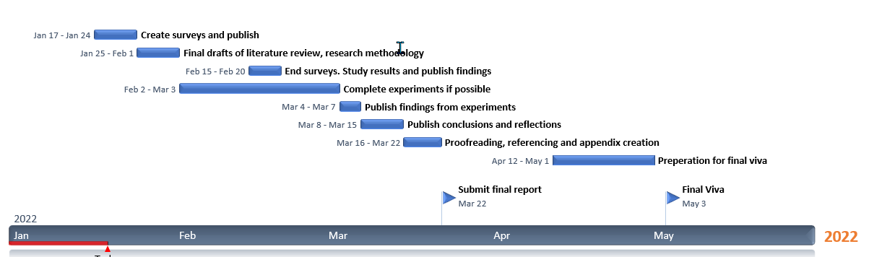
Figure 2 - GANTT chart

Design and Implementation
A survey is being used for this project, the reasoning for this is because it would be interesting to compare results to my literature review, to find out whether people are taking the same steps to secure their network, or whether things have gotten better or worse. It also allows for research using demographics.

4.1. Survey Design
For the project, a survey has been created using Google Forms. This survey is split up into five different sections, as follows.
(The use of the word ‘Devices’ means PC, Laptop, Tablet or Smartphone.)
- About you
This section is used to find out more about the demographic that is answering the survey. In this section, questions are asked about the age group of the respondent, as well as their gender, the first part of their postcode, whether they have been working from home as well as a general question about their internet access times.
- Your Home Network
This section is used to find out about a user’s home network. This section contains questions about their Internet Service Provider (ISP) as well as what brand router they have. It also asks them whether they are aware of their router settings such as passwords and asks them about various terms related to network security.
- Device Security
This section covers ways that people may secure their devices by using antivirus software, and also asks whether they are familiar with terms related to device security. The user is also asked whether they are securing their smartphone or tablet, and whether they are aware of antivirus being available for these devices.
- Phishing, Viruses, and Scams
This section asks users about their encounters with viruses and phishing scams. Users are then shown examples of emails and texts, four of which are phishing emails and one of which is genuine. This is a test to see if they can correctly identify the legitimate email.
- Final questions
This section questions users on their usage of online banking and shopping as these are high-risk activities where data may be stolen. These questions can be linked to earlier ones to find out if anyone is taking risks such as banking or shopping without antivirus software.
The objectives of the survey are as follows:
- To find out what steps people are taking to secure their home networks and devices
- To find out how often people carry out more risky activity online – such as online shopping and banking, where card details may be handed over
- To assess people on phishing emails and to find out whether people know what to look for
- To find out how knowledgeable people are of certain terms that may be used, and to get their interpretations of the definitions.
There is no specific target group for the survey, as it would be interesting to get different results from different demographics and see how they differ based on age/gender. There is also a question based on location, asking people to input the first part of their postcode to find out how far the survey has been shared.
As for the sample size, the survey is open to anybody over the age of 18. This means that there is a large sample size, and answers can be linked to certain demographics to achieve one of the projects aims – to find out whether the older generation is less tech-savvy than the younger generation, as is often stereotyped.
To prototype the survey, I shared it among a small group of family and work colleagues. One of the main comments that I had was the length of the survey, being twelve pages. However, I did not decide to change anything as five of the twelve pages are brief questions related to one vital area of the study which I did not feel could be removed. As well as this, they were basing this off the progress bar without actually seeing the questions. A lot of the other questions are simple checkboxes, with text input being used to gain knowledge of the people participating, to gather a user’s understanding of terms.
To gain responses on the final version of the survey, it was posted on Swansea area pages, my personal profile, as well as sent to friends around the UK to share with their friends and family. There likely is not any correlation between the area that people live in, and their understanding of the items mentioned in the survey, but it would be interesting to see how far the survey is spread around.

4.2. Survey Questions

Section One – About You
As mentioned earlier, this section is used to build a picture of who is answering the survey. The questions included are as follows:
- What is your age group?
This question has been asked to build up a picture of who is answering the survey based on age. This can be linked in with other answers to help achieve the main aim of this project. The options for this question are 18-24, 25-34, 35-44, 45-54, 55-64, 65 and over, as well as an option for those who prefer not to answer.
- Which gender do you identify as?
Again, this question could be used to build up a demographic, e.g., are women more careful than men on the internet, do men take more steps to secure their devices. However, doing this depends how many of each gender answer the survey. For this question, I have provided the options of male, female, non-binary as well as an option for people who prefer not to answer.
- What is the first part of your postcode (e.g., SA11)?
This will be used to find out how far the survey has been shared, as it is unlikely that location makes any difference on people’s knowledge of Internet security.
- Are you/have you been working from home as a result of the COVID-19 Pandemic?
This question features a yes or no question and can be linked in with home network security as well as some device security questions (However, most companies supply their own devices to home workers).
- How often do you access the Internet via a PC, laptop, tablet, or a smartphone?
This will be used to build a basic picture of internet usage, and can be used to link with certain questions – for example, are people who use the internet more frequently more careful?
Answers for the above question are more than six hours per day, 4-6 hours per day, 1-3 hours per day or less than one hour per day.

Section Two – Your Home Network
This section is used to find out which measures people are taking to secure their home network, as well as why they think they should take these measures.
- Who is your Internet Service Provider (ISP)?
This is used to get some insight into which company people use, and from doing this some basic knowledge can be gained on their security measures – for example, I know from prior usage that Sky do not have a secure router password, but Vodafone have a randomly generated passcode for the router settings, making it much more secure.
The options for this question are BT, Sky/NOW Broadband (As they are the same company), Virgin Media, TalkTalk, PlusNet, Vodafone, as well as an option for other providers or if people do not know who their provider is.
- Who is the manufacturer of your router?
Through some research in my literature review, there is a study that tested router brands to see how easy they are to hack. I plan to use this study as well as my survey to see what percentage of people are using more vulnerable router brands.
Options for this question are the router provided by their service provider, TP-LINK, Technicolor, Netgear, Asus, Belkin as well as an option for other brands and if the user does not know.
- Router security questions
The next three questions tie in with each other – asking users if they have ever logged in to change their router settings, and if yes, asking if they have ever changed the login from the default. The last of the three questions asks the user why they think it is important to change the router password.
This will be compared against the research I have conducted and will find out whether my sample size (which is quite small compared to the original survey conducted, but still comparable) have the same result as the survey conducted earlier. It will also evaluate the understanding of people related to the security of their routers.
- Which of these terms have you heard of?
The user is presented with a list of terms; Firewall, VPN, Antivirus/Antimalware, Phishing, Intrusion Detection System. The user can select all that apply to them, or if they have not heard any of them, select ‘none of the above.’ This question can be used to raise awareness of the least-heard-of items later on.
- Which of the following security measures are in use on your home network?
The options for this question are VPN, Firewall, Strong router password, Strong Wi-Fi passkey, Intrusion Detection System, Antivirus on devices, or none of the above.
This question, again, will be used to see how people secure their networks, and will also be linked with the age demographic to help with achieving the project aim.

Section Three – Device Security
- Which of these terms are you familiar with?
Again, this question is used to assess people’s knowledge of certain terms related to device security and can also be linked in with the age demographic. The next question asks the user to explain their interpretation of the terms that they have selected to see whether they understand them correctly. I am not expecting them to explain all of the terms, just one or two that they have chosen. The options for this question are viruses, malware, phishing, worm, tech support fraud, trojan horse, or none of the above.
- Are you aware that Antivirus and Antimalware software is available for smartphones, and tablets / Do you have Antivirus or Antimalware installed on your smartphone or tablet?
These questions link in with the ONS survey mentioned at the start of the report and asks users whether they are aware that it exists and if they have it installed. I would like to compare the results of this question with the results found in the ONS survey to see if they are comparable or different.
- Do you have antivirus or antimalware software installed on your PC or Laptop? /If not, please explain briefly why you do not have software installed/Do you use a free version/paid version?
I have tied these three questions together as they relate to antivirus and antimalware on a PC. I am expecting a lot of the explanation responses to be because the user has a Mac – this is because of a common misconception that Macs and Apple devices cannot get viruses, even though they are just as likely.
The paid subscription question is there as it would be interesting to know what people pay extra for. The next question asks the user for which brand of antivirus they are using, so these questions can be linked together and a list of features that users pay extra for can be developed.
- Please answer ‘no’ to this question.
This is a reality check question, to ensure people are not clicking through and choosing random options, which could lead to inaccurate statistics.
- Which brand of antivirus or antimalware do you use?
Please see question 3 for an explanation for this question as it is linked in. The answers for this question are Malwarebytes, Norton, Avast, Avira, AVG, Windows Defender, Other/I don’t know or an option for those who do not use antivirus.

Section Four – Phishing, Viruses, and Scams
- To your knowledge, have any of your devices ever been affected by a virus or malware?
This is a simple question to find out whether anyone has been affected by a virus or malware, I am expecting the answer to be an overwhelming yes.
- If the answer to the above question is Yes, what were the ‘tell-tale signs’ you encountered?
This question asks the user what made them suspicious of their device encountering a virus or malware. The answers listed are Device running slowly, Loss of storage space, Loss of files, Virus scan coming back positive, Pop-up windows, Change of browser homepage or search engine, or Other.
- Have you ever encountered a phishing scam/Have you or anyone else that you know been affected by a phishing scam?
These questions tie in together, I am expecting the answer to the first question to be an overwhelming yes. I would like to compare this to the ages of the people undertaking the survey to see whether more older people have been affected by phishing than younger people.
- Have you noticed an increase in phishing scams due to the COVID-19 Pandemic?
This asks the question to tie in with one of the sources in my literature review, to evaluate whether there are more phishing scams now compared to before the pandemic.

Section Five – Phishing Scam Examples
In this section, I have gathered four phishing emails or websites, and one legitimate email. I have asked the users to identify whether they think each image is a phishing site/email or a legitimate site/email, and I have asked them why they think the site or email is legitimate or illegitimate.
For each example, the following questions have been asked:
- At first glance, do you think the email/text message/website (whichever applies) looks legitimate?
- Are there any elements of the image that seem legitimate? Please briefly explain.
- Are there any elements of the image that do not seem legitimate? Please briefly explain.
These questions should be able to find out how educated users are regarding Phishing emails, and whether they fully know what to look out for, or whether they would fall for certain elements of the email.

Example One – DPD Phishing Email
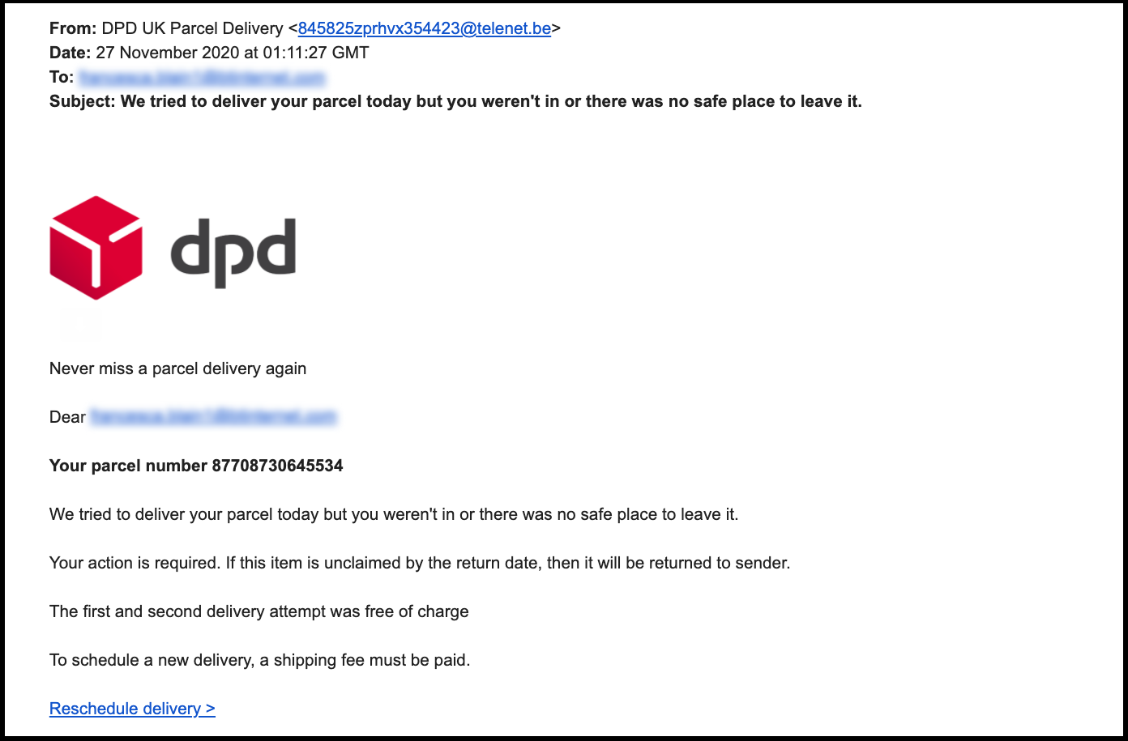
Figure 3 - DPD Phishing Email
Figure 2 shows a phishing email pretending to be from DPD. The elements that make this email look illegitimate are as follows:
- The sender e-mail address.
- DPD will not ask for a payment for redelivery.
- Fake parcel number
- Sent at 1AM (Even though this could be timed to look like an end-of-day email)
- Link is hidden by text and not copy and pasted.
Elements that could lead a user to fall for this email are as follows:
- Could be waiting on a parcel delivered by DPD (Coincidence)
- Use of DPD logo
- Decent spelling and grammar which is unusual for a phishing email

Example 2 – HMRC Phishing Email
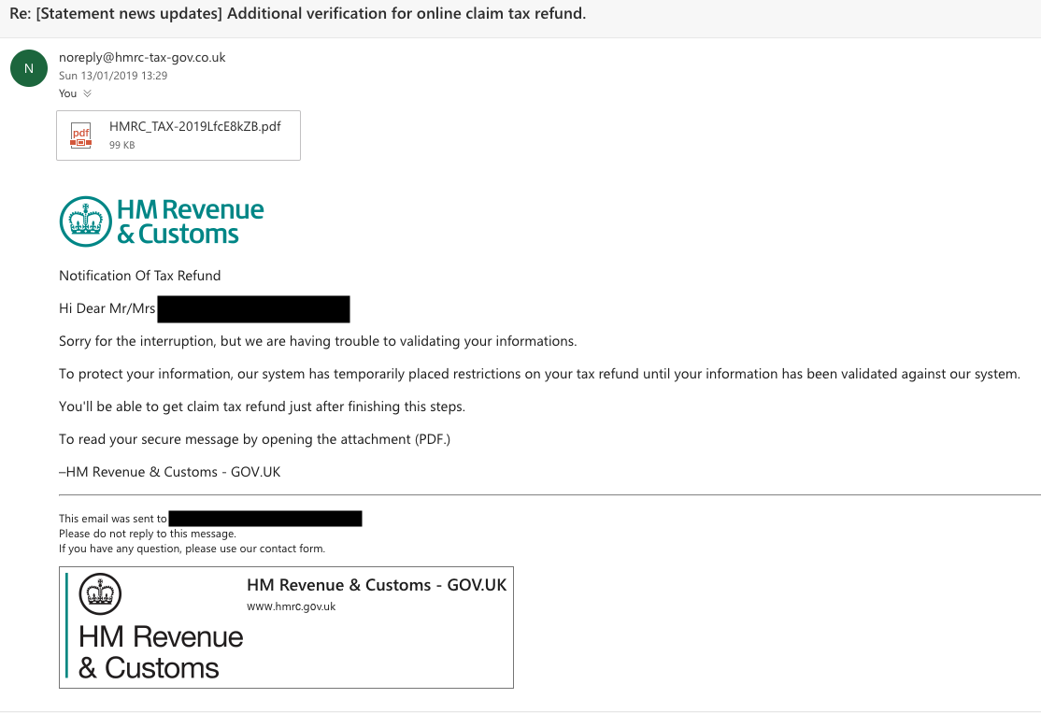
Figure 4 - HMRC Phishing Email
Figure 3 shows a phishing email pretending to be from HM Revenue and Customs. The elements that make this email look illegitimate are as follows:
- Poor spelling and grammar
- HMRC send letters, not emails
- Not sent from a gov.uk email address
- Link at the bottom of the email looks suspicious
The elements that make this email look legitimate are as follows:
- Logos and featuring the person’s name (Could have been involved in a data breach)
- Use of ‘no reply’ email address
- No link to submit personal data although this could be on the PDF document.

Example 3 – Genuine email from Skrill (Online wallet)
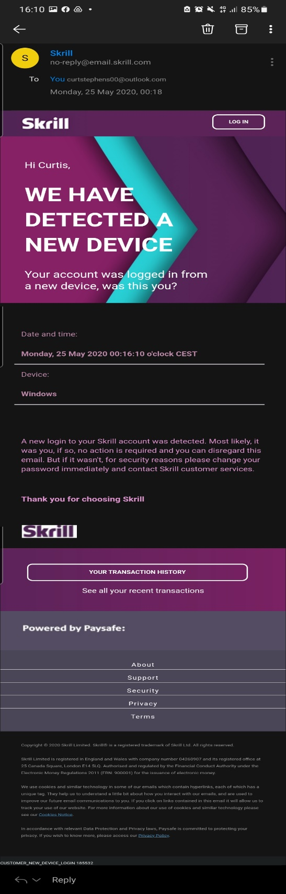
Figure 5 - Genuine Email from Skrill
Figure 4 shows a genuine email from Skrill, an online wallet used for regular and cryptocurrencies.
Elements that make this email look illegitimate include:
- Links are hidden, not plain text/copy and pasted
- Vague information – no specific login location

Elements that make this email look legitimate include:
- Name featured at the top
- Legitimate email address
- Precise time of login and email was expected when logging in
- No link to change password directly and/or contact customer services

Example 4 – NHS Phishing Text
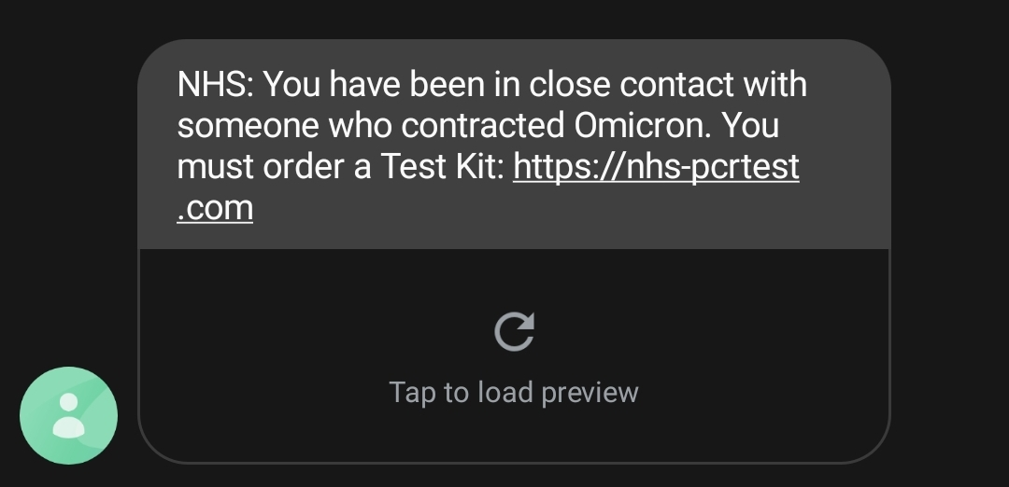
Figure 6 - NHS phishing text
Figure 5 shows a phishing text that I received pretending to be from the NHS claiming that I was in close contact with somebody with COVID-19.
Elements that make this text suspicious include:
- Non-genuine link – NHS-pcrtest.com is not the correct site to book tests.
- Test and trace will call, not text.
- Test and trace will not tell you the variant
- I had not used track and trace for any premises in the 2 weeks prior to this text.
Elements that people may fall for include:
- ‘NHS’ at the start of the text – makes it look more official – social engineering
- People are more likely to click the link as it involves COVID (As mentioned in the literature review)
- Current trend – Omicron – This was sent at a time where Omicron was new, meaning everyone was uncertain about it.

Example 5 – GOV.UK Phishing Website
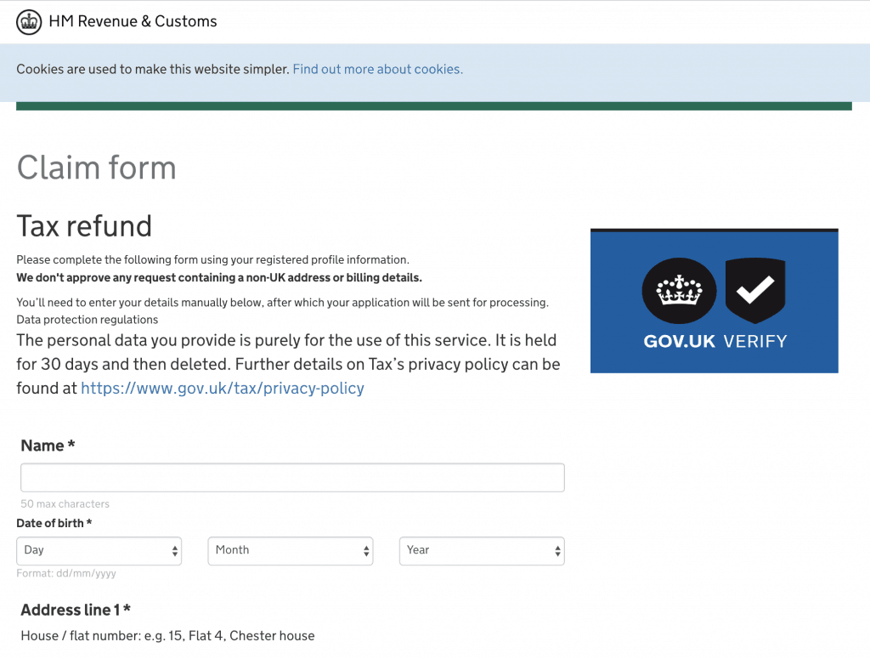
Figure 7 - Fake HMRC data input page
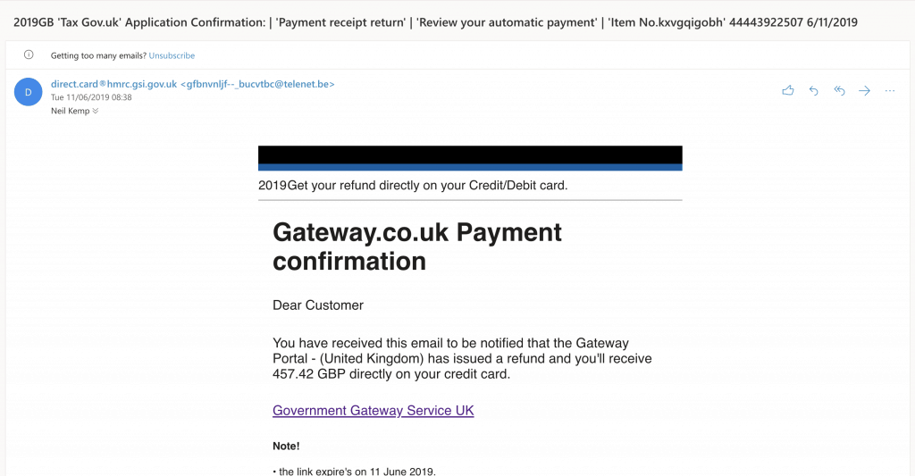
Figure 8 - Fake HMRC phishing email
Figure 9 - Suspicious HMRC link
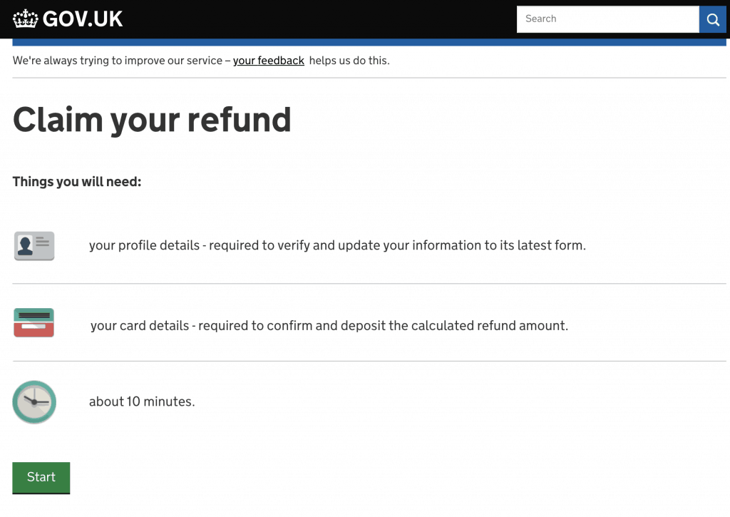
Figure 10 - Landing page from the link featured in the email
Figures 6, 7, 8 and 9 show a fake HMRC tax refund form. Items on this form that make it seem illegitimate are as follows:
- ‘GOV.UK VERIFY’ image seems slightly distorted
- ‘Cookies are used to make this website simpler’ – Cookies are used to track people’s online activity, not make a website simpler.
- Billing details should not be required, HMRC send out cheques for tax refunds.
- Figure X shows the link for this page, despite having HTTPS:// at the start to attempt to convince the user that the page is legitimate, the link is not a genuine gov.uk link as it would be.
Items on this form that a user may fall for are:
- Link to a privacy policy – goes to a genuine government page.
- Data protection details
- Decent spelling and grammar
- Formatted like a government webpage, e.g., imagery, fonts.
Figure X shows the email that leads to this form. Items on this email that make it seem illegitimate are as follows:
- Extremely poor grammar
- Amount would not be disclosed in the email
- Again, HMRC send letters and not emails
- HMRC would not refund to a card, but instead send a cheque
- ‘Dear customer,’ does not feature the person’s name
- Link is hidden by alt text
- The email account is very suspicious
Elements that make this seem legitimate are:
- The username assigned to the email account makes it look like it has been sent from a government email.
- Honestly, nothing else makes this email look legitimate. It is a poor attempt at a scam.

Section Six – Final questions
Finally, at the end of the survey, I have included the following questions:
- How often do you use online banking through any device?
- How often do you shop online?
These questions can be linked into the literature review and the ONS survey related to these uses. As well as this, they can be broken down into age demographic – do younger users shop and bank online more than older users?
As well as this, these questions can also be used to tie-in with device and network security – are people doing these activities on devices that could have viruses that the user does not know of, that could be stealing their data?

Analysis and Findings
For this section, I will be going through the given answers for my survey and reviewing the answers that were given. Through this, links can be created between questions which will help me to achieve my aim and to potentially prove my hypothesis.
The total number of respondents to this survey was 82. There were 84 original respondents however two failed the reality check questions so their responses were deemed invalid.

About You

Figure 11 – Chart showing the age groups of respondents
Figure 2, above, is a graph showing the age groups of the respondents to my survey. The majority of respondents were in the 35-44 age group. It would have been more ideal if there were more respondents in the 65 and over age group, however it has been planned to group together the responses from the 55-64 and 65 and over age groups and compare them to a random sample from the 18-24 and 25-34 age groups.

Figure 12 – Chart showing what gender respondents identify as
Figure three shows the amount of people who identified as each gender who answered. There were almost two times as many females than males which I found to be quite odd, as I anticipated there being a 50/50 split. Regardless, this does not make much difference to the outcomes of the survey.
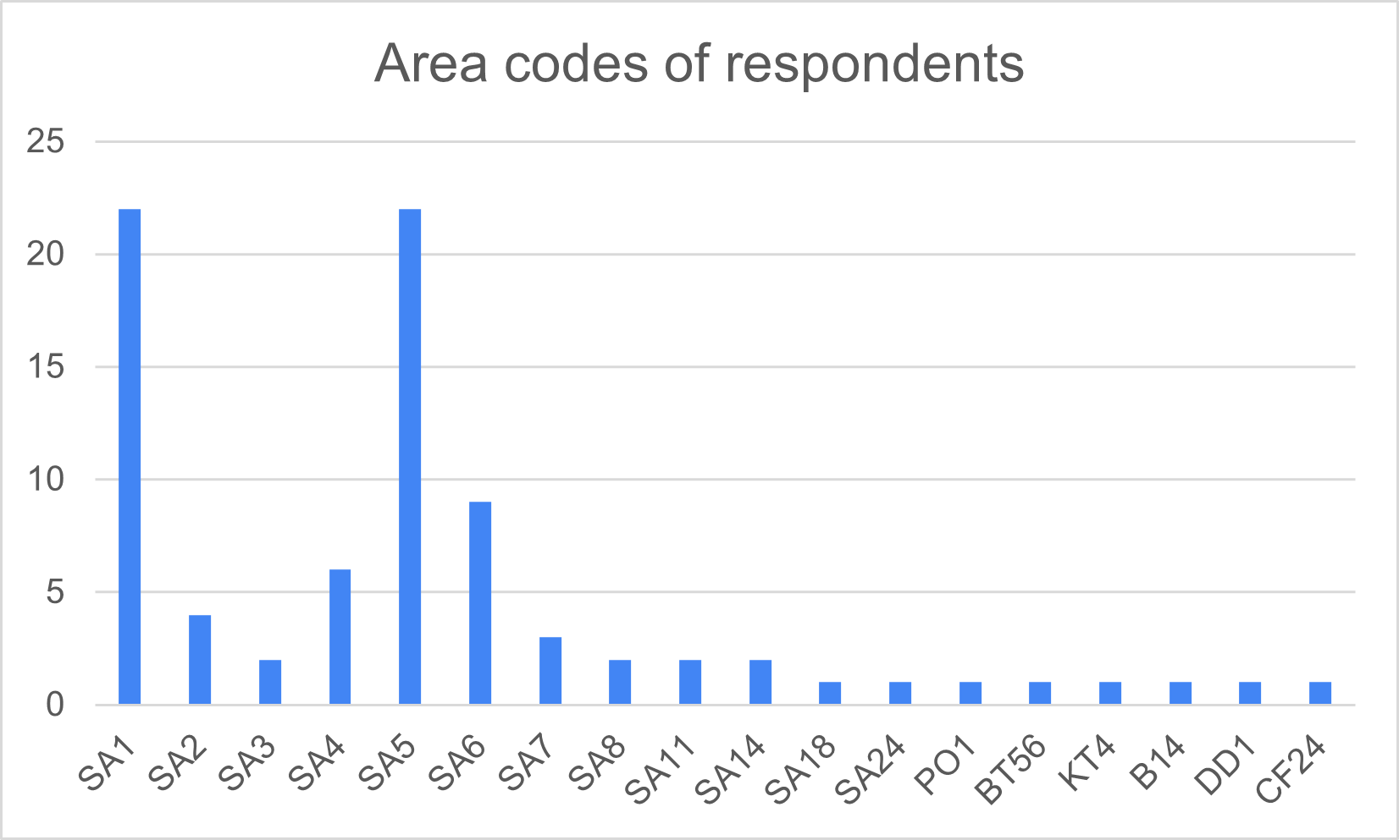
Figure 13 – Chart showing where the respondents to the survey live
Figure 4 shows where the survey has been answered from. The majority of respondents resided in the Swansea area, in the SA1 (Swansea central), SA6 (Llansamlet) and SA5 (Swansea West). There were also responses from outside of Swansea, from PO1 (Isle of Wight), BT56 (Belfast), KT4 (Worcester Park/Surbiton), B14 (Near Birmingham) and DD1 (Dundee). The responses outside Swansea may have been people who have previously lived there and moved, or people to whom the link has been shared.
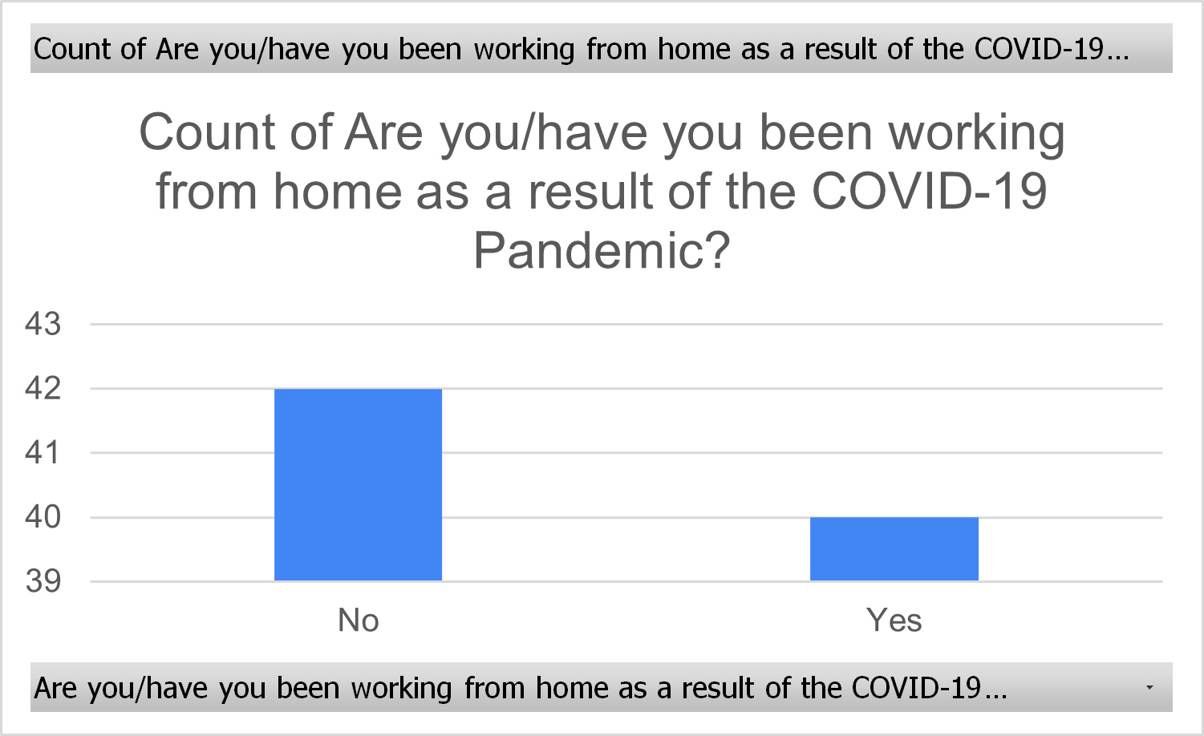
Figure 14 – Chart showing what proportion of respondents have been working from home
The above chart, figure 5 shows that there is slightly less than a 50/50 split in people who have been working from home during the pandemic. 41 people responded Yes, and 43 people responded No to this question.

Figure 15 – Chart showing how often people use the internet
Figure 6 shows a bar chart of how often people use the internet. 59 people responded that they use the Internet more than six hours per day, 20 people responded that they use the Internet for 4-6 hours a day, and five stated that they do not use the Internet for more than three hours per day. Later this statistic will be combined with age – does internet usage go down as people get older?

Your Home Network

Figure 16 – Chart showing which Internet Service Provider people use
Most people had Virgin Media as their provider, with Sky or NOW Broadband (Both owned by the same company) came into second place. Virgin Media have a randomly generated router password, however Sky and NOW use generic logins – with the password being either ‘sky’ or ‘nowtv.’
Sky is the only ISP who do not use a specific password for their router settings, meaning that they have a much lesser amount of security on their devices.

Figure 17 – Chart showing which brands of router people are using
Figure 8 shows that most people use the router provided to them by their service provider. Around 20 people did not know who provided their router or did not use a big-name brand, so for these it will be assumed that they are using branded routers not provided by their ISP.
Routers provided by ISPs apart from Sky/NOW are quite secure. Routers with a brand name rely on the user to set their own password, so if they do not login before a hacker, the hacker can set their password quite easily. Some also have a generic login.

Figure 18 – Chart showing how many people have logged into their router
The responses to this question show that most people have not logged in to change their router settings, and therefore have not changed their login password. The next question asks how many people of the people that said Yes have logged in and changed their password.

Figure 19 – Chart showing how many people have changed their router login
Surprisingly, the majority of people that had logged into their router previously had changed their router login and password. There were 39 people who had changed their default login, which is not the majority of respondents, but surprisingly is not far off.
The next question asked users whether they think it is important to change their router login, and why.
36 people answered that they have not changed their login from the default, either because they do not know how to or because they feel that the default login is secure enough. Some respondents left the answer as a plain ‘no’ without explanation.
The default login being secure enough is a common misconception because as mentioned earlier, some router brands set their login to a default which is generic across all devices, and therefore is not secure. This will be linked with the brand of router people are using as well as their ISP to find out whether they are using a secure router with a truly random password.
The age range of people who had logged in to their router was pretty even. The modal age group was 35-44, with responses being quite even either side of that.

Figure 20 - Chart showing how many people from each age range have logged into their router settings

Figure 21 - Chart showing how many people from each age range have changed their router login
The graphs follow a similar data trend, with more people from the 35-44 age range changing their router login than any other age range. However, 35-44 is the age group with the most respondents. As can be seen in the pattern of the graph below, the responses to this question follow the trend of the age groups that answered the survey.

Figure 22 - Chart showing the age range of respondents
However, based on the age ranges, this can be worked out as percentages.
Table 2 - percentages of people who have logged into, and changed their router password based on age range
Age Range | Percentage that has logged into their router | Percentage of those that have changed their router login
18-24 | 42% | 33%
25-34 | 40% | 20%
35-44 | 45% | 41%
45-54 | 50% | 43%
55-64 | 60% | 60%
65 and over | 28% | 14%
From this table, it shows that the middle-aged population (35-64) have taken more precaution in regard to router security. The younger generation gained a lower score, which is quite surprising as they are regarded as the most knowledgeable people when it comes to security.
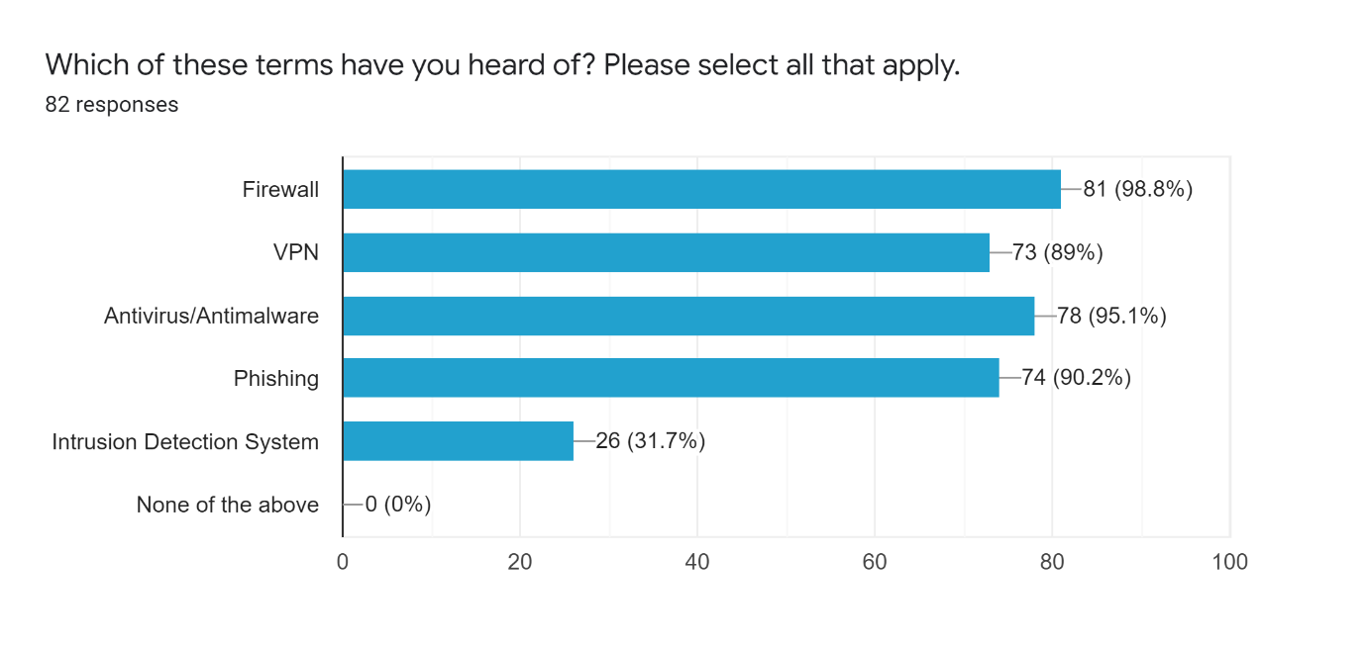
Figure 23 – Chart showing which terms people have heard of
Surprisingly, a lot of people had heard of most of the terms, with one person not ticking Firewall. For this question, this could be filtered by age, to show which age group is answering with which security measure(s).

Figure 24 – Chart showing how many terms have been understood per age range
As can be seen in the chart, the result from this chart shows that the older generation as well as the younger generation have a better understanding of things compared to the middle-aged generation (35-64 years of age).

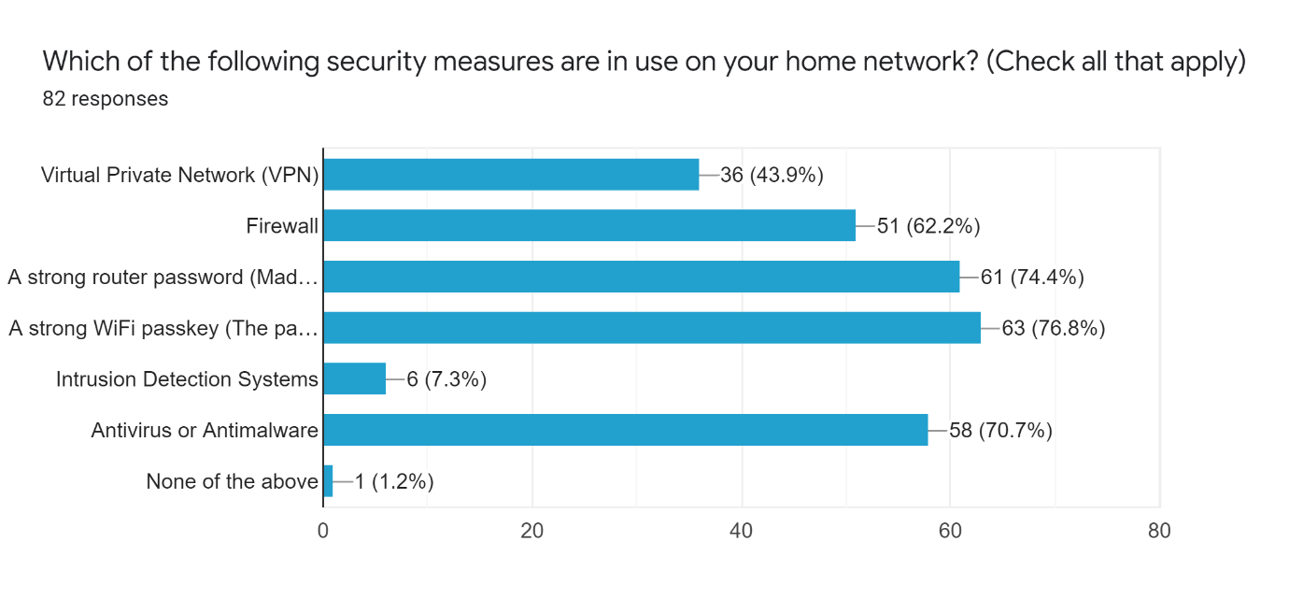
Figure 25 – Chart showing which security measures people have in place on their home network

Figure 26 - Chart showing how many measures people have on their network, by age range
Most people had a strong Wi-Fi passkey in place, mainly because they are autogenerated by the router and do not need to be changed unlike the router login. A lot of people had a strong router login in place as well, possibly because they use the autogenerated one by their ISP.
By age, this question produced a mixed bag of results. There is not really a definitive answer to the question of which age generation takes the most precaution in regard to their home network security, as 55-64 and 25-34 both have similar results.

Device Security
The next questions were based on the ONS survey, which is referenced in the introduction of this report, and looked into smartphone security.

Figure 27 - Chart showing how many people are aware of antivirus for smartphones and tablets

Figure 28 - Chart showing how many people have antivirus installed on their smartphone or tablet

There is almost a 50/50 split between people who do and do not have the software installed on their smartphone or tablet, whilst around 20 people are not aware that it is unavailable or do not know whether it is installed. In the survey mentioned above, 54% of people either did not have any security installed or did not know it existed. In this survey, a staggering 70.8% of respondents did not have security installed or were unaware that it is available.
Percentages have been used to break this down by age category. If a respondent answered, ‘I am unaware that it is available’ to the previous question, the response to this question will be changed to that, instead of ‘No’ or ‘I don’t know.’ The percentages are as follows:
Table 3 - Percentage of how many people have antivirus on their smartphone or tablet, by age category
Age group | Yes | No | I don’t know | Unaware that it is available
18-24 | 20% | 70% | N/A | 10%
25-34 | 33% | 33% | 17% | 17%
35-44 | 39% | 22% | N/A | 39%
45-54 | 54% | 38% | N/A | 8%
55-64 | 60% | 20% | N/A | 20%
65 and over | 72% | N/A | 14% | 14%
It is evident that as people get older, they take more precautions to secure their mobile phones and tablets. This could be due to younger people being more complacent, potentially thinking that because they do not think they go to any websites that may harm their devices, or download any files that may compromise their device, even though it may be easier than they think to do so.
As well as smartphone and tablet security being on the rise as age goes up, it is also evident that computer and laptop security increases with age, as shown in the table below:

Table 4 - How many people have antivirus or antimalware installed on their computer, by age category
Age group | Yes, I have antivirus or antimalware installed | No, I do not have antivirus or antimalware installed
18-24 | 82% | 18%
25-34 | 71% | 29%
35-44 | 91% | 9%
45-54 | 100%
55-64 | 90% | 10%
65 and over | 100% | N/A

The next question asked people whether they have antivirus or antimalware software installed on their PC or laptop. Out of 82 responses, 72 said yes and 10 said that they do not.

Figure 29 - Chart of how many people have antivirus or antimalware installed on their PC or laptop
After that, there is a question asking the user for reasoning behind not having antivirus. A lot of the responses said that they used a Mac, which is a common misconception. Apple have a strong inbuilt security feature on Mac and Macbook, but they are just as vulnerable to attacks as PCs.
Some people said that they do not access websites that are risky, or download suspicious software. Unfortunately, this attitude often leads to people becoming more vulnerable to attacks as they do not take any precautions, and it only takes one bad download or click to get a virus on a device.

Phishing, Viruses and Scams

Figure 30 - Chart showing a percentage of people who have had their devices affected by viruses and/or malware
Surprisingly there was a near 50/50 split in response to this question, it was expected to be an overwhelming Yes.
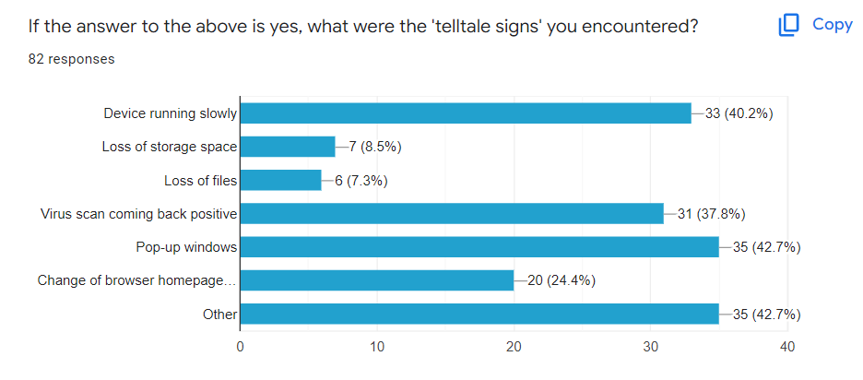
Figure 31 - Chart showing the tell-tale signs people had when their devices had a virus or malware
Most people found that their device either ran slowly or received pop-up windows when infected with a virus. They also said that a routine virus scan came back positive, which is why it is important to have scheduled virus scans. A change of browser homepage was a slightly less common answer – this usually means that extensions have been installed by a virus. As well as this, there may be an almost unnoticeable redirect to another website when a link is clicked – this is a way for attackers to gain ad revenue.

Figure 32 - Chart showing how many people have encountered a phishing scam
As expected, the answer to this question was an overwhelming yes. It is unlikely that people go without seeing a phishing email pop into their inbox – however, they are not always easy to spot, and this becomes apparent in the next section of the survey.

Figure 33 - Chart showing how many people have seen a rise in Phishing due to COVID-19
A little over 75% of people have claimed to have seen more phishing scams as a result of the COVID-19 pandemic. This links back to the literature review findings that people are probably more likely to click on a phishing link related to COVID-19 due to emotional factors.

Phishing Scam Examples
For each of these questions, users were asked whether they thought the material was legitimate or a scam and were also asked to briefly explain why they would think it is legitimate, and why they would think of it as a scam.
Figure X, above, shows a phishing email pretending to be from DPD, the courier company.

Figure 34 - Chart showing how many people correctly identified the DPD phishing email

50 people, around two thirds of respondents correctly identified the email from DPD as a phishing email.
Most users picked up on the following as to why the email could seem legitimate:
- The use of the DPD logo
- Parcel number – if someone is expecting a delivery, they could receive this email and trust it due to coincidence.
- Good spelling and grammar
- Layout of the email is similar to that of a genuine DPD email.

The reasons why users disregarded this email are as follows:
- Email address not being relevant to DPD
- No named recipient
- Asking for a charge for redelivery, DPD would not ask for this
- The time that the email was sent (Around 1AM)
- Threat of loss if no action is taken
From this example, it is evident that people would be led to believe a phishing scam due to the use of logos in the email, and if the email is formatted similarly. As well as this, a string of random characters which is said to be a parcel number is an easy way to fool people.
Figure X is a phishing email claiming to be from HMRC. For this one, 33 people thought the email was legitimate, where 49 people correctly thought it was a phishing email.

Figure 35 - Chart showing how many people correctly identified the HMRC phishing email
People picked up on the following in terms of it looking legitimate:
- The use of the HMRC logo
- The senders email address – this is quite clever as it is made to look legitimate, and people were persuaded by the ‘gov’ part.
- Inclusion of fine print
- Use of ‘no reply’ email address
- Use of more formal language
People said that the email did not look legitimate because:
- Poor spelling and grammar
- HMRC will always send a letter, not an email
- Tax refunds are usually automatic and not applied for
- No mention of recipients’ name
- PDF document looks illegitimate
- Whole email just ‘feels off’
This was quite a clever email, as the sender made sure that they used a more convincing email address. As well as this, people again picked up on the use of the HMRC logo, which is quite concerning, as anyone can put a logo on an email and appear as a company. If the spelling and grammar were correct, this email would catch more people out.
Figure X was a genuine email from Skrill, an online wallet typically used for cryptocurrency and other online transactions.
Most people correctly picked up that this was a legitimate email, with 69 people saying it is legitimate, and only 13 thinking that it was not.
Figure 36 - Percentage of people who correctly identified the Skrill email as genuine

Users said the email looks legitimate because:
- Contact details for the company in the email
- Date and time of the email match the date and time of the login attempt
- Does not ask anyone to click on any links, but instead log in on the site.
- There are terms and conditions on the email which may not be used on a scam email
- The email looks more professional than a phishing email
Meanwhile, users said it does not look legitimate because:
- The device is listed as ‘Windows’ which seems like a vague guess
- Use of CEST rather than GMT
- Email looks too elaborately designed for such a simple purpose
This email was a genuine email that was received after logging in on a laptop for the first time. The email features a name, the email address is a legitimate email address, and it does not have a link to log in. The time the email was sent also lines up with the login attempt.

The fourth example (figure x) was a text message pretending to be from the NHS, claiming that the recipient was a close contact of someone with Omicron, and told them to order a testing kit from a website which asked for card details, despite them being free at the time.
Figure 37 - Percentage of people who correctly identified the NHS text as a scam
Most people correctly identified this as a phishing text. The reasons for this are:
- Lacks detail
- Says the strain of covid, which is not typically named in a legitimate text
- Does not mention the recipient’s name or any other details
- Asks user to pay
- URL is not a genuine NHS link
- A lot of people, without reason, stated that the text does not look legitimate at all
The reasons people gave for this email looking legitimate are as follows:
- Spelling and grammar are not too bad
- Use of ‘NHS:’ at the start makes it look like a genuine NHS text at first glance
- Relevant to recent events
- May look legitimate to someone who has not seen a track and trace text before

The final example (figure x, x, and x) was an email, a website URL, and the webpage masquerading as HMRC. Surprisingly, most people that responded thought this was a genuine HMRC email and webpage.

Figure 38 - Percentage of people who correctly identified the HMRC material as a scam
The reasons that respondents thought the website was legitimate were:
- The formatting of the webpages are remarkably similar to that of the government
- Website has a padlock in the address bar which implies to users that it is a safe website
- Colour scheme and imagery are similar to what the government would use
- Use of correct fonts
- Using links that direct to the actual government website, e.g., privacy policy
- The URL looks like something that the government could use, and this did fool some people.
The reasons for people thinking that the website is not legitimate were:
- Government would not send an email or ask for bank details
- The government would send a cheque, not deposit into your bank account
- HMRC would ask you to login via Government Gateway, not confirm your details on a webpage form
- The URL, which looked real enough to fool some people.
- ‘HMRC Verify’ logo on figure x looks pixelated.
After filtering out the responses, it was found that only 11 people managed to correctly identify the phishing scams from the genuine email. Only three of these people were aged over 54.

Figure 39 - people who identified all 5 phishing scams correctly
Meanwhile, there was one respondent, aged 35-44 who answered all this section incorrectly.
25 people, and the majority of respondents answered four of the questions correctly, with the majority being within the 35-44 age bracket. Three age categories tied at five, with 25-34 surprisingly being the lowest age bracket to answer four correctly.

Figure 40 - People who correctly identified four phishing scams

Figure 41 - People who correctly identified three phishing scams
All but one person over the age of 65 answered three or more of the questions correctly.

Figure 42 - people who only identified 0-2 phishing scams
Surprisingly, the 35-44 age group identified most of the phishing materials incorrectly. This could be down to factors such as more awareness being aimed towards the older generation and/or the elderly, as well as younger people (Under 35s) being more aware as phishing is something that they would have learned about more in school than the middle-aged respondents.

Final Questions
This section asked users two questions: how often they used online banking, and how often they used online shopping.

Figure 43 - how often people use online banking
As expected, most users used online banking services at least once or twice per week, and most use them more than that. This was different before the pandemic, with people being more reluctant to leave their homes during the pandemic and becoming more familiar with, and therefore using online banking services more.
In the literature review, there is a source comparing online banking usage with age. Therefore, a table has been created using percentages to compare with the research, to see whether this remains similar.
Table 5 - How often people use online banking, as a percentage by age group
Age group | More than once per day | Once per day | Once or twice a week | Once every fortnight | Once a month or less | Do not use online banking
18-24 | 42% | 25% | 33% | 0% | 0% | 0%
25-34 | 40% | 20% | 27% | 7% | 6% | 0%
35-44 | 18% | 45% | 32% | 0% | 0% | 5%
45-54 | 31% | 31% | 31% | 7% | 0% | 0%
55-64 | 20% | 30% | 40% | 0% | 10% | 0%
65 and over | 0% | 14% | 43% | 14% | 29% | 0%
From this table, it shows that younger people (18-34) log onto online banking more than once every day for the most part, whereas older people mostly only check their accounts once or twice a week. This could be due to the rise in online banking apps and app-based banks such as Monzo, Revolut and Chase starting to take over as they provide better services than high street banks.
However, this also means that the younger generation could also be more vulnerable to attacks on their bank accounts, as it has been found above that they are less likely to have any form of security on their mobile devices, and the people that did not have antivirus or antimalware on their devices are all from the younger generation.
The final question in the survey was how often people shop online. The results to this question are as follows:
Table 6 - How often people shop online, as a percentage by age group
Age Group | More than once a day | Once a day | Once or twice a week | Once a fortnight | Once a month or less | Does not shop online
18-24 | 8% | 0% | 25% | 25% | 42% | 0%
25-34 | 27% | 7% | 33% | 13% | 13% | 7%
35-44 | 5% | 8% | 55% | 14% | 18% | 0%
45-54 | 19% | 19% | 50% | 6% | 6% | 0%
55-64 | 0% | 0% | 50% | 10% | 40% | 0%
65 and over | 0% | 14% | 43% | 14% | 29% | 0%
The trend appears the same for all age categories, where most people shop online once or twice a week. Surprisingly, 18–24-year-olds have the highest percentage for people choosing to shop online once a month or less, however that could be because they are more likely to go out to a shop rather than shop online, whereas older people may use online shopping to order groceries and the like.

Evaluation
The findings produced from this survey show many different things. For example, it is shown that the older generation take more precaution when securing both their PCs and laptops, as well as their smartphones and tablets. They were also good with spotting the phishing scams.
More people from the survey sample had logged into the router settings than had been stated in the literature review – only 44% of people had logged into their router interface and changed the password in the reviewed literature, however the survey showed that 61% of respondents had changed their login from the default, which could be due to awareness being brought up from ISPs – some now tell their customers to change the login from the default.
Another source pointed out that just over 70% of the older generation used online banking at least once a week – this has been proven true from the survey sample used for this project, as most of the older generation claimed to use online banking at least once or twice a week.
Another source used in the literature review claimed that people used items such as fonts, imagery, headers, and footers in determining whether a phishing email was genuine or not. They also claimed that people used items such as order numbers to determine whether the materials were genuine or not. As can be seen from the survey results, most people mentioned logos and order numbers for some of the materials, as well as official wording. People also seemed to look at the content of the email over the context that it was sent in.
In terms of the aims that were established at the beginning of this project, most of them have been met, with some exceptions.
Researching to gain a better knowledge and understanding of current internet and network security issues.
This aim was researched in the literature review, where issues such as phishing scams related to COVID-19 were investigated. As well as this, router security was investigated to be able to get a better understanding of security measures that could be take, as well as measures that people could be taking to secure their network better.
Carrying out surveys with a wide audience to find out how far people are going to keep their home network and devices secure, as well as finding out how susceptible they would be to a phishing scam.
This aim was achieved in the above section, with people answering questions on various phishing scams, as well as questions on their home network and device security. These answers were also tied in with age to achieve the main aim of the project.
Researching and experimenting with Virtual Private Networks (VPNs) to better understand how they could work within a home network regarding safety.
VPNs were briefly researched in the literature review, however due to time constraints it was quite difficult to do any in-depth research with them. Despite this, the survey produced some satisfactory results which can be used to research further.

Conducting research on phishing scams to find out if, and how they can relate to network security – can they be used to take control or change administrative settings on a home network?
In the literature review, there is a section from a report which stated that phishing can be used to hack into a home network – albeit in a slightly different way. This can be done using clickjacking and tab jacking, using UI redressing.
Conducting research into how the COVID-19 pandemic relates to network and device security – Did the pandemic lead to more victims of online fraud or hacking?
The source in the literature review stated that the answer to this question is a yes – a lot of people felt that emotional factors such as fear, distress and anxiety linked to COVID-19 influenced their choice to react to a phishing scam, especially since the beginning of the pandemic. As well as this, respondents to the survey claimed they noticed a rise in COVID-related phishing scams, and a lot claimed that official looking language would influence them to click on a phishing link.
Finally, the main aim:
To investigate and produce a strategy to help people keep their home network and devices safe, whilst looking at user demographics – Are younger people more careful than the older generation, or is it just a stereotype?
In a short answer – this is just a stereotype.
The answers from the survey did not actually indicate any age group was less careful with their network and device security overall – the different age groups all had flaws in different sections. For example, the middle aged (35-54) were less careful and less observant when it came to the phishing scams. A theory for this is that there are no awareness campaigns targeted at this group – only to the over-60s and when taught about the scams in school. As well as this, the middle-aged are possibly more likely to be under financial stress with bills having to be paid, so they may be better influenced by reward. However, the survey results showed that the middle-aged were better when it came to router security, with them being the group that was more likely to have changed their password from the default, when worked out by percentages.
Meanwhile, the younger generation (18-34) were less careful when it came to device security, both on their PCs and laptops, as well as their phones and tablets. The responses seemed to correlate – the older the respondent was, the more likely it was that they had some form of security on their devices. This could be due to younger people being more complacent – thinking that they do not download or visit unsafe material, even though it seems inevitable that they will at some point.
The answers from the older generation showed that they did not secure their routers well. Of all the respondents, the lowest percentage to secure their routers came from the older generation, meaning that more awareness should be brough to this aimed at the older generation.
Overall, the answers were not what I expected them to be. I expected the results to conform to the stereotype – that the older generation would be less knowledgeable regarding Internet security, however that turned out to be the opposite at times, with the younger not taking steps or not recognising threats.

Conclusion and Recommendation
In conclusion, the results that were received helped to answer the question that has been set out in the aim of the project. Despite the results for each section being different and only one of the sections ‘conforming to the stereotype,’ the results achieved helped to disprove the hypothesis that was set out earlier in the project, that the older generation are less knowledgeable about technology and that they are less careful in regard to Internet and home network security.
The recommendation based on the findings of this study is that there should be different campaigns aimed at the different age groups – especially a campaign aimed at 35–54-year-olds based on Phishing, as it is quite worrying that a lot of that age group are unaware of how to spot a Phishing scam. There should be a lot more awareness about the subject anyway – especially with people in no position to lose money when the cost of living is so high.
A campaign should also be aimed toward the older generation, which explains to them how they could better secure their home network, with tips on router security as well as basic things such as up-to-date virus protection, and up to date information based on recent threats.
Meanwhile, more awareness should be given to the younger generation regarding protecting their devices, as well as more awareness of the types of device security that are available, for example, smartphone and tablet security which is especially important to have currently where people have their lives in the palm of their hands.
With the cost of living so high nowadays, people are likely to face similar levels of stress that they faces when the COVID-19 pandemic struck, and therefore are potentially just as likely to react to a phishing email – and with the focus being on energy prices, it is very likely that people are going to send materials attempting to masquerade as these energy companies in an attempt to steal data.

Suggestions for further work
In the future, it would be interesting to repeat this study to see whether people are taking these extra steps, and to see if awareness has grown regarding the ways that people can protect their devices and home networks.
As well as the above, more research on VPNs in regard to their uses could be completed. People use VPNs for more things than working from home, and as mentioned earlier, they are used to watch TV shows in other countries, hide their location whilst watching online sports streaming services, and to keep connections private. Another survey-based project would be optimal for this, as this could be filtered by demographics.
In addition to this, this study could be turned into an experimental study as originally planned, albeit with a different aim. The aim could be something like evaluating router security by brand and finding out which brand is the most, as well as the least secure.

Reflection
In reflection, I feel that this is a good piece of work and that it has covered most of the bases that I set out to cover. However, there are, of course, a few things that could have been done better, or added to the project to make it better.
Firstly, I would have liked to complete more practical experiments, such as experimenting with routers and performing penetration testing on them, to see just how easy they are to hack. This was originally the plan as set out in my project proposal and during my interim viva, however due to time constraints and having to plan for exams for other units, I decided to keep it purely survey based, which has produced a good set of results regardless.
Secondly, I would have liked the survey to have reached more people. Whilst the responses received were adequate, and the survey was valid, it would have been better to have more responses to further back up the figures.
Finally, in hindsight I would have omitted and changed some questions in the survey. The question regarding brands of antivirus and whether people pay or use a free version is not relevant to the study, and the results from these questions were not really used. As well as these, the questions asking for people to define certain terms were not answered that well due to people not wanting to type the answers but instead keep them concise. However, people did answer them correctly and have a good understanding. In place of these questions, it would have been good to ask people more questions regarding COVID-19 and how it relates to network security.
Personally, I feel that I have gained more confidence and skill in interaction, as there were some questions asked whilst publishing the survey – in particular one person who was worried about their data due to the survey, despite me not being able to identify anybody who completed the survey.
As well as the above, I feel that I have gained more knowledge in report writing, for example, trying to keep things concise – whilst this report has gone over the allotted word count, I do not feel that any of the information contained in the report is not necessary.
Finally, completing the project and looking at the results has taught me not to always judge by stereotypes. Whilst the older generation will always be stereotypically less tech-savvy and knowledgeable, this report and the results from the survey has taught me different – that this stereotype is shifting towards the younger generation, and it is those who should have awareness tailored to them.

Bibliography
1. Jansson, K. and von Solms, R. Phishing for phishing awareness. Behaviour & Information Technology. 2011, Vol. 32, 6.
2. Abroshan, Hossein, et al. COVID-19 and Phishing: Effects of Human Emotions, Behavior, and Demographics on the Success of Phishing Attempts During the Pandemic. 2021, Vol. 9.
3. Express Computer. COVID-19 related phishing attacks up by massive 667%: Report. Mumbai : s.n., 2020.
4. Assessing end-user awareness of social engineering and phishing. Karakasiliotis, A, Furnell, S M. and Papadaki, M. Plymouth : Edith Cowan University, 2006.
5. Breaching the Human Firewall: Social engineering in Phishing and Spear-Phishing Emails. Butavicius, Marcus, et al. Adelaide : s.n., 2015.
6. Older Generations Use Digital Banking Too. American Banker. [Online] 22 January 2016. [Cited: 12 April 2022.] ISSN 00027561.
7. Dataquest. Poor Router Security is Making Indians Vulnerable to Cyberattacks. Gurgaon : s.n., 2018.
8. Savvas, Anthony. Router security flaw is exposed. Computer Weekly. 2007, 26.
9. Niemietz, Marcus and Schwenk, Jorg. Owning Your Home Network: Router Security Revisited. 2015.
10. CIOL Writers. Cyber-criminals are hacking home networks to attack large companies. Ciol. 2016.
11. UK Government. Cyber Security Breaches Survey 2021. GOV.UK. [Online] UK Government, 24 March 2021. [Cited: 27 April 2022.] https://www.gov.uk/government/statistics/cyber-security-breaches-survey-2021/cyber-security-breaches-survey-2021#summary.
12. Haider, Anser. VPN use spikes during coronavirus, boosting business, exposing limitations. SNL Kagan Media & Communications Report. 2020.
13. Simpson, Scott. Securing Your Home Office. s.l. : Linkedin.com.
14. Athena Information Solutions Pvt. Ltd. Why Working-from-Home Makes VPNs Critical. Bangalore : s.n., 2020.
15. VPN usage soars, helps boost cybersecurity. Hill, G. 10, Yarmouth : Security Systems News, 2020, Vol. 23.

