Module Title: CERTIFICATE OF HIGHER EDUCATION IN
SKILLS FOR THE WORKPLACE
Module Title: CERTIFICATE OF HIGHER EDUCATION IN
SKILLS FOR THE WORKPLAC
Module Title: CERTIFICATE OF HIGHER EDUCATION IN
SKILLS FOR THE WORKPLAC
Module Title: CERTIFICATE OF HIGHER EDUCATION IN
SKILLS FOR THE WORKPLAC
Module Title: CERTIFICATE OF HIGHER EDUCATION IN
SKILLS FOR THE WORKPLACE

Assignment Title: DIGITAL SKILLS AND RESEARCH METHODS
Module Lecturer’s Name: BMSW4003
Student Number:1908753

Table of Contents
Introduction 3
Background 3
Aims and objectives 5
Method 5
Results 6
Discussion 11
Conclusion 12
References 13

Introduction
The research evaluates the importance and impact of Virtual Learning Environment on the learning experiences of the students of the University of Wales Trinity Saint David London Campus. VLE refers to a web-based platform used for the digital courses on the students in which academic resources are provided and interactions are conducted to improve student experiences (Cassidy, 2016). It helps the teachers in planning lessons and managing administrative works to improve performance of the student by providing them additional support.
The research is conducted to make the students and teachers aware of the importance of VLE in increasing performance and memorising power. There is a lack of usage of VLE among the students due to lack of awareness of its benefits as well as complexities of technology use. Therefore, the present study can help the students to determine its effectiveness over traditional methods to gather huge knowledge and reduce time to learn. It can also enhance the educational capabilities of the students of the university.

Background
Concept of VLE
Virtual learning environment is considered as an application of digital technology that improves the learning process of the students by providing necessary resources using the internet. This teaching and e-learning tool is designed to increase the learning experience of the students by developing new skills and taking the opinions to improve the schedule to teach them in a better way (Phungsuk et al., 2017). VLE learning platform allows content management, learner engagement, collaboration, curriculum mapping and real-time communication. In this process, the teachers schedule different lessons for the students, measure their performance and provide them feedback to improve performance of the students. Most VLEs support the “Sharable Content Object Reference Model (SCORM)” as a standard to improve learner performance.
Importance of VLE in learning experiences
VLE is beneficial for the students to increase their learning capabilities and gather a large amount of resources to enhance their knowledge in a specific area. As the content can be observed through the audio and video media, it is effective for memorising the content more easily. Real time conferencing between the students and teachers can be possible that helps the students to identify their problems immediately and accurately. Alongside, it is also beneficial as the students can communicate among them and determine the level of learning standard. It can motivate them to study hard and enhance confidence to learn.
VLE also promotes self-paced learning among UK students and keeps them more engaged with the training courses. As the students spend time doing practical tasks, it enhances practical knowledge and experiences among the students not only the theoretical knowledge. It has been identified from a survey that passing in exams have been increased by 19% after using VLE in Community schools in the UK. The teachers can more easily track the performance of the students and manage administrative work to plan appropriate study schedules for the students (Rienties et al., 2016). The students can access coursework at anytime from anywhere that increases flexibility of learning.

Challenges of using VLE in modern education system
VLE also possesses some challenges for the students due to its slow evolution and no self-discipline. It has been stated that VLE has lack of transformer power and lack of inputs from the trainers on a regular basis that makes the study difficult (De Boer et al., 2016). The combination of freedom and lack of structure can distract the students from learning. Alongside, asynchronous discussion with the classmates reduces communication and integration among the classmates. Besides, it is also noticed that there can be technical issues that can stop the learning session of a student and probability of hacking causes disruption in study. Lack of computer literacy among students can also be a challenge for effective learning. Proper time management is required to acquire knowledge and resources from the platform that can be difficult for the students to cope up. Lack of self-motivation is observed sometimes due to lack of regular interaction with the peers and teachers.

Impact of VLE on student activities
VLE is the key platform for the students to increase their satisfaction, engagement and learning experiences that can enhance student retention. Classroom acquired knowledge has limitations due to its lack of resources and physical presentation of the students, but VLE helps the studies to gather large resources and learn advanced technology theory. VLE creates positive correlation between the students’ log that is necessary for university students to understand complex subjects (Wijesooriya et al., 2019). VLE increases the quality of learning as well as increases motivation and participation of more students in class that maximises adaptability, accessibility and clarity of the subjects. On the other hand, excessive online behaviour can hamper collaboration between students in the real world that can reduce integration and sometimes immediate testing of the results can cause depression. However, it is an effective tool in gathering resources, measuring performance and memorising learning for the students.

Aims and objectives
The aim of the study is to determine the impact of Virtual Learning Environment (VLE) on the learning experiences of the students of the University of Wales Trinity Saint David London Campus.
Objectives
- To identify the benefits Importance of VLE in increasing learning experiences of the students of the University of Wales Trinity Saint David London Campus
- To evaluate the challenges of using Virtual Learning Environment and the changes of the student activities due to the impact of VLE
- To suggest the processes that can be followed by the students to use VLE effectively to reduce its drawbacks.

Method
Research methods
Research methods provide the step-by-step processes of collecting and analysing research data. Quantitative research method has been used in this research to measure the data statistically. Positivism philosophy has been selected in this research to gather true and scientific information and integrate the numeric data through a proper structure (Edson et al., 2016). This research study has chosen a deductive approach because the research objectives related to the impact of the virtual learning environment have been created here and the concept of VLE already exists. Descriptive research design has been chosen here due to its capabilities of in-depth analysis of the importance of VLE on gaining student's learning experiences.
Data collection process
Primary and secondary data has been collected in this research. Secondary data has been fetched from the books, journals and online websites regarding the impact of virtual environment in learning experiences of the students. Primary quantitative data has been gathered through the survey process in which data has been fetched from the students of the University of Wales Trinity Saint David London Campus. Closed-ended questionnaires have been provided to them and an online survey has been taken to determine their opinion regarding VLE. Likert scale and analytical questions.
Sampling technique
Population of the survey has been all students of the university and some of them have been selected as a sample size. In this research, 23 students of the University of Wales Trinity Saint David London Campus were surveyed. Random non-probability sampling has been used to choose the participants in which the students have been selected randomly from those who use VLE. It reduces biases of data and accurate results can be obtained regarding VLE effects on learning experiences.

Results
Q1. What is your age?
Age | Total number of respondents | Number of responses | Percentage of responses (%)
18-21 | 23 | 8 | 35
21-25 | 23 | 7 | 30
25-30 | 23 | 5 | 22
Above 30 | 23 | 3 | 13
Table 1: Age of students
(Source: Learner)
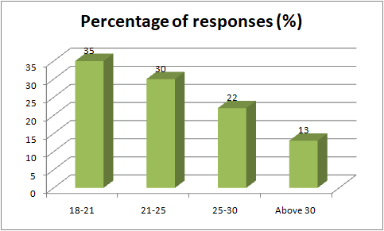
Figure 1: Age of students
(Source: Learner)
2. What are the challenges associated with virtual learning platforms for University of Wales Trinity Saint David London Campus for better understanding of the subject?
Options | Total number of respondents | Number of responses | Percentage of responses (%)
Technical issues | 23 | 7 | 31
Cost of instalment | 23 | 6 | 26
Lack of integration | 23 | 4 | 17
Slow evolution | 23 | 6 | 26
Table 2: Challenges associated with virtual learning platforms
(Source: Learner)
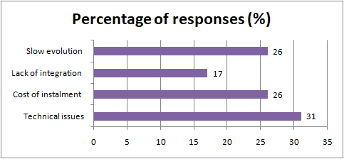
Figure 2: Challenges associated with virtual learning platforms
(Source: Learner)
Q3. What are the provisions that help the students to manifest better understanding on application of virtual learning platforms?
Options | Total number of respondents | Number of responses | Percentage of responses (%)
Effective time management | 23 | 6 | 26
Expanded knowledge and view | 23 | 9 | 39
Access to coursework anytime | 23 | 3 | 13
Asynchronous discussions with classmates | 23 | 5 | 22
Table 3: Provisions for virtual learning platforms
(Source: Learner)
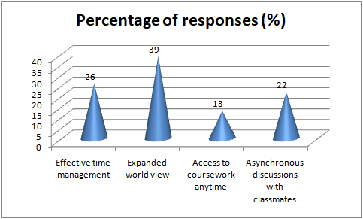
Figure 3: Provisions for virtual learning platforms
(Source: Learner)
Q4. How much do you agree that the virtual learning platform would help in bringing about a revolution in the teaching paradigm for the University?
Options | Total number of respondents | Number of responses | Percentage of responses (%)
Strongly agree | 23 | 4 | 18
Agree | 23 | 8 | 35
Neutral | 23 | 2 | 8
Disagree | 23 | 6 | 26
Strongly disagree | 23 | 3 | 13
Table 4: Revolution by virtual learning platform
(Source: Learner)
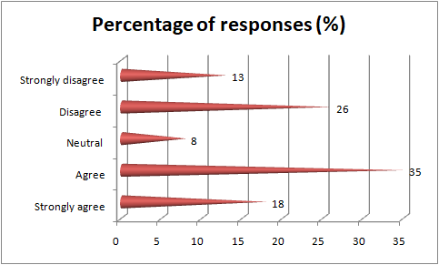
Figure 4: Revolution by virtual learning platform
(Source: Learner)
Q5. How far do you agree that the students of University of Wales Trinity Saint David London Campus would be able to grasp the new technology of virtual learning platform?
Options | Total number of respondents | Number of responses | Percentage of responses (%)
Strongly agree | 23 | 7 | 31
Agree | 23 | 6 | 26
Neutral | 23 | 1 | 4
Disagree | 23 | 5 | 21
Strongly disagree | 23 | 4 | 18
Table 5: New technology grasping capacity
(Source: Learner)
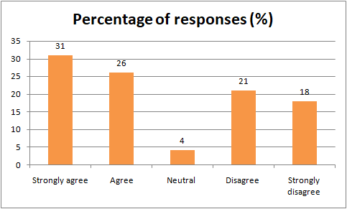
Figure 5: New technology grasping capacity
(Source: Learner)

Discussion
The students with the age range of 18-21 seem to have an enlarged interest in the application of virtual learning environments for better attainment of classes. An enriched virtual classroom would allow better learning for the students by virtue of enhanced diversification of each and every subject. This can be achieved by usage of projectors and smart classes which would allow the students to study according to their convenience. Furthermore, a virtual learning environment enhances the environment of learning by providing the students with an advanced analysis of the subject in a diversified manner. Changes in the learning style would also attract the attention of the students to initiate new learning strategies. In this manner, the students would also be able to develop the base for better understanding of the minute details regarding a specific subject.
It is identified that VLE creates a new paradigm for the teachers because they can successfully manage the schedule and administrative work for teaching. The teachers can successfully prepare the teaching schedule for the students as per their performance as a regular measurement of the performance of the students is possible.it helps to create immediate decisions for the students to provide accurate teaching resources and learning parameters for the students. They support and deliver a variety of daily tasks including general class assignment and monitoring of the students whether they can earn to gather the necessary resources for improving their skills, knowledge and views regarding a particular subject (Herrera Mosquera, 2017). The students can gather knowledge regarding the online technology and computer literacy that helps the students to gain technological knowledge more efficiently.
However, the installation of the amenities required in the virtual classroom environment is very difficult and there is not much details available regarding the likelihood of the students. The treacherous also might face technical issues in teaching by virtue of a virtual learning environment due to lack of understanding. This can invariably hamper the pace of learning for the students if a teacher is not able to apply the virtual learning platform to the fullest extent. The students of University of Wales Trinity Saint David London Campus might also face difficulty in making themselves associated with the new regime of teaching. The cost of installation of the objects required for developing a virtual learning platform is very high. This can invariably lead to more spending for the university which could hamper their budget for other expenses.

Conclusion
In conclusion, a virtual learning environment is beneficial for the students to improve the learning experiences, gathering resources, knowledge and engagement in the learning. Self-paced learning can provide practical experiences and knowledge to the students that can help them to apply in the real world that can enlarge the vision and view of the students. It is also important to learn through audio and video processes that increase memorising power of the students. a synchronous collaboration between the students is created that enhances knowledge of the students. However, technical issues, complexities of computer literacy and lack of integration between the students create problems for using VLE.

References
Cassidy, S., 2016. Virtual Learning Environments as Mediating Factors in Student Satisfaction with Teaching and Learning in Higher Education. Journal of Curriculum and Teaching, 5(1), pp.113-123.
De Boer, I.R., Wesselink, P.R. and Vervoorn, J.M., 2016. Student performance and appreciation using 3D vs. 2D vision in a virtual learning environment. European Journal of Dental Education, 20(3), pp.142-147.
Edson, M.C., Henning, P.B. and Sankaran, S. eds., 2016. A guide to systems research: Philosophy, processes and practice (Vol. 10). Springer.
Herrera Mosquera, L., 2017. Impact of Implementing a Virtual Learning Environment (VLE) in the EFL Classroom. Íkala, Revista de Lenguaje y Cultura, 22(3), pp.479-498.
Phungsuk, R., Viriyavejakul, C. and Ratanaolarn, T., 2017. Development of a problem-based learning model via a virtual learning environment. Kasetsart Journal of Social Sciences, 38(3), pp.297-306.
Rienties, B., Giesbers, B., Lygo-Baker, S., Ma, H.W.S. and Rees, R., 2016. Why some teachers easily learn to use a new virtual learning environment: A technology acceptance perspective. Interactive Learning Environments, 24(3), pp.539-552.
Wijesooriya, C., Heales, J. and Rohde, F., 2019, January. Evaluation of virtual learning environment characteristics in learning performance. In Proceedings of the 10th International Conference on E-Education, E-Business, E-Management and E-Learning (pp. 259-263).

