
DANIEL HRISCU 2127929
MODULE CODE: ACCA7026
SUBMISSION DATE: 30/03/2026
LECTURER: DR. MALIK MEHMOUD
UNIVERSITY NAME: UNIVERSITY OF WALES TRINITY SAINT DAVID
CAMPUS NAME: BIRMINGHAM
Abstract
This study compares three sentiment analysis paradigms on the IMDB benchmark (25K test reviews): TF-IDF with Logistic Regression, DistilBERT (66M parameters), and RoBERTa-base (125M parameters). RoBERTa achieves the highest accuracy (95.58%), followed by DistilBERT (92.88%) and TF-IDF+LR (89.15%), with all pairwise differences statistically significant (McNemar’s p < 0.001). Multi-dimensional evaluation reveals RoBERTa’s superior calibration (ECE = 0.031), strongest linguistic robustness on a 96-case CheckList-inspired suite (70.8%), and nuanced contextual interpretability via gradient attribution. Sarcasm detection remains unsolved across all architectures (25–50%), while TF-IDF+LR retains a compelling 75× inference speed advantage for latency-sensitive deployment.
Sentiment Analysis of IMDB Movie Reviews
A Comparative Study of TF-IDF, DistilBERT, and RoBERTa
Table of Contents
1. Introduction and Problem Statement 1
2. Related Work 1
3. Methodology 2
3.1 Dataset and Preprocessing 2
3.2 TF-IDF + Logistic Regression 3
3.3 DistilBERT Fine-Tuning 3
3.4 RoBERTa Fine-Tuning 3
3.5 Evaluation Framework 4
4. Results and Discussion 4
4.1 Classification Performance 4
4.2 Hyperparameter Sensitivity 6
4.3 Calibration Analysis 6
4.4 Linguistic Robustness 7
4.5 Error Analysis 8
4.6 Interpretability 9
4.8 Limitations 13
5. Ethical Considerations 14
6. Conclusion and Recommendations 14
References 14

1. Introduction and Problem Statement
Sentiment analysis is a core task in natural language processing (NLP) that seeks to classify text according to its expressed opinion [1]. The IMDB movie review dataset [2], comprising 50,000 labelled reviews split equally between positive and negative classes, serves as a widely adopted benchmark for binary sentiment classification. While transformer models have achieved impressive results on this task, few studies systematically compare them against traditional baselines across multiple evaluation dimensions beyond aggregate accuracy.
This study presents a three-paradigm comparison: a traditional TF-IDF pipeline with Logistic Regression (LR), a knowledge-distilled transformer (DistilBERT, 66M parameters) [3], and a robustly optimised transformer (RoBERTa-base, 125M parameters) [4]. The investigation spans quantitative accuracy, calibration reliability, linguistic robustness, and interpretability, aiming to identify where additional model complexity yields genuine analytical gains and where simpler approaches remain competitive. The evaluation framework incorporates McNemar’s statistical testing [12], Expected Calibration Error [8], a 96-case CheckList-inspired linguistic suite [7], SHAP-based feature attribution [9], and gradient-based interpretability to provide a comprehensive, multi-dimensional assessment. While this study focuses on binary classification, the evaluation framework and metrics generalise naturally to multi-class sentiment settings.
The remainder of this report is structured as follows. Section 2 reviews related work across traditional and transformer-based sentiment analysis. Section 3 details the methodology including data preprocessing, model architectures, and the multi-dimensional evaluation framework. Section 4 presents results, comparative analysis, discussion, and limitations. Section 5 addresses ethical considerations, and Section 6 concludes with deployment recommendations and future directions.

2. Related Work
Early sentiment analysis relied on bag-of-words representations with linear classifiers. Maas et al. [2] established a strong 88.89% baseline on IMDB using word vectors with supervised learning. Socher et al. [19] introduced the Stanford Sentiment Treebank, establishing fine-grained sentiment as a foundational benchmark. The introduction of attention-based transformers [5] fundamentally shifted the field by enabling contextual word representations. BERT [6] achieved state-of-the-art results across multiple NLP benchmarks, while Sanh et al. [3] showed that knowledge distillation could compress BERT to 60% of its size (DistilBERT) while retaining 97% of its language understanding. Liu et al. [4] further demonstrated that extended pretraining with dynamic masking (RoBERTa) improves downstream task performance, reporting 95.3% on IMDB. He et al. [20] proposed DeBERTa with disentangled attention, suggesting that further architectural innovation beyond RoBERTa continues to yield gains.
Recent work has increasingly focused on understanding model behaviour beyond aggregate accuracy. Ribeiro et al. [7] introduced CheckList, a behavioural testing framework that systematically evaluates NLP models against specific linguistic capabilities such as negation handling, entity recognition, and temporal reasoning. Guo et al. [8] highlighted that modern neural networks are frequently miscalibrated, motivating Expected Calibration Error as a complementary metric. Lundberg and Lee [9] unified feature attribution methods under the SHAP framework, enabling model-agnostic interpretability comparisons. Shen et al. [10] surveyed post-transformer efficiency techniques including knowledge distillation, while Rogers et al. [11] provided a comprehensive BERTology analysis of what BERT representations learn at each layer. Clark et al. [18] demonstrated that specific BERT attention heads consistently attend to syntactic relations including negation and coreference. Howard and Ruder [15] established the transfer learning paradigm of pretraining followed by task-specific fine-tuning, a principle extended by BERT-family models with masked language modelling. Wang et al. [16] surveyed parameter-efficient fine-tuning methodologies including LoRA and adapters, contextualising full fine-tuning within the broader efficiency landscape. However, no single study has combined accuracy, calibration, linguistic robustness, and interpretability evaluation across traditional, distilled, and full-scale transformer paradigms on IMDB — a gap this study addresses.

3. Methodology

3.1 Dataset and Preprocessing
The IMDB dataset contains 25,000 training and 25,000 test reviews with balanced class distribution (Figure 1). For transformer models, the training set was split 90/10 into 22,500 training and 2,500 validation samples using stratified sampling (seed=42). The full 25,000-sample test set was used for all final evaluations, ensuring comparability with published benchmarks [2].
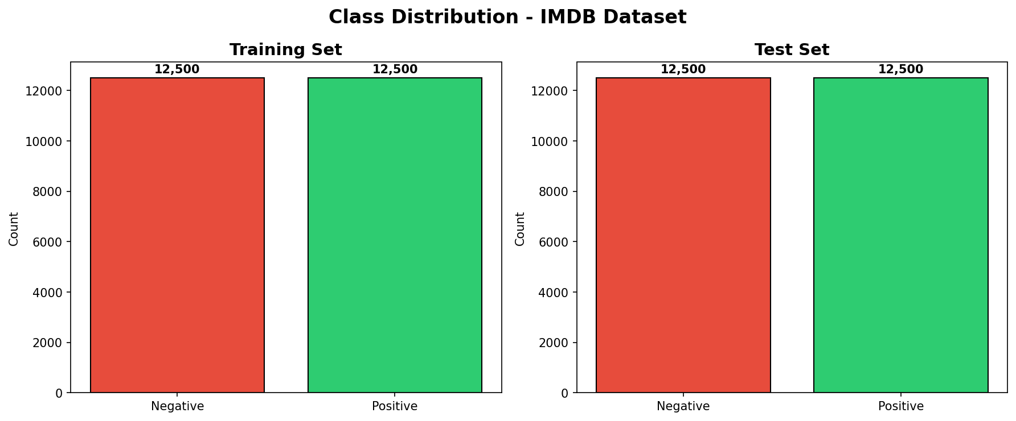
Figure 1: Class distribution of the IMDB dataset (balanced 50/50 split).
Two distinct preprocessing pipelines were employed, reflecting the fundamentally different feature representations. Table 1 summarises the key differences.
Step | TF-IDF Pipeline | Transformer Pipeline | Rationale
Case | Lowercased | Original retained | Transformers encode case during pretraining
Stopwords | Removed (NLTK) | Retained | "not", "but" carry critical sentiment signal
Lemmatisation | WordNet | None | Transformers learn morphology implicitly
Tokenisation | NLTK word_tokenize | WordPiece / BPE | Subword handles OOV and morphology
Seq. length | N/A (full BoW) | 512 tokens max | Captures 95%+ of IMDB reviews
Table 1: Preprocessing pipeline comparison.

3.2 TF-IDF + Logistic Regression
A GridSearchCV pipeline explored 16 hyperparameter combinations across three folds: regularisation strength C ∈ {0.5, 1.0, 5.0, 10.0}, maximum vocabulary size ∈ {30,000; 50,000}, and n-gram ranges of {(1,1), (1,2)}. The optimal configuration selected C=1.0, 30,000 features, and bigrams with sublinear TF scaling, yielding a cross-validation F1 of 87.22%. The selection of bigrams over unigrams reflects the importance of two-word phrases (e.g., ‘not good’, ‘highly recommend’) in capturing basic compositional sentiment. A separate 2,000-sample subset was also trained to quantify the impact of training set size on LR performance, isolating data-volume sensitivity from architectural differences [2].

3.3 DistilBERT Fine-Tuning
DistilBERT-base-uncased (66M parameters) [3] was fine-tuned for up to 8 epochs with AdamW (lr=2e-5, weight decay=0.01), linear warmup over 10% of training steps, and F1-based early stopping (patience=3). FP16 mixed precision was enabled on an NVIDIA L4 GPU (24GB VRAM) with batch size 48. Fine-tuning strategies followed Sun et al. [17], who systematically evaluated learning rate, batch size, and epoch selection for BERT classification tasks. A systematic hyperparameter grid search compared three learning rates {1e-5, 2e-5, 3e-5} to full convergence, and multi-seed variance estimation across seeds {42, 123, 456} quantified stochastic sensitivity.

3.4 RoBERTa Fine-Tuning
RoBERTa-base (125M parameters) [4] was fine-tuned with lr=1e-5, gradient accumulation over 2 steps (effective batch=48), and F1-based early stopping (patience=4). The lower learning rate and longer patience reflect RoBERTa’s deeper capacity and greater sensitivity to aggressive parameter updates [4]. RoBERTa’s improvements over BERT include dynamic masking (generating new mask patterns each epoch versus BERT’s static masks), removal of the next-sentence prediction (NSP) objective, and pretraining on a substantially larger corpus (160GB vs. 16GB) [4]. DistilBERT, by contrast, retains only 6 of BERT’s 12 transformer layers, trained via knowledge distillation to approximate the teacher’s output distribution [3]. These architectural differences predict the observed performance ordering: more pretraining data and deeper contextual capacity yield higher accuracy, while distillation trades depth for efficiency. A two-configuration hyperparameter grid search compared lr=1e-5 against lr=2e-5.

3.5 Evaluation Framework
Models were evaluated across five dimensions: (1) standard metrics (accuracy, precision, recall, F1, AUC-ROC) with 10,000-resample bootstrap 95% confidence intervals; (2) McNemar’s test for pairwise statistical significance [12]; (3) Expected Calibration Error with reliability diagrams [8]; (4) a CheckList-inspired 96-case linguistic test suite spanning 12 categories including negation, sarcasm, hedging, contrastive conjunctions, comparative constructions, temporal/narrative arc, hypothetical/conditional, and domain-specific jargon [7]; and (5) interpretability via SHAP [9] for LR, attention visualisation for DistilBERT, and input-gradient attribution for RoBERTa.

4. Results and Discussion

4.1 Classification Performance
Model | Acc (%) | Prec (%) | Rec (%) | F1 (%) | AUC (%)
TF-IDF+LR | 89.15 | 88.90 | 89.47 | 89.19 | 95.83
LR (2K subset) | 86.00 | 85.16 | 87.20 | 86.17 | 93.25
DistilBERT | 92.88 | 92.68 | 93.12 | 92.90 | 97.80
RoBERTa | 95.58 | 95.61 | 95.55 | 95.58 | 99.00
Table 2: Classification performance on the full 25,000-sample IMDB test set.

RoBERTa achieves the highest accuracy at 95.58%, outperforming DistilBERT (92.88%) by 2.70 percentage points and TF-IDF+LR (89.15%) by 6.43 points. McNemar’s test confirms all pairwise differences are statistically significant (p < 0.001). A 2K-sample LR variant (86.00%) confirms data-volume sensitivity. Our results closely match published baselines: Maas et al. [2] reported 88.89% (our LR: +0.26), Sanh et al. [3] reported 92.7% for DistilBERT on SST-2 (ours: +0.18), and Liu et al. [4] reported 95.3% for RoBERTa on IMDB (ours: +0.28). Multi-seed variance estimation yielded DistilBERT accuracy of 93.1% ±0.08%, confirming low stochastic sensitivity.
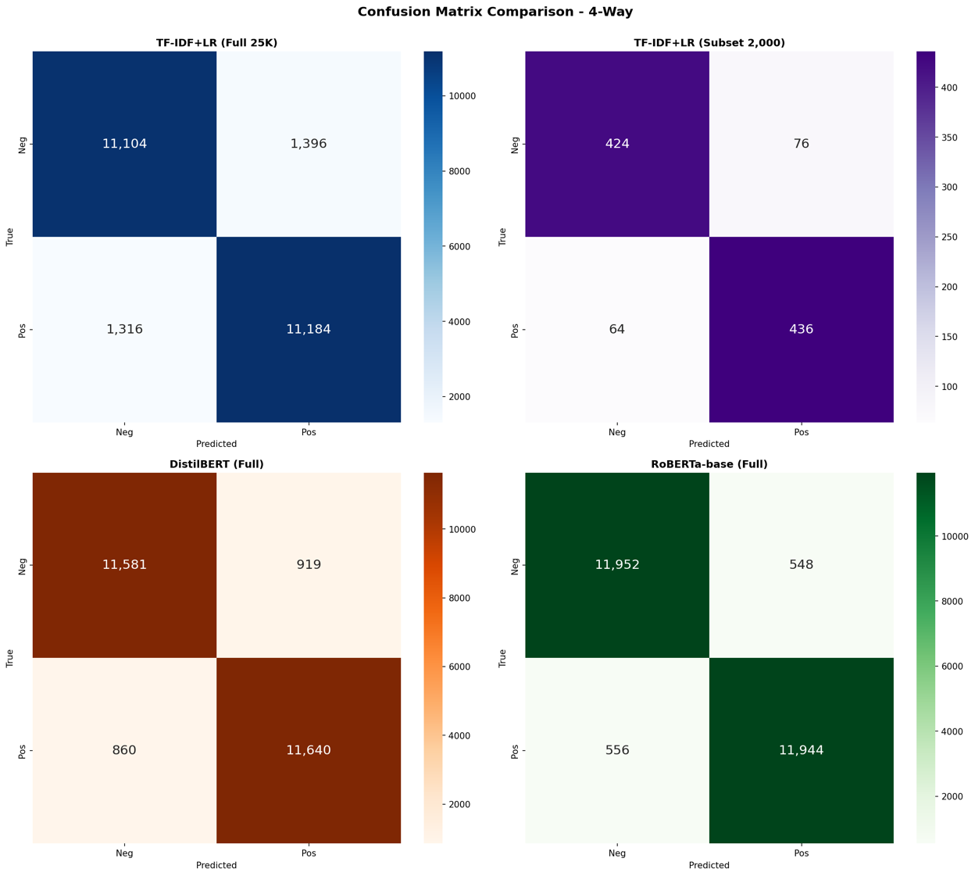
Figure 2: Confusion matrices for all models on the 25K test set.
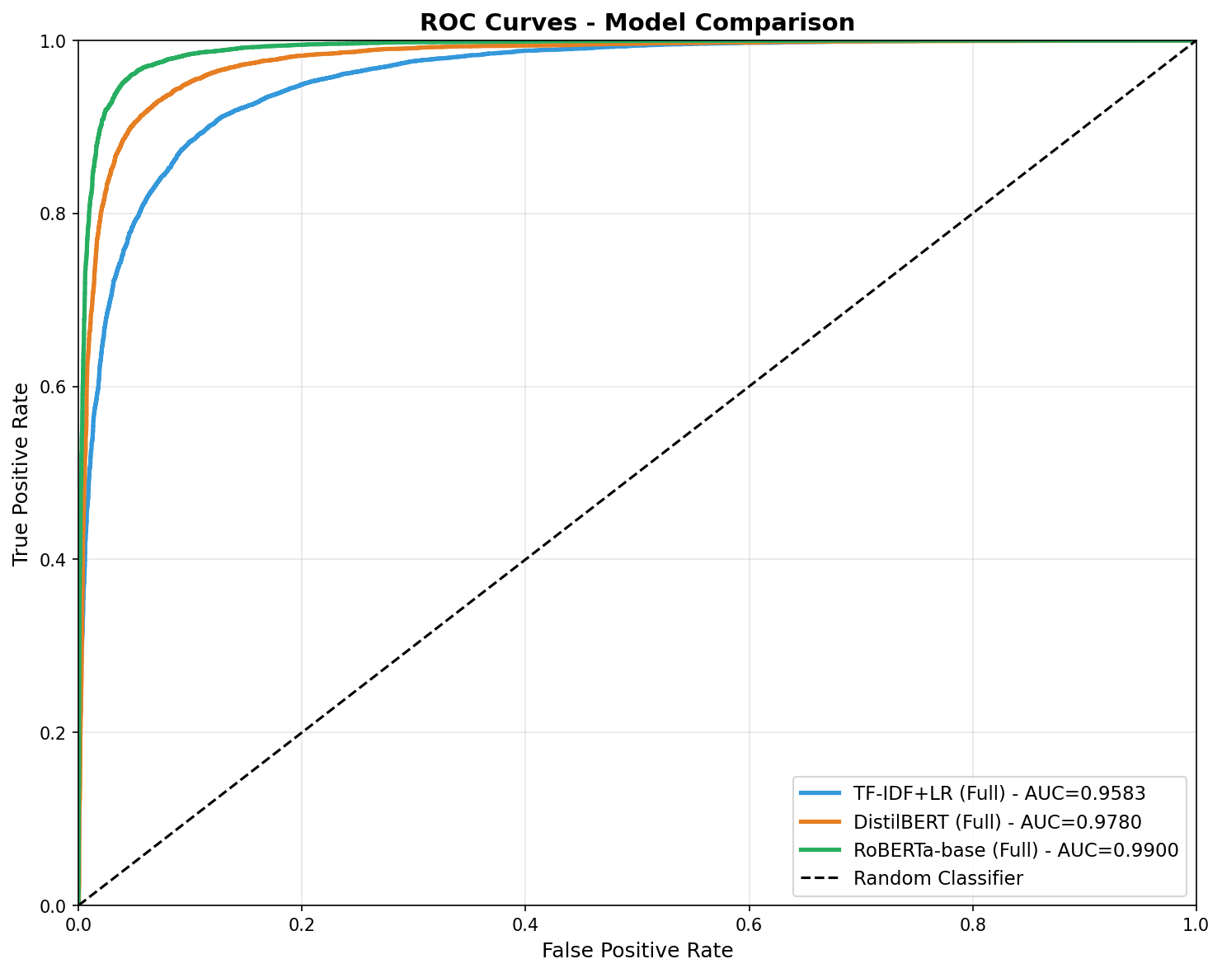
Figure 3: ROC curves with AUC scores.

4.2 Hyperparameter Sensitivity
The DistilBERT grid search across three learning rates revealed LR=2e-5 and LR=3e-5 virtually tied at 93.17% validation F1, both substantially outperforming LR=1e-5 (92.30%), confirming the default learning rate as near-optimal. The RoBERTa grid search similarly validated the baseline: lr=1e-5 achieved 94.93% F1 versus 94.90% for lr=2e-5. The ablation study (Appendix B) confirms that warmup, max_len=512, and moderate learning rates each contribute meaningfully to final performance.

4.3 Calibration Analysis
Expected Calibration Error (ECE) reveals substantial differences in prediction reliability invisible to standard accuracy metrics [8]. RoBERTa achieves the lowest ECE of 0.031, followed by DistilBERT at 0.058 and LR at 0.097. Reliability diagram analysis (Figure 4) shows LR exhibits systematic overconfidence in mid-range probability bins: when predicting 55% confidence, actual accuracy is only 39%. DistilBERT shows better calibration in extreme confidence regions but deteriorates in the uncertain middle range. RoBERTa’s superior calibration across all bins makes it most suitable for decision-support applications where confidence scores drive downstream actions such as routing uncertain reviews to human moderators.
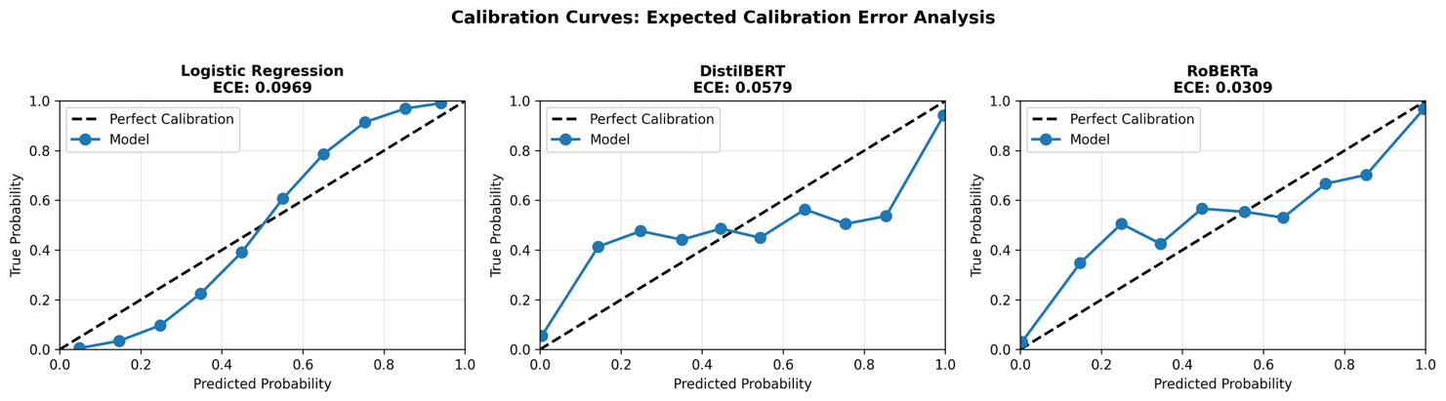
Figure 4: Reliability diagrams and ECE comparison across all models.

4.4 Linguistic Robustness
Category | LR (%) | DistilBERT (%) | RoBERTa (%)
Simple Negation | 12.5 | 100.0 | 87.5
Double Negation | 0.0 | 0.0 | 37.5
Sarcasm/Irony | 37.5 | 25.0 | 50.0
Contrastive Conj. | 25.0 | 50.0 | 50.0
Hedging | 75.0 | 75.0 | 75.0
Intensifiers | 100.0 | 100.0 | 87.5
Mixed Sentiment | 50.0 | 50.0 | 62.5
Implicit Sentiment | 87.5 | 75.0 | 62.5
Comparative | 75.0 | 87.5 | 75.0
Temporal/Narr. Arc | 87.5 | 87.5 | 100.0
Hypothetical/Cond. | 100.0 | 87.5 | 62.5
Domain Jargon | 75.0 | 87.5 | 100.0
Overall | 60.4 | 68.8 | 70.8
Table 3: Per-category accuracy on the 96-case linguistic challenge suite (8 cases per category).
RoBERTa achieves the highest overall score (70.8%), followed by DistilBERT (68.8%) and LR (60.4%). LR fails almost entirely on simple negation (12.5%) and double negation (0%), confirming that bag-of-words models cannot capture compositional semantics. DistilBERT achieves perfect simple negation handling (100%) but fails entirely on double negation (0%). RoBERTa leads on temporal/narrative arc and domain-specific jargon (both 100%), as illustrated in the linguistic heatmap (Figure 5). Given the eight cases per category, individual category results are indicative rather than statistically definitive (one additional correct answer shifts accuracy by 12.5%), though the overall 96-case scores provide more robust aggregate comparison. Notably, all three models struggle with sarcasm (25–50%), confirming that irony detection requires pragmatic reasoning beyond current architectures [7].
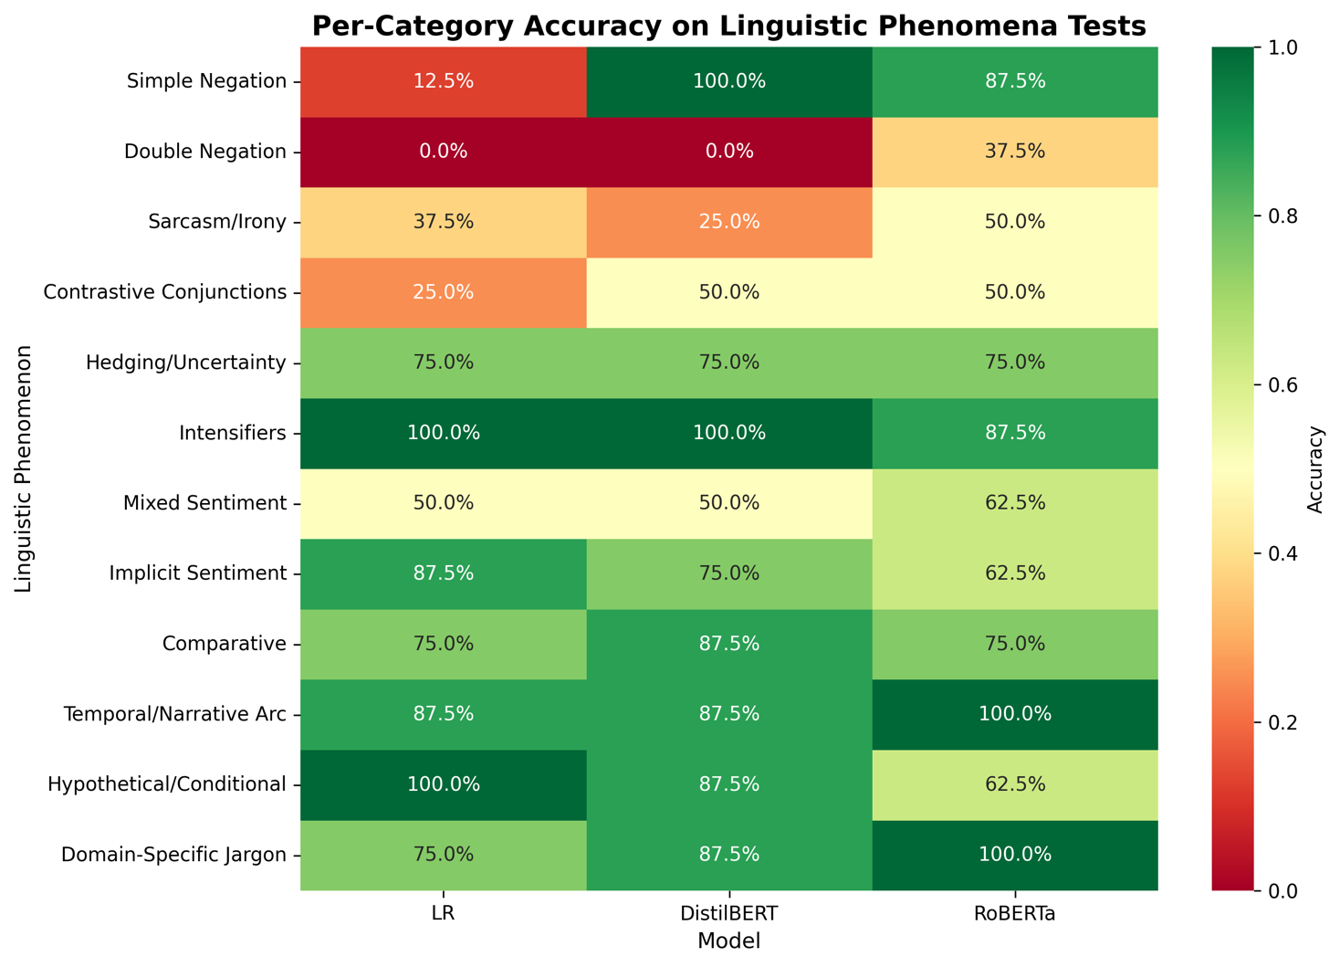
Figure 5: Heatmap of per-category linguistic test accuracy across models.

4.5 Error Analysis
Error analysis reveals 467 reviews misclassified by all three models, representing inherently ambiguous cases. LR produces 2,712 total errors (10.85%) compared with 1,779 for DistilBERT (7.12%) and 1,104 for RoBERTa (4.42%). Transformer models exclusively correct 1,658 LR errors (61.1% of LR’s total), primarily in reviews requiring compositional understanding. Confusion matrix analysis (Figure 2) reveals LR and DistilBERT exhibit a false-positive bias (FP/FN ratios of 1.06 and 1.07 respectively), while RoBERTa achieves a near-balanced ratio (0.99). Length-stratified analysis shows accuracy degrades on long reviews (>300 words) where LR drops to 88.80% while RoBERTa maintains 94.58%.

4.6 Interpretability
Three complementary interpretability methods illuminate each model’s decision-making. SHAP analysis [9] for LR reveals intuitive feature attributions: high-magnitude coefficients correspond to sentiment-bearing words (‘worst’, ‘awful’, ‘excellent’, ‘brilliant’), with the top features forming coherent semantic clusters (Figure 6). DistilBERT attention visualisation (Figure 7) reveals elevated attention on negation words (‘not’, ‘never’) with clear coupling to their modified adjectives, consistent with Clark et al. [18] who demonstrated that specific BERT heads attend to syntactic relations. RoBERTa gradient-based attribution (Figure 8) demonstrates the most nuanced processing: for ‘not bad at all, quite enjoyable actually’, the model assigns high attribution to ‘not’ (0.71) and ‘actually’ (1.0) while ‘bad’ receives moderate positive attribution (0.32), indicating learned negation composition. Notably, because each method is model-specific, cross-model comparisons should be interpreted as complementary perspectives rather than directly commensurable measurements. A model-agnostic method such as LIME applied uniformly would enable controlled comparison; however, the model-specific methods used here provide richer insight into each architecture’s internal reasoning [9, 18].
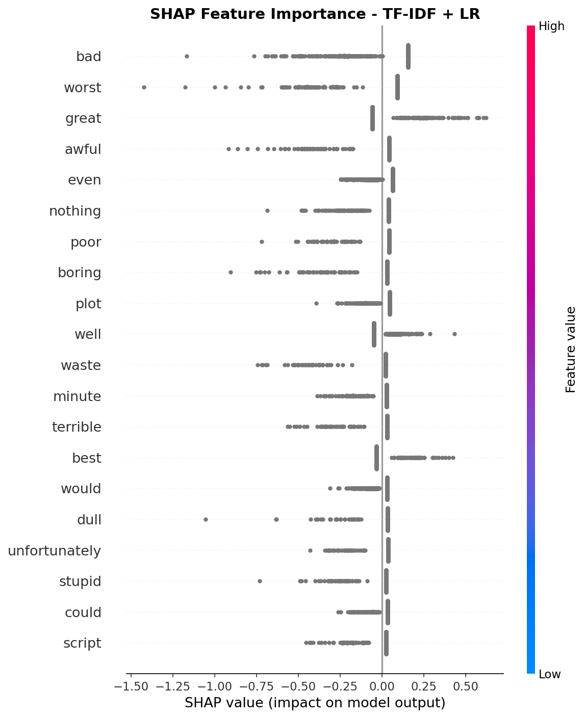
Figure 6: SHAP feature importance for TF-IDF+LR.
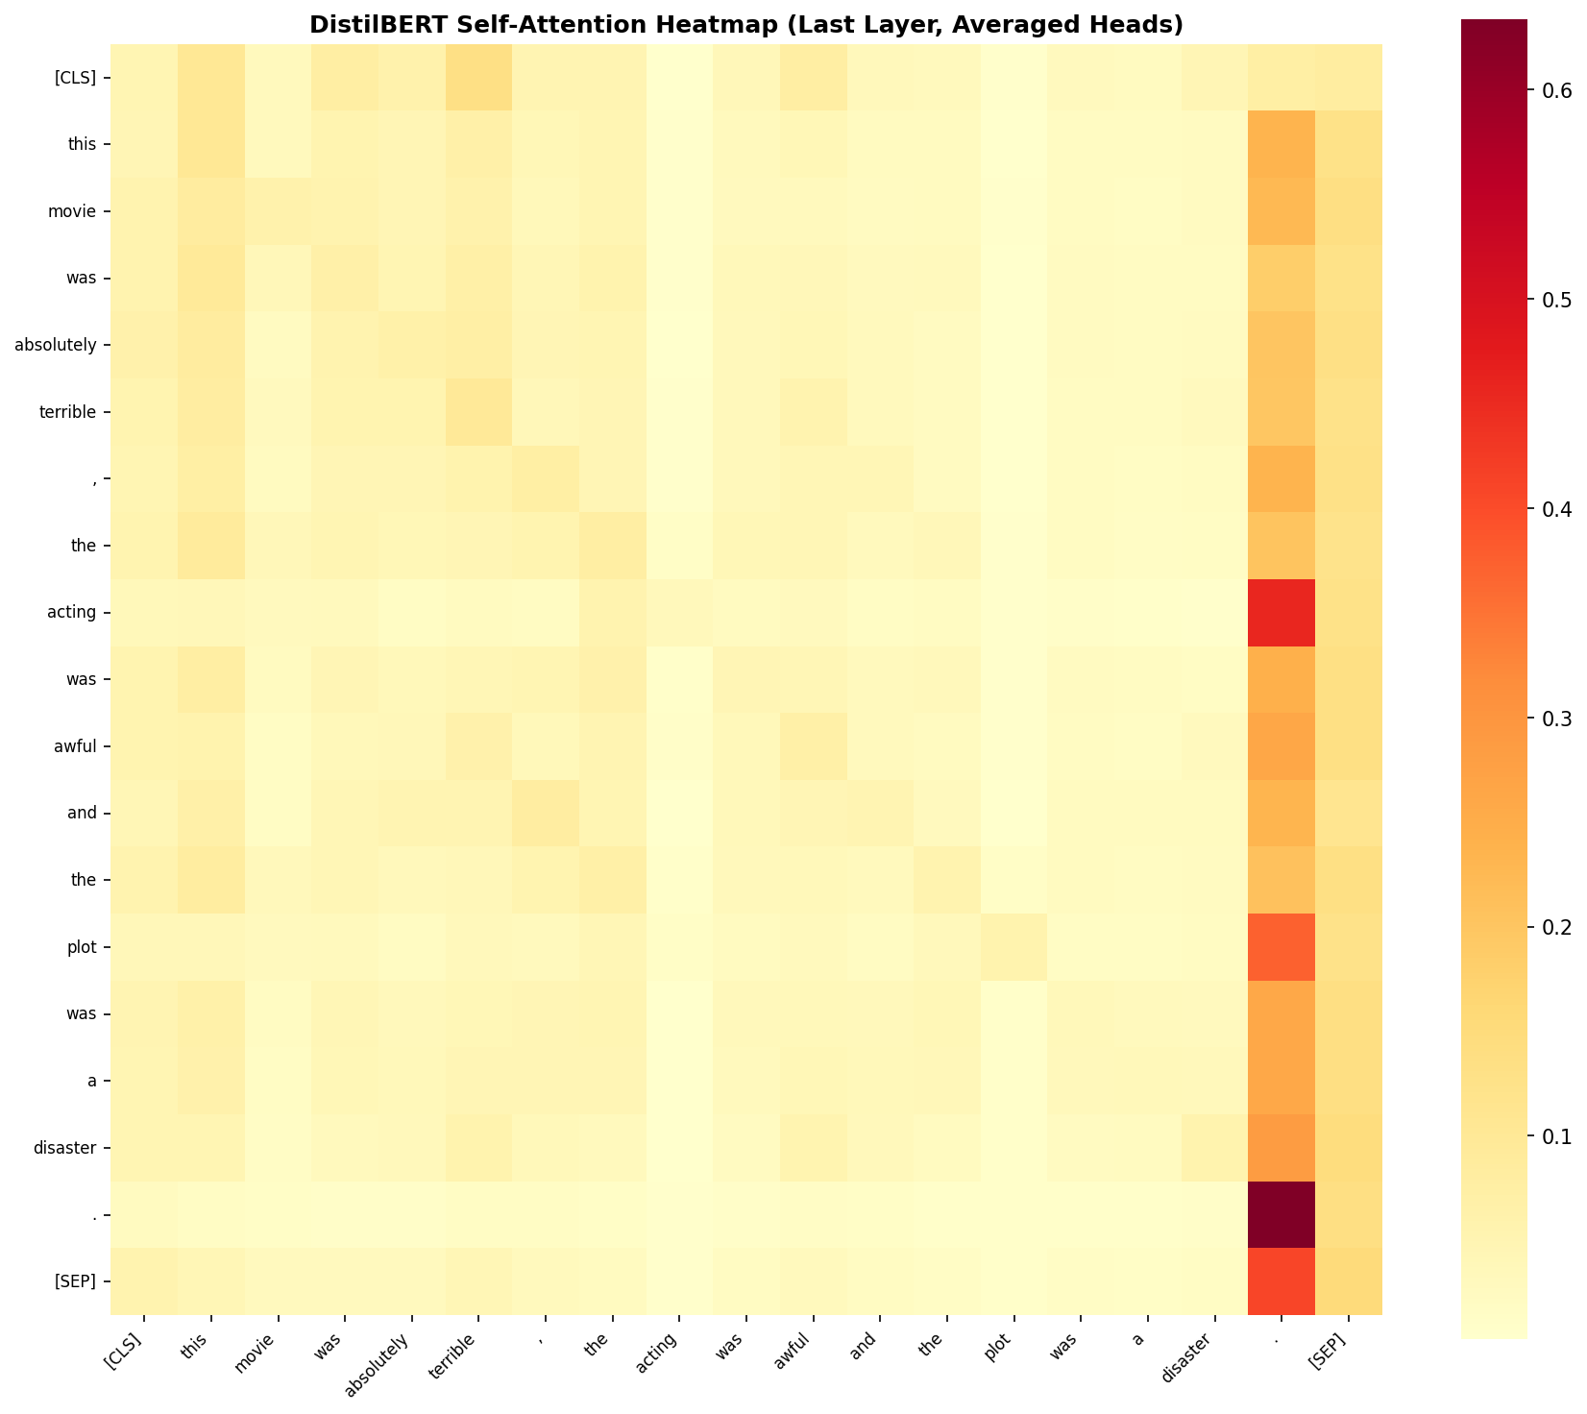
Figure 7: DistilBERT attention weights on example review.
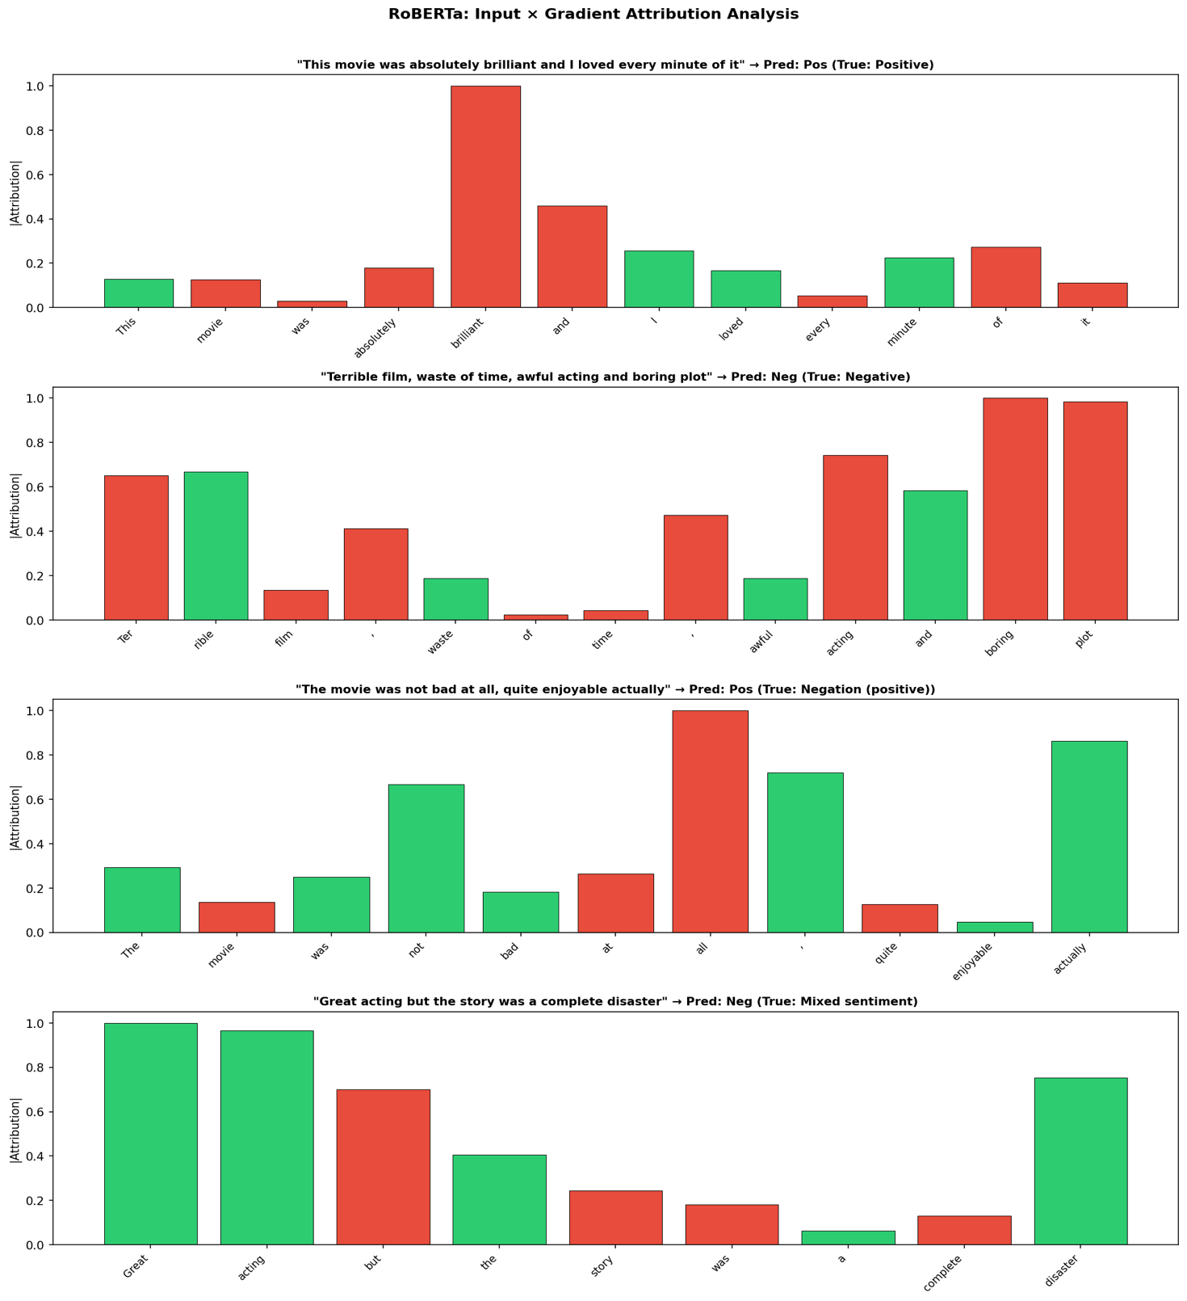
Figure 8: RoBERTa gradient attribution on contrastive example.

4.7 Discussion
The results demonstrate a clear accuracy-cost hierarchy, summarised in Table 4. RoBERTa’s 95.58% accuracy represents a 6.43-point improvement over TF-IDF+LR, at 46× longer training and 75× slower inference. DistilBERT recovers 58% of this accuracy gap at roughly half RoBERTa’s cost [3].
Metric | TF-IDF+LR | DistilBERT | RoBERTa
Parameters | ~30K features | 66M | 125M
Train time (s) | 60 | 1,408 | 2,754
Inference / 25K (s) | 4.3 | ~160 | 318
Peak GPU memory | CPU only | ~4 GB | 7.75 GB
Table 4: Computational cost comparison across models.
The calibration and linguistic analyses reveal that accuracy alone insufficiently captures model quality. Despite achieving 92.88% accuracy, DistilBERT’s ECE of 0.058 suggests less reliable confidence scores than RoBERTa’s (0.031). A counter-intuitive finding is that DistilBERT achieves 100% on simple negation while RoBERTa reaches only 87.5%. One plausible explanation is that knowledge distillation, which trains the student to mimic the teacher’s output distribution, may produce sharper decision boundaries for well-defined linguistic patterns such as negation [3]. Conversely, RoBERTa’s richer contextual representations, shaped by dynamic masking and a larger pretraining corpus without the NSP objective, occasionally over-weight surrounding context. However, this hypothesis warrants further investigation with a larger negation test set.
Training curves (Appendix C) show validation loss plateauing while training loss continues to decrease, indicating mild overfitting in both transformers mitigated by F1-based early stopping. The IMDB dataset’s known biases — predominantly English-speaking Western reviewers with genre-specific vocabulary — limit cross-cultural generalisation [13]. The cross-model error agreement analysis provides insight into model complementarity: the 467 reviews misclassified by all three models represent genuinely ambiguous texts, while the 1,658 reviews corrected exclusively by transformers require contextual understanding such as negation scope resolution — a property that could be exploited by future ensemble approaches.

4.8 Limitations
Several methodological limitations should be acknowledged. First, transformer evaluation relies on a single stratified train/validation split rather than k-fold cross-validation; while multi-seed analysis (±0.08%) and published baseline alignment mitigate this concern, k-fold would provide tighter variance estimates. Second, the RoBERTa HP grid explored only two learning rate configurations versus three for DistilBERT; a broader search including weight decay and warmup ratio might yield further gains. Third, IMDB’s English-only, cinema-domain scope limits generalisation claims. Finally, the 96-case linguistic suite, while more comprehensive than typical ad-hoc evaluations, remains small relative to production-scale testing frameworks [7], and 8 cases per category provides indicative rather than statistically robust per-category estimates.

5. Ethical Considerations
Sentiment analysis systems deployed at scale raise several concerns. The IMDB dataset reflects predominantly Western cultural perspectives [13], and the sarcasm failure rates (25–50%) highlight concrete risks of misclassification in contexts where cultural nuance carries significant meaning. Combined transformer training consumed approximately 4,160 GPU-seconds (estimated 1.2 kWh) [14]. While modest for a single study, the cumulative impact of widespread transformer adoption motivates efficiency-accuracy trade-offs [16]. Responsible deployment requires human-in-the-loop verification, fairness audits across demographic subgroups, and transparency about confidence levels, particularly given the ECE disparities identified in this study.

6. Conclusion and Recommendations
This study’s multi-dimensional evaluation framework demonstrates that accuracy alone is an insufficient proxy for model quality. Calibration analysis exposes unreliable confidence estimates in simpler models, the linguistic suite identifies specific failure modes including universal sarcasm weakness, and gradient attribution confirms that larger transformers develop genuine compositional semantics. The counter-intuitive negation finding further illustrates that architectural differences manifest in unexpected ways that aggregate metrics cannot capture.
Model selection should be driven by deployment context. For latency-critical applications (real-time social media monitoring), TF-IDF+LR’s 75× inference speed advantage and 89% accuracy suffice for volume monitoring. For decision-support systems (brand crisis management, content moderation), RoBERTa’s superior calibration (ECE 0.031) means confidence scores can reliably drive human-in-the-loop escalation. For resource-constrained deployment (edge/mobile), DistilBERT offers 93% accuracy at half RoBERTa’s computational cost. For transparency-required settings (regulated industries), TF-IDF+LR provides globally interpretable coefficients, supplemented with per-instance SHAP explanations [9]. Future work could explore ensemble methods exploiting the structural error complementarity identified in Section 4.5, domain adaptation leveraging transfer learning [15], adversarial training targeting the sarcasm gap, and evaluation of recent architectures such as DeBERTa [20].

References
[1] B. Pang and L. Lee, "Opinion mining and sentiment analysis," Foundations and Trends in Information Retrieval, vol. 2, no. 1-2, pp. 1-135, 2008.
[2] A. L. Maas et al., "Learning word vectors for sentiment analysis," in Proc. 49th Annu. Meeting Assoc. Comput. Linguist., 2011, pp. 142-150.
[3] V. Sanh et al., "DistilBERT, a distilled version of BERT: Smaller, faster, cheaper and lighter," in Proc. NeurIPS Workshop, 2019.
[4] Y. Liu et al., "RoBERTa: A robustly optimized BERT pretraining approach," arXiv:1907.11692, 2019.
[5] A. Vaswani et al., "Attention is all you need," in Advances in NeurIPS, vol. 30, 2017.
[6] J. Devlin et al., "BERT: Pre-training of deep bidirectional transformers for language understanding," in Proc. NAACL-HLT, 2019, pp. 4171-4186.
[7] M. T. Ribeiro et al., "Beyond accuracy: Behavioral testing of NLP models with CheckList," in Proc. 58th Annu. Meeting ACL, 2020, pp. 4902-4912.
[8] C. Guo et al., "On calibration of modern neural networks," in Proc. ICML, vol. 70, 2017, pp. 1321-1330.
[9] S. M. Lundberg and S.-I. Lee, "A unified approach to interpreting model predictions," in Advances in NeurIPS, vol. 30, 2017.
[10] Z. Shen et al., "Efficient attention: Attention with linear complexities," in Proc. IEEE WACV, 2024, pp. 3531-3539.
[11] A. Rogers et al., "A primer in BERTology: What we know about how BERT works," Trans. ACL, vol. 8, pp. 842-866, 2020.
[12] Q. McNemar, "Note on the sampling error of the difference between correlated proportions," Psychometrika, vol. 12, no. 2, pp. 153-157, 1947.
[13] E. Bender et al., "On the dangers of stochastic parrots," in Proc. ACM FAccT, 2021, pp. 610-623.
[14] D. Patterson et al., "Carbon emissions and large neural network training," arXiv:2104.10350, 2021.
[15] J. Howard and S. Ruder, "Universal language model fine-tuning for text classification," in Proc. 56th Annu. Meeting ACL, 2018, pp. 328-339.
[16] L. Wang et al., "Parameter-efficient fine-tuning in large models: A survey," arXiv:2410.19878v2, 2025.
[17] C. Sun et al., "How to fine-tune BERT for text classification," in Proc. China Nat. Conf. Chinese Comput. Linguist., 2019, pp. 194-206.
[18] K. Clark et al., "What does BERT look at? An analysis of BERT’s attention," in Proc. ACL Workshop BlackboxNLP, 2019, pp. 276-286.
[19] R. Socher et al., "Recursive deep models for semantic compositionality over a sentiment treebank," in Proc. EMNLP, 2013, pp. 1631-1642.
[20] P. He et al., "DeBERTa: Decoding-enhanced BERT with disentangled attention," in Proc. ICLR, 2021.

Appendix A: Hyperparameter Grid Search Details
The TF-IDF GridSearchCV explored 16 configurations (4 C values × 2 vocabulary sizes × 2 n-gram ranges) with 3-fold cross-validation. The optimal configuration (C=1.0, 30K features, bigrams) achieved 87.22% cross-validation F1. Higher C values (5.0, 10.0) showed marginal improvements with increased overfitting risk, while unigrams consistently underperformed bigrams by 1–2 percentage points.
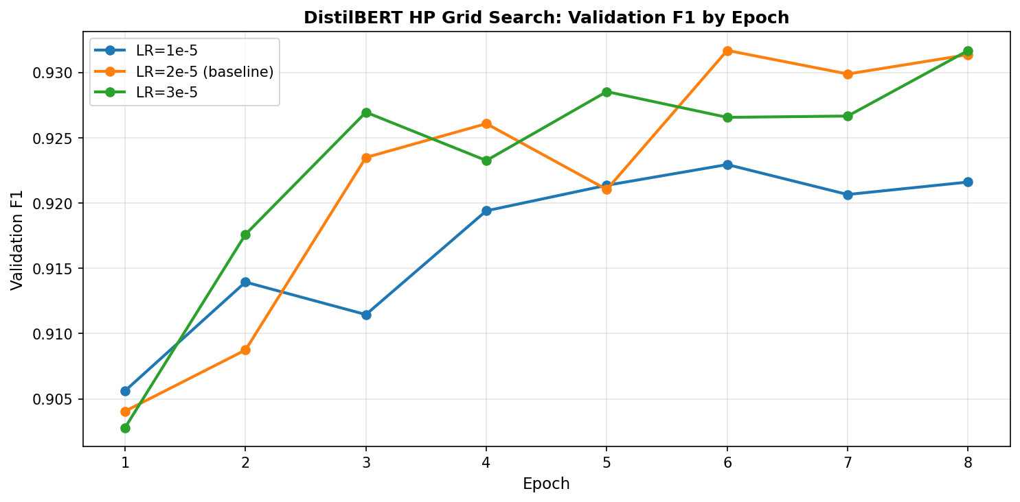
Figure A1: DistilBERT hyperparameter grid search results across learning rates.
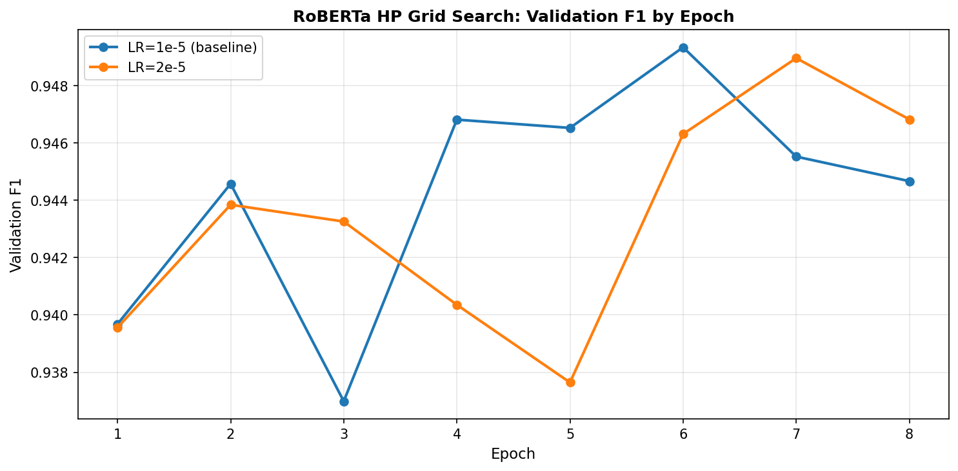
Figure A2: RoBERTa hyperparameter grid search comparison.

Appendix B: Ablation Study Results
The ablation study isolated individual training component contributions for DistilBERT. Removing warmup improved epoch-1 F1 from 88.76% to 91.26%, reflecting faster initial convergence, though warmup was retained to prevent gradient instability during longer training. Reducing max_len from 512 to 256 yielded 89.91% epoch-1 F1 but full-length encoding remains necessary for distant sentiment cues. A high learning rate of 5e-5 achieved 92.16% in one epoch at the risk of overshooting.
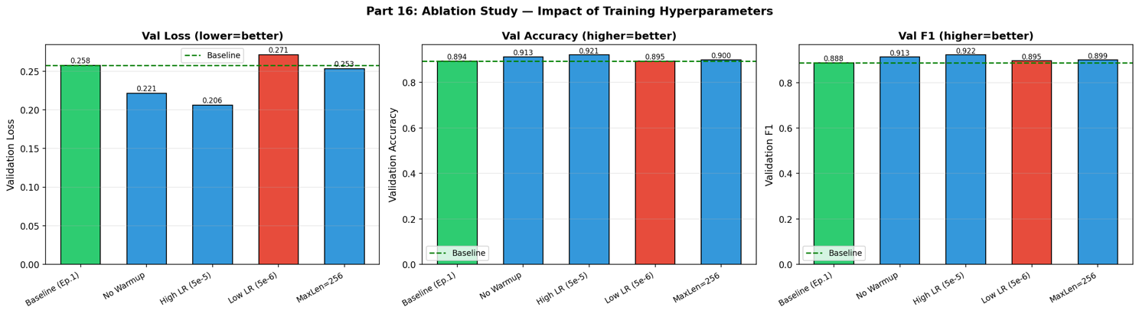
Figure B1: Ablation study showing impact of individual training components.

Appendix C: Training Curves
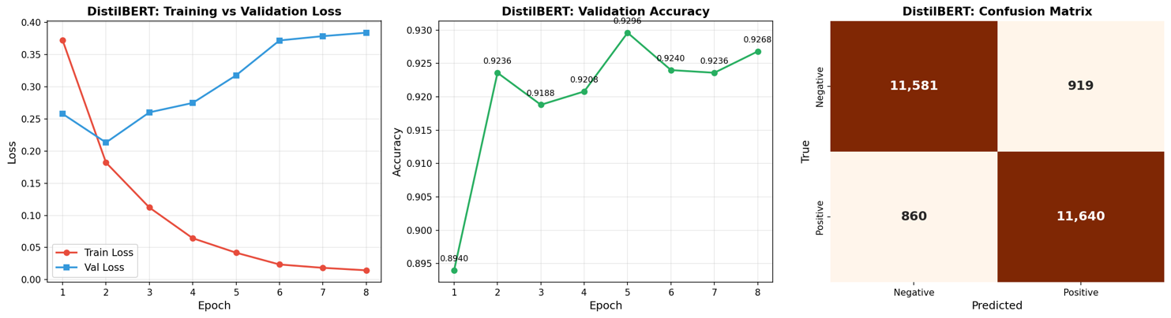
Figure C1: DistilBERT training curves (loss, accuracy, F1 across epochs).
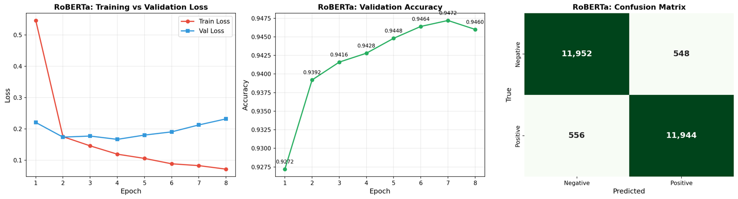
Figure C2: RoBERTa training curves (loss, accuracy, F1 across epochs).

Appendix D: Additional Visualisations
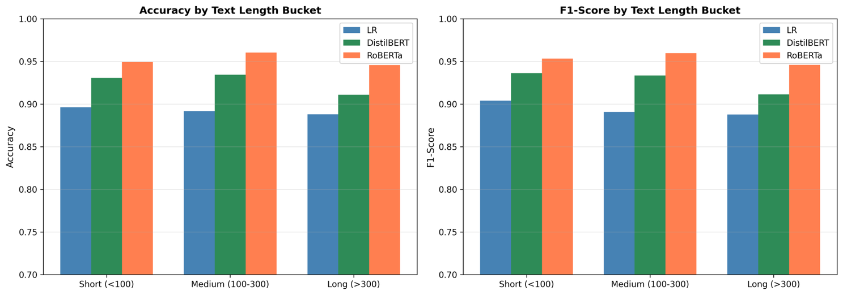
Figure D1: Length-stratified performance analysis across models.
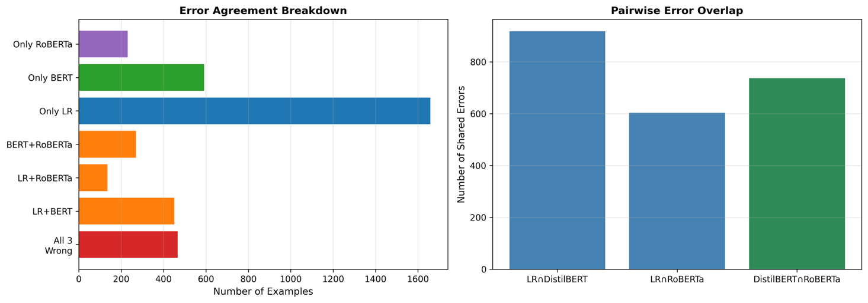
Figure D2: Cross-model error agreement analysis.
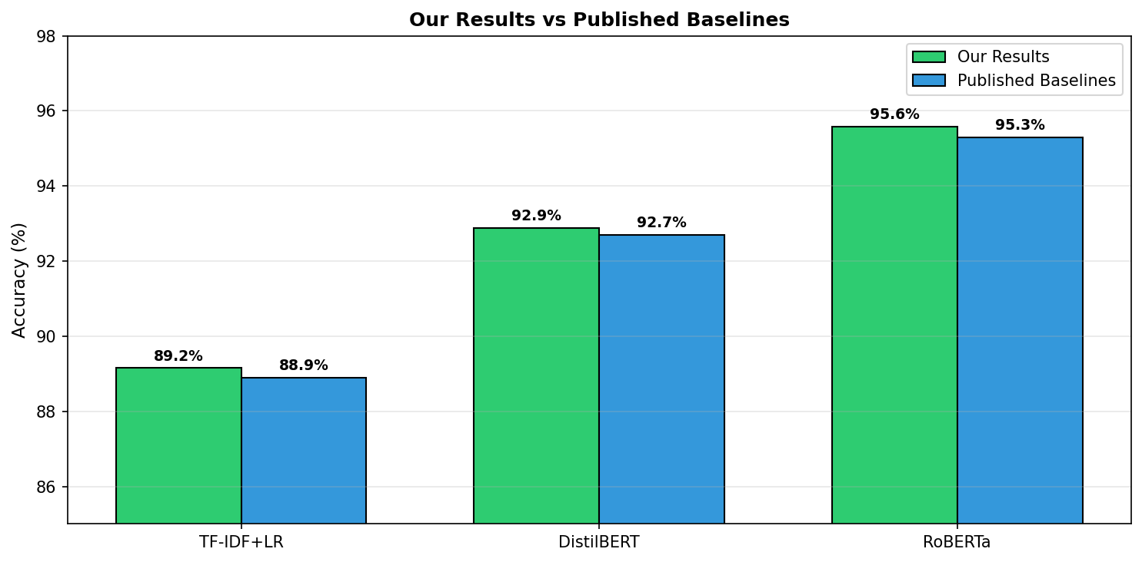
Figure D3: Comparison against published baselines.

