Gareth Lewis 1909139
Wordcount: 2742
25th March 2022
BA Leadership and Management Skills for the Workplace
Why Innovation is Essential for Business Success.
BMSW6102_SWAN Developing Innovation and Creativity for Business Advantage.

Executive Summary
The purpose of this report is to investigate the effect of innovation on business success in a high-profile company, taken from a list of the world’s 50 most innovative companies in 2021. It takes as an example the company of Tesla, and the innovation opportunity of self-driving and driving-assisted road vehicles. The similarities and differences between creativity, innovation and invention will be discussed, different types of innovations categorised, and assessments of effectiveness made. Various models will be examined, and the benefits and drawbacks of their use discussed. The role of leaders and line managers will be assessed, and their use in the field of Organisational Development evaluated.
This report concludes that the innovation in general is of critical consideration to companies like Tesla, and that the selected innovation of Self-Driving and Assisted-Driving represents an important leap in the industry. The report finds organisations must include in their organisational developmental programmes a platform for allowing new innovations and for facilitating new ways of innovating. This report finds that Tesla has landed on an innovation strategy which frees the leadership from being stifled creatively, but will eventually solidify into another imperfect structure which in its own way will eventually likely prevent new innovations and ways of innovating from emerging. Organisations which can correctly implement the appropriate use of emergent innovation within the overarching organisational development programmes employed are likely to benefit in the medium to long term. This report need not be circulated beyond the immediate superior of the author.

Contents
Executive Summary 1
1.0 Introduction 3
2.0 Findings 4
2.1 Overview of Innovation Opportunity 4
2.2 Type of Innovation 4
2.3 Creative Thinking Process 5
2.4 Innovation Models 5
2.4.1 Open and Closed Innovation 5
2.4.2 Innovation Process 5
2.4.3 The 4 ‘P’s of Innovation 6
2.5 Assessment of Effectiveness 6
2.5.1 Barriers and Risks 7
2.6 Leadership and Management 7
3.0 Conclusion 8
References 9
Appendices 11
Appendix 1 11
Appendix 2 12
Appendix 3 13
Appendix 4 14
Appendix 5 15
Acknowledgements 15
Task 2 16
Question 1 16
Question 1 References 16
Question 2 17
Question 2 References 18

Introduction
This report was commissioned by Davina Evans, and the request received on 10th January 2022. Gareth Lewis compiled this report and submitted on 25th March 2022. The secondary research comprised academic textbooks; industry journals; credible news outlet publications; and various websites. No primary research was initiated for this report. The purpose of this report is to: critically evaluate the benefits of an innovation strategy, investigate similarities and differences between innovation and creativity, to analyse an innovative opportunity and applicable models of innovation. It will indicate an organisation’s assessment of its own innovation opportunity. The attitudes towards creativity and innovation juxtaposed with the associated barriers and risks will be discussed. The style of leadership that led to the relevant creative idea shall be examined. Credible conclusions are to be drawn from these findings.
Many theorists favour nebulous definitions of innovation regarding its distinction from creativity: signalling the difference while not precluding its involvement, perhaps due to perceived large areas of crossover. Ahmed and Shepherd (2010) view innovation as ‘a value-adding process as well as an outcome’, Drucker (1999) labels innovation as: ‘the specific tool of entrepreneurs, the means by which they exploit change’. Covey (2004) obliquely references the implied duality, asserting that ‘everything is created twice’, firstly in the mind, secondly in the attempted application in practice. While Covey demonstrates the split process of invention, one can take a similar overview of innovation as a concept; with innovation occupying the ‘second creation’ slot, invention occupying the initial position of idea creation; and while each part of the process can exist independently of the other, each complements the other, and creativity can and does exist in both. Erroneous beliefs, deliberated and eschewed by Davila et al (2006), abound among managers as to the impossibility of applying management process to creativity, as if it can only be stifled, not facilitated by the correct provision of tools and encouragement. Tidd (2014) identifies the fallacious belief in ‘the lightbulb moment’ as another false allegory. Trott (2016) asserts that innovation is a process, not a singular event. The author, in keeping with most credible theorists proffers the definition of innovation as: the implementation or use of invention, effecting a change in process.
The organisation selected for this report is Tesla Inc. Founded in 2003, it designs and develops batteries and solar power systems, which it helps finance through its manufacture of high-profile status-symbol automobiles (Marketline, 2022). It is the current market leader in Electric Vehicles (EV) despite falling EV market share (from 80% in 2020 to 66% in 2021). Its revenue is up 70% from 2021 to $53.8 Billion. Its net income is $5.5 Billion. It employs 70,000 staff worldwide, and is currently planning to transfer its headquarters from California to Texas. It enjoys celebrity leadership in the form of CEO Elon Musk, a high-profile billionaire oligarch. Musk’s flamboyancy can bring conflict with politicians and regulators, and his unorthodoxy leads to the potential for positive and negative effects on innovation within the organisation.

Findings

Overview of Innovation Opportunity
The selected innovation opportunity for this report is the burgeoning market for Autonomous Vehicles and Advanced Driver-Assistance System (ADAS) technology (Forbes, 2022). Tesla’s public perception as automotive innovators (Visual Capitalist, 2021) leaves them well-placed to capitalise and seize the mantle of market leader. Forbes compares this opportunity to the dawn of the internet, and to Henry Ford’s production line in terms of the potential revolution it could bring to society.
Drucker (1999) describes seven sources for innovative opportunity that systematic innovation should monitor: The Unexpected, The Incongruity, Innovation Based on Process Need, and Changes in Industry/Market Structure, each of which lie within the enterprise or industry itself; and Demographics, Changes in Perception/Mood/Meaning, and New (scientific and non-scientific) Knowledge, which involves change outside the enterprise or industry. The opportunity for autonomous vehicle innovation deals largely with two (Incongruity, and Changes in the Industry/Market Structure) of the sources internal to the industry; and each of the three external sources. Drucker cautions against overreliance on the latter sources, pointing to New Knowledge as the least reliable source. An incongruity has been publicly noted by Musk, pointing out the absence of autopilot in cars despite its existence for decades in aeronautics (Business Insider, 2013). Frick (2016) describes changes in the overall market and how multiple automotive companies are developing self-driving capabilities, even where degrees of autonomy are combined with human drivers to complement abilities, such as parking sensors and lane tracking. The external sources begin with demographic changes, such as an ageing population causing a rise in the number of those facing exclusion from society’s benefits through their inability to drive (Forbes, 2022). The public perception of and mood towards autonomous cars has seen a marked change in recent years, with satellite navigation becoming mainstream, and increasing acceptance of technological robustness by consumers and authorities. New Knowledge exists scientifically in the great strides made in AI (Artificial Intelligence) and the data trawled by the software contained in increasingly computerised vehicles.

Type of Innovation
Davila et al (2006), draw on the earlier work of Gatignon et al, (2002) which measured different aspects of innovation, such as generational/architectural, incremental/radical, and core/peripheral. The Innovation Matrix (Davila et al, 2006) is a tool that can be used to categorise innovations into generic groups of radical, semi-radical, and incremental. Davila et al argue in favour of holding a broad portfolio of all three innovation types. The matrix proffered by Davila et al is heavily influenced by the similar Product Innovation Grid of Meyer and Roberts (1986) which plots technology against market dimensions (as opposed to the business model). Davila et al name six levers of innovation, three for each axis of their matrix. Value Proposition, Supply Chain, and Target Customer are identified as the Business Model levers; Product and Service, Process Technologies, and Enabling Technologies are identified as technology levers. Tesla’s self-driving innovation opportunity shows significant changes in multiple technology levers, but just small change in business model levers. This is in part due to their business model already being geared towards innovation, by design. This, set against the framework, reveals it to be a technology-driven semi-radical innovation (see appendix 1).

Creative Thinking Process
Ahmed and Shepherd (2010) describe creativity, from an organisational viewpoint, as: ’the ability to consistently produce different and valuable results’. Hesselbein and Johnston (2002) divide the creative thinking process into five stages: Preparation, Innovation Opportunity, Divergence, Incubation, and Convergence. Ahmed and Shepherd explain that rather than a linear five-step process, innovation occurs through repeating cycles of divergence then convergence, and that creativity ‘spans the entire process’. Examples of this process at Tesla include, but are not limited to:
- Divergence in the Industry. Tesla’s policies have regularly diverged from established automotive companies.
- Convergence at the Organisation. Tesla’s implementation of the creative thinking process as applied to the organisational level has involved flattening the company structure (CNBC 2018), showing signs of organic rather than mechanistic (King and Anderson, 1995) structure, enabling the convergence of ideas at an appropriate level.
- Preparation at Team level. The rapid hiring forecast (CNBC, 2018) displays an intention for teams to have adequate preparation for their roles.
- Individual. Much of Tesla’s business is indistinguishable from the personal ambition of CEO Elon Musk. As such, Tesla is often subject to the creative whim of one specific individual. This has had positive and negative effects (Bloomberg, 2022) but Tesla’s actions have without doubt been influenced from the long-term incubation of ideas within Elon Musk’s mind.

Innovation Models

Open and Closed Innovation
Tesla show Post-Schumpeterian (Akdere and Benli, 2018) awareness, with swift growth largely driven by investor speculation. Furr and Dyer (2020) coin the term ‘Innovation Capital’ to describe Musk’s considerable ability and resource in winning support from stakeholders. Musk’s success in winning the adulation of supporters while affecting the political agenda to gain substantial financial concessions, chimes with Schumpeter’s prediction of industrialists’ growing political domination. It is possible that Musk considers himself to be what Schumpeter termed a ‘benevolent monopolist’ (Drucker, 1999).
Apple and Google’s differing methods (CNN, 2010) show the contrast in open and closed innovation models. Tesla have belatedly opened up patents in a sign of open innovation (Musk, 2014). They have also allowed other electric cars to use Tesla charging stations (BBC, 2021). Tesla’s policy of eschewing lidar laser is a contrasting sign of closed innovation, revealing a ’pick-and-choose’ attitude to innovation models (see Appendix 2).

Innovation Process
Tidd and Bessant (2018) describe four areas in what they term ‘the Innovation Process’. As with the creative process, it is not intended to be a linear operation, but more a mental model showing the areas normally represented. This is illuminated specifically, and Tidd returns to the point (2014) to underline how the unfamiliar had mistaken this, including his own publishers. This could be considered a flaw by many, as unclear by some, or partially unavoidable by others who may believe there will always be those who attempt to apply linear order to inapplicable situations. As Tidd explains, the idea is for there to be visual model the mind can grasp: ‘a framework for a way of thinking, not a description of the actual process’ (Tidd, 2014). The tool defines the process from the context. The four areas recognised by Tidd and Bessant are: Recognising the Opportunity; Finding the Resources; Developing the Idea; and Capturing Value. Applying Tesla’s opportunity for autonomous vehicles to the Innovation process shows the presence of each area being represented.
- Recognising the opportunity. The identification of incongruity of autonomous absence in road vehicles as compared to aeroplanes by Musk (Business Insider, 2013) falls neatly into this category. It also occurs first, although the model is not intended to display lineage. This recognition could be considered incidental, rather than the result of good practice having been embedded.
- Finding the Resources. Vance (2015) and Furr and Dyer (2020) regale in detail Musk’s repeated and successful attempts to glean investment and additional successful marketing to drive revenue increases to fund such research.
- Developing the idea. Tesla uses data drawn from their vehicles’ computers to develop understanding regarding appropriate driving actions, drawn from data input from human drivers in addition to self-driving data (Tesla, 2021).
- Capturing Value. This step has not been completed at Tesla for autonomous vehicles. Previous Tesla innovations have led to value capture by establishing itself as synonymous with the innovation (Musk, 2013) and using a branded innovation as a status symbol. If Tesla’s policy of pursuing video-led automation over the alternatives should be successful, it will be advantageous. The emergent relative success of lidar laser technologies will have the opposite, disadvantageous effect.

The 4 ‘P’s of Innovation
The 4 ‘P’s of Innovation Space is a model produced by Tidd and Bessant (2018) which allows the mapping of one’s organisational innovations, and to show potential areas for improvement (see Appendix 4). Tidd and Bessant reveal that cumulative incremental innovation can overtake sporadic radical innovations (in the same way as cumulative interest in finance). It can reveal any absence among the organisation’s innovation portfolio of any radical innovations in one of the four areas mapped by the model: Paradigm, Position, Process, and Product. A radical ‘Paradigm’ change would be to monopolise battery production to prevent being overtaken by competitors. A ‘Position’ change could be a shift to include petrol engines. A ‘Process’ change would include seeking Trade Union advice on working conditions, and a ‘Product’ change might include the introduction of Tesla helicopters. This model is not to be confused with Anthony’s (2010) independently-produced 4Ps for Innovation (Population, Penetration, Price, Purchase Frequency), a separate mnemonic.

Assessment of Effectiveness
Tesla (2021) have continued to transition to their ‘Tesla Vision’ software which enables assisted driving and theoretical ‘full self-driving’. It appears that their assessment of the innovation holds more potential benefits than risks. Using Lewin’s Force Field Analysis tool, featured by King and Anderson (1995) as a template, the author has attempted to replicate the analysis of potential pros and cons. The model is illustrated in Appendix 5. Lewin’s tool is an imperfect device, as the blunt scoring system is arbitrary and down to the whim or passing fancy of the user at any given time. It does however allow weighted responses which allow the significance and substance of each identified reason to be appropriately apportioned. Potential benefits likely to have been identified by Tesla include the following:
- Fulfilment of desire among customers for new products.
- The attraction of new customers (non-drivers) to the industry.
- The positive exposure available to the first company to popularise mass full self-driving capability could be especially lucrative.
- The ownership of the vision video technology utilised precludes heavy licensing costs.
- While full self-driving is not yet authorised, the same technologies can be incorporated into assisted driving technologies which are already legal.
- Authorities in various national markets have shown support for additional assisted driving technology.

Barriers and Risks
Potential risks to proposed innovative changes can be identified by the same Lewin tool (appendix 5), as follows:
- The current position of Tesla has been successful, any change risks upsetting the current profitable balance.
- The Lidar technology could ultimately make Tesla’s vision video obsolete and unattractive.
- The deaths potentially encountered en route to mass adoption could prove lethal to Tesla’s image of successful futuristic innovators (Bloomberg, 2019).
- National authorities have continued to refuse to legalise full self-driving capabilities.
- Sky News (2022) revealed the current plummeting prices of EVs.
The model illustrated demonstrates the marginal positive assessment for Tesla’s pursuit of assisted and self-driving technology.

Leadership and Management
Armstrong (2016) defines leadership as ‘the process of developing and communicating a vision for the future, motivating and guiding people and securing their engagement’. There can be few business leaders known to the general populace that have fulfilled this definition as fully as Elon Musk. Furr and Dyer (2020) detail Musk’s considerable fund-raising exploits in Tesla’s early years, providing ample ‘engagement’ among followers.
Vance (2015) lists examples of autocratic leadership style, including accusations of dictatorial behaviour and an unwillingness to delegate responsibilities, echoed by the Washington Post (2020). Musk is likely to view himself as transformational but has been accused of doing little to improve culture nor positively affect well-being (The Guardian, 2022). His anti-trade union stance has been well documented, (CNBC, 2021) possibly leading to exclusion from industrial discussions with the Biden administration. Musk does not seem averse to exerting transactional influence (CNBC, 2018). It is unlikely that Musk would have chosen to follow a single style of leadership in his decades of various stewardships. His style is more comparable to the tenets of context-dependent models such as situational leadership (Nicholls, 1985) or Tannenbaum and Schmidt’s (1973) Continuum theory. Vance (2015) forwards the idea that Musk is above leadership models. Mullins (2016) points out how innovative companies change with their surroundings, and that it is the flexible culture which allows this. Frick (2018) details Musk’s negative opinion on stability through the analogy of protective moats. Musk remains forthright in his views, even when he changes his mind. Musk chooses not to utilise change agents throughout the company and asserts his own cultural system.

Conclusion
Tesla have had success in driving change with their innovative business model, and financial success with their technological innovations. This does not mean that its culture is one of innovative facilitation in general. In any strategy attempting to cajole innovation, there will be an applicable structure with its own form. The leadership of Tesla recognise the potential for inflexibility in any given structure. That Tesla have departed from such models to allow Musk’s whimsy and vision unfettered agility shows an understanding that conditioning to innovate in one particular style can condition one not to innovate in new ways. Tesla, in avoiding the stifling of innovation through rigid structure, also simultaneously fail to encourage innovation throughout the company, anywhere below the executive board. While this is not intended or viewed as stifling behaviour, the company’s culture is not in general conducive to innovation, and the next generation of innovators and entrepreneurs are likely to find Tesla an inhospitable base for their aspirations.
Tesla’s attempts to differentiate itself through its own innovative outlook on innovation strategy has hitherto been remarkably successful. By embracing change, it hopes to avoid stagnation and stagnant strategy. The danger it faces is if this credulity in its own tactics becomes a touchstone of assumed advantage and forges an undesirable stability of its own.

References
Ahmed, P. and Shepherd, C. (2010) Innovation Management. 1st Ed. Harlow: Pearson.
Akdere, C. and Benli, P. (2018). The Nature of Financial Innovation: A Post-Schumpeterian Analysis. Journal of Economic Issues. 52. 717-748. 10.1080/00213624.2018.1498717.
Anthony, S. (2010) The 4 Ps of Innovation. Harvard Business Review. Available at: hbr.org/2010/06/the-4ps-of-innovation (Accessed: 16th February 2022).
Armstrong, M. (2016) How to Manage People. 3rd Ed. London: Kogan Page.
BBC (2021) Tesla opens its chargers to other electric cars. Available at: www.bbc.co.uk/news/technology-59122605 (Accessed: 16th February 2022).
Bloomberg (2019) Tesla’s Autopilot Could Save Lives. Available at: www.bloomberg.com/news/features/2019-10-09/tesla-s-autopilot-could-save-the-lives-of-millions-but-it-will-kill-some-people-first (Accessed: 16th February 2022).
Business Insider (2013) Elon Musk: Autopilot is a good thing in planes and we should have it in cars. Available at: www.businessinsider.in/elon-musk-autopilot-is-a-good-thing-in-planes-and-we-should-have-it-in-cars/articleshow/21132426.cms (Accessed: 16th February 2022).
CNBC (2018) Here’s the memo Elon Musk just sent announcing a major shake-up at Tesla. www.cnbc.com/2018/05/14/elon-musk-tells-employees-tesla-will-streamline-management.html (Accessed: 16th February 2022).
CNBC (2021) Musk Anti-union tweet must be deleted. Available at: www.cnbc.com/2021/03/25/tesla-elon-musk-anti-union-tweet-must-be-deleted-nlrb.html (Accessed: 16th February 2022).
CNN (2010) Google Vs. Apple = Open Vs. Closed. Available at: youtube.com/watch?v=2ukqne5OE3o&t=2s (Accessed: 16th February 2022).
Covey, S. (2004) The 7 habits of highly effective people. London: Simon and Schuster.
Davila, T. et al (2006) Making Innovation Work. New Jersey: Pearson.
Drucker, P. (1999) Innovation and Entrepreneurship. Oxford: Butterworth-Heinemann.
Forbes (2022) Autonomous Vehicles and Their Impact on the Economy. Available at: www.forbes.com/sites/forbestechcouncil/2022/02/14/autonomous-vehicles-and-their-impact-on-the-economy/?sh=1149d28960de (Accessed: 16th February 2022).
Frick, W. (2016) Tesla Autopilot and the challenge of trusting machines. Available at: hbr.org/2016/07/tesla-autopilot-and-the-challenge-of-trusting-machines (Accessed: 16th February 2022).
Frick, W. (2018) A 40 year debate over corporate strategy gets revived by Elon Musk and Warren Buffett. Available at: hbr.org/2018/05/a-40-year-debate-over-corporate-strategy-gets-revived-by-elon-musk-and-warren-buffett (Accessed: 16th February 2022).
Furr, N. and Dyer, J. (2020) Lessons from Tesla’s Approach to Innovation. Harvard Business Review. Available at: hbr.org/2020/02/lessons-from-teslas-approach-to-innovation (Accessed: 16th February 2022).
Gatignon, H. et al. (2002) ‘A Structural Approach to Assessing Innovation: Construct Development of Innovation Locus, Type, and Characteristics’, Management science. 48 (9), 1103–1122.
Hesselbein, F. and Johnston, R. (2002) On Creativity, Innovation, and Renewal: A leader to Leader Guide. New Jersey: Jossey-Bass Publishing.
King, N. and Anderson, N. (1995) Innovation and Change in Organizations. London: Routledge.
Marketline (2022) Tesla Inc. Available at: advantage-marketline-com.ezproxy.uwtsd.ac.uk/Company/Summary/tesla-motors-inc (Accessed: 16th February 2022).
Meyer, M. and Roberts, E. (1986) ‘New Product Strategy in Small Technology-Based Firms: A Pilot Study’, Management science. 32 (7), 806–821.
Mullins, L. (2016) Management & organisational behaviour. 11th Ed. Harlow: Pearson.
Musk, E. (2013) The Mission of Tesla. Available at: www.tesla.com/blog/mission-tesla (Accessed: 16th February 2022).
Musk, E. (2014) All our patent are belong to you. Available at: www.tesla.com/blog/all-our-patent-are-belong-you (Accessed: 16th February 2022).
Nicholls, J. (1985) ‘A New Approach to Situational Leadership’, Leadership and Organization Development Journal, 6(4) p.60.
Sky News (2022) Electric car prices could be about to plummet. Available at: news.sky.com/story/electric-car-prices-are-about-to-plummet-heres-why-12536407 Accessed: 16th February 2022).
Tannenbaum, R. and Schmidt, W. (1973) ‘How to Choose a Leadership Pattern’, Harvard Business Review (May/June).
Tesla (2021) Transitioning Tesla Vision. Available at: www.tesla.com/support/transitioning-tesla-vision (Accessed: 16th February 2022).
The Guardian (2022) Black Workers accused Tesla of Racism for Years. Available at: theguardian.com/technology/2022/feb/18/tesla-california-racial-harassment-discrimination-lawsuit Accessed: 16th February 2022).
Tidd, J. (2014) Developing an Innovation Process. Available at: www.youtube.com/watch?v=l9sNGnxMEXE (Accessed: 16th February 2022).
Tidd, J. and Bessant, J. (2018) Managing innovation: integrating technological, market and organizational change. 6th Ed. Hoboken: Wiley.
Trott, P. (2016) Innovation Management and New Product Development. 6th ed. Harlow: Pearson.
Vance, A. (2015) Elon Musk: How the Billionaire CEO of Spacex and Tesla is Shaping our Future. London: Penguin.
Visual Capitalist (2021) Ranked: The Most Innovative Companies in 2021. Available at: visualcapitalist.com/ranked-the-most-innovative-companies-in-2021/ (Accessed: 1st March 2022).
Washington Post (2020) How Elon Musk went from sleeping on the factory floor. Available at: www.washingtonpost.com/technology/2020/02/21/how-elon-musk-went-sleeping-factory-being-cusp-launching-crew-into-space/ Accessed: 16th February 2022).

Appendices

Appendix 1
Tailored Innovation Matrix, from Davila et al, (2006).
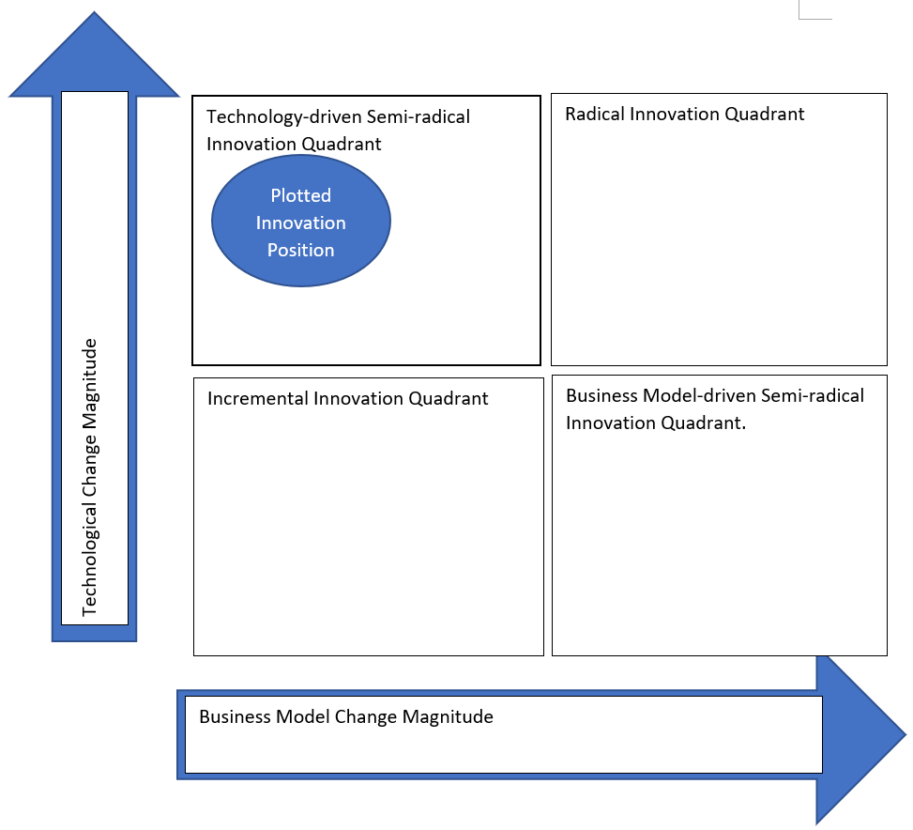

Appendix 2
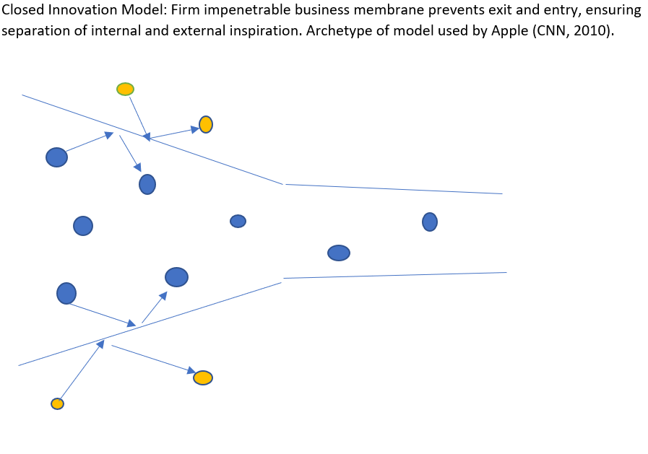
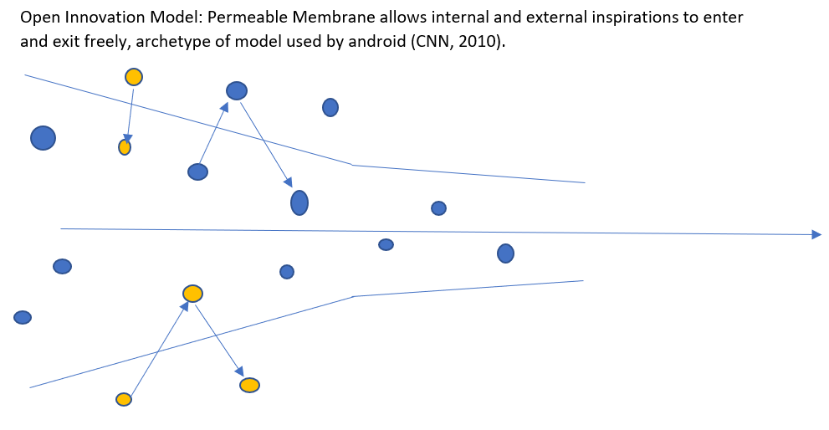
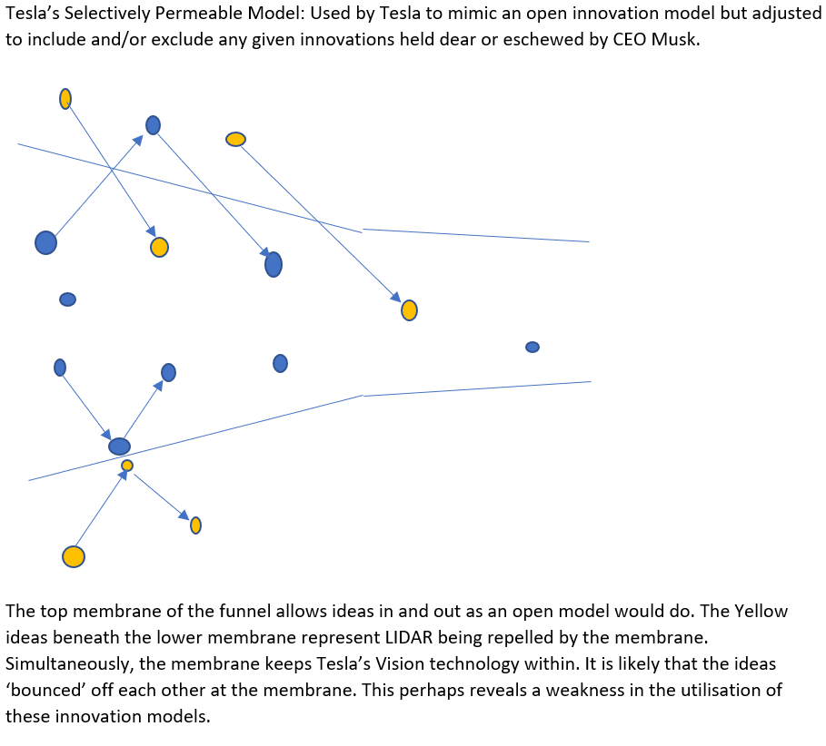

Appendix 3
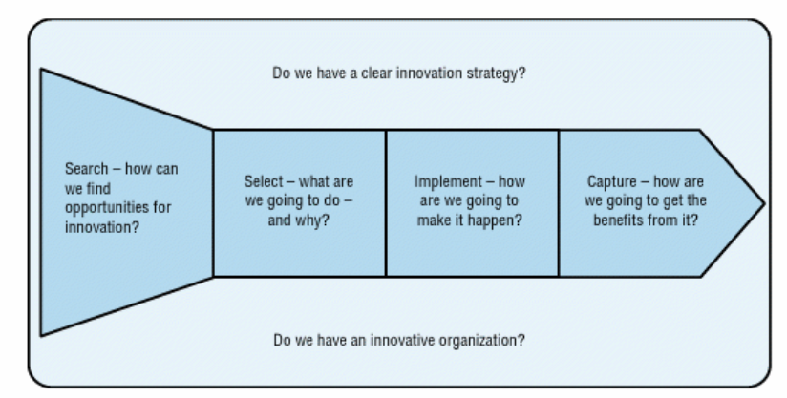
Capturing Value
Finding the resources
Developing the idea
Recognising the opportunity
Framework of areas represented
Innovation Process

Appendix 4
4 ‘P’s of Innovation Space.
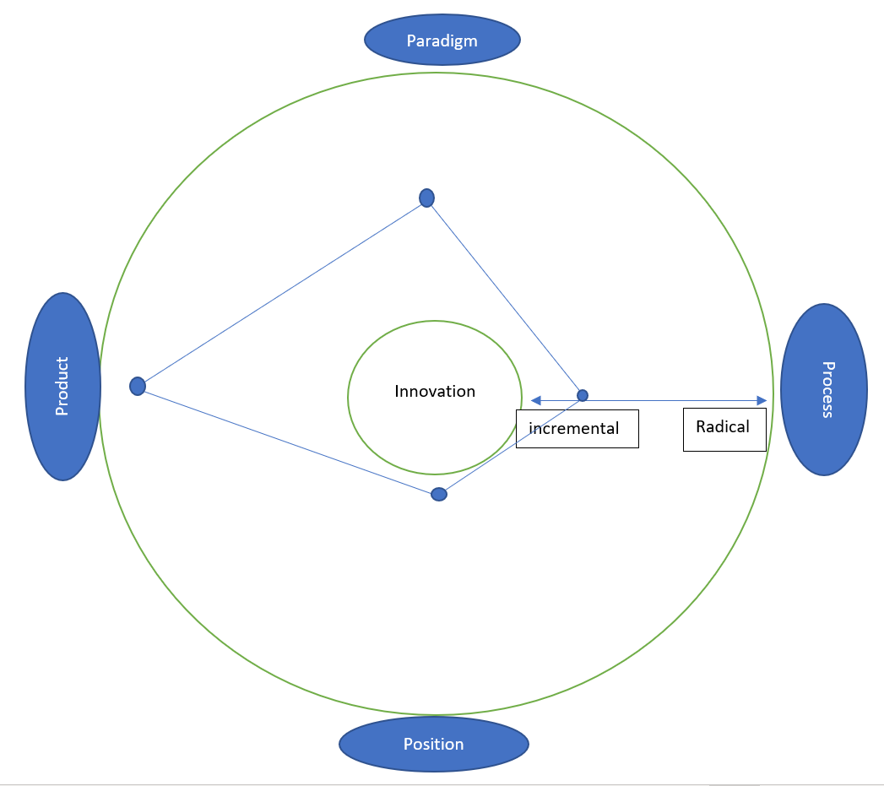
The mapping shows low radicalism of Process and Position for this innovation at Tesla. It reveals high radicality for the Product, and the Paradigm falls between the two extremes. This shows underuse of opportunities for Process and Position Innovation.

Appendix 5
Lewin’s Force Field Analysis (King and Anderson, 1995).
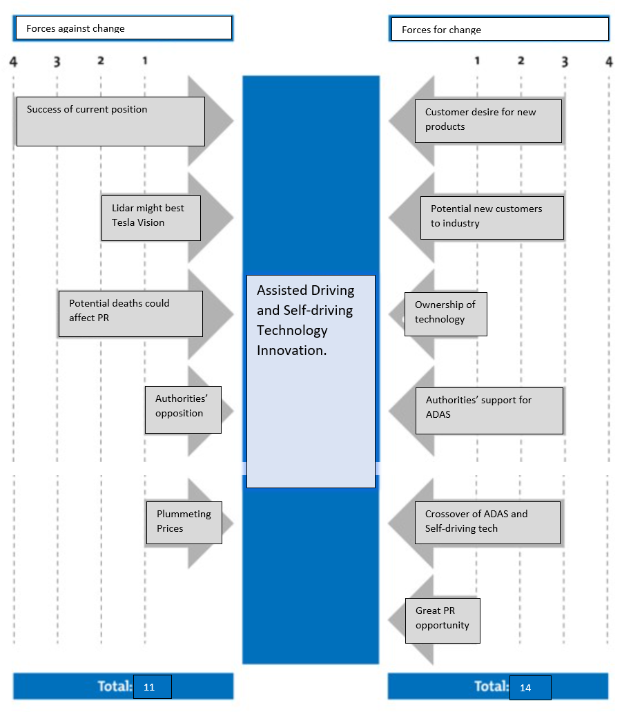

Acknowledgements
The author wishes to acknowledge the assistance provided by Davina Wyn Evans and the University of Wales Trinity St. David in the preparation of this report.

Task 2

Question 1
Critically Explain how innovation and creativity can support business advantage.
Innovation and Creativity are two interrelated concepts. The increasing pace of change in the business world (Ridderstrale and Nordstrom, 2002) has led to an increasing amount of discussion on the subject by contemporary theorists. Much is made of the best conditions for creative thinking, how companies can encourage and facilitate their staff to contribute and how organisations can capture value or alter the paradigm. Tushman and Anderson (1997) identify innovation (along with new product management) as a ‘crucial source of competitive advantage’. They caution on the likelihood of failure for companies which fail to innovate, while reminding readers that the aim of being adaptive can bring with it inefficiency, which threatens competitivity. Innovation, they assert, would be a simple errand were it the only concern, but the attempted balance of innovation with all other pressures is far more challenging. Listing several examples of innovative success, e.g. Nokia, Intel, Sony and Motorola, Tushman and Anderson reveal innovation, whether incremental or discontinuous, as the source of those organisations’ competitive advantage. While Henry and Mayle (2002) suggest in a broad and sweeping statement that ‘Software is central to virtually all sophisticated innovation and management activities’, Tushman and Anderson warn how highly technological and resource-rich organisations ‘often fail to compete in the ‘technologically-turbulent environments they helped to create’. It is possible that De Bono (2016) sought to confront this apparent contradiction in his treatise on ‘the failure of Western thinking’ to deal with change. Innovations are not limited to new products or new uses. Nonaka and Takeuchi (1995) also draw a distinction between cultural attitudes to innovation. Business models, and ways of thinking are also open to innovation. Kawasaki (2014) refers to innovation as an art, rather than a science, accepting the somewhat arbitrary perception of what makes ‘correct’ policy to encourage creativity and innovation. Kawasaki attempts to underline the importance of ‘rolling the dice’ and expecting to get some things wrong. The freedom to polarise opinion, allow inefficiencies, and to produce sub-standard musings along with inspired ideas are, according to Kawasaki, an essential part of the process. The acceptance of ‘bad’ ideas and potential breakages along the way become a running theme in discourse surrounding innovation and creativity, as evidenced by Burstein (2012), who encourages the challenging of limitations, and of ‘breaking the mould’ as essential steps on the path to drawing out creativity. Taylor (2015) makes the point that moments of innovation may have come about accidentally, but that the correct conditions for innovation were nevertheless present. The evidence strongly suggests that innovation and creativity are indeed a boon to business advantage, that preparation for innovation and creativity are helpful, but no guarantee for future long-term success, and that while creativity and innovation can occur naturally and accidentally, that the creation of the correct conditions can drive the concepts into a virtuous circle of sorts. The disadvantages of eschewing such conditions are of a potentially high magnitude.

Question 1 References
Burstein, J. (2012) 4 Lessons in Creativity. Available at: www.youtube.com/watch?v=sY0Pf_pfqCI (Accessed: 21st March 2022).
De Bono, E. (2016) Parallel Thinking. London: Vermilion Publishing.
Henry, J. and Mayle, D. (2002) Managing Innovation and Change. 2nd Ed. London: Sage.
Kawasaki, G. (2014) The Art of Innovation. Available at: www.youtube.com/watch?v=Mtjatz9r-Vc (Accessed: 21st March 2022).
Nonaka I. and Takeuchi H. (1995) ‘The Knowledge-creating Company: How Japanese Companies Create the Dynamics of Innovation’, Long range planning, 29(4), p.592.
Ridderstrale, J. and Nordstrom, K. (2002) Funky Business. 2nd Ed. London: Pearson.
Taylor, J. (2015) What is the difference between innovation and creativity? Available at: www.youtube.com/watch?v=TL2d2t2iZkY&t=3s (Accessed: 21st March 2022).
Tushman, M. and Anderson, P. (1997) Managing Strategic Innovation and Change. New York: Oxford University Press.

Question 2
Critically review and evaluate one lecture from the module and reflect on how this has supported your understanding of innovation and creativity. Further reflect on how you could have improved on your understanding of this lecture.
For this reflective piece, I have chosen to use Gibbs’ (1988) ‘Learning by doing’ reflective model as a tool and as a structure for its comprehensive simplicity.
Stage One: Description. As an undergraduate studying for a BA in Leadership and Management Skills for the Workplace, I attended a programme of lectures and tutorials focussing on the interrelated concepts of Innovation and Creativity. The blended nature of the module meant that lectures took place online and occasionally in person on campus. The occasion selected for reflection is the first that took place on campus this term. It took place on the morning of Monday 7th February. The lecture centred on Innovation Models. Much of the class ultimately elected not to attend campus and contributed remotely. The result was a limited success.
Stage Two: Feelings. Returning to campus was a charged emotional experience, tinged with ambivalence. The stressful nature of our pandemic-induced long-term absence from campus had been an isolating and claustrophobic experience, and I was mildly excited in anticipation of the event, eager to renew relationships with my contemporaries. I was disappointed with the low in-person turnout, a feeling shared by others in attendance, but happy to have the opportunity of social interaction, nevertheless. Afterwards, I felt unsure if the mode of delivery was optimal.
Stages Three and Four: Evaluation and Analysis. This event was a qualified success, but the remote presence of so many students detracted from the experience, proving to be a severely limiting factor. Discussion of some of the class materials centred on the cyclical creative and destructive nature of innovation. This brought back to my mind the art of Kintsugi (BBC, 2021), featured recently in an episode of niche animated comedy Bojack Horseman (Good Damage, 20##) and a subject which had featured in a previous lecture. This connection was a pleasing sign of successfully coordinating the various aspects of the module. I had prefaced the event by familiarising myself with an article on change agents (Barratt-Pugh et al, (2008) but conversely, this information had no connection with the content of the lecture. I was inspired to research a NY Times article (2021) on the company chosen for my report. During the morning, I sought the opinion of my lecturer on some articles I had, something scarcely possible during online lectures. It occurred to me (and I suspect, not only to me) that the Monday morning timetable was a large looming factor in the minds of those who did (and indeed those who did not) choose to attend remotely.
Stage Five: Penultimately, in conclusion, the first return to in-person lectures was a qualified success with unfulfilled potential, limited by the external forces of change and internal resistance to the re-introduction of previously normal expectations. Consideration of the efforts that had been employed to bring us successfully back to a working in-person model left me pondering the contextual choice of Kotter’s (1996) dichotomy faced by the faculty, and believing that in this case, managing stability had trumped leading change.
The final phase, the Action Plan is thus: to read class materials in advance to maximise discussion opportunity; to coordinate and to enthuse more students to attend in person on specific designated campus lectures; and to examine the possibility of Monday afternoons as a potential preferable window of activity.

Question 2 References
‘Good Damage’, (2020) Bojack Horseman, Netflix, 6th January.
Barratt-Pugh, L. et al (2013) Managers as Change Agents. Journal of Organizational Change Management. Emerald Group Publishing.
BBC (2021) Kintsugi: Japan’s Ancient Art of Embracing Imperfection. Available at: www.bbc.com/travel/article/20210107-kintsugi-japans-ancient-art-of-embracing-imperfection (Accessed: 18th February 2022).
Gibbs, G. (1988) Learning by Doing. Oxford: Oxford Polytechnic.
Kotter, J. (1996) Leading Change. Massachusetts: Harvard Business School Press.
NY Times (2021) Inside Tesla as Elon Musk Pushed an Unflinching Vision for Self-Driving Cars. Available at: nytimes.com/2021/12/06/technology/tesla-autopilot-elon-musk.html (Accessed: 16th February 2022).

