  Component One: Student Journal (learning log) 750 words +/- 10%  Contribution to Overall Module Assessment: 25% | Student No: | 2244785
 | Module Title: | Operating Hotel Facilities
 | Module Code: | BMIH4006
 | Lecturer: | Ben Chong

Student Journal

My placement as housekeeping staff in Premier Inn Evesham has been a staggering and meticulous experience as the tasks I went through are mostly new to me. Maintaining and cleaning rooms and house areas, Responsibilities of housekeeping staff include addressing executive housekeeper management duties, management and co-ordination among the departments, cleaning hotel rooms, controlling quality and others (Revfine, 2023). In this regard, when I work in housekeeping, the first thing when I enter the room I open the window to air it out, then I take the dirty linen from the bed, wipe the dust with a blue cloth and D10 disinfectant, and that I take the trash from the room and the bathroom. In the end, I clean the bath, I start with the toilet, which I wipe with a yellow cloth and Sani 4 in 1 only. Then the sink and bathtub with Sani 4 in 1 and red cloth. Then the tile with the red mop and Sani 4 in 1 and finally on the floor with Sani 4 in 1 and the mop. Then in the room, I make the bed with clean linen and finally, I use the vacuum cleaner. At the end of the work schedule, we set the cart with what is needed for the next working day and take the garbage bags outside to the dumpster. For cleaning the sink and bathtub, I use red clothes, and for the toilet, I use yellow clothes. whereas, for the windows, mirrors or furniture, I use blue clothes. An engaged workforce is essential for supporting an organization’s progress (Bridger, 2022). As part of my job, I was also responsible for delivering effective engagement and analyzing the key facts with proper service quality maintaining a good reputation of the organization towards guests.
Initially, I was a little worried about my actions on addressing a holistic ground to deliver the best services. Housekeeping is a fast-paced and highly pressured work culture that housekeepers to address (CPDonline, 2024). Once a complaint from a customer related to sanitation made me nervous and hardly find any way to condemn it. I immediately sought help from my peers to suggest scenarios to address the task within the stipulated time. Their suggestions allowed me to address the client’s needs appropriately which boosted my confidence and improved my morale of being responsible.
I have realized that communication is one of my key weaknesses which needs to be improved. Since there were many tasks of housekeeping, I had to manage time in an efficient manner which has helped in develop time management skills. For the particular work, I use some of the products like, Sani 4 in 1 Cleaner, Suma Bac D10 and Taski Sprint 200 to clean the facilities. Sani 4 in 1 Cleaner is a 1.4 litre concentrated cleaner, descaler, disinfectant and deodorizer for all acid-resistant hard surfaces in washroom areas. (Needs to be mixed with water). Similarly, Suma Bac D10 is a highly concentrated detergent surface sanitiser for one-step cleaning and disinfection (Needs to be mixed with water). Additionally, Taski sprint 200 is used for windows or mirrors (Needs to be mixed with water). The bad thing about the placement experience is that the shift hours were very long which has also affected my mental well-being to a certain extent. I have also discussed the problem with other members of the management to solve it. After the discussion, I realized that effective communication is the key to problem-solving.
The placement significantly impacted my basic abilities and the housekeeping department’s role in guest satisfaction. In addition to this, as per the remarks of Thébaud et al. (2021), housekeeping involves general housework activities and norms such as dusting. The reviews of Attia et al. (2022) have remarked that housekeeping also involves mitigating health hazards. As a result, the operational tasks of the housekeeping department also help in achieving the success of the hotels.
According to the opinion of Mullins and Dossor (2013), hospitality management can be explained as the study of the hospitality industry which focuses on providing a customer experience to consumers. Communication, time management and problem-solving are the key lessons which I have learnt from the housekeeping experience. Previously, I considered the hospitality industry to be very complex and challenging, however, after the placement experience, I think that the hospitality industry provides great opportunities for learning and career development.
Action plan
Actions | Steps | Timeline
To improve my communication skills | I intend to take suggestions from industry experts, superiors and skilled workers | 3 Months
To improve my time management ability to address tasks on time | I will volunteer to do housekeeping tasks and set a to-do list | 4 Months
To improve my analytical skills for developing qualities such as attention to detail | I will take self-assessments in complex scenarios and participate in diploma courses associated with housekeeping | 3 Months
Table 1: Action Plan
(Source: Self Developed)

Component Two: Health and Safety Guide
Contribution to Overall Module Assessment: 25%

1. Identifying potential risks, and best practices and regulations related to housekeeping safety
The potential risks of the tourism industry regarding housekeeping safety include:
- Slips and Falls
- Fire Hazards
- Tracking materials
- Chemical exposure
- Sanitization
Best practices related to housekeeping safety include:
- Slip-resistant spill mats can quickly conceal spills and warn others to avoid the region until the spill has been cleaned.
- A zero-tolerance stance for sidewalk obstacles will lower the risk of falling or slipping.
- As a consequence of the COVID-19 epidemic, several companies implemented new thorough cleaning methods to eradicate microorganisms that cause transmissible illnesses (Rai et al. 2020). When working with chemical-based cleaning remedies, cleaning professionals at PREMIER INN EVESHAM Inn may be asked to put on gloves and face shields.
- Housekeeping employees are in charge of chemical materials that, if not handled correctly, might become harmful (Neog, 2021).
- Strong sanitization rules protect everyone, including the health and safety of the entire community.
Regulations for housekeeping safety include two primary laws. The UK's Health and Safety at Work Act 1974 (HSWA) is the primary component of the law having control over workplace health and safety (GOV, 2024). It compels companies to protect their staff's well-being, security, and welfare within the workplace. On the other hand, the Workplace (Health, Safety, and Welfare) Regulations 1992 require that every place of employment, as well as its furniture, decor, and fixtures, be maintained properly clean (Legislations, 2024). All working surfaces within buildings, including floors, walls, and ceilings, must be able to be maintained clean.

2. Necessary precautions to prevent accidents and injuries.
- Creating a timetable for regular examinations and safety checks guarantees that the system and components are running smoothly (Zaki, 2022).
- Delegating a senior member of the staff to schedule and track maintenance processes will help to avoid electrical dangers.
- The level of craftsmanship of the materials utilized influences the general quality of the lodging establishment (Manfreda et al. 2023). Therefore, hotel managers at PREMIER INN EVESHAM ought to priorities quality over cost and convenience when selecting materials. Electrical service vendors can also propose superior components for the hotel's electrical infrastructure.
- In addition, every member of the team should be trained on safety around electricity. Staff members should be trained on potential electrical risks and the procedures they may take to avoid difficulties.

3. Step-by-step procedure for room cleaning incorporating safety measures.
- The first step in making hotel visitors feel cared for is to change their bed linen (Tarlengco, 2023).
- Regardless of whether there is a small piece of paper in the garbage container, personnel must ensure that all waste is removed from the room.
- Considering how frequently the hotel rooms are scrubbed, a feather duster might be quite useful in the regular hotel room cleaning routine.
- The vacuum cleaner's performance will be affected by the kind of carpet in the accommodations.
- Wipe off the concrete floors with cleaning towels and a general-purpose cleanser to ensure there are no spots for guests to notice.
- To ensure that no stains remain on the counters, personnel must disinfect and wipe down the whole bathroom, from the restroom to the shower and basin.

4. Essential equipment and tools that should be used safely during room cleaning.
Some of the essential equipment and tools that should be used safely during room cleaning are:
- Vacuum cleaner: A vacuum cleaner is essential for sanitizing spaces and keeping them dust-free.
- Brooms and dustpans: Brooms and dustpans constitute two of the most important household cleaning items.
- Brush: A brush is an important piece of bathroom equipment that helps to keep restrooms clean and tidy at all times.
- Mop: A mop is a housekeeping instrument that is essential for all cleaning tasks (Maid Zen, 2023). It is critical to use a sponge that can spin and wash with ease.
- Rubber gloves: Gloves made from rubber are a crucial component in each cleaning kit.

5. Identifying potential hazards for room cleaning and practical solutions to mitigate them.
According to the ideas of Attia et al. (2022), some of the key hazards associated with housekeeping are respiratory illness, skin reactions, injuries, cuts, infectious diseases and bruises. In addition to this, it has been found that if a room is not cleaned properly then dust remains in the rooms which often leads to dust allergy and respiratory problems in people. On the other hand, a lack of cleanliness of sharp objects in the room also can cause cuts and injuries. As per the reviews of Mangco, and Andales (2023), hygiene practices, sanitation procedures, and room cleanliness are some of the key strategies to mitigate the potential hazards. Besides that, cleanliness of sharp objectives, dusting, better management of chemicals, and timely changes in bedcovers are the key solutions to mitigate potential hazards in a room. However, the reviews of Battan et al. (2023) have argued that hotels have also been providing training to housekeeping staff for better cleanliness and maintenance of rooms.

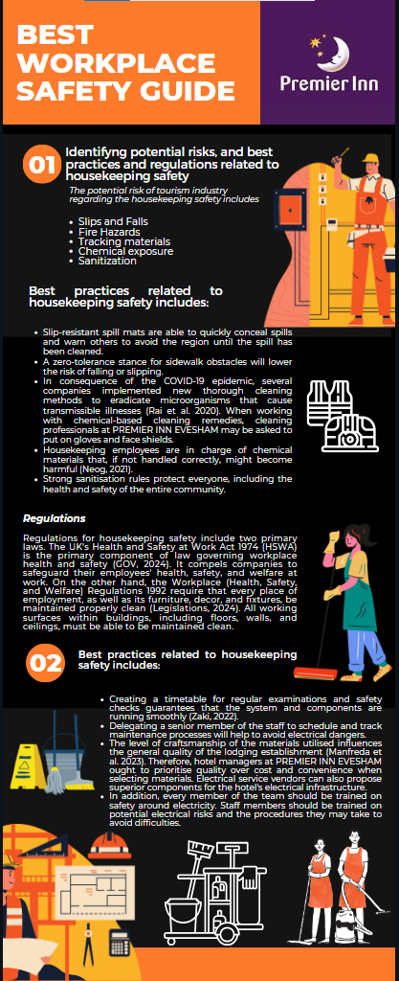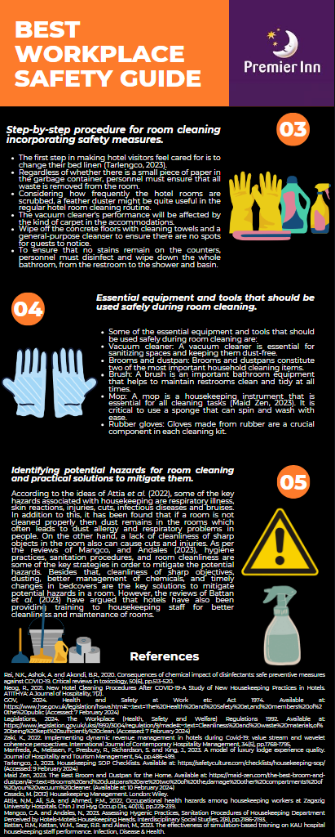
Reference List
Attia, N.M., Ali, S.A. and Ahmed, F.M., 2022. Occupational health hazards among housekeeping workers at Zagazig University Hospitals. Chin J Ind Hyg Occup Dis, 40(13), pp.229-239.
Battan, R.M., Kattan, W.M., Saqr, R.R. and Alawi, M., 2023. The effectiveness of simulation-based training on KAU hospital housekeeping staff performance. Infection, Disease & Health.
Bridger, E., 2022. Employee engagement: A practical introduction (Vol. 24). Kogan Page Publishers.
Casado, M. 2012. Housekeeping Management. London: Wiley.
CPDonline, 2024. How to Become a Housekeeper. Available at: https://cpdonline.co.uk/career-guides/how-to-become-a-housekeeper/#:~:text=The%20role%20is%20fast%2Dpaced,and%20customers%20can%20be%20challenging. (Accessed on: 6 February 2024)
GOV, 2024. Health and Safety at Work etc Act 1974. Available at: https://www.hse.gov.uk/legislation/hswa.htm#:~:text=The%20Health%20and%20Safety%20at,and%20members%20of%20the%20public (Accessed: 7 February 2024)
Legislations, 2024. The Workplace (Health, Safety and Welfare) Regulations 1992. Available at: https://www.legislation.gov.uk/uksi/1992/3004/regulation/9/made#:~:text=Cleanliness%20and%20waste%20materials,of%20being%20kept%20sufficiently%20clean. (Accessed: 7 February 2024)
Maid Zen, 2023. The Best Broom and Dustpan for the Home. Available at: https://maid-zen.com/the-best-broom-and-dustpan/#:~:text=Brooms%20and%20dustpans%20are%20two%20of%20the,damage%20other%20compartments%20of%20your%20vacuum%20cleaner. (Available at: 10 February 2024)
Manfreda, A., Melissen, F., Presbury, R., Richardson, S. and King, J., 2023. A model of luxury lodge experience quality. Journal of Hospitality and Tourism Management, 54, pp.486-499.
Mangco, C.A. and Andales, N., 2023. Assessing Hygenic Practices, Sanitation Procedures of Housekeeping Department Perceived by Hotels-Motels Housekeeping Heads. Interdisciplinary Social Studies, 2(8), pp.2186-2193.
Mullins, L. and Dossor, P. 2013. Hospitality Management and Organisational Behaviour. 5th ed. Harlow: Pearson.
Neog, R., 2021. New Hotel Cleaning Procedures After COVID-19-A Study of New Housekeeping Practices in Hotels. ATITHYA: A Journal of Hospitality, 7(2).
Rai, N.K., Ashok, A. and Akondi, B.R., 2020. Consequences of chemical impact of disinfectants: safe preventive measures against COVID-19. Critical reviews in toxicology, 50(6), pp.513-520.
Revfine, 2023. Housekeeping Duties: 8 Main Responsibilities of a Room Attendant. Available at: https://www.revfine.com/housekeeping-duties/ (Accessed on: 4 February 2024)
Tarlengco, J., 2023. Housekeeping SOP Checklists. Available at: https://safetyculture.com/checklists/housekeeping-sop/ (Accessed: 9 February 2024)
Thébaud, S., Kornrich, S. and Ruppanner, L., 2021. Good housekeeping, great expectations: Gender and housework norms. Sociological Methods & Research, 50(3), pp.1186-1214.
Zaki, K., 2022. Implementing dynamic revenue management in hotels during Covid-19: value stream and wavelet coherence perspectives. International Journal of Contemporary Hospitality Management, 34(5), pp.1768-1795.

