Report and Role Play on Professional Career Development (interviewee and interviewer)

Yana Taneva
2133822
Professional career development
(BMSW4005_LON)
Husam Alharahsheh

Table of Contents
Task 2: Report 3
Career Path 3
Current Skills 3
Gaps in Skills 4
Systematic Approach to Skills acquisition 5
Recruitment and Selection 6
Conclusion and Recommendations 8
References 9
Appendix 10
Task 1: Role Play 10

Task 2: Report

Career Path
Architecture is a field that involves designing and creating buildings and other physical structures (Fajaryati et al., 2020). It is a dynamic and challenging profession that requires a unique blend of technical skills, creativity, and problem-solving abilities. Architects are responsible for designing and planning the built environment, considering aesthetics, functionality, safety, and environmental sustainability. The field of architecture has a rich history and has contributed significantly to the development of human civilisation. From ancient times to the modern era, architects have played a critical role in shaping the world we live in today.
As an architecture professional, one is expected to have a solid foundation in various areas such as mathematics, physics, engineering, and design principles. These skills enable an architect to translate a client's needs and ideas into practical, aesthetically pleasing designs that meet regulatory requirements and budgetary constraints (Fajaryati et al., 2020). Architecture is a highly competitive field, and one needs to continually update their skills and knowledge to remain relevant in the industry. Therefore, pursuing further education and training is crucial to career growth and advancement.
Growing up, I was always interested in the design of buildings and how they could be made aesthetically pleasing and functional for the people using them. Pursuing a career in architecture was a natural choice for me, and I have been on this path for several years.
In this reflective report, I will discuss my career development plan as an aspiring architect, reflecting on my experiences, strengths, weaknesses, and goals. I will use Gibb's reflective cycle as a guide to examine my journey so far and identify areas for improvement and future growth. This report aims to provide insight into my personal and professional development and how I plan to achieve my career aspirations.

Current Skills
As an aspiring architect, I possess a combination of technical, creative, and interpersonal skills necessary for success in this profession. My current skills and abilities are well-aligned with the demands of this career, and I am continually working to improve them as I progress in my career.
Technical skills are essential for an architect (Prospects, 2023), and I have honed my abilities in software applications such as AutoCAD, SketchUp, and Revit. These tools allow me to create and manipulate digital models and produce accurate and precise drawings that meet clients' requirements. In addition, I have developed excellent design skills that enable me to conceptualise and develop architectural designs that blend functionality with aesthetics. My experience in project management and site analysis allows me to execute projects effectively while ensuring compliance with regulations and standards.
Collaboration is crucial in architecture (Prospects, 2023), and I possess excellent teamwork skills. I am adept at working with others to solve complex problems, and I can provide constructive criticism and feedback to team members to improve the final project's quality. Additionally, I possess strong written and oral communication skills, enabling me to articulate my ideas clearly and effectively.
Empathy and self-awareness are essential in architecture as they help architects understand clients' needs and perspectives (Prospects, 2023). I can empathise with clients and stakeholders, which helps me design spaces that meet their requirements while reflecting their values and culture. My self-awareness also helps me understand my strengths and limitations, which enables me to work collaboratively with others to achieve the best results.
Relationship management is critical in architecture (Fajaryati et al., 2020), and I possess excellent skills. I am skilled at building and maintaining relationships with clients, stakeholders, and contractors, which has helped me secure repeat business and build a positive reputation in the industry. Additionally, I possess strong mentoring skills that enable me to guide and support junior team members, helping them develop the skills and abilities they need to succeed.
Furthermore, digital competence is becoming increasingly important in architecture (Fajaryati et al., 2020), and I possess a keen interest in emerging technologies such as Building Information Modelling, Virtual Reality, and Augmented Reality. These technologies allow architects to create immersive and interactive environments, providing clients with a better understanding of the project before it is constructed.
In conclusion, my current skills and abilities align well with the demands of a career in architecture. However, I am committed to continuously developing my skills and knowledge to remain relevant and competitive in the industry.

Gaps in Skills
As an architect, a range of skills is essential to succeed. While I have developed some of these skills, there are also areas where I need to develop my abilities further.
One skill that is crucial for an architect is leadership (Bamboohr, 2023). As an architect, it is important to effectively manage a team of professionals, including engineers, contractors, and other designers. Leadership skills will enable me to communicate effectively with team members, delegate tasks, and ensure that projects are completed on time and within budget (Bamboohr, 2023). I plan to take on leadership roles in my future projects, such as leading design teams and coordinating with other professionals to develop this skill.
Another important skill for an architect is adaptability (McKenney and Handley, 2019). The architecture industry constantly evolves, with new design technologies and materials always emerging. Being adaptable will enable me to keep up with these changes and to remain innovative and competitive in the industry. I plan to keep myself updated with the latest technologies, attend industry conferences and workshops, and seek opportunities to work on diverse projects that challenge me to think outside the box.
Communication skills are also essential for an architect, enabling me to effectively convey my ideas to clients, team members, and other stakeholders (McKenney and Handley, 2019). This includes written and verbal communication and the ability to present complex ideas clearly and concisely. To improve my communication skills, I plan to attend public speaking courses, practice giving presentations, and seek opportunities to work with diverse clients and stakeholders.
Furthermore, business acumen is a key skill for architects. Architects must manage projects efficiently, market their services effectively, and navigate the business's financial aspects to succeed (McGuinness and Ortiz, 2016). Developing my business acumen will enable me to make informed decisions, negotiate with clients, and manage project budgets more effectively. To develop this skill, I plan to take courses in business management, read industry publications, and seek out mentorship from experienced architects who have successfully navigated the business side of the profession.

Systematic Approach to Skills acquisition
I plan to take a step-by-step approach to build the skills I need for my chosen career path in architecture that includes the following:
- Conduct a self-assessment: The first step in building any skill is understanding where an individual stand (Vereijken et al., 2019). I intend to conduct a self-assessment to identify my strengths and weaknesses, areas that need improvement, and skills that require development.
- Set clear goals: Once I have identified the skills I need to develop, the next step is to set clear, measurable, and achievable goals for each skill. I will set specific targets for each skill and break them down into manageable steps to make them more achievable.
- Seek out learning opportunities: To develop the skills I need for my career, I plan to seek opportunities to acquire the necessary knowledge and expertise. This could include attending workshops, seminars, and conferences related to architecture, taking online courses, or enrolling in a formal training program.
- Seek out mentors: Mentors can be an invaluable resource for career development. I plan to seek experienced architects who can provide guidance, share their expertise, and offer feedback on my progress.
- Practice regularly: Building skills requires consistent practice (Akkermans et al., 2018). I plan to set aside time each day or week to practice the skills that I need to develop. For example, if I need to improve my 3D modelling skills, I will set aside time to practice using relevant software regularly.
- Seek feedback: Constructive feedback is crucial for skill development (Ruetzler et al., 2019). I plan to regularly seek feedback from mentors, peers, and supervisors to gauge my progress and identify improvement areas.
- Reflect on progress: Regularly reflecting on my progress is crucial to building the skills I need for my chosen career. I regularly assess my progress against my goals, identify improvement areas, and adjust my approach accordingly.
In conclusion, building the skills I need for my chosen career in architecture requires a step-by-step approach that includes self-assessment, goal setting, seeking out learning opportunities and mentors, consistent practice, seeking feedback, and regularly reflecting on my progress (Vereijken et al., 2019). This approach allows me to build the skills necessary to excel in my chosen career.

Recruitment and Selection
The Gibbs Reflective Model is a flexible and adaptable framework that can be used to reflect on a wide range of experiences and situations (Williams et al., 2019). Individuals can develop a deeper understanding of their experiences, as well as identify areas for growth and improvement by using this model (Wallbridge, 2022). I recently participated in a job interview role play for an architecture position. Using the Gibbs Reflective Model, I will now reflect on my personal experience during this role play.
Description: Brief description of the situation
I recently participated in a job interview role-play exercise as part of my preparation for an interview for a role in Architecture. During the role-play, I was asked several questions about my previous experience, skills, and knowledge in the field of architecture, as well as my suitability for the job. I was also asked to provide examples of my work and to demonstrate my ability to work effectively in a team.
Feelings: Describing thoughts and feelings about the situation
I felt nervous and apprehensive about the role-play exercise, as I knew my performance would be evaluated and used to determine my suitability for the job. I was also worried that I might need help articulating my ideas effectively or forgetting important details about my previous experience and achievements.
Evaluation: Evaluating the positive and negative aspects of the situation
Ultimately, the role-play exercise was a positive experience. It allowed me to practice my communication and interpersonal skills and reflect on my strengths and weaknesses concerning the job requirements. However, there were some areas where I could have done better, such as providing more detailed and specific examples of my work and demonstrating greater enthusiasm and passion for architecture.
Analysis: Analysing the situation
From the role-play exercise, I have learned that it is important to prepare thoroughly for a job interview and to have a clear understanding of the role requirements and the skills and experience necessary to succeed. I have also learned that it is important to communicate clearly and confidently and to provide specific examples and evidence of your achievements and capabilities.
Conclusion
The role-play exercise was a valuable learning experience, and I feel more confident and prepared for my upcoming interview. In hindsight, I could have done better by preparing more detailed examples of my work and demonstrating greater enthusiasm and passion for architecture. However, I am now better equipped to tackle these challenges, and I am committed to continuing to develop my architectural skills and knowledge.
Action Plan
In the future, I plan to practice more job interview role plays and work on remaining calm and composed under pressure. I also intend to research companies and roles before any job interview to be better prepared. Furthermore, I will continue to develop my communication and presentation skills to improve my performance during job interviews.



Figure 1: A diagrammatic representation of Gibbs Reflective Model

Conclusion and Recommendations
In summary, this reflective report has explored my career development plan in architecture. I have discussed my current skills and how they fit into my career, identified the skills I need to develop, and outlined a step-by-step approach to building them.
Additionally, I reflected on a job interview role play from a personal perspective, identifying the strengths and weaknesses in my performance and discussing what I could have done better. This reflection highlighted the importance of being well-prepared for interviews, listening actively to the interviewer, and effectively communicating my skills and experience.
Moving forward, I plan to progress my career by actively seeking out opportunities to develop the skills I have identified as necessary for my success in architecture. This will involve seeking professional development opportunities, networking with other professionals in the field, and continuing to reflect on my experiences and learning from them.

References
Akkermans, J., Schaufeli, W. B., Brenninkmeijer, V., & Blonk, R. W. B. (2018). The role of career competencies in the Job Demands—Resources model. Journal of Vocational Behavior, 83(3), 356-366.
Bamboohr (2023) What is a skills gap? | bamboohr. Available at: https://www.bamboohr.com/resources/hr-glossary/skills-gap (Accessed: 8 April 2023).
Fajaryati, N. et al. (2020) ‘The employability skills needed to face the demands of work in the future: systematic literature reviews’, Open Engineering, 10(1), pp. 595–603. Available at: https://doi.org/10.1515/eng-2020-0072.
McGuinness, S. and Ortiz, L. (2016) ‘Skill gaps in the workplace: measurement, determinants and impacts: Skill gaps in the workplace’, Industrial Relations Journal, 47(3), pp. 253–278.
McKenney, M.J. and Handley, H.A. (2019) ‘Identifying and quantifying personnel skill gaps’, Proceedings of the Human Factors and Ergonomics Society Annual Meeting, 63(1), pp. 332–336.
Prospects (2023) What skills do employers want? | Prospects.ac.uk. Available at: https://www.prospects.ac.uk/careers-advice/applying-for-jobs/what-skills-do-employers-want (Accessed: 8 April 2023).
Ruetzler, T., Baker, W., Reynolds, D., Taylor, J., & Allen, B. (2019). Perceptions of technical skills required for successful management in the hospitality industry—An exploratory study using conjoint analysis. International Journal of Hospitality Management, 39, 157-164.
Vereijken, B., Whiting, H.T.A. and Beek, W.J. (2019) ‘A dynamical systems approach to skill acquisition’, The Quarterly Journal of Experimental Psychology Section A, 45(2), pp. 323–344. Available at: https://doi.org/10.1080/14640749208401329.
Wallbridge, A. (2022) Gibbs reflective cycle – how to learn from experience and become a better leader, TSW Training. Available at: https://www.tsw.co.uk/blog/leadership-and-management/gibbs-reflective-cycle/ (Accessed: 8 April 2023).
Williams, K., Woolliams, M. and Spiro, J. (2019) ‘Using a framework for reflection: Gibbs’ reflective cycle’, in Williams, K., Woolliams, M., and Spiro, J., Reflective Writing. London: Macmillan Education UK, pp. 90–102.

Appendix

Task 1: Role Play
Job Description
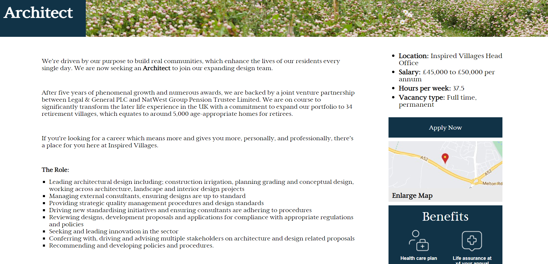
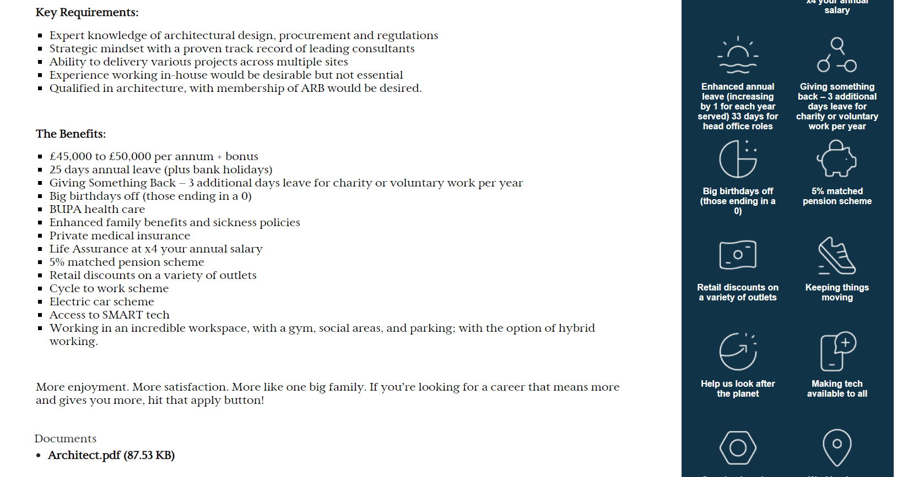
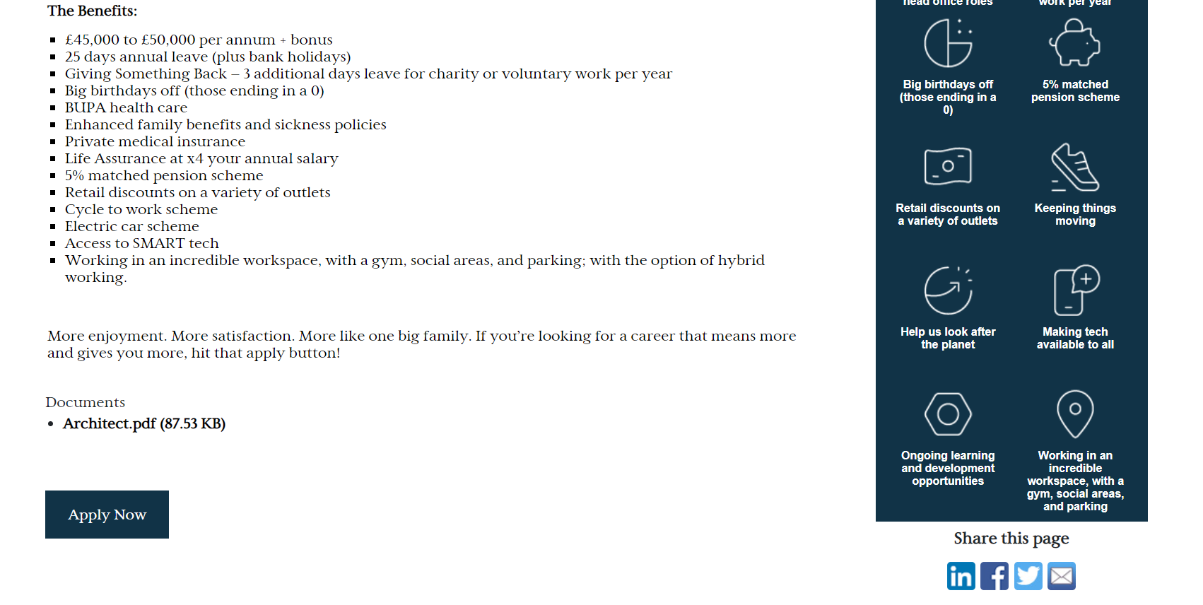

Application Form
Dear Human Resource Manager,
I am writing to express my interest in the Architect position at Inspired Villages. With a proven track record of leading architectural design projects across multiple sites, I have the skills and experience required to excel in this role.
As an experienced architect, I have a deep understanding of construction irrigation, planning grading, and conceptual design, and I have managed external consultants to ensure designs are up to standard. I am adept at providing strategic quality management procedures and design standards and always seek to drive new standardising initiatives and ensure consultants adhere to procedures. In addition, I have reviewed designs, development proposals, and applications for compliance with appropriate regulations and policies, and I am committed to seeking and leading innovation in the sector.
I am qualified in architecture, with a membership of ARB which give me expert knowledge of architectural design, procurement, and regulations. While I have not worked in-house previously, my experience working on multiple projects across multiple sites has prepared me well for this role.
The opportunity to work for a company with such a strong purpose and commitment to building real communities is truly inspiring. I would be honoured to contribute to Inspired Villages' mission to transform the later life experience in the UK. I am excited about joining your expanding design team and contributing to the company's continued success.
Thank you for considering my application. I look forward to discussing my qualifications and experience with you further.
Sincerely,
Yana.

Interview Questions and Answers
Question 1
Interviewer: Why did you apply for this position?
Interviewee: I applied for this position because I am passionate about architecture and its positive impact on people's lives. The purpose of Inspired Villages to build real communities that enhance the lives of residents aligns with my values, and I am excited to be a part of a company that is committed to transforming the later life experience in the UK. My experience in architectural design, project management, and knowledge of regulations and policies make me a strong fit for this role. I am excited about the opportunity to lead design projects and contribute to the growth and success of Inspired Villages.

Question 2
Interviewer: What skills do you have that fit this position?
Interviewee: Architects need to be great communicators. This has been the single most important ability for my professional success. As concerns develop, I need to communicate effectively with my team to find solutions and keep progressing with the project. Work quality improves when people can talk to one another.
Question 3
Interviewer: What experiences do you have?
Interviewee: I have extensive experience in architecture, having worked on various projects throughout my career. I have experience in architectural design, construction, planning, and project management, all of which are important skills for this role. In addition, I have a degree in architecture. I am a member of ARB, which has given me a strong foundation in architectural principles and industry regulations. I have also undergone additional training in various software tools used in architectural design, such as AutoCAD, Revit, and SketchUp, allowing me to hit the ground running in this role.

Question 4
Interviewer: How does this role align with your future career?
Interviewee: This role aligns perfectly with my future career aspirations in architecture. As an experienced architect, I am looking to take on more challenging and impactful projects, and this role allows me to work on complex and large-scale projects. I am also looking to work with a team that values collaboration and innovation, and this company has a reputation for both. In addition, the company's commitment to enhancing the lives of residents through real communities resonates with my personal values and career goals.

Question 5
Interviewer: Where would you like to be career-wise five years from now?
Interviewee: In five years from now, I see myself continuing to grow and develop my skills as an architect. I am passionate about architecture and always seek learning and improvement opportunities. I plan to take on more leadership responsibilities within five years and become a trusted client advisor. I also want to contribute to the design and execution of large-scale and complex projects, showcasing my creativity and technical skills. Furthermore, I would like to have obtained my professional architect license, demonstrating my commitment to the profession and enabling me to take on more challenging projects.

