Effective Team Work and Communication

Student Name: Elena-Andreea Salavastru

Student Number: 2020994

Module: Effective Team Work and Communication

Module Code: BMSW4002

Lecturer’s name: Akinseye Aluko

Assignment title: Effective Team Work and Communication Assessment 2

Table of Contents

1.Introduction 3
2.Models of Communication 3
2.1 Shannon and Weaver Model 3
2.2 Schramm Model 5
2.3 Berlo Model 5
3.Communication Skills 6
3.1 Methods of Communication 6
3.2 Tools and Approaches 8
3.3 Communication between Management and Employee 9
4.Conclusion 9
References 11

1.Introduction
Communication refers to the process of sending and receiving messages to each other through different traditional and digital channels (Fielding, 2016). In workplaces, effective communication is an indispensable part of team work and business excellence (Dewydar, 2015). Effective communication allows innovation, builds sustainable relationship, fosters employee engagement and brings sustainability in the organisational productivity and teamwork (Husain, 2017). Any barriers like noise, language differences, cultural misconception etc. can hamper the communication process in building effective communication and result in decrease of profit, employee retention and many more (Maund, 2018).
So, in this report, the relevant theories of communication i.e., Shannon and Weaver, Schramm and Berlo model will be discussed for showing the importance of process of communication in workplaces. Moreover, the communication skills, methods, tools and techniques will be described for ensuring better communication at workplace. In short, this report will show how these issues are affecting the workplaces in general with examples of my workplace at the end.

2.Models of Communication
Three most acknowledged communication theories are discussed below:

2.1 Shannon and Weaver Model
Shannon and Weaver model is known as ‘mother of all models’ in the communication and information sector (Bowman and Targowski, 2018). This model is published as “the mathematical theory of communication” by Shannon in 1948 and co-authored by Weaver in 1949. This model is the framework that helps to understand how communication flows between source to receiver and how noise can distort or misinterpret the information in the process (Ritchie, 2017). For example, in the case study of Maria and Pedro, it is seen that the communication got distorted due to the noise of working in building sites, Maria said chicken but Pedro heard kitchen. Similarly, in my workplace communication, it is shown that the noise of traffic outside the office distorted the information from letter to better. The Shannon and Weaver model shows the communication starts from the sender and ends through the effective feedback of receiver (Cobley and Schulz, 2016).
The framework of Shannon and Weaver communication process is shown and described below:

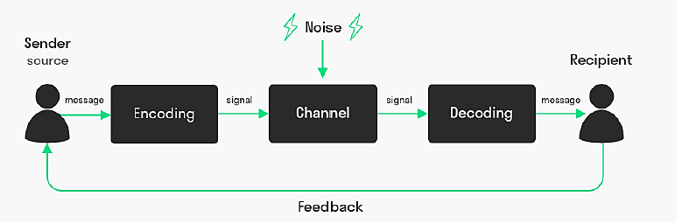
Figure 1: S&W Communication Model
Source: (Ritchie, 2017)

- Sender: This is source of starting the communication where an individual or entity intends to share message with others in a specific setting. The sender also selects the channels through which the information will be shared to the intended users (Husain, 2017).
- Encoding: This means coding of information where no one else understand the message except the selected receiver. In this model, the radio wave, computer or digital binary encoding process has been focused (Fielding, 2016).
- Channel: It is the medium through which sender and receiver communicates with other through encoding and decoding process. Communication medium can be both traditional and digital (Ritchie, 2017).
- Noise: This is known as the disturbances that cause misinterpretation of information. Noise distorts the actual information and makes it difficult for the receiver to understand the message sent by the sender (Taylor, 2015). Noise can be both internal and external like failure of decoding, disruption of internet, technical difficulties, cultural issues etc. (Cobley and Schulz, 2016).
- Decoding: This is the opposite process of encoding the information. In this process, receiver uses specific devices to understand the encoded information. In direct communication process, the decoding process is not needed (Ritchie, 2017).
- Receiver: It can be referred as the ultimate stage of communication. In this stage, the information reaches the destination and meets the objective of starting the communication (Bowman and Targowski, 2018).
- Feedback: This is the additional step to ensure the effectiveness of communication. Here, the receiver informs the sender about the completion of the communication process and how the information is interpreted (Husain, 2017).

2.2 Schramm Model
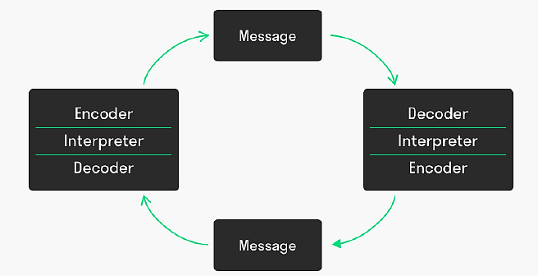
Wilber Schramm has proposed this communication model in 1954. It is somewhat different from the Shannon and Weaver’s model because this model is circular and other one is linear (Cobley and Schulz, 2016). According to Schramm, the role of sender or receiver depends on the cycle of communication. In this model, Schramm has given importance to the encoding and decoding process of communication. This model says that information is useless until it is converted into understandable manner and that’s why, encoding and decoding is the two most essential parts of communication process (Taylor, 2015). The Schramm’s communication model is a dynamic model which considers that communication is a two-way process and interpretation or feedback of information is a central feature of this (Bowman and Targowski, 2018). For example, Pedro could phone again to Maria by going into a silent place to ensure whether she has really asked for kitchen. Similarly, in my workplace, the employee could give feedback to the supervisor about the information he heard, which would help to ensure effectiveness of the communication. The process of communication is same as Shannon and Weaver in this model (Fapohunda, 2017). A sample diagram of this model has shown below where message circulates in a circular form through showing the encoder and decoder in between. The sender and receiver can start their communication at any place of this circle.

Figure 2: Schramm Communication Model
Source: (Cobley and Schulz, 2016)

2.3 Berlo Model
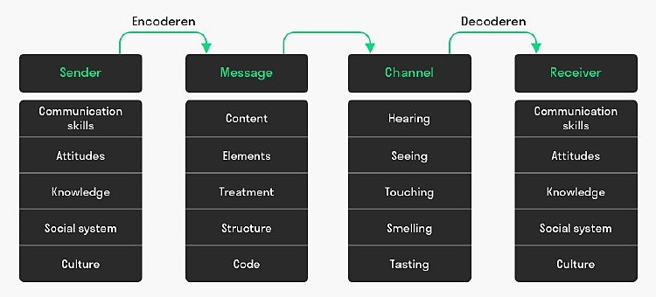
Berlo communication model is another linear model of communication which shows how noise disrupts the communication process between sender and receiver (Andrews and Baird, 2020). The model is proposed by David Berlo in 1960 and known as S-M-C-R communication model which describes the four essential elements of communication in this model (Bowman and Targowski, 2018). According to Berlo, the sender and receiver should have the same skills to participate in the communication process. Similarly, the same communication factors are applicable for both ends of the communication process. This means, the source and receiver should be on the same level for making the communication effective (Taylor, 2015). Berlo’s model includes some specific factors at each element of SMCR. Here, the S means source, M means message, C means channel and R means receiver.
Figure 3: Berlo Communication Model
Source: (Bowman and Targowski, 2018)
Both sender and receiver include the same factors, which are communication skills, attitudes, knowledge, social system and culture. As mentioned before, the sender and receiver need to have same knowledge, communication skill, attitude, culture and social system for effective communication otherwise the information will be interpreted in wrong way or ineffectively. There are some factors in message as well, like content, elements, code, structure, and treatment (Cobley and Schulz, 2016). This model is good for understanding the cultural issues. For example, in my workplace, I use this model for understanding the communication of my Asian colleagues. It seems that their attitudes, social systems are completely different, so we try to know more about them for ensuring better communication.

3.Communication Skills

3.1 Methods of Communication
Three most common types of communication methods are mentioned below:
- Verbal: This is the most common method of communication irrespective of workplaces, social engagement, personal grooming etc. (Lasater, 2019). The verbal communication includes both oral and written form of communication. The oral communication refers to the process of communication where both the sender and receiver engages in the communication through speaking which can be face-to-face, over the video or telephone calls etc. (Husain, 2017). On the other hand, the written communication is the way of sharing the message or information through writing to sender to receiver. The written communication can be conducted into many forms like through a document, an email, a tweet, a report or a post in the Facebook etc. (Bowman and Targowski, 2018). Verbal communication has the less complexity than any other forms of communication. It is easily understood by the people of every working class in the society and in workplace, it makes easier to build the team engagement. The intonation like pitch, tone, and cadence also plays important roles in making the verbal communication effective (Andrews and Baird, 2020).
- Non-Verbal: This is the unique form of sharing messages or information without speaking (Moore and Stacks, 2019). The non-verbal communication refers to the ability to communicate through body gestures, facial expression, eye-contact, hand-movement, posture and many more. It also refers the way of speaking without saying words (Lasater, 2019). The cultural or personal differences are major hindrances to make the non-verbal communication effective. One needs to understand the situation, context, culture and depth of a situation before giving any non-verbal gestures (Fapohunda, 2017). For example, in a meeting with Japanese people, one always should keep smiling, keeping unhappy face gives them the gesture of negativity. Similarly, in the workplace, when boss avoids eyes contact or give sigh to any activity, that sound negative in the communication process through non-verbal gestures (Harper and Matarazzo, 2016). It is very much important to pay attention to the gestures of people in work meetings because the non-verbal communication helps to make the deal in great context.
- Listening: It is often ignored in the list of communication methods, but this is one of the key methods of effective communication in the workplace. Active listening is one of the key communication methods in which people should have mastered for ensuring better communication at every level of the work life (Jonsdottir and Fridriksdottir, 2020). Because if one does not become able to listen other, then how they will be engaged to bring output or results after the communication takes place (Lasater, 2019). Active listening makes the communication process effective and productive at the same time. This is also known as the empathetic listening which means being responsive and focused while having conversation with others (Taylor, 2015). For example, in the negotiation process, the active listening plays the key role to bring out the best for the organisation or oneself. Because without being focused in the negotiation process, one will not be able to assess or determine the win/win situation for both the parties (Bowman and Targowski, 2018).

3.2 Tools and Approaches
For improving the communication skills in different methods of communication, some tools and approaches are suggested by communication experts (Fielding, 2016). Among them, these mentioned tools are known as the effective ones:
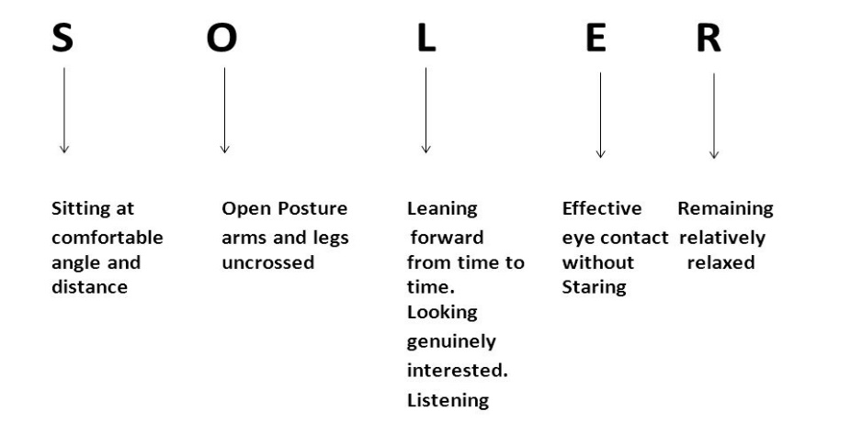
- S.O.L.E.R: This approach is developed by psychologist Gerard Egan for improving the effectiveness of non-verbal communication (Jonsdottir and Fridriksdottir, 2020). According to Egan, by adopting some micro skills like eye contact, sitting forward etc. can make the communication process more comfortable, effective and secured (Harper and Matarazzo, 2016). The abbreviation of S.O.L.E.R given below:

Figure 4: S.O.L.E.R
Source: (Harper and Matarazzo, 2016)

This technique also helps to improve the listening skills by which converts a communicator into an active listener. So, both in non-verbal and listening communication methods, S.O.L.E.R is a proven technique of improving skills for effective communication (Lasater, 2019).
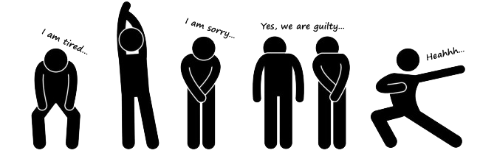
- Kinesics: It refers to the study of non-verbal communication through body movements. It refers to the actions of body, face expressions, gestures, hand movements of people while they are involved in the communication process (Moore and Stacks, 2019).

Figure 5: Kinesics
Source: (Moore and Stacks, 2019)
It is very much helpful for cross-cultural study as the non-verbal communication gestures varies from culture to culture (Dewydar, 2015). Through developing knowledge on kinesics, one can make the communication effective in non-verbal ways (Jonsdottir and Fridriksdottir, 2020). Some examples of Kinesics shown here.

3.3 Communication between Management and Employee
Basically, communication is referred as a bridge between management and employee for making the work done in the most efficient and effective manner (Lasater, 2019). Communication serves several purposes in the organisation starting from building good relationships among team-members to recognizing good work, appreciating the employees’ efforts and ensuring quick resolution of conflicts between management and employee (Dewydar, 2015). In the workplace, effective communication ensures the best results of the organisation (Maund, 2018). Employee and management both understands the objectives of the communication and acts accordingly. A good workplace environment and understanding develops through effective communication between management and employee (Fapohunda, 2017).
The necessity of effective communication is easily understandable through looking at my workplace practices. There are different people from different backgrounds and as Harper and Matarazzo (2016) mentioned, the non-verbal communication plays a significant role in interpreting the information. Some colleagues from my team use their hands while having conversation which makes our supervisor angry as she is from different background. I try to make them understand the importance of non-verbal communication and our supervisor also suggested them to read about the non-verbal communication in order to give importance to their body gestures, hand movement, signals, tones etc.
Another problem we found is the written communication quality, especially for non-native colleagues. One of them was always misspelling “which” in his emails, writing “witch” instead. He kept receiving replies with witches’ pictures at the bottom of the email and he couldn’t understand why serious emails were responded with derision.

4.Conclusion
Undoubtedly, communication is the backbone of ensuring effective teamwork and better workplace environment. But ensuring effective communication is difficult as several barriers affect the process of communication as mentioned by Shannon and Weaver in their model. The discussed theories like Shannon and Weaver helps to understand the importance of communication and how to ensure an effective one. The communication methods also needed to be chosen carefully based on the skills of employees in the organisation. Some tools like Kinesics, S.O.L.E.R can help significantly to improve the non-verbal and active listening skills. Organisations should give focus on their communication process through analysing the loopholes in it.

References
Andrews, P.H. and Baird, J.E., (2020). Communication for business and the professions. New York, NY: McGraw-Hill.
Bowman, J.P. and Targowski, A.S., (2018). Modelling the communication process: The map is not the territory. The Journal of Business Communication (1973), 24(4), pp.21-34.
Cobley, P. and Schulz, P.J. eds., (2016). Theories and models of communication (Vol. 1). Walter de Gruyter.
Dewydar, W.M.E.N.S., (2015). The optimum relationship between managers and employees. International Journal of business and social Science, 6(8), pp.135-141.
Fapohunda, T.M., (2017). Towards effective team building in the workplace. International journal of education and research, 1(4), pp.1-12.
Fielding, M., (2016). Effective communication in organisations. Juta and Company Ltd.
Harper, R.G., Wiens, A.N. and Matarazzo, J.D., (2016). Nonverbal communication: The state of the art. John Wiley & Sons.
Husain, Z., (2017). Effective communication brings successful organizational change. The Business & Management Review, 3(2), p.43.
Jonsdottir, I.J. and Fridriksdottir, K., (2020). Active listening: Is it the forgotten dimension in managerial communication?. International Journal of Listening, 34(3), pp.178-188.
Lasater, I., (2019). Words that work in business: A practical guide to effective communication in the workplace. PuddleDancer Press.
Maund, A. ed., (2018). BA in Leadership and Management: Skills for the Workplace Student Yearbook, Final Year. SAGE Publications Limited.
Moore, N.J., Hickson, M. and Stacks, D.W., (2019). Nonverbal communication. New York: Oxford University Press.
Ritchie, D., (2017). Shannon and Weaver: Unravelling the paradox of information. Communication research, 13(2), pp.278-298.
Taylor, S., (2015). Communication for business: A practical approach. Pearson Education India.

