Academic Discipline of Hospitality & Tourism Management BA International Hotel Management

BMIH5003
Foreign Languages and Cultural Awareness
Module: Cultural Awareness
LEVEL 5
Student name: Andreea Mangarea
Student ID: 2208277
Word counted 1000

Executive Summary
Understanding the culture of a country before expanding the business operations to that location is important for gaining success. Diversity Hotel & Spa is a five-star business that is planning to expand in France and this report has conducted a detailed analysis of the country based on the GLOBE project database. The graphs have been used for analysing or evidencing the leadership and cultural factors discussed. French culture focuses less on future-oriented decisions and it has an average score as a collective society. There are some basic customs and values of this culture such as greetings, participative leadership, high score power distance index and performance orientation that must be respected. Recommendations such as learning about the French language and becoming less assertive to avoid challenges while visiting the country or dealing with clients.

Table of Contents
Introduction 4
Chosen country’s culture and customs 5
Analysis of France as a country 6
Importance of cultural intelligence and sensitivity for hotel personnel 10
Recommendations 11
Conclusion 12
References 13

Introduction
Expanding businesses in the international market and foreign countries is impacted by various cultural factors. The term “culture” is broadly defined by Hofstede as a “collective programming of mind” that helps in differentiating between two groups of people (Pavlidou and Efstathiades, 2021). This is also explained as a collective phenomenon that is shared by people who live in the same environment and there are various layers to it. This report will focus on providing a detailed report on the cultural atmosphere of France where Diversity Hotel & Spa is going to open a new office. The following report to the general manager will provide a detailed analysis of French culture on the relevant factors of the GLOBE Project. Challenges that managers can encounter while dealing with employees will also be highlighted in this section.

Chosen country’s culture and customs
France is the chosen country in this report and this country`s culture is often associated with rich fashion, art and architecture. However, Gordon & Zimmermann (2022) explained that there is more to French culture than what is evident on the surface. Cultural variety is present in France as Roman, German and Celtic cultures are amalgamated to historically shape the French culture. French is the official language of the country and 88% of the people speak this language. Family is one of the fundamental units of French society and the culture is family-oriented (Ensign, 2020). The motto of the French people is “Liberty, Equality, and Fraternity” indicating that equality is given priority in the French culture (diplomatie.gouv, 2023). Greetings are an important part of the customs in the country that must be developed by foreigners.

Analysis of France as a country
The GLOBE project is a research program that focuses on understanding the relationships between different national cultures and the desirable attributes of leaders. It has described culture as the beliefs, values, identities, motives and interpretations that differentiate among collective groups. Nine cultural dimensions are used for analysing the culture of any country and here some relevant dimensions have been used (globeproject, 2020).
Cultural Analysis of the country
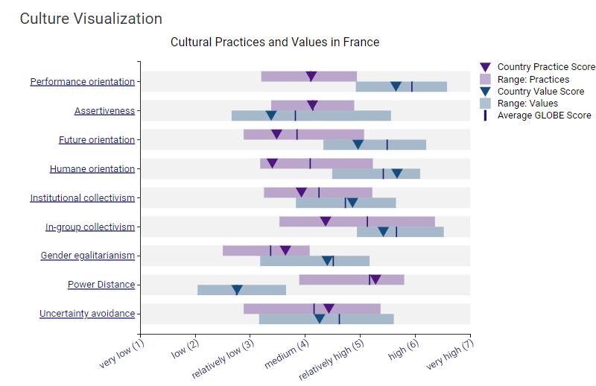
Figure 1: Cultural Visualisation
Source: (globeproject, 2020)
Performance Orientation
This parameter is used to define the degree to which the collective encourages and provides rewards to the employees working well. Rewards for performance improvement and excellence are discussed here. Above mentioned graph explains that both the practice score and range of practices are medium where the score of practice is 4.11. The value score of this country is relatively high scoring 5.65, the range is also relatively high and the average GLOBE score is high.
Assertiveness
Confrontational quality and assertiveness among the individuals in a society and aggressiveness of the people in their relationship are measured with it. Range and practice in French culture are rated medium as per the analysis where the practice scored 4.13. Country values assertiveness relatively low and close ranges from low to relatively high. As per the average score of the GLOBE, assertiveness is rated as relatively low to medium. Ruffa (2021) have also talked about the assertiveness among French people and presented some contradictory view.
Future Orientation
This parameter measures the extent to which the people in the society value future-oriented works such as planning, investing and delaying gratification in the future. The future orientation score is 3.48, rage is from relatively low to relatively low. The country value score for future orientation is 4.96 which is higher than the average GLOBE score which is 3.85.
Institutional Collectivism
The degree to which organisational and societal practices encourage collective actions along with the distribution of resources in a collective manner. The country practice score for institutional collectivism is 3.93 whereas the average practice score for French society is 4.25 indicating it is lower than other countries. Vale for institutional collectivism score is 4.86 which is higher than the average value of 4.73.
In-group collectivism
Pride, loyalty and cohesiveness of the people in their organisations are measured through this parameter. The practice score is 4.37 when the average score is 5.13, referring that it practices loyalty, and cohesiveness comparatively lower than average countries. The country value score for the group collectives is 5.42 whereas the average score is 5.66.
Gender Egalitarianism
It refers to the extent the French community reduces gender inequality and the country's practice score is 3.64 which is higher than the average score which is 3.37. The value score is 4.4 which is slightly lower than the average score of 4.51. This matrix can help understand the way one should behave in the workplace.
Power Distance
The power distance demonstrates to the extant French society accepts power differences and authority. Country practice score is 5.28 which is higher than the average score of 5.17. The value score is 2.76 indicating the value of this country has a relatively low support for power distance.

Analysis of leadership in French culture
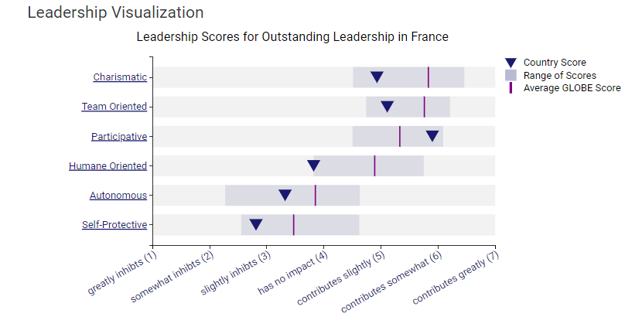
Figure 2: Leadership Visualisation
Source: (globeproject, 2020)
Various factors are used by GLOBE data to describe the ideal leader that a culture accepts. Some of the factors that are relevant for analysing the French leadership are discussed below.
Charismatic: The country's score for the charismatic factors of the leaders is 4.93 which is lower than the average score of 5.83 which indicates charisma contributes slightly in leadership.
Team Oriented: The range of score of team orientation among French leaders is from neutral to somewhat contributive. A score of France is 5.11 whereas the average GLOBE score is 5.76.
Participative: The involvement of others in decision-making is included in the participative parameter and the score of the country is 5.9. This means participative leaders can somewhat impact the leadership approach.

Importance of cultural intelligence and sensitivity for hotel personnel
Cultural intelligence and sensitivity among the hotel personnel are very important as they directly address the customers. Christiansen et al. (2020) have explained that businesses rely on culture heavily and culture is directly influenced by national values. Knowledge about the cultural practices and national values among individuals can hugely impact the customer services they provide (Caputo et al., 2019). Cultural sensitivity refers to showing respect towards the customs and traditions of the people working in the organisation. The ability to become culturally sensitive will allow individuals to increase the satisfaction among the customers and retain them for a longer time (Prentice, 2020). For example, the general manager can encounter challenges in communication if they do not know the French language which is spoken by the majority. They must develop the practice of greeting people around them to avoid being rude and build strong relationships.

Recommendations
The analysis has provided a detailed description of the importance of the value of practice orientation and practice of the same in the country. The assertiveness among the French people is lower than the English population (globeproject, 2023). Hence, it is recommended that individuals should be comparatively less assertive while dealing with clients and employees. Language is a huge part of the culture and the General manager is recommended to learn the language to be able to build strong relationships with customers. Abramson and Moran (2018) have mentioned that communication and understanding different cultures are paramount to the success of any business.

Conclusion
Culture is an important part of business operations in the hospitality industry as gaining holistic knowledge about a culture streamlines customer relationship management. This report has pointed out that performance orientation is valued and practised within French culture. Moreover, French society is not future-oriented which indicates that individuals are more focused on living in the current time. The organisation expanding their business to this country must focus on developing strategies to become appealing.

References
Abramson, N.R. and Moran, R.T., (2018). Managing cultural differences: Global leadership for the 21st century. Routledge.
Caputo, A., Ayoko, O.B., Amoo, N. and Menke, C., (2019). The relationship between cultural values, cultural intelligence and negotiation styles. Journal of business research, 99, pp.23-36.
Christiansen, B., Branch, J.D. and Karmowska, J. eds., (2020). Cultural Factors and Performance in 21st Century Businesses. IGI Global.
diplomatie.gouv, (2023). Liberty, Equality, Fraternity. [Online] Available at: https://www.diplomatie.gouv.fr/en/coming-to-france/france-facts/symbols-of-the-republic/article/liberty-equality-fraternity#:~:text=A%20legacy%20of%20the%20Age,itself%20under%20the%20Third%20Republic. [Accessed 23 October 2023].
Ensign, A., (2020). French Traditions and Culture. [Online] Available at: https://www.familysearch.org/en/blog/french-culture-traditions#:~:text=Equality%20and%20unity%20are%20important,are%20common%20over%20the%20weekend [Accessed 23 October 2023].
globeproject, (2020). An overview of the 2004 study: Understanding the Relationship Between National Culture, Societal Effectiveness and Desirable Leadership Attributes. [Online] Available at: https://globeproject.com/study_2004_2007 [Accessed 23 October 2023].
globeproject, (2020). France. [Online] Available at: https://globeproject.com/results/countries/FRA?menu=list#country [Accessed 23 October 2023].
globeproject, (2023). England. [Online] Available at: https://globeproject.com/results/countries/GBR?menu=list#country [Accessed 23 October 2023].
Gordon, J. & Zimmermann , K. A., (2022). French culture: Customs & traditions. [Online]Available at: https://www.livescience.com/39149-french-culture.html [Accessed 23 October 2023].
Pavlidou, C.T. and Efstathiades, A., (2021). The effects of internal marketing strategies on the organizational culture of secondary public schools. Evaluation and Program Planning, 84, p.101894.
Prentice, C., Dominique Lopes, S. and Wang, X., (2020). Emotional intelligence or artificial intelligence–an employee perspective. Journal of Hospitality Marketing & Management, 29(4), pp.377-403.
Ruffa, C., (2021). Military Culture and the Challenge of Ambidexterity in Complex Operations. The Yin-Yang Military: Ambidextrous Perspectives on Change in Military Organizations, pp.101-109.

