Task A
RI = 2 x (Length + Width) / Height x (Length + Width)
Number Of Lamps = LDL X Room Area x Illuminated Level / LLF x UF

RI = 2 x (60 + 24) / 8 x (60 + 24) = 168 / 672 = 0.25
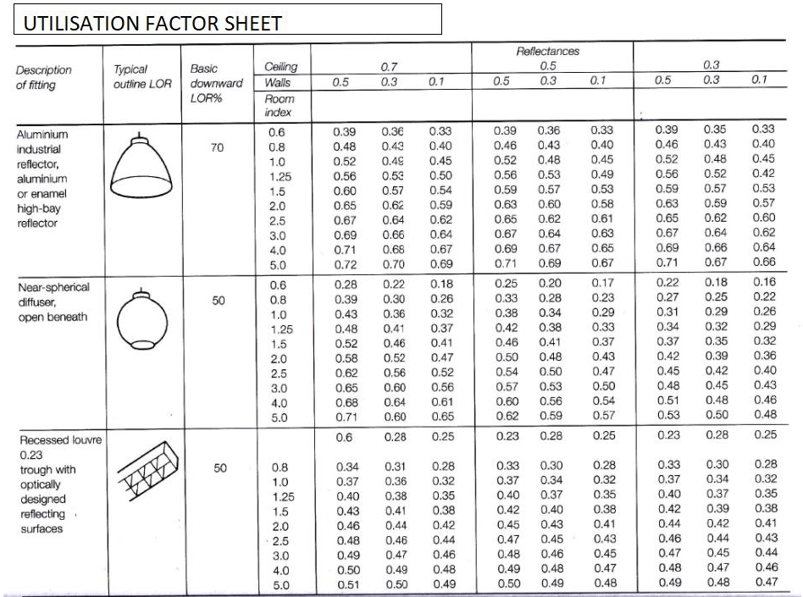

From the Utilisation Factor sheet, for a "Recessed louvre trough with optically designed reflecting surfaces" fixture with a DLOR of 0.23, we need to find the UF for a room index of 0.25, ceiling reflectance of 0.3, and wall reflectance of 0.5. Referring to the table, the UF is approximately 0.28.

Number of Lamps Required
Number of Lamps = LDL x Room Area x Illumination Level / LLF x UF
Number of Lamps = 18,000 x (60 x 24) x 200 / 0.75 x 0.28
Number of Lamps = 18,000 x 1440 x 200 / 0.21
Number of Lamps = 51,840,000 / 0.21
Number of Lamps = 246,857
Suitable Layout
The layout of the lamp fittings depends on factors such as spacing between lamps and their arrangement within the space. A typical layout for recessed fluorescent lamps may involve a grid-like pattern with equal spacing between lamps.

Summarize
Room Index = 0.25
Utilisation Factor = 0.28
Number of Lamps = 246,857
Suitable Layout = Grid like pattern with equal spacing between lamps

Task B

Frequency and wavelength
Frequency:
Frequency refers to the number of vibrations or cycles of a sound wave per unit of time and is measured in Hertz (Hz). It determines the pitch of a sound, with higher frequencies corresponding to higher pitches and lower frequencies corresponding to lower pitches. In the context of sound waves, frequency is directly related to the perception of the sound's pitch by the human ear.
Wavelength:
Wavelength, symbolized by the Greek letter λ (lambda), represents the spatial interval between successive points on a wave exhibiting identical phases, like consecutive peaks or troughs. This measure is expressed in meters. In the realm of sound waves, wavelength and frequency share an inverse relationship; as frequency rises, wavelength diminishes, and vice versa. This connection is mathematically defined by the formula: λ = c / f, where λ denotes the wavelength, c represents the speed of sound, and f signifies the frequency.

Implications in Building Design and Construction
- A buildings internal design and services support:
In building design, understanding the frequency and wavelength of sound waves is crucial for creating spaces with optimal acoustics. Different spaces within a building, such as auditoriums, offices, and classrooms, have varying requirements for sound control and reverberation.
For instance, in auditoriums and concert halls, where high-quality sound reproduction is essential, designers must consider the wavelength of sound waves to properly position sound-reflective and sound-absorbing surfaces. Large, open spaces with high ceilings may produce longer wavelengths, necessitating the use of acoustic panels or diffusers to control reverberation and prevent sound distortion.
In offices and conference rooms, where speech intelligibility is important, designers may need to address mid-range frequencies associated with human speech. Implementing sound-absorbing materials in partition walls, ceilings, and floors can help reduce noise transmission and improve overall comfort and productivity.
Additionally, building services support systems, such as HVAC (Heating, Ventilation, and Air Conditioning) systems, can generate noise at specific frequencies. Designing ductwork and ventilation systems to minimize noise propagation and selecting appropriate insulation materials to attenuate sound transmission are critical considerations in building design and construction.
- A partitions wall’s construction technique:
Partition walls play a significant role in separating spaces within a building and controlling sound transmission between rooms. The construction technique used for partition walls can greatly influence their sound insulation properties.
The frequency and wavelength of sound waves determine the effectiveness of partition walls in attenuating noise. For example, low-frequency sounds, such as those produced by heavy machinery or traffic noise, require thicker and denser partition walls to block transmission effectively. In contrast, high-frequency sounds, such as speech or music, may be adequately attenuated by thinner partition walls with sound-absorbing materials.
Choosing construction materials with suitable mass and stiffness properties can help match the partition wall's impedance to that of the sound waves, maximizing sound insulation performance across a range of frequencies. Additionally, incorporating resilient mounting systems and sealing gaps and joints can further enhance the partition wall's ability to reduce noise transmission.

- The choice of insulation types
The selection of insulation types plays a pivotal role in managing sound transmission through building envelopes, encompassing walls, floors, and ceilings. Various insulation materials demonstrate diverse acoustic properties, encompassing their capacity to absorb, reflect, or convey sound waves across varying frequencies.
For instance, fiberglass and mineral wool insulation are widely employed for their commendable sound-absorption capabilities spanning a wide frequency spectrum. These materials effectively dampen both low and high-frequency sounds, rendering them suitable for mitigating airborne noise transmission within buildings.
Conversely, mass-loaded vinyl (MLV) and soundproofing membranes are meticulously engineered to impede the propagation of low-frequency noise, such as vibrations stemming from machinery or vehicular traffic. These materials are frequently integrated as barriers within walls, floors, and ceilings to hinder the passage of sound waves through building structures.
In the process of selecting insulation types, designers and builders must evaluate the specific frequency range of noise sources prevailing in the environment and opt for materials that deliver optimal performance across those frequencies. Additionally, adhering to proper installation practices, including ensuring airtight seals and minimizing gaps, proves indispensable for optimizing the efficacy of insulation in managing sound transmission.
To sum up, the frequency and wavelength of sound waves exert significant influence on building design and construction endeavours, particularly in crafting spaces with superior acoustics, devising efficacious partition walls, and identifying suitable insulation materials to regulate noise transmission. Through a comprehensive understanding of these parameters and their implications on sound behaviour, designers and builders can cultivate environments that foster comfort, productivity, and well-being for occupants of buildings.
Part 2

- Thermal Transmittance and Thermal Resistance
Thermal transmittance, often represented as the U-value, characterizes the speed of heat transfer across a material or assembly per unit area, per unit temperature difference. This parameter is gauged in watts per square meter per degree Celsius (W/m²·°C). A diminished U-value denotes superior thermal insulation, indicating reduced heat transmission through the material or assembly.
Thermal resistance, denoted as the R-value, stands as the reciprocal of thermal transmittance (R = 1/U). It gauges a material's capacity to hinder heat flow and is measured in square meters kelvin per watt (m²·K/W). A heightened R-value signifies enhanced resistance to heat transfer, leading to superior thermal insulation.
The relationship between thermal transmittance (U-value) and thermal resistance (R-value) is inverse. Mathematically, the R-value equals the reciprocal of the U-value (R = 1/U). Hence, as the U-value decreases (indicating lower heat transfer), the R-value escalates (indicating heightened thermal resistance). Conversely, as the U-value increases (indicating amplified heat transfer), the R-value diminishes (indicating reduced thermal resistance). This correlation is fundamental in comprehending how disparate materials and assemblies affect the pace of heat loss or gain through a building's fabric.

