The proposed use of a digital app to share information with families known to the Children’s Speech and Language Therapy service.

Introduction:
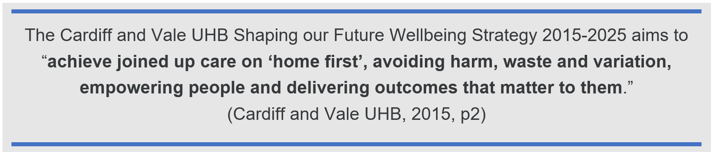

The Cardiff and Vale University Health Board (UHB) Children’s Speech and Language Therapy (CSLT) service seeks to support and empower those most proximal to the child known to the service (i.e. parents/carers, education staff, and others who have frequent interactions with the child) in order to maximise the impact of the interventions for the child and family. Encouraging those most proximal to the child to contact the CSLT service when they have queries or feedback is important to joint working and shared decision making with the CSLT service.
Over the last two years, the CSLT service has adopted new ways to share information with families known to the service. Resources and activities can be e-mailed via a generic e-mail account, reports and targets can be sent via an online Secure File Sharing Portal (SFSP), therapists can send an e-mail via the SFSP so parents can reply attaching videos of their child at home, and the departmental website is being developed to provide families and other professionals with a range of information and resources; these more recent digital methods to communicate and share information with families known to the CSLT service sit alongside the more traditional means of sending documents in the post. Although the number of ways the CSLT service can send information to families has increased, if parents want to initiate communication with the service they are still limited to telephoning or sending information by post. Enabling easier means of two-way communication between service users (families of children known to the CSLT service) and the CSLT service, will support the UHB Principles for Change (Figure 1) in particular the ‘empower the person’ and ‘home first’ policies (Cardiff and Vale UHB, 2015, p12), through promoting joint working on the child’s intervention.

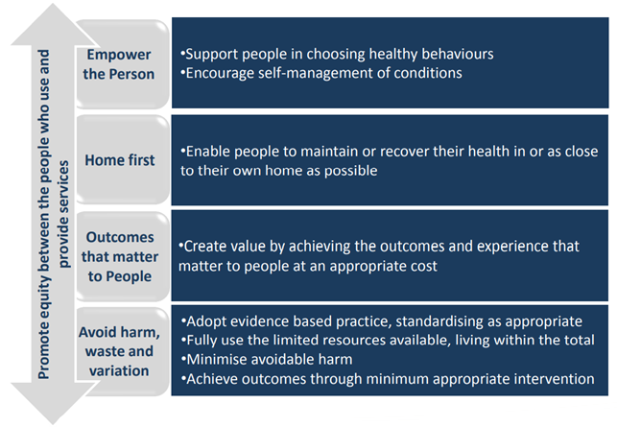
Figure 1: Working Together: Principles for Change (Cardiff and Vale UHB, 2015, p12).

Some families known to the CSLT service have requested to be able to communicate directly with their child’s therapist via e-mail (information gathered in a survey of CSLT therapists regarding how the service currently shares information with service users, April 2022). Currently, CSLT service policy does not permit therapists to directly e-mail families due to concerns regarding therapist’s e-mail addresses being accessible to some vexatious families.
The SFSP was introduced as a means of sending documents with patient identifiable information (PII) or receiving videos from families; although this enables families to contact the therapist, the link for these e-mails automatically expires after 21 days. Therapists have mixed views on the ease of use of the SFSP and several families have reported that they are unable to upload the videos requested by the therapist to support in the assessment/intervention process. Although the SFSP was designed to prevent the sharing of therapist’s e-mail addresses, it has been found that some families’ devices do show this without the therapist’s knowledge.

Parents of school-aged children are familiar with using apps on Smartphones to access information from their child’s school. Apps frequently used by schools within the Cardiff Local Education Authority (LEA) and Vale LEA include SeeSaw, SIMS, Class DoJo and Parent Pay. Information regularly shared by schools includes term dates, updates on their child’s progress, and sharing newsletters, key events and class activities. Families are also able to send messages to school staff on many of these apps including to report absence/attendance.
Healthcare apps are becoming increasingly popular to enable individuals to book appointments (for example with GPs, using apps such as MyGP developed by iPLATO Healthcare Ltd), or to help individuals self-manage their condition at home (for example, the NHS Wales AsthmaHub app developed through a collaboration between NHS Wales and The Institute of Clinical Science and Technology).
The creation of an app for the CSLT service as a means of communicating with families known to the service is one potential option that would support the UHB aims by empowering families through facilitating easier two-way communication, leading to improved collaborative working and shared decision making, and enabling several of the existing means of communication to be centralised into one place. In addition to supporting the UHB strategy aim, this potential digital solution also enables other UHB policies, NHS Wales policies and wider Welsh Government aims (Figure 2.).
The introduction of an app for the CSLT service to facilitate a change in the way families and the CLST service communicate would be a service wide change located at the ‘targeted service intervention’ level (Figure 3) of Lilford et al.’s adaptation of Donadebian’s causal chain theory (Lilford et al., 2010, p1). A change at this level within the service will also impact on other clinical processes carried out (e.g. how appointment information and report/activities are shared) and the outcome for the families (e.g. they will be able to initiate communication with the CSLT service more easily, and have all communication regarding their child’s intervention in one place).

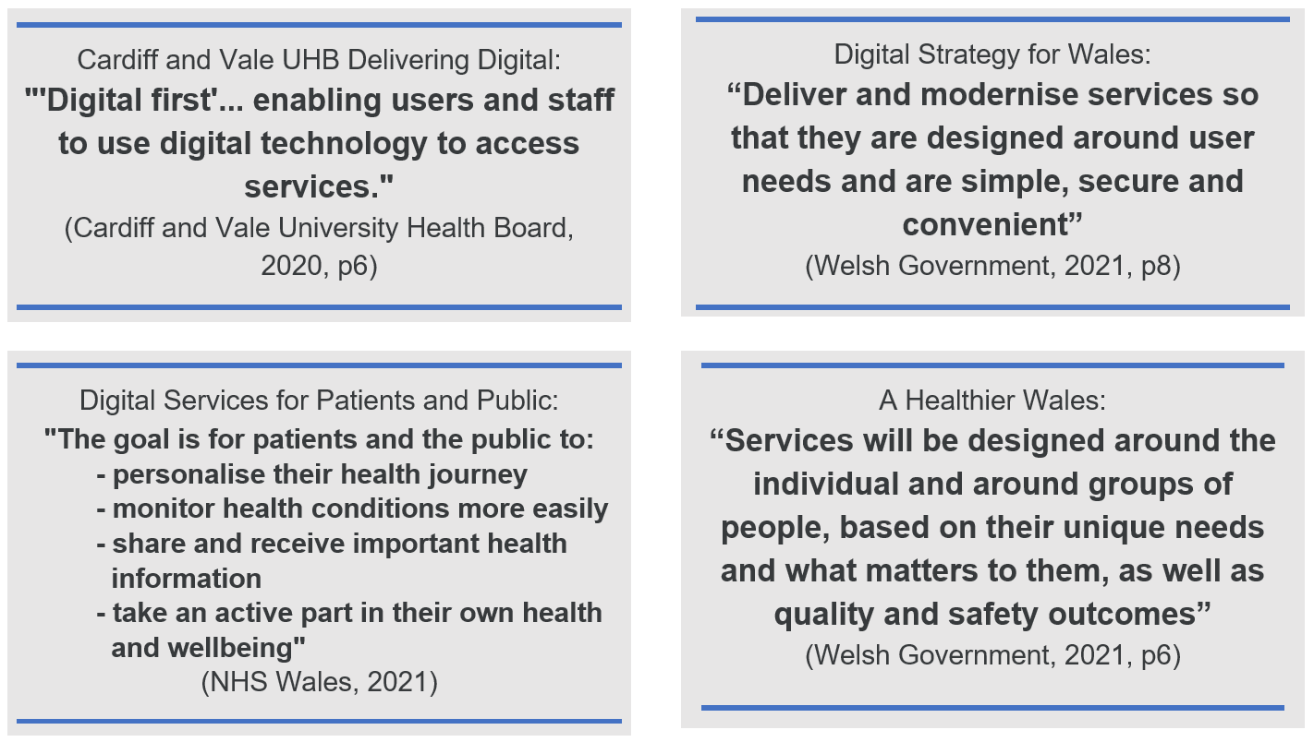
Figure 2: policy aims that can be enabled with the use of a digital app.

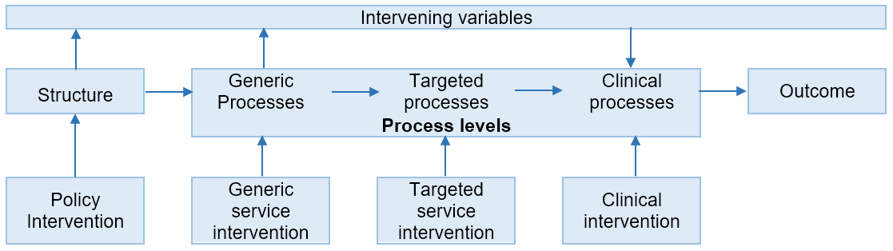
Figure 3: Lilford’s adaptation of Donabedian causal chain theory.

Methods:
A survey was e-mailed to CSLT therapists in April 2022 to gather information on how they currently communicate with families (outside of appointments) and their opinions around the usefulness of a potential app for the CSLT service and service users. Therapists were also asked what features they felt would be most helpful within an app.

A gap analysis (Terrell-Hanna, 2021) was conducted to evaluate the methods currently used by the CSLT service to communicate with service users, in comparison to the target state of improved communication systems between therapists and families to enable greater shared decision making and collaborative working. Information from the survey of CSLT therapists, and semi-structured interviews with a small number of therapists, provided the basis for these analyses. The discrepancy between the current state and target state evaluations was used to look at options that may help close the gap for the CSLT service to work optimally with service users; the development of an app is one potential solution that was explored further.
An options appraisal (Local Partnerships, 2012) was undertaken to compare building the app within the UHB versus procuring the development and app platform from an external company, including looking at the advantages and disadvantages for each option and taking into consideration future developments and adaptations that may need to be made.

Results:
A survey of CSLT Therapists conducted in April 2022 (20 of 45 therapists responded; a 44% response rate) showed 70% of therapists responded positively about the potential use of a app to enhance communication with families known to the service, and a further 15% said they would need more information about its use and functionality before deciding if it would be beneficial to their caseload.

A gap analysis comparing the advantages and disadvantages of the different communication methods currently available to the CSLT service (Table 1) and the target state of 1) enabling two-way communication with families (to facilitate empowering families to be more proactive in the joint working and shared decision making regarding their child) and 2) enabling families to have a central place for all the information regarding their child’s care, reveals a discrepancy between the current state and target state. Although the CSLT service can currently communicate information via various methods to families, the methods currently used do not easily enable families to initiate communication with the CSLT service.
This discrepancy indicates the CSLT service needs to seek alternative ways of communicating with families that incorporates and promotes engagement from families by giving them a means to easily initiate communication with the service. Ideally, there would be one digital system used to communicate with families to enhance and support communication within appointments (i.e. face-to-face/phone/video discussions/ appointments) that would facilitate two-way communication, and enable families to have all the information regarding their child’s care in one place.
The proposed use of an app could be one solution to closing the gap between the current state and the target state. Table 2 proposes the potential advantages and disadvantages of using an app to share information and support communication between the CSLT service and service users. Figure 3 summarises the capabilities of the current and potential methods of communication.

When considering the development of the app, it is important both CSLT staff and end users are involved in the design, planning and trialling of the product. The broad digital technology requirements that need to be considered for the app (Table 4) will need to be agreed collaboratively between the service users, CSLT staff, software developers and other key stakeholders. The requirements will then need to be refined and defined specifically in order to guide the system developers and to enable the requirements to be tested objectively. Sommerville (2016, p109) highlighted that vaguely defined requirements leave room for interpretation by the developers and may therefore result in features that do not meet the users needs; this then leads to additional costs and time delays as the systems are refined.
Careful consideration also needs to be made to whether the app can be built by software developers within the UHB or whether the app would need to be outsourced. Table 4 compares the advantages and disadvantages of both options.

Means of communicating with service users | Advantages | Disadvantages
post | - familiar to service users  - some families request appointment letters so they can put it in a prominent place to remind them of the appointment  - providing resources/activities to families who do not have access to a printer | - cost to CSLT service for paper, printing costs, printer maintenance  - cost to the UHB for postage  - not always accessible for families with literacy difficulties or English as an additional language (EAL)  - some items get lost in the postal system  - families may move address without informing CSLT service
e-mail via generic account | - most families are familiar with using e-mails  - easy to use  - can send copies of activities/resources (that do not contain PII) | - not secure for sending PII  - two-step system (Therapist e-mails the generic account, the e-mail is forwarded to the family by the assistants)  - one-way communication (families are discouraged from e-mailing the generic account due to PII security)  - families may miss or lose the e-mail
e-mail direct from therapist | - most families are familiar with using e-mails  - easy to use  - can send copies of activities/resources (that do not contain PII)  - two-way communication with families (without using the child’s name) | - not secure for sending PII  - not currently permitted within the CSLT service due to concerns regarding some vexatious families having therapist’s direct e-mail addresses
Secure File Sharing Portal (SFSP) | - secure for sending reports/targets/videos containing PII  - two-way communication (within the 21-day timeframe)  - arrives as an e-mail for families | - link expires after 21 days  - families cannot initiate communication with CSLT service (they can only reply within 21 days to an e-mail sent to them)  - not compatible with video formats recorded on all phones/devices  - families may miss or lose the e-mail  - system was not co-produced with Therapists and CSLT end users; mixed responses regarding the ease of use
SMS text messaging | - simple to use  - enables two-way conversation with families  - could be used to gain parental consent for appointments to take place (if parents are unable to attend) | - not yet been authorised by CSLT service for frequent/standard use when communicating with families  - families may change phone number without informing CSLT service  - cost to CSLT service for sending SMS text messages  - cost demand on families (some low-income families may not have credit on their phone)  - unable to attach documents (reports/activities/resources)
CSLT departmental website | - easily accessible to the public  - contains generic advice and support  - will contain common activities/programmes that families can be signposted to (currently under development) | - content is still being developed  - not suitable for sharing reports that contain PII
Table 1: a comparison of the advantages and disadvantages of different ways available to the CSLT service to communicate with families.

Advantages | Disadvantages
- many families are familiar with using apps with schools  - can be co-produced with CSLT staff and end users to ensure it is simple/intuitive to use, and fit for purpose  - over 91% of 16-44 year-olds in Great Britain use a Smartphone (Statista, 2022)  - will enable two-way communication between families and CSLT staff  - correspondence related to the CSLT service will be in one place for families  - can be developed over time to ensure it continues to meet the needs of the CSLT service and end users  - app would include accessibility features for visually impaired, those with low literacy skills, and translation capability for EAL families  - able to be accessed via mobile-data or Wi-Fi (families can access free Wi-Fi connection available in most schools) | - not all families will want to access information through an app, or may not be confident in using an app, therefore families will be given the option of having information via another means if they prefer  - cost of developing and maintaining the app  - some CSLT staff may be reluctant to use a new digital system
Table 2: the potential advantages and disadvantages of a CSLT service app.

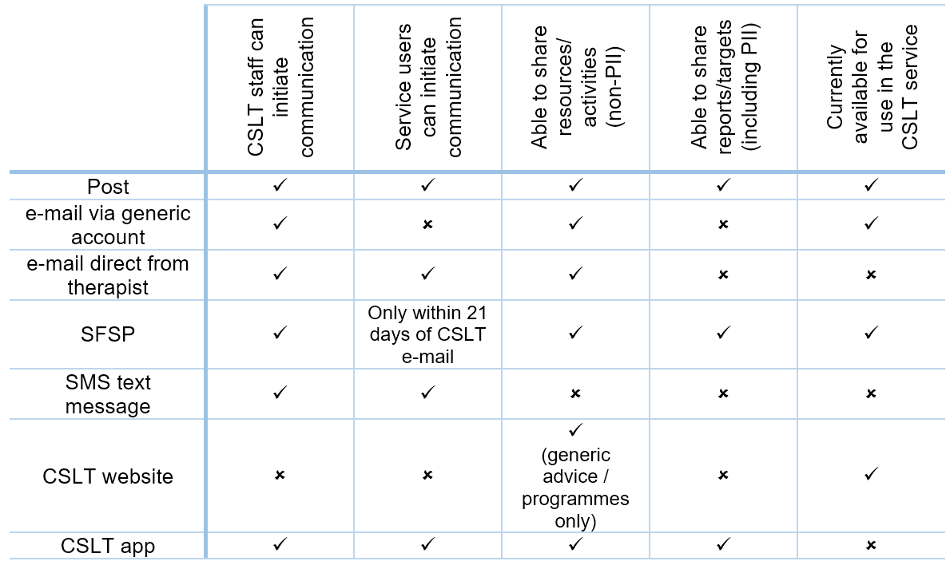
Figure 3: summary of the capabilities of the current methods of communication and potential methods of communication.

 | Requirements | How the requirements can be fulfilled by the CSLT app
Functionality | Must requirements (initial phase of development):  Two-way communication system  Appointment information  Sharing of reports/targets/activities  Want requirements (second/future phases of development):  Session summary  Sharing of video clips  Home-practise motivator  Enable school to access certain information  Option to request documents are printed/posted  Signposting to information | The system will:  - enable families and CSLT staff to initiate communication, and reply, via a chat/messaging feature  - enable CSLT staff to upload information regarding date/time of appointments  - notify the family of the appointments  - enable the family to confirm if they can attend  - enable automatic reminder notifications of appointments for the family  - enable CSLT staff to upload reports/targets/activities  - enable families to view and print reports/targets/activities  - enable CSLT staff to post a summary of an appointment/phone call with key home-practise points  - enable the family to upload short video clips to assist in the assessment/therapy process, or as an update on their child’s progress with home-practise activities  - enable CSLT staff to upload a short video clip demonstrating the activities with the child in the appointment to support home-practise  - enable interactive home-practise charts/worksheets for the child/family to use to help motivate them to implement the strategies/activities  - enable the child’s school to access certain information on the app, in particular the reports/targets to support seamless care between health and education  - enable parents to request activities/resources are printed and posted to them (e.g. if they do not have access to a printer)  - enable signposting to resources on the CSLT website  - enable signposting to other useful websites  - enable signposting to courses/training sessions being run by the CSLT service, LEA, or local 3rd sector organisations
Non-functional requirements | Reliability  Performance  Security  Scalability  Usability  Maintainability | The system will:  - be accessible 24 hours-a-day so service users can access the information when it is convenient for them  - have fast, reliable processing and responsiveness times to ensure service users are able to access different sections of the app quickly and efficiently  - be co-designed with end-users to ensure it is easy and intuitive to navigate  - be trialled with end users before being rolled out to ensure it is fit for purpose  - comply with all data protection and privacy governance  - have a secure log-in for CSLT staff and families  - be clear with end users how their information is being stored and used  - ensure data is backed-up securely  - have processes in place for ending data storage on the app when families have been discharged from the CSLT service, or if families request data is deleted if they no longer want to use the app  - ensure the app maintains security and reliability as it is further developed, and the number of end users increases  - ensure there is sufficient storage available for all the data as the use of the app increases  - ensure there is sufficient capacity for the app to be used by many users at the same time  - comply with usability and accessibility guidance, using NHS service design standard (NHS England, 2021)  - have inbuilt screen readers and translation apps to support families with visual impairments, low literacy levels or EAL  - have a simple ‘how to’ guide to demonstrate to users how to use the app  - have processes in place to notify end users of any maintenance time required (these will be kept to a minimum and occur at times when the app is accessed the least) and when updates are available
Data collection and analysis | Reporting  Security | The System will:  - enable CSLT managers to monitor the use of the app, including generating reports regarding the number of contacts made by families, any issues/complaints raised regarding the functionality  - ensure data protection and privacy is built into the design of the system  - monitor and manage risks, around clinical safety
Knowledge management | Empowering the service users through joint working and shared decision making | The system will:  - enable families to initiate communication with the CSLT service  - enable CSLT staff to check-in with families more easily for feedback on progress towards the current targets and if a further appointment is required to co-produce new targets; encouraging families to actively participate in the intervention process supports best practise standards for CSLT
Technical standards | Interoperability | The system will:  - ensure data is transferred accurately, while staying safe and secure  - integrate with the existing electronic health record (EHR) system to create a casenote of the information CSLT staff share on the app
Table 3: the broad digital technology requirements for a CSLT app

 | Local advantages | Local disadvantages
Built by software developers within the UHB | - likely to be lower cost  - able to develop the app and update features more easily in the future  - greater understanding of UHB requirements  - able to work with stakeholders (managers/directorates) more easily if they have prior experience of developing apps within the UHB  - an understanding of the current EHR system and therefore interoperability needed to integrate the systems | - may not have the expertise within the UHB to develop the app as required  - app may take longer to develop if the development team have other projects within the UHB
Outsourced to an app development company | - may be developed quicker if there is a designated team working on the app  - may have more expertise and potential design experience for apps  - will understand data confidentiality/security requirements if they have developed health apps previously | - may be a higher cost.  - continuing costs for future developments  - less knowledge of the existing EHR system and how the systems can be integrated
Table 4: comparison of the advantages and disadvantages of building or buying the CSLT app

It will be preferable for the app to be developed by software developers within the UHB in order to facilitate the interoperability of the app with the existing EHR system, to more easily comply with UHB PII data confidentiality, and have lower costs for future refinement/development of the app over time. However, if the skills needed to develop the app are not currently available within the UHB, then research would need to be carried out regarding different commercial companies available with previous experience of building apps for healthcare or education, and a further options appraisal will need to be conducted to determine which would be the most appropriate option to move forwards with.
Once the app has been developed, a testing period will take place with a trial group of service users to ensure the app fulfils the digital technology requirements, and to evaluate through a survey how confident they felt about using the messaging function to contact the CSLT service. The number of contacts initiated by families via the app can be monitored and compared to the current number of telephone enquiries to evaluate whether the app is supporting families to be proactive in engaging with the CSLT service; this in turn can be evaluated to see if these contacts are promoting joint working and shared decision making between the families and CSLT service.

Discussion:
The gap analysis conducted of the methods of communication currently available between the CSLT service and families known to the service, and the target state of enabling families to initiate communication to encourage shared decision making in their child’s care, showed the service needs to investigate alternative methods of facilitating two-way communication. The use of a digital app is one option to enable families to initiate communication with the CSLT service, to encourage their involvement in their child’s care, and to enable all correspondence with the service to be in one place.

Enabling families to initiate communication with the CSLT service more easily, and therefore support collaborative working and shared decision making regarding their child’s input, will support the Shaping our Future Wellbeing Strategy (Cardiff and Vale UHB, 2015) as well as supporting other Cardiff and Vale UHB strategies, NHS Wales policies and wider Welsh Government policies (Figure 2).

Moving forwards, key stakeholders within the UHB will need to be consulted to get their support to progress with the development of the project proposal.
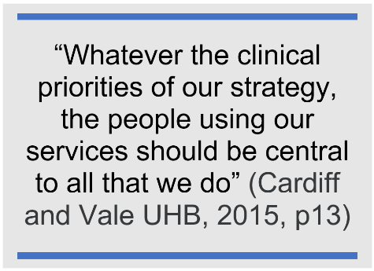
A Patient-Reported Experience Measure (PREMs) questionnaire can be used with service users to gather views on their current experience, and level of ease and satisfaction regarding contacting the CSLT service. Families can be consulted as to whether they would like the option of an app to facilitate easier two-way communication with the CSLT service and to have all the documents/correspondence regarding their child’s intervention collated into one place/app. If families report they feel this would be helpful to them, families should be invited to take part in design meetings and trial use of the app before the app is launched for the whole service to use. Co-design and co-production with CSLT staff and end users will enable an app to be developed that is fit for purpose, simple and intuitive to use, and has the capability to be developed further over time. The digital technical requirements in relation to a potential CSLT app (Table 3) will need to be revisited throughout the iterative co-design and co-production process to ensure the product is fit for purpose and delivers value to the CSLT service and end users. Following the implementation of the app, a further PREMs survey can be conducted to evaluate the level of satisfaction in being able to initiate contact with the service, and how they would rate the ease of use of the CSLT app in relation to other healthcare apps or school/education apps they may use.

References:
Cardiff and Vale University Health Board (2015) Shaping our Future Wellbeing Strategy 2015-2025. Available at: https://cavuhb.nhs.wales/files/shaping-our-future-wellbeing-strategy/10-uhb-shaping-our-future-wellbeing-strategy-final-pdf/ (Accessed: 9 April 2022).

Cardiff and Vale University Health Board (2020) Delivering Digital: Building a learning health and care system. A Five Year Strategy. Available at: https://cavuhb.nhs.wales/files/publications/cardiff-and-vale-uhb-digital-strategy/ (Accessed: 9 April 2022).

Lilford, R.J. et al. (2010) ‘Evaluating policy and service interventions: framework to guide selection and interpretation of study end points’, BMJ (Online), 341(7775), pp. 715–720.
doi:10.1136/bmj.c4413.

Local Partnerships (2012) Options Appraisal Workbook: Planning Advisory Service pilot projects. MH Treasury and Local Government Association. Available at: https://www.local.gov.uk/sites/default/files/documents/pas-options-appraisal-wor-7f5.pdf (Accessed: 25 April 2022).

NHS England (2021) The Digital Technology Assessment Criteria for Health and Social Care (DTAC). Available at: https://view.officeapps.live.com/op/view.aspx?src=https%3A%2F%2Fwww.nhsx.nhs.uk%2Fmedia%2Fdocuments%2FDTAC_version_1.0_FINAL_updated_16.04.odt&wdOrigin=BROWSELINK (Accessed: 9 May 2022).

NHS Wales (2021) Digital Services for Patients and Public (DSPP). Digital Health and Care Wales. Available at: https://dhcw.nhs.wales/systems-and-services/for-patients-and-citizens-of-wales/digital-services-for-patients-and-public/ (Accessed: 9 May 2022).

Sommerville, I. (2016) Software engineering. Tenth Global edition. Boston: Pearson

Statista (2022) Share of individuals who accessed the internet via a mobile phone in Great Britain in 2019, by age and gender. Available at: https://www.statista.com/statistics/275985/mobile-internet-penetration-in-great-britain-by-age-and-gender/#:~:text=Mobile%20phone%20internet%20use%20penetration%20in%20Great%20Britain%202019%2C%20by%20demographic&text=80%20percent%20of%20men%20aged,34%20years%20owned%20a%20smartphone. (Accessed: 7 May 2022).

Terrell-Hanna, K. (2021) Gap Analysis. Available at: https://www.techtarget.com/searchcio/definition/gap-analysis (Accessed: 25 April 2022).

Welsh Government (2021) A Healthier Wales: our Plan for Health and Social Care. Available at: https://gov.wales/sites/default/files/publications/2021-09/a-healthier-wales-our-plan-for-health-and-social-care.pdf (Accessed: 11 April 2022).

Welsh Government (2021) Digital strategy for Wales How we will use digital, data and technology to improve the lives of people in Wales. Available at: https://gov.wales/sites/default/files/pdf-versions/2022/3/4/1646322827/digital-strategy-wales.pdf (Accessed: 11 April 2022).

