PROFESSIONAL CAREER DEVELOPMENT

Ilies Ioan-Paul(1907379)
Professional Carrer Development (BMSW4005_LON)
Lecturer: Malani Gunaratnam

Table of Contents
INTRODUCTION.....................................................................................................................3
REFLECTION...........................................................................................................................3CAREERPLAN..........................................................................................................................5 WHAT EMPLOYERS WANT?................................................................................................6 SELF-MOTIVATION................................................................................................................7 PERSONAL DEVELOPMENT.................................................................................................7 EMPLOYMENT GOALS..........................................................................................................9 CONCLUSION........................................................................................................................10REFERENCES.........................................................................................................................11

INTRODUCTION
The personal career development is a very important process for every individual to gain the success for the successful future, personal development required various ways for improving the knowledge and skills which is most needed for the employability. For the career development set of personal and objective goals are the basic framework for the development of a career. The report below explains the job profile of an HR manager in a company. The reflection of the report is done through the use of Gibbs cycle so, that effective career planning can be done by using various stages through analyzing knowledge and skills that are essential for fulfilling employers' wants. As in personal development self - motivation is an essential part of various learning styles. SWOT analysis and self - Awareness activities used for making personal development in this report. As per PDP plan employment goals are also set for the future development.

REFLECTION
The below reflection is about the personal development which consists of 6 stages as per guidance of the Gibbs's reflection cycle. In the reflection cycle, I analyzed my development and skills for my career needs while the concentration process through necessary frameworks.
GIBBS REFLECTIVE CYCLE
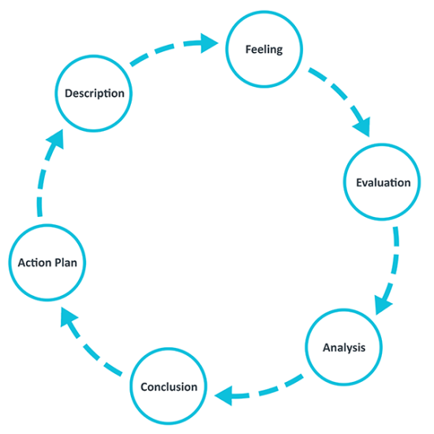
Gibbs's reflection cycle help in learning from the past experiences through continuous improvement cycle as per the market current situation. The Gibbs's reflection cycle consists of six stages that mentioned below -
Description - This is the first stage of the reflective cycle through which important information about the process of development is analyzed and skills which are need at a time of competition facing, for which what I need to grab and several benefits that I will gain through the learning for my personal development(Yehorova and Bila, 2018).
Feelings - As per my experience, I have given a good performance which is effective and helpful for my future development. I always feel consistency in the new things learning that make me always motivate and feel good for making a good profile. As per the situation of COVID -19, I analyzed organizational are reducing and affecting productivity(Berntorp and Di Cairano, 2017).
Evaluation - As now the situation is changed allot which I evaluated in COVID - 19 situation related to my professional development and I find that structure of working in the company changed and it will negatively affect the job profile of HR manager and market also has very limited opportunities for HR managers.
Analysis - Through this cycle, I analyzed that for my career development there are also negative factors such as a various app for recruiting the people which is diminishing required of the HR manager in a future market situation. So, for this, I need to have extraordinary skills and knowledge for getting employment(Gibbs, 2018).
Conclusion -For all the above situations of HR managers in a multinational company there are several issues such as job opportunity, and follow the guidelines. The situation for the company is not good due to COVID -19, so the process of improving and learning is a long way for the personal development.
From the above action plan, I can effectively maintain good relations with customers through my communication skills. For a good HR manager, two main skills needed for me are determination and the Hard work.

CAREER PLAN
For the career planning, I analyzed there are effective stages for the career planning which help me in developing my frame and process of future development. The stages which I follow for career development are -
Step 1: Explore the Career Options - In the first stage I recognize my career option which is best as per my skills and give me a better future. The long term goal of y is being a good HR manager and this is the only career option for me from that I will analyzing futuristic impacts.
Step 2: Conduct the Field Research - I also have done an internship and field research in the company for knowing the manager's key responsibility and what knowledge and skills are need for becoming a successful manager(Yehorova and Bila, 2018).
Step 3: Determine Your Target Job - In the third stage I take the steps to finalize the target job of mine. I decided on my job profile-specific title for becoming the HR manager with an effective set of skills and knowledge.
Step 4: Build Your Resume and Credentials - Through the preparation of an impressive resume and cover letter, I will apply for a manager profile job. I have also done many activities analyses that required to be done cross-check before being considered for a manager job profile.
Step 5: Prepare for the Job Search - I have searched the HR manager job in the Tesco company in UK in which first I will work as an assistant HR manager. Through this, I will gain many of opportunities in my career(Gasca, 2017).
Step 6: Launch Your Job Search - In last I have done the process of application submitting on portals and company website with the requirement of cover letter for providing information related to my capabilities and skills, knowledge.

WHAT EMPLOYERS WANT?
With the planning of career stages, I also observed that searching for Job is also an essential process so, that I can understand the employer wants from me. At the time of applying for the HR manager Job profile, there are several requirements that I need to fulfill.
- Share the creative opinions for projects and ideas, on the profile of the HR manager is basic needs of employer that is expected from employees to give valuable opinions and innovative ideas to make work easy and attractive. Example - Establishing a good workplace culture to give more productive results.
- Excellent communication should be there so, that managers can influence the workforce and also manage activities and tasks. The channels of the interpersonal communication should be very strong for the HR manager profile. Example - HR manager's message should be engaging all workers and consistent(Singh and Singh, 2017).
- Responsibility, in these employers, expects to fulfill their assigned responsibility for employees in a specific duration of time. In this, I analyze various of the activities which I need to give more focus such ad managerial process, group activities, etc. Example - Recruiting the staff, department work of employees.
- Trust and respect, as it is expected from every employer to give respect to employees and trust them which is basis employees' responsibility. Example - Giving equal opportunity in the workplace to all employees (Singh and Singh, 2017).

SELF-MOTIVATION
I analyzed that self - motivation is essential so, that in the workplace of organization pace can be managed. The self - motivation help me in motivating myself, through my performance monitoring. It also helps me in anger management, empathetic, and use a process of learning so, that it helps in focusing on the personal development.
I also searched many of the techniques and tools which are available on the internet through will I gain help in my self - motivation process. I analyzed other motivation and learning which support me to deal with various outcomes. Example - I referred to the motivation theory of Maslow's in which the requirement of personal relations, necessities, help in motivating me(Singh and Singh, 2017).

LEARNING STYLES
The process of learning processes to get information related to various topics which are very necessary for futuristic employment and career development. The VAK learning style is common in learning ways with auditory, visual, and kinaesthetic. The learning style framework is given in 1920. In this process, I analyzed the theoretical learning process is good for me, this is a factual representation which preferred by me to learn theory three learning ways(Yehorova and Bila, 2018).

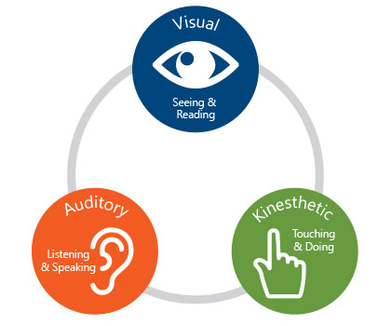
Visual - In this, I learned from reading and seeing various notes, materials, and visualize study. I also analyzed information through seeing various materials in which there are diagrams, color coordination, written materials, etc(Hardiana and Suyata, 2018).
Auditory - The Auditory learning I learned from verbal instruction and hearing information. As per my personal experience oral presentation, the voice tone process is a vest for me to learn things. As my mind directly receive information from the capabilities of hearing.
Kinaesthetic - In this process of the learning through drawing, physical coordination, is a very potential learning source. The basics learning I gained from this is by construction data, draw figures, etc(Singh and Singh, 2017).
I also analyzed I have to more focus on the process of visual learning so, that I can get better information and also cross-check various options. All other process is effective but my focus is mainly on visual learning.

PERSONAL DEVELOPMENT
SELF-AWARENESS TOOLS
The activities of self -awareness help me in personal development and also helpful for me in reducing weakness. The creative framework also helps me in motivate and encourage for archiving goals. Two self -awareness tools are -
MYERS-BRIGGS TYPE INDICATOR (MBTI)
This thoughtful questionnaire of self - report indicators assist me at the preferences of psychological for taking effective decisions tasking. The personal development decisions formulated in theoretical analysis and work the thinking & feeling, perception process, and the judgemental abilities(Lam, 2018).
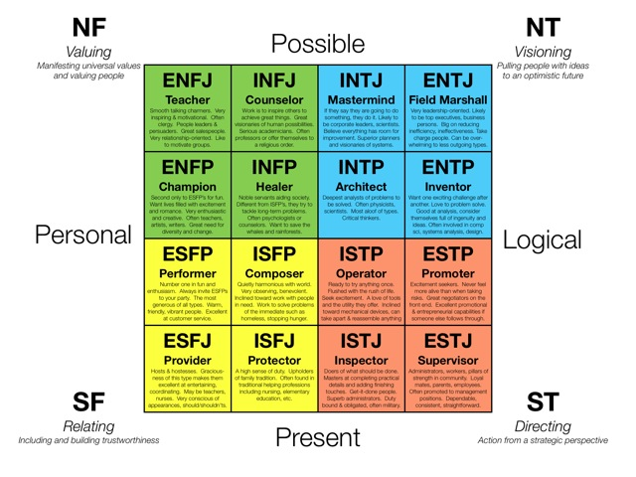

GROUNDING TECHNIQUES
The ground techniques are the second self - awareness tool which can help in me to make reconnect through the present situation and current necessities. In my panic situation, I can use this to move out and distressing the emotions by implementing games of memory, reducing anxiety, and laughing activities(Gasca, 2017).

SWOT ANALYSIS
I used the SWOT analysis framework for evaluating opportunities and strengths of my which strongly support for reducing threats and weaknesses. Through SWOT analysis I analyzed that my skills of communication need to be more polished so, that I can represent myself impressively in front of the public.
STRENGTHS | WEAKNESSES
- I am good at handling the responsibility given to me with effective planning.  - I keep always self - discipline, have a strong work ethic, and have good skills to work under any kind of pressure(Wang and Wang, 2020).  - I am very flexible in nature to adjust as per any situation and people. | - I have less public speaking confidence.  - My skills of initiative-taking and time management are week.
OPPORTUNITIES | THREATS
- Through the training and innovative thinking, I can learn many new skills and overcome my weakness.  - Training will help me in developing the full skills of the manager profile. | - The major threat that I faced time management of my work for taking the right decision at the right time.  - High competition in the market with good profile job people(Wang and Wang, 2020).

EMPLOYMENT GOALS
The goals of employment give the knowledge required and information and skills need to develop, by analyzing the financial objectives, and experience effectiveness for the profile of a specific profession. I also analyzed my objective of long term employment to be an HR manager in a particular organization with the financial stability. The employment aim is to capture the effective organization process and also control activities through manage formations. In the personal development plan, the requirement of the manager is mentioned for focusing on the communication process, working ability, and also the determination of the accomplishment of organizational objectives(Dimitroff, 2018).

CONCLUSION
The above report concludes the advancement of the individual profession through the various process, As through various approaches information and improve aptitudes is there for the employability. The individual accomplishment and set target objectives are essential for the career development. The Gibbs reflection cycle helps me in conveying data and utilizes my career planning by information and breaking down aptitudes for satisfying the required need of the employers. The SWOT analysis and learning style are used for self - motivation. The objective of the work confining the personal development plan which indicated actions of future development.

REFERENCES
● Berntorp, K. and Di Cairano, S., 2017. Particle Gibbs with ancestor sampling for identification of tire-friction parameters. IFAC-PapersOnLine, 50(1), pp.14849-14854.
● Dimitroff, L.J., 2018. Journaling: A valuable tool for registered nurses. American Nurse Today.
●Gasca, A.K.R., 2017. Career planning of personnel as a business process. Стратегии развития социальных общностей, институтов и территорий. Т. 1.—Екатеринбург, 2017, 1(3), pp.269-270.
●Gibbs, C.G., 2018. Learning to believe in secular stagnation. Economics Letters, 163, pp.50-54.
●Hardiana, M.T.A.N. and Suyata, P., 2018. The Effectiveness of VAK (Visual, Auditory, Kinesthetic) Model in Learning of Summary Writing. Int. J. Res. Rev, 5, pp.43-49.
●Kornelakis, A. and Petrakaki, D., 2020. Embedding employability skills in UK higher education: Between digitalization and marketization. Industry and Higher Education, p.0950422220902978.
●Lam, R.H.W., 2018. Invention of microsystems through a self-motivation-driven learning process.
●Singh, A. and Singh, L.B., 2017. E-learning for employability skills: Students perspective. Procedia computer science, 122, pp.400-406.
●Wang, J. and Wang, Z., 2020. Strengths, weaknesses, opportunities and threats (Swot) analysis of china’s prevention and control strategy for the covid-19 epidemic. International Journal of Environmental Research and Public Health, 17(7), p.2235.
●Yehorova, O.I. and Bila, O., 2018. Strategies of Introducing the Individual Learning Style in the Development of the English Language Lexical Competence of Pupils.

