DATA WAREHOUSING STRATEGY FOR DHL SUPPLY CHAIN UK & EUROPE
A Comprehensive Report on Enterprise Data Warehouse Design and Implementation

Prepared for:
Chief Executive Officer and Board of Directors
DHL Supply Chain UK & Ireland Division
Assignment Title: Data Warehousing
Student Name: Buba Tunkara Tunkara
Student ID: 2239608
Module code: ACCA6026
Module: Data Warehousing & Data Mining
Lecturer: Dr Nouh Elmitwally
Academic Year: 2025 / 2026
Submission deadline: 27th March 2026

EXECUTIVE SUMMARY
This report includes a strategy data warehousing solution to the UK and European operations of the DHL Supply Chain. Presently, DHL has several transactional systems (WMS, TMS, OMS) that can work effectively at the localized levels but fail to work across the regions analytically. The proposed enterprise data warehouse will centralize information of the separated operational systems at major hubs such as Daventry, Heathrow, Eurocentral, Dusseldorf, Rotterdam, and Lyon in order to come up with unified information on the efficiency of the logistics, the profitability of the client and service delivery performance. The solution will use dimensional modelling and specially customized data marts to handle directors, finance, and sales team information to make decisions based on data in line with the strategic growth goals of DHL.

Table of Contents
EXECUTIVE SUMMARY 2
1. INTRODUCTION 3
2. TASK 1 – CONCEPTUAL FRAMEWORK 4
2.1 OLTP vs Data Warehouse 4
2.1.1 Nature and Purpose of OLTP Systems 4
2.1.2 Nature and Purpose of a Data Warehouse 4
2.1.3 Benefits of a Data Warehouse for DHL 4
2.2 Data Warehouse Architecture and ETL 5
2.2.1 Source Systems and Data Landscape 5
2.2.2 Target Data Warehouse Architecture 5
2.2.3 ETL Process Overview 6
2.2.4 Minimizing Disruption to Daily Operations 6
2.3 Data Marts for Management Decision-Making 6
2.3.1 Overview of Data Mart Concept 7
2.3.2 Managing Director Data Mart 7
2.3.3 Finance Director Data Mart 7
2.3.4 Sales & Marketing Director Data Mart 7
2.4 OLTP Normalization vs Dimensional Modelling 8
2.4.1 Normalized OLTP Structures 8
2.4.2 Dimensional Modelling in Data Warehouses 8
2.4.3 DHL Logistics Star Schema Example 8
3. TASK 2 – DATA WAREHOUSE DESIGN AND IMPLEMENTATION 10
3.1 Source System Identification 10
3.1.1 Internal Source Systems 10
3.1.2 External Data Sources 10
3.2 Star Schema Design 10
3.2.1 Design Principles and Scope 10
3.2.2 Core Fact Tables 11
3.2.3 Dimension and Master Data Tables 11
3.2.4 Aggregate and Summary Tables 12
3.3 Data Marts and Schema 13
3.3.1 Finance Data Mart 13
3.3.2 Operations Data Mart 13
3.3.3 Client Services / Sales Data Mart 14
3.4 ETL Plan (Task 2.4) 14
3.5 Data Quality and Governance (Task 2.5) 15
4.Conclusion 15
5.References 16

1. INTRODUCTION
DHL Supply Chain is a business unit of Deutsche Post DHL Group, and it is a global market leader in the sphere of the contract logistics; DHL Supply Chain deals with the complex warehousing, transport, and value services in more than 60 countries. In the UK and European environment, DHL has a comprehensive distribution network of centres and transport fleet that serves various segments such as the retail, automotive, life sciences, healthcare, and technology. The focus on data analytics as a source of operational excellence and a competitive edge is supported by the fact that the company is dedicated to innovation and digitalization..
In this report, the strategic imperative of DHL is discussed by offering a detailed data warehousing solution. The solution brings about data of different functional systems, and offers actionable information, which maximizes logistics effectiveness, client satisfaction, and strategic expansion. The report is presented in a way that facilitates non-technical stakeholder (CEO and board of directors) through the background concepts of data warehousing (Task 1) and then takes them through the specifications of design and plans of implementation (Task 2).

2. TASK 1 – CONCEPTUAL FRAMEWORK

2.1 OLTP vs Data Warehouse

2.1.1 Nature and Purpose of OLTP Systems
OLTP systems are currently involved in day to day business activities and this is because they are able to support a high number of short transactions with high response times and good data integrity (Elmasri and Navathe, 2015). They also tend to store normalized (which can be third normal) types of schemas to ensure reduced redundancy and prevent update anomalies. OLTP systems are implemented in the core processes of DHL Supply Chain: the Warehouse Management System (WMS) tracks inventory movements and pick /pack operations in real time in hubs, like Daventry and Heathrow, the Transportation Management System (TMS) handles routes, GPS events, fuel usage and delivery confirmations, and the Order Management System (OMS) captures client orders and shipment status, all optimized to capture transactions reliably rather than cross system analysis.

2.1.2 Nature and Purpose of a Data Warehouse
Data warehouse (DW) is not intended to be used to conduct day to day transactions. It can be generally described as an integrated, subject focused, time variant and non volatile body of data that is used to aid in making management decisions (Inmon, 2005; Kimball and Ross, 2013). Subject orientation implies that data is structured around such themes as shipments, clients and financial performance.

2.1.3 Benefits of a Data Warehouse for DHL
In the case of DHL, a Data warehouse would transform an operating snapshot that is fragmented into a single enterprise wide insight. It would facilitate end to end tracking of deliveries between hubs such as Daventry, Eurocentral and Rotterdam, assists in exposing cross regional bottlenecks and capacity problems. On time delivery could be evaluated on a holistic basis as to the service type, hub utilization and route complexity against the other system, rather than on each system individually.

2.2 Data Warehouse Architecture and ETL

2.2.1 Source Systems and Data Landscape
The ecosystem of operations of DHL creates large volumes of data in a variety of internal and external systems. The Order Management System (OMS) is an internal source and captures the orders of clients, date of delivery, order value, and delivery requirements. The Warehouse Management System (WMS) captures SKU information, warehousing locations, stock and pick/packing time and space occupied at the hubs of Daventry, Heathrow and Lyon. The TMS and fleet platform records vehicle IDs, routes, GPS positioning, fuel consumption, mileage and maintenance plans. Financial system and CRM system avails information on invoicing, cost, contract, and interaction with customers.

2.2.2 Target Data Warehouse Architecture
The suggested architecture is based on a layered architecture that is compatible with industry best practices (Kimball & Ross, 2013; Inmon, 2005). The source systems layer is the entry point of the data into a staging area where the raw extracts are stored in the meantime. This layer separates transformation processes of operation variability and offers recovery in case of ETL failure.
Most importantly, there are subject specific views of finance, operations and sales teams that are provided by data marts. The BI layer (e.g. Power BI, Tableau) provides the management with dashboards and KPI reporting.
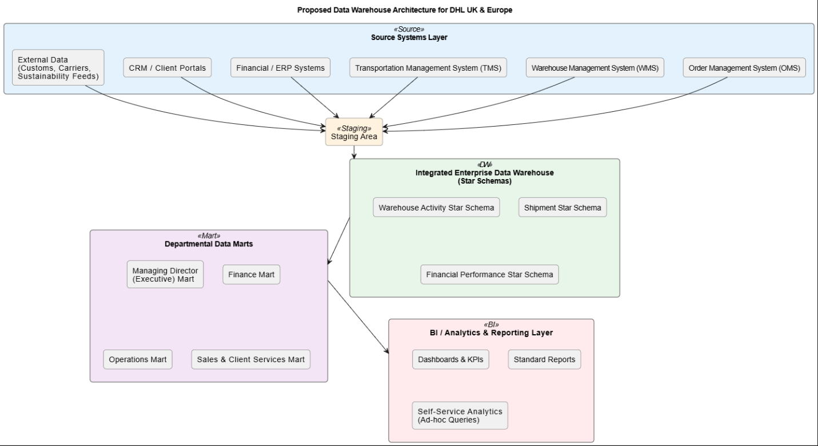
Figure 1: Proposed Data Warehouse Architecture for DHL UK & Europe

2.2.3 ETL Process Overview
Reading data with the help of the ETL process allows a structured movement of the data out of the source systems into the warehouse (Vassiliadis et al., 2002).
Some of the transformations involved are the removal of duplicates, standardization of units and location codes, derivation of metrics like transit time, on-time flags, and profit margins. Surrogate keys as well as conformed dimensions facilitate historical tracking and slowly changing dimensions (Kimball and Ross, 2013).
The loading starts with a full dataset migration then thereafter scheduled incremental updates. Fact tables are loaded with dimensions in order to ensure referential integrity.

2.2.4 Minimizing Disruption to Daily Operations
Stable operationality is realized by the read only extraction, off-peak scheduling and change data capture (CDC). The staging, which decouples transformation with source systems, monitoring tools and SLA monitor ETL performance. Such steps enable DHL to become more analytical without affecting the efficiency of transactions (Watson, 2021).

2.3 Data Marts for Management Decision-Making

2.3.1 Overview of Data Mart Concept
Data marts are topic-focused fragments of the enterprise data warehouse that is created to support the demands of particular users in their analysis (Kimball & Ross, 2013). Whereas central warehouse has integrated organizational view, data marts offer performance optimized simplified datasets based on the departmental priorities. This method gives flexibility to departments whilst ensuring the enterprise-wide integration so that the finance, operations and sales department can access helpful information without the complexity of the entire warehouse.

2.3.2 Managing Director Data Mart
The Managing Director (MD) needs to have strategic visibility of the network performance both in the UK and the European operations. This mart incorporates the shipment, warehouse and fleet data which are backed by such dimensions as DimDate, DimLocation, DimServiceType and DimClient.
The main KPIs comprise on-time delivery rates in each region and hub (Daventry, Heathrow, Dusseldorf, Rotterdam, Lyon) and transit times by mode (road, air, ocean) as well as warehouse utilization rates, i.e. space occupancy and throughput. Cross-border analytics are used to track the period of customs clearance and the effects of Brexit. (Eckerson, 2010).

2.3.3 Finance Director Data Mart
The Finance Director is concerned with the issues of revenue, cost management and profitability. The mart is based on financial and shipment fact tables whose dimensions are DimClient, DimServiceType and DimLocation.
Revenue is examined at client, sector, the type of service and the transport lane. These are fuel, labour, and custom charges, and storage and overhead expenses. Profit margins would be made per shipment, contract and hub so that under performing accounts can be identified. (Sharda et al., 2020).

2.3.4 Sales & Marketing Director Data Mart
The Sales and Marketing Director needs to understand client behaviour and performance of services. This mart combines shipment, returns as well as SLA data and client and service dimensions.
It gives order volume trends, SLA compliance rates and returns analysis to determine the risks of churns and service gaps. Client segmentation is used to determine profitability and growth opportunities, whereas cross-sell opportunities are based on use patterns of services. These analytics enhance competitive positioning and evidence-based client engagement tactics (Davenport and Harris, 2017).

2.4 OLTP Normalization vs Dimensional Modelling

2.4.1 Normalized OLTP Structures
Normalization is the process of sorting data into associated tables in order to reduce redundancy and preserve integrity. The third normal form (3NF) is also a common feature of OLTP systems that guarantee that non-key attributes are only dependent on the primary key (Elmasri & Navathe, 2015). This design eliminates anomalies of updates and can handle a high level of transactional processing.

2.4.2 Dimensional Modelling in Data Warehouses
Kimball proposed dimensional modelling, which is optimized to the analytical processing (Kimball and Ross, 2013). The star schema is made up of a central fact table connected to denormalized dimension tables.
The denormalized dimensions minimize joins and enhance the speed of queries. Surrogate keys are easy to index and the warehouse platforms are efficient in terms of aggregation (Inmon, 2005).

2.4.3 DHL Logistics Star Schema Example
A FactShipment table (one record per shipment leg) would be the center of a Shipment Performance Star schema of DHL and would contain measurements:
- Shipment count
- Planned and actual transit time.
- On-time flag
- Weight and volume
- Freight cost and revenue
- Gross margin
Dimensions include:
• DimDate (calendar attributes)
• DimClient (sector, contract type, SLA tier)
• DimLocation (origin/destination hubs)
• DimServiceType (standard, express, cold chain)
• DimVehicle (type, fuel, capacity)
• DimRoute (lane, mode, corridor)
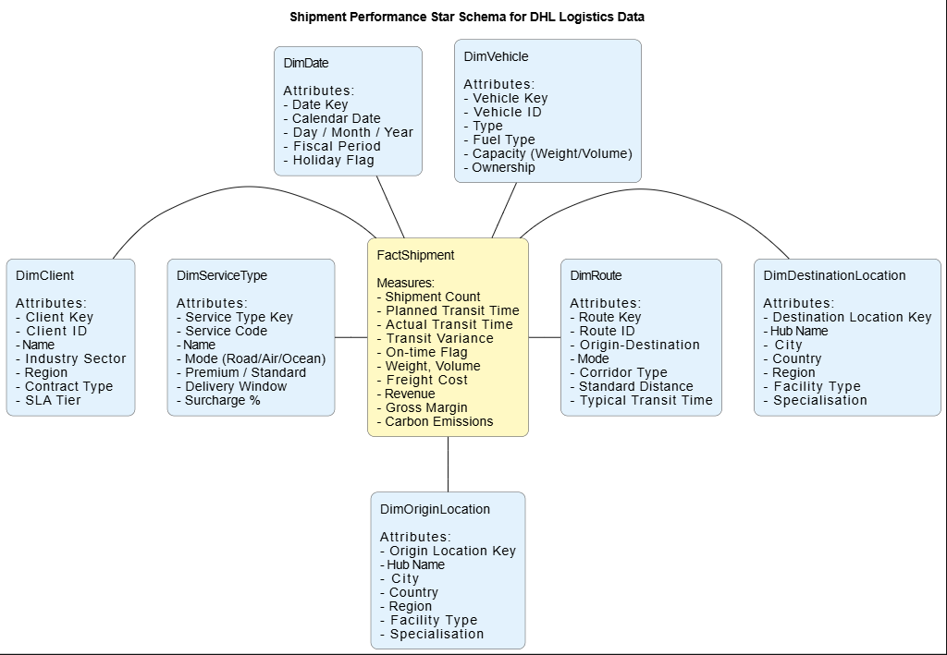
Figure 2: Shipment Performance Star Schema for DHL Logistics Data.
This star schema enables rapid analytical queries such as:
- When asked about the average transmission time of express shipments between Daventry and Dusseldorf in Q4 2025, what is the average time?
- How do the on-time delivery rates of the different clients based on service type and the region served look?
Such queries have a small number of joins (usually only one per dimension) and exploit optimized indexing and aggregation policies only available on data warehouse platforms, unlike normalized OLTP structures.

3. TASK 2 – DATA WAREHOUSE DESIGN AND IMPLEMENTATION

3.1 Source System Identification

3.1.1 Internal Source Systems
The systems within DHL that feed the data warehouse are a number of systems:
- Order Management System (OMS): Records the details of orders, delivery dates, values, discounts, and order status.
- Warehouse Management System (WMS): Data of SKUs, storage position, inventory, inbound/outbound, pick/pack, and utilization at various hubs like Daventry and Lyon.
- Transportation Management System (TMS) / Fleet Systems: Records vehicle and driver information, routes, GPS positioning, fuel consumption, repair, and delivery records.
- Financial/ERP Systems: store invoicing, cost components, revenue, margins, and financial reporting information.
- CRM and Client Portals Store client master data, contracts, SLAs and customer interactions.
- ePOD and Returns Systems: Get delivery confirmations, exception events and returns processing details.

3.1.2 External Data Sources
- Customs Systems: Rigorous cleavages, duty expenditure and regulation information.
- Carrier Systems: The third-party performance and cost information.
- Sustainability Platforms: The measures of emissions and fuel-efficiency in support of green logistics.

3.2 Star Schema Design

3.2.1 Design Principles and Scope
The designed data warehouse will use dimensional modelling based on Kimball approach where focus is made on user friendliness, query processing speed and incremental development (Kimball and Ross, 2013). The design aims at three main subject areas namely shipments, warehouse operations and financial performance which are represented by separate fact tables linked on shared and conformed dimensions. Dimensions like DimDate, DimClient and DimLocation are conformed so that they can be defined in a way that will be used across the fact tables to support drill-across analysis. Analysts are able to relate the shipment on-time performance ( FactShipment ) to the warehouse activity ( FactWarehouseActivity ) and client profitability ( FactFinancialPerformance ), always by client, date range, and location.

3.2.2 Core Fact Tables
FactShipment
- Grain: There is one record per leg of shipments (origin to the destination).
- Measures: number of shipments, planned/actual transit time, transit variance, on-time flag, distance, weight, volume, the number of packages, freight cost, revenue, gross margin, carbon emissions, damage flag.
- Packet keys: DateKey (role playing of order, ship planned, actual dates), ClientKey, OriginLocationKey, DestinationLocationKey, ServiceTypeKey, VehicleKey, RouteKey, DriverKey.
FactWarehouseActivity
- Grain: One record daily, one record to each SKU and each warehouse or one pick/pack/put-away.
- Some of the measures include: quantity picked/ packed/ put- away, pick/pack/ put away time, handling cost, space started to use, pick error, damage cases.
- Foreign Keys : DateKey, WarehouseLocationKey, SKUKey, StaffKey, ClientKey, ShiftKey, are Foreign Keys.
FactFinancialPerformance
- Grain: There is one record on each line of invoice or a consolidated shipment/service.
- Measures: revenue, direct costs (fuel, labour, customs, warehousing), overheads, gross /net margin, payment received, days to payment.
- Foreign Keys: DateKey, ClientKey, Servicetypekey, Locationkey, Contract key.
Optional Fact Tables: FactReturns (volume of returns, reason, disposition), FactCarbonEmission (emissions, fuel, modal efficiency).

3.2.3 Dimension and Master Data Tables
- DimDate: Calendar characteristics, numerous functions (order, ship, delivery dates).
- DimClient: Sector, type of contract, SLA, account manager, SCD Type 2 historical changes.
- DimLocation: Hub identifiers, country, region, facility type/specialisation, capacity.
- DimVehicle, Type, fuel, capacity, ownership, maintenance.
- DimRoute Lane, transport mode, corridor, distance, transit time, complexity.
- DimServiceType: The type of service, guaranteed windows, pricing and SLA.
- DimProduct / SKU: Description, category, temperature, hazard, weight/volume / value per unit.
- DimContract/SLA: Dates of contracts, SLA measures, fines, cost model.
- DimDriver/Staff: Staff information, job position, date of hiring, certifications.

3.2.4 Aggregate and Summary Tables
FactMonthlyDeliverySummary
- Grain: 1 record per month hub service client.
- Measures: total shipment, on-time shipment/ percent, average transit time, average cost, average margin, total revenue, total carbon emission.
- Purpose: Uses aggregated key metrics in advance to support executive dashboards and board-level reporting, decrease query times, and facilitate trend analysis (e.g., Q4 2025 vs Q4 2024).
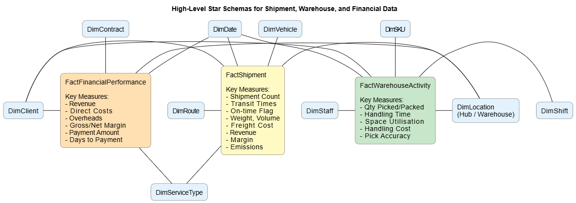
Figure 3: High-Level Star Schemas for Shipment, Warehouse, and Financial Data
- Schema Diagram: three star schemas either on top of each other, or in parallel with fact tables linked to common and unique dimensions.
Aggregates trade is stored to improve performance to minimize response time to popular queries. These tables help in self-service BI and allow them to keep their analytical performance by both delivering millions of shipments every year (Eckerson, 2010).

3.3 Data Marts and Schema

3.3.1 Finance Data Mart
Purpose: Assists the Finance Director with the analysis and control of revenues, cost, and profitability, and financial planning purposes.
Schema Components:
- Fact Tables: FactFinancialPerformance (primary), FactShipment (cost/revenue reconciliation)
- Dimensions: DimDate, DimClient, DimService type, DimLocation, DimContract
- Key Metrics:
  - Client, type of services, lane, hub revenue.
  - Breakdowns of costs: fuel, labour, custom, warehousing, overhead.
  - Margin analysis: gross, net, margin,%
  - Payment performance: DSO, unconscionable invoices.
  - Contract profitability vs. agreements.
Use Cases:
- Determine high vs. low-margin customers on whom to set pricing.
- Study cost drivers to facilitate budget and cuts.
- Review contract re-negotiation on historical performance.

3.3.2 Operations Data Mart
Purpose: Allows monitoring the operations, capacity planning, and streamline the processes.
Schema Components:
- Fact Tables: Fact WarehouseActivity Fact Fleet Fact Shipment Fact CarbonEmission
- Dimensions: DimDate, DimLocation, DimVehicle, DimRoute, DimService type, DimDriver and DimSKU.
- Key Metrics:
  - Hub on-time delivery, type of service, and route.
  - Productivity of the warehouse: picks/ hour, pack time, space utilisation.
  - Fleet performance: fuel/km, utilisation, down time.
  - JIT performance (Eurocentral)
  - Sustainability: per shipment emissions.
Use Cases:
- Determine bottleneck hubs/routes in which process improvements can be made.
- Surveillance of warehouse trends to be automated.
- Evaluate fleet performance in order to inform replacements.

3.3.3 Client Services / Sales Data Mart
Purpose: Understanding the behaviour of the clients, quality of services and growth prospects.
Schema Components:
- Fact Tables: Fact Shipment, Fact Returns, Fact OrderActivity.
- Dimensions: DimClient, DimIndustry, DimContract, DimSLA, DimServiceType, DimDate.
- Important Measures: SLA compliance, returns, volume of orders, service mix, churn measures.
- Use Cases: Maintain at-risk accounts, find opportunities to cross-sell, assist with data-driven sales pitches.

3.4 ETL Plan
The data warehouse ETL process of DHL data warehouse maps the source systems to target tables. FactShipment is a combination of OMS and TMS that takes the events of order and shipment and uses them to compute transit times, on-time flags, distance, and margins that are further enhanced by using the financial system. FactWarehouseActivity summarizes pick, pack, and put-away events of warehouse and SKU. FactFinancialPerformance has an association between invoice and cost data with DimClient and DimContract. CRM and master data are constructed into dimension tables, including DimClient and DimLocation, using deduplication, code standardization and slowly changing dimension methods. There are aggregated tables such as FactMonthlyDeliverySummary which include monthly statistics per hub, client, and type of service.
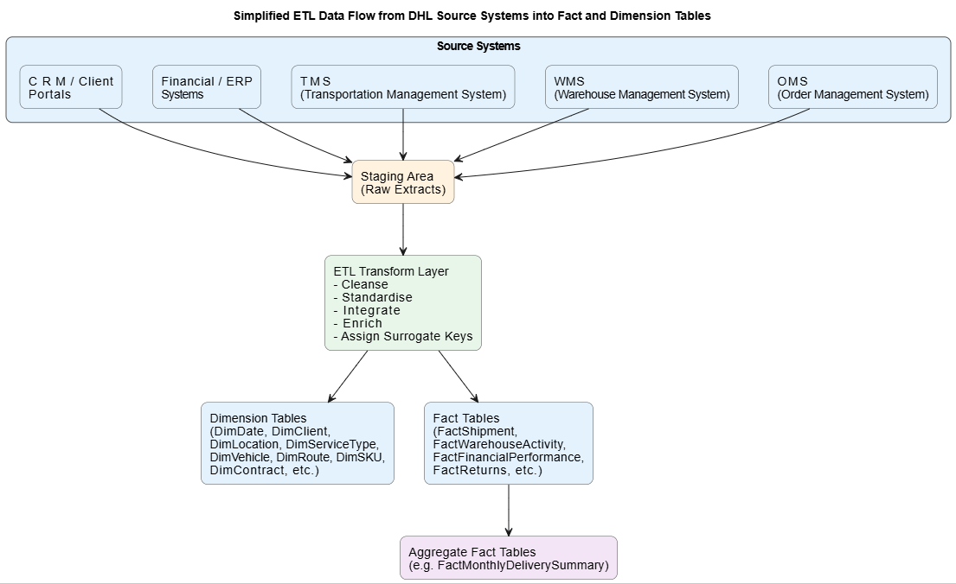
Figure 4: Simplified ETL Data Flow from DHL Source Systems into Fact and Dimension Tables

3.5 Data Quality and Governance
Good governance and data quality will also make the data warehouse at DHL a dependable single version of the truth. Financial accuracy, completeness, consistency and timeliness are ensured through validation, deduplication and reconciliation. The sensitive information is protected with role-based access, documented standards, data ownership, and GDPR compliance, and the detected and resolved problems are identified and addressed as soon as possible.

4.Conclusion
This report has described how a dedicated data warehouse divorced of current OLTP systems of DHL can deliver an integrated, historical and analytics ready view of operations across UK and Europe. In Task 1, the CEO and the board members were presented with the main distinctions between OLTP and data warehousing, the offered architecture and ETL model, the importance of data marts to various directors, and the benefits of dimensional modelling as applied to logistics analytics. Task 2 put these ideas into a practical design, defining shipment, warehouse and financial star schema, aligned data marts and simplified ETL plan and necessary data quality and governance practices. Together, the suggested solution will provide DHL with an effective roadmap to attain better logistics performance, enhanced understanding of client profitability, enhanced SLA performance measurement, and enhance sustainability goal support.

References

Davenport, T.H. and Harris, J.G., 2017. Competing on Analytics: The New Science of Winning. Updated ed. Boston, MA: Harvard Business Review Press.

[1] T. H. Davenport and J. G. Harris, Competing on Analytics: The New Science of Winning, Updated ed. Boston, MA, USA: Harvard Business Review Press, 2017.

[2] W. W. Eckerson, Performance Dashboards: Measuring, Monitoring, and Managing Your Business, 2nd ed. Hoboken, NJ, USA: John Wiley & Sons, 2010.

[3] R. Elmasri and S. B. Navathe, Fundamentals of Database Systems, 7th ed. Harlow, U.K.: Pearson, 2015.

[4] W. H. Inmon, Building the Data Warehouse, 4th ed. Indianapolis, IN, USA: Wiley Publishing, 2005.

[5] R. Kimball and M. Ross, The Data Warehouse Toolkit: The Definitive Guide to Dimensional Modeling, 3rd ed. Hoboken, NJ, USA: John Wiley & Sons, 2013.

[6] R. Sharda, D. Delen, and E. Turban, Business Intelligence, Analytics, and Data Science: A Managerial Perspective, 4th ed. Harlow, U.K.: Pearson, 2020.

[7] P. Vassiliadis, A. Simitsis, and S. Skiadopoulos, “Conceptual modeling for ETL processes,” in Proceedings of the 5th ACM International Workshop on Data Warehousing and OLAP (DOLAP ’02), McLean, VA, USA, Nov. 2002, pp. 14–21.

[8] H. J. Watson, “Data management: databases, data warehouses, and data lakes,” Communications of the Association for Information Systems, vol. 49, no. 1, pp. 51–65, 2021.

[9] AskOnData, “Data Quality & Governance in Data Warehouse,” 2024. [Online]. Available: https://askondata.com/data-quality-governance-in-data-warehouse/

[10] DataGalaxy, “Implementing data governance in a warehouse: 3 top tips,” 2026. [Online]. Available: https://www.datagalaxy.com/en/blog/implementing-data-governance-warehouse/

[11] DecisionWorks, “Dimensional Modeling: Kimball Fundamentals,” 2020. [Online]. Available: https://decisionworks.com/wp-content/uploads/2020/08/DecisionWorks-Dimensional-Modeling-Kimball-Fundamentals-2020.09.pdf

[12] Holistics, “Kimball’s Dimensional Data Modeling,” 2017. [Online]. Available: https://www.holistics.io/books/setup-analytics/kimball-s-dimensional-data-modeling/

[13] Kimball Group, “The 10 Essential Rules of Dimensional Modeling,” 2016. [Online]. Available: https://www.kimballgroup.com/2009/05/the-10-essential-rules-of-dimensional-modeling/

[14] Kimball Group, “Dimensional Modeling Techniques,” 2013. [Online]. Available: https://www.kimballgroup.com/data-warehouse-business-intelligence-resources/kimball-techniques/dimensional-modeling-techniques/

[15] Qualytics, “7 Best Practices for Effective Data Warehouse Governance,” 2025. [Online]. Available: https://www.linkedin.com/pulse/7-best-practices-effective-data-warehouse-governance-qualyticsinc-bndae

[16] Data Sleek, “Logistics Data Integration: Governance & Compliance,” 2025.

