Travel Review
Bern: Historical Tourism
Introduction
The aim of this travel review is to introduce Bern (the capital of Switzerland) and review the historical tourism it has on offer, and how this niche market appeals to tourists and attracts them to Bern. The review will include statistics and financial figures related to the tourism market in Bern, how Switzerland are marketing Bern and how they can improve.

To begin, Bern which is also known and spelt otherwise as Berne is the capital of Switzerland, the two main languages spoken in Bern are German and French, and the population of the city according to dicconbewes is just over 130,000 people. This compared to the capital city of Wales (Cardiff) there is a massive difference as Cardiff has a population of 474,187 taken from worldpopulationreview. This indicates that Bern is a reasonably quite city in Europe compared to other capital cities and therefore attracting large numbers of tourists to Bern may be more difficult if it is not done the right way.

Bern is located in the centre of Switzerland as indicated by the map provided below and is easily accessible to reach by car, train, bus and air. Bern is made up of Old Bern and New Bern, the two parts of the city are connected by several bridges to travel between the two parts of the city. Old Bern is home to the history that once lived in Bern and it has preserved more of its medieval appearance compared to any other city in Switzerland according to britannica. In 1983 Bern was named a UNESCO World Heritage Site.
Photograph of Switzerland map.
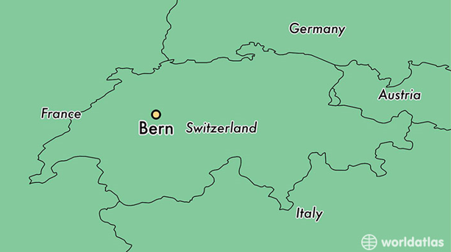

Source : https://www.worldatlas.com/eu/ch/be/where-is-bern.html
Main Body
As soon as you visit Bern you will feel as though you have stepped back in time and instantly believe that you are in a different time zone. Bern has maintained the old buildings and features that gives the city it’s medieval appearance that makes people feel as though they have stepped back in time. The city does this well as everywhere you turn it’s all the same cobbled streets and buildings that look the same but are slightly different. This city is a great historical tourism spot with numerous attractions and sightseeing features that needs to reach more tourists around the world.

The most popular feature in Bern and what the city is popular for is the Berner Munster, alternatively known as the Bern Cathedral and/or Cathedral of St Vincent. The famous cathedral is the largest church from the middle ages, and it has played an important role in the cities amazing architecture and is a must see for historical tourism tourists. The Cathedral is so tall it overlooks all the city that it can’t be missed.
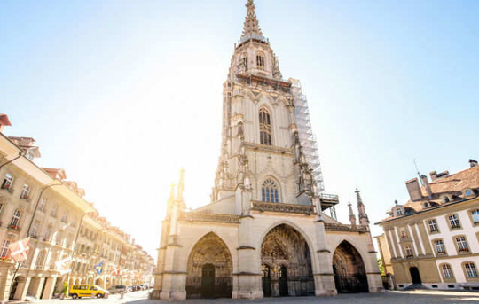

Source : https://timesofindia.indiatimes.com/travel/bern/berner-munster/ps58255788.cms

Other sites that are recommended by bern.com to experience when in Bern are ; ‘The Parliament Building with its Parliament Square, Berns landmark the Zytglogge (Clock Tower), The traditional BearPark, The river Aare that invites to go urban swimming or simply enjoy the sun at the riverpool Marzili and Over 100 fountains that provide guests fresh drinking water’. These sites are very much tailored for the historical tourism tourists which is the niche market this review targeting.
Along with visiting the sites above that are regarded as historical tourism in Bern, tourists could also visit The Einstein Museum. This museum is historical as it’s a museum full of the time line of Mr Albert Einstein’s life, it’s a very informative and an interesting museum that is worth a visit when in Bern. This could also attract many fans of Mr Albert Einstein if it was marketed and reached out to tourists more effectively.

Bern is a very slow, quite and relaxed city very different to your stereotypical city where you automatically think crowds, busy and loud, cities such as NewYork and London are examples and they are on the other end of the spectrum in comparison to Bern. However, the fact that Bern is a quite and slow city is what gives the tourist who visit Bern see the history that lives there and realistically it wouldn’t have the same feeling of stepping back in time if Bern was a busy, loud and crowded city. This however is a factor that Bern can’t control or prevent as over time if Bern does grow in popularity and become one of the top cities to visit in the world then the whole historic feel of the town will disappear, and it won’t have its uniqueness if the city becomes crowded and loud.

The tourism industry in general in Switzerland is very important to the country’s economic sector as it employs 4% of the working population in Switzerland taken from eda.admin.ch. Bern doesn’t have one type of tourist visiting the city and therefore there is a place to market the city as a historical destination and grab the attention of historic tourists. According to swisscommunity.org Bern is a great business location for medium and small size enterprises as it is near European centres of technology. Located in Bern are the headquarters of some recognisable international groups such as Swisscom, The Swatch Group and ebay. The city of Bern is the business centre for these international groups and this can bring a reasonable amount of business tourism to the city and this helps the tourism economy, this is the sort of tourists at the moment that Bern is attracting and therefor they need to market the city not just as a business city but as a historical city as this will attract a lot more tourist.

Travelling in and around Bern is easy for tourists and the city has an array of public transport networks and the main two networks are the trams and buses. Tickets to use these networks are purchased by machines only and cannot be purchased on buses or trams which means there are rarely any delays in the transport providers and it’s a quick and efficient services being provided. Bern provides tourists who stay in an accommodation provider for one night in the city with a Bern ticket which taken from bern.com is ‘Overnight visitors don’t need to worry about tickets in Bern. From your first overnight stay in tourist accommodation in the city, you will receive a Bern Ticket for your whole stay’. This scheme provides tourist to travel one day for free around the city and it also includes free transport to and from Bern airport. This is a good scheme set up to make travelling around the city accessible and easy for tourists, this also helps the historical tourism in the city as tourists can travel with ease around the city when visiting the BearPark, Parliament Square and Zytglogge. According to thelocal.ch overall the hotel industry in Switzerland during the first half of 2018 recorded 18.4 million overnight stays. The amount of tourist from that number who stayed in Bern isn’t stated but can only be presumed as a reasonable amount indicates that many of the free travel pass scheme would have been given out to tourist who stayed overnight in the city which may encourage them to visit Bern again knowing that they can travel, around the city at ease, hassle free and of course the main factor that it is free.

In terms of marketing Bern have their own website for tourists which is called the Official Website of Bern Tourism which gives tourist information about the city and what to do there, providing readers with an overview of the city and the attractions. Another website used to market Bern is MySwitzerland.com which again does the same as the tourism website just slightly differently in terms of having different attractions on there or have spoken about attractions in Bern more in depth. However it has the same purpose and suggests to tourists things to do when visiting the city. Although these websites promote the city another question is if people are viewing the websites and is it reaching different types of tourists, this is what Bern needs to work on to bring more historical tourism tourists into the city to experience the attractions.

Now moving on to if Bern is a safe place to visit. This is a question everyone asks themselves before going away on a trip and visiting a new place, they want to make sure that it is going to be as safe as it can be, which is understandable. This is what attracts tourists as it puts them at ease and of course makes them feel safe. For Bern found on osac.gov ‘Most crimes are non-violent and involve petty theft, pickpocketing or burglary. Concerning theft, including pickpocketing, for the Canton of Bern, 15,151 thefts, a decrease from 17,790 reported cases in 2016, were reported.’ This confirms Bern is a safe place to visit and has very low levels of criminal activity which is a factor many tourists do consider when visiting a new place. For example after the terrorist’s attacks that happened in Paris 2015 it put many tourists off visiting the city for a while and many even cancelled their upcoming trips to the city. Therefore criminal activity and terrorist threats are a big factor in attracting tourists to a city.

Conclusion
In conclusion Bern’s historical tourism and the attractions on offer in Bern needs no improvement, however tourism providers in Bern need to improve their marketing strategies to bring more tourism into the city. Bern has plenty of fun and interesting sites to go and see but the city doesn’t get a lot of tourists which is letting the tourism industry in the city down.

Although the city has online websites promoting the city and showing what the city has on offer, they should look at using social media accounts such as Instagram, Facebook and Twitter to promote to city. Social media plays a big part in promoting any tourist destination and having pictures to upload to the social media accounts will grab the attention of tourists. Using social media accounts is another good way to promote the city as they can create hashtags, in turn tourists who visit Bern and upload their pictures and talk about their experiences to their social media accounts can use the hashtags too which will help the social media account get more views.

Public transport in Bern and in surrounding cities could advertise the attractions in Bern so that it reaches tourists not just inside the city but outside of the city too. They could do this by advertising on trains, buses in the train stations and in the airports in Switzerland so that it has the chance of reaching more tourists. This way anyone who uses public transport in Switzerland and who are travelling into the country by plane have a higher chance of viewing an advertisement for Bern and will encourage them to visit on their trip or on their next trip to the country.

Considering Bern is such a safe city it is let down by the cities marketing strategies, therefore this is something the city needs to look at in order to put Bern on the map as a popular tourists destination. Some recommendations that have been suggested above could help promote Bern and the historical tourism that lives there to tourists.

Word Count – 1,875

References
bern. ‘UNESCO World Heritage’. [Online]. Available: https://www.bern.com/en/detail/unesco-world-heritage. [2019, March, 26].
bern. ‘Public transport’. [Online]. Available: https://www.bern.com/en/detail/public-transport. [2019, March, 28].
britannica. ‘Bern’. [Online]. Available: https://www.britannica.com/place/Bern. [2019, March, 26].
Dicconbewes. ‘Ten essential facts about Bern’. [Online]. Available: http://www.dicconbewes.com/2011/09/14/ten-essential-facts-about-bern/. [2019, March, 27].
eda.admin.ch. ‘Tourism’. [Online]. Available: https://www.eda.admin.ch/aboutswitzerland/en/home/wirtschaft/taetigkeitsgebiete/tourismus.html. [2019, March, 26].
helloswitzerland. ‘BERN FACTS & FIGURES’. [Online]. Available: https://www.helloswitzerland.ch/-/bern-facts-figures. [2019, March, 26].
planetware. ’14 Top Tourist Attractions in Bern & Easy Day Trips’. [Online]. Available: https://www.planetware.com/tourist-attractions-/bern-berne-ch-be-ber.htm. [2019, March, 27].
swisscommunity. ‘Berne: Economy’. [Online]. Available: https://www.swisscommunity.org/en/explore-switzerland/berne/economy. [2019, March, 26].
swissfo.ch. ‘Tourism today’. [Online]. Available: https://www.swissinfo.ch/eng/tourism-today/29054498. [2019, March, 27].
thelocal.ch. ‘Number of foreign tourists visiting Switzerland rose in first half of 2018’. [Online]. Available: https://www.thelocal.ch/20180806/number-of-foreign-tourists-visiting-switzerland-rose-in-first-half-of-2018. [2019, March, 27].

timesofindia. ‘BERNER MUNSTER’. [Online]. Available: https://timesofindia.indiatimes.com/travel/bern/berner-munster/ps58255788.cms. [2019, March, 29].
worldatlas. ‘Where Is Bern, Switzerland?’ [Online]. Available: https://www.worldatlas.com/eu/ch/be/where-is-bern.html. [2019, March, 26].
worldpopulationreview. ‘Cardiff Population 2019’. [Online]. Available: worldpopulationreview.com/world-cities/cardiff-population/. [2019, March, 26].

