Muireall Costiniano Dissertation Proposal [ P148793 ]
The topic that I will be exploring is, the use of grotesque imagery, specifically the representation of death, in graphic design/ advertising, and questioning its effectiveness as a persuasive tool despite taboos surrounding it. People have used drastic images in design for decades as a form of persuasion via shocking imagery. I want to explore the reasons as to why shocking imagery can be used for public consumption and why are people so interested in the concept of death and its use in design as a persuasive tool. The response of the human psyche and the concept of death, grotesque and the macabre, researching how it is represented in, as well as censored/ banned in design and why.

KEY WORDS
- Macabre/ death
- Human psyche/ thanatology
- Fascination/ persuasion

THINKERS
- Sigmund Freud - “…in the unconscious every one of us is convinced of his own immortality” and, “our unconscious therefore does not believe in it’s own death; it acts as though it were immortal.” And “The fear of death, which controls us more frequently than we are aware, is comparatively secondary…”
These quotes by Freud will help me first explain the conception of death as being a finite thing that people fear by instinct; And yet humans still deny and try to prevent the inevitable, even to go as far as saying that such an abstract concept such as immortality is just as, maybe even more so, valid as death, despite more people dying than becoming an immortal super being, people like to cling to an ideal that hides the reality that comes with our greatest weakness, the ability to age, and subsequently dying as a part of the process. The reality that people choose to look over, that this immortality that people strive for is only realised when they die; In death do we become truly immortal.
I will explore the innate human psychology and find reasons as to why people fear death, as well as linking the fascination with death with the fear of it. People are curious of the unknown and their fears, to the point where they can be influenced greatly by them, this is how I will tie the fascination of the fear of death as a catalyst in advertisement.

- Charles Horton Cooley - “"A self-idea of this sort seems to have three principal elements: the imagination of our appearance to the other person; the imagination of his judgment of that appearance, and some sort of self-feeling, such as pride or mortification."”
I will use this quote to form the basis of the idea that the appearance we display to each other influences our thought and actions subconsciously. People like to see what they normally see, a repetitive pattern, for we are all creatures of habit in varying degrees, so when a shocking advert is seen, or even something as extreme as a public display, reaches our scope of attention, people have either one of two extremes, intrigue and disgust. The reason for intrigue will be explored with the previous thinker, Freud, and the disgust, will be explored with Cooley.
The reason why people get disgusted, is because it is scene that the average person is not usually familiar with. The reality of our morality comes as a surprise because we repress the idea so much in not only our daily, but also our private lives as well. So, when something as drastic as a PETA public display is encountered by the layman, they are usually quick to go on the offensive, as it is as nature intended it to be, human instinct declares that we are to fear death, and anything associated with it, for fear of the unknown and innate survival instincts we still harbour. This dual extreme reaction is what I will focus on next.

- Michel de Montaigne - “Now, of all the benefits that virtue confers upon us, the contempt of death is one of the greatest, as the means that accommodates human life with a soft and easy tranquillity, and gives us a pure and pleasant taste of living, without which all other pleasure would be extinct.”
With Montaigne, I will explore the virtue of death. The other side of the extreme and the acceptance of it. For the more death is features in advertising, the more we become desensitised to it; The less we begin to fear it and the more we accept our grim realities as not truly grim, but a process of nature and a product of life. Montaigne, explains that with death comes tranquillity, and it is this feeling of tranquillity that intrigues me. How can two extremes such as utter oblivion and recaching tranquillity be associated with the same word?
This dual mentality towards death is what I will explore in advertising and its ethical uses. Should it be allowed? Why are some adverts banner over others, and why do people not like them so much? I will use this quote as a basis to challenge the notion that death is something that is to be feared and resented, and to argue that death is in fact universally beautiful, as seen in other cultures who, as a part of their culture, celebrate death and accept it as not a means to an end but as a way to connect with others through loss and as something that is to be celebrated rather than shunned and be thought of as a taboo.

ARTISTS
- Damien Hirst - an artist that often does sculptures and 3D art pieces featuring taxidermy and dead animals, and other things of the like. I will explore the reasons why Hirst does the art her does, and why his art pieces are allowed and for the most part not widely banned, and adverts do, despite having almost the same amount of exposure and similar themes, while one is celebrated for its poetic sensibilities, and the other is shamed for its vulgar and it supposedly trauma inducing imagery.

Hirst often portrays deceased animals encased in clear blue resin in varying states, this is a fascinating depiction of death as it shows how death can be suffocating. How people are trapped inside their heads with the idea of death and constantly fighting the fear of dying, and yet, when you look at the pieces that Hirst create, what we feel is not fear or disgust, but fascination. The way they are presented, and the clear blue resin shows an unusual yet, calming sight. The dead animals as real as air, yet in the resign they look so calm, frozen in time, the blue helps enhance this effect.

Hirst also creates statues of humans being consumed by fungi and various other foliage. It shows the relationship between an organic life form and symbiotic plant life. The depiction of such a relationship is both surreal and real. Depictions of the faces and bodies of people being swallowed by coral seems so strange, yet familiar in the sense that you know what humans look like, and you know what coral looks like, but when you put these seemingly familiar images together, it creates something unfamiliar. Links with my keywords, death and fascination.

- Maria Ionova-Gribina (PHOTOGRAPHY) – a photographer that mostly depicts road kill that she finds on her travels as something beautiful. Gribina dresses up the deceased animals and often adorns them with flowers and bright colours, often asking the fact that they were found on the side of the road and recently killed in a brutal mix between organic and metal flesh.

This artist will aid me in raising the question of why death must be portrayed in such a negative matter, and surrounded by less than favourable stigma, despite there being photographers like Gribina being able to make death look so sweet. It begs the question of, if death can be portrayed in such a way, why isn’t it? The outstandingly beautiful and serene can be as effective, if not even more so effective as a tool used to persuade as death; So why is it not used as much as its more widely hated, yet more frequently used, counterpart? Linking with my keywords, death, fascination and persuasion.

- Emma Kisiel (PHOTOGRAPHY) – another photographer that does things similarly Gribina, but has a slightly different approach in that with her photography pieces, she surrounds the dead animal in things that she found near the site of their death, it gives a different perspective to Gribina, as they way she arranges the items and the way she photographs them doesn’t take the fact of death asway from the images, instead it shown it as the central theme with no distractions, but still manages to portray their death as something that is beautifully sombre. More heart-warming and delicate.

The two photographers will serve as an example that portraying death in such a soft way can be achieved and can be just as persuasive, take for example Cancer research adverts, the most effective one is the Run for Breast Cancer advert/ campaign. It is a perfect example of showing death in an advert, but not in a negative light, and showing its success as a tool used in persuasion. Linking with my keywords of death and persuasion.

These artist and thinkers have inspired me to explore the topic of the use of death in advertising and it effectiveness in using the human psyche as a persuasive tool. For I am interested in the human psyche and how it reacts to shocking images despite death being as natural as breathing. I am baffled by the fact that despite being surrounded by so many people, the visuals of death rarely cross my path in any form. So, whenever I see advertising with even hints of death I become engrossed and I want to question the idea that society has on death and how death is more widely agreed to be ugly instead of beautiful. I want to challenge the banning of some advertisements over other and I want to know the reason why people are so afraid to face death, despite it being something that goes hand-in-hand with our realities. So, my question will be:

“Why are people so afraid of the concept of death? Exploring the representations and its use in advertising.”
KEY IMAGES
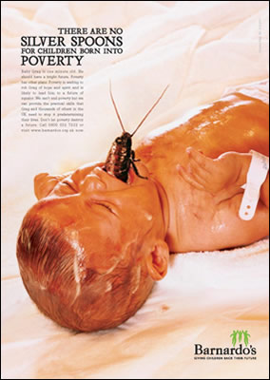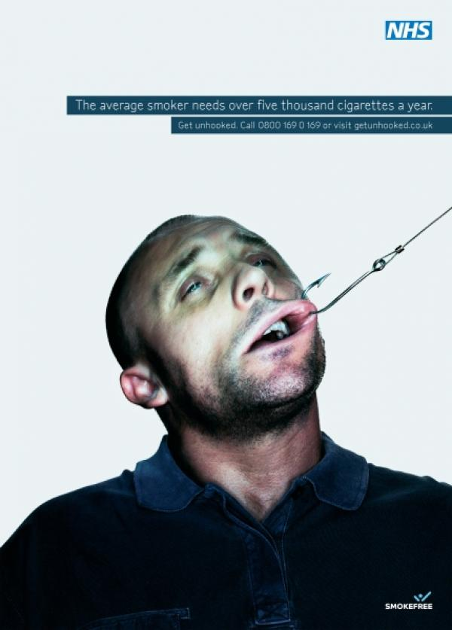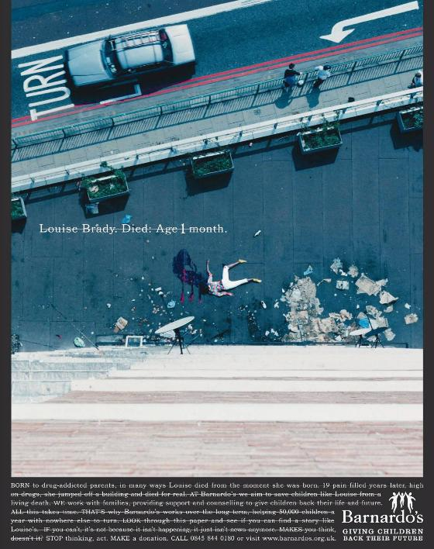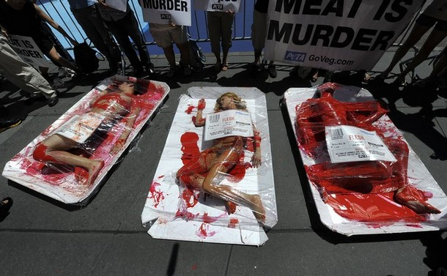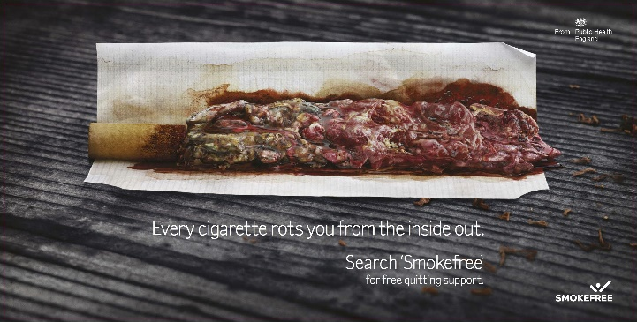

These are the key images I will be using, they are adverts than were banned and some that were deemed fair to use in public. They are arguable as extreme and graphic as each other, yet some were banned, and others were not. I want to use these images as a visual case study in why people are so afraid of the concept of death and are quick to disregard it, its effectiveness in advertising, and why is death chosen to be represented like this despite there being imagery like the ones below that represent death in a far more calming manner.

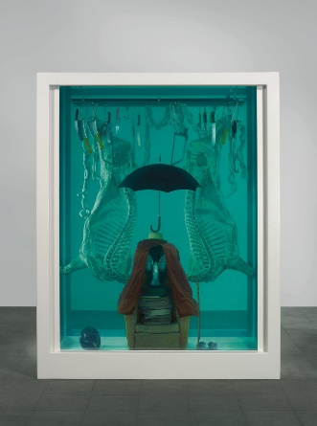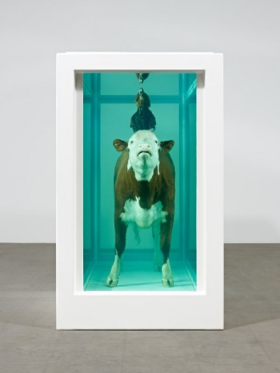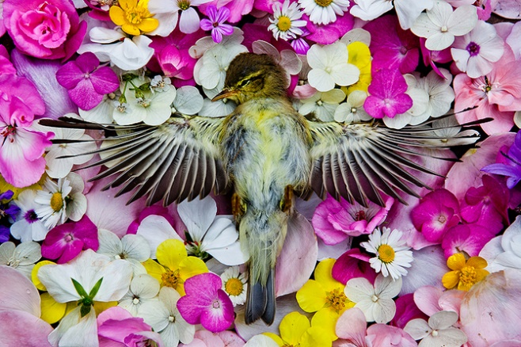

ADDITIONAL QUOTES
- Arora A.S., Arora A., Bradford S.K. - “ We developed and validated a scale for measuring slice-of-life and slice-of-death (SOL&D) advertising appeals through our conceptualization of SOL&D advertising comprising of three factors: advertising complexity, advertising relevance, and advertising valence. SOL&D appeals use these three factors to evoke both positive and negative emotions in advertising, which in turn contribute to attitudes toward the ad and brand. “

Bibliography – books
Montaigne, M and Screech M (1993). The complete Essays. London, England: Penguin Books.
Arora A.S., Arora A., Bradford S.K. (2017) Measuring Slice-of-Life Versus Slice-of-Death Advertising Appeals: An Abstract. In: Stieler M. (eds) Creating Marketing Magic and Innovative Future Marketing Trends. Developments in Marketing Science: Proceedings of the Academy of Marketing Science. Springer, Cham
S, Freud (1953). Thoughts for the Times on War and Death. The Standard Edition of the Complete Psychological Works of Sigmund Freud, Vol. 4. London: Hogarth Press.
Cooley, C. (1983). Human Nature and the Social Order. New York: Routledge.

