Student Number 2225279

14th April 2024

Trudi Meyrick

Word Count 5425 (excluding titles and citations)
STRATEGIC MANAGEMENT IN POLICING (BMPO7004D)
Programme: MSc (Operational and Strategic Leadership)

Contents
Executive Summary 2
Introduction 3
Strategic Position 6
Strategic Choices 18
Strategy In Action 27
Conclusion 31
Appendices 34
Appendix A – SWOT Analysis 34
Appendix B – PESTELE Analysis 35
Appendix C – Custody Action Plan 36
References 38

Executive Summary
In June 2023 an inspection of South Wales Police (SWP) custody provisions by Her Majesty's Inspectorate of Constabulary and Fire & Rescue Services (HMICFRS) and the Care Quality Commission (CQC) published a report that highlighted various deficiencies and challenges (HMICFRS, 2023). This raised concerns regarding the safeguarding and healthcare of individuals held in custody and highlighted the recurrence of issues within SWP custody provisions which further influenced the reputation of SWP.

In the context of policing, academic research emphasises that strategic management and planning is highlighted as a key mechanism for efficiently managing specialist areas of policing, resource allocation, financial strategies, and personnel management. This underscores the crucial role of strategic management in attaining desired outcomes with the overarching objective of achieving optimal results and enhanced performance. This is corroborated by Langley (2018) who posits the concept the idea that a well-defined strategic plan via a systematic process and a clear vision have been instrumental in enabling organisations to achieve success. This highlights the importance of strategic planning in the governance activities of SWP and further emphases the importance and necessity of maintaining transparency and legitimacy in policing through the strategic planning processes.

This report examines the significance of proactive strategic management and planning in complex environments addressing the HMICFRS custody report and future anticipated challenges.

Introduction
The term 'strategic management’ can be applied in many contexts from government, small business to not for profit organisations underscoring the heightened significance of strategic planning (Bryson, 2018). Commonly used within the realm of UK policing there is uncertainty into the depth of comprehension and the authentic interpretation of this term within the contemporary policing landscape. This is particularly significant considering the external challenges faced by policing operations in areas marked by heightened complexity. Moreover, policing practices are often rooted in a model from the early industrial period, adopting a 19th-century approach to tackle the challenges of the 21st century (College of Policing, 2020).

Strategic management is defined as "the identification of the purpose of the organisation and the plans and actions to achieve that purpose" (Lynch, 2021, p. 9). In contrast, Charrier (2004, p. 1) characterises it as "a process by which managers choose a set of actions that will enable their organisation to achieve one or more of its long-term goals and attain better performance." Analysing both definitions, despite the 16-year gap between them, certain key elements have emerged from the academic discourse of strategic management. Both definitions suggest that strategic management necessitates leadership support and involvement to align decisions with organisational objectives, engage individuals, and facilitate resource.

Strategic planning is vital for effective strategic management within policing. Established by legislation, government policies, and regulatory frameworks, the Police Act 1996 (Home Office, 1996) serves as the legal foundation, while the Home Office and National Police Chiefs' Council (NPCC) issue guidelines aligning strategic plans with national objectives (GOV.UK 2023; National Police Chiefs Council, 2021). This comprehensive framework facilitates goal setting, resource allocation, optimisation of performance opportunities and mitigation of organisational threats.

In the realm of policing, strategic management encompasses the formulation and execution of plans and initiatives to achieve set goals and objectives. It serves as a proactive approach and a foundation for strategic problem-solving rather than a reactive response to crisis (Walsh & Vito, 2018). As an integral component of strategic management and planning ‘strategy’ provides the essential framework and direction for effective decision-making and resource allocation to address the multifaceted challenges and requirements of policing.

Originating in Athens during the sixth century BC, the term 'strategy' combines 'stratos,' referring to an army spread out on the ground, and 'agein,' meaning to lead (Whittington, et al., 2019), underscoring its pivotal role in strategic management within policing. Nevertheless, Yu (2021) highlights the existence of over 90 definitions of strategy, each employing diverse terminology to elucidate its essence. Whilst the word 'strategy' is commonly used in organisational and policing contexts, there exists no universally agreed-upon definition that delineates the field and confines its boundaries (Freedman, 2013). However, the College of Policing (CoP), the professional body for police in England and Wales, defines a strategy within the context of strategic planning as a plan of action designed to achieve a series of objectives toward a specific goal (College of Policing, 2013). This demonstrates the complexity, uncertainty, and versatility of the concept of ‘strategy’ highlighting its dynamic nature and its authentic implications within strategic management and planning.
Within this context Whittington, et al., (2019) defines strategic management as underpinned by three interlinked areas, strategic position, strategic choices and strategy in action - figure1.

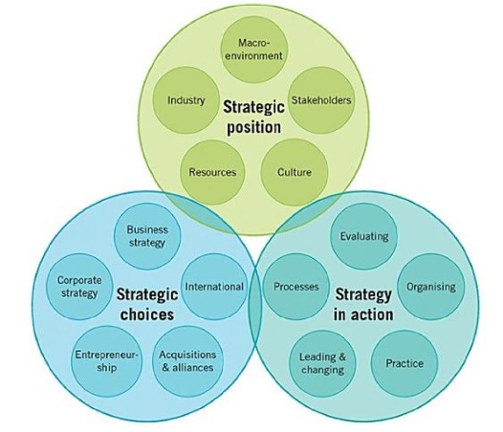

Figure 1 - The Exploring Strategy Model (Whittington, et al., 2019)

The purpose of this report is to review and consider how theories of strategic management relate to the development of a strategic custody plan for SWP.

Hereafter, I apply the ‘Exploring Strategy Model’ as a comprehensive framework and structure to underpin the report, encompassing research, supporting literature and discussion points.

Strategic Position
Strategic Position refers to the unique market position and competitive advantage that organisations aim to achieve within its industry of market. Understanding how the organisation differentiates itself form competitors ‘out-thinking its competitor or finding new, even greater opportunities’ (McKeown, 2020, p. 12) thereby leveraging its strengths to create value for the customer.

To enhance the effectiveness and accountability of an organisation it is imperative to develop a strategic plan. The development of a strategic plan is a thoughtful and deliberate discipline that entails making fundamental decisions on what an organisation does and why, aiming to assist leaders in effectively addressing key organisational issues (Bryson, 2018). This can be the determining factor for the success of failure of an organisation, all of which questions the implementation and effectiveness of strategic planning in policing.

It is imperative to acknowledge that every organisation necessitates a strategy, as it signifies the ability to transcend short-term concerns and envision a future beyond immediate needs (Freedman, 2013). This strategic approach empowers organisations to formulate plans and transition from their current state to their envisioned future objectives.

To ensure efficient operations and delivery within the custody unit of SWP, effective strategic planning is crucial to address the inspection recommendations and deliver optimal performance. To implement this approach, the three-horizon model for strategy and strategic planning serves as an effective strategic management model – figure 2.

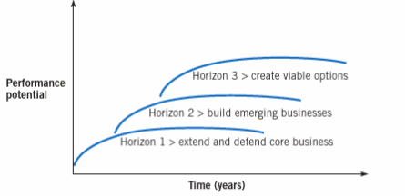
Figure 2 - Three Horizons for strategy (Whittington, et al., 2019)

Serving as a growth strategy framework, the three-horizon model can aid in envisioning the future trajectory of the custody unit. Recognising the significance of this framework it offers a common language for undertaking and discussing growth, it further supports and facilitates continued development aligned with the HMICFRS inspection and strategic planning work.

The primary objective of strategic planning is to align organisational activities with its mission, vision, and values providing clarity of purpose – figure 3.

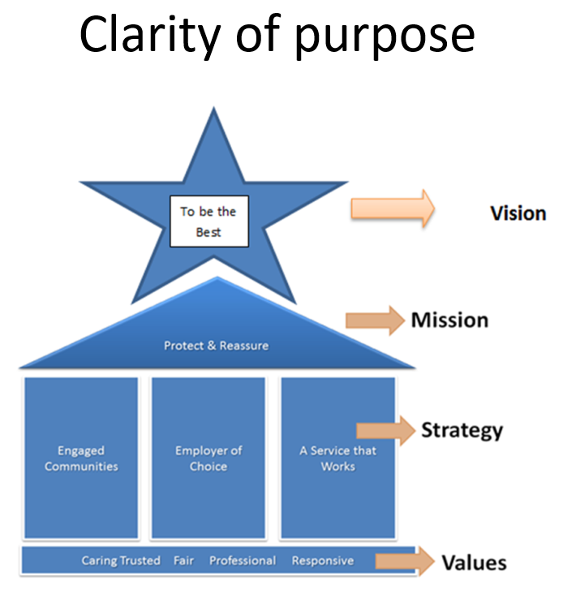
Figure 3 – Strategy Building, Clarity of Purpose (Farrar, 2024)

A mission statement is designed to offer employees and stakeholders a clear understanding of the fundamental purpose of the organisation and the effective framing can evoke emotional impact (Whittington, et al., 2019; Conger 1991). Defining the organisation's purpose, values, and long-term aspirations, it is essential to stress the significance of assessing both the internal and external environment and reaching agreements on delivery timeframes and defining success criteria.

Adhering to the strategic planning process, the development of a custody strategy and framework necessitates the prioritisation of simplicity while ensuring alignment with the organisational values and key principles of the chief constables’ delivery plan (South Wales Police, 2021).

In the context of strategic management, this process requires a strategic statement aligning to SWP mission, vision, and values (South Wales Police Heddlu De Cymru, 2023). Alignment of the statement to operational and organisational values, considering the statutory responsibilities of protecting, and safeguarding the most vulnerable in custody is imperative in the planning process (College of Policing, 2016; College of Policing, 2024).

. 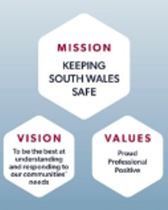
Figure 4 - SWP Mission, Vision and Values (South Wales Police Heddlu De Cymru, 2023)

To comprehend barriers that could impede and hinder the organisations current position and need for improvement, it is recognised that the custody unit has encountered a gradual divergence from the organisations intended strategic direction. This is due to internal and external factors following leadership transitions as identified in the report and findings. The onset of instability characterised by declining performance and fragmented responsibilities lacking cohesive direction has influenced the culture within the custody environment. Strategic drift has occurred, this is s when an organisation does not adequately address its strategic position amidst a slow changing environment (Johnson, et al 2017; Jeffs 2008). Therefore, open-ended questions to address the highlighted issues in the report and an examination of both internal and external factors is required to attain a comprehensive and holistic perspective of the custody environment.

Adapting to the evolving requirements of the organisation is essential for effective and efficient leadership to gain a deep understanding of the organisation’s cultures and subcultures. Durivage, et al., (1992), describes culture as ‘a set of shared values, with common behaviour norms, rules and actions. Whereas Cockcroft, (2020) emphasises the importance of leadership as it is intrinsically linked to the concept of culture. However, (White & Robinson, 2014) argues that the inherent nature of the policing role has cultivated a distinct organisational culture that is exclusive to policing due to the perpetual possibility of life-and-death encounters, coupled with distinctive pressures and challenges.

Evaluating the diverse academic perspectives of organisational culture within policing its formation and sustenance are complex processes influenced by multiple factors. Acknowledging these diverse academic perspective and varied viewpoints is crucial for comprehending the intricate nature of workplace dynamics and its effects on operational efficiency. In conclusion, adopting a comprehensive and holistic approach that integrates values, leadership and the unique challenges of policing environments is essential for fostering a culture that empowers policing to effectively serve and protect communities whilst adapting to evolving threats and demands in the pursuit of public safety.

In an increasing complex environment, utilising strategic analysis to gain a deeper understanding of the custody operating environment is an imperative first step in the planning process. Whilst there is limited academic definitions, strategic analysis is considered as the formation of an effective and impactive strategic plan that provides a framework upon which strategy formulations are based (Grant, 2021). This is crucial for making informed decisions and formulating effective strategies that defines the internal and external environment, aligning to the vision, mission statement and the purpose for the existence of the organisation that resonates with the workforce.

Utilising both qualitative and quantitative date to form a viable strategy will yield greater results than relying on either method alone (Morgan, 2014). However, it is important to acknowledge that excessive analysis can be ineffective causing paralysis by analysis, hindering effective decision making (Kahneman, 2011). Moreover, an abundance of choices can often result in suboptimal decisions or a lack of decision making altogether. Therefore, following the strategic analysis process - figure 5 (CFI Team, 2023) and striking a balance between in-depth analysis and practical decision making ensures the right ideas are implemented, (Contorno, 2016) – figure 5.

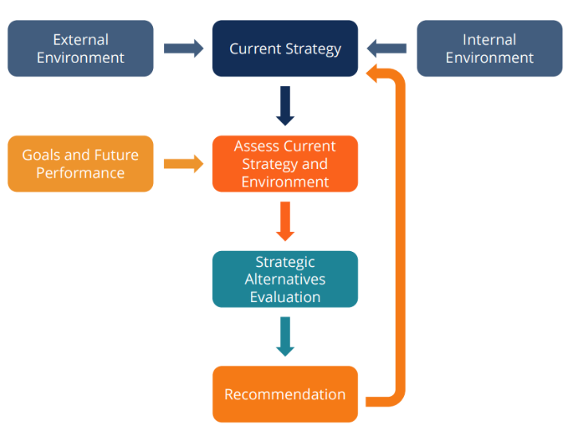
Figure 5 - Strategic Analysis Process - (CFI Team, 2023)

Utilising analytic methods to develop fuller organisational awareness including SWOT as a management framework and diagnostic tool will further facilitate strategic planning and options (Schooley, 2024). The delineation and advancement of strategic analysis and initiatives help to optimise performance, paving the way for strategic growth and innovation (Morden, 2007). To assist the development of a custody strategy, to leverage strengths, overcome weaknesses, capitalise on opportunities, and mitigate threats, utilising the SWOT process and framework will identify strategic options (Griffiths & Wall, 2011). However, it is essential to consider the disadvantage of SWOT and the disproportionate amount of time organisations dedicated to analysis which may not produce accurate results (Almutairi, et al., 2021). This process should encompass relevant data sets supported by HMICFRS findings and a broader evaluation of environmental factors ensuring it differentiates between critical issues that require immediate attention, ensuring it considers broader environmental factors and is based upon executive leadership and professional judgement, drawing upon expertise and ethical considerations to make informed decisions. (Tripp, 2007).

Whilst acknowledging the limitations of SWOT analysis, it is essential to critically review its effectiveness. When utilised in conjunction with other strategic planning methods including Porter’s five forces and gap analysis (Mind Tools, 2024; Leonard & Bottorff, 2022) SWOT provides a valuable tool in assessing and enhancing strategic planning processes.

Setting Goals and Objectives is also essential to establish specific, measurable, achievable, relevant, and time-bound (SMART) goals and objectives that align with the organisation's mission and vision. (Mind Tools, 2016). This approach aims to comprehensively assess the environmental factors influencing the HMICFRS inspection report through an integrated approach. By addressing these areas of improvement and implementing the SWOT strategy, the custody unit can enhance its overall effectiveness, compliance, and detainee welfare outcomes - Appendix A.

Alternative future forecasting in the custody strategy development will further explore different scenarios and outcomes, integrating the PESTELE model (Political, Economic, Social, Technological, Environmental, Legal, Ethical) to anticipate potential developments and prepare for diverse possibilities (Professional Academy, 2023).

Formulating the custody strategy and plan, single point forecasting focuses on predicting a precise value for a future variable based on historical data and trends, whilst range forecasting, in the custody context, provides a range of possible values for the variable, considering external influences highlighted by PESTELE analysis. This allows for scanning the environmental and legislative frameworks that impacts custody (College of Policing, 2013; Gov.UK, 1984) – figure 6.

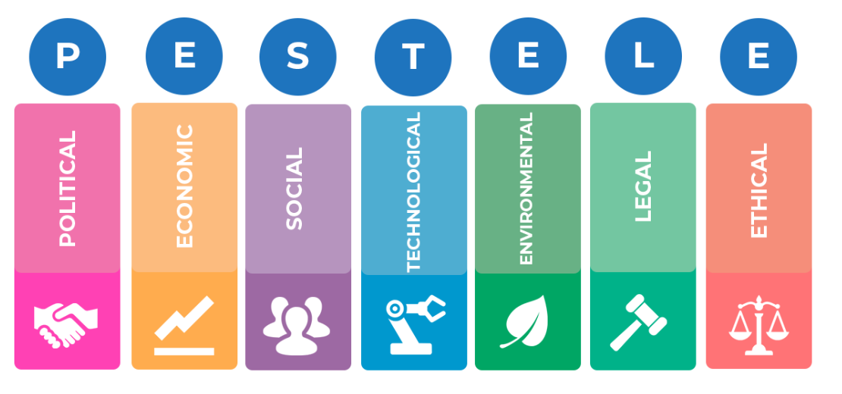
Figure 6 - PESTELE (Professional Academy, 2023)

Transitioning from historical events to exploring new and emerging trends is essential for predicting and determining future performance. This transition plays a pivotal role in predicting and integrating environmental forecasting into analysis to enhance and improves the accuracy of performance forecasting, resulting in enriched outcomes (Ansoff, 2007).

Considering PESTELE analysis, the custody unit can assess external influences and risks that may impact its operations and decision-making processes. This analysis can help in identifying opportunities for improvement and mitigating potential threats to the effective management of custody services. Utilising PESTELE to develop an effective custody strategy and plan is further supported via a thorough investigation of the key strategies and initiatives employed to achieve custody goals, organisational objectives and HMICFRS recommendations – Appendix B.

Strategic planning in conjunction with insight enables strategic decision through the prioritisation of actions, allocation of resources and development of strategies informed by internal and external analysis. This approach establishes a solid foundation aimed at enhancing overall organisational performance, whilst promoting staff involvement and engagement, contributing to a positive and cohesive environment. People respond according to how they are treated. To achieve the organisational purpose, it is important to understand the challenges and demands of the custody unit and staff roles, promoting open communication, encourage active participation and soliciting feedback (Mullins, 2019). This approach will ensure staff are integrated in the purpose and vision of the workplace environment and HMICFRS custody strategic plan of action – figure 7.

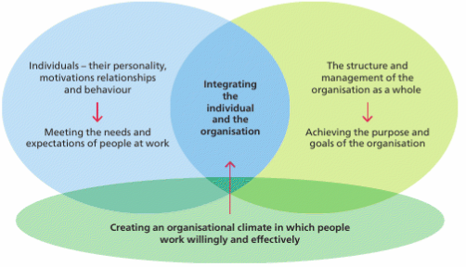
Figure 7 - Integrating the individual and the organisation (Mullins, 2019, p. 27)
Resource modelling and management is complex within policing. Xu, et al., (2012) suggests that business processes may not align with resource utilisation, potentially leading to sacrifices in terms of costs and time. Alignment of a financial and resource business case will be beneficial setting out the requirement of additional resource with pertinent skills to be uplifted into the custody unit. This holds significance as wider research indicates that performance may suffer if individuals are assigned tasks that are irrelevant to their skills (Yuki & Gardner, 2019). Considering both viewpoints,
this is true as on one hand, the allocation of resources can be influenced by the structure of SWP processes and vice versa due to task dependencies. The interconnected relationship between resource allocation, structural improvements in business processes and task dependencies within the custody environment remains a challenge with the requirement of consistent workforce planning and resource modelling - figure 8.

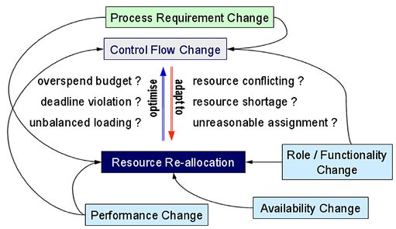
Figure 8 - Resource allocation model for business processes (Xu, et al., 2012)

Any strategy regardless of its formulation quality, lacks effectiveness unless individuals throughout the organisations actively implement it (Yasin Ates, et al., 2020). Reviewing the strategic position and to achieve effective strategy implementation delivering value for money, organisations require the right resourcing model aligning capability and teams with defined purpose, inspiring vision, and an operational model that unlocks potential and delivers performance. Within a rapid changing environment, a continuous review of the strategy to be clear on its purpose aligned to mission, vision, statement of values and statement of objectives is essential.

Strategy also plays a role in guiding decision-making processes helping to prioritise initiatives, setting performance targets, and develop team performance. Havard Business Review (2021) analysed data from 100 teams and found that the drivers of effective team performance are the group’s average level of emotional intelligence and a high degree of communication between members. Supporting this view strategic leadership is crucial in decision making, embodiment of the strategy and a robust communication plan, all playing a crucial role in shaping the vision and guiding the growth and prosperity of SWP custody plan. Embedding this vision, leaders in the custody environment will assist members in engaging and empowering the workforce, translating objectives into actionable steps, maintaining momentum and inspiring passion and dedication towards achieving longer-term objectives (Management Guru, 2014).

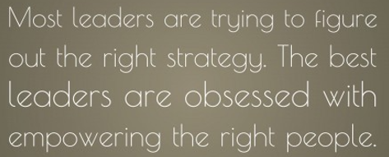
Figure 9 - (Groeschel, 2024)

Strategic Choices
Strategic choices refer to the decisions made regarding directions and scope of activities and resource allocation to achieve strategic objectives (Whittington, et al., 2019) – figure 10.

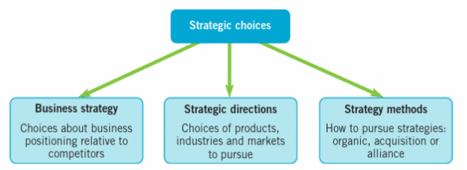
Figure 10 - Strategic choices (Whittington, et al., 2019)

Exploring various theories of business, strategy and models, include market analysis, competitive analysis, and the identification of strategic priorities (Whittington, et al., 2019). Focusing on the optimal business strategy and business model which is also relevant to private business sectors, charities and public sector organisation, the aim of the custody strategy is to enhance a delivery of a secure custody environment which caters to the diverse and vulnerable needs of all.

Scenario planning used since the 1970s and part of corporate decision making has been found to help make sense of uncertain environments bringing together decision makers and key stakeholders who generate insight through a workshop type process (Canyon, 2018). A strategic workshop with key stakeholders to engage in discussions and reach consensus on the HMICFRS objectives and custody action plan will be beneficial. Supported by local collaborative governance incorporating both formal and informal mechanism it encourages stakeholder involvement in local policy decision making process (Fernandes, et al., 2021). Thereby this collaborative effort can be aimed to align with the organisation's vision, overcome obstacles, and establish a practical list of actions to implement the strategic plan effectively within the operational context. Importantly embracing this approach ‘resists the urge to provide solutions which is a mechanism of control’ (Marquet, 2012, p. 92).

Scenario planning analysis, horizon scanning, and long-term planning are essential strategic management tools. Helping to prepare for diverse future possibilities, identifying emerging trends and risks for proactive planning, enables the development of preventative strategic risk management based on the results of horizon scanning and foresight (Gollner, et al., 2015). Long-term planning is also critical as it lays foundations for strategic issues, establishing objectives that go beyond the immediate future to attain sustainable growth and success. Notwithstanding that the disadvantages lay in the accuracy reliant on data available to the organisation. However, these tools together provide a robust framework to navigate uncertainties and proactively drive recommendations aligned with the custody plan. This approach supports the implementation of HMICFRS recommendations and targets short, medium and long-term objectives with the aim of enhancing and future proofing the resilience of the custody environment.

Strategic and scenario planning also serves as a systematic method for delineating the feasible boundaries, proving beneficial in uncertain environments by facilitating the identification and creation of optimal strategic alternatives (Ram & Montibeler, 2013) - figure 11.
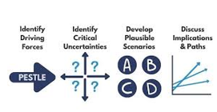
Figure 11 – Scenario Planning (Whittington, et al., 2019)

Identifying how the custody unit might develop in future, implementation of a focus strategy with dedicated attention that provides focus on a narrow and specific segment of the organisation, namely custody services is crucial for creating a tailored strategic plan that enhances safety, efficiency, and service delivery in the context of the custody setting and delivery of the HMICFRS recommendations.

A further component of the strategic planning process for consideration is adoption of a prescriptive strategy – figure 12. This is defined as one in which the objectives are pre-determined, and the key elements are formulated prior to implantation of the strategy (Lynch, 2021). This provides planned and deliberate actions based on a clear understanding of the situation and specific objectives to be achieved linked to the HMICFRS findings. This is important to ensure that there is one common set of goals ensuring organisation and personal goals align to the same direction (Mullins, 2019).

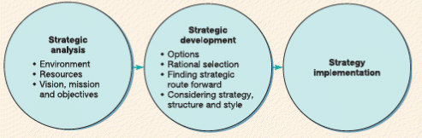
Figure 12 - The Prescriptive Approach (Lynch, 2021)

Critically reviewing both strategies, the integration of both in tandem can be beneficial as the focus strategy niche market approach complements the prescriptive strategy structured planning enhancing strategic effectiveness.

Furthermore, it is paramount to review and analyse the challenges inherent in the strategic workforce planning process. This encompasses budget allocation constraints, evolving demands influenced by societal changes and the imperative of promoting diversity to attract and retain a qualified diverse workforce. High staff turnover in the context of organisational restricting further complicates workforce planning, thereby collaboration with internal human resource is critical. Contemplating the strategic direction and objective, the aim is to discern the most effective utilisation of talent to align with short- and long-term goals for enhanced outcomes, prioritising optimal strategies over expedient solutions in the strategy implementation (Tucker, 2022).
The importance of identifying and communicating the strategy revised from the strategic plan is essential when engaging staff and internal stakeholders. It highlights the significance of aligning other strategies including the custody strategic plan. Incorporating Bryson's (2010) inclusive approach, engaging internal departmental stakeholders, including individuals who could affect the achievement of the organisation in deliberating on the organisation's purpose and future vision as a collective agreement is essential (Elliott, et al., 2020).
To successfully implement the custody strategy and action plan, teams that possess the necessary capabilities to execute strategic initiatives must be established. This necessitates the development of a well-defined purpose that serves as a motivating force for individuals to act, an inspirational vision that guides their efforts, and an operational model that unlocks the full potential of the organisation, ‘encouraging and inspiring individuals and teams’ (Morden, 2007, p. 332). In this context leaders play a pivotal role in guiding and inspiring others towards a shared vision (Chand, 2017). The foundation of effective performance lies in well-defined objectives, a fundamental aspect of servant leadership (Blanchard & Broadwell, 2018). By compelling and gathering individuals to pursue common objectives, leaders embody the essence of effective leadership in organisational growth and success.

Achievers play a crucial role in organisational dynamics bridging the gap between wanderers and followers. Whilst wanderers lack vision and followers may not independently pursue it, achievers are driven by intrinsic motivation to take decisive action and lead by example. In fostering organisational growth staff must be supported by an integrated structure, system and processes and where leadership motivates followers (Hannes, et al., 2018). This framework is essential to facilitate the development and advancement of the custody strategy and ensure alignment with the organisational overarching objectives.

To achieve this the C4 strategic planning approach (Ernst & Young, 2023) - figure 13, as a strategic planning tool can be utilised to inform discussions at the custody oversight board supported by corporate services who provide a professional, proactive and dynamic advisory and support service to the organisation across a wide range of business areas (South Wales Police, 2020).

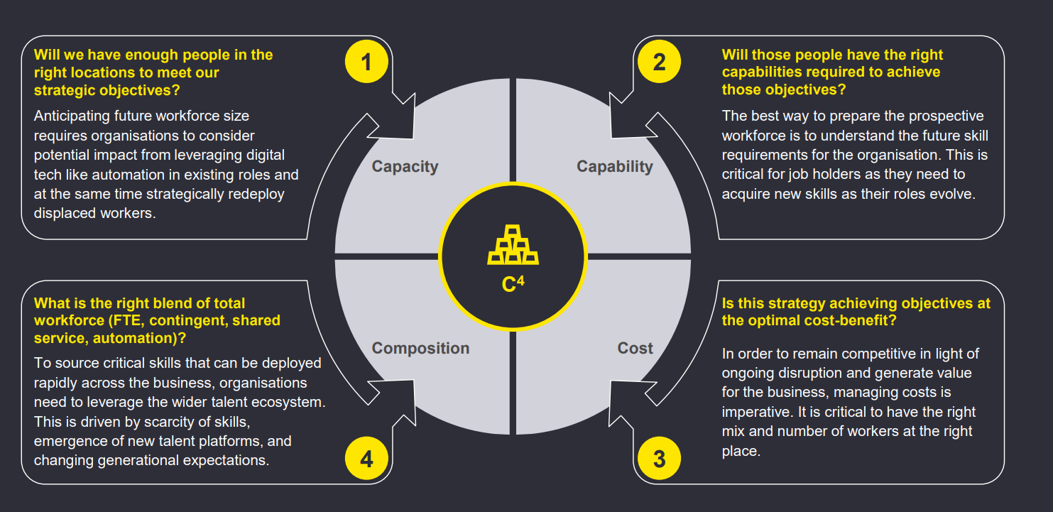
Figure 13 - The C4 Approach to Strategic Planning (Ernst & Young, 2023)

The C4 approach to strategic planning will facilitate an examination of whether the custody workforce is suitably positioned to deliver the intended business outcomes in the medium to long term. Developing a strategic plan further enhances the custody environment to meet the diverse needs of stakeholders effectively, whilst addressing specific challenges and opportunities aligning with the organisational objectives (Whittington, et al., 2019).

Adapting a strategy lens, the design process will facilitate a systematic and logical approach to planned development. Utilising the variety lens enables the exploration of diverse options and perspectives, fostering innovation and inclusivity across all levels of the custody unit. Whereas the lens of experience, through the lens of organisational culture, provides valuable insights (Johnson, 2000). Integrating design, experience, and variety lenses promotes an iterative and dynamic strategic planning process that prioritises stakeholder engagement and feedback. Analysing this approach, it encourages the consideration of alternative strategies, scenarios, and outcomes to promote adaptability and comprehensiveness in decision-making (Shujahat, et al., 2017). The emphasis on clear objectives and efficient actions ensures the alignment of resources and efforts towards meeting the HMICFRS inspection requirements. Critically reviewing and analysing the integration of various lenses, including strategy, design, experience, and variety, in the strategic planning process demonstrates a comprehensive and forward-thinking approach to organisational management.

As detailed in Whittington, et al (2019) exploring strategy model, resource allocation and a robust business model is fundamental to strategic planning supporting firm strategies (Maritan & Kee, 2017). The strategic plan serves as a framework that integrates the business model and relevant data to navigate the environmental landscape. It delineates strategic objectives, goals, and options in alignment with the organisation's mission statement.

By acknowledging the importance of stakeholder engagement, resource allocation, and innovation, the strategic plan can become more adaptable and responsive to external challenges and opportunities. Maintaining a competitive advantage creating value for money can be underpinned by a competitive strategy and newly revised contract for tendering via procurement. However, it is essential to ensure that the strategic planning process remains agile and open to continuous improvement to address evolving organisational needs and market dynamics. Moreover, the critical evaluation of different perspectives and the willingness to challenge conventional thinking will lead to more innovative and effective strategic outcomes.

Assessing strategic choices and incorporating the 4 C strategic workforce planning approach (Ernst & Young, 2023) – figure 14, provides a roadmap, which remains uncomplicated and does not impede internal innovation. Consequently, the aim is to ensure it guides decision-making, directs resources effectively to achieve short to medium-term success, all of which requires continuous monitoring, adaptation, and alignment with changing internal and external factors.

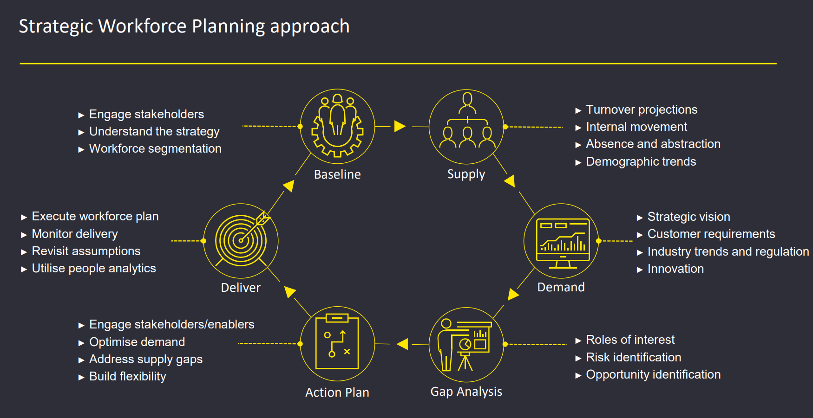
Figure 14 - 4 C Strategic Workforce Planning Approach (Ernst & Young, 2023)

Strategically determining the path forward, it is essential to evaluate whether the proposed options effectively align with the critical opportunities and risks outlined in the custody plan and the strategic position of the SWP. This strategic approach necessitates the active involvement of all stakeholders, with decision-making cascading through the hierarchical structure of the organisation. The success of the plan hinges on the commitment of strategic leadership, middle managers, and practitioners, ensuring a comprehensive understanding of the action plan and operational and organisational requirements to foster genuine investment and achievability. The overarching objective of the custody plan is to establish a secure and safe environment for all detainees through heightened leadership efforts that deliver value for money.

Strategy In Action
Once the strategic position and strategic choices have been established, the analysis completed, and the mission and objectives concluded the custody strategic plan will be in a position to determine the pathway and action to be taken. ‘How you arrive at the end goal is an essential component of a strategy’ (Clearfield, 2021, pp. 1-3). Within this context the middle manager within the custody suite emerges as a key figure and plays a crucial role in strategic management orchestrating the management and implementation of the strategy.

Balancing long term-vision with short terms goals can pose a challenge. The successful implementation of the custody strategy necessitates the support of cohesive integrated structures, systems, and processes. When executing the strategy, adjustments to the organisational structure and control will be necessary, requiring the implementation of various change management tools to facilitate and support the transition (Jeffs, 2008). Putting the strategies into action by allocating resources, assigning responsibilities, and monitoring progress, strategic management should be flexible, fostering a culture of motivation and participation, and able to undergo regular review and evaluation to remain dynamic and relevant.

Examining the relationship between the strategy and how the custody unit functions, the strategic direction necessitates revision, requiring prompt acceptance from staff, emphasising the importance of their understanding, the rationale for change in the custody environment and actively contribution to the strategy formulation to enhance comprehensive understanding of the reasons for change. Managing organisational change and employee buy-in can present a challenge in terms of change management and resistance. Within this context a psychological contract is vital, representing the mutual beliefs and expectations between employers and employees. Establishing clear organisational expectations will effectively manage the psychological contract and facilitate change management thereby enabling the implementation of change with less resistance (White & Robinson, 2014).

Managing change effectively utilisation of the 3 Horizons of Growth will bring improvement, transformation and innovation – figure 15,
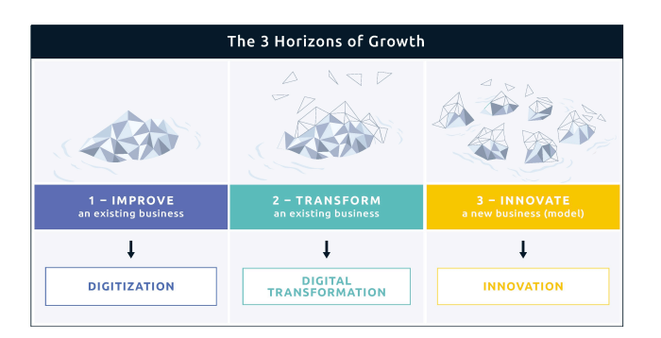
Figure 15 - The 3 Horizons of Growth (Digital Leadership, 2023)

Implementing incremental small changes in line with Horizon 1 can assist to execute and process current systems in custody far more effectively (Digital Leadership, 2023).

Transforming the custody business model, implementing incremental adjustments to evolve existing processes, will facilitate a more substantial transformation of processes and culture aligning with Horizon 2.
Aligned to Horizon 3, the focus is to shift to an innovative new custody model, emphasising the exploration of innovative methods to enhance the custody environment:

To enhance the effectiveness of the strategic plan, it is essential to proactively anticipate and understand potential outcomes. This proactive approach aids in making informed decisions and ensures that the strategic plan remains aligned with its intended objectives. Moreover, evaluating the impact of the strategic plan, achieving objectives and assessing its effect is beneficial for gauging the overall success of the plan.

Operating as an enabler for the Custody Superintendent to make the appropriate and justifiable decisions the plan must be aligned to its general principals ensuring the strategy is high level to direct staff, it remains unique to the purpose and is dynamic and constantly reviewed in line with the CoP approved professional practise (College of Policing, 2013). This approach allows insertion of tactical planning without curtailing responsibilities and direction, it ensures individuals thrive when they are recognised and appreciated for their contributions to organisation success and it reinforces organisations core values, helping to shape the culture and environment (Blanchard & Broadwell, 2018).

Delineating objectives with specific outcomes in accordance with the SMART model will prove advantageous. Performance comparisons will offer clarity through qualitative and quantitative measurements that are in alignment with the organisation's vision and mission. This approach, along with conducting a gap analysis, will facilitate a detailed comparison between actual and projected performance, enabling the identification of any shortcomings and necessary actions (Whittington, et al., 2019) - Appendix C.

Evaluating and analysing the potential effects and consequences of a strategic decision or action on various aspects of the custody unit assesses how the strategy influences organisational goals, objectives, stakeholders, resources, and overall performance. Implementing the strategy in action phase, the utilisation and leveraging of the Unite Horizon of Growth serves to promote collaboration across different departments, roles and ranks within the organisation. This approach supports effective communication at various hierarchical levels, leading to the implementation of organisational change and growth – figure 16.
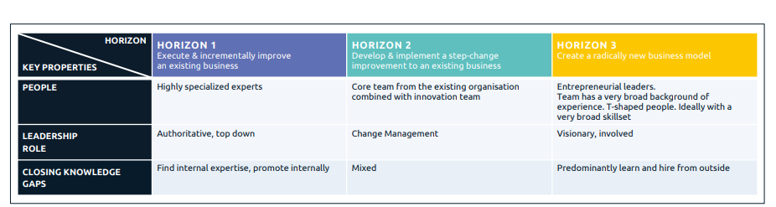
Figure 16 - The UNITE Horizons of Growth: Leadership & Team (Digital Leadership, 2023)

Evaluating the current state of the custody unit including its internal resources, capabilities, and performance, and the external factors that impact its success, the structure review and analysis will emphasis where tailored growth initiatives are required to meet demand. This will enhance custody performance against the goals and objectives, making timely and adaptive adjustments.

The structured hierarchy within the realms of policing is marked by effective governance and precise delineation, encompassing clear boundaries and designated responsibilities. A primary advantage of this is its ability to address preplanned incidents promptly and effectively through a well-defined command framework. As indicated in the preceding section of the report, policing practise are rooted in a model from the industrial period (College of Policing, 2020), it is recognised this integral facet of the organisation and hierarchical framework provides flexibility to implement change, oversee innovations and stimulate active involvement which is pivotal for fostering the development of the organisation (Mintzberg, et al., 2009) and delivering the strategic plan.

Conclusion
The HMICFRS evaluates police forces, reinforcing the importance of strategic planning. However, Mintzberg (1994) considers strategic planning too simplistic and is a ‘critic of paper plans that bear no resemblance to reality’.

Critically analysing both distinct viewpoints, it is concluded that with specific intention or goals in mind when developing the custody strategic plan and strategy, the results and manifestations of that strategy may vary based on external factors, unexpected events, or the interpretation and execution by leaders and individuals within the organisation. This highlights the dynamic and evolving nature of the strategy and the importance of flexibility and adaptability in achieving desired outcomes.
To underscore the importance, it is crucial to highlight and summarise the necessity of financial investment, strategic oversight, and strategic workforce planning for effective organisational and operational success. Supported by Smith (2021) the budget reflects strategic priorities and budget trimming is unstainable and must be replaced by a strategic finance framework. Via strategic planning, this comprehensive approach will ensure the allocation of resources in a judicious manner, enhancing the decision-making process and optimises the utilisation of human resource investment to achieve strategic objectives and uphold organisational standards. By integrating financial investment, strategic oversight, and robust strategic workforce planning, SWP can proactively address the HMICFRS recommendations and capitalise on opportunities. Furthermore, it allows the organisation to effectively anticipate and respond to future challenges and opportunities futureproofing and strategising the custody facilities, prioritising the safety and wellbeing of all detainees delivering safer detention.

On conclusion and in the concept of strategic planning, any strategic plan should be meticulously crafted with an intentional vision, embodying conscious decisions and actions that shape its implementation and execution. The multifaceted outcomes and manifestations of the strategy underscore the importance of strategic leadership in navigating the dynamic and evolving landscape of organisational strategies. Flexibility and adaptability are critical components that enable strategic leaders to respond effectively to changes and uncertainties, ensuring the alignment of actions with the overarching goals and objectives of the organisation.

By fostering a culture of strategic agility and resilience, leaders can optimise the strategic planning process and enhance the organisation's capacity to achieve sustainable success in a rapidly changing environment.

Appendices

Appendix A – SWOT Analysis
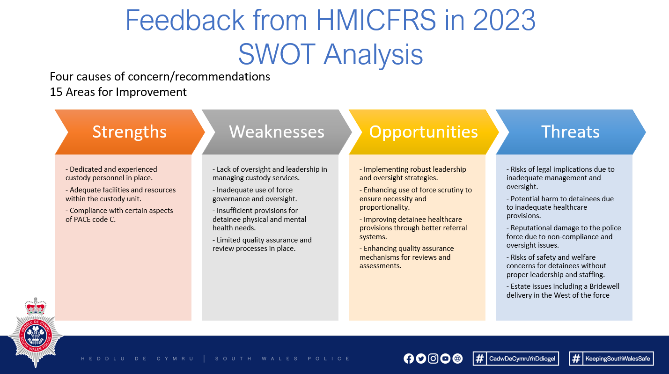

Appendix B – PESTELE Analysis

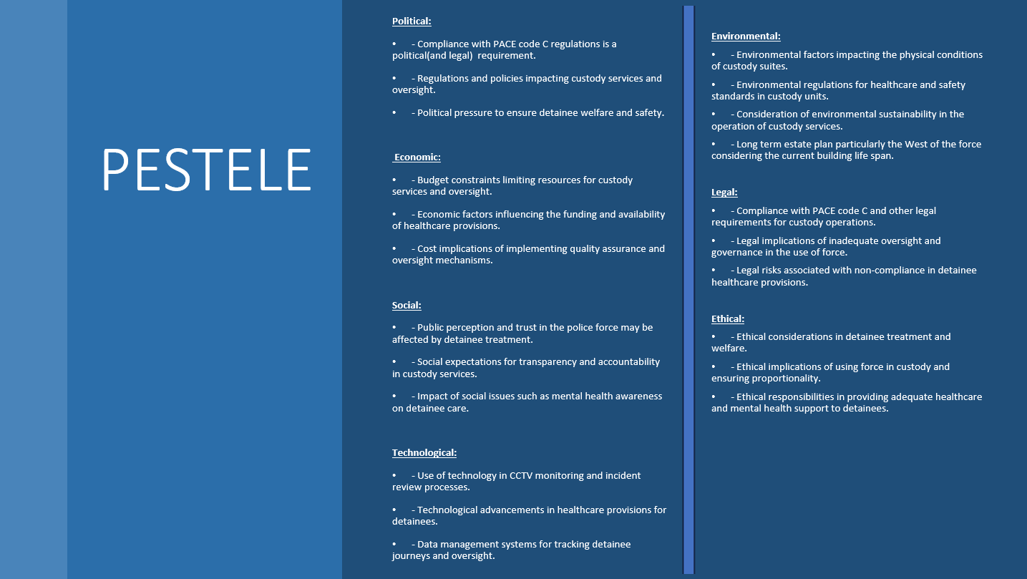
Appendix C – Custody Action Plan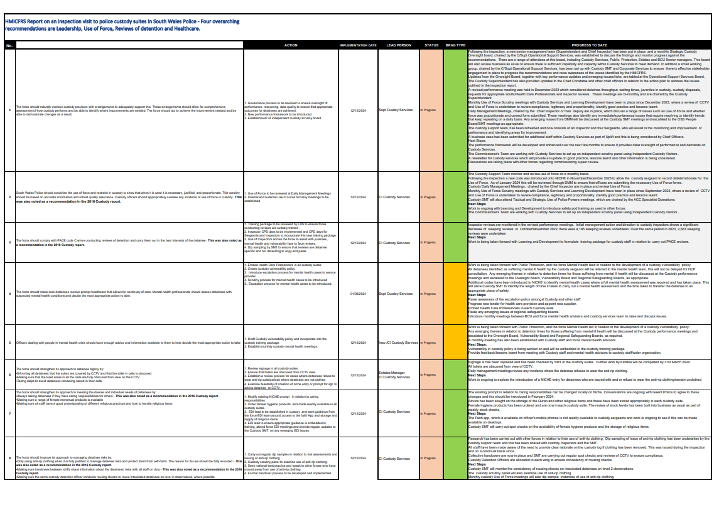 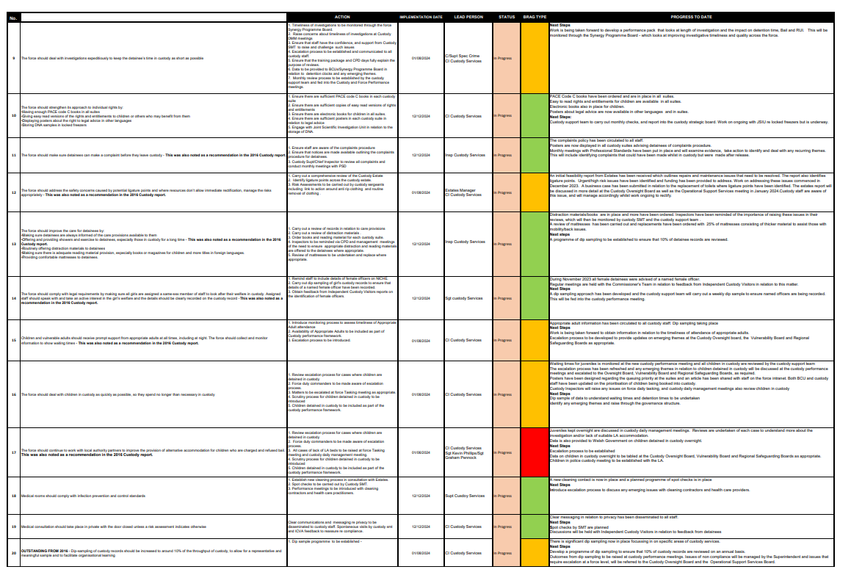

References
Almutairi, K. et al., 2021. Determination of optimal renewable energy growth strategies using SWOT analysis, hybrid MCDM methods, and game theory: A case study. [Online]
Available at: https://onlinelibrary-wiley-com.ezproxy.uwtsd.ac.uk/doi/pdf/10.1002/er.7620
[Accessed 10th april 2024].

Ansoff, H. I., 2007. Strategic Management. Classic ed. Basingstoke: Palgrave Macmillan.

Blanchard, K. & Broadwell, R., 2018. Servant Leadership in Action; How You Can Achieve Great Relationships and Results. 1st ed. Oakland: Berrett-Koehler Publishers, Inc.

Bryson, J. M., 2010. The Future of Public and Nonprofit Strategic Planning in the United States. Public Administration Review, Volume 70, pp. 255-267.

Bryson, J. M., 2018. Strategic Planning for Public and Non Profit Organisations;AGuide to Strenthening and Sustaining Organizational Achievement. 5th ed. Newark: John Wiley & Sons.

Canyon, D., 2018. Simplifying Complexity with Strategic Foresight and Scenario Planning. [Online]
Available at: https://www-jstor-org.ezproxy.uwtsd.ac.uk/stable/resrep28876?sid=primo&seq=3
[Accessed 31st March 2024].

CFI Team, 2023. Strategic Analysis. [Online]
Available at: https://corporatefinanceinstitute.com/resources/management/strategic-analysis/
[Accessed 31st March 2024].

Chand, S. R., 2017. Bigger Faster Leadership. New York: Harper Collins Publishers.

Charrier, K., 2004. Strategic Management in Policing: The Role of the Strategic Manager. The Police Chief , 71(6), pp. 1-6.

Clearfield, C., 2021. Investing in Strategic Leadership. MIT Sloan Management Review, 63(1), pp. 1-3.

Cockcroft, T., 2020. Police Occupational Culture: Research and Practise. Bristol: Policy Press.

College of Policing, 2013. Authorised Professional Practise - Detention and Custody. [Online]
Available at: https://www.college.police.uk/app/detention-and-custody
[Accessed 31st March 2024].

College of Policing, 2013. Strategic Planning. [Online]
Available at: https://www.college.police.uk/app/operations/operational-planning/strategic-planning
[Accessed 16th February 2024].

College of Policing, 2016. Competency and Values Framework for Policing. [Online]
Available at: https://d17wy4t6ps30xx.cloudfront.net/production/uploads/2017/09/Competency-and-Values-Framework-for-Policing_4.11.16.pdf
[Accessed 2024 March 1st].

College of Policing, 2020. Preparing policing for future challenges and demands. [Online]
Available at: https://assets.production.copweb.aws.college.police.uk/s3fs-public/2020-08/Future-Operating-Environment-2040-Part3-Challenges.pdf
[Accessed 20th February 2024].

College of Policing, 2024. Code of Ethics. [Online]
Available at: https://www.college.police.uk/ethics/code-of-ethics
[Accessed 1st March 2024].

Conger, J. A., 1991. Inspiring others: the language of leadership. JSTOR, 5(1), pp. 31-45.

Contorno, D., 2016. Paralysis by analysis. Benefits PRO.

Digital Leadership, 2023. the UNITE Horizons of Growth. [Online]
Available at: file:///C:/Users/swp3979/AppData/Local/Temp/724aeabe-0e5c-4eea-bcee-2b09237e0835_UNITE-Horizons_of_Growth.zip.835/UNITE-Horizons_of_Growth-Presentation.pdf
[Accessed 24th February 2024].

Durivage, A., Barrette, J., Montcalm, L. & Laberge, M., 1992. Analysis of Orgnisational Culture: The Key to Streategic Planning. Canadian Police College Journal, 16(2), pp. 94-134.

Elliott, G., Day, M. & Lichenstein, S., 2020. Strategic planning activity, middle manager divergent thinking, external stakeholder salience, and organizational performance: a study of English and Welsh police forces.

Public Management Review, 22(11), pp. 1581-1602.

Ernst & Young, 2023. The 4 C Approach to Strategic Planning., Coventry: The College of Policing.

Farrar, J., 2024. Delivering Effective Performance. Cardiff: Jeff Farrar.

Fernandes, M. E., Lopes, A. S. & Sargento, A. L., 2021. Improving stakeholder engagement in local strategic planning. Policy Studies, 42(4), pp. 381-396.

Freedman, L., 2013. Strategy; A History. Oxford: Oxford University Press.

Gollner, J., Klerx, J. & Mark, K., 2015. Knowledge Development and Horizon Scanning for Strategic Longterm Planning in Cyber Security. Secuirty and Defence Quarterly, 7(2), pp. 5-21.

Gov.UK, 1984. Police and Criminal Evidence Act 1984 (PACE) codes of practice. [Online]
Available at: https://www.gov.uk/guidance/police-and-criminal-evidence-act-1984-pace-codes-of-practice
[Accessed 31st March 2024].

GOV.UK, 2023. Strategic Policing Requirement. [Online]
Available at: https://www.gov.uk/government/publications/strategic-policing-requirement-2023
[Accessed 17th February 2024].

Grant, R. M., 2021. Contemporary Strategic Analysis. 11th ed. New Jersey: John Wiley & Sons.

Griffiths, A. & Wall, S., 2011. Economics for Business & Management. 3rd ed. Harlow: Pearson.

Groeschel, C., 2024. Quotefancy. [Online]
Available at: https://quotefancy.com/quote/1521758/Craig-Groeschel-Most-leaders-are-trying-to-figure-out-the-right-strategy-The-best-leaders
[Accessed 31st March 2024].

Hannes, L., Segers, J., Dierendonck, D. V. & Hartog, D. D., 2018. Managing People in Organizations:

Integrating the study of HRM and Leadership,. Human Resource Managment Review, 28(3), pp. 249-257.

Havard Business Review, 2021. HBR Guide to Collaborative Teams. Boston: Havard Business Review Press.

HMICFRS, 2023. Report on an inspection visit to police custody suites in South Wales Police. [Online]
Available at: https://hmicfrs.justiceinspectorates.gov.uk/publication-html/inspection-of-custody-suites-in-south-wales-2023/
[Accessed 18th February 2024].

Home Office, 1996. Police Act. [Online]
Available at: https://www.legislation.gov.uk/ukpga/1996/16/contents
[Accessed 17th February 2024].

Jeffs, C., 2008. Strategic Managment. London: Sage.
Johnson, G., 2000. Strategy through a cultural lens: Learning from manager's experience. Scholarly Journal, 31(4), pp. 403-426.

Johnson, G., Whittington, R. & Scholes, K., 2017. Exploring Strategy: Text and Cases. 11th ed. Harlow: Pearson Education Limited.

Kahneman, D., 2011. Thinking Fast and Slow. New York: Farrar, Straus and Giroux.

Langley, A., 2018. Strategic Planning - A Practice Perspective. [Sound Recording] (Henry Stewart Talks Ltd).

Leonard, K. & Bottorff, C., 2022. What Is A Gap Analysis? Definition & Guide. [Online]
Available at: https://www.forbes.com/advisor/business/what-is-gap-analysis/
[Accessed 1st April 2024].

Lynch, R., 2021. Strategic Managment. 9th ed. London: Sage.

Management Guru, 2014. Why Strategic Leadership is Important. [Online]
Available at: https://www.managementguru.net/why-strategic-leadership-is-important/
[Accessed 31st March 2024].

Maritan, C. & Kee, G. K., 2017. Resource Allocation and Strategy. Sage Journals, 43(8), pp. 2411-2420.

Marquet, D. L., 2012. Turn the Ship Around: A True Story of Turning Followers into Leaders. New York: Portfold Penguin Random.

McKeown, M., 2020. The Strategy Book. 3rd ed. Harlow: Pearson Education Ltd.

Mind Tools, 2016. SMART Goals. [Online]
Available at: https://www.mindtools.com/a4wo118/smart-goals
[Accessed 25th February 2024].

Mind Tools, 2024. Porter's Five Forces - The Framework Explained. [Online]
Available at: https://www.mindtools.com/at7k8my/porter-s-five-forces
[Accessed 1st April 2024].

Mintzberg, H., 1994. The Rise and Fall of Strategic Planning. New York: The Free Press.

Mintzberg, H., Ahlstrand, B. & Lampel, J., 2009. Strategy Safari: Your complete guide through the wilds of strategic management. 2nd ed. New Jersey: Pearson Education Ltd.

Morden, T., 2007. Principles of Strategic Managment. 3rd ed. Ashgate: Ashgate Publishing Ltd.

Morgan, D. L., 2014. Integrating Qualitative and Quantitative Methods: A Pragmatic Approach. Los Angeles: Sage Publications.

Mullins, L. J., 2019. Organisational Behaviour in the Workplace with Jacqueline Mc Lean. 12th ed. Harlow: Pearson Education Limited.

National Police Chiefs’ Council, 2021. Strategic Plan 2021 – 2025, London: NPCC.

Professional Academy, 2023. Marketing Theories – PESTEL Analysis. [Online]
Available at: https://www.professionalacademy.com/blogs/marketing-theories-pestel-analysis/
[Accessed 25th February 2024].

Ram, C. & Montibeler, G., 2013. Exploring the impact of evaluating strategic options in a scenario-based multi-criteria framework. Technological Forecasting and Social Change, 80(4), pp. 657-672.

Schooley, S., 2024. What is a SWOT Analysis? (And When To Use It). [Online]
Available at: https://www.businessnewsdaily.com/4245-swot-analysis.html
[Accessed 14th April 2024].
Shujahat, M. et al., 2017. Strategic management model with lens of knowledge management and competitive intelligence: A review approach. Emerald Insight, 47(1), pp. 55-93.

Smith, G. A., 2021. Revisiting Strategy in a Time of Crisis. ProQuest, 35(3), pp. 1-18.

South Wales Police Heddlu De Cymru, 2023. Our vision, values, purpose and ethics. [Online]
Available at: https://www.south-wales.police.uk/police-forces/south-wales-police/areas/about-us/about-us/our-vision-values-and-ethics/
[Accessed 18th February 2024].

South Wales Police, 2020. Corporate Development, Bridgend: South Wales Police.

South Wales Police, 2021. Chief Constables Delivery Plan. [Online]
Available at: https://www.south-wales.police.uk/SysSiteAssets/media/downloads/south-wales/about-us/chief-constables-delivery-plan-final.jpg
[Accessed 1st March 2024].

Tripp, D., 2007. Critical Incidents in Teaching: Developing Profesional Judgement. 2nd ed. Oxon: Routledge.

Tucker, E., 2022. Strategic workforce planning: from closing skills gaps to optimizing talent. ProQuest, 21(1), pp. 14-19.

Walsh, W. F. & Vito, F. G., 2018. Police Leadership and Administration : A 21st-Century Strategic Approach. New York: Routledge Taylor & Francis Group.

White, V. & Robinson, S., 2014. Leading Change in Policing: Police Culture and the Psychological Contract. Sage Journals, 87(4), pp. 258-269.

Whittington, R. et al., 2019. Exploring Strategy. 12th ed. Harlow: Pearson Education.

Whittington, R. et al., 2019. Exploring Strategy, Text and Cases. 12th ed. London: Pearson Higher Education and Professional Group.

Xu, J., Liu, C., Zhao, X. & Ding, Z., 2012. Incorporating structural improvement into resource allocation for business process execution planning. Wiley Online Library, 25(3), pp. 427-442.

Yasin Ates, N. et al., 2020. The Dark Side of Visionary Leadership in Strategy Implementation: Strategic Alignment, Strategic Consensus, and Commitment. Sage Journals, 46(5), pp. 637-665.

Yuki, G. & Gardner, W. L., 2019. Leadership in Organizations. 9th ed. Harlow: Pearson.

Yu, X.-b., 2021. The Fundamental Elements of Strategy; Concepts, Theories and Cases. Singapore: Springer.

