Student Name: Rhys Alexander Davies

Student Number: 1803152

Module Code: ACCA5012

Lecturer: Kemi Ademoye

Module Name: Web Technologies (PHP)

Contents
Introduction 3
Requirements 4
Website Introduction 4
Main Features 4
Design & Implementation 5
Landing Page – Recently listed 5
For Sale & For Rent Page – Filter and Pagination 6
Login/Register 9
CRUD (Create, Read, Update, Delete) 10
Create: 10
Read: 11
Update: 12
Delete: 13
Conclusion 16

Introduction
The following report will document the creation of a web application using dotnet core. The report will brief mention the software used and the main requirements required for the application to run. The scripts and features will be explained to show an understanding of the usage within the project along with how it displayed on a web browser. An in-depth testing report of all the included features will then be carried out to show if the implemented feature work as they should.

Requirements

Website Introduction
The web application is on the topic of buying and renting houses. The purpose of the website is to allow users to view listed houses for sale or for rent and book viewings to see them. The target audience for this website is new home owners or people looking to sell or rent their houses, which they can do easily by creating a listing on the website that will allow people to see.

Main Features
- Searching
- Pagination
- Login/ Register
- CRUD functionality
- Recently added scroll bar

Design & Implementation

Landing Page – Recently listed
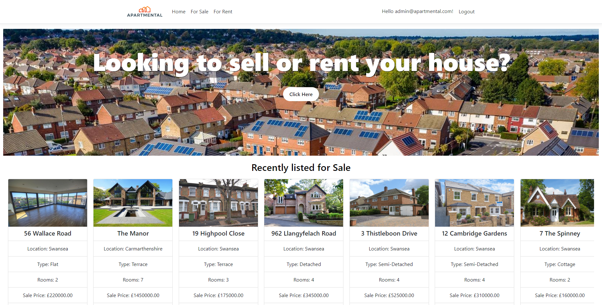
Figure 1, shows the landing page created for the website.
The landing page, as shown in figure 1, contains a simple navigation bar with a jumbotron banner to ask users if they wish to sell or rent a house. Followed by the recently listed items, as shown further in figure 2.
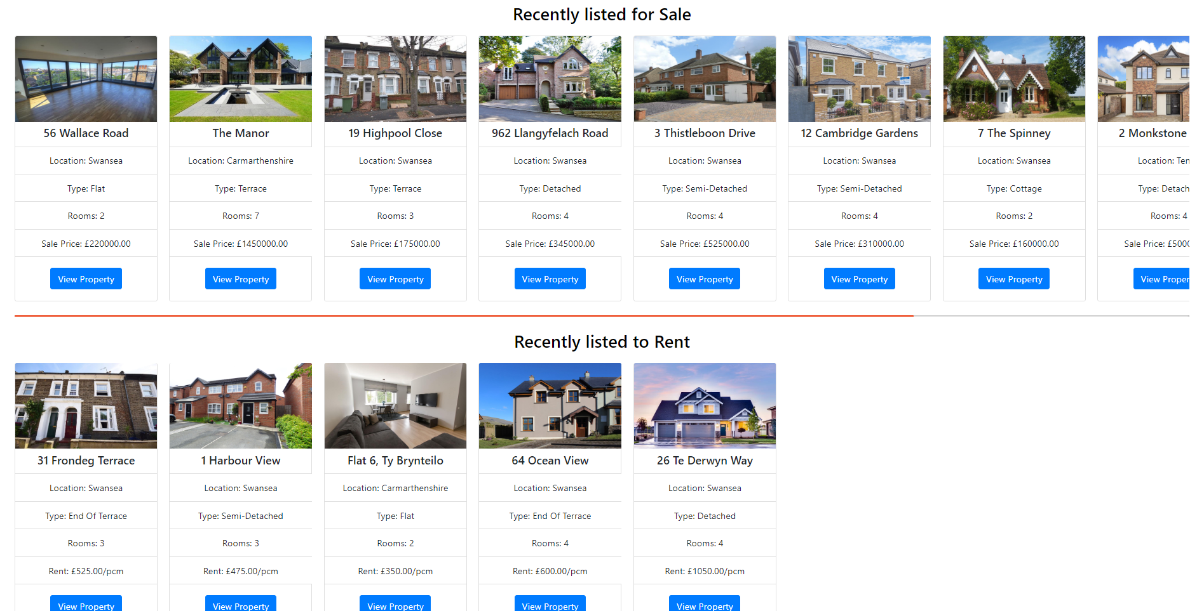
Figure 2, Shows the recently added properties for sale and for rent.
The recently added functionality is a core feature of the website as it enables users to view easily the newest properties added. The scroll bar shows a maximum of 10 properties at one time. This was created by changing the initial view on the home controller to include a reference to the database and running a query that return both the for-sale properties and the for-rent properties which were sorted by ID in descending order to get recently added, as shown by code in figure 3. These where then displayed in the view.
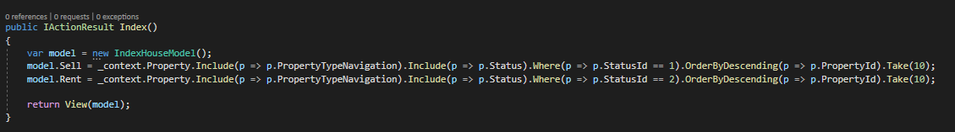
Figure 3, shows the code required to display 2 models that bring back different requests.

For Sale & For Rent Page – Filter and Pagination
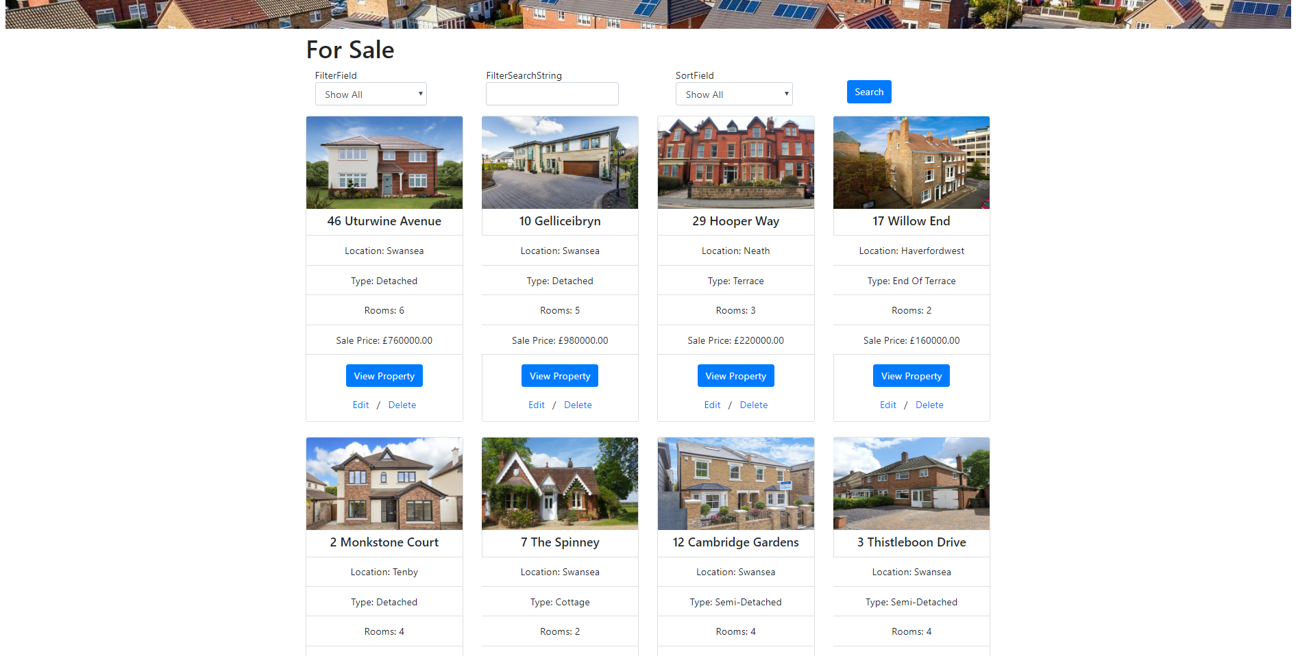
Figure 4, shows the view for the for-sale page.
The for-sale page is identical to the for-rent page in terms of design as users like familiarity between pages and it’s a logical action to take. The properties listed display in a bootstrap card and show a photo of the property followed by key information pulled from the database, shown in figure 4. The searching controls at the top of the page allows for customers to filter the results, as shown in figure 5.
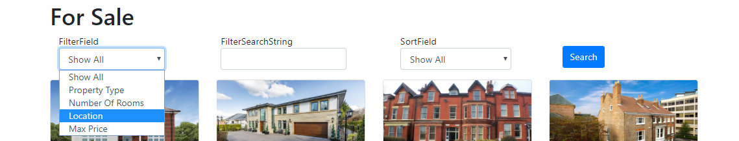
Figure 5, shows the filters available.
The customers can enter a specific property in which they wish the search for the retrospective filter category. The results can be chosen to be sorted by ascending or descending as shown in figure 6.
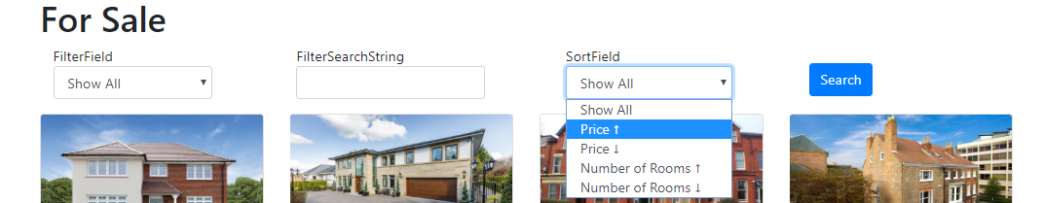
Figure 6, shows the sorts available.
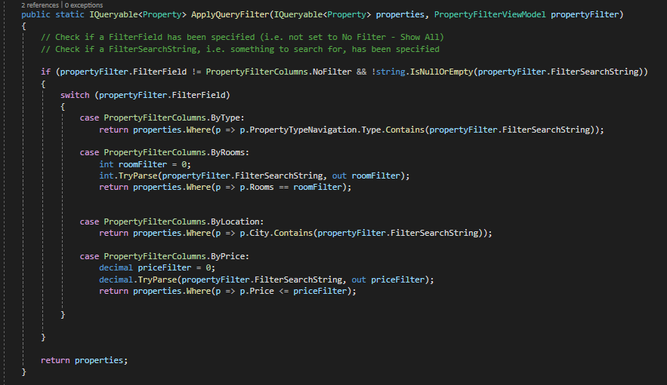
Figure 7, shows the code required for the implementation of filtering.
The code for the implementation, as shown in figure 7, of the filter options involved running lambda expressions on the database which produced a result. A switch statement was used to check every case available for the filter field, options shown in figure 5. The result of the lambda expressions is then returned to be used to display. The sort version is shown in figure 8, which follows the same style however using order by classes to specifically sort the selected filters.

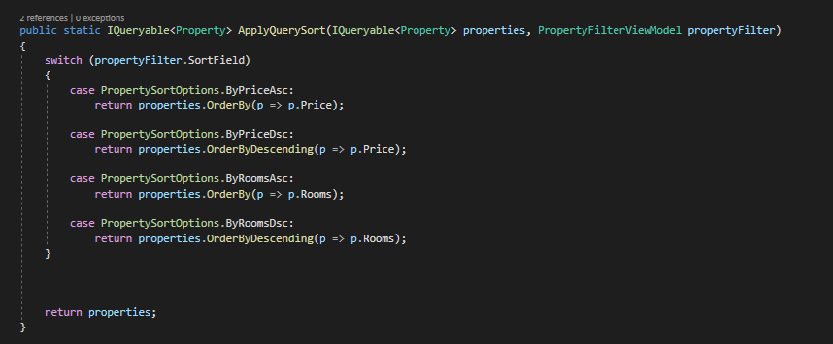
Figure 8, shows the code required for the implementation of sorting

Pagination, as shown in figure 9, is at the bottom of the page and allows for users to click between the available pages and also change the amount of properties displayed.


Figure 9, shows the pagination.
Figure 10, shows the code required for the implementation of pagination.
The code for the implementation of the pagination begins, as shown in figure 10, by fetching the range in which the user has clicked to display. The function then returns the result based on the range click.
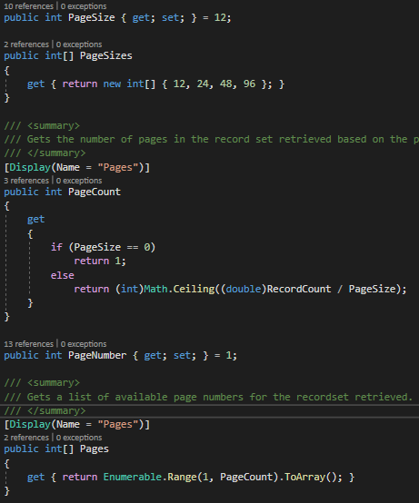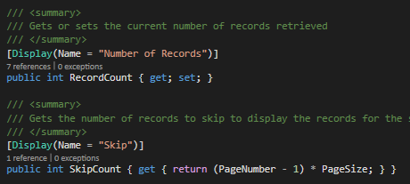
Figure 11, shows the code for implementing the functionality of the pagination.
The page results are displayed within an array for users to choose from on the page. The math calculates ahow many pages are required by dividing the record count by the page size.

Login/Register
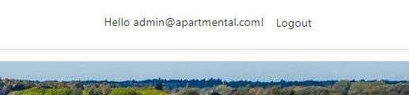
Figure 12, shows admin logged into the website.
The website contains login and register functionality, most of which is auto complete by ASP.NET, however the user can login and it will display their email in the nav bar, as shown in figure 12. The registration system had the phone number added to the form as an additional piece of information. The code is shown in figure 13.
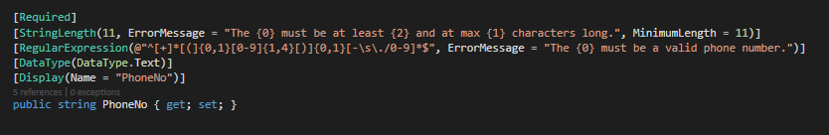
Figure 13, shows the code to implement the phone number requirement for the registration form.
Adding fields to the registration form, as shown in figure 13, displays set rules for the input of the data. The phone number has been branded as required, given constraints in which the data that is entered must be checked against and the formatting of that data otherwise an error will be thrown.

CRUD (Create, Read, Update, Delete)

Create:
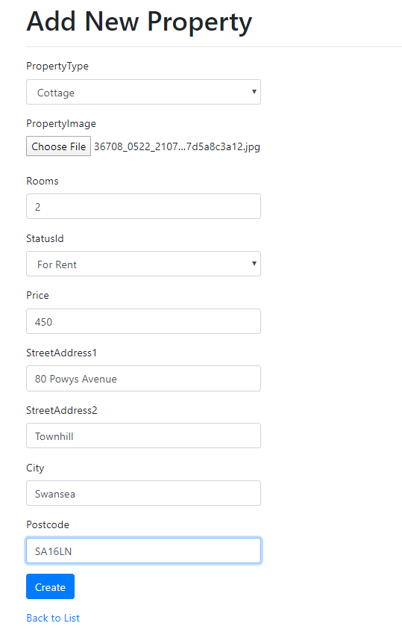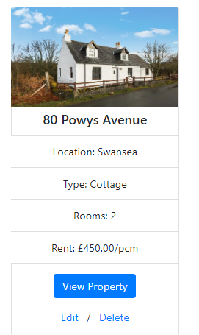
Figure 14, shows the create property form which allows users to upload their properties to the website.
The create functionality of the CRUD controls, as shown in figure 14, is a form for users to fill in that asks them all the relevant information about the house. The image upload is for the user to upload an image for display. When creating the submission for a house it gets inserted into the database and is then available for display, as shown in figure 14.

Read:
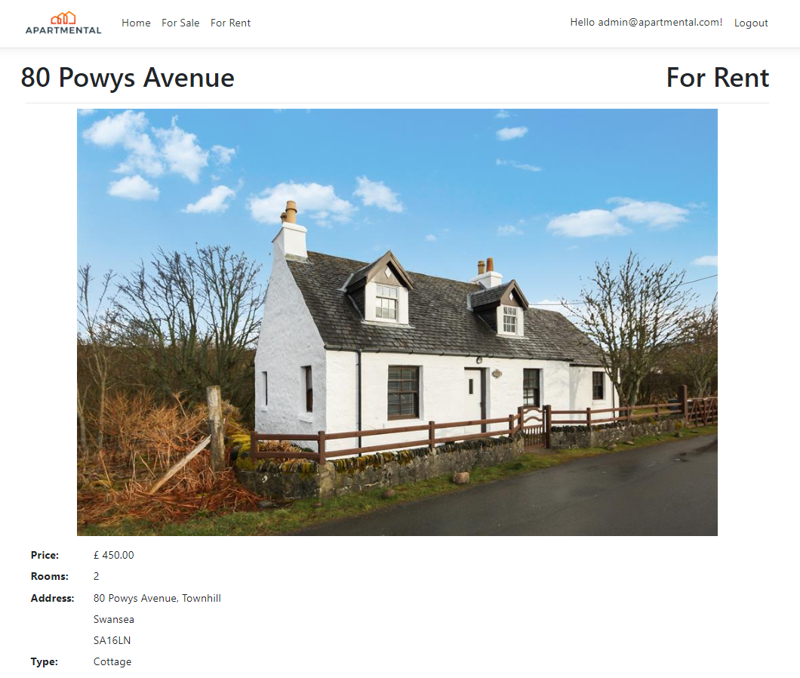
Figure 15, Shows the read functionality and how it displays the data.
The read aspect, as shown in figure 15, of the CRUD functionality displays the item that is clicked on and all the data in reference to that item.

Update:
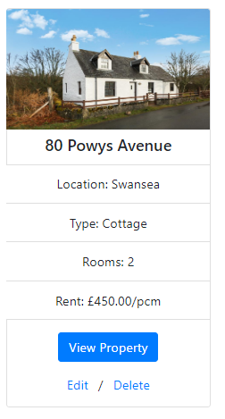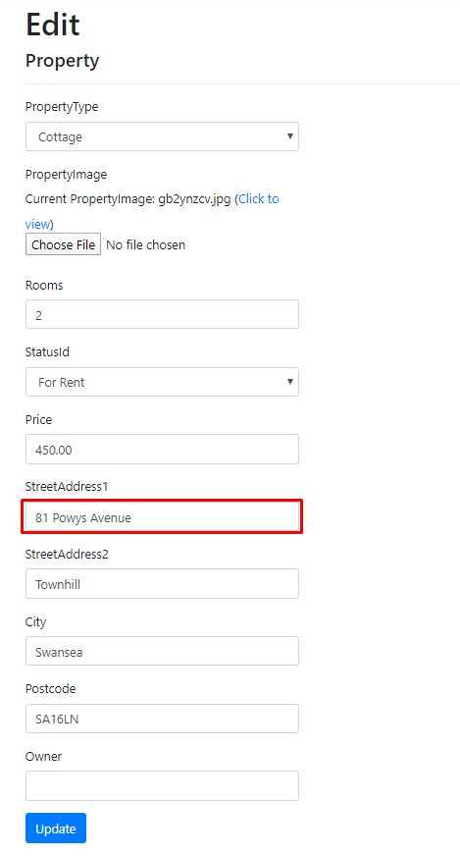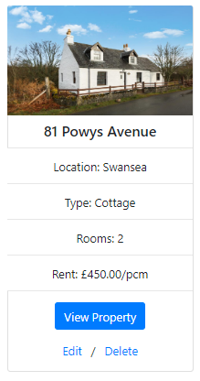
Figure 16, shows before and after edits.
The Edit aspect, as shown in figure 16, of the CRUD functionality allows for the property to be edited and for the edit to be applied and update the database in order for the updated version to be pulled and viewed on the website.

Delete:
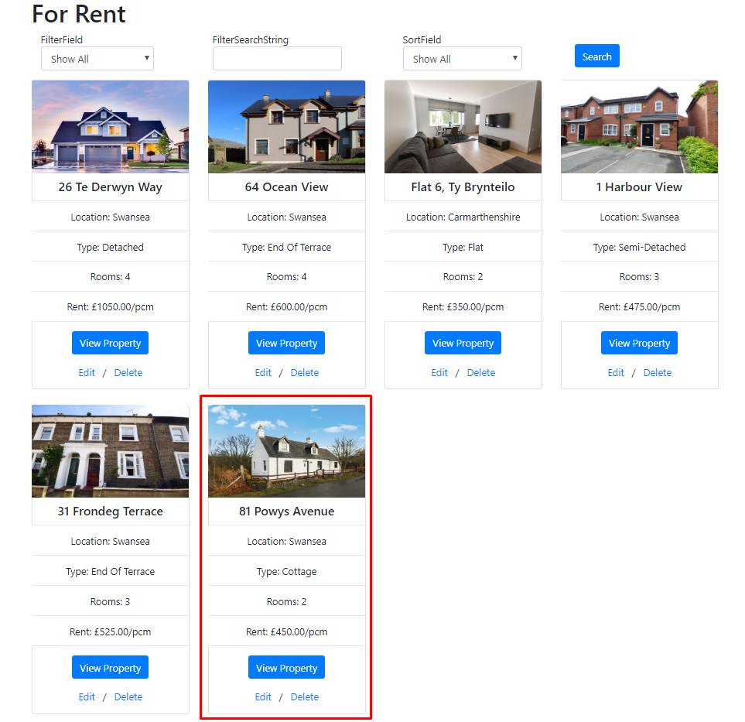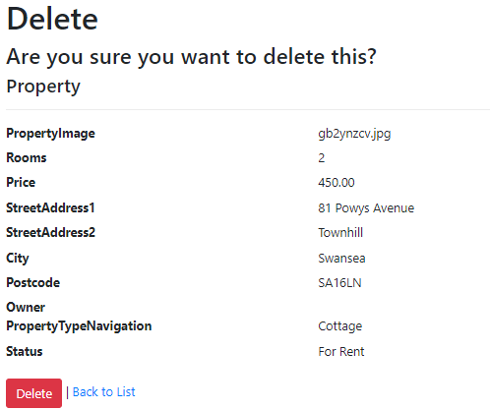
Figure 17, Shows the delete CRUD controls.

The delete functionality, shown in figure 17, of the CRUD controls show how when the item is clicked on the be deleted a delete menu shows up and allows for the property to be deleted, which is then demonstrated in figure 18 where the deleted property is no longer displayed.
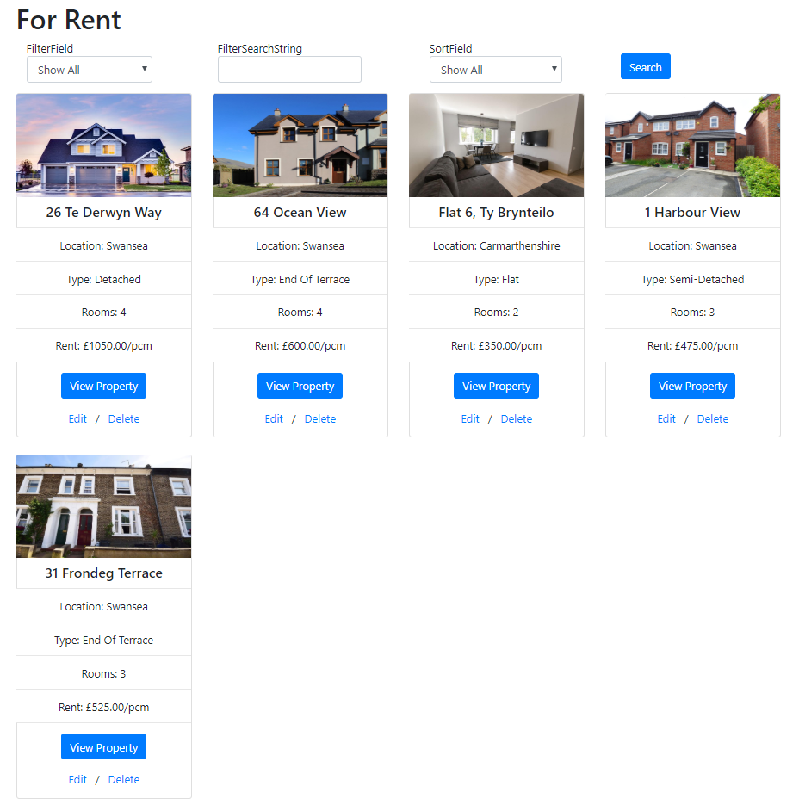
Figure 18, Shows the deleted property from the list,

Test Description | Test Steps | Test Data | Expected Result | Actual Result | Status
Does the website load? | Load website | N/A | Load with no errors | As Expected | True
Does home page display recently added items? | Load Website | N/A | Display the recently added items bar | As Expected | True
Does adding a new property show on recently added? | Load Website,  Create new property  Go back to home page | Refer to figure 14 | Displays the newly added property in the slider. | As Expected | True
Can user log in? | Load Website,  Click Login,  Enter Admin Details | admin@apartmental.com  Admin@_2020 | Redirected to home page, nav bar now says email of user | As Expected | True
Can a user be registered? | Load Website  Click Register  Enter New user details | IwanJones412@gmail.com  Password@_2020 | Redirected to login page, for user to log in | As Expected | True
Can user see property details? | Click on view property button | N/A | Displays property details | As Expected | True
Can user create list their own property? | Click on add new property in jumbotron.  Enter new property details | Refer to figure 14. | Displays the newly added property | As Expected | True
Can admin delete property? | Click on delete as admin and confirm delete | N/A | Property gets deleted from database | As Expected | True
Can admin edit property? | Click on edit as admin.  Make changes to the property | Refer to figure 16. | Property gets updated with new details. | As Expected | True
Can the user search for property by location? | Load For sale page.  Enter search for property location | Swansea | Shows all the results of properties in location Swansea | As Expected | True
Can the user search for property by no rooms? | Load For sale page.  Enter search for property by number of rooms | 4 | Shows all the results of properties with 4 rooms | As Expected | True
Can the user search for property by price? | Load For sale page.  Enter search for property by price | £500,000 | Shows all the results of properties that cost less than £500,000 | As Expected | True
Can the user search for property by type? | Load For sale page.  Enter search for property type | Bungalow | Shows all the results of properties that are type bungalow | As Expected | True
Can the user sort by price Ascending? | Load for sale page.  Enter sort by price ascending | N/A | Results change to show results sorted by price in ascending order | As Expected | True
Can the user sort by no rooms Ascending? | Load for sale page.  Enter sort by rooms ascending | N/A | Results change to show results sorted by rooms in ascending order | As Expected | True
Can the user sort by price Descending? | Load for sale page.  Enter sort by price in descending order | N/A | Results change to show results sorted by price in descending order | As Expected | True
Can the user sort by no rooms? | Load for sale page.  Enter sort by rooms in descending order | N/A | Results change to show results sorted by rooms in descending order | As Expected | True

Conclusion
In conclusion the report has documented how an ASPNETCORE web application was created and main features and workings behind them. A testing plan was also conducted on the main features to ensure that they worked. If the web application was to be developed again more research would conduct to get the booking system to work as it caused a lot of issues, hence not being in the final website. Overall, the website was a success and has a simplistic but easy to understand design with implementation of key features to show understanding.

