

Student name: | Nazifa Sultana Ohia | Student ID number: | 2410582
Programme: | MBA
Module: | Managing Marketing Change
Module code: | BMMB7026 | Contribution to Overall Module Assessment (%): | 75%
Lecturer: | Gwyneth Jones | Internal Verifier: | Marie Pitson
Assignment Title: | Future Developments in the Field of Marketing (SHEIN)  (Individual Report) | Word count (or equivalent): | 3,750 words  (+/- 10%)
Submission deadline: | Thursday 24th July 2025 | Return date of provisional marks & written feedback: | Thursday 21st August 2025

Executive Summary
This report critically analyses the marketing strategy employed by a leading fast-fashion firm by the name Shein, and reviews the effectiveness of the strategy on its key target group, that is the Generation Z and Millennials. The rapid growth of Shein has been supported by data-driven methods, intensive use of social-media promotion, and strategic creation of partnerships with influencers, which have increased the brand image in the very competitive industry. The digital first strategy also helps the company to maintain its market lead, as the company is capable of providing a large volume of trend-driven fashion at unprecedented speed in an affordable manner.
However, the growing importance of sustainability and ethics in the fashion industry is set to be a big blow to Shein. The fast fashion commitment of the brand has also produced increased attention on its impact on the environment, its labour conditions, both of which are becoming highly important in influencing consumer buying decisions. The report uses the PESTLE model to evaluate the external environment of Shein. The internal factors are analysed by Porter’s Five Forces model. The report also takes on Segmentation, Targeting and Positioning, as well as the Marketing Mix to be used in assessing the current marketing strategy applied by Shein.
The conclusion outlines flaws in the current strategy of Shein, especially its low emphasis on sustainability and transparency. To make the marketing more efficient, several suggestions are provided, such as adopting environmentally friendly practices, using broader media coverage in addition to social media, rethinking prices, and developing customer relations via loyalty programmes even further.
The mentioned actions would help Shein maintain its competitive edge and address the growing demand of consumers related to sustainable fashion and sustainable production to guarantee its future success in an environment that is becoming more eco-friendly.

Table of Contents
Executive Summary 2
1. Introduction 5
2. Critical Evaluation of Shein’s Marketing Activities 6
2.1 Concept and Importance of Marketing 6
2.2 Macro Environment - PESTLE Analysis 7
2.2.1 Political 7
2.2.2 Economic 7
2.2.3 Social 8
2.2.4 Technological 8
2.2.5 Legal 8
2.2.6 Environmental 8
2.3 Micro Environment – Porter’s Five Forces 8
2.3.1 Threat of New Entrants 9
2.3.2 Bargaining Power of Suppliers 9
2.3.3 Bargaining Power of Buyers 10
2.3.4 Threat of Substitutes 10
2.3.5 Rivalry among Competitors 10
2.4 Target Market Analysis 11
2.4.1 Segmentation 11
2.4.2 Targeting 11
2.4.3 Positioning 12
2.4.4 Marketing Mix 12
2.5 Selection of Media 13
2.6 Measuring Success 13
3. Conclusion: Shein's Marketing Strategy Shortcomings 14
4. Recommendations for Improving Shein’s Marketing Strategy 15
4.1 Integrate Sustainability into the Core Marketing Strategy 15
4.2 Diversify Media Channels to Reach a Broader Audience 15
4.3 Emphasise Brand Transparency and Ethical Practices 16
4.4 Revise the Pricing Strategy for Long-Term Sustainability 16
4.5 Enhance Customer Engagement and Loyalty 16
5. Reference 17

Introduction
Started in 2008, Shein has become a leading player in the international fast-fashion industry and is characterised by its digital-first attitude and an ability to provide fashion-forward and affordable clothes in the shortest period possible (Shein, 2023). As an online-only retailer, the brand has developed a considerable following of customers in the youth segment, largely belonging to Generation Z and Millennials, whose attraction to the brand lies in the reasonable prices and relevance of its products. This extraordinary growth has been supported by the marketing approach of the firm; the usage of social media platforms has been one of the primary pillars, followed by the strategy of cooperating with influencers and data-driven advertisement processes (Business Insider, 2023).
The success of the Shein marketing strategy is based on the ability to provide new fashion collections at a very fast pace, and this is made possible due to a very efficient supply chain and efforts of effective technology-based systems. This sensitivity to the trends in fashion results in the maintenance of competitive advantage of the company in a highly competitive field. The brand communicates with the core audience on social media such as Instagram, TikTok, and YouTube and develops a base of loyal, responsive consumers (Shein, 2023).
On the other hand, the Shein business model is facing more and more questions regarding its environmental implications. The raised interest of the editorial and the audience in the problem of sustainability has contributed to an increased set of demands on fashion to reduce waste, improve labour conditions, and transfer to more ethical production practices (Holman, 2023). Since consumers are increasingly becoming aware of the ecological and social problems, the company is under intense pressure to align the success of fast fashion with the increased pressure towards sustainability practices.
This report assesses the marketing practice of Shein, an evaluation of the effectiveness of the existing strategies, as well as opportunities that need to be improved, especially in comparison with the sustainability issues that face the company. Theological theories applied to the science of change management will be used to suggest the future marketing direction that can take Shein through the challenges without taking away its leadership in the market.

Critical Evaluation of Shein’s Marketing Activities

Concept and Importance of Marketing
Marketing plays a central role in the operational structure of Shein that enables the company to have the machinery to increase the speed of customer searching and to protect its competitive status in the fast fashion industry. To be more precise, the promotion strategy of Shein is premised on the digital forms, namely social media, data analytics, and influencer marketing, in connection with the help of which the brand has connected with an international customer base, specifically focusing on generations Z and Y (Degli et al., 2024). The organisation's ability to balance the selling value of its trendy apparel with fast delivery supports its commercial success and expansion path, as a digital-first approach (Gómara, 2023).
Investments into the costs of marketing are huge, and digital advertising on Instagram, TikTok, and YouTube is the pivotal form of reaching one-on-one with the target consumer, a digitally native person attuned to fashion (Uchańska and Obłój, 2023). By deploying AI and machine learning technologies, the company will be able to create personalised promotional materials and recommendation systems based on the behavioural data of the consumers and, thus, improve the effectiveness and relevance of every campaign.
Marketing on social media is another pillar of brand efficacy, as Shein organises work with influencers to create credible content and redirects traffic to its online store. Such collaboration programs help not only to spread the information about the product but also create a community of brand supporters, which again enhances customer loyalty (Cameron & Green, 2015). The value proposition of the firm, which went by the tag line of providing affordable fashion at velocity, has been linked to how the market segment held the view that value fashion needed to be cost-effective yet comply with the emerging trends.
Nonetheless, despite such success, Shein continues to be faced with heightened concern over its environmental impact. This has continued to rely on fast fashion processes that trigger waste and pollution, raising doubts about the sustainability of the organisation in the long term. Even though the company has launched symbolic sustainable product lines, its promotional activities need to be adjusted to the growing consumer concern related to ethical labour practices and the sustainability of the environment.

Macro Environment - PESTLE Analysis
The PESTLE framework can be used to analyse the external factors that influence the marketing strategy of Shein. According to this system of terminology, the Political, Economic, Social, Technological, Legal, and Environmental forces, taken together, condition the sensitivity of Shein to the demands of an international consumer population.
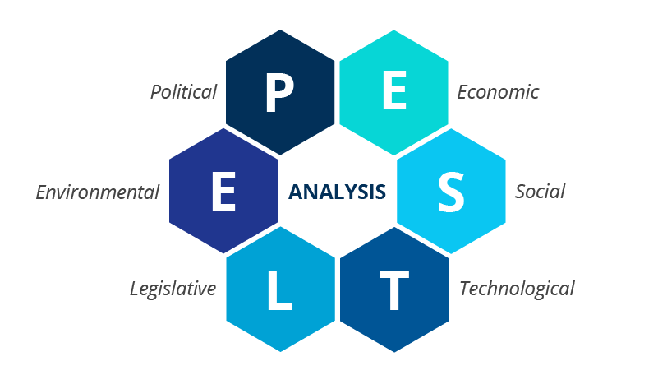
Figure 1 PESTLE Analysis, Source: (Christodoulou and Cullinane, 2019)

Political
This growth to the international level depends on the ability of Shein to operate across the various political environments. Other factors, such as regulatory factors such as tariffs, trade protocol, and political stability of the host country, are important determinants in setting up pricing schemes, as well as logistics arrangements (Dieleman, 2023). Namely, Shein needs to abide by the rules of data-protection systems like the GDPR in Europe, but it struggles with the issues concerning the use of work and intellectual property rights (Wu and Yang, 2024).

Economic
Factors affecting Shein in terms of pricing have been seen to influence economic variables, which in most instances are the disposable income and macroeconomic conditions. The low-cost model that the firm offers appeals to the low-cost consumer when the economic times are low and the purchasing power is low (Business Insider, 2023). The competitive advantage enables the company to provide high-quality products at a low price, especially in several markets.

Social
Societal trends have a decisive control over the case of Shein marketing. The domination of the social-media culture, especially among the members of Generation Z and Millennials, is the fertile ground on which the brand can act to involve users (Sarkar, 2021). Shein takes advantage of immediacy existing in fashion consumption by satisfying the demand of quick turnover between the delivery of a product and its design. However, the increased attention on sustainability and ethical production is causing Shein to tighten its acts as a trend towards environmentally aware clothes becomes prominent among consumers.

Technological
One of the most important pillars of Shein marketing is technological developments. Data analytics and artificial intelligence help the organisation enhance the realisation of the campaign, keep track of consumer behaviour, and customise offers (Burnes, 2014). Mobile technologies allow conducting business activities with customers in real-time, which is an additional lever that increases sales through mobile applications and social media.

Legal
The marketing activities of Shein fall within a variety of regulatory systems, either explicitly in the field of advertising, intellectual property, and consumer safety (Business Week, 2023). The organisation has been facing lawsuits related to copyright violation and taking issue with supposed opacity in the supply chain, both of which have the potential to destroy the reputation and credibility of advertising.

Environmental
Shein's promotional programs are also under environmental influences. Concerns have continued to be raised with the company about its dedication to sustainability, especially insofar as its involvement in fast fashion is concerned. With the potential of the like-minded market groups requesting more sustainable products, it is crucial that Shein would have to changes its marketing strategies and aligns them to the sustainability concerns and overall trend of the sustainable fashion movement.

Micro Environment – Porter’s Five Forces
On the internal side, the marketing strategy of Shein is determined by the organisational structure, capabilities of its operation, and the use of advanced technologies. The company also takes the giant data analytics and artificial-intelligence resources to optimise the campaigns and make them highly personalised and relevant to personal consumer preferences (Chen et al., 2023). With the help of machine-learning algorithms, Shein can predict trends, track customer behaviour, and rebalance marketing strategies on a real-time basis, thus being capable of responding to changes in the levels of consumer demand promptly.
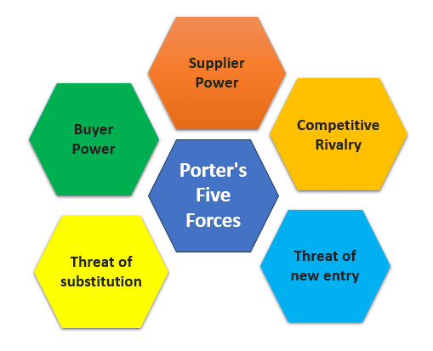
Figure 2 Porter’s Five Forces, Source: (Bruijl, 2018)

Threat of New Entrants
New entrants' threat within the micro-environment is low because there is a relatively low barrier to entry in the fashion industry, particularly for brands that are purely online. The data-driven approach and an effective supply chain provide Shein with significant competitive advantages, yet there was always a chance that other fast fashion companies would mimic its digital-first approach, particularly in terms of increased social-media presence and collaborations with influencers (Burnes, 2014). Shein needs to continue being innovative and guarantee brand commitment to remain leading the competitive marketplace.

Bargaining Power of Suppliers
The global supply chain operated by Shein relies on cheap producers, most of whom are located in Asia. The bargaining power of Shein is also significant due to the size of its operations, as well as the quantities of orders. However, increasing pressure on sustainability implications is likely to force the company to deal with suppliers that meet ethical and environmental standards (Medina, 2022). This will tend to weaken the bargaining power of the company because the trend of environment-friendly inputs and ethical labour standards will further increase.

Bargaining Power of Buyers
Customer power is a central force in Shein's marketing concept. Modern customers are also very well informed, and online they can easily compare the products, prices, and brands. An even greater development of influencer marketing has provided them with an insight into the ability to influence a brand image generating process, in a way that will allow them to affect and instigate demand.
Shein can keep consumers interested by constantly suggesting trend-influential products at affordable prices and by having a strong social media presence (Chen, Dai, & Wang, 2023).

Threat of Substitutes
Consumers are gaining more and more access to alternative fashion brands with sustainability, ethical production, and quality at the centre of operations rather than quantity. Rival companies like Zara and H&M are also incorporating more sustainable operations, something that can earn their attention of Shein, which mainly targets the price-conscious and trendy shoppers (Foreman et al., 2014). In turn, Shein needs to balance low prices and environmentally-friendly programs to retain its competitive position.

Rivalry among Competitors
The fast-fashion industry has been marked by a very high level of rivalry as well as traditional outlets such as Zara and H&M struggle to command market shares with the emerging online clothing stores. The advantage of Shein in producing and delivering fashion trends within a shorter time does not go without consistent innovation in the business to create a unique position for the firm amid the rising competitors.
With increasing concern regarding the sustainability of business, Shein will be forced to update its marketing messages to explain the degree to which it must achieve sustainability in its business and corporate social responsibility (Kim & Mauborgne, 2014).
Although there is a significant level of market competition, Shein is doing very well in marketing, especially when it comes to data analysis and the use of social media to build brand awareness and brand loyalty. With the user-generated content and collaborative marketing, the retailer has created a customer community, which not only buys the products but also takes the responsibility of promoting brand advocacy online (Chen et al., 2023). This constant social interaction is the key that allows Shein to create a sense of belonging in its consumer audience and, consequently, helps it to continue succeeding.

Target Market Analysis
The key target market of Shein comprises both Generation Z and Millennials, as these generations are interested in inexpensive, chasing fashion. Being digital natives, these customers spend a lot of their time on social media like Instagram, TikTok, and YouTube. Using this digital native expertise, Shein therefore smartly uses these platforms to run ads, collaborate with influencers or generate content made by users. This means that the target market of the retailer is low-price shoppers who want quick deliveries and fashionable products.
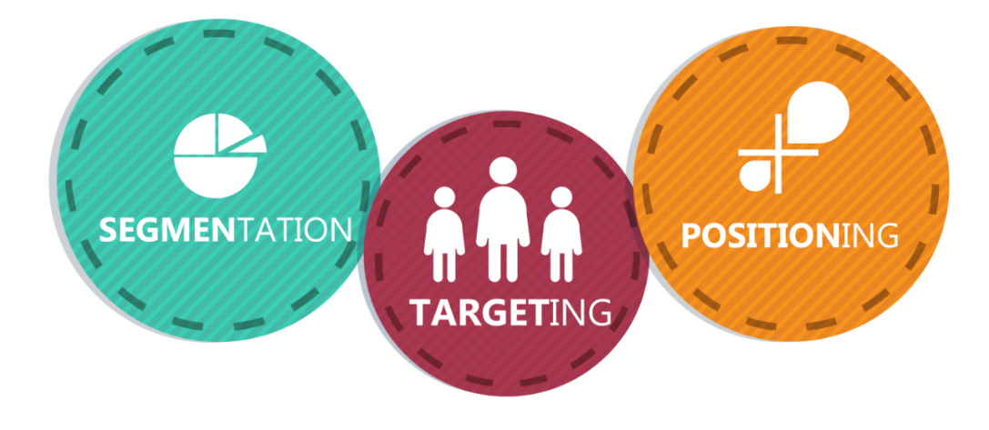
Figure 3 STP Analysis, Source: (Kampamba, 2015)

Segmentation
Shein conducts its marketing by focusing on the process of segmentation that uses demographic, psychographic, and behavioural strategies. Demographically, the retailer focuses on the youthful and trendy customers aged between 16 and 35 years who are very active on digital platforms. The psychographics of the Shein target consumers include those who are willing to pay low prices but care about the style, and are filled with the trendiness of fast shopping (Bieling et al., 2015). The behavioural segmentation is also very important as the firm divides customers based on purchasing patterns, price sensitivity and buying habits based on trends and seasonal interests.

Targeting
Shein has diversified marketing programs that would target specific customers. The main target will be price-conscious, fashion-savvy young people, especially people belonging to Generation Z and Millennials, who desire cheap fashion that meets the new trends. The ability to target the selected population segment via particular data science can be observed in the fact that the company has been using data analytics to tailor both the products and the campaigns to the identified preferences (Kim & Mauborgne, 2014). With the help of prior purchases and browsing history, personalised advertising guarantees the visualisation of products that match current style preferences and buying patterns to each user.

Positioning
In terms of positioning, Shein positions itself as a fast fashion brand that offers inexpensive and on-trend clothing. It networks its value offering on fast delivery and low prices, which makes the company so lucrative to young consumers who care most about accessibility and speed (Kotter, 2009). Such a low-cost structure helps to compete with rivals, especially with young people who look to be stylish but save a lot of money.

Marketing Mix
Regarding marketing mix, the strategic positioning of Shein is also in line with the interest of its target market in coordinated application of the 4Ps.
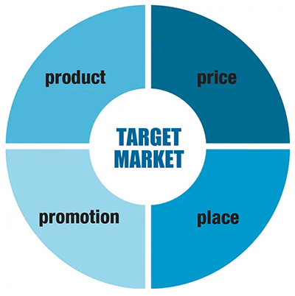
Figure 4 Marketing Mix, Source: (Goi, 2009)
Product: The range of the firm can be characterised by the wide variety of affordable fashion products, such as clothing and accessories, which are aimed at reaching the low end of the market with the young, trendy customers. New styles are being added regularly so that Shein can consistently follow the current fashion trends (Liu, 2022).
Price: Shein uses a penetration pricing method, and it sells goods at affordable prices that its clients can easily buy. Further encouragement to buy the things is provided by extra incentives like discounts, flash sales, and other promotional opportunities.
Place: As a strictly online company, Shein takes advantage of the e-commerce market to connect with the target audience all over the world. This supply system helps the company to reduce its operating expenses as it increases access.
Promotion: After identifying social media advertising, employing influencers, and sending out emails as the appropriate ways to send promotional information to its main consumer group, Shein uses all these strategies to reach its main demographic with promotional material. Close-ended product promotions based on time and strategic flash sales produce emotion that can formulate a sense of urgency that will urge customers to buy rapidly (Shein, 2023).

Selection of Media
The marketing activities of the firm are carried out through an inexhaustible set of media, and social media and online marketing should be used as the main channels. Among the discussed distribution models, Instagram, TikTok, YouTube, and email marketing have desirable positions. The essence of these channels is that they enable building connections with the cohort of digitally native consumers that is essentially large.
Specifically, social media marketing works incredibly well: by engaging in real-time with users, the company takes advantage of the competencies of targeted advertising, endorsement by opinion leaders and user-generated content to maintain the high activity level and the feeling of community regarding the brand. This type of interaction not only encourages sales but also enhances loyalty (Aaker, 2015).

Measuring Success
Shein uses a set of key performance indicators (KPIs) that help determine the effectiveness of the company's promotional efforts. The engine of analysis entails the engagement rates, conversion rates, click-through rates, and growth in sales. The company also measures the effectiveness of its strategy by questioning the social media management: likes, shares, and comments, whose alteration indexes the perceptions of consumers of the existing content proposals (Chen et al., 2023). The effectiveness of influencer-driven campaigns is also examined through the prism of the traffic that a certain website receives as a result of such a partnership and the volume of sales that are made throughout a single collaboration.
However, the intensive growth path pursued by the firm is exposed to the constraints that are characteristic of data-based short-term measurement. An even more detailed evaluative framework should include longitudinal measures of brand reputation and consumer loyalty as a safeguarding approach to a long-term stay in a market, in opposition to an ever-growing environmental and ethical responsibility movement in fashion retailing (Zimand-Sheiner and Lissitsa, 2024).

Conclusion: Shein's Marketing Strategy Shortcomings
To conclude, the marketing programme of Shein is substantively successful due to the wise combination of the data-driven approach, high-volume activities in the social-media context, and effective use of influencers. The price sensitivity and trend affinity-related segmentation responses, the mobile-first orientation, and the personalisation promised by the algorithm have helped the company to pick the marching direction in the market and solidify customer loyalty.
Although it is quite successful, there are some shortcomings associated with the marketing strategy of Shein that jeopardise its ability to remain sustainable in the long term. First is the rising demand for sustainable fashion. As customers in the core demographic of the company are getting environmentally conscious, the focus of Shein in fast fashion, where the company produces high-turnover and low-cost fashion products, has been under scrutiny for a long time, given its environmental impacts. The discontinuity between the current strategy of the firm and the demand among consumers to utilise ethical manufacturing processes and eco-friendly resources is increasing with each passing day.
A similar issue is connected to how Shein relies on the use of social media marketing and collaboration with influencers. Although such strategies have been achieving short-run success, they might not be that effective in the long run. The influencer-based content marketing is about to reach its saturation point, and, as the over-exposure to sponsored content is becoming more and more apparent, there is a risk of reduced interest among consumers in the products offered by Shein. Moreover, the approach also veils other, possibly more powerful avenues, such as traditional advertising and content marketing, that have the potential to expand the influence that Shein can have on a broader audience that is increasingly less frantic to go viral.
Despite the fact that Walmart-like pricing has driven Shein to success, there are other companies, like Zara and H&M, trying to include some sustainability-related initiatives in their services without making the cost materially higher, which serves as a potential threat of compromising Shein's pricing factor. Recognising the company as a fast fashion brand which practices negligence in terms of environmental sustainability can affect its brand image, especially among the younger and environmentally friendly consumers.

Recommendations for Improving Shein’s Marketing Strategy

Integrate Sustainability into the Core Marketing Strategy
Shein will be recommended to realign its marketing patterns to sustainability. Sustainability has to be a leading part of the brand identity and the Messages. An effective solution can be promoting sustainable faculties in fashion using advertisements and celebrating green collections. Placing recycled resources, sustainably produced materials, and ethical sourcing of fabrics, as well as production at the forefront, Shein may establish its reputation of doing good among various touchpoints, social media platforms, most importantly, where the company has a large following.
The existing marketing budget is already invested substantially in digital campaigns; a certain percentage of such funds is redirected to the promotion of sustainable development products, and partnership with environmentally friendly influencers will be a cost-effective strategy.

Diversify Media Channels to Reach a Broader Audience
Despite the current need for social media, Shein will have to expand its media mix. The traditional media, like commercials on TV, billboards, and placing them on magazine pages, are suggested as the means of reaching the generations that are less active on social media. Complimentary strategies such as sustainability blogs, fashion tutorials and behind-the-scenes discussion of ethical production mechanisms can improve brand credibility and appeal to a mixed consumer base.
This shift is made possible with the current digital prominence of Shein. These smaller, selective investments in the conventional media, especially the major markets, would allow the company to reach new population brackets without a significant increase in overall expenditure.

Emphasise Brand Transparency and Ethical Practices
Shein ought to implement a new level of supply-chain transparency, as well as ethical conduct, to foster consumer confidence. To this effect, the company should make the provisions of working conditions, sourcing of materials and carbon-footprint equivalent publicly available just like sustainability reports issued occasionally by the fashion houses that are already well known. Such a revelation would not only aptly outline the commitment of Shein to growth, but also appeal to environmentally aware shoppers demanding ethical fashion. Though such transparency would require too many resources in creating, the demand for ethical products is going up, which makes it possible.

Revise the Pricing Strategy for Long-Term Sustainability
The current pricing policy of Shein is based on the simplicity of price at the peak; however, the company should add this offering to the line of sustainable products. The launch of high-quality, environmentally friendly lines at more expensive prices will help this firm to take a market share of consumers who are ready to pay more for green products. They can provide both sustainable alternatives in addition to a large range at the regular price, thus maintaining the price sensitivity factor as well as increasing its appeal to those consumers who have dedicated themselves to ethical consumption.
The proposed recommendation can be supported using the existing price architecture of Shein, since it will allow the company to appeal to the customers based on their moral values without pushing away the current customer base.

Enhance Customer Engagement and Loyalty
An eco-friendly, sustainable consumption customer rewards program can strengthen customer participation further. The program would encourage the behaviour that is close to sustainability by awarding points based on buying the items from the eco-friendly selection or even recycling clothes. All these can be exchanged with discounts or promo offers, and thus, can make the consumer more loyal to the brand and gain more confidence in their choice of sustainable options.
This kind of program is not only an inexpensive program of retention but also easy to execute since Shein already has an e-commerce platform and customer-tracking infrastructure.

Reference
Aaker, D. (2015). Brand Personalities Are Like Snowflakes, Marketing News, 49(7), pp. 20-21. Available at: https://www.marketingnews.com [Accessed: 7 July 2025].
Bieling, G., Stock, R. M., & Dorozalla, F. (2015). Coping with Demographic Change in Job Markets: How Age Diversity Management Contributes to Organisational Performance, Zeitschrift für Personalforschung, 29(1), pp. 5-30.
Bruijl, G. (2018). The Relevance of Porter’s Five Forces in Today’s Innovative and Changing Business Environment. SSRN Electronic Journal, [online] 1(1), pp.1–23. doi:https://doi.org/10.2139/ssrn.3192207.
Buchanan, D. A., & Badham, R. J. (2008). Power, Politics and Organisational Change (2nd ed.). London: Sage Publications. Available at: https://uk.sagepub.com/en-gb/eur/power-politics-and-organisational-change/book226776 [Accessed: 7 July 2025].
Burnes, B. (2014). Managing Change (6th ed.).Harlow: Pearson
Burnes, B. (2014). Managing Change (6th ed.). Harlow: Pearson. Available at: https://www.pearson.com/store/p/managing-change/P100000283911 [Accessed: 7 July 2025].
Business Week. (2023). Shein’s Competitive Advantage in Fashion eCommerce. Available at: https://www.businessweek.com [Accessed: 7 July 2025].
Cameron, E., & Green, M. (2015). Making Sense of Change Management: A Complete Guide to the Models, Tools and Techniques of Organisational Change (4th ed.). London: Kogan Page. Available at: https://www.koganpage.com/product/making-sense-of-change-management-9780749474907 [Accessed: 7 July 2025].
Chen, H., Dai, Q., & Wang, S. (2023). The Role of Influencer Marketing in Shein’s Growth. Social Media Marketing Journal, 6(3), pp. 13-27. Available at: https://www.socialmediamarketing.com [Accessed: 7 July 2025].
Christodoulou, A. and Cullinane, K. (2019). Identifying the Main Opportunities and Challenges from the Implementation of a Port Energy Management System: a SWOT/PESTLE Analysis. Sustainability, [online] 11(21), p.6046. doi:https://doi.org/10.3390/su11216046.
Danciu, V. (2013). The Future of Marketing: An Appropriate Response to the Environmental Changes, Theoretical and Applied Economics, 20(5), pp. 33-52.
Degli Esposti, P., Mortara, A. and Roberti, G. (2024). Unsustainable Fashion: SHEIN and the Fast Fashion Consumption Model. Italian Sociological Review, 14(3), pp.929–951. doi:https://doi.org/10.13136/isr.v14i3.822.
Dieleman, M. (2023). Strategy at Shein: The Secrets of Ultra-Fast Fashion. SAGE Publications: SAGE Business Cases Originals. doi:https://doi.org/10.4135/9781529622713.
Eco-Stylist. (2024). The Environmental Impact of SHEIN: Is Fast Fashion Sustainable?. Available at: https://www.eco-stylist.com/environmental-impact-of-shein/ [Accessed: 7 July 2025].
Foreman, J., et al. (2014). The performance implications of planning, implementation, and evolution of firms’ customer and competitor orientations, Journal of Marketing Theory and Practice, 22(4), pp. 349-366.
Goi, C.L. (2009). A Review of Marketing Mix: 4Ps or More? International Journal of Marketing Studies, [online] 1(1), pp.1–4. Available at: https://pdfs.semanticscholar.org/006a/f4780f1cff9f7075ab5b7073f4cebb32c3d5.pdf/1000 [Accessed 7 Jul. 2025].
Hayes, J. (2014), The Theory and Practice of Change Management, 4th edn. Basingstoke: Palgrave Macmillan
Holman, J. (2023). Fast-Fashion Leaders Shein And Forever 21 Team Up. The New York Times, [online] 9(2), pp.B4–B4. Available at: https://go.gale.com/ps/i.do?id=GALE%7CA762064854&sid=googleScholar&v=2.1&it=r&linkaccess=abs&issn=03624331&p=AONE&sw=w [Accessed 7 Jul. 2025].
Kampamba, J. (2015). An Analysis of the Potential Target Market through the Application of the STP Principle/Model. Mediterranean Journal of Social Sciences, [online] 6(4). doi:https://doi.org/10.5901/mjss.2015.v6n4s3p324.
Kim, W. C., & Mauborgne, R. (2014). Blue Ocean Leadership, Harvard Business Review, 92(5), pp. 60-72. Available at: https://hbr.org/2014/05/blue-ocean-leadership [Accessed: 7 July 2025].
Kotter, J. P. (2009). Leading Change. Mass: Harvard Business Essentials. Available at: https://www.hbs.edu/faculty/Pages/item.aspx?num=33188 [Accessed: 7 July 2025].
Liu, J. (2022). Research on the Business Strategy and Deficiency of the Fast Fashion Industry to Enhance Development - a Case Study of Shein. [online] www.atlantis-press.com. doi:https://doi.org/10.2991/978-94-6463-036-7_268.
Marketing Week. (2023). Shein’s Marketing Effectiveness. Available at: https://www.marketingweek.com [Accessed: 7 July 2025].
Martinicorena Gómara, A. (2023). Fast fashion and sustainability. The case of Shein. academica-e.unavarra.es, [online] 24(7). Available at: https://academica-e.unavarra.es/entities/publication/174048be-76cb-450a-a5d2-16836ad9110f [Accessed 7 Jul. 2025].
Medina, S. (2022). GREENWASHING IN FAST FASHION BEAST, SHEIN’S, COMMUNICATIONS? — A CONTENT ANALYSIS. [online] Carolina Digital Repository. Available at: https://cdr.lib.unc.edu/concern/masters_papers/1g05fn52m [Accessed 7 Jul. 2025].
Sarkar, A. (2021). The Impact of Consumer Demand on Sustainability in Fast Fashion. International Journal of Fashion Marketing, 7(1), pp. 12-28. Available at: https://www.fashionmarketing.com [Accessed: 7 July 2025].
Shein Group. (2023). Our On-Demand Business Model. Available at: https://www.sheingroup.com/our-business/our-business-model/ [Accessed: 7 July 2025].
Uchańska-Bieniusiewicz, A. and Obłój, K. (2023). Disrupting fast fashion: A case study of Shein’s innovative business model. Przedsiębiorczość Międzynarodowa, 9(3), pp.47–59. doi:https://doi.org/10.15678/ier.2023.0903.03.
Wu, Y. and Yang, C. (2024). Analysis of Fast Fashion Brand Marketing Innovation Strategy -Taking SHEIN as an Example. SHS Web of Conferences, [online] 193(1), p.01030. doi:https://doi.org/10.1051/shsconf/202419301030.
Zimand-Sheiner, D. and Lissitsa, S. (2024). Generation Z - factors predicting decline in purchase intentions after receiving negative environmental information: Fast fashion brand SHEIN as a case study. Journal of Retailing and Consumer Services, 81(103999), p.103999. doi:https://doi.org/10.1016/j.jretconser.2024.103999.

