Project management
ASDA’s response to COVID-19



Author: Adrian-Gigi Ciacareanu (1710292)
Tutor: Shehla Khan
Host organisation: University of Wales Trinity Saint David
Date of report publication: 03/07/2020

1.0.Introduction

This report was requested by Lecturer Shehla Khan, tutor at the University of Wales Trinity Saint David, Swansea Business Campus.
The purpose of this report is to evaluate ASDA, the British supermarket chain and its response to the Coronavirus outbreak.
Given the circumstances, and the fact that this is a deadly virus, the organisation has decided to implement a series of safety measures to help reducing the spread of COVID-19 while continuing to supply necessary goods for its customers and for the most vulnerable ones.
The project management life cycle will be divided into stages, and each phase will be individually analysed using relevant tools and techniques.

Table of contents

1.0.Introduction…………………………………………..….pg.1
2.0.Findings…………………………………………………..…pg.3-17
2.1.Project management……………………………..…..pg.3
2.2.Initiation phase………………………………………..…pg.3-9
2.3.Planning phase…………………………………………...pg.9-15
2.4.Implementation phase……………………………..…pg.14-16
2.5.Monitoring and evaluation phase……………..…pg.16-18
3.0.Conclusions and recommendations…………..…pg.19
4.0.Reference list……………………………………………....pg.20-22

2.Findings

This report will start by defining the project. A project is a unique, temporary and focused activity with fixed starting and ending points, a restricted budget and the involvement of a team to achieve a change for the organisation. (Maylor, 2010)
2.1.Project management is the application of knowledge, aptitudes, instruments and methods to project activities to meet the project requirements. (What is Project Management, 2020)
No matter the size, any project has a life cycle. The project life cycle is a framework that helps a project manager to divide the project into phases and to maintain control over the project. (Project Management Life Cycle: Definition, Phases & Models, 2017)

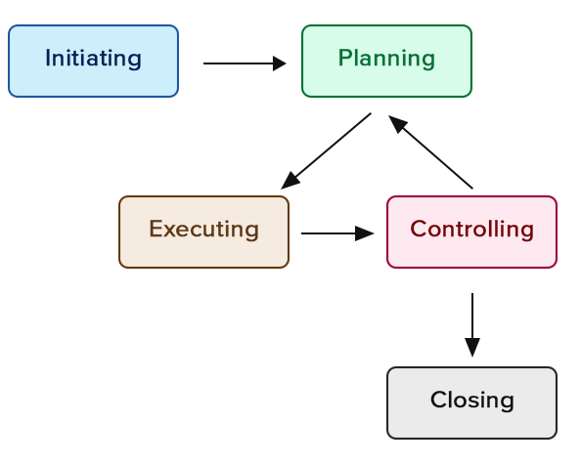

2.2.Initiaton phase
The first phase of the project life cycle is the initiation phase. It can be defined as the calm before the storm, and it is a critical point in the success of the project. During this phase, the project manager draws the requirements of the project, estimates the resources and assigns the future tasks for the team members. The project manager should focus on three central areas: people, product and processes. One cannot start a project without the right people, and it is crucial to know things like the skills and the experience they possess or the availability of the team members. This phase of the project requires the involvement of stakeholders, internal or external, and communication plans must be set. (Haworth, 2018)

Last but not least, the author recognises the importance of a good project manager and the impact he has upon the success of the whole project. A
good project manager must have a distinct set of essential competencies.
The project manager must have decision-making skills, the decisions he undertakes are based on relevant data, realities, necessities and contexts. Communication is another field in which the project manager must shine, and this is because he delivers essential information to stakeholders, holds presentations and regulates the suitable communication channels.
Given the fact that the project manager must solve conflicts inside the team and delegate specific tasks to certain individuals, he must show excellent team-management abilities. (Udo and Koppersteiner, 2004)

For further development of the topic, I have chosen to talk about ASDA and the measures it implemented due to Covid-19 pandemic. ASDA is a British supermarket born in 1965 after a merger between Associated Dairies and Asquith’s chain of three supermarkets. Nowadays, more than 145,000 people are working for the giant retailer and about 18 million customers that shop weekly at ASDA. (ASDA, 2020)
At the beginning of the Covid-19 pandemic, ASDA took severe actions to reduce the spread of the virus throughout its stores. The retailer decided to close its cafes and pizza counters, and also reduced opening times as well as rationalising products to make sure every customer can buy the desired ones. ASDA instructed its cleaners to be extra cautious when cleaning the "high traffic areas" to help reduce the spread of the virus. (Wright, 2020)

The initiation phase contains a project scope, included in the contractual deal between the service supplier and the client, which encompasses a set of expressed deliveries and objectives for the report. Everything else that does not belong to the project scope, such as things not needed by the organisation or things that are not economically viable, is out of reach and the project manager does not have to deliver them to the client. Negotiating scope sometimes proves to be very difficult because of the stakeholders and their different preferences, desires or agendas expected to be fulfilled without exceeding the initial budget or without any other resources. (Clayton, 2017)
In addition to scope, the project has aims and objectives, who are acting as guidelines to measure the fruitful development and achievement of all project's techniques. These objectives must be measurable and usually encompass extents such as costs, quality and time to accomplish. Goals also provide direction to the task and define areas for fulfilment. While aims are specified in standard terms, the goals are much more specific, meaning that an inevitable result is expected to be delivered at a particular point of time. (Heerkens, 2001)
As any other organisation that is looking to overcome the barriers imposed by this pandemic, ASDA's project defines its aims and objectives. For a better understanding of these two concepts and the way they apply to the giant retailer, the author decided to create a Quad chart. The Quad chart is a one-page summary of a project, both visual and descriptive used to plan and communicate in order to explain the meaning of the project itself. (What is a Quad Chart, 2020)

The first quadrant of the Quad chart encompasses the aims and objectives of the project, which is adhering to governmental regulations and taking care of ASDA’s shoppers. The COVID-19 pandemic brought a series of major changes to the usual shopping habits of customers. To help reduce the spread of this deadly virus, people were recommended to wear face masks inside supermarkets or any other enclosed food stores. Customers were encouraged to reduce the unnecessary visits to the local supermarket, plan ahead or even create a shopping list, and use disinfectants to clean trolleys and sanitizers to protect hands. (COVID-19 Advice for Supermarket Visits, 2020)

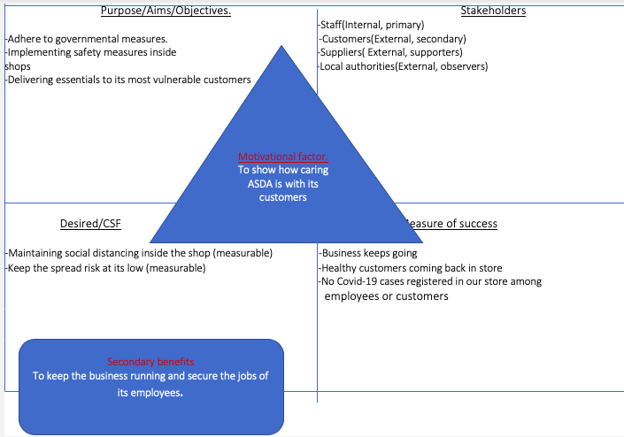

For the most vulnerable category, ASDA works alongside the British government, creating programmes so these people will receive their goods in time without leaving their homes. Perhaps the most significant programme is the “volunteer shopping card”, through which the vulnerable ones can delegate close friends, neighbours or family members to do their shopping without the stress of using bank cards or cash payments. For a better shopping experience, ASDA instructs its clients that there is no need to rush into supermarkets early in the morning, reassuring them of the fact that they are very well stocked for the whole day, for both grocery and pharmaceutical goods. (Cunningham, 2020)

The researcher discussed the measures implemented by the retailer to protect its most vulnerable customers. In the following paragraph, the author will reveal how ASDA is protecting its most vulnerable employees and its reliable suppliers. CEO Roger Burnley reassured those vulnerable staff members that they will still receive the full payment for 12 weeks even though they will be at home in self-isolation. Furthermore, the grocer encourages its workers to recommend friends or family members who are looking for a job in these hard times to submit a job application or C.V. at the nearest ASDA store. In its efforts to help and sustain small businesses, ASDA pledges to pay the small suppliers, adding that: "we want to play our part, and where we are able to reduce the strain on our smaller suppliers and tenants, we will do so." (Jahshan, 2020)

Managing a project is no easy thing, and it is the project manager attribution to know the people associated with the project, whether they are directly or indirectly involved. To have a better understanding of who are the people that one can count on when starting a project, the manager of the project must conduct a stakeholder analysis. A stakeholder analysis is a process used to identify the individuals or group of individuals that might be interested in a project before this starts. (What is Stakeholder Analysis?, 2020)
Brainstorming is the best method a project manager can use when identifying the people interested in the realisation of the project. After identifying the stakeholders, the project manager classifies them by judging the level of power or interest they have in the project. Primary stakeholders are those individuals that are ultimately affected and will gain benefit either positively or negatively depending on the outcome of the project. This category includes general managers and stockholders' board, or even ordinary employees and regular customers. The intermediaries or the audience represent secondary stakeholders. The project manager must keep a close connection with the primary stakeholders as they are the most powerful and most influential for the project. (Stakeholder Analysis: Winning Support for Your Projects, 2020)
Now it is the right time to pinpoint the project champion, that member of the team, or the most influential stakeholder, that a project manager can rely on and ask for support at any stage of the project. The big question is how the project manager can identify the project champion? The answer resides in the project manager's capability to find the individual that possess the entire set of attributes required for a project champion. A true hero has to be an excellent and influential communicator, a respected member of the organisation whose ideas are appreciated to be relevant and worthwhile, a passionate character and a believer, and with fantastic leadership skills. (O'Reilly, 2018)

A stakeholder analysis of ASDA wishes to assess both components, internal and external, and express the impact these components have in regard to the whole project. The internal stakeholders of ASDA are the
executive board members, managers, employees and stockholders. Following the first group of stakeholders, the author categorises the external stakeholder: customers, suppliers, local communities and the government. There are several ways in which ASDA keeps its shareholders updated. The retailer uses its official website, www.asda.com to share information about products and services, employment opportunities and other useful tips. (Rahman, 2019)

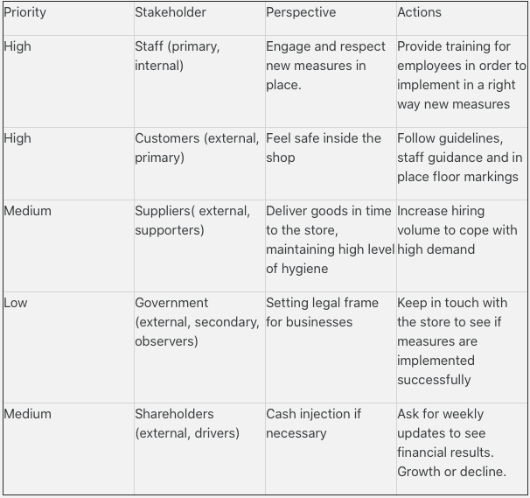

2.3.Planning phase
The project life cycle moves on to its second phase: the planning phase. It is by far the most challenging step of the project management, and it involves the conception of smaller plans to help the project manager with the administration of cost, risk, suppliers or quality. The author will use a set of relevant tools for this phase of the project to keep track of every specific activity.
The work breakdown structure (WBS) is "a deliverable-oriented hierarchical decomposition of the work to be executed by the project team to accomplish the project objectives and create the required deliverables." (Brotherton, 2008)

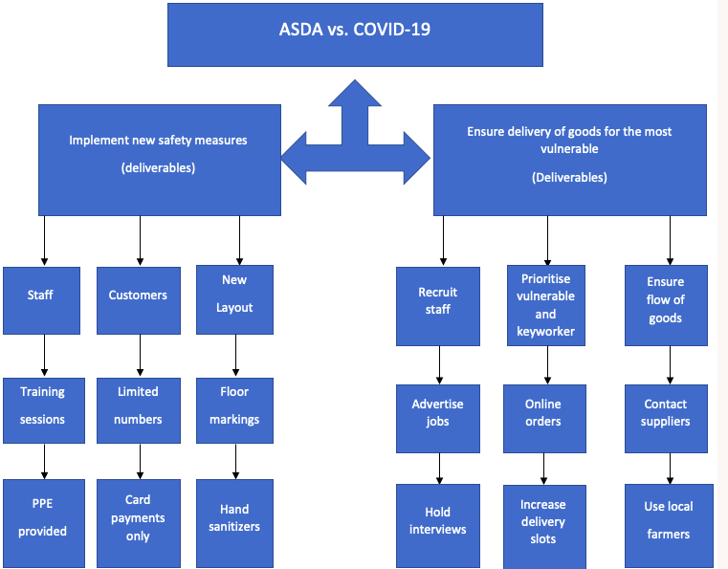

According to the WBS, ASDA implemented a series of measures to protect the health of its customers and employees. To ensure the quality of these measures, ASDA is acting accordingly to the guidelines imposed by the government and the health secretary. By visiting one of ASDA's stores, customers will observe the presence of staff members at the entrance to limit the number of persons allowed inside the premises to help with social distancing. Inside the shop, ASDA fitted floor markings to highlight the 2-metre distance and created one-way systems that customers are encouraged to follow so they could maintain a safe distance between other customers and staff members. To remind both customers and staff how vital is to follow these rules, and to raise awareness about this virus, ASDA decided to use its internal radio system to transmit regular messages related to health and safety. The retailer asks its clients to avoid touching items they do not intend to buy, to help reduce the dispersion of the virus, and also compelled them to use card payment only for check-out. In this battle against coronavirus, ASDA focused its efforts towards the most vulnerable customers, who are not able to leave their house and shop in-store. For this, the supermarket chain increased the delivery slots for on-line orders, reaching 700,000 per week in comparison to the 450,000 per week before COVID-19 outbreak. To cope with this high demand reached through on-line orders, ASDA increased its fleet, securing 48 new electric vehicles designated for delivery purposes. (Steps we have taken in response to the Coronavirus outbreak, 2020)
The author strongly believes that any project is subject to certain unknowns and risks during its completion. Risks analysis is a process used to determine and define the risks that could occur to a project, and it can provide a decision-maker with the best possible information about loss exposure and their options for dealing with it. (Copeland, 2017)
The researcher conducted the risk analysis for ASDA, identified the mitigating actions and highlighted the likelihood of these risks to happen.

Risk | Likelihood  H/M/L | Impact  H/M/L | Mitigating actions
1)Customers staying to close to each other.  2)Customers rushing inside the store.  3)Crowding at check-out points. | High | High (external) | 1)Markings on the floor to highlight the 2-metre distance.  2)20 people inside the store at the same time.  3)Safe distance between tills.
1)Staff not wearing correct PPE, face masks and gloves.  2)Staff unable to instruct customers | Medium | High (internal) | 1)Ensure availability and use of PPE.  2)Provide appropriate training for employees.
1)Stock shorting.  2)Delays on deliveries from suppliers. | Medium | High (external) | 1)Use local suppliers/ farmers.  2)Book in advance.
The project manager should not disregard or hide risks; it is his responsibility to deal with them suitably with the help of every member of the team. Projects are subject to different types of risks, and these can have an impact on the operational budget or the schedule. Using risk management knowledge, the project manager must detect and calculate the potential risks that might impact the project and minimise their damage to the project. Risk management might prove inefficient without a controlled framework, and in the situation of a fragmented effect, evaluation can harm some project objectives such as scope, time, quality and cost. (Doval, 2019)

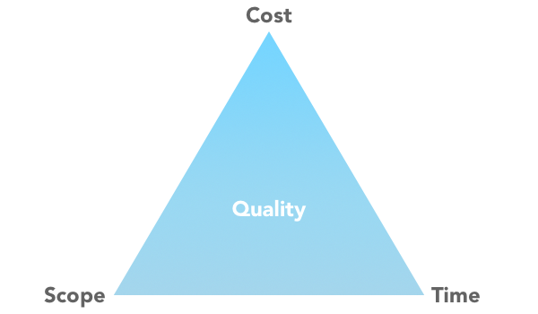

The elements mentioned above form the Iron Triangle, also known as the Triple Constraint, is a tool that will offer valuable insight that will help the reader to understand project management. The iron triangle will not solve problems for the project manager but will provide a clear idea of the choices that he has and will help him make the best decisions. Once you choose a scope that meets your needs, allocate a budget, so you understand the cost and set up a time to which the project will be delivered, you locked together the three corners of the triangle. At this point, the triangle is in perfect balance.
Still, things can change rapidly for the project if the project manager tries to deliver the project sooner, reduce resources to save money or alter the quality of the project. If the project manager decides to increase the quality of the project, he will have to increase the costs and extend the delivery time for the project. Beneficiary demands or financial limitations puts pressure on the third component of the triangle, so the project manager may be unable to fulfil all three of them. By doing this, the triangle of balance becomes the Triple Constraint. This kind of situation is often encountered and articulated as "good, fast or cheap- pick two." (Pollack, 2018)

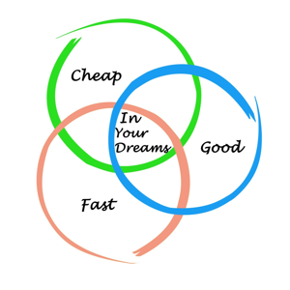

The researcher applied the iron triangle to ASDA and came up with the following assertions.
Time
Asda extended opening times for some stores to help critical workers procure their necessary goods, and increased delivery slots to 700,000 a week to ensure groceries to the most vulnerable.
Cost
The organisation acquired 48 new electric vans to cope with the high demand registered via on-line shopping. Short-term profit affected by this acquisition, but from a long-term point of view is a good investment.
Scope
To ensure customers keep a safe distance between them at check-out points, ASDA installed plexiglass screens to offer a higher level of confidence to its shoppers. The researcher praises ASDA's initiative of introducing a call and collect service for pharmaceutical items, also to limit the number of in-store customers. (Hodgson, 2020)

Time- extended opening times.
-increased delivery slots

Scope-limit the number of clients in-store
-increase clients confidence installing plexiglass

Cost-increased cost by the acquisition of 48 electric vans

Every specific activity that ASDA undertakes during the COVID-19 pandemic is time-bound. When it comes to tracking the progress of a project through time, usually project managers make use of the Gantt chart. The Gantt chart is perhaps the most potent visual reporting device, offering an observation of tasks scheduled over a specific time. It is the most preferred tool by managers because it is easy to construct and simple to understand. (Pradeep, 2005)

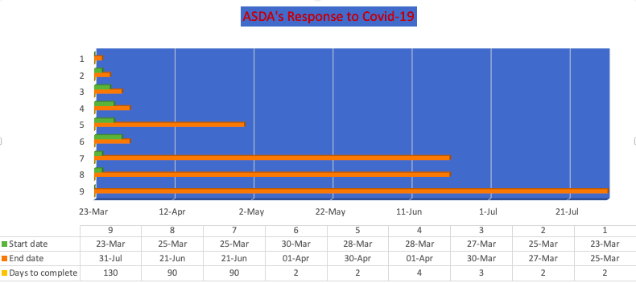
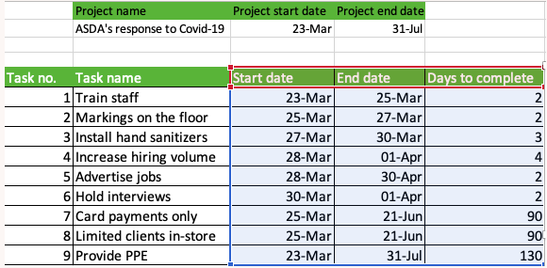

2.4.Implementation phase
For most of the project managers and team members, it is the most satisfying stage of the project because the plan is put into action. In this phase of the project management life cycle, the project manager keeps the work going, coordinates team members and makes sure everything follows the precise track. The project manager is the one that feeds updates to the stakeholders involved in the project, guides team members on how tasks should be concluded and monitors the quality of work. (Taylor, 2006)
The researcher identified the network diagram as the most appropriate tool to work out the timetable of a project, in addition to tracing its advancement across each step. (Tran, 2019)

The author of the report compiled a network diagram showing the deliverables and sub deliverables of ASDA’s project management. As seen in the table below, the deliverables were represented by the two main objectives, to deliver goods for the most vulnerable and to implement new safety measures.

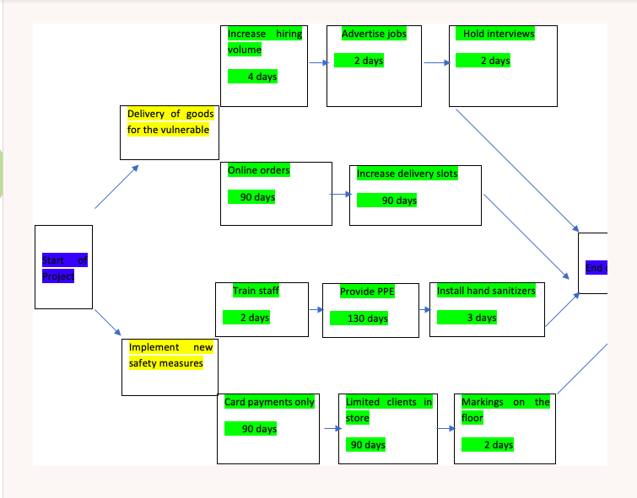

A vital factor for the success of the project management, that the project manager should bear in mind is motivating the project team members. Motivation theory in project management comes in two distinct shapes, intrinsic, derived from values and beliefs, and extrinsic motivation like financial recognition. According to Maslow's theory of needs, people are more likely to meet lower-level objectives like shelter and security before looking for motivation from higher goals. As a result, individuals will not invest time and resources to reach higher levels of the pyramid until they have reached the low-level ones. Money is a powerful vehicle of motivation, especially when the individual finds himself at the lower levels of the pyramid, but not a long-term one. The strongest motivators, self-esteem and self-actualisation are the ones at the very top of the pyramid, the ones that the individuals aim. (Schmid and Adams, 2008)

2.5. Monitoring and evaluation phase
These two important tools go hand in hand, and while monitoring is used to “warn and instruct”, evaluation is used “to judge the value or condition of something in a careful and thoughtful way”. (Leconte, 2020)
According to this phase of the project management life cycle, one cannot fix and recuperate something until that thing is not adequately identified and measured. Even though project monitoring plays a vital role in project management, it is usually disregarded, and it is compiled only to follow the project management plan. Project monitoring is about directing tasks and observing all project activities to make sure the specific works are implemented accordingly. There are a few relevant questions answered during the monitoring phase of the project:
- are there any elements of the projects that need to be changed?
- is the team performing at its best and in the right direction?
- are the tasks fulfilled as planned?
The most common types of project monitoring can be achieved through weekly or monthly staff meetings, through progress reports or learning forums. (How Important Is Project Monitoring And How Do We Implement It Through AI?, 2017)
The evaluation of project performance is done when the initial scope that everyone agreed upon was reached. Appraisals are a systematic and impartial assessment of expected and achieved accomplishments. Evaluations are usually conducted externally by evaluators or specialists with no link to the organisation, ensuring an unbiased judgement. The assessment can be qualitative or quantitative, and even though these are conflicting terms, they both bring benefits when trying to understand data or information. Qualitative evaluations are subjective, and they cannot reproduce the same outcome with accuracy. On the other side, there are quantitative evaluations, more objective representations of evaluating project performance, which can be measured and counted, producing the same result every time. (Collins, 2020)

For ASDA, the monitoring and evaluation model is described in the following table.

What is evaluated/monitored | Types of evaluation | Hard/Soft | Outcome
Employees | Participative | Soft | Observing if employees follow guidelines and if they show active support to clients
Customers | Formative | Soft | Check if customers adhere to guidelines and floor markings
Equipment | Formative | Soft | Ensure PPE for staff and make sure customers use disinfectants and hand sanitizers
On-line shopping | Summative | Hard | Growth in on-line shopping requires more timeslots
Stock availability | Summative | Hard | Keep in touch with suppliers and use local farmers to ensure stock availability

ASDA’s response to COVID-19 pandemic project management is not yet completed, the author does not have the capability or the necessary resources to compel the last phase of the project which is the Project closure phase.

3.Conclusions and recommendations

As a conclusion the researcher acknowledges the hard work and the effort dedicated by the project manager in the completion of the project management.
From the initial phase of the project life cycle to the last stage of the project, the project manager’s responsibility grows gradually, and it is on his shoulders he must carry the successful completion of any project.
In regard to the organisation, the author is convinced that all the steps undertaken by it during the coronavirus lockdown were successfully implemented. As a result, ASDA continued to stay open for business, despite the threat of this terrible virus. By hiring delivery drivers and purchasing new vans the grocer managed to deliver foods and medication to the most vulnerable people. The questions arising now are: was the project successful, was the project adhering to the government regulations , were all the customers satisfied by our measures? Judging by the number of customers who are still shopping at ASDA, the answer is yes, yes the project was a massive success.
However, there is always room for improvement, and the fight with the virus will carry on for who knows how long. At this moment in time ASDA must focus on ensuring product availability for its customers and help local communities as an alternative to traditional suppliers.

4.Reference list
- ASDA. (2020). The biggest companies in the world. Available at: https://www.companieshistory.com/asda/ (Accessed 16 March 2020).
- Brotherton, S. A., Fried, R. T., & Norman, E. S. (2008). Applying the work breakdown structure to the project management lifecycle. Paper presented at PMI® Global Congress 2008—North America, Denver, CO. Newtown Square, PA: Project Management Institute.
- Chegg.com. (2020). What Is A Quad Chart. Available at: https://www.chegg.com/homework-help/questions-and-answers/quad-chart-quad-chart-one-page-summary-project-visual-well-descriptive-simple-tool-extreme-q25204961 (Accessed 5 June 2020).
- Clayton, M. (2017) What Is Project Scope? Project Management In Under 5. Available at: <https://www.youtube.com/watch?v=NXw0bvvYWYo> (Accessed 30 June 2020).
- Collins, B. (2020) Available at: <https://www.theclassroom.com/difference-between-qualitative-quantitative-evaluation-8281411.html> (Accessed 2 July 2020).
- Copeland, J. (2017). Risk Analysis vs. Risk Assessment: What’s The Difference?
- COVID-19 Advice For Supermarket Visits.(2020) Available at: <https://www.birmingham.gov.uk/info/50246/local_guidance_during_covid-19/2144/covid-19_advice_for_supermarket_visits> (Accessed 2 July 2020).
- Cunningham, A. (2020) The New 'Rules' Asda Is Enforcing For Shoppers During The Virus Pandemic. Available at: <https://www.essexlive.news/news/essex-news/asda-issues-new-rules-help-4019650> (Accessed 2 July 2020).
- Doval, E. (2019) Review of General Management. , Vol. 29 Issue 2, p97-113.
- Haworth, S. (2018). Start Your Projects Right: A Complete Guide To Project Initiation - The Digital Project Manager. Available at: <https://thedigitalprojectmanager.com/project-initiation-guide-how-start-projects/> (Accessed 29 June 2020).
- Heerkens, G. (2001). Project management, New York, N.Y.: McGraw-Hill Trade.
- Hodgson, B.(2020) Asda Reveals New Health And Safety Measures And In-Store Changes. Available at: <https://www.chroniclelive.co.uk/whats-on/shopping/asda-reveals-new-heath-safety-18152240> (Accessed 2 July 2020).
- How Important Is Project Monitoring And How Do We Implement It Through AI?. (2017) Available at: <https://www.knowledgehut.com/blog/project-management/important-project-monitoring-implement-ai> (Accessed 2 July 2020).
In pp. 237–274.
- Jahshan, E. (2020) Asda To Pay Coronavirus-Isolated Staff In Full; Concessions Given Rent Holiday. Available at: <https://www.retailgazette.co.uk/blog/2020/03/coronavirus-self-isolated-asda-workers-will-still-be-given-full-pay/> (Accessed 1 July 2020).
- Leconte, P. (2020) What Is A Monitoring & Evaluating System? Available at: <https://www.clearpointstrategy.com/monitoring-and-evaluating-system> (Accessed 22 June 2020)
- Maylor, H. (2010). Project management (4th ed.). Harlow: Financial Times Prentice Hall.
- O'Reilly, G. (2018) 6 Attributes To Look For In Your Project Management Champions! Available at: <https://www.brightwork.com/blog/6-attributes-to-look-for-in-your-project-management-champion> (Accessed 30 June 2020).
- Pollack, J. (2018) What is the Iron Triangle, and how has it changed? International Journal of Managing Projects in Business, 11(2), pp.527–548.
- Pradeep, K.P. (2005) Effective Use of Gantt Chart for Managing Large Scale Projects. Cost Engineering Journal, 47(7), pp.14–22.
- Productplan.com. 2020. What Is Stakeholder Analysis? Available at: https://www.productplan.com/glossary/stakeholder-analysis/ (Accessed 5 June 2020).
- Project Management Life Cycle: Definition, Phases & Models, (2017). Available at: https://study.com/academy/lesson/project-management-life-cycledefinition-phases-models.html (Accessed 22 May 2020).
- Rahman, M. (2019) Stakeholders of Asda (An analysis of ASDA’s stakeholders) Available at: <https://www.howandwhat.net/stakeholders-asda-analysis-asdas-stakeholders/> (Accessed 30 June 2020).
- Schmid, B. and Adams, J. (2008) Motivation in project management: The project manager's perspective. Project Management Journal, 39(2), pp.60–72.
- Stakeholder Analysis: Winning Support For Your Projects. (2020) Available at: <https://www.mindtools.com/pages/article/newPPM_07.htm> (Accessed 30 June 2020).
- Steps We Have Taken In Response To The Coronavirus Outbreak.(2020) Available at: <https://corporate.asda.com/20200309/steps-we-have-taken-in-response-to-the-coronavirus-outbreak> (Accessed 30 June 2020).
- Taylor, J. (2006) A survival guide for project managers, CHAPTER 13: The Implementation Phase. American Management Association International
- Tran, L., 2019. Back To Basics (Part 10): How To Create A Project Network Diagram. Available at: <https://www.inloox.es/empresa/blog/articles/back-to-basics-part-10-how-to-create-a-project-network-diagram/> (Accessed 2 July 2020).
- Udo, N. & Koppensteiner, S. (2004). What are the core competencies of a successful project manager? Paper presented at PMI® Global Congress 2004—EMEA, Prague. Czech Republic. Newtown Square, PA: Project Management Institute.
- What Is Project Management? (2020). Available at: <https://www.pmi.org/about/learn-about-pmi/what-is-project-management> (Accessed 29 June 2020)
- Wright, G. (2020). Coronavirus: Asda Closes Counters And Rations Products. Available at: <https://www.retailgazette.co.uk/blog/2020/03/coronavirus-asda-closes-counters-rations-products-grocery/> (Accessed 29 June 2020).

